APPLICATION FOR LISTED BUILDING CONSENT
OFFICER DELGATED REPORT

APPLICATION REFERENCE: | PL/2025/09265
APPLICATION TYPE: | Listed building consent (Alt/Ext)
SITE ADDRESS: | Wye House, Barn Street, Marlborough, SN8 1AB
DESCRIPTION OF WORKS: | Like for like replacement of nine single glazed timber sash windows
RECOMMENDATION: | Approve with Conditions

SITE DESCRIPTION/CONTEXT

Wye House is a large two storey detached building that has been converted into 6 flats. Its historic development is described in the supporting heritage statement. It is a grade II listed building

The site also lies within the Marlborough conservation area.

The list entry, for means of identification purposes only, provides the following description:

Late C18. Two storey. Brick on small stone plinth, with wide angle pilaster projections, moulded cornice, slight central projection with blocking course, and hipped slate roof. Five windows on first floor. Four tall windows on ground floor, and central glazed door, under Greek Doric porch of ashlar bath stone, two columns in antis, and arched glazed lights at sides. Central square stone gate piers and brick flanking walls on road front.

PROPOSAL

This is a listed building consent application for Like for like replacement of nine single glazed timber sash windows.

The applicants have submitted 4 different window elevation plans, a full window survey report (photos) and a window condition report. The proposal is also supported by two annotated elevational window photos which corresponds to the elevation plans.

The applicants have stated that the same glazing bar details on drawing No 112 are also proposed for the dormer window plans (113) although they have been missed off the plan. The applicants have accepted that a condition for the same details as shown on plan 112 will also apply to plan 113.

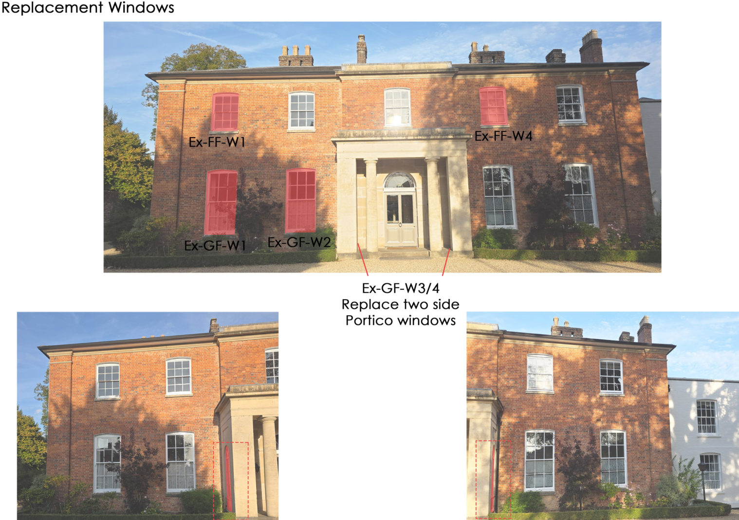

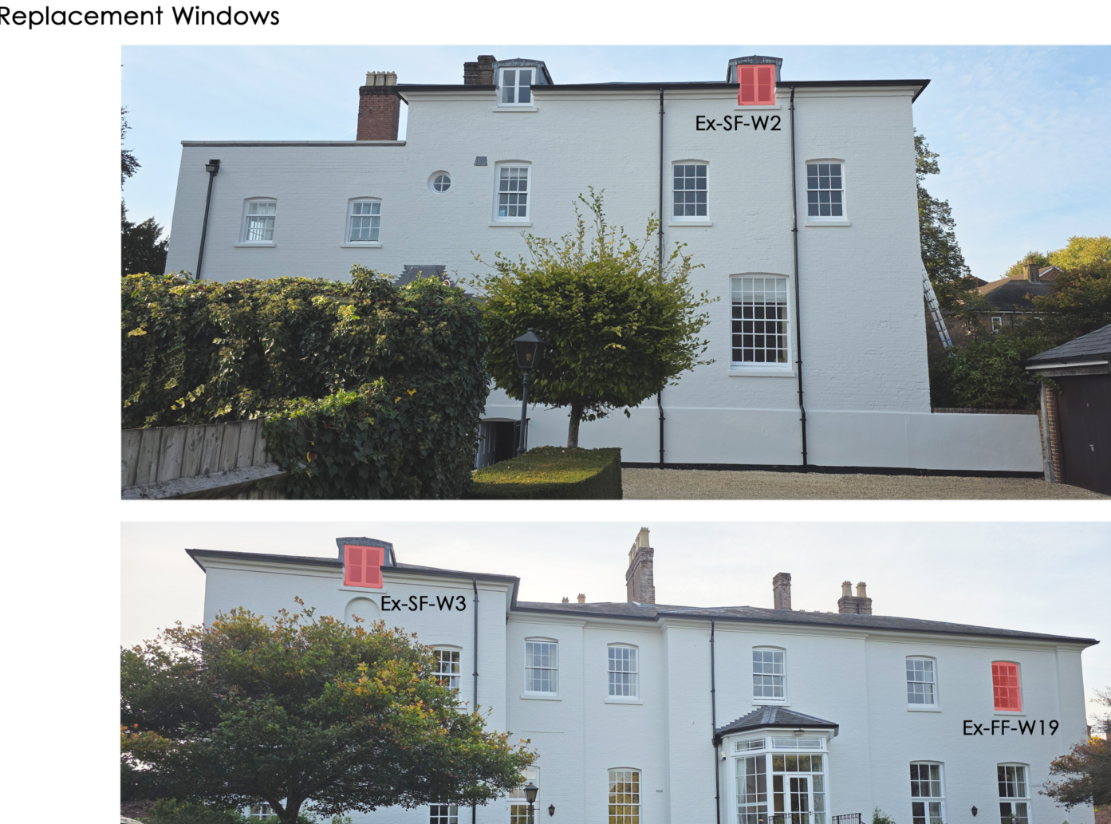

Annotated Elevational Window Plans

RELEVANT PLANNING HISTORY

There has been an extensive planning history on the site however, none relate to replacing the existing windows.

RELEVANT LEGISLATION, POLICIES AND GUIDANCE
Legislation
From the point of view of the historic environment the main statutory tests are set out within the Planning (Listed Building and Conservation Areas) Act 1990. Section 16 requires that special regard be given to the desirability of preserving listed buildings, their settings or any features of special architectural or historic interest which they possess.

Section 72(1) of the Planning (Listed Building and Conservation Areas) Act 1990 also requires the Council to pay special attention to the desirability of preserving or enhancing the character or appearance of designated Conservation Areas.

National Policy and Guidance

The National Planning Policy Framework (NPPF) sets out government policy, including in respect of the historic environment.

Section 16 of the NPPF ('Conserving and enhancing the historic environment') sets out the Government's high-level policies concerning heritage and sustainable development.

Paragraphs 213-215 of the NPPF require a balanced approach with any harm which would be caused being weighed against the potential public benefits which might be achieved. Paragraph 210 requires local planning authorities to take account of the desirability of sustaining and enhancing the significance of heritage assets and of new development making a positive contribution to local character and distinctiveness.

Section 14 of the NPPF addresses the challenge of climate change, flooding and coastal change.

Paragraph 167 advises that “Local planning authorities should also give significant weight to the need to support energy efficiency and low carbon heating improvements to existing buildings, both domestic and non-domestic (including through installation of heat pumps and solar panels where these do not already benefit from permitted development rights).

National Planning Practice Guidance provides guidance on interpreting the NPPF.

Historic England Advice Note 2: Making changes to Heritage Assets, illustrates the application of policies set out in the NPPF in determining applications for LBC (and planning permission).

Historic England’s publication ‘Traditional Windows – Their Care, Repair and Upgrading (2017)’ encourages the retention of windows that contribute to the significance of listed buildings but sets also out their approach to the alteration/replacement of windows where this is acceptable in principle:

- Where historic windows, whether original or later insertions, make a positive contribution to the significance of a listed building they should be retained and repaired where possible. If beyond repair they should be replaced with accurate copies.
- Where historic windows have already been replaced with windows whose design follows historic patterns, these usually make a positive contribution to the significance of listed buildings. When they do, they should therefore be retained and repaired where possible. If beyond repair they should be replaced with accurate copies.
- Where historic windows or replacement windows of historic pattern survive without historic glass it may be possible to introduce slim-profile double-glazing without harming the significance of the listed building. There are compatibility issues to consider as the introduction of double-glazing can require the renewal of the window frame to accommodate thicker glazing, thereby harming significance. These issues are covered in Section 4 of this guidance.
- Where historic windows have been replaced with ones whose design does not follow historic patterns, these are unlikely to contribute to the significance of listed buildings. Replacing such windows with new windows of a sympathetic historic pattern, whether single-glazed or incorporating slim-profile double-glazing, may cause no additional harm. It also provides an opportunity to enhance the significance of the building, which is the desired outcome under national policy.
- Where a new window or re-glazing is agreed, the reflective properties of secondary and double-glazing as compared to modern, polished single-glazing, do not usually harm the significance of the building. But when new multi-paned windows are proposed, the desirability of reproducing broken reflections by individually glazing each pane should be considered. Where the aesthetic value of the building is high, then the impact on the whole of the relevant elevation should be considered, including the desirability of accurately matching other windows.

Historic England Advice Note 18: Adapting Historic Buildings for Energy and Carbon Efficiency, provides advice in support of consistent decision making on approaches to improve the energy efficiency and support carbon reduction of historic buildings, whilst conserving their significance.

Wiltshire Core Strategy:
Whilst not directly relevant to listed building consent applications, the below policies give an indication of the Council’s approach to development affecting heritage assets:

- Core Policy 57 ‘Ensuring high quality design and place shaping’: A high standard of design is required in all new developments, including extensions, alterations, and changes of use of existing buildings. Development is expected to create a strong sense of place through drawing on the local context and being complementary to the locality.

- Core Policy 58 ‘Ensuring the conservation of the historic environment’ requires that “designated heritage assets and their settings will be conserved, and where appropriate enhanced, in a manner appropriate to their significance.”

ISSUES

Impact upon the preservation of the listed building or its setting or any features of special architectural and/or historic interest.

CONSULTATION RESPONSES

Marlborough Town Council – No objection subject that the Council’s Conservation Officer is satisfied.

Wiltshire Council Conservation Officer – following receipt of window survey, no objection subject to conditions.

REPRESENTATIONS

In accordance with the requirements of Section 5(1) of the Planning (Listed Buildings and Conservation Areas) Regulations 1990 (as amended) the application for listed building consent was publicised by way of:

- A site notice displayed near the site;
- An advertisement placed in the local press.

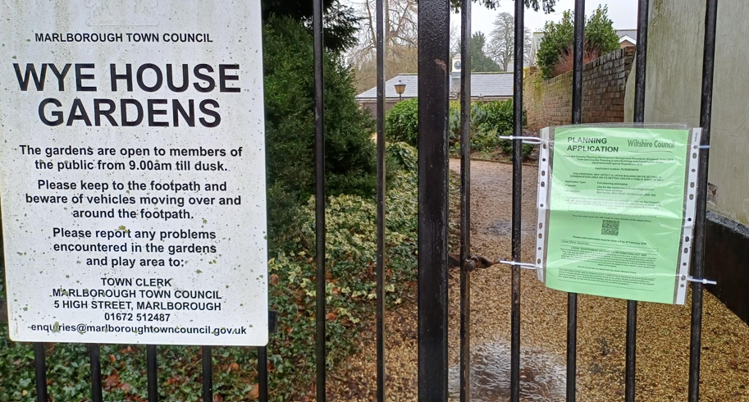

These methods were used to inform interested parties and to allow a statutory consultation period of 21 days for representations to be submitted.

No comments were received.

ASSESSMENT

In accordance with Section 16(2) of the Planning (Listed Buildings and Conservation Areas) Act 1990, special regard has been given to the significance of the listed building, including its architectural and historic interest, and the desirability of preserving both the building and its setting. Relevant policies within the National Planning Policy Framework (NPPF), particularly Section 16: Conserving and Enhancing the Historic Environment, have also been taken into account. These policies require that any harm to the significance of a designated heritage asset must be clearly justified and weighed against the public benefits of the proposal.

In order to be acceptable, the application needs to be assessed against the following criteria:

Information considered/submitted
Paragraph 207 requires that applicants describe the significance of any heritage assets affected, including any contribution made by their setting. This should include sufficient information to provide a clear understanding of the significance of the heritage asset and its setting and the potential impact of any proposals on that significance.

As set out in the introduction, the applicants submitted a heritage statement, window survey (with photos document) and elevation plans.

Assessment of significance:
According to the National Planning Policy Framework (NPPF), significance is defined as:

“The value of a heritage asset to this and future generations because of its heritage interest. The interest may be archaeological, architectural, artistic or historic. Significance derives not only from a heritage asset’s physical presence, but also from its setting.”

Historic England further categorises significance into four key values:

- Evidential – the potential of the asset to yield evidence about past human activity.
- Historic – the ways in which the asset illustrates aspects of history.
- Aesthetic – the sensory and design qualities of the asset.
- Communal – the meanings and associations attached to the asset by people.

Wye House is an important grade II listed building from the 18 Century and in this case the original windows still date from that time. The conversion from a single dwelling into 6 flats did not change the historic significance of the building as the conversion was adapted to the original window layout of the building. The windows therefore are an important part of the historic significance of the listed building.

Impact of proposals on the significance and setting of the building/structure:

Understanding the impact of proposed works on a listed building requires a careful and proportionate assessment of how those changes affect the asset’s heritage significance and its setting. This includes both the physical alterations to the building itself and any changes to its spatial or visual relationship with surrounding structures or spaces.

The significance of a heritage asset is not static; it is shaped by its architectural, historic, and communal values, and by how these are experienced in context. Therefore, any intervention must be considered in light of the asset’s identified significance, with attention given to both potential harm and benefits. Benefits may include repairs that support the long-term conservation of the building, improved energy performance, or enhanced public access and understanding.

This assessment is grounded in the statutory duty under Section 16 of the Planning (Listed Buildings and Conservation Areas) Act 1990, which requires special regard to be given to the desirability of preserving the building and its features of special interest. It is also informed by national policy, particularly paragraphs 199–208 of the National Planning Policy Framework (NPPF), and relevant local heritage policies and guidance.

The Council’s Conservation Officer comments;

“Wye House is an important grade II listed building within the Marlborough Conservation Area. Dating from the late 18th century, the house has connections with distinguished local architect Charles Edwin Ponting, who lived in the house from 1896-1919. Originally the grounds were much more extensive than today, but considering the town centre location, the gardens are still quite generous despite modern 20th century development to the side and rear of the site. Some of this residential development relates to Wye House, as it is now a private retirement estate with a combination of apartments within the late Georgian building, and numerous new-build properties within the grounds.

The proposal is for the replacement of nine sash windows.

The heritage statement considers the windows identified for replacement as dating from the 1850s, therefore the proposals result in the loss of historic fabric that positively contributes to the significance of the designated heritage asset.

When historic windows are proposed for replacement, a strong justification for the loss of historic fabric needs to be made.

Additional supporting information has been provided since my previous comments – these are in the form of a photographic survey of the 9 windows proposed for replacement, and a condition report going into more detail to understand the problems experienced with the windows identified. These give a much more detailed greater understanding of the situation and proposals, giving more support to the works.

The joinery details do not show the glazing, to confirm the thickness of this, but as the rebate and sprig are not deep enough for anything other than 4-6mm plate glass, it is assumed that single glazing is proposed.

Now that the supporting information has been submitted, giving a clear understanding of the works to the windows identified, there are no objections to the replacements as identified, as these do appear to be beyond reasonable repair. The joinery details confirm that the new sash windows will match the existing, and these are considered acceptable. The joinery details for the dormer window do not show the glazing bar detail, and these should be provided, although there is scope for slim line double glazing to be used within this window, as its use in this location should not impact the building’s visual qualities.

Therefore, as set out by the conservation officer, whilst it is preferred for the windows to be repaired, the applicants have demonstrated that each window is beyond repair and would be replaced with like for like timber windows and detailing. Therefore, whilst the loss of this historic fabric would at the higher end of NPPF paragraph 215 (of less than substantial harm), the loss is unfortunately unavoidable in this instance, and the windows have to be replaced.

The primary benefits of the proposal are private; however, there are limited public benefits in securing the long-term conservation of the listed building through necessary replacement works, maintaining visual consistency through like-for-like detailing, and achieving modest improvements to thermal performance. When these benefits are weighed against the identified less than substantial harm, the balance is considered to favour the proposal.

Impact on Ecology

While Sections 16 and 72 of the Planning (Listed Buildings and Conservation Areas) Act 1990 do not explicitly reference protected species, Local Planning Authorities have a statutory duty to consider potential impacts on protected species when determining applications. This responsibility arises from broader environmental legislation and national planning policy, and must be taken into account where relevant.

Does the site or proposed development possess/impact on any of the features where
protected species are likely to be present (assessed against Natural England’s standing
advice) and where species are likely to be found?
 |  | Y / N / NA
(a) | Does the site or proposed development possess/impact on any of the features where protected species are likely to be present (assessed against Natural England’s standing advice) and where species are likely to be found? | N/A
(b) | If yes, has a protected species survey been submitted? | N
(c) | If yes, does the survey show a detailed consideration of ecological impacts, wildlife mitigation and the creation, restoration and enhancement of wildlife corridors to preserve and enhance biodiversity in accordance with the standing advice? | N/A

The application is to replace windows and would not affect any potential bat roosts in the building.

CONCLUSION

The NPPF confirms that when considering the impact of a proposed development on the significance of a designated heritage asset, great weight should be given to the asset’s conservation (and the more important the asset, the greater the weight should be). It makes clear that any harm to a designated heritage asset requires clear and convincing justification.

Positive/neutral
In this case the proposals will also result in considerable heritage benefits by virtue of the proposed investment in repair and upgrading/structural repair which will help to secure the future/stability of the building /via facilitating the optimum viable use.

Overall, the proposals would result in less than substantial harm to the significance of the listed building. That harm is clearly identified, justified by evidence that the windows are beyond reasonable repair, and is outweighed by the public benefits identified above. The requirements of current conservation legislation, policy or guidance are considered to be met.

RECOMMENDATION:
That Listed Building Consent be GRANTED, subject to conditions:

