APPLICATION FOR HOUSEHOLDER PLANNING PERMISSION
DELEGATED REPORT

APPLICATION REFERENCE: | PL/2026/00476
APPLICATION TYPE: | Full planning permission
SITE ADDRESS: | Wye House, Barn Street, Marlborough, SN8 1AB
DEVELOPMENT DESCRIPTION: | Like for like replacement of nine single glazed timber sash windows
RECOMMENDATION: | That Planning Permission be GRANTED

PROPOSAL

The proposal seeks planning permission for Like for like replacement of nine single glazed timber sash windows at Wye House, Barn Street, Marlborough, SN8 1AB

The applicants have submitted 4 different window elevation plans, a full window survey report (photos) and a window condition report. The proposal is also supported by two annotated elevational window photos which corresponds to the elevation plans.

The applicants have stated that the same glazing bar details on drawing No 112 are also proposed for the dormer window plans (113) although they have been missed off the plan. The applicants have accepted that a condition for the same details as shown on plan 112 will also apply to plan 113.

This planning application is accompanied by a separate listed building consent application, which addresses the acceptability of the works in heritage terms; however, the heritage impacts are also material to this planning decision and are considered below.

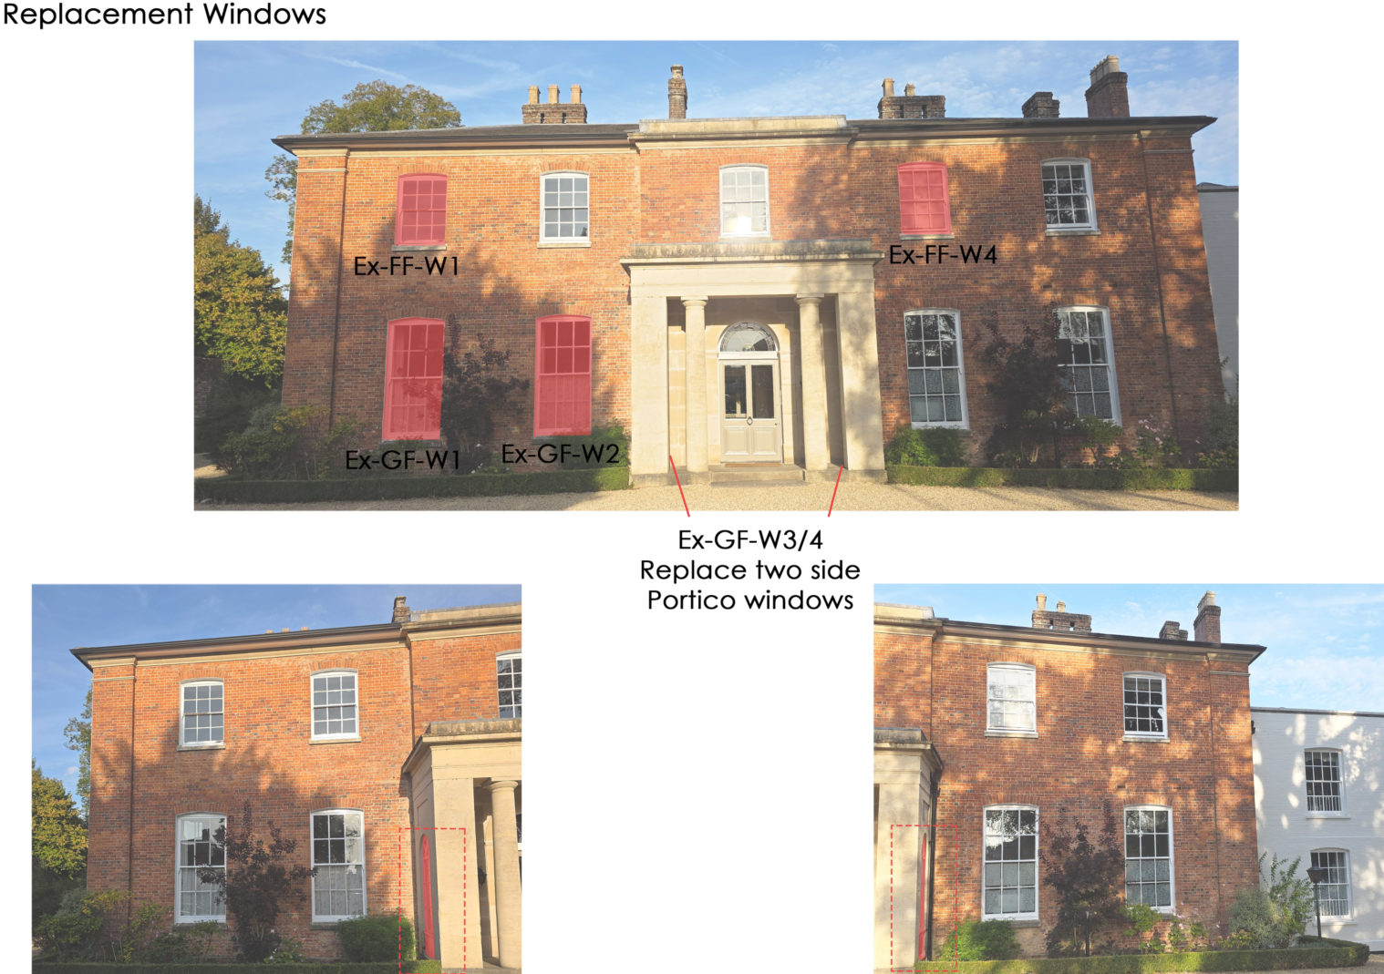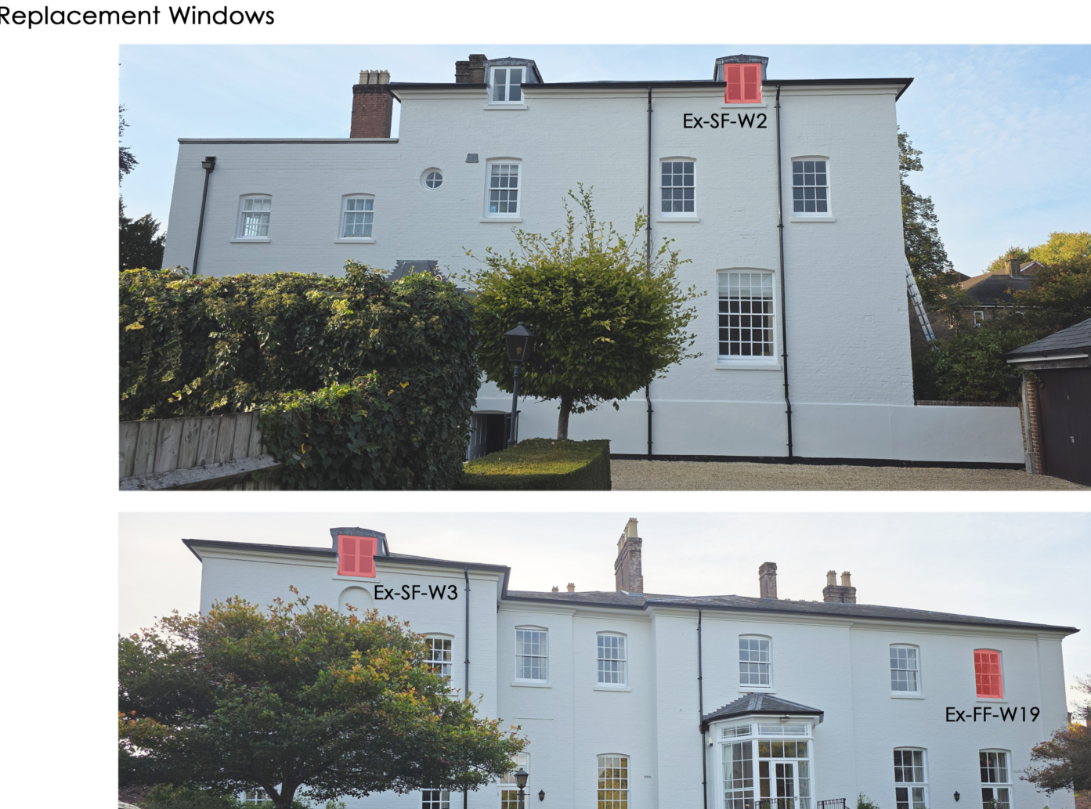

Annotated Plans showing the location of the replacement windows and the corresponding glazing plans

SITE DESCRIPTION/CONTEXT

Wye House is a large two storey detached building that has been converted into 6 flats. Its historic development is described in the supporting heritage statement. It is a grade II listed building

The site also lies within the Marlborough conservation area.

The list entry, for means of identification purposes only, provides the following description:

Late C18. Two storey. Brick on small stone plinth, with wide angle pilaster projections, moulded cornice, slight central projection with blocking course, and hipped slate roof. Five windows on first floor. Four tall windows on ground floor, and central glazed door, under Greek Doric porch of ashlar bath stone, two columns in antis, and arched glazed lights at sides. Central square stone gate piers and brick flanking walls on road front.

The application site is subject to the following planning policy constraints:

- North Wessex Downs National Landscape

PLANNING HISTORY

There has been an extensive planning history on the site however, none relate to replacing the existing windows.

RELEVANT POLICIES AND GUIDANCE

National Context:
The National Planning Policy Framework (NPPF)

The NPPF outlines government policy for planning. Chapter 16 of the NPPF 'Conserving and enhancing the historic environment' sets out the Government's high-level policies concerning heritage and sustainable development.

The Planning Practice Guidance

From the point of view of the historic environment the main statutory tests are set out within the Planning (Listed Building and Conservation Areas) Act 1990.

Section 66 of the Planning (Listed Buildings and Conservation Areas) Act 1990 requires ‘special regard’ to be given to the desirability of preserving a listed building or its setting

Section 72 of the Planning (Listed Buildings and Conservation Areas) Act 1990 states that in the exercise of any functions, with respect to any buildings or other land in a conservation area, under or by virtue of any of the provisions mentioned in this Section, special attention shall be paid to the desirability of preserving or enhancing the character or appearance of that area.

Local Context:
Wiltshire Core Strategy:

- Core Policy 50: Biodiversity and Geodiversity
- Core Policy 51: Landscape
- Core Policy 57 Ensuring High Quality Design and Place Shaping
- Core Policy 58: Ensuring the Conservation of the Historic Environment

The Council’s Core Strategy Policy CP58 ‘Ensuring the conservation of the historic environment’ requires that designated and non-designated heritage assets and their settings will be conserved, and where appropriate enhanced, in a manner appropriate to their significance and encourages proposals which improve the condition of heritage assets at risk.

The Council’s Core Strategy CP 57: Ensuring high quality design requires a high quality of design in all new developments. The policy requires applicants to “demonstrate how the proposal will make a positive contribution to the character of Wiltshire through (amongst other things) responding to the value of the natural and historic environment and being sympathetic to and conserving historic buildings and landscapes. Development is required to respond positively to the existing in terms of building layouts, built form, height, mass, scale, building line, plot size, elevational design, materials, streetscape and rooflines to effectively integrate the building into its setting.

Marlborough Neighbourhood Plan 2023

Wiltshire Design Guide: Appendix D – Design Guidance for Householder extensions

CONSULTATION RESPONSES

Marlborough Town Council – No objection subject that the Council’s Conservation Officer is satisfied.

Wiltshire Council Conservation Officer – following receipt of window survey, no objection subject to conditions.

REPRESENTATIONS

No comments were received.

ASSESSMENT

Section 38(6) of the Planning and Compulsory Purchase Act 2004 states:

"If regard is to be had to the development plan for the purposes of any determination to be made under the planning Acts, the determination must be made in accordance with the plan unless material considerations indicate otherwise."

In accordance with this statutory requirement, this application has been assessed against the relevant policies of the Development Plan, including the adopted Wiltshire Core Strategy (2015) and, where applicable, any made Neighbourhood Plans.

Design and Impact upon the character and context of the area

Core Policy 57 - Ensuring High Quality Design and Place Shaping of the Wiltshire Core Strategy seeks to ensure that all new development is of high design quality, reflecting local context, character, and distinctiveness.

The proposal would be a like for like replacement of the existing windows and therefore no harm would be caused to the host building or the character of the area.

Having regard to the above, the proposal complies with the design principles set out in Core Policy 57 of the Wiltshire Core Strategy and Appendix D of the Wiltshire Design Guide.

Amenity

Point vii of Core Policy 57 - Ensuring High Quality Design and Place Shaping of the Wiltshire Core Strategy seeks to ensure that developments do not adversely affect neighbouring properties.

The National Planning Policy Framework (NPPF), particularly Paragraph 135(f), stresses that planning decisions should ensure developments provide a high standard of amenity for existing and future users.

Given that the proposal involves like-for-like replacement of existing window openings, it would not give rise to any material effects on neighbouring amenity.

The proposal would have no amenity issues as the proposal is for like for like replacement of existing windows.

The proposal therefore accords with Core Policy 57 point vii in respect of safeguarding residential amenity and Appendix D of the Wiltshire Design Guide.

Heritage Impact

The proposal, by virtue of its scale, design, and use of materials, is considered to preserve the character and appearance of the conservation area and the setting of the listed building. It would not result in harm to the significance of the listed building or the character and appearance of the conservation area, as the replacement windows replicate the existing timber sash form, proportions, glazing bar detailing and materials, thereby preserving the building’s historic fabric and appearance. No objections have been raised by the Conservation Officer.

The development is therefore considered to comply with Core Policy 58 of the Wiltshire Core Strategy and Sections 66 and 72 of the Planning (Listed Buildings and Conservation Areas) Act 1990, as well as the relevant provisions of the NPPF.

National Landscape

Core Policy 51 of the Wiltshire Core Strategy requires all development to protect, conserve, and where possible enhance the character and quality of Wiltshire’s landscapes, giving particular weight to designated areas such as National Landscapes.

The National Planning Policy Framework (NPPF), in Paragraph 176, states that “great weight” should be given to conserving and enhancing landscape and scenic beauty in National Landscapes (formerly Areas of Outstanding Natural Beauty). Development within or affecting the setting of a National Landscape must demonstrate that it will not result in unacceptable harm to the special qualities of that area.

Given the minor and like-for-like nature of the works, the proposal would have no perceptible effect on the special qualities or scenic character of the North Wessex Downs National Landscape.

The development therefore complies with Core Policy 51 of the Wiltshire Core Strategy and Paragraph 176 of the NPPF in conserving and enhancing the National Landscape.

Biodiversity Net Gain

Householder planning applications are exempt from the requirement to deliver Biodiversity Net Gain under Schedule 7A, Section 4(2)(a) of the Town and Country Planning Act 1990, as inserted by the Environment Act 2021.

CONCLUSION

The proposed development is considered to be acceptable in terms of its design, scale, and relationship with the surrounding area. It would not result in any unacceptable harm to the character of the locality, the amenities of neighbouring occupiers, or the interests of highway safety, heritage, or ecology.

The proposal is therefore considered to comply with the relevant policies of the Wiltshire Core Strategy, the Wiltshire Local Plan, and the National Planning Policy Framework. As such, the application is recommended for approval, subject to the conditions set out below.

RECOMMENDATION: That Planning Permission be GRANTED subject to conditions.

