APPLICATION FOR HOUSEHOLDER PLANNING PERMISSION
DELEGATED REPORT

APPLICATION REFERENCE: | PL/2026/01215
APPLICATION TYPE: | Householder planning permission
SITE ADDRESS: | Chapel Cottage, Clevancy, Hilmarton, Calne, SN11 8ST
DEVELOPMENT DESCRIPTION: | New residential access and driveway
RECOMMENDATION: | That Planning Permission be GRANTED

PROPOSAL

The proposal seeks planning permission for a new residential access and driveway at Chapel Cottage, Clevancy, Hilmarton, Calne. The proposal would require the removal of an existing breeze brick wall.

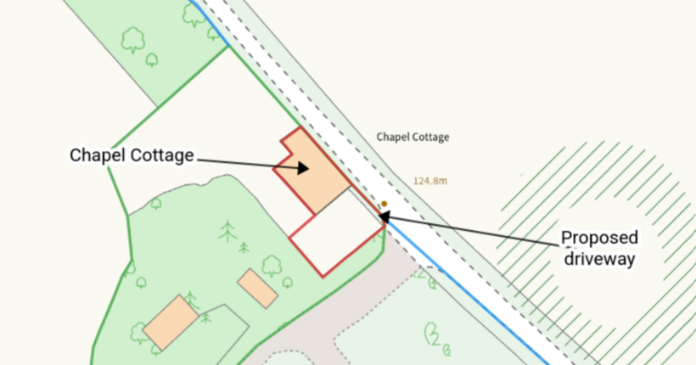

Site Location Plan

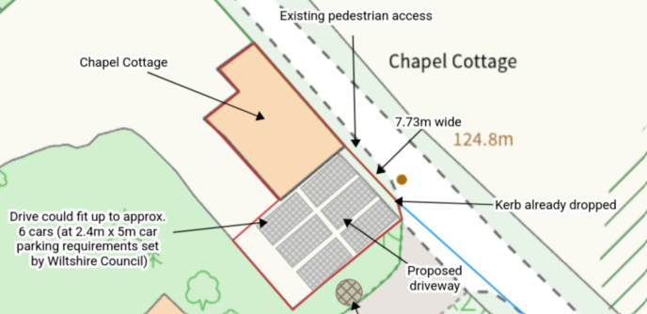

Proposed Site Plan

SITE DESCRIPTION/CONTEXT

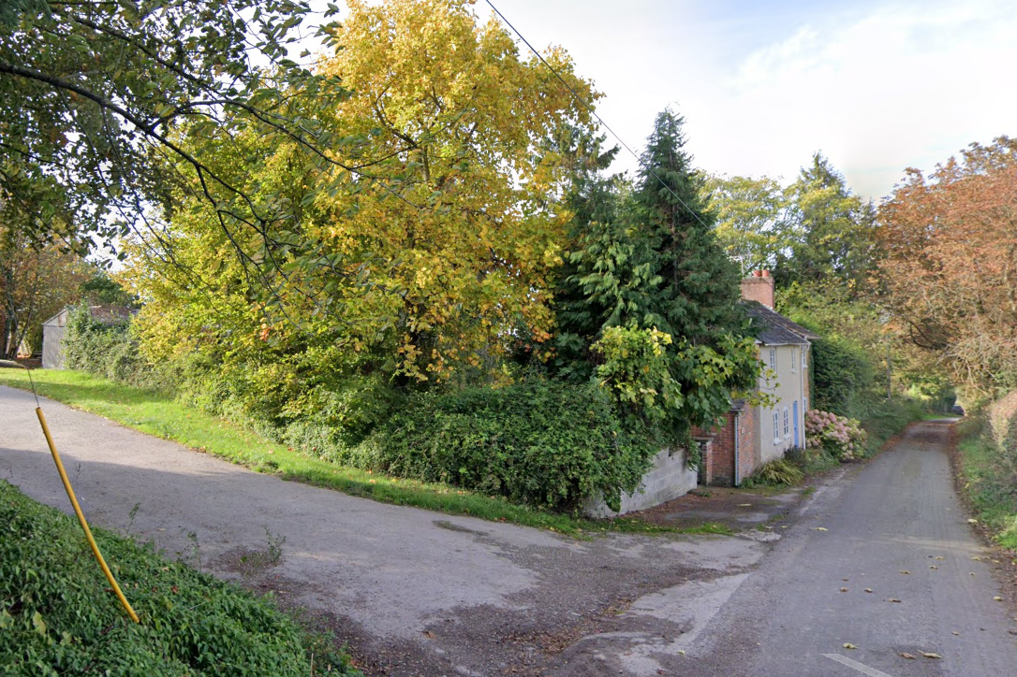

October 2022 Google Street View Image of the site (and adjacent access to Clevancy Farm)

Chapel Cottage is a detached two storey dwelling located on an unclassified adopted road which terminates approximately 140m to the southeast. Both the access and the garden are broadly level with the road, removing the need for any excavation works. The applicants will have to pass over a small section of highways verge (as the red outline does not extend right up to the road). The applicants have only signed certificate A on the application form.

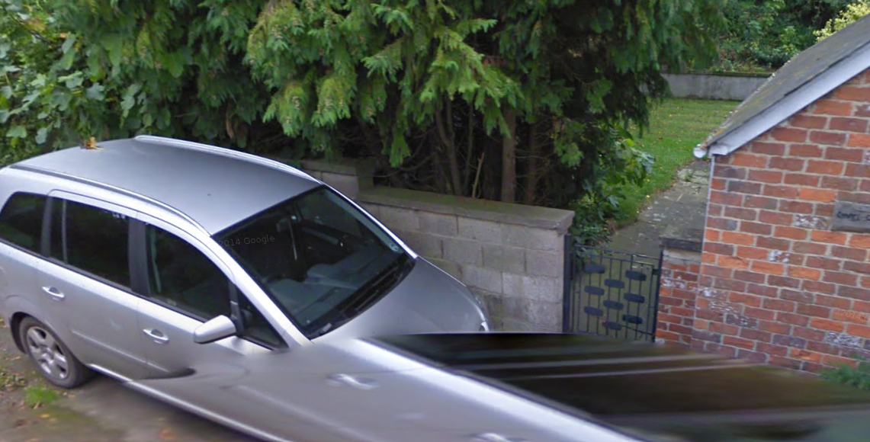

October 2011 Google Street View Image of proposed parking area

The site is within the North Wessex Downs National Landscape but is not subject to any other policy constraint including ground and surface water flood risk.

PLANNING HISTORY

Proposal / Summary
N/90/00398/OUT - Outline Planning Decision - Refused Date: 18/4/1990 – OUTLINE - ERECTION OF NEW DWELLING ON SITE OF OLD CHAPEL
N/88/02464/OUT - Outline Planning Decision - Refused Date: 10/10/1988 – OUTLINE - DWELLING AND GARAGE

RELEVANT POLICIES AND GUIDANCE

National Context:

The National Planning Policy Framework (NPPF)

The Planning Practice Guidance

General Permitted Development Order – Schedule 2, Part 2, Class B – Means of access to a Highway

The formation, laying out and construction of a means of access to a highway which is not a
trunk road or a classified road, where that access is required in connection with development
permitted by any Class in this Schedule (other than by Class A of this Part)

Local Context:

Wiltshire Core Strategy:

- Core Policy 57 Ensuring High Quality Design and Place Shaping
- Core Policy 61: Transport and New Development

Hilmarton became a designated area for a Neighbourhood Plan in 2019 but has not progressed to referendum stage.

Wiltshire Design Guide: Appendix D – Design Guidance for Householder extensions

CONSULTATION RESPONSES

Hilmarton Parish Council: No objection

Wiltshire Council Highways Officer: Comments only

The principle of off-street parking within the curtilage may be considered acceptable if the further information requested demonstrates no adverse impact on the surrounding highway network or existing access points.

REPRESENTATIONS

No comments were received.

ASSESSMENT

Section 38(6) of the Planning and Compulsory Purchase Act 2004 states:

"If regard is to be had to the development plan for the purposes of any determination to be made under the planning Acts, the determination must be made in accordance with the plan unless material considerations indicate otherwise."

In accordance with this statutory requirement, this application has been assessed against the relevant policies of the Development Plan, including the adopted Wiltshire Core Strategy (2015) and, where applicable, any made Neighbourhood Plans.

Creation of a highway access for an existing dwelling, onto an unclassified road is considered permitted development where it is required in connection with development permitted under Schedule 2 of The Town and Country Planning (General Permitted Development) (England) Order 2015 other than Class A of Part 2 of that Schedule. This includes creation of a hardstanding for parking.

As the applicants have submitted a planning application for development that does not require planning permission, it would be unreasonable to apply conditions. However, an informative will be added that will advise the applicants of the plans that they have submitted and to which the development should relate.

Highways Impact

Core Policy 57 (xiv) of the Wiltshire Core Strategy seeks to ensure that development must meet the requirements of Core Policy 61. This policy requires proposals to be capable of being served by safe access to the highway network. Core Policy 64 seeks to ensure compliance with parking standards set out in the Local Transport Plan.

The National Planning Policy Framework (NPPF), particularly Paragraph 115 and 116, requires that development proposals do not have an unacceptable impact on highway safety and that safe and suitable access to the site can be achieved for all users.

The Highways Officer has raised a few points of concern relating to the width of the access, the visibility from the access, its relationship with the adjacent access and requiring a turning area to prevent reversing out onto the road itself. However, as planning permission is not required these details and sought revisions cannot be requested by the planning authority.

However, those details will be relevant to the highway development control under s184 of the Highways Act 1980. Highways consent is needed to cross the highway verge and for any works to the highway itself and to assess the safety aspects of the proposal.

From a planning perspective there are no objections to the driveway providing more than 3 off road car parking spaces for the dwelling.

National Landscape

Core Policy 51 of the Wiltshire Core Strategy requires all development to protect, conserve, and where possible enhance the character and quality of Wiltshire’s landscapes, giving particular weight to designated areas such as National Landscapes.

The National Planning Policy Framework (NPPF), in Paragraph 176, states that “great weight” should be given to conserving and enhancing landscape and scenic beauty in National Landscapes (formerly Areas of Outstanding Natural Beauty). Development within or affecting the setting of a National Landscape must demonstrate that it will not result in unacceptable harm to the special qualities of that area.

As the proposal does not need planning permission this assessment does not have to be made, however should planning permission had been required, it is considered that no harm would be caused to the National Landscape due to the limited scale of the proposal with limited public view, which would cause no harm to the special qualities or scenic character of the North Wessex Downs National Landscape.

The development therefore complies with Core Policy 51 of the Wiltshire Core Strategy and Paragraph 176 of the NPPF in conserving and enhancing the National Landscape.

Biodiversity Net Gain

Householder planning applications are exempt from the requirement to deliver Biodiversity Net Gain under Schedule 7A, Section 4(2)(a) of the Town and Country Planning Act 1990, as inserted by the Environment Act 2021.

CONCLUSION

The proposed development is considered to be acceptable in terms of its design, scale, and relationship with the surrounding area. It would not result in any unacceptable harm to the character of the locality, the amenities of neighbouring occupiers, or the interests of highway safety, heritage, or ecology.

The proposal is therefore considered to comply with the relevant policies of the Wiltshire Core Strategy, the Wiltshire Local Plan, and the National Planning Policy Framework. As such, the application is recommended for approval.

RECOMMENDATION: That Planning Permission be GRANTED subject to informatives

