CASE OFFICER'S REPORT

Application Reference: | PL/2025/09355
Application Type: | Full planning permission
Consultation ends: | 06 January 2026
Case officer: | Steven Sims

Site Address: | Pickers Palmers Farm, Capps Lane, Heywood, Westbury, BA13 4NE
Proposal: | Changes after approval for Barn 1 (residential conversion to units 1-5), Barn 2 (residential conversion to unit 6). Proposed boundary change to external areas for units 1-6. Proposed roof alteration to units 1-5 to include solar panels. Proposed brickwork finish to unit 6 to match units 1-5. Proposed bin store area and sheds added for units 1-6.
Recommendation: | Approve with Conditions

PROPOSAL AND SITE DESCRIPTION

The site

Pickers Palmer Farm is located in the open countryside to the east of the village of Heywood. The site is surrounded by farmland with mainly farm buildings located adjacent. The site is located within the Salisbury Plain Special Protection Area (SPA) and within the ‘Grey’ and 'Yellow’ zones of the adopted Trowbridge and Westbury Bat Mitigation Strategy (TWBMS) relating to areas at medium risk for habitat loss and increased pressure from recreational impacts. A lake referenced as the Clay Pit is located directly to the south. The site does not lie within Flood Zones 2 or 3 and is not subject to high levels of surface water or ground water flooding.

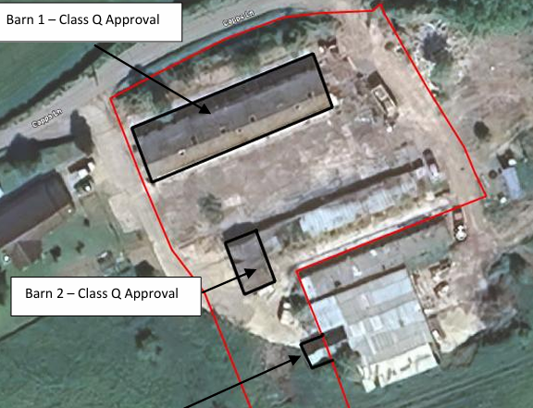
Application site

The application

This is a full application for works to the dwellings approved under prior approval applications PL/2025/06077 (unit 6) and PL/2025/03730 (units 1-5) (detailed in the history section below). These works consist of –
- Proposed boundary change to external areas for units 1-6, increasing the size of both the front and rear garden/ amenity spaces of units 1-5 and the rear garden/ amenity space area of unit 6 with additional soft and hard (grass/ planting/ bug area/ patio area) landscaping plus fencing (2ft high close boarded fence)
- Proposed bin store area and sheds added to units 1-5 in the rear/ front gardens and to the front/ side of unit 6.
- Proposed roof alterations to units 1-5 to include solar panels.
- Proposed brickwork finish to unit 6 to match units 1-5 (red facing brickwork/ anthracite grey profiled roofing).
- Minor revisions to parking layout.

Except as detailed above no alterations are proposed to the layout of the proposed dwellings. As detailed in the following plans.
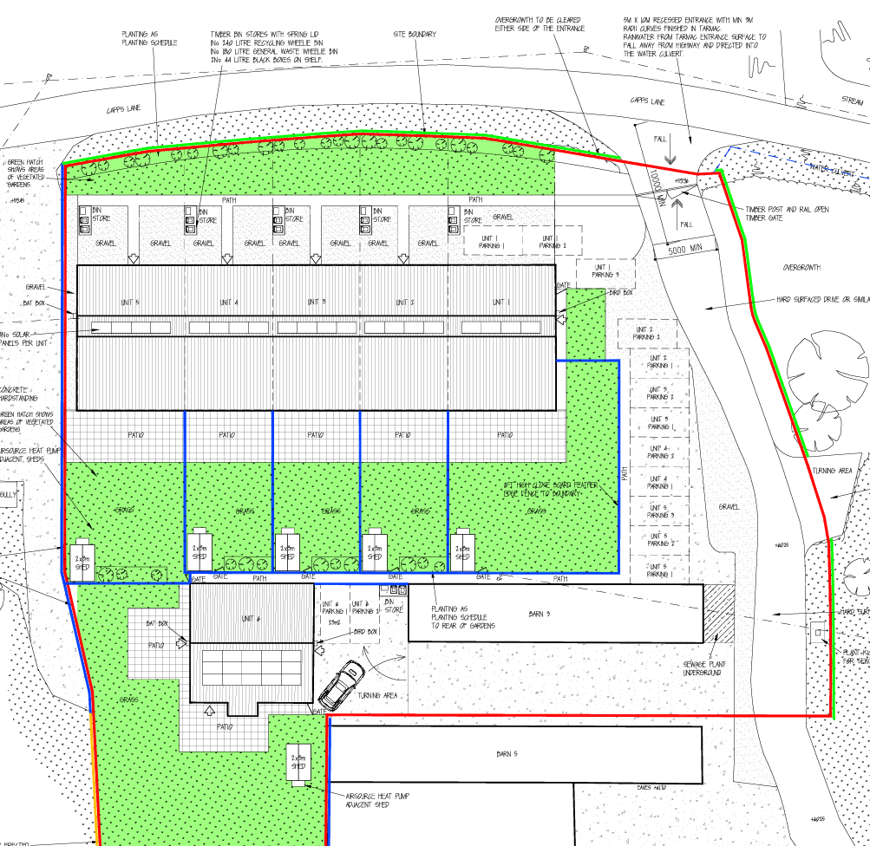
Proposed block plan detailing revised external layout of units 1-6

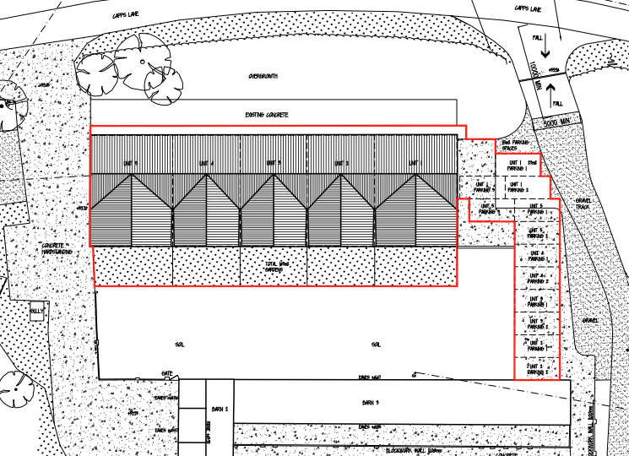
Approved site layout units 1-5 (PL/2025/03730)

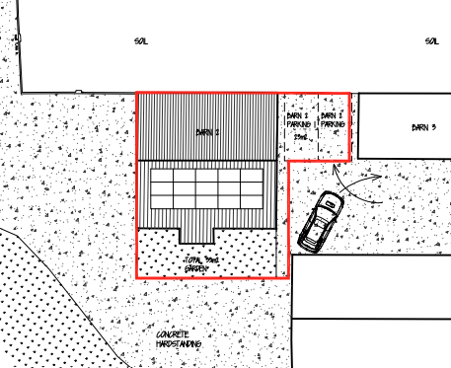
Approved layout unit 6 (PL/2025/06077)

POLICIES

Wiltshire Core Strategy (WCS) 2015
Core Policy 1: Settlement Strategy; Core Policy 2: Delivery Strategy; Core Policy 32: Spatial Strategy for the Westbury Community Area; Core Policy 50: Biodiversity and Geodiversity; Core Policy 51: Landscape; Core Policy 57: Ensuring High Quality Design and Place Shaping; Core Policy 60: Sustainable Transport; Core Policy 64: Demand management Core Policy 67: Flooding

National Planning Policy Framework 2024 (the Framework) and Planning Practice Guidance (PPG)

Other
Wiltshire Local Transport Plan 2011 – 2026

Wiltshire Local Transport Plan 2025 – 2038 (endorsed at full council on 11 March 2025)
Wiltshire Local Transport Plan 2011 – 2026: Cycling Strategy

Wiltshire Design Guide SPD 2024
Trowbridge & Westbury Bat Mitigation Strategy (TWBMS) 2025

Wiltshire Council’s Emerging Local Plan (WLP) 2020-2038 – The examination of the emerging Wiltshire Local Plan has been paused and the weight to be afforded to any part of the emerging plan can be no more than very limited. A decision on how to proceed will be made by the Council in May 2026.

RELEVANT PLANNING HISTORY

PL/2025/06077 – Convert barn 2 into 1 dwelling with proposed rear extension and external insulation to walls and roof not exceeding 0.2m (200mm). Proposed external garden and parking space area to not exceed the original Barn area. – Prior Approval Granted

PL/2025/04488 – Prior approval under Part 3 Class Q for the Conversion of barn to 1 dwelling. – Prior Approval Refused

PL/2025/03730 – Prior approval under Part 3 Class Q to convert barn to 5 dwellings with proposed rear extension and external insulation to walls and roof not exceeding 0.2m (200mm). Proposed external garden and parking space area to not exceed the original Barn area. – Prior Approval Not Required

PL/2023/06122 – (Class Q) Change of use of agricultural building to 4 no. dwellinghouses – Prior Approval Not Required

CONSULTATION RESPONSES

Bratton Parish Council: No comments received

Highways Team: No objection subject to conditions

Ecology Officer: No objection subject to conditions

REPRESENTATIONS

None received

ASSESSMENT
Principle of development

Section 70(2) of the Town and Country Planning Act 1990 and section 38(6) of the Planning and Compulsory Purchase Act 2004 require that the determination of planning applications must be made in accordance with the Development Plan, unless material considerations indicate otherwise.

In accordance with this statutory requirement, this application has been assessed against the relevant policies of the Development Plan, including the adopted Wiltshire Core Strategy (2015) and, where applicable, any made Neighbourhood Plans.

The principle of development of use of the site and buildings for residential purposes was established by the granting of applications PL/2025/06077 (unit 6) and PL/2025/03730 (units 1-5) under Part 3 Class Q of the of the Town and Country Planning (General Permitted Development) Order 2015 (as amended – by the Town and Country Planning (General Permitted Development) (England) (Amendment) Order 2024).

The site is located outside any settlement limit and in the open countryside. Therefore, it is in an area where planning policy does not support the erection of new dwellings unless one of the exception criteria listed under paragraph 4.25 of the WCS applies or there are any relevant exceptions in national planning policy. Ordinarily, such a development would be deemed to be unacceptable in principle. However, in this case, there is a fallback position to consider. Permission exists under Schedule 2, Part 2, Class Q of the Town and Country Planning (General Permitted Development) Order 2015 for the conversion of the existing agricultural buildings on site to residential use as detailed above.

The existing buildings can currently be converted to residential dwellings if consent under the current application is not forthcoming. It can therefore be concluded that there is a realistic prospect of the fall-back position being implemented. It has been accepted elsewhere (case law/appeal decisions) that the existence of a planning approval under Class Q of the GDPO where it is considered the building is capable of being converted is a valid fall-back position.

The proposed dwellings would be located in the same location as that approved under applications PL/2025/06077 (unit 6) and PL/2025/03730 (units 1-5) with no change to the footprint or size. Minor changes to design are proposed with alterations to the roof and brickwork with increases in amenity/ garden space and as such the development is very similar to that approved under the above prior approval applications. The minor alterations to the external appearance of the buildings and additional amenity space would not result in harm to the character of the area.

As such, when compared to the Class Q approval, the alterations listed above are considered acceptable. Therefore, the development, in terms of siting and size, are still consistent with the Class Q approval and the finished building would not be any more harmful to the character of the area than would occur as a result of the proposed conversions under the Class Q approval. In addition, there would be some planning gain with regards use of solar panels and improvements with regards design of the buildings over that approved. The increased curtilage of the property would also provide better living standards for future occupants, albeit at the expense of loss of a small section of agricultural land.

For the reasons given above it is considered the principle of development for the works detailed above has been established. However, the development must also be assessed against other policies of the plan as detailed below.

Impact on the character of the area

Core Policy 51 of the WCS outlines that development should protect, conserve and where possible enhance landscape character and must not have a harmful impact upon landscape character. Core Policy 57 requires a high standard of design in all new developments and states that development should respond positively to the existing townscape and landscape.

The site is located in the open countryside and consists of a small compound of redundant agricultural buildings. The character of the area is one of open fields bordered by hedgerows, within a heavily rural setting.

The alterations to the buildings on site including the addition of solar panels to the roof are considered acceptable and would cause no harm to the local rural character of the area.

Increased amenity space would cause some harm to local rural character as activities associated with residential development become more prevalent, however the additional amenity spaces associated with units 1-5 consists of gravel hardstanding/grass area to the front (north) of the development and rear (south) gardens laid with grass. The proposed rear garden areas in particular would be located within the confines of the overall site. The proposed bin stores and sheds are of limited size and, the sheds in particular would be located to the rear of the properties and between existing buildings compromising unts 1 to 5 and unit 6 plus barn 3, resulting in very limited impact on local character.

The increase in curtilage of unit 6 extends to the south to form a large garden area and consists of the conversion of an area of hardstanding to a grassed garden area and includes some loss of agricultural land to the west of barn 4. A condition will therefore be imposed onto the approval removing permitted development rights for additional outbuildings in the garden of unit 6 to prevent encroachment of built form into this area. As such it is considered the impact of the development on the rural character of the area would not be so harmful as to warrant a recommendation for refusal.

The principle of use of units 1 to 6 with some element of residential curtilage has been established with the granting of the prior approval applications. The current scheme simply looks to extend this use. As such it is considered the impact of additional amenity space/ garden paraphernalia on the rural character of the area, would not be significant or so harmful as to warrant a recommendation for refusal.

Impact on neighbour/existing residents amenity

Core Policy 57 of the WCS requires a high standard of design in all new developments and that development has regard to the compatibility of adjoining buildings and uses, the impact on the amenities of existing occupants and ensuring that appropriate levels of amenity are achievable within the development.

The nearest residential properties to the site are located at Pickers Palmers Farm directly adjacent the site to the west and Brickwood Farm over 130 metres to the southwest. The proposed alterations including additional amenity space for occupiers, erection of garden sheds, and roof alterations are limited in scope, and would cause no harm to the amenity of adjacent neighbours in terms of loss of light/ overbearing impact or additional loss of privacy/overlooking.

Ecology issues

Core Policy 50 of the Wiltshire Core Strategy requires all development to demonstrate no net loss of local biodiversity resource and to secure the integrity of local ecological networks. Core Policy 50 also requires development to seek opportunities to enhance biodiversity, whilst the NPPF encourages applications to deliver measurable net gains (para 193 d).

The application is accompanied by a completed statutory metric calculation, map and condition assessments (Preliminary Ecological Appraisal and Biodiversity Net Gain Assessment, Herdwick Ecology, March 2026; Statutory Biodiversity Metric, Ceri Griffiths, March 2026) stating the baseline and predicted post development biodiversity units of the site have been submitted.

This application site lies within the 6.4km zone of influence of the Salisbury Plain SPA and in light of the HRA for the Wiltshire Core Strategy and the HRA for the Wiltshire Housing Site Allocations Plan it is screened into Appropriate Assessment (AA) due to the potential impact of recreational pressure on stone curlew in combination with other plans and projects.

A strategic Appropriate Assessment (AA) has been prepared pertaining to development within the 6.4km zone of influence that could result in a likely significant effect on the SPA as a result of an increase in recreational / visitor pressure. The AA reached a conclusion of no adverse effects on the integrity of the SPA or its qualifying features provided that the council’s mitigation strategy continues to be implemented. Annual stone curlew monitoring and protection measures continue to be secured by the Council. In January 2026 Natural England (NE) confirmed that the 2026 strategic AA for Salisbury Plain SPA continues to be supported by NE.

The application site is located within the yellow and grey zones of the Trowbridge & Westbury Bat Mitigation Strategy (TWBMS), and is close to the boundary of a Bechstein’s bat core roost buffer, and therefore has potential to result in significant adverse impact on the special features of the Bath & Bradford on Avon Bats Special Area of Conservation (SAC). The application must therefore be considered under the Habitats Regulations.

The yellow medium risk zone represents areas where habitat has been shown to be of importance, and in particular takes into consideration the foraging areas and flightlines of horseshoe and Bechstein’s bats and is anticipated to be able to accept a degree of development pressure provided applications are designed in accordance with the principles in the TWBMS. Impacts will arise on individual sites and in-combination with other sites as a result of loss and/degradation of habitat of importance to the qualifying bats. In this case, no works are proposed to a greenfield site, no new lighting or impacts on core bat habitat is anticipated, and there are no roosting opportunities within the barns. Therefore, no strategic habitat mitigation contribution is required, and the yellow zone is not considered further.

The grey medium risk zone represents an area where new residential development is likely to result in increased recreational use of important woodland bat sites. New residential development proposals for 49 dwellings or less within the grey hatched medium recreational risk zone will be expected to provide a financial contribution of £925 per dwelling towards the council’s strategic recreational pressure mitigation scheme. However, this application does not concern the conversion of the barns into dwellings (which have been permitted under prior approval) and thus the above contribution does not apply.

With regard to the present application, a test of likely significance (screening assessment) has been carried out by Wiltshire Council as required under Regulation 63 of the Conservation of Habitats and Species Regulations 2017 (as amended). No loss of green habitat is proposed, with the works to primarily impact areas of hardstanding and result in the creation of vegetated gardens. Further, no new dwellings are proposed as part of this application. As such, the proposal, which is for new gardens and external alterations, is not considered likely to adversely affect roosting bats, or foraging or commuting habitat, and the principles of the TWBMS are not considered further. This application is screened out of Appropriate Assessment with respect to the Bath and Bradford-on-Avon Bat SAC.

The preliminary ecological appraisal notes that the site offers limited opportunities for badgers, nesting birds, great crested newts and reptiles, given that it largely comprises hardstanding. The bat roosting potential of the barns is reported as “negligible” owing to their open constructions, corrugated metal roof and lack of any potential roosting features. However, these taxa could be present in the wider landscape, as the site is surrounded by grassland fields with trees and hedgerows, a large lake 60m southeast and pond 120m northeast. The mitigation measures detailed in the ecology report will be secured via condition.

The Biodiversity Gain Plan condition will automatically apply in this case. The ecology report and metric show that the creation of vegetated gardens on-site will result in a biodiversity gain of 51.98%. However, confirmation of how the development will achieve BNG is a post-determination matter.

Highway/ parking issues

Core Policy 61 of the WCS seeks to ensure that all new developments are capable of being served by safe access to the highway network. Core Policy 64 sets out to manage the demand for parking and sets residential parking standards based on minimum parking standards.

The scheme involves minor alterations to the location of parking spaces associated with units 1 to 5, however no reduction in off road parking is proposed. No alterations to the access are being proposed. As such the development would cause no additional harm to highway safety and there are no objections to the scheme from the Council’s highways officer.

Drainage/ flooding issues

Core Policy 67 of the WCS states all new development will include measures to reduce the rate of rainwater run-off and improve rainwater infiltration to soil and ground (sustainable urban drainage) unless site or environmental conditions make these measures unsuitable.

No changes to surface water or foul water drainage are being proposed. A condition will be imposed requiring the development to avoid private water from entering the highway.

CONCLUSION

Planning law requires that applications for planning permission must be determined in accordance with the development plan unless material considerations indicate otherwise.

Officers are satisfied that the proposed development would not harm the amenity of neighbouring residents or future occupiers and the design of the dwelling is considered acceptable, and the overall form of the development is still broadly consistent with the Class Q approval.

The development would not result in harm to the rural character of the area. No changes to access, parking or drainage are proposed and the development would cause no harm to local biodiversity interests.

There would be some short-term benefits afforded to the construction phase of the development through direct and indirect job creation.

RECOMMENDATION: APPROVE subject to conditions

