VARIATION OF A CONDITION PLANNING APPLICATION.
CASE OFFICER REPORT

APPLICATION REFERENCE: | PL/2026/001676
APPLICATION TYPE: | Variation of a planning condition
SITE ADDRESS: | 79 LACOCK GARDENS, HILPERTON, TROWBRIDGE, BA14 7TG.
DEVELOPMENT DESCRIPTION: | Variation of Condition 2 (Approved Plans) of application PL/2025/07340 (Proposed loft conversion and front porch, including internal alterations) - Change relates to the colour of the approved porch cladding.
RECOMMENDATION: | Approve with Conditions.

PROPOSAL
The proposal seeks a variation to the extant permission PL/2025/0734 for proposed changes, which includes the change of colour to the proposed porch to that of a natural timber colour as opposed to the initial proposed grey colour.

SITE DESCRIPTION/CONTEXT
The site is 79 Lacock Gardens, Hilperton which is a detached two storey building located within the Paxcroft Mead residential housing estate, within the Large Village of Hilperton. The building is of a red brick construction with concrete interlocking roof tiles. The site is not in a Conservation Area.

RELEVANT PLANNING HISTORY
Proposal / Summary
2025/07340 Proposed loft conversion and front porch, including internal alterations. Approved.

RELEVANT POLICIES AND GUIDANCE
Wiltshire Core Strategy:

- Core Policy 57 Ensuring High Quality Design and Place Shaping
- Core Policy 50: Biodiversity and Geodiversity
- Core Policy 51: Landscape
- Core Policy 58: Ensuring the Conservation of the Historic Environment
- Core Policy 61: Transport and New Development
- Core Policy 64: Demand Management
- Core Policy 67: Flood Risk

Hilperton ‘Made’ Neighbourhood Plan

Wiltshire Design Guide: Appendix D – Design Guidance for Householder extensions

The National Planning Policy Framework (NPPF)

The Planning Practice Guidance

National Design Guide

Emerging Wiltshire Local Plan:
The examination of the emerging Wiltshire Local Plan has been paused and the weight to be afforded to any part of the emerging plan can be no more than very limited. A decision on how to proceed will be made by the Council in May 2026.

CONSULTATION RESPONSES
Hilperton Parish Council: No comment.

REPRESENTATIONS
No comments were received.

PRINCIPLE OF THE PROPOSAL.
The principle of the proposed scheme is considered to be acceptable for the reasons as discussed below.

ASSESSMENT
Section 38(6) of the Planning and Compulsory Purchase Act 2004 states:

"If regard is to be had to the development plan for the purposes of any determination to be made under the planning Acts, the determination must be made in accordance with the plan unless material considerations indicate otherwise."

In accordance with this statutory requirement, this application has been assessed against the relevant policies of the Development Plan, including the adopted Wiltshire Core Strategy (2015) and the made Neighbourhood Plan for Hilperton.

Design and Impact upon the upon the character and context of the area

Core Policy 57 - Ensuring High Quality Design and Place Shaping of the Wiltshire Core Strategy seeks to ensure that all new development is of high design quality, reflecting local context, character, and distinctiveness.

The proposals can be viewed within the plan snippets taken from the submitted plans:

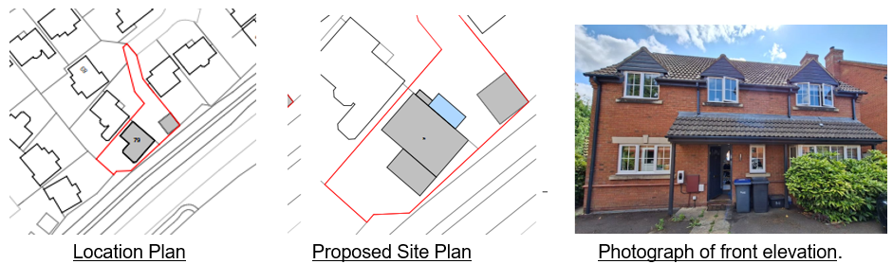

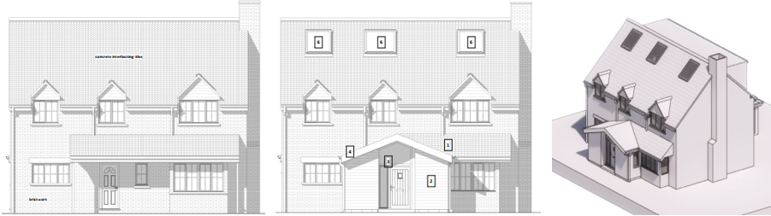
Existing & Proposed North Front Elevations as approved within application ref: 2025/07340.

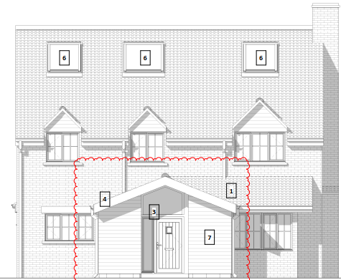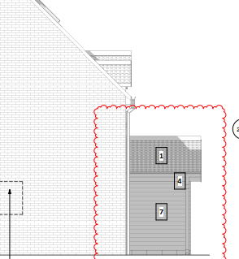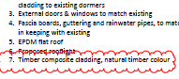
Proposed change of colour of front porch to natural timber colour.

The initial design proposal saw the conversion of the attic area to accommodation with the provision of two bedrooms and a bathroom. A dormer window on the rear roof elevation was proposed and approved which would have timber cladding, with the incorporation of high level ‘strip’ or horizontal slit windows to ensure privacy. In addition, three small sized front facing rooflights, to provide natural daylight for this new accommodation were also proposed and approved.

All of these aspects of the design are to be retained, together with the newly designed front porch, which is the sole subject of the current proposed alterations relating to its change of final colour and finish, to that of natural timber.

Therefore, in summary, having regard to the above, the proposal complies with the design principles set out in Core Policy 57 of the Wiltshire Core Strategy and Appendix D of the Wiltshire Design Guide.

Amenity
Point vii of Core Policy 57 - Ensuring High Quality Design and Place Shaping of the Wiltshire Core Strategy seeks to ensure that developments do not adversely affect neighbouring properties. The National Planning Policy Framework (NPPF), particularly Paragraph 135(f), stresses that planning decisions should ensure developments provide a high standard of amenity for existing and future users.
The proposals relate to the change in colour of the newly designed front porch, which would retain its single storey status and so would continue to not harmfully impact on neighbouring amenity.

The proposal therefore accords with Core Policy 57 point vii. in respect of safeguarding residential amenity and Appendix D of the Wiltshire Design Guide.

Ecology Impact The consideration of ecology remains the same in that CP50 requires no net loss of biodiversity on site. The site is located within the grey hatched zone of the Trowbridge Westbury Bat Mitigation Strategy Area (TWBMS) as well as the Bath & Bradford on Avon Bat SAC. The proposed development because of its minor nature and high-density urban location is considered unlikely to result in harm to bats or their habitat. There is no mechanism for significant effects from recreational pressure since it does not result in the creation of a new dwelling. Accordingly, the proposal is acceptable in this regard. As such, the development complies with Core Policy 50 of the Wiltshire Core Strategy and the relevant provisions of the NPPF.

Biodiversity Net Gain. This application is exempt from the requirement to deliver Biodiversity Net Gain under Schedule 7A, Section 4(2)(a) of the Town and Country Planning Act 1990, as inserted by the Environment Act 2021.

CONCLUSION
The proposed development continues to be acceptable in terms of its design, scale, and relationship with the surrounding area. The proposed colour change of the porch would not result in any unacceptable harm to the character of the locality, or the amenities of neighbouring occupiers.

The proposal is therefore considered to comply with the relevant policies of the Wiltshire Core Strategy, the Wiltshire Local Plan, and the National Planning Policy Framework. As such, the application is recommended for approval, subject to the conditions set out below.

RECOMMENDATION: Planning Permission be GRANTED subject to conditions.

