APPLICATION FOR FULL - PLANNING PERMISSION
CASE OFFICER REPORT

APPLICATION REFERENCE: | PL/2026/00920
APPLICATION TYPE: | Full planning permission
SITE ADDRESS: | Hinton House, 13 Hinton Lane, Great Hinton, Trowbridge, BA14 6BS
DEVELOPMENT DESCRIPTION: | Proposed natural wildlife pond with ancillary recreational swimming
RECOMMENDATION: | APPROVE SUBJECT TO CONDITIONS

SITE DESCRIPTION/CONTEXT: The application site is located to the south of the subject dwelling, Hinton House, which is located within a generous plot in open countryside, with existing residential dwellings to the west.

The application site is not located in any landscape designations but is situated within the grey hatched zone associated with the Trowbridge and Westbury Bat Mitigation Strategy. The site is also located in Flood Zone 1 and is not shown to be located within an area at risk of surface water flooding, but with reference to the Council’s Strategic Flood Risk Assessment (SFRA), the site is shown to be in an area susceptible to high groundwater:

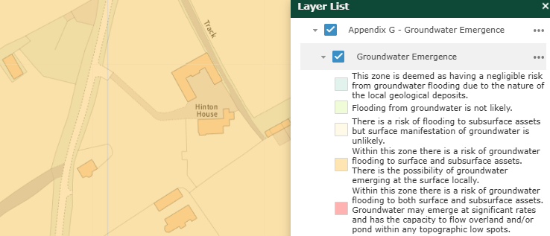

PROPOSAL: This application is seeking planning permission for the construction of a natural wildlife pond, with ancillary recreational swimming use, within part of an existing residential garden and paddock. The pond is shown to measure approximately 25.3m in length and 10.3m wide, based on the submitted proposed site plan drawing (no. 04).

The proposal would constitute a change of use of part of the site, as not all of the site is located within the existing residential curtilage of the dwelling and is located within part of an adjoining paddock that is within the applicant’s ownership.

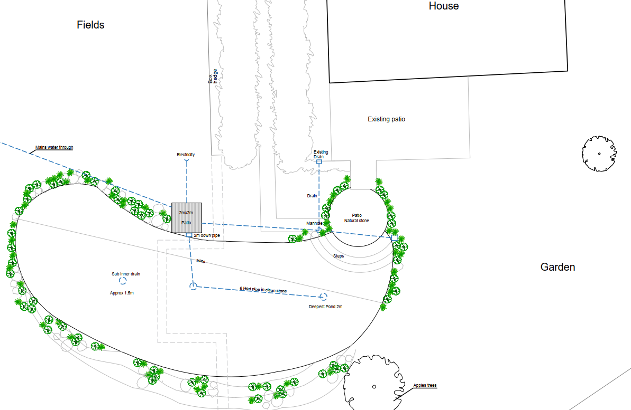

The extract provided above is taken from the submitted site plan and illustrates the proposed location of the pond, to the south of the existing dwelling. A new patio area would be provided, extending off an existing patio area, with steps leading down to the pond, which would have a maximum depth of 2m.

With reference to the submitted Planning Statement, the pond would be formed “using natural land contours and materials, with gently sloping banks and no concrete walls or engineered pool structures” and is intended to function as a natural swimming pool for ecological purposes with occasional swimming use.

The spoil from the swimming pool excavations would be spread out and levelled on land within the applicant’s ownership.

The applicant intends to introduce aquatic and marginal habitats with native planting to provide an ecological benefit.

RELEVANT PLANNING HISTORY

W/07/02382/FUL - Extension to existing house - Approved with conditions - Date: 5/9/2007

W/09/00524/FUL - Formalisation of a track into a driveway – Approved with conditions – Date: 2 June 2009

W/12/00560/FUL - Demolition of existing outbuilding and replace with new stable block/store with office above - Approved with conditions - Date: 30/5/2012

RELEVANT LEGISLATION, POLICIES AND GUIDANCE

National Planning Policy: National Planning Policy Framework (NPPF); Planning Practice Guidance (PPG)
Development Plan: The development plan for Wiltshire comprises the Wiltshire Core Strategy (WCS) (adopted January 2015) and any made neighbourhood plans, which remain the principal statutory planning document guiding development across the county. In line with Section 38(6) of the Planning and Compulsory Purchase Act 2004, planning decisions must be made in accordance with the development plan unless material considerations indicate otherwise.

Though the development plan is considered as a whole, those parts deemed to be particularly relevant to this application are listed below:

The adopted Wiltshire Core Strategy (WCS), with particular regard to:

- Core Policy 1 Settlement Strategy;
- Core Policy 2 Delivery Strategy;
- Core Policy 50 Biodiversity and Geodiversity;
- Core Policy 51 Landscape;
- Core Policy 52 Green Infrastructure;
- Core Policy 57 Ensuring High Quality Design and Place Shaping;
- Core Policy 67 Flood Risk

Draft Wiltshire Local Plan Policies: The examination of the emerging Wiltshire Local Plan has been paused, and the weight to be afforded to any part of the emerging plan can be no more than very limited. A decision on how to proceed shall be made by the Council in May 2026.

Supplementary Planning Documents and other Guidance:
- Wiltshire Design Guide (adopted April 2024)
- Trowbridge and Westbury Bat Mitigation Strategy (TWBMS), July 2025

ISSUES: The main issues that need to be addressed in this case include the principle of the development;
impact on neighbour amenity; ecology; and drainage/flood risk

CONSULTATION RESPONSES

Wiltshire Council Drainage: The Council’s Drainage team advised that consultation with them was not required, reflecting the low flood risk nature of the proposal.

Wiltshire Council Ecology: No objection subject to informative

REPRESENTATIONS: In accordance with the requirements of the Town and Country Planning (Development Management Procedure) (England) Order 2015 (as amended), the application was publicised by way of neighbour notification letters sent to adjoining and nearby properties. This method was used to inform interested parties and provide a period of 21 days for comments to be submitted. No letters of objection were received.

ASSESSMENT: Section 38(6) of the Planning and Compulsory Purchase Act 2004 states:

"If regard is to be had to the development plan for the purposes of any determination to be made under the planning Acts, the determination must be made in accordance with the plan unless material considerations indicate otherwise."

In accordance with this statutory requirement, this application has been assessed against the relevant policies of the Development Plan, including the Wiltshire Core Strategy (2015) and, where applicable, any made Neighbourhood Plans. Consideration has also been given to the policies of the National Planning Policy Framework (NPPF) as a material consideration in the assessment.

Principle of Development: Policy CP1 of the WCS establishes a hierarchy of settlements to guide where development should be focused. The policy prioritises growth in:
- Principal Settlements (e.g., Salisbury, Chippenham, Trowbridge) – main focus for strategic growth.
- Market Towns – support local services and employment; suitable for sustainable development.
- Local Service Centres – smaller towns and villages with a range of services; limited development supported.
- Large and Small Villages – development should be limited and respond to local needs.
- Outside the defined settlements – development is strictly controlled and generally not supported unless exceptional circumstances apply.
.
Policy CP2 of the WCS sets out how development will be distributed and delivered across Wiltshire. The policy emphasises:
- Sustainable patterns of growth, reducing the need to travel and supporting local services.
- Development should be plan-led, aligning with the settlement strategy and supported by infrastructure.
- Windfall development (not allocated in plans) must still comply with the principles of sustainable development.
- Development outside settlement boundaries is generally not permitted, unless it meets specific policy exceptions (as set out in paragraph 4.25 of the WCS).

Together, CP1 and CP2 ensure that new development is strategically located, sustainable, and supports the character and function of Wiltshire’s communities.

The proposed development is partly located within the existing defined residential curtilage of the host property and also incorporates land associated with the neighbouring paddock, which is in the applicant’s ownership. The application site lies within the open countryside and outside any defined settlement limits. However, it is in close proximity to existing residential dwellings and, given the scale and nature of the proposed development, it is not considered to result in any material harm to the character or appearance of the surrounding landscape.

Although the proposal would involve an extension of the residential curtilage associated with Hinton House, due consideration has been given to the site’s location, its relationship with the host property and nearby residential dwellings. On this basis, the change of use to extend the residential curtilage in order to accommodate the proposed pond is considered acceptable in this instance and would not materially erode the character of the countryside or conflict with the objectives of CP1, 2 and 51 of the adopted WCS.

Amenity: Policy CP57 (criterion vii) of the adopted WCS requires development to respect the amenity of existing occupants and ensure appropriate amenity levels for future residents.

Paragraph 135 of the NPPF reinforces the need for development to provide a high standard of amenity for both existing and future users.

The proposed pond would be located to the rear of the host dwelling and set at a distance from neighbouring properties. Given its use as a natural pond with only occasional recreational swimming, it would not generate significant noise, disturbance or overlooking. There would be no increase in built form beyond the construction of the pond and construction of two patio areas or external lighting. As such, the proposed development would not have an adverse impact on the amenity of neighbouring occupiers.

Ecology, Biodiversity and Landscape: The ecological impact of development is a key planning consideration, especially for larger schemes. Proposals must assess and address potential effects on:

- Protected species
- Priority habitats
- Ecological networks
- Green and blue infrastructure

Policy CP50 of the adopted WCS requires development to:

- Avoid harm to ecological assets.
- Deliver measurable Biodiversity Net Gain (BNG), in line with the Environment Act 2021.
- Support habitat restoration and connectivity.
- Integrate biodiversity into site design.

The Green & Blue Infrastructure Strategy (2022–2030) promotes nature recovery, ecosystem services, and habitat connectivity through development.

Unless exempt, National policy requires a minimum of 10% Biodiversity Net Gain (BNG) for major developments, demonstrated via:

- Biodiversity Metric calculations
- Ecological assessments (e.g. PEAs, Phase 1 surveys, protected species surveys)

The application site is located within the boundary of the grey zone of the TWBMS, which represents an area where new residential development is likely to result in increased recreational use of important woodland bat sites.

In order to conclude an Appropriate Assessment (AA) favourably, new residential development proposals for 49 dwellings or less within the grey hatched medium recreational risk zone are expected to provide a financial contribution per dwelling towards the council’s strategic recreational pressure mitigation scheme. As this particular proposal is not for residential development, a financial contribution is not required.

A test of likely significance (screening assessment) has been carried out by Wiltshire Council as required under Regulation 63 of the Conservation of Habitats and Species Regulations 2017 (as amended) (also known as the Habitat Regulations). The proposal is not considered likely to significantly adversely affect roosting bats, or foraging or commuting habitat, and the principles of the TWBMS are not considered further.

As set out within the application particulars for this development, the proposal would not require the removal of any trees, though a very small area of box hedge may be removed. The submitted Ecological Assessment (produced by Brakes Ecology) confirms that this hedge is suffering from box blight and is of low ecological value. Nonetheless, it should be noted that adults, young, eggs and nests of all species of
birds are protected by the Wildlife and Countryside Act 1981 (as amended) while they are breeding. Therefore, the applicant is advised that works should not take place while they could harm nesting birds (such as vegetation clearance or building demolition) from March to August inclusive.

The applicant is also advised to check any structure or vegetation capable of supporting breeding birds and delay removing or altering such features until after young birds have fledged.

During the preliminary roost assessment, the submitted Ecological Assessment confirms that no trees with potential bat roosting features were recorded, and no buildings or structures would be impacted by the proposed works. Further, the habitats to be affected (mown lawn and box hedge) are of limited value to great crested newts, reptiles, and other protected wildlife.

Overall, the proposed creation of a natural pond would enhance the site for wildlife, relative to the current situation.

In terms of Biodiversity Net Gain (BNG), which became mandatory under Schedule 7A of the Town and Country Planning Act 1990 (as inserted by Schedule 14 of the Environment Act 2021) in 12 February 2024, the completed small sites statutory metric (completed by Brakes Ecology, dated February 2026) confirmed the baseline units of the site to be 2.03 habitat units, with 2.42 units to be created as part of the proposal. This equates to 18.97% increase in total area habitat units.

In light of the above assessment, the proposal is considered to comply with CP50 of the adopted WCS and the relevant provisions of the NPPF.

CP51 seeks to protect the character and local distinctiveness of Wiltshire’s landscapes. The proposal would involve a modest alteration to the landform, utilising natural contours and materials, with native planting proposed around the pond margins. The development would therefore assimilate into its rural context and would not result in visual harm to the surrounding countryside.

Flood Risk and Drainage: Policy CP67 of the adopted WCS and NPPF paragraphs 170–182 require:
- Avoidance of increased flood risk.
- Use of appropriate mitigation measures.
- Application of the sequential and exception tests for developments in Flood Zones 2 or 3.

Sustainable Drainage Systems (SuDS) are required for all major developments and must:
- Manage runoff near its source.
- Improve water quality.
- Support biodiversity and amenity.
- Be integrated into the site layout and green infrastructure.

Whilst the application site lies within Flood Zone 1 and is not at risk of fluvial flooding, the Council’s SFRA identifies the area as having susceptibility to groundwater emergence. However, given the nature of the proposal (an excavated pond), the absence of built development apart from two small patio areas, and confirmation from the Council’s Drainage team that consultation was not required, the proposal is not considered to exacerbate flood risk elsewhere or result in unacceptable on-site risk.

PLANNING BALANCE AND CONCLUSION: At the heart of the NPPF there is a presumption in favour of sustainable development requiring local planning authorities to approve development proposals that accord with an up-to-date development plan without delay; and where there are no relevant development plan policies, or the policies which are most important for determining the application are out-of-date, permission should be granted unless (taken from paragraph 11d of the NPPF):

- The application of policies in the NPPF that protect areas or assets of particular importance provides a clear reason for refusing development proposed; or
- Any adverse impacts of doing so would significantly and demonstrably outweigh the benefits, when assessed against the policies in the NPPF taken as a whole;

The principle of development is considered acceptable when assessed against the settlement strategy of the Wiltshire Core Strategy and the emerging Local Plan.

The proposal represents a small-scale form of development within the open countryside, involving the extension of residential curtilage. However, it would not introduce additional built form beyond two patio areas, would respect landscape character, and would preserve neighbouring amenity. The development would deliver measurable ecological enhancement, including a biodiversity net gain in excess of the mandatory 10%, which attracts significant positive weight.

When assessed against the development plan as a whole, and having regard to the NPPF, the limited harm identified does not outweigh the ecological benefits of the proposal. No material considerations have been identified that would significantly and demonstrably outweigh these benefits or indicate that permission should be refused, having regard to the assessment above.

Accordingly, the proposal is considered acceptable in planning terms and in accordance with the Wiltshire Core Strategy, the National Planning Policy Framework, and all other relevant material considerations.

RECOMMENDATION: That Planning Permission be GRANTED, subject to conditions

