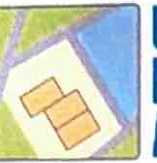
UK

Planning
Maps

Borrow Back Stables

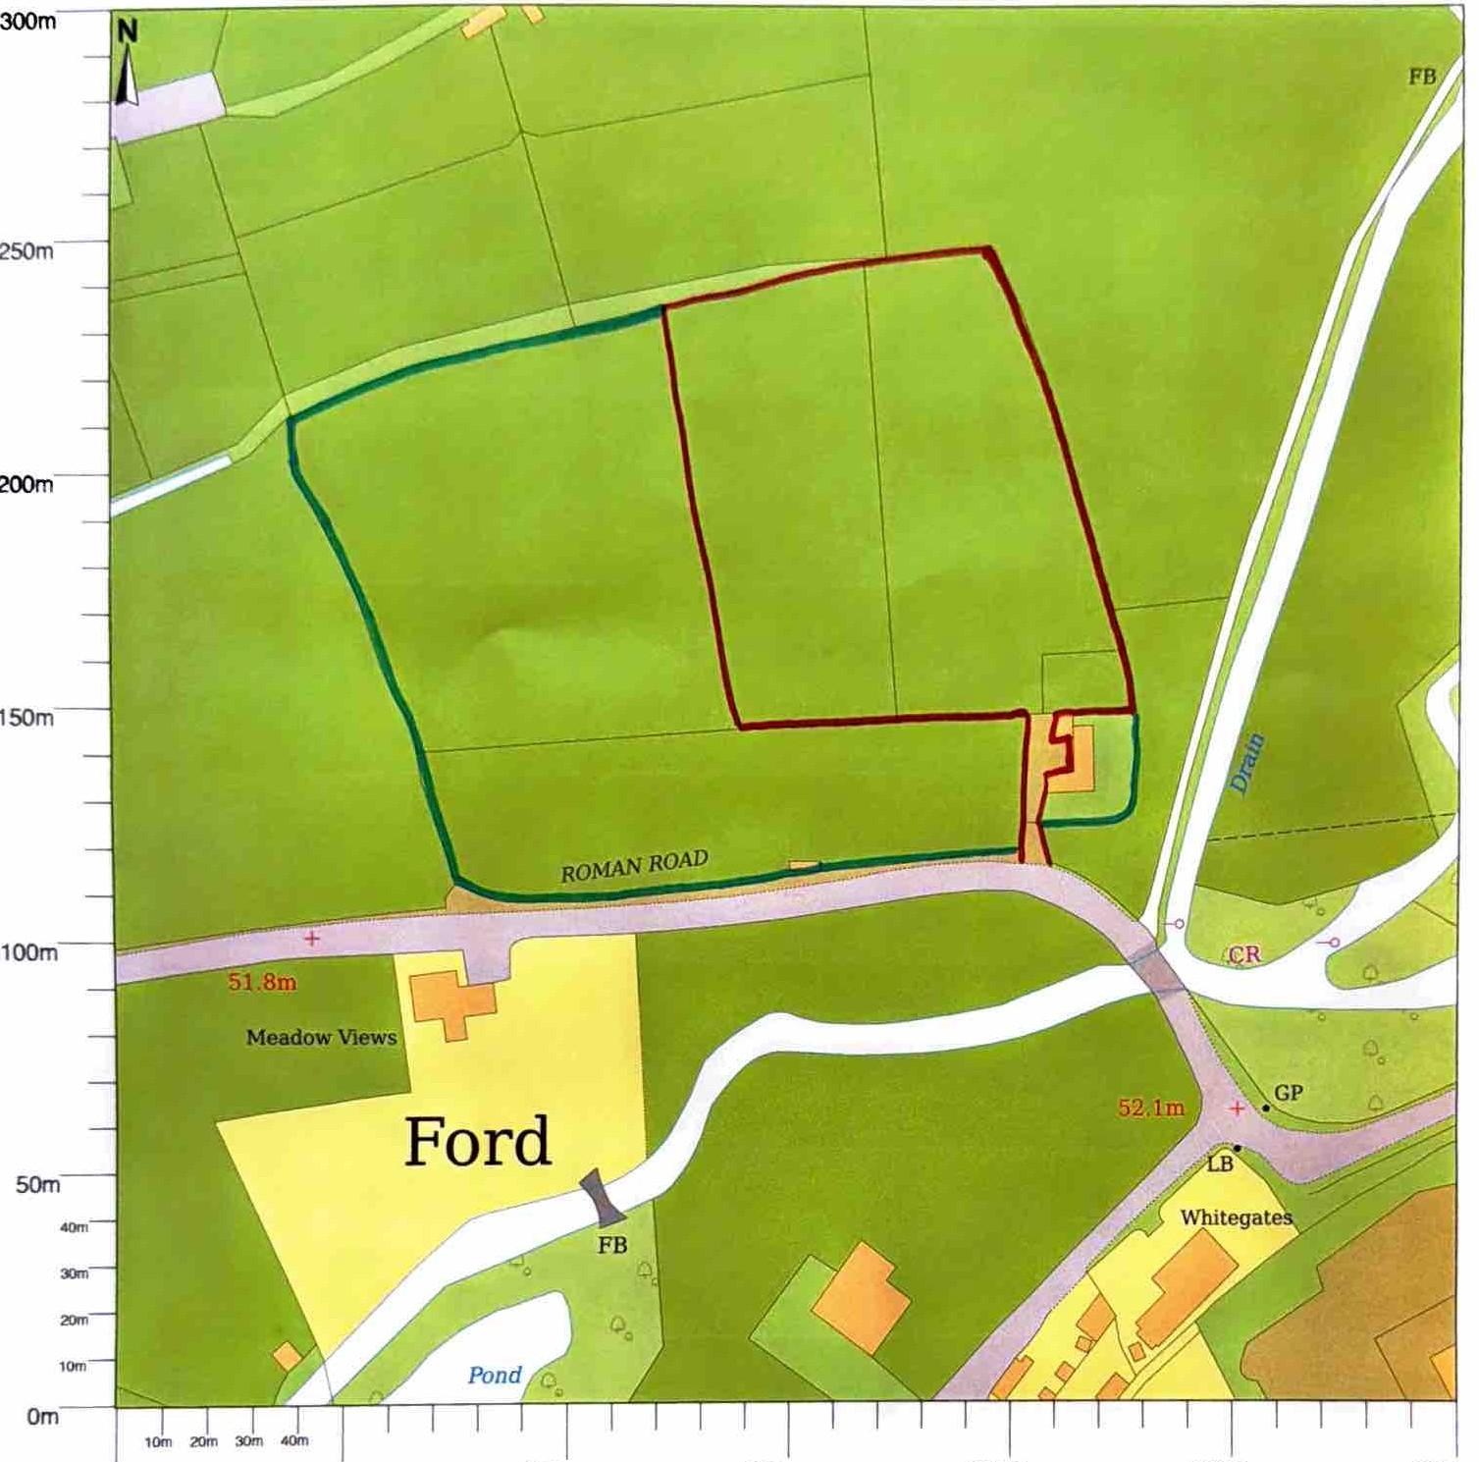


Om 50m
Scale 1:1250 at A3
100m 150m 200m 250m 300m

