Photo Supplement – Harnham Slope
T23 – ///blunt.slope.reply
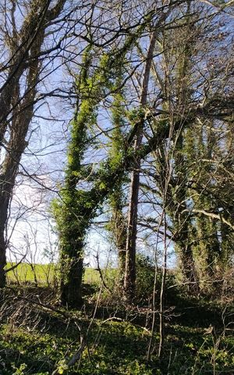
T26 - ///update.faster.bill
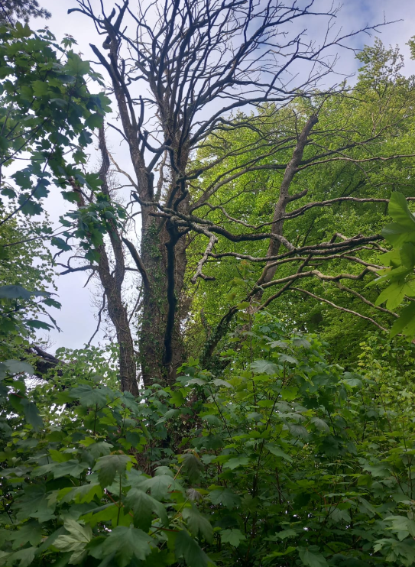

T27 -///degree.fumes.cling
