APPLICATION FOR HOUSEHOLDER PLANNING PERMISSION DELEGATED REPORT

APPLICATION REFERENCE: | PL/2026/01906
APPLICATION TYPE: | Householder planning permission
SITE ADDRESS: | Langford Cottage, St Andrews Road, South Newton, Salisbury, SP2 0QR
DEVELOPMENT DESCRIPTION: | The proposed construction of a 6m x 3m pergola in the garden.
RECOMMENDATION: | That Planning Permission be GRANTED

PROPOSAL

The proposal seeks planning permission for erection of a single storey pergola measuring approx. 6 metres by 3 metres, located to the rear of the existing dwelling.

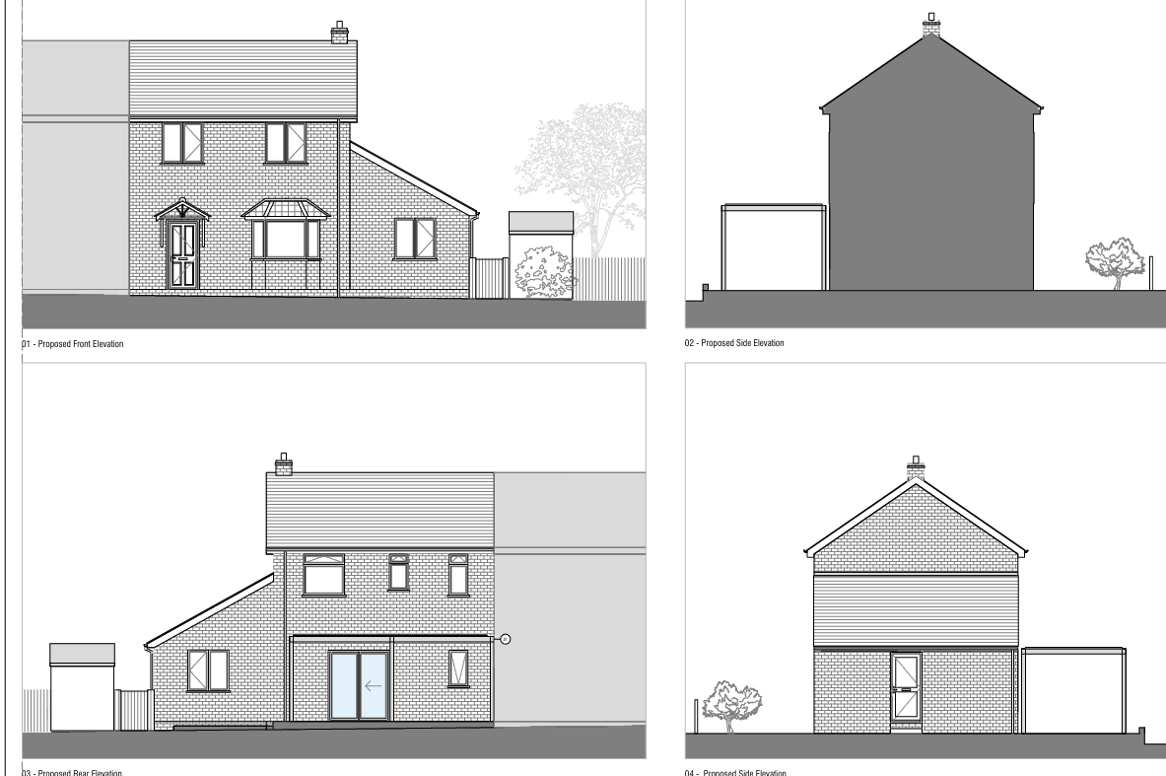

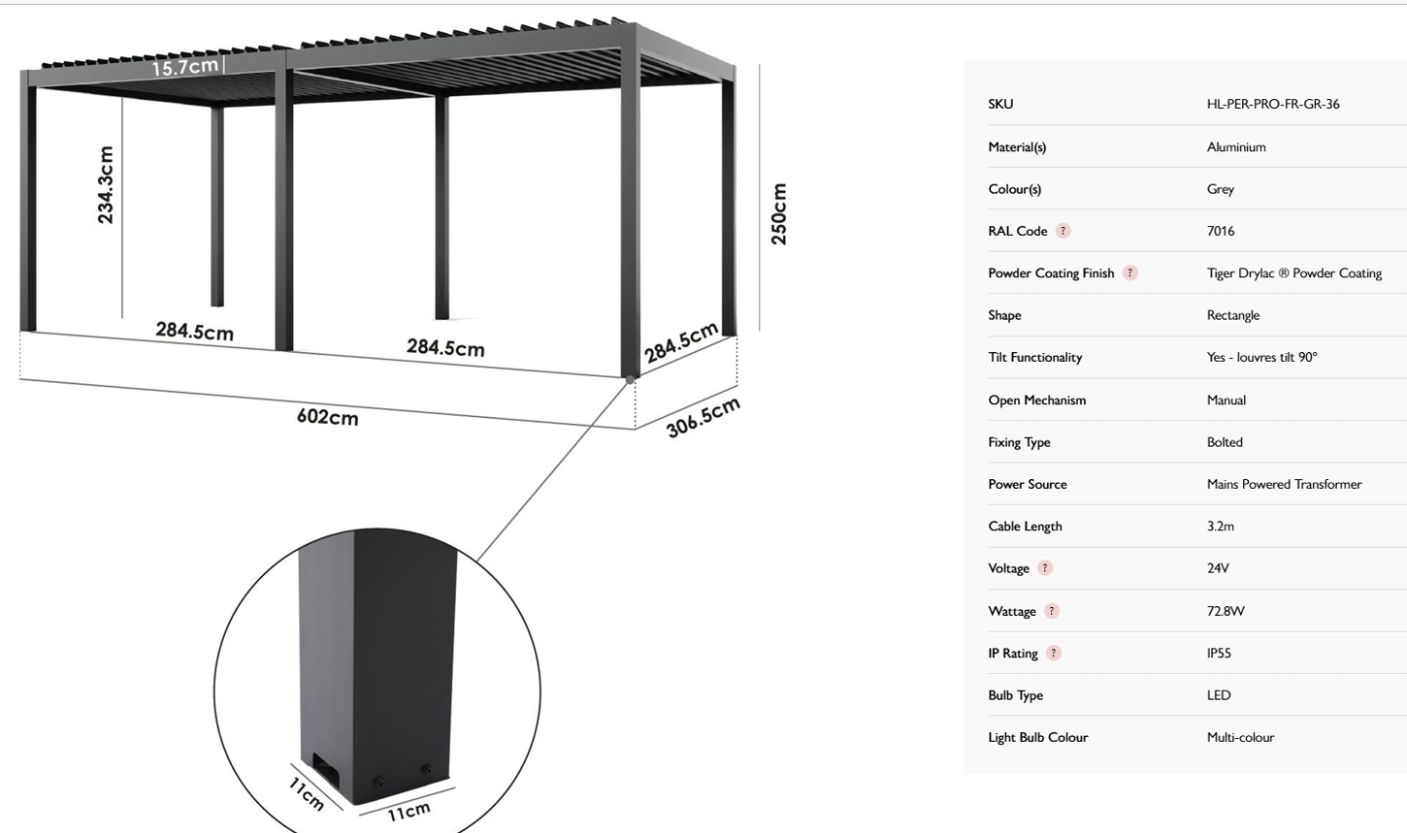

Planning permission is required for the pergola due to permitted development rights being removed as part of the planning approval S/2005/0473 for the erection of the dwelling.

(10) Notwithstanding the provisions of Classes A-H of Schedule 2 (Part 1) to the Town and Country Planning (General Permitted Development) Order 1995, (or any Order revoking and re-enacting that Order with or without modification), there shall be no extensions to the dwellings nor the erection of any structures within the curtilage unless otherwise agreed in writing by the Local Planning Authority upon submission of a planning application in that behalf.

Reason: To enable the Local Planning Authority to ensure that sufficient space is retained around the dwelling(s) in the interests of neighbourliness and amenity.

During the course of the application, amended plans were received to address a couple of discrepancies with labelling/N arrow, the amendments did not affect the development as proposed and shown on the submitted plans, therefore, no re-consultation was deemed necessary.

SITE DESCRIPTION/CONTEXT

The application site relates to a modern two storey semi detached dwelling located on the south side of St Andrews Road, to the east of the A36. The site is located within the small village of South Newton as defined by core policies 1, 2 and 33 of the Wiltshire Core Strategy. The property is not listed and is not located within a conservation area. The site is located within flood zone 1 and within the Hampshire River Avon Catchment and is within a Special Landscape Area.

PLANNING HISTORY

Proposal / Summary
S/2005/0473 - Full planning permission Decision - Approve with Conditions Date: 22/4/2005 – amendment to approved scheme S/2004/248
S/2003/0208 - Full planning permission Decision - Approve with Conditions Date: 16/6/2003 – pair of semi detached cottages and two vehicular accesses and associated parking
S/2003/2371 - Full planning permission Decision - Withdrawn Date: 2/1/2004 – pair of cottages re-submission of S/2003/0208
S/2004/0248 - Full planning permission Decision - Approve with Conditions Date: 24/12/2004 – pair of semi detached cottages and two vehicular accesses and associated access

RELEVANT POLICIES AND GUIDANCE

The National Planning Policy Framework (NPPF)
The Planning Practice Guidance
National Design Guide

Core Policy 1 – Settlement Strategy
Core Policy 2 – Delivery Strategy
Core Policy 33 – Spatial Strategy for the Wilton Community Area
Core Policy 50 – Biodiversity and Geodiversity
Core Policy 57 - Ensuring High Quality Design and Place Shaping
Core Policy 69 - Protection of the River Avon SAC

Salisbury District Local Plan policies (saved by Wiltshire Core Strategy)
C6 – Special Landscape Area

Supplementary Planning Documents:
Wiltshire Design Guide
Creating places design guide

CONSULTATION RESPONSES

Parish Council: None received

REPRESENTATIONS

One letter of support received and included in full below

We are neighbours to Langford Cottage, and after reviewing all information provided to us and having a conversation with next door, we are happy with the plans submitted and happy to support this application, no objections from us.

ASSESSMENT

Section 38(6) of the Planning and Compulsory Purchase Act 2004 states:

"If regard is to be had to the development plan for the purposes of any determination to be made under the planning Acts, the determination must be made in accordance with the plan unless material considerations indicate otherwise."

In accordance with this statutory requirement, this application has been assessed against the relevant policies of the Development Plan, including the adopted Wiltshire Core Strategy (2015) and, where applicable, any made Neighbourhood Plans.

Design and Impact upon the character and context of the area

Core Policy 57 - Ensuring High Quality Design and Place Shaping of the Wiltshire Core Strategy seeks to ensure that all new development is of high design quality, reflecting local context, character, and distinctiveness.

The proposed pergola is a metal structure and contemporary in appearance. The proposed pergola will stand out in comparison to the design and appearance of the brick built associated dwelling and surrounding dwellings. However, the rear of the application site is largely screened from public views, save possible views from the allotment gardens and Jubilee Terrace to the east. The rear garden associated with the application site is topographically lower that the allotments with land sloping gently down from east to west. The photo below was taken by the case officer from Jubilee Terrace looking across the allotments back towards the application site.

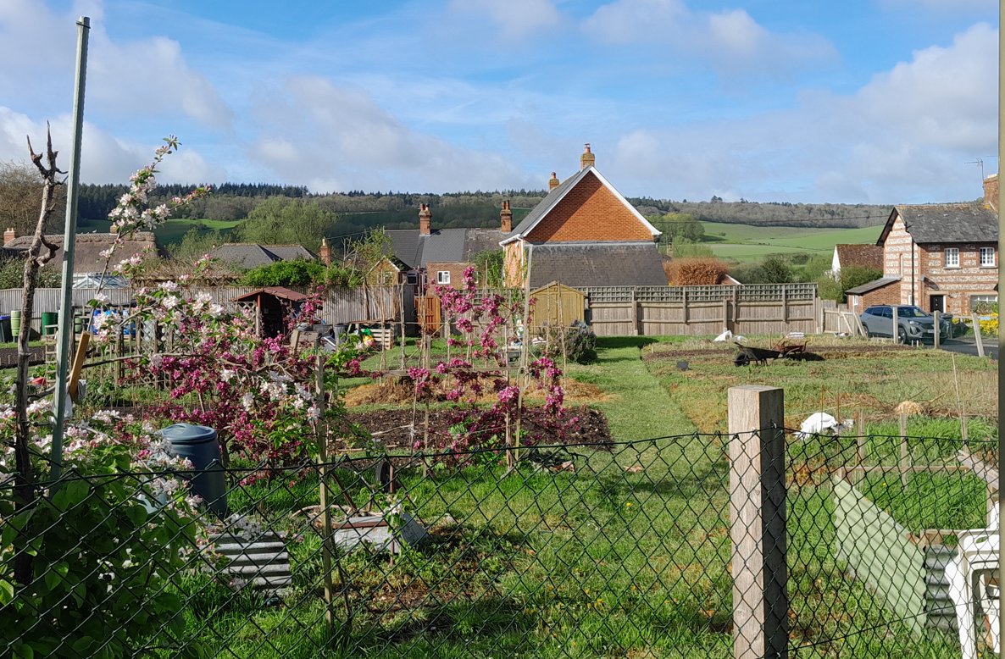
It is likely that the roof of the pergola may be seen from Jubilee Terrace but is not considered that this will create significant visual harm to the character of the area; the majority of the pergola will be screened by existing fencing and greenery in the locality.

Having regard to the above, the proposal complies with the design principles set out in Core Policy 57 of the Wiltshire Core Strategy and Appendix D of the Wiltshire Design Guide.

Amenity

Point vii of Core Policy 57 - Ensuring High Quality Design and Place Shaping of the Wiltshire Core Strategy seeks to ensure that developments do not adversely affect neighbouring properties.

The National Planning Policy Framework (NPPF), particularly Paragraph 135(f), stresses that planning decisions should ensure developments provide a high standard of amenity for existing and future users.

The proposed development has been assessed in terms of its potential impact on the residential amenity of neighbouring properties, with particular regard to loss of light, overshadowing, loss of privacy, and overbearing effects.

The proposed pergola is an opened sided structure with a flat roof with louvres which can either be open or closed as needed. The pergola is to be approx. 2.50 metres in height, sited on existing decking.

Given the design, scale and siting of the proposed pergola and the relationship with surrounding neighbouring dwellings it is not considered that there will be significant amenity impacts to adjacent dwellings.

The proposal therefore accords with Core Policy 57 point vii in respect of safeguarding residential amenity and Appendix D of the Wiltshire Design Guide.

Ecology Impact
Core Policy 50 of the Wiltshire Core Strategy seeks to protect and enhance biodiversity and geodiversity, including through ensuring that development avoids harm to protected species and habitats.

The National Planning Policy Framework (NPPF), in Paragraphs 193, requires that development minimises impacts on and provides net gains for biodiversity, including ensuring mitigation is secured where harm cannot be avoided.

Hampshire River Avon Special Area of Conservation (SAC) Catchment - This development falls within the catchment of the River Avon SAC and has potential to cause adverse effects alone or in combination with other developments through discharge of phosphorus in wastewater. Appropriate Assessment must be carried out by the relevant Competent Authority (the LPA) to determine the potential significant effects, and the suitability of any measures proposed to avoid or mitigate those effects.

A test of likely significance has been conducted by the relevant Competent Authority (Wiltshire Council). This assessment determined that, due to the nature of the development, with no increase in dwellings and the lack of any increase in water supply, drainage installation within this development, there will be no mechanism for effect on the River Avon catchment. The Habitat Regulation Assessment (HRA) has concluded that the application is not likely to have significant impacts on the River Avon Catchment, and the proposal is screened out of Appropriate Assessment.

Biodiversity Net Gain - Householder planning applications are exempt from the requirement to deliver Biodiversity Net Gain under Schedule 7A, Section 4(2)(a) of the Town and Country Planning Act 1990, as inserted by the Environment Act 2021.

As such, the development complies with Core Policy 50 and 69 of the Wiltshire Core Strategy and the relevant provisions of the NPPF.

CONCLUSION

The proposed development is considered to be acceptable in terms of its design, scale, and relationship with the surrounding area. It would not result in any unacceptable harm to the character of the locality, the amenities of neighbouring occupiers or ecology.

The proposal is therefore considered to comply with the relevant policies of the Wiltshire Core Strategy, the Wiltshire Local Plan, and the National Planning Policy Framework. As such, the application is recommended for approval, subject to the conditions set out below.

RECOMMENDATION: That Planning Permission be GRANTED subject to conditions.

1. The development hereby permitted shall be begun before the expiration of three years from the date of this permission.

REASON: To comply with the provisions of Section 91 of the Town and Country Planning Act 1990 as amended by the Planning and Compulsory Purchase Act 2004

2. The development hereby permitted shall be carried out in accordance with the following approved plans:

Application form received 20/03/2026
Location Plan Drg no 10-002 Rev B received 24/04/2026
Proposed site plan Drg no 00-002 Rev B received 24/04/2026
Proposed elevations Drg no 10-200 Rev B received 24/04/2026
Proposed roof plan Drg no 10-100 Rev B received 24/04/2026
Pergola specification received 20/03/2026

REASON: For the avoidance of doubt and in the interests of proper planning.

Informatives to Applicant
BNG not required
The effect of paragraph 13 of Schedule 7A to the Town and Country Planning Act 1990 is that planning permission granted for development of land in England is deemed to have been granted subject to the condition (biodiversity gain condition) that development may not begin unless:

(a) a Biodiversity Gain Plan has been submitted to the planning authority, and
(b) the planning authority has approved the plan.

The planning authority, for the purposes of determining whether to approve a Biodiversity Gain Plan, if one is required in respect of this permission would be Wiltshire Council.

There are statutory exemptions and transitional arrangements which mean that the biodiversity gain condition does not always apply. For further information on exempt developments please refer to:
https://www.gov.uk/guidance/biodiversity-net-gain-exempt-developments
Based on the information available this permission is considered to be one which will not require the approval of a biodiversity gain plan before development is begun because one or more of the statutory exemptions or transitional arrangements is considered to apply.

