APPLICATION FOR HOUSEHOLDER PLANNING PERMISSION
DELEGATED REPORT

APPLICATION REFERENCE: | PL/2026/01189
APPLICATION TYPE: | Householder planning permission
SITE ADDRESS: | Fosgate House, Upper Chute, Andover, SP11 9EW
DEVELOPMENT DESCRIPTION: | Construction of a hard surfaced tennis court with surround fencing
RECOMMENDATION: | That Planning Permission be GRANTED

PROPOSAL

The proposal seeks planning permission for the construction of a hard surfaced tennis court enclosed with chain-link fencing in the north west part of the garden of Fosgate House. The proposed hardstanding would have a footprint of 595m². The surface will be green with white court lines. A new native species hedge is proposed along the north, east and south sides of the tennis court. No lighting is proposed.

Pre-application advice was received ENQ/2025/01217.

Location Plan Proposed Block Plan

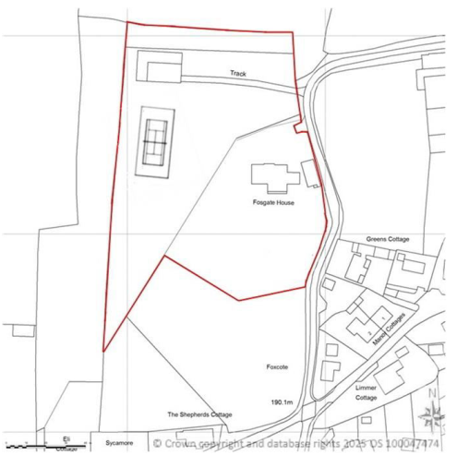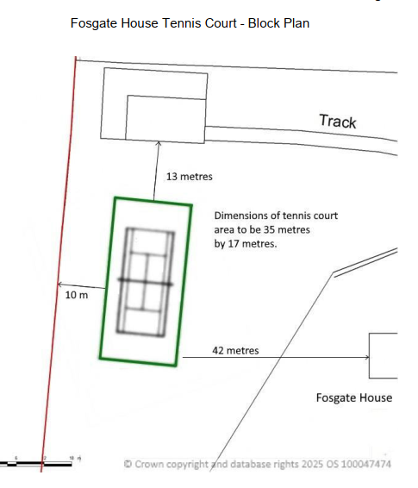

Proposed elevations

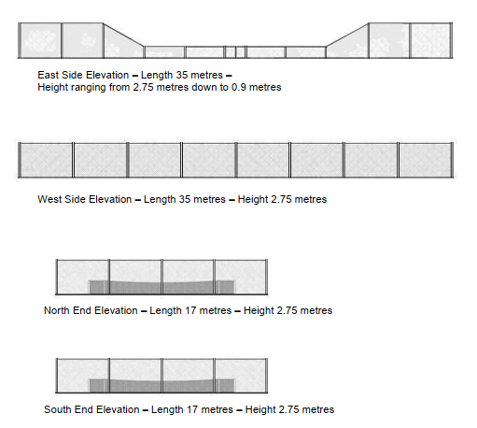

SITE DESCRIPTION/CONTEXT

Fosgate House is a detached dwelling, located off the western side of Forst Lane North, on the northern edge of the village of Upper Chute, defined by Core Policy 26 of the Wiltshire Core Strategy as a small village. The property is within the Upper Chute Conservation Area and the North Wessex Downs National Landscape (formally AONB). The dwelling sits within a large plot, Public Right of Way CHUT18 runs across the site with the house, gardens, swimming pool and detached garage to the south and land historically used as a paddock and stables to the north.

The application site is subject to the following planning policy constraints:
- Hampshire Downs Countryside Character Area
- North Wessex Downs National Landscape
- Within the Upper Chute Conservation Area
- Closest listed building is Vallance Cottage, 120m south west
- Public Right of Way CHUT18 crosses the site and CHUT17 runs north of the application site.
- River Test catchment
- Confirm Great Crested Newt record in pond 300m to the soutweast of the pond.

Green fill showing extent of conservation area, PRoW purple

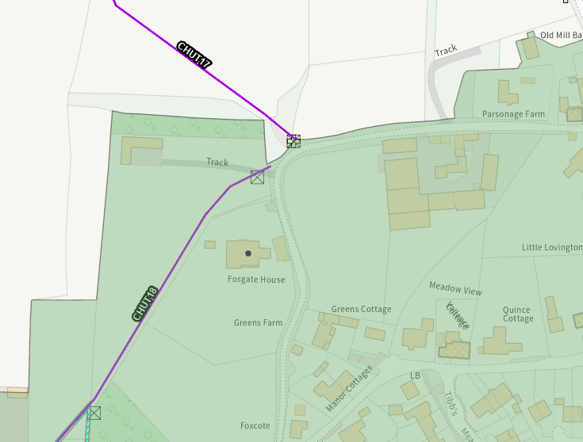

PLANNING HISTORY

Proposal / Summary
K/50503/F - Full planning permission Decision - Refused Date: 10/8/2004 – Stable block and storage.
K/54898/F - Full planning permission Decision - Approve with Conditions Date: 22/9/2006 – Change of use of agricultural land to garden
K/41858 - Full planning permission Decision - Approve with Conditions Date: 21/12/2001 – The erection of a detached dwelling and a detached garage with living accommodation.
K/46839 - Full planning permission Decision - Approve with Conditions Date: 17/2/2004 – The erection of a single storey side extension.
K/39368 - Full planning permission Decision - Approve with Conditions Date: 7/9/2000 – Demolition of 2 No cottages and outbuildings and construction of new house and garage with ancillary staff accommodation.
PL/2024/01565 - Householder planning permission Decision - Approve with Conditions Date: 5/4/2024 – Erection of bespoke garden room to rear elevation
PL/2024/04517 - Householder planning permission Decision - Approve with Conditions Date: 23/7/2024 – Provision of pool house, pergola and swimming pool
K/30531/O - Outline Planning Decision - Refused Date: 21/11/1994 – The erection of an agricultural workers dwelling.
K/31099/O - Outline Planning Decision - Refused Date: 28/2/1995 – The erection of dwelling for occupation by an agricultural worker
K/46957 - Full planning permission Decision - Refused Date: 27/2/2004 – Erection of new stables and storage
K/51973/F - Full planning permission Decision - Approve with Conditions Date: 13/6/2005 – Stable block and storage

RELEVANT POLICIES AND GUIDANCE

Wiltshire Core Strategy:
- Core Policy 1 Settlement Strategy
- Core Policy 2 Delivery Strategy
- Core Policy 26 Spatial Strategy Tidworth Community Area
- Core Policy 57 Ensuring High Quality Design and Place Shaping
- Core Policy 50: Biodiversity and Geodiversity
- Core Policy 51: Landscape
- Core Policy 58: Ensuring the Conservation of the Historic Environment
- Core Policy 61: Transport and New Development
- Core Policy 67: Flood Risk

Conservation Area Statements
Upper Chute Conservation Area Designation Statement

Statutory Legislation
Section 72 of the Planning (Listed Buildings and Conservation Areas) Act 1990
Section 85 of the Countryside and Right of Way Act 2000 (CRoW Act)

Wiltshire Design Guide: Appendix D – Design Guidance for Householder extensions

North Wessex Downs AONB Management Plan 2019-2024

The National Planning Policy Framework (NPPF)

The Planning Practice Guidance

National Design Guide

CONSULTATION RESPONSES

Chute Parish Council: Support
The Parish Council have reviewed the application for a hard surface tennis court and support it.

Ecology: No objection, subject to conditions

River Test catchment and Solent protected sites
The site falls within the River Test catchment which drains into the Solent. This region is protected by a number of international designations including the Solent Maritime Special Area of Conservation (SAC), Chichester and Langstone Harbours Special Protection Area (SPA) and Ramsar site; as well as the nationally designated Sites of Special Scientific Interest (SSSIs) that underpin these international designations. This development therefore has potential to cause adverse effects alone or in combination with other developments through discharge of nitrogen in wastewater. Appropriate Assessment must be carried out by the relevant Competent Authority (the LPA) to determine the potential significant effects and the suitability of any measures proposed to avoid or mitigate those effects.

A test of likely significance has been carried out by the relevant Competent Authority as required by Regulation 63 of the Conservation of Habitats and Species Regulations 2017 (as amended). This concluded that since there is no proposal to create any additional overnight accommodation/water discharge, there would be no overall mechanism for adverse effect. The HRA has concluded that the application is not likely to have significant impacts on the SAC and subsequently the application is screened out of Appropriate Assessment.

Protected species
The submitted documents state that there is a pond 300m to the southeast with a confirmed GCN record. This pond is separated from the site by roads and houses. Generally, it is considered that many GCN stay within 250m of a breeding pond, but may disperse more widely if there is good and well-connected habitat surrounding and with limited barriers to dispersal. Given the barriers to dispersal noted between the pond and application site, as well as the habitats to be impacted (regularly mown lawn), the overall risk to GCN is considered to be low provided suitable precautions are implemented.

The GCN method statement details a number of precautionary mitigation measures, including a pre-commencement site search, supervised vegetation removal, escape routes in any trenches left overnight, and avoidance of creating habitat piles in/near the construction area. Adherence to these measures must be secured via a condition.

A native-species hedgerow is proposed along the northern, eastern and southern borders of the tennis court. This enhancement is welcomed and will provide some wildlife benefits; this plan should be secured via condition.

It is noted that no new lighting is proposed.

Biodiversity Net Gain
From 12 February 2024 Biodiversity Net Gain (BNG) became mandatory under Schedule 7A of the Town and Country Planning Act 1990 (as inserted by Schedule 14 of the Environment Act 2021). Based on the information available the biodiversity gain planning condition is not considered to apply to this application as it is for development which is subject of a householder application within the meaning of article 2(1) of the Town and Country Planning (Development Management Procedure) (England) Order 2015.
Note to case officer: you should be satisfied that the proposals meet the above criteria and act accordingly. Further information will be required from the applicant prior to determination in the event the application is considered to be subject to mandatory biodiversity net gain.

CONDITIONS:
1. Compliance with submitted documents
The development will be carried out in strict accordance with the following documents:
• Figure 8 – Great Crested Newts Metod Statement, Mark Jarman, December 2025
• Figure 7 – Soft Landscaping Plan
REASON: For the avoidance of doubt and for the protection, mitigation and enhancement of biodiversity.

REPRESENTATIONS

One representation of no objection was received as follows:
Given the proposed location of the tennis court to the western side and towards the rear of Fossgate House I can confirm we have no objections and would only have any if the proposed siting of the court changed to the far southern end of the plot.

ASSESSMENT

Section 38(6) of the Planning and Compulsory Purchase Act 2004 states:

"If regard is to be had to the development plan for the purposes of any determination to be made under the planning Acts, the determination must be made in accordance with the plan unless material considerations indicate otherwise."

In accordance with this statutory requirement, this application has been assessed against the relevant policies of the Development Plan, including the adopted Wiltshire Core Strategy (2015) and, where applicable, any made Neighbourhood Plans.

The proposed tennis court would not be considered permitted development Schedule 2: Part 1, Class E due to its location within the North Wessex Downs National Landscape.

Design and Impact upon the character and context of the Conservation area

Core Policy 57 - Ensuring High Quality Design and Place Shaping of the Wiltshire Core Strategy seeks to ensure that all new development is of high design quality, reflecting local context, character, and distinctiveness. The policy requires applicants to “demonstrate how the proposal will make a positive contribution to the character of Wiltshire through (amongst other things) responding to the value of the natural and historic environment and being sympathetic to and conserving historic buildings and landscapes. Development is required to respond positively to the existing in terms of building layouts, built form, height, mass, scale, building line, plot size, elevational design, materials, streetscape and rooflines to effectively integrate the building into its setting.

From the point of view of the historic environment the main statutory tests are set out within the Planning (Listed Building and Conservation Areas) Act 1990.

Section 72(1) of the Act requires the Council to pay special attention to the desirability of preserving or enhancing the character or appearance of designated Conservation Areas.

The NPPF outlines government policy for planning. Chapter 16 of the NPPF 'Conserving and enhancing the historic environment' sets out the Government's high-level policies concerning heritage and sustainable development.

The proposal lies within the Upper Chute Conservation Area and seeks planning permission for the construction of a hard surfaced tennis court with fencing in the northwest part of the garden of Fosgate House. The proposed hardstanding would have a footprint of 595m². The surface will be green with white court lines. The court is proposed to be enclosed by fencing at 2.75m and 0.9m high. The fencing is proposed to be ‘post and chain link system with all steel work galvanised and painted black’.

There is a slope across the site from north to south of approximately 1.5m, the court is proposed to be positioned level with a small amount of ‘cut and fill’. A new native species hedge is proposed along the north, east and south sides of the tennis court and is proposed to grow to a height of 2.5m. No lighting is proposed.

The proposal is within a mature garden, bounded by trees and hedges, however the Public Right of Way, CHUT18 crosses to the south of the proposed tennis court, and it would therefore be visible from public vantage points. However as the footpath crosses through the site, it is considered that this area of the footpath is already within domestic curtilage and as such it is not out of character to encounter facilities that are of incidental use.

While the development would be visible from the nearby footpath, its modest scale and the proposed planting would limit the extent of visibility. It is considered that it would not result in significant harm to the character or scenic quality of the landscape.

The proposal, by virtue of its scale, design, and use of materials, is considered to preserve the character and appearance of the conservation area. It would not result in harm to the significance of any heritage assets.

The development is therefore considered to comply with Core Policy 57 and 58 of the Wiltshire Core Strategy and Section 72 of the Planning (Listed Buildings and Conservation Areas) Act 1990, as well as the relevant provisions of the NPPF.

Amenity

Point vii of Core Policy 57 - Ensuring High Quality Design and Place Shaping of the Wiltshire Core Strategy seeks to ensure that developments do not adversely affect neighbouring properties.

The National Planning Policy Framework (NPPF), particularly Paragraph 135(f), stresses that planning decisions should ensure developments provide a high standard of amenity for existing and future users.

The proposed development has been assessed in terms of its potential impact on the residential amenity of neighbouring properties, with particular regard to loss of light, overshadowing, loss of privacy, and overbearing effects.

Due to the significant residential curtilage and subsequent distance from neighbouring dwellings, it is concluded that the proposed development would not materially impact upon the occupiers of the neighbouring properties as a consequence of overbearing impact, overshadowing or loss of privacy. The proposal therefore accords with Core Policy 57 point vii in respect of safeguarding residential amenity and Appendix D of the Wiltshire Design Guide.

Highways Impact
Core Policy 57 (xiv) of the Wiltshire Core Strategy seeks to ensure that development must meet the requirements of Core Policy 61. This policy requires proposals to be capable of being served by safe access to the highway network. Core Policy 64 seeks to ensure compliance with parking standards set out in the Local Transport Plan.

The National Planning Policy Framework (NPPF), particularly Paragraph 115 and 116, requires that development proposals do not have an unacceptable impact on highway safety and that safe and suitable access to the site can be achieved for all users.

No changes are proposed to access or parking, therefore the proposed development would not result in any adverse impact on highway safety.

Public Rights of Way
Public Right of Way CHUT18 crosses to the south of the proposed tennis court, the siting will not affect the PRoW. Pre-application advice from the Highways Records Technical Officer proposed an informative that the footpath should remain open and available at all times. This will be included in the decision notice.

Ecology Impact
Core Policy 50 of the Wiltshire Core Strategy seeks to protect and enhance biodiversity and geodiversity, including through ensuring that development avoids harm to protected species and habitats.

The National Planning Policy Framework (NPPF), in Paragraphs 193, requires that development minimises impacts on and provides net gains for biodiversity, including ensuring mitigation is secured where harm cannot be avoided.

The application site lies within the River Test catchment which drains into the Solent. This region is protected by a number of international designations including the Solent Maritime Special Area of Conservation (SAC), Chichester and Langstone Harbours Special Protection Area (SPA) and Ramsar site; as well as the nationally designated Sites of Special Scientific Interest (SSSIs) that underpin these international designations. Due to the nature of the development, with no proposal to create additional overnight accommodation, the HRA has concluded that the application is not likely to have significant impacts on the SAC and subsequently the application is screened out of Appropriate Assessment.

The application site lies within 300m of a pond with a confirmed GNC record. The application has been supported by a method statement ‘Protecting and safeguarding Great Crested Newts during the construction of the tennis court’. The Council’s Ecologist has commented that the pond is separated from the site by roads and houses, and the impacted habitat (mown lawn) means that the overall risk to GCN is considered to be low provided the precautionary mitigation measures set out in the method statement are adhered to. This will be secured via condition.

The proposals include for a native-species hedgerow along the north, east and south boarder of the tennis court. This will provide wildlife benefit, and the Ecologist has requested this be secured via condition.

As such, the development complies with Core Policy 50 of the Wiltshire Core Strategy and the relevant provisions of the NPPF.

National Landscape
Core Policy 51 of the Wiltshire Core Strategy requires all development to protect, conserve, and where possible enhance the character and quality of Wiltshire’s landscapes, giving particular weight to designated areas such as National Landscapes.

The National Planning Policy Framework (NPPF), in Paragraph 176, states that “great weight” should be given to conserving and enhancing landscape and scenic beauty in National Landscapes (formerly Areas of Outstanding Natural Beauty). Development within or affecting the setting of a National Landscape must demonstrate that it will not result in unacceptable harm to the special qualities of that area.

The proposal is for a tennis court within the garden of Fosgate House. It is viewed within the context of the dwelling house and the village.

The proposal, by virtue of its scale, siting, and design, would not harm the special qualities or scenic character of the North Wessex Downs National Landscape.

The development therefore complies with Core Policy 51 of the Wiltshire Core Strategy and Paragraph 176 of the NPPF in conserving and enhancing the National Landscape.

Biodiversity Net Gain

Householder planning applications are exempt from the requirement to deliver Biodiversity Net Gain under Schedule 7A, Section 4(2)(a) of the Town and Country Planning Act 1990, as inserted by the Environment Act 2021.

CONCLUSION

The proposed development is considered to be acceptable in terms of its design, scale, and relationship with the surrounding area. It would not result in any unacceptable harm to the character of the locality, the amenities of neighbouring occupiers, National Landscape or the interests of highway safety, heritage, or ecology.

The proposal is therefore considered to comply with the relevant policies of the Wiltshire Core Strategy, the Wiltshire Local Plan, and the National Planning Policy Framework. As such, the application is recommended for approval, subject to the conditions set out below.

RECOMMENDATION: That Planning Permission be GRANTED subject to conditions.

- The development hereby permitted shall be begun before the expiration of three years from the date of this permission.
REASON: To comply with the provisions of Section 91 of the Town and Country Planning Act 1990 as amended by the Planning and Compulsory Purchase Act 2004.

- The development hereby permitted shall be carried out in accordance with the following approved plans and documents:

Location Plan, received 19/02/2026
Figure 2 Block Plan, received 19/02/2026
Figure 3 Fence Elevations, received 19/02/2026
Figure 4 Fence and Court detail, received 19/02/2026
Figure 7 Soft Landscaping Plan, received 19/02/2026
Figure 8 Method Statement – Protecting and safeguarding Great Crested Newts during the construction of the tennis court, received 19/02/2026
Design & Access Statement, received 19/02/2026

REASON: For the avoidance of doubt and in the interests of proper planning.

- The materials to be used in the construction of the external surfaces of the development hereby permitted shall match in material, colour and texture detailed on the application form and approved plans.

REASON: In the interests of visual amenity and the character and appearance of the area.

- The development will be carried out in strict accordance with the following documents:
Figure 8 – Great Crested Newts Method Statement, Mark Jarman, December 2025
Figure 7 – Soft Landscaping Plan

REASON: For the avoidance of doubt and for the protection, mitigation and enhancement of biodiversity.

INFORMATIVES
- The applicant should note that it is a criminal offence to obstruct a public right of way under section 137 of the Highways Act 1980 and therefore no materials, plant, temporary structures or excavations of any kind should be deposited / undertaken which obstruct or adversely affect the public right of way CHUT18 whilst development takes place, without prior consultation with, and the further permission of, the highways authority at Wiltshire council.
The applicant should note that no gates or stiles should be erected across the public right of way without prior consultation and approval from the Countryside Access Officer
(contact rightsofway@wiltshire.gov.uk). Unauthorised structures across a right of way are an obstruction and gates may only be authorised for the control of stock under section 147 of the Highways Act 1980.

