APPLICATION FOR FULL PLANNING PERMISSION
DELEGATED REPORT

APPLICATION REFERENCE: | PL/2026/01265
APPLICATION TYPE: | Full planning permission
SITE ADDRESS: | 95 Studland Park, Westbury, BA13 3HN
DEVELOPMENT DESCRIPTION: | Outbuilding extension & conversion to form small residential annexe, and associated works
RECOMMENDATION: | That Planning Permission be GRANTED

PROPOSAL

The proposal seeks planning permission for an extension to an existing brick-built outbuilding to form an ancillary annexe for elderly relatives.

SITE DESCRIPTION/CONTEXT
This application relates to a large detached two storey dwelling, 95 Studland Park, located within an established residential cul de sac in Westbury. The host dwelling benefits from an off-road parking area to the front elevation and an attached garage.

The surrounding properties consist of large, detached properties set centrally within their respective plots. The application site sits within the Bath and Bradford on Avon Special Area of Conservation for bats, the Trowbridge and Westbury Bat Mitigation Strategy (TWBMS) and falls within the recreational impact zone of the Salisbury Plain Special Protection Area for birds

PLANNING HISTORY
Proposal / Summary
W/04/00587/FUL - Full planning permission Decision - Approve with Conditions Date: 6/5/2004 – Two storey and single storey extensions

RELEVANT POLICIES AND GUIDANCE

Wiltshire Core Strategy:
Core Policy 1 Settlement Strategy
Core Policy 2 Delivery Strategy
Core Policy 32 – Spatial Strategy for the Westbury Community Area
Core Policy 50 – Biodiversity and Geodiversity
Core Policy 57 - Ensuring High Quality Design and Place Shaping
Core Policy 60 – Sustainable Transport
Core Policy 61 – Transport and Development
Core Policy 64 – Demand Management
Emerging Policy – Wiltshire Local Plan Review
The examination of the emerging Wiltshire Local Plan has been paused and the weight to be afforded to any part of the emerging plan can be no more than very limited. A decision on how to proceed will be made by the Council in May 2026.
Westbury Neighbourhood Plan 2023-2036

Wiltshire Design Guide: Appendix D – Design Guidance for Householder extensions

The National Planning Policy Framework (NPPF)

The Planning Practice Guidance

National Design Guide

CONSULTATION RESPONSES

Westbury Town Council: No objection

Wiltshire Council Highways: No objection

REPRESENTATIONS

No comments were received.

ASSESSMENT
Section 38(6) of the Planning and Compulsory Purchase Act 2004 states:

"If regard is to be had to the development plan for the purposes of any determination to be made under the planning Acts, the determination must be made in accordance with the plan unless material considerations indicate otherwise."

In accordance with this statutory requirement, this application has been assessed against the relevant policies of the Development Plan, including the adopted Wiltshire Core Strategy (2015) and, where applicable, any made Neighbourhood Plans.

Principle of Development
The proposed development comprises an extension to an existing outbuilding, to form ancillary accommodation, set within an established residential curtilage within the settlement boundary of Westbury. As such, the principle of development is considered acceptable, subject to the detailed assessment of design, amenity, and other material considerations set out below.

Design and Impact upon the character and context of the area
Core Policy 57 - Ensuring High Quality Design and Place Shaping of the Wiltshire Core Strategy seeks to ensure that all new development is of high design quality, reflecting local context, character, and distinctiveness.

This application is seeking permission for an extension to an existing single storey outbuilding to form an annex for elderly relatives. The works would facilitate ground floor accommodation consisting of a living room, kitchen/dining room, bathroom and bedroom. The existing outbuilding sits within the private residential rear curtilage of the host dwelling, accessed from the front elevation of the host dwelling.

The applicant proposes extending the existing building forward from the front elevation by a length of 5.5m so that the front elevation would be adjacent to the southwest rear elevation of the host dwelling. The extension would maintain the height and width of the existing building with an additional window and rooflights inserted on the northwest side elevation and a pedestrian door and window inserted on the southeast side elevation.

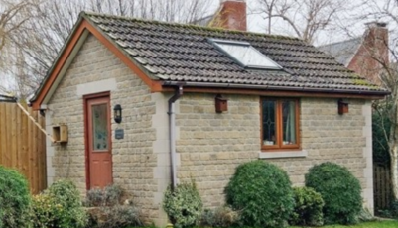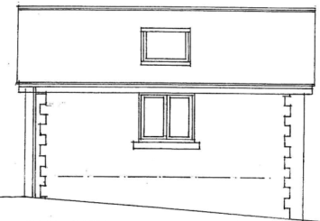
Existing northwest side elevation

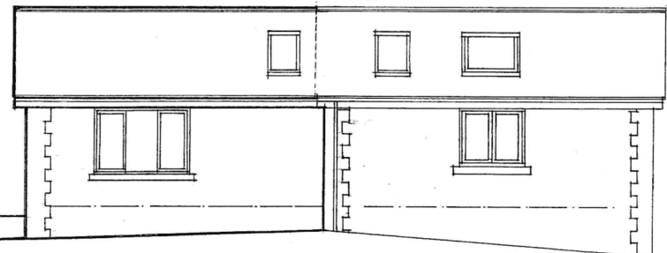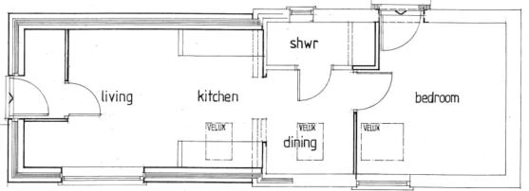
Proposed northwest side elevation and floor plan of the annexe

The use of matching materials (Cotswold stone coloured blockwork under a concrete roof) with matching brown UPVC fenestration would ensure the proposal would integrate into the surrounding setting. It is considered that the proposal would by virtue of its height, scale and design constitute an acceptable addition within the application site that would appear commensurate to the size of the property and plot.

Having regard to the above, the proposal complies with the design principles set out in Core Policy 57 of the Wiltshire Core Strategy and Appendix D of the Wiltshire Design Guide.

Amenity
Point vii of Core Policy 57 - Ensuring High Quality Design and Place Shaping of the Wiltshire Core Strategy seeks to ensure that developments do not adversely affect neighbouring properties.

The National Planning Policy Framework (NPPF), particularly Paragraph 135(f), stresses that planning decisions should ensure developments provide a high standard of amenity for existing and future users.

The proposed development has been assessed in terms of its potential impact on the residential amenity of neighbouring properties, with particular regard to loss of light, overshadowing, loss of privacy, and overbearing effects.

All windows proposed would look out over the applicant’s private gardens to the rear, and the pedestrian door and window on the southeast side elevation, adjacent to the common shared boundary with No.93 raise no overlooking concerns given the single storey nature of the scheme.

It is acknowledged that there would be an additional mass adjacent to the common shared boundary with the neighbouring property at No.93 Studland Park, but this not considered to present any overbearing issues or overshadowing, the additional form being restricted to the height of the existing outbuilding positioned in the rear curtilage of the host dwelling and maintaining a separation distance of 12.5m to the adjacent dwelling.

This application seeks to utilise the proposed building as ancillary accommodation, and a condition would be applied on any planning permission granted to ensure that the accommodation shall remain as ancillary to the host property and not as separate independent accommodation.

Given the scale of the development proposal, it is considered that the proposed extension would not result in unacceptable loss of light, overlooking, overshadowing and would not have an overbearing impact upon neighbouring properties.The proposal therefore accords with Core Policy 57 point vii in respect of safeguarding residential amenity and Appendix D of the Wiltshire Design Guide.

Highways Impact
Core Policy 57 (xiv) of the Wiltshire Core Strategy seeks to ensure that development must meet the requirements of Core Policy 61. This policy requires proposals to be capable of being served by safe access to the highway network. Core Policy 64 seeks to ensure compliance with parking standards set out in the Local Transport Plan.

The National Planning Policy Framework (NPPF), particularly Paragraph 115 and 116, requires that development proposals do not have an unacceptable impact on highway safety and that safe and suitable access to the site can be achieved for all users.

In order to comply with the Wiltshire Local Transport Plan 2011 – 2026: Car Parking Strategy (March 2015) three on-site car parking spaces would be required for a 5+ bed dwelling (standard min. size 2.4m x 4.8m).
The Local Authority Highways officer was consulted on the proposal and offered the following comments
’The proposal will provide a totally independent residential unit and as such a parking space is required for its use. The main dwelling is 5 bed and therefore requires 3 off street parking spaces. The property benefits from 2 garages and 2 driveway parking spaces which is adequate for both the main dwelling and the proposed annexe.
I raise no highway objection’
The proposed development would not result in any adverse impact on highway safety. Adequate parking and turning provision is provided in accordance with Wiltshire’s adopted parking standards, and access arrangements are acceptable.

The proposal is therefore considered to comply with Core Policies 57 (xiv), 61 and 64 of the Wiltshire Core Strategy, the NPPF, and the Wiltshire Local Transport Plan.

Ecology Impact
Core Policy 50 of the Wiltshire Core Strategy seeks to protect and enhance biodiversity and geodiversity, including through ensuring that development avoids harm to protected species and habitats.

The National Planning Policy Framework (NPPF), in Paragraphs 193, requires that development minimises impacts on and provides net gains for biodiversity, including ensuring mitigation is secured where harm cannot be avoided.

This proposal falls within the recreational impact zone of the Salisbury Plain Special Protection Area for birds. Therefore, potential disturbance to nesting birds through the creation of additional visitor numbers to the Salisbury Plain has to be assessed. However, given that this proposal relates to an extension to existing accommodation only, without the creation of separate independent living accommodation, it is considered that there would not be any adverse impacts on the Special Protection Area.

The application site sits within the Bath and Bradford on Avon Special Area of Conservation for bats as well as the grey, hatched zone of the Trowbridge and Westbury Bat Mitigation Strategy (TWBMS). As this application involves disturbance to an existing outbuilding located within two bat zones due consideration has to be given to the potential disturbance of any bats because of the proposed development.

However given the established high density urban residential nature of the location, it is considered highly unlikely that any bats would be affected and significant effects relating to the disturbance to bats can be ruled out.

As a precautionary measure an informative would be added to any decision that in event any evidence of bat activity is detected that the applicant should follow the advice of a professional ecologist or contact Natural England.

As such, the development complies with Core Policy 50 of the Wiltshire Core Strategy and the relevant provisions of the NPPF.

Biodiversity Net Gain
As of April 2024, unless exempted, applications need to demonstrate no net loss and a minimum of 10% net gain in biodiversity (BNG) on the site, in line with the requirements of the NPPF, PPG, WCS policy CP50 (Biodiversity and Geodiversity) and the Environment Act. In this case, the application was submitted with a de minimis exemption.

However, the small-scale nature of this proposal means that the scheme falls within De minimis Exemption (less than 25sqm of habitat or 5m of linear habitat) and therefore BNG is not required.
CONCLUSION
The proposed development is considered to be acceptable in terms of its design, scale, and relationship with the surrounding area. It would not result in any unacceptable harm to the character of the locality, the amenities of neighbouring occupiers, or the interests of highway safety or ecology.

The proposal is therefore considered to comply with the relevant policies of the Wiltshire Core Strategy, the Wiltshire Local Plan, and the National Planning Policy Framework. As such, the application is recommended for approval, subject to the conditions set out below.

RECOMMENDATION: That Planning Permission be GRANTED subject to conditions.

Conditions

- The development hereby permitted shall be begun before the expiration of three years from the date of this permission.
REASON: To comply with the provisions of Section 91 of the Town and Country Planning Act 1990 as amended by the Planning and Compulsory Purchase Act 2004.

- The development hereby permitted shall be carried out in accordance with the following approved plans and documents:
Location & Site Plans DWG No VL.2026/04/01
Outbuilding Existing Floor Plan DWG No VL.2026/04/02
Outbuilding Existing Elevations DWG No VL.2026/04/03
Proposed Annexe Floor Plan DWG No VL.2026/04/04
Proposed Annexe Elevations DWG No VL.2026/04/05
Main House Floor Plans DWG No VL.2026/04/06
All Plans Received 23.02.2026

REASON: For the avoidance of doubt and in the interests of proper planning.

3. The accommodation] hereby permitted shall not be occupied at any time other than for purposes ancillary to the residential use of the main dwelling, known as 95 Studland Park and it shall remain within the same planning unit as the main dwelling.

REASON: The additional accommodation is sited in a position where the Local Planning Authority, having regard to the reasonable standards of residential amenity, access, and planning policies pertaining to the area, would not permit a wholly separate dwelling.

Informative
If bats or evidence of bats are found during the works, the applicant is advised to stop work and follow advice from an independent ecologist or to contact Natural England’s Bat Line through the internet.

