APPLICATION FOR HOUSEHOLDER PLANNING PERMISSION
DELEGATED REPORT

APPLICATION REFERENCE: | PL/2026/01101
APPLICATION TYPE: | Householder Planning Permission
SITE ADDRESS: | 18 Piplar Ground, Bradford On Avon, BA15 1XF
DEVELOPMENT DESCRIPTION: | Replacement of the existing front porch canopy, erection of rear veranda, replacement of the garage door with a window, replacement of the front entrance door to the house and enlargement of the existing front driveway into part of the front garden to create additional gravelled parking space.
RECOMMENDATION: | That Planning Permission be GRANTED

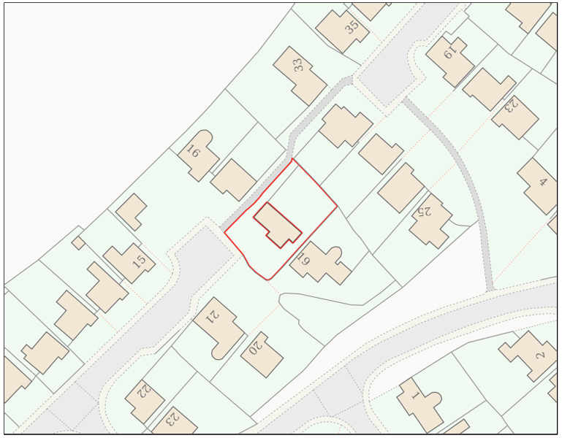

PROPOSAL

The proposal comprises a series of minor domestic alterations, including the replacement of the existing front porch canopy, erection of a rear veranda, replacement of the garage door with a window, and replacement of the front entrance door. In addition, the existing front driveway would be extended into part of the front garden to provide an enlarged gravelled area for additional off-street parking.

SITE DESCRIPTION / CONTEXT

The application site consists of a detached two-storey dwelling with associated residential curtilage, set within an established housing estate inside the Bradford on Avon settlement boundary. The property is of buff/bradstone construction with a dark grey tiled roof and white uPVC features, which are characteristic of the surrounding dwellings. The site lies within Flood Zone 1 and is not subject to conservation designations, although it falls within designated bat consultation buffer zones. A pedestrian footpath runs adjacent to the site through the estate, although it is not a designated public right of way.

PLANNING HISTORY

No relevant planning history has been identified for the site subject of this application.

RELEVANT LEGILSATION, POLICIES AND GUIDANCE

Wiltshire Core Strategy:

Core Policy 1 Settlement Strategy;
Core Policy 2 Delivery Strategy;
Core Policy 7 Spatial Strategy: Bradford on Avon Community Area;
Core Policy 50 Biodiversity and Geodiversity;
Core Policy 51 Landscape;
Core Policy 57 Ensuring High-Quality Design and Place Shaping;
Core Policy 60 Sustainable Transport;
Core Policy 61 Transport and Development;
Core Policy 64 Demand Management;
Core Policy 67 Flood Risk;

The Bradford on Avon Neighbourhood Plan 2013-2026

The National Planning Policy Framework (NPPF) and The Planning Practice Guidance (PPG)

Wiltshire Design Guide - Appendix D – Design Guidance for Householder extensions

The Wiltshire Local Transport Plan 2011 – 2026: Car Parking Strategy (March 2015).

The Wiltshire Local Transport Plan 4 (LTP4) (March 2025)

Emerging Policy – Wiltshire Local Plan Review

The examination of the emerging Wiltshire Local Plan has been paused and the weight to be afforded to any part of the emerging plan can be no more than very limited. A decision on how to proceed will be made by the Council in May 2026.

CONSULTATION RESPONSES

Bradford on Avon Town Council – Objects
Widened parking area would be out of keeping with the estate’s original layout and character, due to its proximity to the footpath serving neighbouring dwellings and the associated loss of vegetation.

REPRESENTATIONS

One objection was received from the Bradford on Avon Preservation Trust, raising concerns that the increased width of the front garden parking area, its close proximity to the connecting footpath, and the resulting loss of vegetation would harm the street scene and fail to respect the original layout and character of the estate.

ASSESSMENT

Section 38(6) of the Planning and Compulsory Purchase Act 2004 states:

"If regard is to be had to the development plan for the purposes of any determination to be made under the planning Acts, the determination must be made in accordance with the plan unless material considerations indicate otherwise."

In accordance with this statutory requirement, this application has been assessed against the relevant policies of the Development Plan, including the adopted Wiltshire Core Strategy (2015) and, where applicable, any made Neighbourhood Plans.

Householder extensions are generally acceptable in principle, as they typically fall within the established residential curtilage of a property and do not result in new residential development in the open countryside. In this case, the proposal also lies within the defined limits of development set out in the Core Strategy, further reinforcing its acceptability in principle.

Design and Impact upon the upon the character and context of the area

Core Policy 57 Ensuring High Quality Design and Place Shaping of the Wiltshire Core Strategy requires all new development to achieve a high standard of design that responds positively to its local context. Proposals must reinforce and enhance local character and distinctiveness, relate appropriately to the surrounding landscape, and demonstrate a thoughtful response to existing townscape features. This includes careful consideration of elements such as building height, scale, massing, building line, materials, and overall appearance, ensuring new development integrates harmoniously with its setting.

In design terms, the majority of the proposed works are considered acceptable and would not result in harm to the character or appearance of the dwelling or surrounding area. The replacement of the garage door with a window would utilise matching materials and represent a minor, incongruous-free elevational change. The alteration to the front porch, involving a change from a pitched canopy to a modest gabled form with exposed roof beams, would remain minimal in scale relative to the host dwelling and is acceptable in design terms. The rear veranda, positioned at ground-floor level, would be clearly subservient and constructed with an anthracite grey aluminium frame and glazed roof panels, providing a muted, cohesive appearance typical of domestic development while maintaining permeability and visual integration. The replacement front entrance door is also a minor alteration to which no material harm is identified.

The enlargement of the front parking area is the most contentious element, attracting objection from the Town Council and Preservation Trust due to the increased hardstanding and loss of vegetation; however, while this loss is acknowledged as a negative impact, it is noted that such development appears capable of falling within Class F permitted development rights, subject to appropriate permeable surfacing or drainage measures. This represents a reasonable fall-back position, and having regard to the wider street scene—where similar double-width driveways are evident—the proposal would not be out of character with prevailing residential development and is therefore considered acceptable on balance.

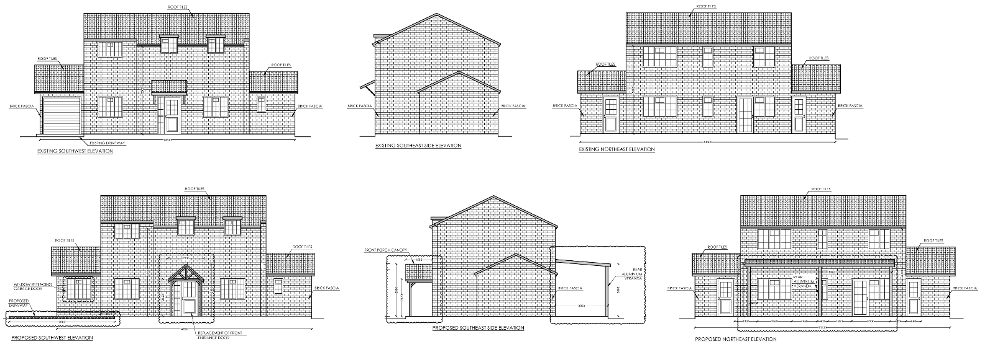
Exisiting and Proposed Elevations

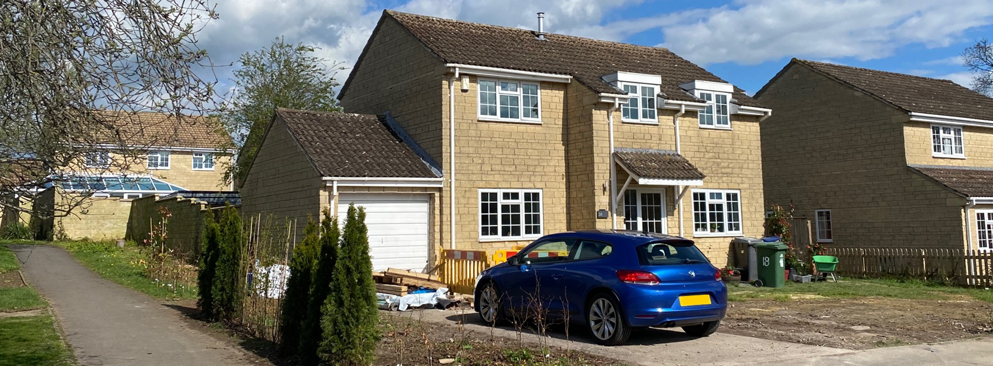
Site Visit Image (Front Elevation)

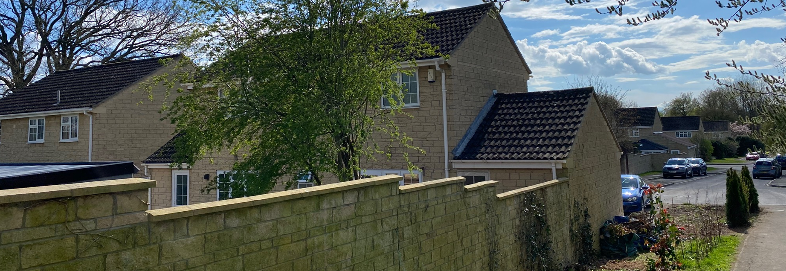
Site Visit Image (Rear Elevation)

Having regard to the above, the proposal complies with the design principles set out in Core Policy 57 of the Wiltshire Core Strategy and Appendix D of the Wiltshire Design Guide.

Amenity

Point vii of Core Policy 57 Ensuring High Quality Design and Place Shaping of the Wiltshire Core Strategy seeks to ensure that developments do not adversely affect neighbouring properties.

The National Planning Policy Framework (NPPF), particularly Paragraph 135, stresses that planning decisions should ensure developments provide a high standard of amenity for existing and future users.

In terms of residential amenity, the proposed alterations would not result in any material harm to neighbouring occupants. The driveway works, garage frontage alteration and front porch changes do not introduce additional built bulk or any new opportunities for overlooking, and would therefore have no impact in terms of overbearing effect, loss of privacy or overshadowing. The rear veranda is centrally positioned within the plot and set away from neighbouring boundaries; there is no residential neighbour to the northwest, where a footpath is present, and its modest height relative to the host dwelling ensures that it would not give rise to overshadowing, particularly as both the application property and neighbouring dwellings are primarily overshadowed by their own built form due to the sun’s southern path. Furthermore, the open nature of the veranda, incorporating glazed roof panels and lacking solid enclosure, would limit its visual mass and ensure it would not appear overbearing when viewed from adjacent land, thereby safeguarding neighbouring amenity.

The proposal is appropriately sited, designed, and oriented to ensure that it would not result in unacceptable impact upon/to the amenities or living conditions of neighbouring residential occupiers, particularly in terms of outlook, privacy, or access to natural light.

The proposal therefore accords with Core Policy 57 point vii in respect of safeguarding residential amenity and Appendix D of the Wiltshire Design Guide.

Transport and Highways

Core Policies 60 and 61 of the Wiltshire Core Strategy require developments to support safe and efficient movement, demonstrate consideration of the hierarchy of transport users, and provide safe access to the highway network, while paragraph 116 of the NPPF confirms that development should only be refused on highway grounds where there would be an unacceptable impact on highway safety or severe residual impacts on the road network. Core Policy 64, alongside the Wiltshire Local Transport Plan, policy PS6 and the Council’s Car Parking Strategy, requires development to meet minimum parking standards having regard to dwelling size. The property is understood to be an existing three-bedroom dwelling, which attracts a requirement for two parking spaces; however, in recognition of the loss of a garage parking space and the potential for the internal space to be used as additional habitable accommodation, the proposed parking provision has been examined further. The enlarged driveway would measure approximately 9.6m by 6m, which is sufficient to accommodate three standard parking spaces in accordance with the Council’s dimensions of 2.4m by 4.8m per space, and therefore the proposal is considered to accord with adopted parking standards and to raise no highway safety concerns.

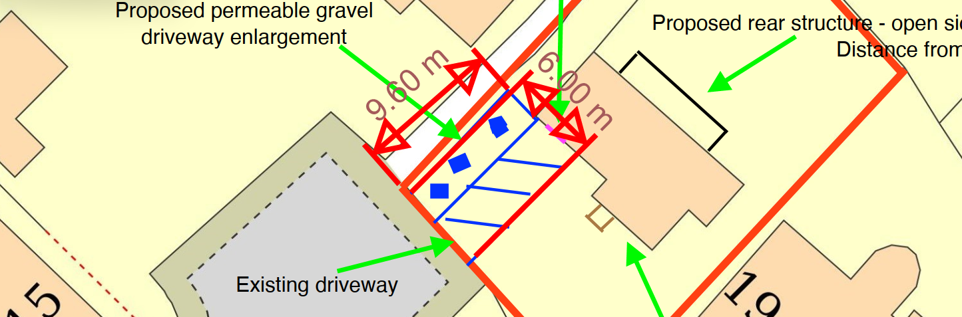
Proposed Block Plan (with annotated parking area measurements)

Ecology

In ecological terms, the proposal has been assessed against Core Policy 50 of the Wiltshire Core Strategy, which seeks to avoid and reduce disturbance to sensitive wildlife species and habitats. While Biodiversity Net Gain is now a mandatory consideration under Schedule 7A of the Town and Country Planning Act 1990 (as amended), householder developments are explicitly exempt from this requirement. Notwithstanding the site’s location within defined Core Roost Buffer and SAC buffer zones, the nature and scale of the proposed works are such that there would be minimal interaction with habitats or ecological interests: the garage alteration involves only a minor change to an existing external wall, the porch and the rear veranda would be located within areas of existing garden and hardstanding, and the enlarged parking area would affect front garden land considered to have limited ecological value. As such, no material adverse impact on biodiversity is identified and the proposal is considered acceptable from an ecological perspective.

Flooding and Drainage

In drainage and flood risk terms, the proposal has been assessed against Core Policy 67 of the Wiltshire Core Strategy and relevant national guidance and is considered acceptable. The site lies within Flood Zone 1 and the Council’s Strategic Flood Risk Assessment identifies no risk from surface water or groundwater flooding. Paragraphs 172 and 176 of the NPPF confirm that householder development below 250 m² is exempt from the sequential and exception tests, which applies in this instance. The works would introduce only limited areas of additional hard surfacing, comprising approximately 24.3 sqm of driveway, 15.3 sqm for the rear veranda and 1.8 sqm for the porch, and the driveway is proposed to be constructed using permeable materials. As such, surface water runoff can be managed sustainably within the site, ensuring that runoff rates would not exceed existing conditions and that there would be no increase in flood risk on or off site. The development therefore accords with both local and national flood risk and drainage policy.

CONCLUSION

The proposal is considered to be acceptable and in accordance with the relevant policies and guidance outlined above.

RECOMMENDATION: That Planning Permission be GRANTED subject to the following conditions:

1.
The development hereby permitted shall be begun before the expiration of three years from the date of this permission.
REASON: To comply with the provisions of Section 91 of the Town and Country Planning Act 1990 as amended by the Planning and Compulsory Purchase Act 2004.

2.
The development hereby permitted shall be carried out in accordance with the following approved plans and documents:

Planning Statement (17 February 2026)
Location Plan (17 February 2026)
Proposed Site Plan (17 February 2026)
Exisiting and Proposed South West Elevations A001 (5 March 2026)
Exisiting and Proposed South East Elevations A002 (5 March 2026)
Exisiting and Proposed North East Elevations A003 (5 March 2026)

REASON: For the avoidance of doubt and in the interests of proper planning.

3.
The development hereby permitted shall not be first brought into use until the first five metres of the access, measured from the edge of the carriageway, has been consolidated and surfaced (not loose stone or gravel). The access shall be maintained as such thereafter.

REASON: In the interests of highway safety.

