Wiltshire Council Planning Consultation Response

[Date]

Monday, 27 April 2026

Application No: | PL/2025/03672
Site Address: | Land East of Biddestone Lane, Yatton Keynell

Please note the particulars in connection with the above planning application are available to view on the planning website http://www.wiltshire.gov.uk/planninganddevelopment.htm

I would welcome any comments that you have about this particular application by EARLIESTDECISIONDATE. If I do not receive your observations and comments by this date I will assume you have none. If you require an extension of time please contact the Planning Officer above who will do their best to accommodate this.

Recommendations:

No Comment
Support
Support subject to conditions (please see out below)

Object (for reasons set out below)
No objections

Proposal:

Full Planning Application for Residential Development to Provide 55 Dwellings, Public Open Space, Access, Drainage, Landscaping, Associated Infrastructure and Ancillary Works

Provision of containers for waste and recycling:

The council requests s106 contributions towards the provision of waste and recycling containers for each residential unit, under policies CP3 and WCS6. The following estimated contribution is required for the proposed development:

Property type category | Contribution per house/per category | Quantity | Total
Individual house | £121.00 | 55 | 6,655
Bin store for block of 6-10 flats | £971.00
Bin store for block of 11-14 flats | £1,8458
Bin store for block of 15-18 flats | £2,725.00
 |  | Total | 6,655

Policy:

Policy support for seeking developer contributions towards the provision of waste management facilities is provided by the adopted Wiltshire Core Strategy, Wiltshire and Swindon Waste Core Strategy and the Wiltshire Planning Obligations Supplementary Planning Document, as detailed in the sections below.

Wiltshire Core Strategy – Core Policy 3 (CP3)

Core Policy 3 of the Wiltshire Core Strategy (adopted January 2015) provides overarching policy support for securing developer contributions towards ‘waste management services such as recycling and collection facilities’, which is classed as ‘essential infrastructure’. In the event of competing demands for infrastructure provision, essential infrastructure will be afforded the highest priority.

Planning Obligations Supplementary Planning Document

The Wiltshire Planning Obligations Supplementary Planning Document (SPD) (Adopted May 2015) supports Core Policy 3 and provides further detail on the council’s approach to developer contributions. The Planning Obligations SPD lists ‘waste and recycling containers’ as a type of site-specific infrastructure that would be sought through section 106 contributions rather than through the Community Infrastructure Levy (CIL). The provision of bins, and the services required to support waste collection, is a burden on the council that can often be directly related to new developments and hence firmly within scope for financial contributions to be made through s106 agreements. Container provision is directly related to the type and scale of the development, as they are issued on a per-residential-unit basis (except where communal containers are required for apartments sharing the use of bin stores).

To meet the requirements of the Written Ministerial Statement on small-scale developers, contributions are not sought for developments which include 10 residential units or fewer.

Policy WCS6 of the Wiltshire and Swindon Waste Core Strategy

Policy WCS6 of the Wiltshire and Swindon Waste Core Strategy requires developers “to design and provide facilities for occupiers of the development to recycle/compost waste […] and/or facilities within individual groups of properties or premises for the source separation and storage of different types of waste for recycling and/or composting”. Wiltshire Council retains control of procuring containers that are issued to occupiers of residential properties. The reasons for this are to ensure that the containers are compatible with lifting equipment and that branding – which is essential for ensuring that residents know what materials are designated for each container – meets the required standard. As a developer cannot directly provide the facilities for the separation and storage of waste, instead the requirement under WCS6 is met by securing a section 106 contribution.

The same policies provide policy support for ensuring that developments are designed so as to be suitable for delivery of waste collection services.

Core Policy 3 states that it is “important that all new development proposals build safeguards into schemes to protect and enhance appropriate services and facilities, including […] waste collection and management services”. These safeguards can be achieved by allowing suitable space for waste storage and collection operations in accordance with the council’s waste SPD at the outset of the application process.

Policy WCS6 requires developers to provide facilities for separation and storage of waste for recycling and composting. It also states that any such provision must “have regard to […] the existing […] Municipal Waste Management Strategy”. The council’s waste strategy expects that new developments are designed to enable waste collection services to operate safely and efficiently and, to this end, the waste SPD sets out what is deemed to be safe and efficient. Meeting the requirement of WCS6 can be achieved by following the guidance in the waste SPD.

Please note this is subject to change in accordance with government guidelines which may affect vehicle sizes and waste and recycling containers in the future

Access to waste collection services:

I attach a guidance document setting out the council’s technical requirements to ensure that residents will be able to use the standard waste collection service. In general terms, following the attached guidance will allow the service to operate as intended and generally will mean that plans are acceptable to the waste management services team. The following paragraphs highlight some areas that would need to be addressed at the next stage of an application.

Please note this is based on s106 for individual properties and groups of flats. This could be amended in the completion of a Full planning application subject to conditions.

Vehicle access

Vehicle tracking is required to demonstrate that refuse collection vehicles (RCVs) can move through the development and turn at the ends of roads, especially taking account of cars parked in allocated spaces and at the roadside. Adequate turning room should be provided to take account of the restrictions on carry distances for residents set out in Part H of Building Regulations (25m), the limitations on carry distances for waste collection crews, where the vehicle should be able to stop within 10m of a collection point (see section 4.4 of the attached guidance) and due to the requirement to minimise reversing to meet the requirements of BS 5906:2005.

The council requires an indemnity to operate on any roads that are not adopted, including during any period where the council needs to deliver waste collection services prior to adoption. The required arrangements are set out in section 5.8 of the attached guidance with a sample indemnity provided in Appendix C

Collection points

Each dwelling should have a collection point that is on level hardstanding off any roadway or footway at the curtilage of the property, as further described in section 5.2 of the waste SPD. Plans should identify these areas for each dwelling and demonstrate that they do not impact on space available on driveways and that soft landscaping won’t prevent or encumber the collection crew when emptying bins.

Storage points

In accordance with the guidance in section 5.4 of the waste SPD, plans in future submissions should demonstrate that each property has suitable storage space that takes account of the guidance. Showing containers to scale in situ will help to demonstrate compliance.

Routes between storage and collection points

As noted in the ‘Vehicle access’ section above, residents should not have to carry their waste containers more than 25m from the storage point to the collection point and crew more than 10m to a bin collection point. Plans should demonstrate that this is achievable for each dwelling, preferably with a supplementary table listing the carry distances per dwelling, for ease of reference. Section 5.3 of the waste SPD provides further details on matters to consider when designating these routes.

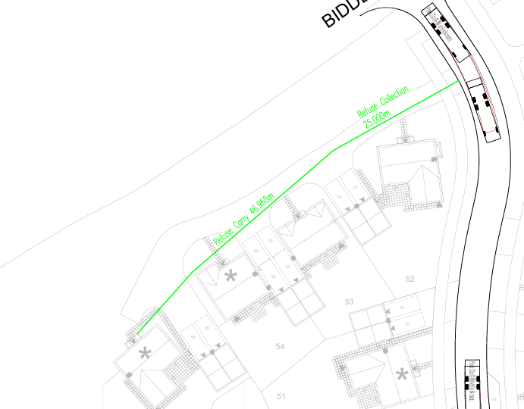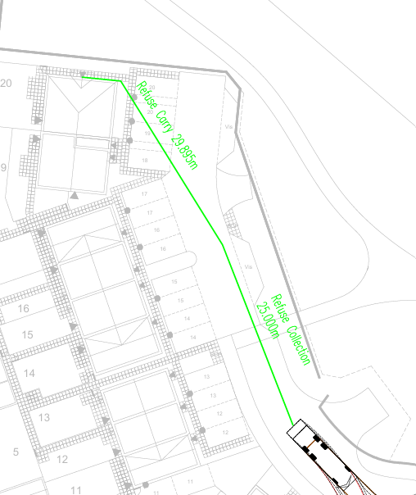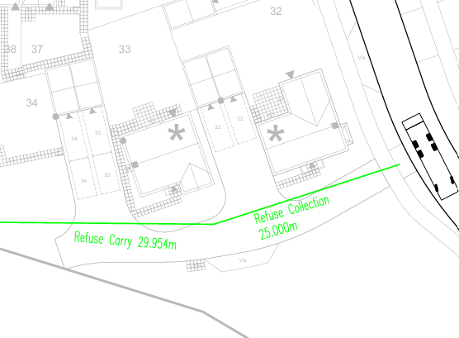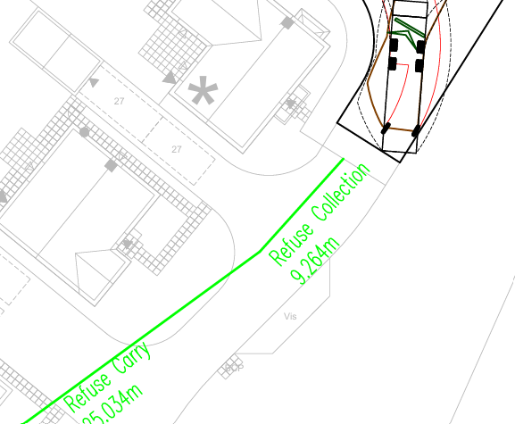

The collection service for flats

If final designs include communal bin stores for flats, the detailed guidance in section 5.6 of the attachment should be followed. Attention should be paid to the location and accessibility of bin stores, as the RCV should be able to park within 10 metres of the store without obstructions and with dropped kerbs in place to enable the bins to be safely manoeuvred to the rear of the RCV. We have experienced problems where poor location, insufficient storage space or doorways of inadequate width mean that services can’t be delivered, which impacts on the quality of life of residents as waste accumulates. Final designs should demonstrate how these problems are mitigated.
Please be advised that, in light of the food waste and soft plastic policies scheduled to come into effect in August 2027, additional capacity will be required within the bin store(s) to ensure it is appropriately future-proofed.

Conditions

- S106 contribution of £6,655 based on 55 dwellings.
- Indemnities.
- Bin Collection points within 10m for crews, 25m for residents.

Supporting documents

