Design, Access and Heritage statement

The application has been carefully designed to preserve the character and appearance of the existing building, whilst enabling its viable reuse as a residential dwelling.

Existing Character
The building is a modest former Baptist chapel of simple vernacular design, characterised by:
A rectangular plan form
Pitched roof structure
White-coloured rendered external finish
Tall, narrow arched windows with black surrounds and minimal detailing
The overall appearance is functional and understated, typical of small rural chapel buildings, and it contributes positively to the local character.
The building is not highly ornate, and its significance is derived primarily from its historic use and simple architectural form.

Design Approach
The design strategy has been to retain the defining characteristics of the building, whilst introducing only those changes necessary to support a sustainable residential use whilst also keeping those changes in-keeping with its current design.
The key principles guiding the design are:
- Retention of the existing form, scale, and massing
- Zero intervention to external elevations
- Concentration of alterations within the existing structure to provide the necessary access for the intended occupier.
- Avoidance of incongruous or overly domestic alterations that are not in keeping with the building.
This ensures that the building remains clearly legible as a former chapel and is recognised as such.

External Impact
External alterations are deliberately limited in extent and are driven by the need to create a safe, practical and accessible residential environment suited to the requirements of the intended occupier. The proposal includes:
Replacement of selected rear west-facing restricted-height PVC doors with full-height timber-framed bifold doors, to provide safe and practical access between internal and external spaces. The increased opening height and width improves ease of movement and usability on a day-to-day basis, while also enhancing natural light into the rear living areas.
Ref: Proposed West Elevation.
Replacement of the west-facing upper-level window with a full-height, glazed timber-framed double door, to support the internal layout and provide improved access to external outlook. This intervention increases natural light and creates a more functional and usable upper-level space in line with the needs of the occupier.
Ref: Proposed West Elevation.
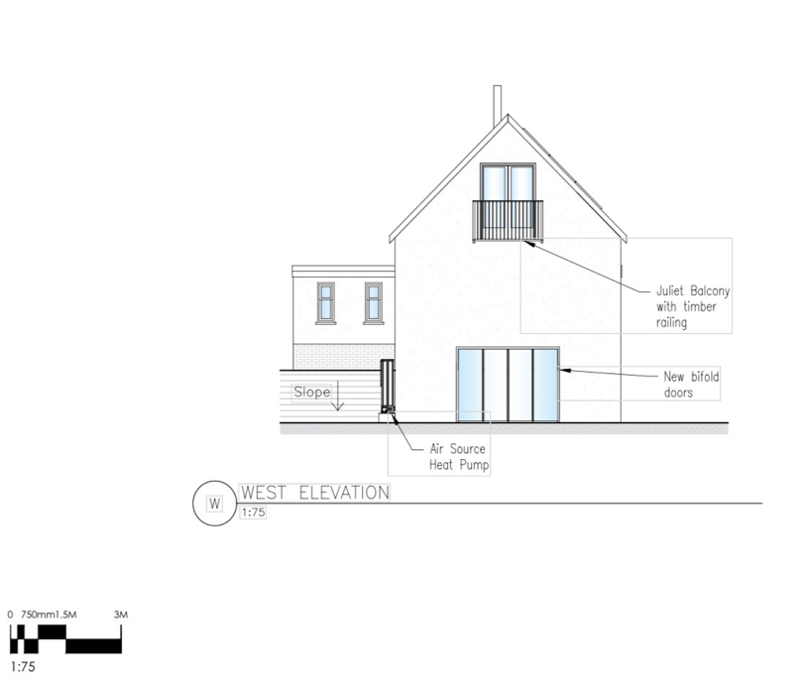
Installation of a Juliet balcony to the west-facing upper level, allowing for increased natural light and ventilation to the mezzanine level. This contributes to a more comfortable and usable internal environment, particularly important where internal arrangements have been adapted to suit specific living requirements.
Ref: Proposed West Elevation.

Installation of an air source heat pump to the rear (north-facing elevation), providing an efficient and reliable heating system. This ensures the dwelling can maintain a consistent internal environment, which is particularly important for day-to-day comfort and ease of living.
Ref: Proposed North/South Elevation.
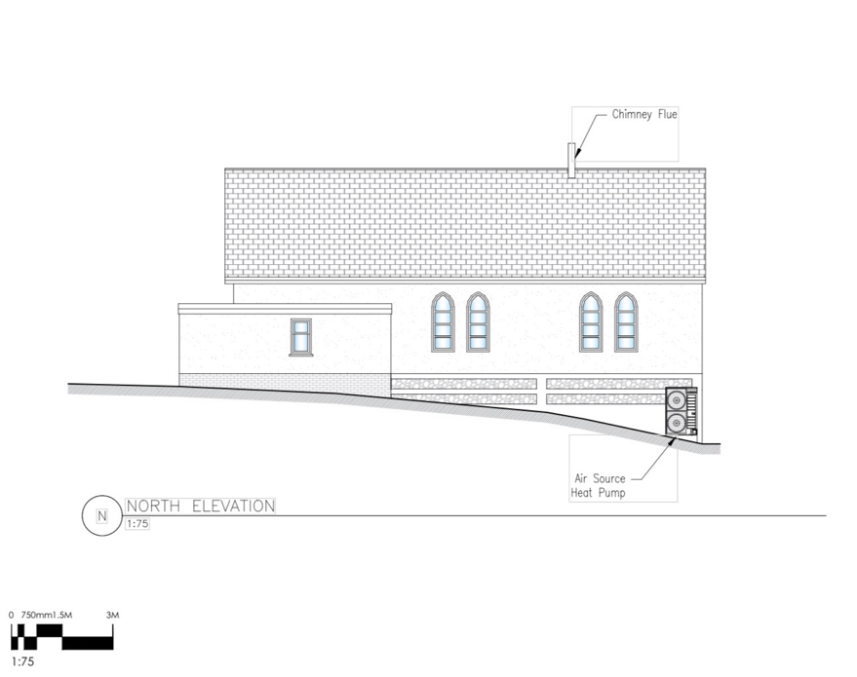

Solar panels limited to the south-facing roof slope, forming part of a wider strategy to improve energy efficiency and reduce long-term running costs of the dwelling. This supports the creation of a sustainable and manageable home environment for the occupier.
Ref: Proposed South Elevation.
Installation of x1 7.4kW smart EV charging station to the South-facing elevation situated on the flat roof extension section of the building.
Ref: Proposed South Elevation
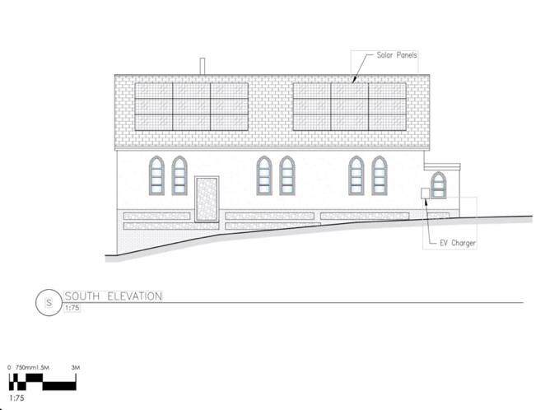
The removal of the side exit door situated on the south-facing elevation to reduce heat loss from the existing structure and to conform to building and fire regulations, alternative access to and from the rear of the building will be incorporated into the main hall/ under Croft area. The removal of this door and the overall render/flint construction will be maintained.
Ref: Proposed South Elevation

Replacement of selected front (east-facing) PVC entrance doors with timber-framed doors, improving the quality, accessibility and usability of the main entrance. The proposal retains the character of the existing chapel over the current PVC doors while providing a more practical and welcoming point of access suited to residential use.
Ref: Proposed East Elevation
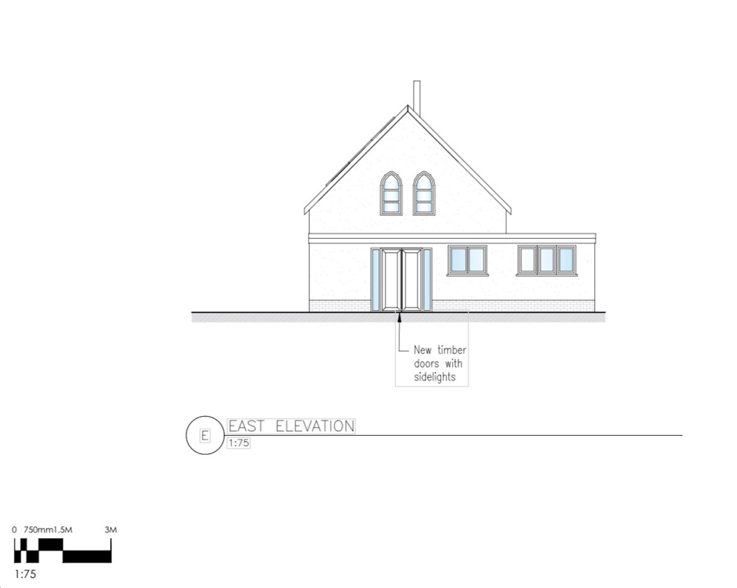

“The external alterations have been carefully considered to support the internal reconfiguration of the building, ensuring it can function as a practical and accessible home for the intended occupier.”

Solar panels & Air Sourced Heat Pump (ASHP)
The proposal includes the installation of solar photovoltaic (PV) panels as part of a wider strategy to enhance the environmental performance and long-term sustainability of the building. While the site is located within a designated Conservation Area, the building itself is not listed, and therefore the assessment focuses on preserving the character and appearance of the area rather than the protection of a designated heritage asset.
The solar panels are proposed to be positioned on the least visually prominent south roof slope that is not readily visible from public vantage points. This siting has been deliberately selected to minimise their presence within the wider streetscape and to ensure that key views of the building, which contribute to the character of the Conservation Area, remain unaffected.
In terms of design, the panels would be low profile and flush mounted to the existing roof covering. This approach avoids any raised or bulky installations and ensures that the panels sit discreetly within the roof plane. The panels would be of a simple, uniform appearance with a dark, non reflective finish, reducing glare and visual prominence. Framing and associated equipment would be minimal where possible to further reduce visibility.
No alteration to the overall form, scale, or structure of the roof is required to accommodate the panels. The installation would not result in the loss of any significant architectural features or materials that contribute to the building’s character. The works are therefore considered to be minor and reversible in nature.
Given their siting, scale, and design, the solar panels would not be visually intrusive and would not detract from the character, appearance, or significance of the Conservation Area. The proposal has been carefully developed to ensure that the introduction of modern renewable technology is achieved in a sensitive and proportionate manner.
Furthermore, the inclusion of solar panels and an ASHP aligns with national and local planning policy objectives which support the transition to low-carbon energy and encourage the sustainable reuse of existing buildings. Improving the energy efficiency of older buildings is an important component of ensuring their viable long-term use, particularly where a change of use is proposed.
In this case, the introduction of solar panels and an Air Source Heat Pump System would contribute positively to the building’s ongoing use as a dwelling, reducing energy demand and supporting environmental sustainability, without causing harm to the heritage significance of the Conservation Area.
Overall, the proposal represents a balanced approach that preserves the character and appearance of the Conservation Area while incorporating appropriate and sensitively designed sustainable technology.
No significant changes are proposed to the principal (front) elevation, and the building’s overall form, roofline, and proportions remain unchanged.
The previously constructed 2005 rear extension with a flat roof is retained as existing. No further external additions or extensions are proposed.
As a result, the visual impact of the development is minimal, and the building will continue to sit comfortably within its setting.

Internal Alterations
Internal works are required to enable the lawful and practical residential conversion of the former chapel into a dwelling that is suitable for the occupiers day-to-day needs, including all disability-related requirements. The proposed layout has therefore been developed not simply for convenience, but to create a safe, functional and accessible living environment that can properly support the occupiers long-term occupation of the building.
The proposed internal alterations include:
- the introduction of mezzanine accommodation at the front (east-facing) and rear (west-facing), designed to sit within the existing building volume;
- the removal of the partition between the two existing WCs to create a single family bathroom that is more practical, usable and capable of providing improved accessibility on a single level.
- the opening up, integration and upgrading of the existing rear undercroft/croft space so it can form part of the main residential accommodation;
- the installation of a central chimney feature, which will serve both a functional purpose and provide structural support for the rear west-facing mezzanine level; and
- the removal of sections of the internal ceiling to create a more open arrangement within the main hall and make better use of the building’s existing height and volume.
These works are necessary to adapt the interior of the building into a form that can reasonably accommodate the occupiers needs and provide a more accessible standard of residential living. The proposals have been designed around the constraints of the existing structure and seek to make the building fit for modern occupation while retaining the character of the main internal space.
All of these changes are contained within the existing envelope of the building and do not in themselves result in harmful external impact.
The mezzanine has been designed to sit comfortably within the existing volume, utilising the available ceiling height without requiring alterations to the roof structure. It remains subservient to the overall space and does not result in overdevelopment of the interior.
The central chimney structure is both functional and architectural in nature. It reflects traditional building elements and introduces a focal point within the space without detracting from the overall character.
The upgrading of the under-croft area currently only accessible from the rear west facing restricted hight doors, (which may not currently meet modern Building Regulations) is necessary to ensure the building can function as a safe and habitable dwelling.
The proposed Juliet balcony is modest in scale and does not include an external platform. It is positioned on the rear (west-facing) elevation, where it will have limited visibility within the wider streetscape.
The alterations are considered to be subordinate and proportionate, and do not alter the overall form, scale, or architectural simplicity of the building.
Importantly, no significant changes are proposed to the principal elevation, ensuring that the most publicly visible aspects of the building remain unaffected.
The existing 2005 East/North facing extension with a flat roof is retained as built, and no further extensions are proposed.

Impact on Neighbouring Amenity
The proposed rear west-facing openings, including the Juliet balcony, have been considered in relation to neighbouring properties.
The site has a limited number of immediately adjoining neighbours, and the orientation and separation distances ensure that there will be no material overlooking or loss of privacy.
Furthermore, the adjacent neighbour has confirmed their support for the proposal, including the change of use of the building to a residential dwelling. This indicates that the development is considered acceptable at a local level but did state concerns over the implementation of any roof windows to the North-facing elevation to which we agree will not be considered.

Access Statement
Access to the site is taken from the existing frontage on the east-facing elevation. This access point will be retained as part of the proposed development, with improvements made through the installation of a new timber gate set within the boundary treatment. The access arrangement will remain in its current position and continue to serve both vehicular and pedestrian movement to and from the site.
Vehicular access will be unchanged from the existing arrangement, with vehicles entering and exiting via the established frontage access. Adequate space is available within the site to accommodate parking associated with the residential use. The proposal does not introduce any intensification of use that would materially alter the existing access requirements.
Pedestrian access to the dwelling will be clearly defined via the front (east-facing) entrance. The proposed replacement of the existing front doors with a more appropriate timber double door arrangement, including sidelights, will improve both the functionality and legibility of the entrance, providing a more suitable point of access in keeping with the building’s character.
Internally, the building will be arranged to provide practical and functional circulation. The principal accommodation will be located at ground floor level, with additional accommodation provided at mezzanine level. Circulation between levels will be achieved via an internal staircase. The layout has been designed to make efficient use of the existing structure while maintaining a clear and logical flow through the building.
In terms of accessibility, the proposal relates to the conversion of an existing building, and as such, the opportunities to fully meet modern accessibility standards are influenced by the constraints of the existing structure. Notwithstanding this, the arrangement provides level access at ground floor where practicable, and the primary living spaces are located at ground level, ensuring the dwelling remains functional and accessible for day-to-day use.
Overall, the proposal retains and enhances the existing access arrangements, providing a safe, practical, and appropriate level of access for a single residential dwelling without introducing any adverse impacts.

Heritage Considerations

The building is considered to be a non-designated heritage asset, contributing positively to the character and appearance of the area through its former use as a Baptist chapel and its simple vernacular form. The building’s modest scale, traditional proportions, pitched roof, and features such as arched window openings contribute to its local significance and its role within the streetscape.
Although not statutorily listed, the building holds local heritage value as a recognisable and established feature within the village, reflecting historic patterns of community use and development.
In accordance with the National Planning Policy Framework (NPPF), the impact of the proposed development on the significance of the heritage asset has been carefully assessed, with regard to both the fabric of the building and its wider setting.
The proposed development will result in less than substantial harm, and in several respects will enhance the building, for the following reasons:
- The overall form, massing, and scale of the building will be preserved, with no extensions or alterations that would disrupt its established proportions
- The existing roof structure and natural slate covering will be retained, maintaining the building’s traditional appearance
- Key architectural features, including arched window openings and the simple chapel form, will remain unaltered
- Existing unsympathetic modern interventions, including uPVC doors and poorly proportioned openings, will be removed and replaced with high-quality timber alternatives more in keeping with the character of the building
- The insertion of a mezzanine level is entirely internal and will not impact on the external appearance or heritage significance of the asset
- The proposed solar photovoltaic panels will be located on the south-facing roof slope and installed flush with the roof covering, using a low-profile, non-reflective finish to minimise visual impact within the wider setting
- Boundary treatments will be rationalised and improved using traditional timber materials, enhancing the setting of the building
The proposal has been designed to respect the existing character of the building, with materials and detailing selected to complement the original fabric and to ensure a cohesive and sympathetic appearance.
Any limited harm arising from the proposed works is clearly outweighed by the public benefits, in line with the NPPF. These benefits include:
- Securing the long-term viable use of the building through conversion to a single dwelling
- Preventing further deterioration and potential loss of historic fabric associated with vacancy
- Enhancing the overall appearance of the building through the removal of unsympathetic features
- Retaining and reinforcing the building’s contribution to the character of the area

Overall, the proposal represents a sensitive and appropriate approach to the reuse of a non-designated heritage asset, preserving its significance while ensuring its continued use and long-term conservation.

Summary
The proposal represents a sensitive and well-considered design response, which:
- Retains the essential character of the building
- Limits external change
- Introduces necessary internal adaptations in a controlled manner
Overall, the development preserves the character and appearance of the building and is fully acceptable in design and heritage terms.
Additionally, Our plans improve the environmental performance of the building through the introduction of energy efficient systems, including solar panels, an air source heat pump and insulating the building to current standards, reducing reliance on fossil fuels and supporting long term sustainability.

