APPLICATION FOR FULL PLANNING PERMISSION
DELEGATED REPORT
APPLICATION REFERENCE: | PL/2025/08409
APPLICATION TYPE: | FULL planning permission
SITE ADDRESS: | Outmarsh Farm, Outmarsh, Semington, BA14 6JX.
DEVELOPMENT DESCRIPTION: | Retrospective application for the siting of a static caravan for temporary residential use in connection with agricultural operations for a period of three years.
RECOMMENDATION: | That Planning Permission be REFUSED

1.PROPOSAL
The proposal seeks planning permission for the retrospective siting of a static caravan within a field at Outmarsh Farm, Semington, for the temporary retention period of three years.

2.SITE DESCRIPTION/CONTEXT
The application site relates to an open field which forms a part of Outmarsh Farm, which is in the open countryside and lies to the West of Semington Road, Semington. The defined red lined site lies to the North of the existing access from the highway, with the nearby Market Town of Melksham located to the north, Berryfield village also to the north and the village of Semington located to the south. The site is 2.1 hectare in size and is outside of settlement boundary limits and is within the open countryside.

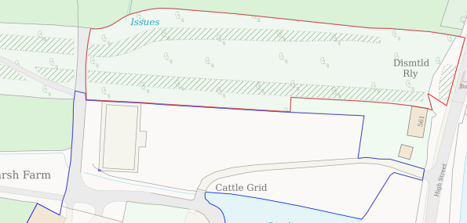
Location Plan

The site adjoins farmland with farm buildings being located to the south within a farmyard, with the static caravan being 157 metres away from the main farmhouse on site, known as Outmarsh Farmhouse, which is a grade II Listed Building. A public footpath reference MELW11 runs through the site via the main entranceway, as shown in the plan and aerial photograph extracts below:

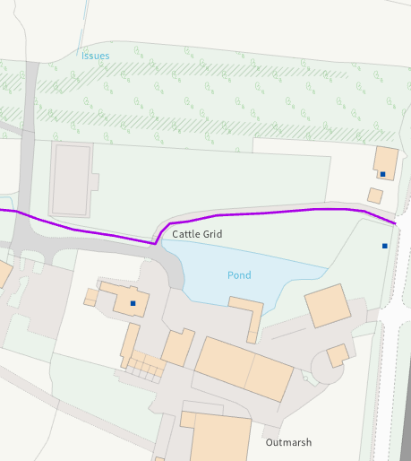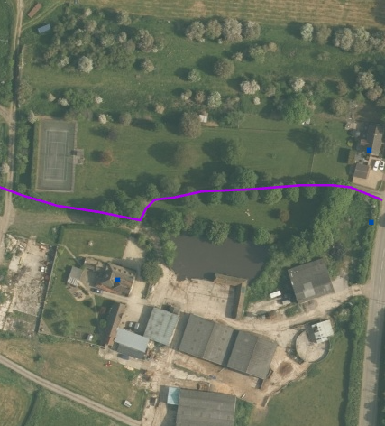
PRoW Insert Aerial

The immediate area is rural with development having taken place to the northeast at Hampton Park.

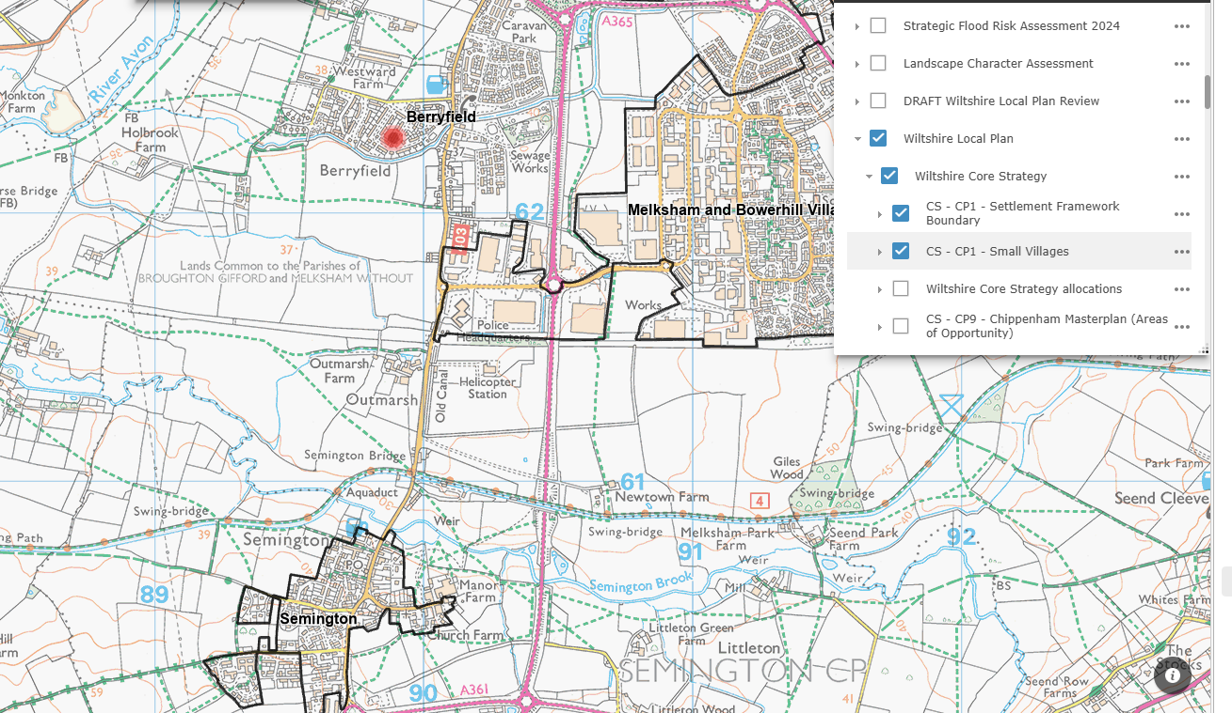
Site Context with Settlements

3. RELEVANT PLANNING HISTORY
Proposal / Summary
None of relevance

4. RELEVANT POLICIES AND GUIDANCE

Wiltshire Core Strategy:
- Core Policy 48 Supporting Rural Life
- Core Policy 57 Ensuring High Quality Design and Place Shaping
- Core Policy 58 Ensuring conservation of the historic environment.
- Core Policy 50: Biodiversity and Geodiversity
- Core Policy 51: Landscape
- Core Policy 58: Ensuring the Conservation of the Historic Environment
- Core Policy 61: Transport and New Development
- Core Policy 64: Demand Management

Paragraph 84 of the NPPF – Rural housing

Wiltshire Design Guide: Appendix D – Design Guidance for Householder extensions
The National Planning Policy Framework (NPPF) and Planning Practice Guidance (PPG)
National Design Guide

Emerging Wiltshire Local Plan:
The examination of the emerging Wiltshire Local Plan has been paused and the weight to be afforded to any part of the emerging plan can be no more than very limited. A decision on how to proceed will be made by the Council in May 2026.

5. CONSULTATION RESPONSES
Melksham Without Parish Council: No objections and seek clarification on the following points:
• Clarification of the 3-year time period in the application - Is this from the point of approval of the application or from time the caravan was located on the site (as this is a retrospective application)?
• Tight control/supervision to prevent residential creep
• Clarification of vehicular access/parking arrangements

Archaeology: No objections.

Highways: If the planning officer is minded recommending approval, the highways officer would request an additional plan, illustrating the point of vehicular access and car parking provision for the site.

6. REPRESENTATIONS
Neighbour notification letters were sent out, and a green site notice was displayed at the site’s location, no neighbour comments were received.

7. ASSESSMENT
Existing/Proposed Farming Practice
The case for the temporary retention of the mobile home as put forward by the applicant states that an on-site presence is required for the small holding.

The accompanying applicant’s statement describes the farming activities as the keeping of:

‘Sheep, goats, poultry, and several beehives, alongside a developing orchard producing apples and pears. The long-term aim is to establish a viable small-scale farm producing meat, eggs, honey, and orchard products for local sale.’

The application claims that the livestock and beehives require close and regular monitoring, particularly during the lambing and kidding seasons and during adverse weather. It is maintained that immediate on-site access is essential for animal welfare, security, and the effective day-to-day management of the land. The static caravan has been on site since October 2024.

The applicant has requested that the static caravan remain on site for an initial period of three years and then longer if required. A three-year business plan has been submitted which seeks to make the business grow, with the presence and utilisation of the static caravan being required for a close, hands-on presence when required, such as during lambing times. The submitted business plan is set out as follows with financial details being redacted where appropriate for this public report.

Applicant’s Three-Year Business Plan
The redacted version of the business plan is reproduced below, omitting personal financial figures:

Year 1
• Expand to 20 breeding ewes, producing around 30 lambs annually, generating approximately…
• Increase poultry operation to 60 laying hens, producing roughly 300 eggs per week, generating
around £redacted sum.
• Grow to 4 beehives for honey and wax products, producing an estimated £redacted sum
• Begin regular local sales through farm gate, small shops, and community markets.
• Establish rotational grazing to improve soil and pasture health.
Estimated Year 1 estimated annual income: £redacted sum.

Year 2
• Increase flock to 25 breeding ewes, producing around 40 lambs annually, worth approximately £ redacted sum
• Expand to 70 laying hens, producing roughly 350 eggs per week, generating around £ redacted sum.
• Maintain 5 beehives with improved yields, generating approximately £ redacted sum.
• Set up a small farm-gate stall or mobile unit for eggs, honey, and orchard produce, adding
around £ redacted sum.
• Continue investing in fencing, water systems, and equipment to support long-term growth.
Estimated Year 2 estimated annual income £redacted sum.

Year 3
• Reach 30 breeding ewes, producing around 45 lambs, with a mix of direct and liveweight sales
• Maintain 80 laying hens, producing up to 500 eggs per week, generating around £ redacted sum
• Operate 6 beehives for honey and wax production, producing approximately £ redacted sum.
• Expand orchard output with seasonal produce and value-added goods such as jams, chutneys,
and beeswax items, generating approximately £ redacted sum.
• Supply local shops and markets directly to increase margins and introduce small-scale farm
experiences such as honey tastings or farm visits, contributing around £ redacted sum.
Estimated Year 3 estimated annual income:
By the third year, the holding is expected to provide a full-time workload and generate a sustainable income, demonstrating the clear need for on-site accommodation to manage and grow the enterprise effectively.

Need for on-site residency
The applicant argues that a full-time on-site presence is essential for the proper running of the holding and especially for the following:

• Animal welfare: Lambing requires supervision around the clock, and prompt intervention can mean the difference between life and death for ewes and lambs.
• Security: Livestock, poultry, and equipment are vulnerable to theft and predation.
• Daily management: Feeding, watering, egg collection, and animal checks are required every day.
• Emergencies: Quick response is often needed for lambing complications, illness, or extreme weather Staying on-site will allow me to manage these responsibilities effectively and safeguard the welfare of the animals.

Principle of the Proposal.
Under the provisions of section 70(2) of the Town and Country Planning Act 1990 and section 38(6) of the Planning and Compulsory Purchase Act 2004, applications for planning permission must be determined in accordance with the development plan, unless material considerations indicate otherwise. The statutory development plan in respect of this application is the Wiltshire Core Strategy (WCS), adopted 20th January 2015.

The proposal site lies in the open countryside location outside of any settlement boundary to the north of the village of Semington. Paragraph 84 of the NPPF states that decisions should avoid the development of isolated homes in the countryside unless there is an essential need for a rural worker to live permanently at or near their place of work.

The Wiltshire Core Strategy and Core Policy 1 outline the settlement strategy for Wiltshire and identifies the settlements where sustainable development will take place.

This settlement Strategy identifies four tiers of settlements, namely Principal Settlements, Market Towns, Local Service Centres and Large and Small Villages. The village of Semington is classed as a Large Village. Core Policy 2 sets out the delivery strategies. The following plans show the location plan and site plan:

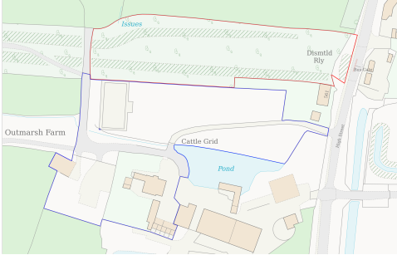
Location Plan

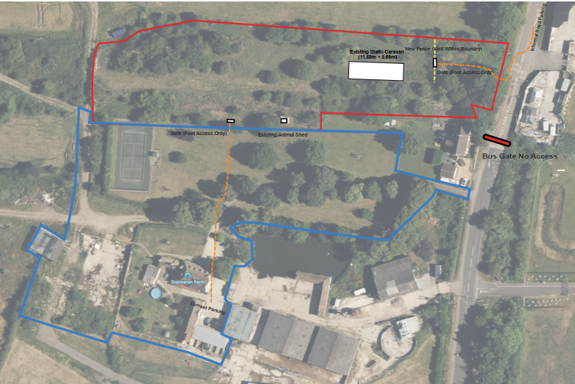
Site Plan showing the location of the caravan.

The plan details of the static caravan are set out below:

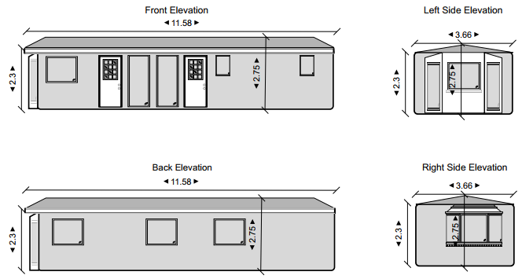
Fig. 6. Caravan Elevations.

As highlighted, the static caravan is located within an open field in the countryside, measuring 11.6 metres by 3.7 metres with a height of 3.7 metres. It is of a light colour with the site access being taken from the immediate east of the site via a gated access off the main adjacent highway.

As submitted, the application that seeks to regularise the siting if the static caravan is made on a temporary basis for three years. The photograph below shows the structure in place:

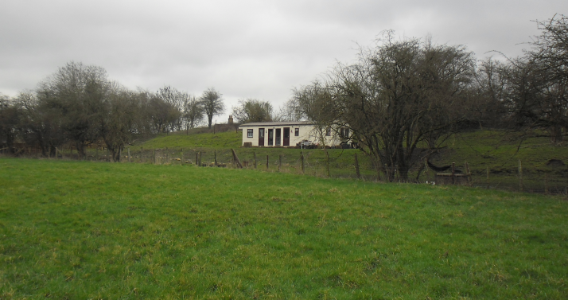
Photograph of the static caravan on site.

Paragraph 84 of the NPPF relating to rural housing is of relevance in that it states:

Planning policies and decisions should avoid the development of isolated homes in the countryside unless one or more of the following circumstances apply:
a) there is an essential need for a rural worker, including those taking majority control of a farm business, to live permanently at or near their place of work in the countryside.

As far as the adopted Wiltshire Core Strategy is concerned, CP48 is of relevance titled– Supporting Rural Life, as it relates to supporting rural life and the provision of dwellings when justified in the open countryside, the policy states:

“Outside the defined limits of development of the Principal Settlements, Market Towns, Local Service Centres and Large Villages, and outside the existing built areas of Small Villages, proposals for residential development will be supported where these meet the accommodation needs required to enable workers to live at or in the immediate vicinity of their place of work in the interests of agriculture or forestry or other employment essential to the countryside. Proposals for accommodation to meet the needs of employment essential to the countryside should be supported by functional and financial evidence”.

The above policy clearly states that there is a requirement for any new housing for agricultural purposes in the countryside to be supported by functional and financial evidence.

In this instance the application site and the applicant’s identified landholding is not considered to be remote and is instead, located in relatively close proximity to the main residential farmhouse on site, known as Outmarsh Farmhouse and nearby villages and the market town of Melksham.

The submitted passage taken from the applicant’s statement sets out the reasons why the residential use of the farmhouse is not practical:

‘The two areas are separated by internal fencing and a steep embankment, with a small gate at the bottom that cannot be used by vehicles. There is also no permission to use the nearby bus gate, meaning that to reach the fields from the farmhouse requires driving the long way around — a journey of roughly ten to fifteen minutes each way, depending on traffic and conditions.

When officers conducted their site visit the ‘bus gate’ as mentioned was observed, which prevents most non-bus vehicular movement, it was also noted that there is a main wooden gate entrance to this area, directly opposite the Semington Road, allowing access to the area of land where the static mobile home is sited.

Whilst the above statement says there is no permission to use both gates, access has been possible to allow for the transportation of the caravan onto the site. The Bus Gate area does not prevent pedestrian access.

The following snippet below shows the respective distance of 157 metres from the extant farmhouse to the unauthorised caravan.

It is noted within the other provided site plan, an orange dotted line is shown indicating a direct pedestrian access from the main farmhouse to the red lined area.

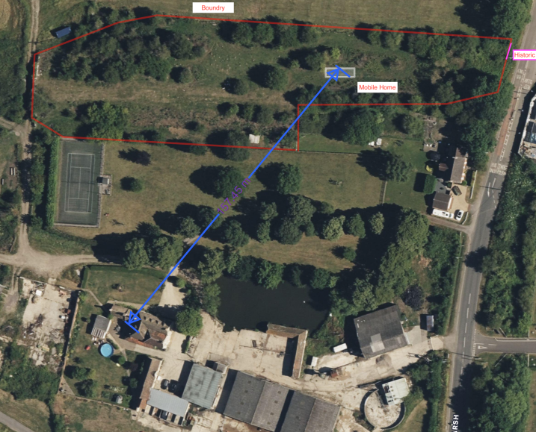
Close proximity to farmhouse to the south

The distance shown is 157 metres from the main farmhouse to the static caravan, which could reasonable be reached on foot.

The second limb of the CP48 policy criteria for the retention of the mobile home is the submission of financial information of the farming business. This information is crucial in the assessment of the functional and financial viability of the farming business, and the provision of financial evidence for the agricultural business and in turn justification for the need to have the mobile home on site. This information has been provided, and the Council has employed an independent agricultural consultant to appraise the submitted information.

The Council’s Commissioned Agricultural Consultant’s Findings.
As set out in the applicant’s statement, the agricultural business is owned by Mr. Robert Vaughan, and his son Mr. Oscar Vaughan would run the business and reside within the caravan and implement the 3-year business plan.

The caravan is currently unoccupied, as Mr. Oscar Vaughan is currently employed away from Outmarsh Farm.

The agricultural consultant’s findings are set out below.

6.0 NPPF – ESSENTIAL REQUIREMENT

6.1 The planning application for the retention of the dwelling is associated with the proposed business. The National Planning Policy Framework (NPPF) was revised in 2024. In the context of the application for the proposed dwelling, paragraph 84 of the NPPF states:

“Planning policies and decisions should avoid the development of isolated homes in the countryside unless one or more of the following circumstances apply.
a) there is an essential need for a rural worker to live permanently at or near their place of work in
the countryside.”

6.2 Under the NPPF it is therefore relevant to consider the requirements of the proposed enterprises and whether those requirements present an essential need for a worker to live at or near the enterprises.

6.3 In my view there will be a requirement for close care and assistance to livestock during lambing. The Plan does not specify a lambing period, but the typical lambing period is not extensive, covering a few weeks in spring. Lambing and the neo-natal lamb can require close supervision, however in this context the number of ewes is very low, with a maximum of 30 head by year three. In my view the associated essential need could only be considered partial.

6.4 In my view the remaining enterprises do not present an essential need for livestock husbandry. Clearly, they will require inspection and management, but those aspects do not equate to an essential need for a presence on the site at most times.

7.5.3 The above appraisal does not agree that there is a need for there to be an essential presence on site. Regarding the applicant’s proposed 3-year business plan, the council’s agricultural consultant states the following:

7.0 BUSINESS ASSESSMENT

7.1 There is no express reference in the NPPF to an assessment of either an existing or proposed business which will operate in association with the proposed rural dwelling. It is my opinion that such an assessment is critical to forming an opinion on the continuation of the “essential need”. In this case the essential need described and recognised above will only continue through the operation of the business. If the business does not operate on a profitable and viable basis then it will fail and the authority would be left with a dwelling but no “essential need” for its presence.

7.2 Following the Government’s update to Planning Practice Guidance (PPG), published in July 2019, financial viability is now referenced as a consideration when determining the need for a rural worker’s dwelling.

7.3 The applicant has submitted the Plan. In my experience a business plan for a new agricultural business would typically set out:

• Gross Margins for the proposed enterprises including anticipated outputs and variable costs
on a unit basis for each of the proposed enterprises.
• Proposed fixed costs including electricity, water, property costs, finance costs and any
employed labour.
• Projected profit and loss accounts for the three-year period.
• A summary cashflow for the three-year period.
• Budget capital costs and a Balance Sheet for the project.

7.4 The Plan provided sets out in summary the development of the enterprises. There are estimated levels of revenue from the enterprises together with receipts showing previous sales. There are no other budgetary financial information or projections, for example:
• There are no enterprise budgets (gross margins) setting out variable costs.
• There is no indication of fixed costs.

• There are no budget profit and loss accounts.
• There is no cashflow.
• There is no indication of capital requirements.

7.5 In addition to the above there is no indication of demand from local shops and there is no indication of which local markets will be targeted. Whilst there is reference to farmgate sales it is noted that the public highway adjoining the application site is effectively a no through road due to the Bus Gate which lies outside the entrance to the site.

7.6 Overall it is my view that the business has not been planned on a sound basis.

The consultant has found financial planning shortfalls as discussed above in paragraphs 7.3, 7.4 and 7.5 and has concluded that there is not an essential requirement for there to be a presence on site at most times, the council does not have any reasons to disagree.

The Council’s agricultural consultant concludes that the applicant’s proposal does not present an essential agricultural need for an agricultural worker to reside at the site, and moreover, the business plan does not appear to be planned on a sound financial basis.

“The proposed business does not present an essential need for a presence at most times and does not present a requirement for a full-time labour unit (excluding marketing). The Plan does not demonstrate that the business has been planned on a sound financial basis”.

To avoid unwarranted housing in the countryside, WCS CP48 states that

‘Proposals for residential development will be supported where these meet the accommodation needs required to enable workers to live at or in the immediate vicinity of their place of work in the interests of agriculture or forestry or other employment essential to the countryside. Proposals for accommodation to meet the needs of employment essential to the countryside should be supported by functional and financial evidence’.

From the above agricultural appraisal, the application and proposed business requirements fail to satisfy national and local planning requirements for housing when tested against essential agricultural needs. Therefore, the retention of the caravan is not supported, even on a temporary basis.

5 Year Housing Land Supply.

The Wiltshire Housing Land Supply Statement (published on June 2025 with an April 2024 baseline) confirms that the Council is unable to demonstrate a five-year supply of deliverable housing land, which is a material consideration in the determination of planning applications.

The December 2024 National Planning Policy Framework reimposed the requirement for Councils to be tested against a 5-year housing land supply requirement and ended the interim 4-year test arrangements that Wiltshire Council previously benefitted from. The December 2024 NPPF iteration requires Wiltshire Council to demonstrate five years’ worth of deliverable sites along with a 5% buffer.

The Government also changed the methodology for calculating local housing need, which in Wiltshire Council’s case, resulted in a substantial increase in the five-year housing requirement to be met from the previous calculation. The resulting position shows that the Council can currently demonstrate a 2.42 years housing land supply of housing at a unitary authority level. This is considered to be a substantial shortfall.

The absence of a five-year housing land supply is a material consideration in the determination of this application. In accordance with Paragraphs 78 and 11(d) of the National Planning Policy Framework (NPPF), for applications involving the provision of housing, where there is a shortfall in the supply of deliverable housing sites, the most important policies for determining the application should be considered out of date.

The current housing land supply shortfall is a factor that must be considered in the planning balance and in this case, as a five-year housing land supply cannot be demonstrated, the weight that can be applied to the most important policies for determining this application should be assessed and altered in the light of the shortage in housing land supply.

The proposal must be assessed against the national policy context of the need to boost housing supply and the benefits of delivering new homes whilst having particular regard to the key policies set out in paragraph 11(d)(ii) and the associated/linked footnotes.

Heritage Impacts

From the point of view of the historic environment the main statutory tests are set out within the Planning (Listed Building and Conservation Areas) Act 1990.

Section 66 requires that special regard be given to the desirability of preserving listed buildings, their settings or any features of special architectural or historic interest which they possess.

Section 72(1) of the Act requires the Council to pay special attention to the desirability of preserving or enhancing the character or appearance of designated Conservation Areas.

The Council’s Core Strategy Policy CP58 titled ‘Ensuring the conservation of the historic environment’ requires that designated and non-designated heritage assets and their settings will be conserved, and where appropriate enhanced, in a manner appropriate to their significance and encourages proposals which improve the condition of heritage assets at risk.

Outmarsh Farmhouse is a Grade II listed building and is at the opposite end of the site, located 157 metres away from the caravan, this distance is intersected with mature trees and vegetation with uneven land levels, preventing any direct views. The caravan is not highly visible from the listed farmhouse, and the separation distance is sufficient for there to be no harmful impact on its setting, character or significance. The site is not in a Conservation Area.

Landscape, Design, Visual Impact upon the upon the surrounding character and context of the area.

WCS Core Policy 57 titled ‘Ensuring High Quality Design and Place Shaping of the Wiltshire Core Strategy seeks to ensure that all new development is of high design quality, reflecting local context, character, and distinctiveness.

Likewise, Core Policy 51 requires that development should protect, conserve and where possible enhance landscape character and must not have a harmful impact upon landscape character.

Further consideration is the Wiltshire Design Guide SPD (2024) which promotes a context-led approach, encouraging integration with natural features and settlement patterns while avoiding visual intrusion.

The caravan is not highly visible from the PRoW and is of a modest size and height.
The harmful impact of the caravan would be exacerbated by the inevitable introduction of associated paraphernalia, such as washing lines, barbeques, tables and chairs that are often associated with the use of a residential dwelling. It was noted by the case officer at the time of the site inspection that there were already tables and chairs near to the caravan.

The applicant claims that the caravan is required for animal welfare as well as for security reasons with machinery having previously been stolen. From the submissions made and having considered the Council’s agricultural advisor’s consultation response, the applicant’s justification is not supported by officers. The agricultural justification does not justify a farm worker to be resident on site for the outline/projected business and occupation of the nearby farmhouse or within the nearby settlements could support the agricultural operations as set out.

Amenity

WCS Core Policy 57 (Point vii) requires development to respect the amenity of existing occupants and ensure appropriate amenity levels for future residents.

The National Planning Policy Framework (NPPF), particularly Paragraph 135, reinforces the need for development to provide a high standard of amenity for both existing and future users.

These policies guide the assessment of amenity impacts, such that the caravan accommodation would satisfy the amenity requirements of the proposed occupiers in terms of amenity such as adequate amenity space and bedroom sizes.

The static caravan is also located a sufficient distance away from any neighbouring properties (approximately 48 metres to the southeast) so as not to result in an adverse impact in terms of overlooking, overshadowing, overbearing.

Ecology.
WCS CP50 requires no net loss of biodiversity on site. The site is not located within any of the bat zones of the area and falls outside of the Bath and Bradford on Avon Bat SAC and is not within the Trowbridge Westbury Bat Mitigation Strategy Area (TWBMS).

Highways.
The highways officer was consulted for this application and asked for further information pursuant to site access and car parking provisions if the application is to be recommended for approval. As the application is not being supported for the reasons set out above, requesting additional information from the application and exposing them to additional expense, was considered unreasonable.

Other Matters.
It is noted that the red line the applicant has used to define the site extent which includes the sited caravan is extensive and includes the whole field and is not considered to appropriately define a proportionate residential curtilage around the caravan.

PLANNING BALANCE AND CONCLUSION
At the heart of the NPPF there is a presumption in favour of sustainable development requiring local planning authorities to approve development proposals that accord with an up-to-date development plan without delay; and where there are no relevant development plan policies, or the policies which are most important for determining the application are out-of-date, permission should be granted unless (taken from paragraph 11d of the NPPF):

- The application of policies in the NPPF that protect areas or assets of particular importance provides a clear reason for refusing development proposed; or
- any adverse impacts of doing so would significantly and demonstrably outweigh the benefits, when assessed against the policies in the NPPF taken as a whole.

Having regard to NPPF paragraph 11, the Council accepts the adopted Wiltshire Core Strategy is out of date by virtue of the Council not being able to demonstrate a 5-year housing land supply and consequently, para 11d is engaged.

Pursuant to the above, the NPPF states that

“For decision-taking this means:
c) approving development proposals that accord with an up-to-date development plan without delay; or
d) where there are no relevant development plan policies, or the policies which are most important for determining the application are out-of-date, granting permission unless:
i. the application of policies in this Framework that protect areas or assets of particular importance provides a strong reason for refusing the development proposed; or
ii. any adverse impacts of doing so would significantly and demonstrably outweigh the benefits, when assessed against the policies in this Framework taken as a whole, having particular regard to key policies for directing development to sustainable locations, making effective use of land, securing well-designed places and providing affordable homes, individually or in combination”

In this particular case, the Council is not satisfied there is a justified essential need for a farm worker to reside on site and the caravan that is located at the application site is not considered to be a suitable sustainable form of development. As set out above, the application is not supported by a robust agriculture business plan that points to the proposal being functionally or financially viable. In addition, the Council is not satisfied that the agricultural operations could not be managed from either a residence located within one of the settlements located near to the site (i.e. Berryfield, Semington or Melksham) or from the nearby occupation of the Outmarsh Farmhouse shown below which is contained within the applicant’s blue coloured landholding.

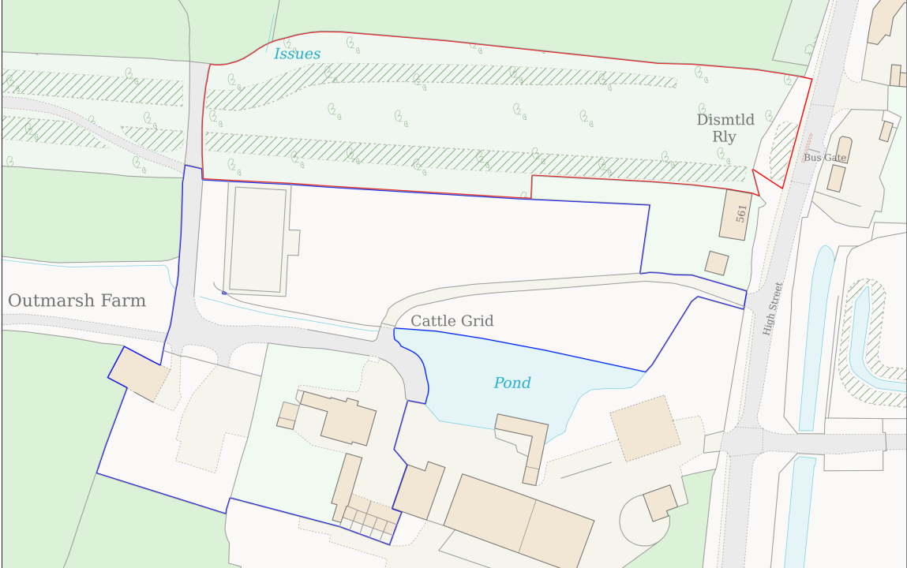

The benefits of allowing the occupation of the caravan when an essential test is not satisfied would run counter to established good planning practice and the delivery of sustainable forms of development. The occupation of the caravan would not make a significant impact on the Council’s housing land supply and whilst some weight should be afforded to the delivery of one temporary dwelling as part of the planning balance, the harm created by allowing an unjustified, unsustainable form of development as well as the intrusion within the countryside and associated residential paraphernalia at the site, outweighs any benefits.

RECOMMENDATION:
Planning Permission be REFUSED.

The application site is located within open countryside outside any defined settlement boundary as set out in the adopted Wiltshire Core Strategy 2015 where new residential development is strictly controlled. The applicant has failed to satisfactorily demonstrate that there is an essential functional and financial need for a full-time worker to reside on the site to support the submitted enterprise, as required by national and local planning policy.

Furthermore, insufficient justification has been provided to demonstrate why the farming business could not be suitably managed and operated from the existing nearby dwelling at Outmarsh Farmhouse, which is located nearby and within blue coloured land owned by the applicant so as to provide any animal husbandry or site security needs for the identified landholding. In the absence of clear evidence of exceptional circumstances to justify a new dwelling in the countryside, the siting of a static caravan for residential occupation represents inappropriate development which conflicts with Core Policies CP1, CP2 and CP48 of the Wiltshire Core Strategy 2015 and NPPF paragraphs 8, 11 and 84.

The siting of the static caravan, together with associated domestic paraphernalia including outdoor seating and tables, introduces a visually intrusive form of development within the open countryside with an unacceptable domestication and encroachment in the rural landscape contrary to Core Policies CP51 and CP57 of the adopted Wiltshire Core Strategy.

The defined red lined application site extent is also considered excessive and disproportionate in terms of establishing a reasonable curtilage associated to the static caravan.

Informative Notes:

- The plans and documents that have been considered by the Council pursuant to this application are as follows:

Site Identification Plan
Location Plan
Caravan Elevations – Dwg 00001 Rev C
Caravan Floor Plan – Dwg 00002 A
Site Plan Rev E
The Applicants Supporting Justification Statement

- In recognising the unauthorised status of the proposal, the Council’s Planning Enforcement team will be informed of the refusal decision and be invited to begin formal enforcement proceedings.

