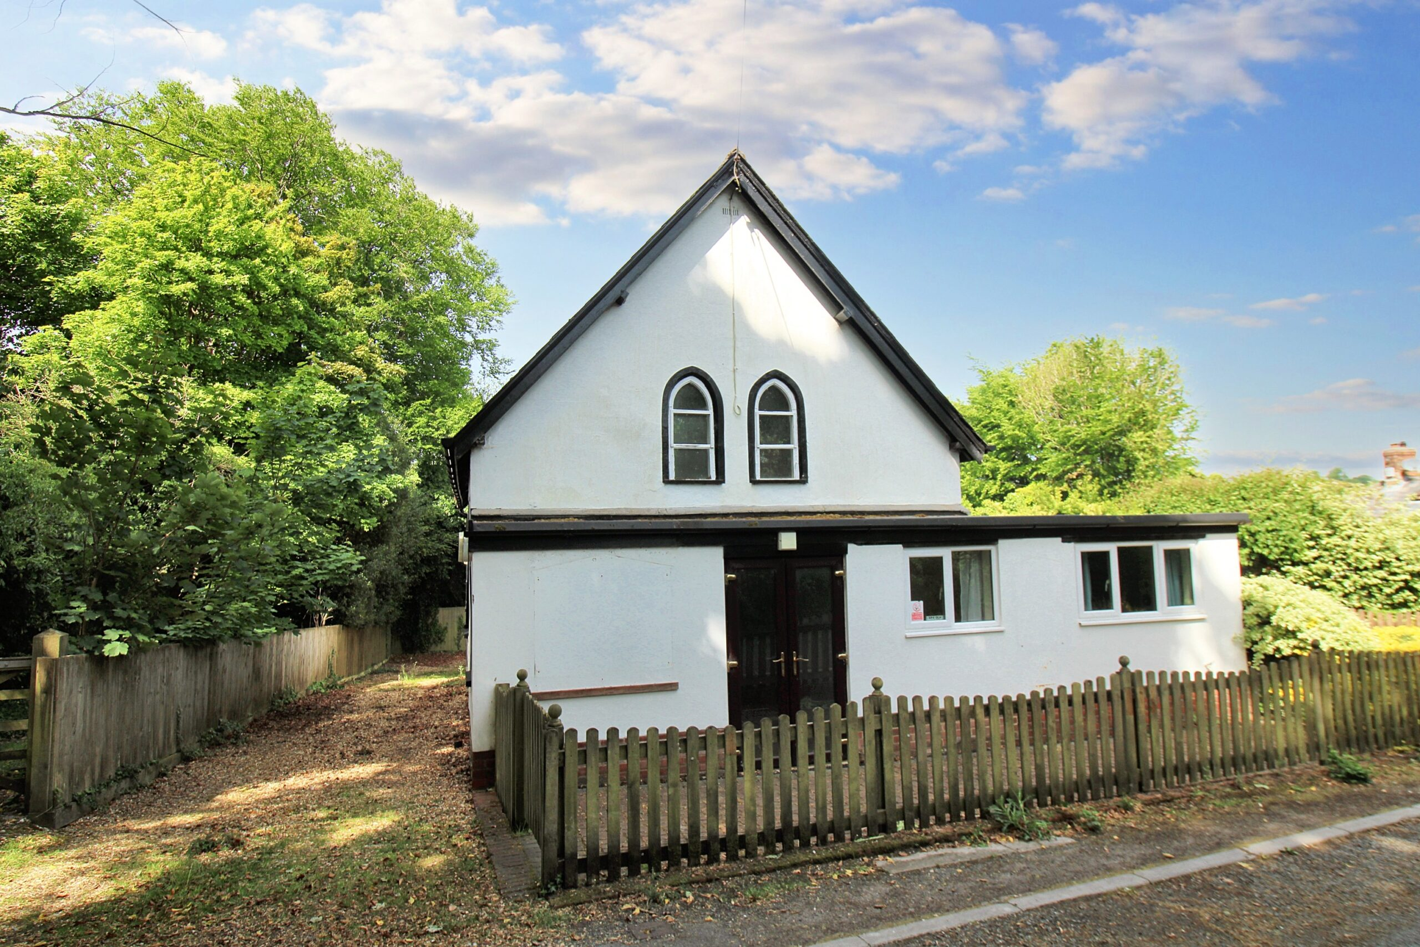  Planning statement  Former Baptist chapel, High street, Porton, Wiltshire, SP4 0LH | Abstract  Porton Baptist Chapel is a small, previously used place of worship located within the residential area of Porton. The building is no longer required for its former Class F1 use. This Planning Statement accompanies an application for a change of use to Class C3 (Residential), with the intention of bringing the building back into viable and appropriate use.
April 2026
Table of contents

1.1 Introduction.................................................................................................................2
1.2 Site Description......................................................................................................…2/3
1.3 Planning History........................................................................................................3/4
1.4 The Proposal.....................................................................................................…. 4/5/6

1.5 Planning Considerations.................................................................................................7
1.5.1 Development Plan....................................................................................................7
1.5.2 Presumption in Favour of Sustainable Development……………………………….7/8
1.5.3 Reuse of existing building.......................................................................................8
1.5.4 Scale and impact of development...........................................................................8
1.5.5 Redundancy of existing use....................................................................................8
1.5.6 Lack of demand for alternate community use........................................................8/9
1.5.7 Viability and ongoing use.......................................................................................10
1.5.8 Marketing and evidence.........................................................................................10
1.5.9 Planning balance..........................................................................................… 10/11
1.6 Principle of Development.....................................................................................11/12
1.7 Loss of Community Facility..................................................................................… 12
1.7.1 Assesment of Existing Use.............................................................................12
1.7.2 Alternate community Use................................................................................12
1.7.3 Availability of Existing Provisions ...................................................................13
1.7.4 Availability of alternate Religious Facility........................................................13
1.7.5 Neighbour and local Context……………………………………………………..14
1.7.6 Conclusion on Community Facility……………………………………………….14

1.8 Conservation area..............................................................................................… 14/15
1.9 Landscape Impact..............................................................................................… 15
2.0 Highways and Parking......................................................................................….. 16
2.1 Ecology....................................................................................................................17
2.2 Flood risk and drainage.................................................................................……. 18/19
2.3 Biodiversity Net Gain (BNG) Statement……………………………………………….20
2.4 Conclusion...............................................................................................................21/22/23

Introduction

1.1 This statement has been prepared in support of a full planning application for the change of use of a former Baptist chapel (Use Class F1) to a single residential dwelling (Use Class C3).
The proposal includes internal alterations, the introduction of a mezzanine level and limited external modifications. Including repairs required to facilitate a higher quality residential conversion.
The application seeks to secure a viable and sustainable future for a currently vacant building within the village.

Site Description

1.2 The application site comprises a former Baptist chapel located within the village of Porton, Wiltshire. The site sits on the edge of an established rural settlement characterised by a mix of residential properties, agricultural land and community buildings.

The chapel occupies a modest plot and is set back slightly from the road with an established relationship to the surrounding built form. The immediate context is low density and residential in character; with limited adjacent development.

The building itself is of traditional construction and subtle vernacular design, including:

- A rectangular footprint
- Round headed arched windows
- Slate tiled pitched roof form
- White painted render over masonry with a flint block plinth at the bottom
- Modest scale consistent with its original function
- Limited external ornamentation

Internally the building benefits from significant ceiling height within the main hall which will allow for the introduction of a mezzanine level without alteration to the current roof structure.

To the rear of the building is an existing sunken stage/under croft area currently accessed externally, this is not clearly reflected in historic plans but forms part of the existing structure. This area is currently underutilised and presents an opportunity for integration into the proposed residential layout. I suspect was the original chapel lay out, the ceiling height is approximately 5ft7 and from the best of my knowledge (from the neighbours and local community) was added under after the stage was created, it makes access difficult and is an unpractical and a potentially dangerous layout.
It is also noted that this under croft space in its current form may not fully comply with current Building Regulations. In respect of factors such as head height, insulation, damp protection and means of access. As such, modifications will be required as part of the development to ensure the space is brought up to an appropriate standard for residential use.

The site includes limited external amenity space, with defined boundaries and a clear curtilage associated with the building.
The surrounding area is quiet in nature with minimal traffic generation and no significant commercial activity in the immediate vicinity.

Importantly the site is not considered to occupy a prominent or sensitive landscape position and the building does not form part of a tightly controlled or highly formal streetscape.

The building is currently vacant and shows signs of underuse reinforcing the need for a viable long-term use.
Overall the site represents a contained and well-defined plot within an established settlement. A single residential dwelling would sit comfortably within the existing context.
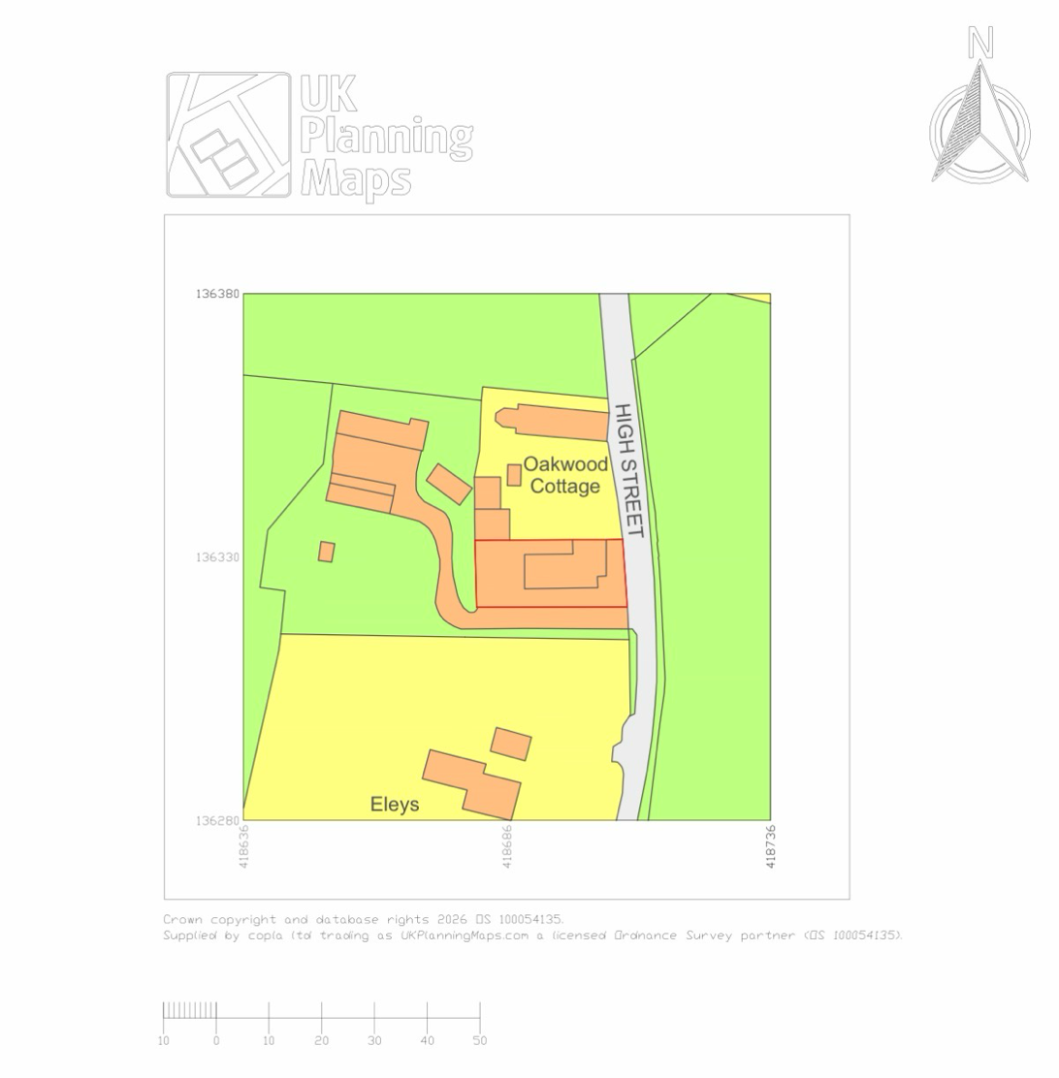

Planning History

1.3 A review of the site’s planning history indicates that the building has historically been used as a place of worship.
Planning permission was granted in or around 2005 for the construction of an extension to the front (East-Facing) of the building incorporating a flat roof element. This extension forms part of the building as it exists today. Within the flat roof extension there is a kitchen and toilet facilities.
It is noted that the introduction of the flat roof represented a departure from the building’s otherwise traditional form and was not entirely reflective of its original character during construction.
The presence of this extension demonstrates that the building has been subject to alteration and adaptation over time, although it also highlights the importance of ensuring that future changes are more sympathetic to the building’s simple and traditional appearance.
The current proposal has been developed with this in mind, seeking to retain the building’s overall form and avoid further incongruous alterations.
No recent planning permissions have been identified that alter the lawful use of the building, and it is understood to remain within Use Class F1 (place of worship).

There is no known planning history that would preclude the proposed change of use.

The proposal

1.4 The application seeks full planning permission for the change of use of the former Baptist chapel to a single residential dwelling (Use Class C3), together with associated internal alterations and limited external modifications.

The proposal has been carefully designed to work within the constraints of the existing building with all primary development contained within the current structure.

The proposal seeks to convert the building into a single residential dwelling with the following key elements:
Internal Works:
- Creation of an open plan living space within the main hall
- Installation of a mezzanine floor to provide additional accommodation
- Formation of a kitchen and bathroom within the existing footprint
- Integration of the existing rear sunken/under croft space into the main hall layout.

Internal Layout and Use
The main chapel space will be converted into an open plan living, kitchen, and dining area, retaining the sense of volume within the building that is accessible and safe for the intended occupier with disabilities.
A mezzanine level will be introduced within the main hall positioned centrally and towards the rear of the building. This will provide additional accommodation (i.e. sleeping/living space) while remaining subservient to the overall volume and avoiding full subdivision of the space.
The existing rear extension section of the building, currently comprising of two public toilet facility will be converted into a family bathroom and also a sunken under croft area situated under the stage in the main hall will be reconfigured to accommodate ancillary living space / storage.
The under-croft area will be regularised and upgraded as part of the works to ensure it is suitable for residential use with accessibility needs for the intended occupier. Ref pic A1
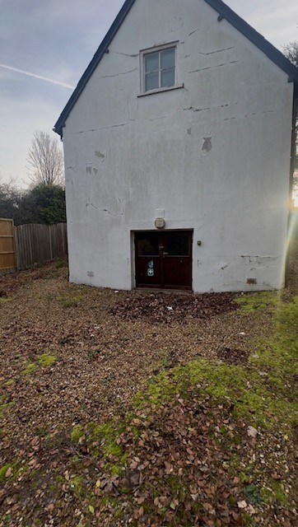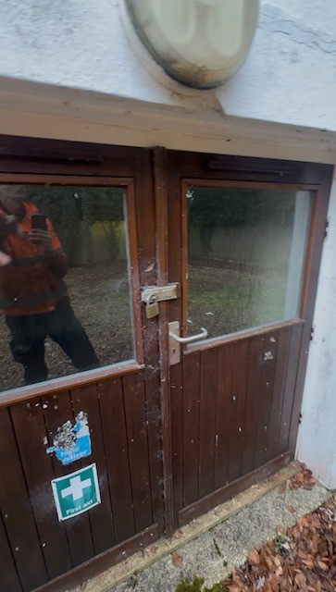 A1

Structural Works
Structural interventions will include:
- Installation of support structure for the mezzanine floor
- Localised strengthening works where required
- Construction of a central chimney structure, extending vertically through the building to roof level that will also provide structure to the rear west-facing mezzanine level

The chimney will serve a dual purpose:
- Functional (to support a heating appliance)
- Architectural (as a central feature within the space to support the rear mezzanine floor)
All structural works will be contained within the existing building envelope and will conform to building regulations.

External Alterations
External changes are intentionally limited and include:
- Replacement of selected rear west-facing doors that access the Croft area with bifold doors to provide improved access to full height. Current doors do not conform to building regulations.

- Minor adjustments to openings where necessary to support the internal layout ie removal of side door (South-facing) (does not conform to building regulations and due to the height of the door is unsafe to use). Heat loss from this opening and unnecessary to the intended use of the building and its occupier.

- Replacement of the front east-facing brown PVC doors on the flat roof extension with double oak doors with wooden frames that match the current character and design of the building so that the overall public view is kept in keeping.

- The addition of solar panels to the south-facing sloped roof which is not visible from the street view.

- The addition of an Air source heat pump system within the grounds of the property situated on the north-facing approach, totally obscured from street view.

- The installation of 1 EV charging unit positioned on the south-facing flat roof extension.

No significant alterations are proposed. The roof profile, and the overall form and scale of the building will remain unchanged.
The existing 2005 east/north facing extension will remain unaltered as part of this application.

Services and Fit Out
The development will include
- Installation of a new underfloor heating system
- Plumbing and drainage infrastructure renewal
- Electrical modernisation throughout
These works are internal in nature and will not materially affect the external appearance of the building.

Scale and Extent of Development
The proposal does not involve:

- Any extension to the building footprint
- Any increase in ridge height or overall scale
- Any significant alteration to the external character of the building
The development represents a conversion rather than redevelopment making efficient use of the existing structure.
Overall, the proposal delivers a clear, well contained residential conversion, retaining the defining characteristics of the building while introducing a viable and sustainable new use.

Planning considerations

1.5 This application has been assessed against relevant local and national planning policy, including the Wiltshire Core Strategy (2015) and the National Planning Policy Framework (NPPF).

1.5.1 Development Plan Context

The Wiltshire Core Strategy (2015) forms the primary Development Plan for the area and provides the basis for determining planning applications. Saved policies from the Salisbury District Local Plan (2011) may also be relevant.
At a national level, the NPPF sets out the Government’s planning policies and is a material consideration in decision making.

1.5.2 Presumption in Favour of Sustainable Development

Paragraph 11 of the NPPF establishes a presumption in favour of sustainable development.
The proposal represents sustainable development by:
- Reusing an existing building within an established settlement
- Avoiding the need for new build development on undeveloped land
- Securing the long-term use of a currently vacant structure

In accordance with the NPPF, proposals that accord with the Development Plan should be approved without delay.

1.5.3 Reuse of Existing Buildings

Both local and national policy support the reuse of existing buildings where:
- The building is structurally capable of conversion
- The proposed use is appropriate to its location
- The development preserves the character of the building

The proposal satisfies these criteria and represents an efficient use of an existing resource.

1.5.4 Scale and Impact of Development
The proposal is limited in scope and involves:

- No extension to the building footprint
- No increase in height or massing
- Minimal external alterations

As such, the development:
  - Respects the existing character and form of the settlement

1.5.5 Redundancy of the Existing Use

The building is no longer in active use as a chapel and has been vacant for 17 months minimum.

This reflects wider changes in patterns of worship and declining congregation numbers, which have reduced the need for smaller, standalone chapel buildings of this nature.
In addition, there are alternative places of worship within the surrounding area, which continue to meet the needs of the local community. As such, the loss of this building would not result in a deficiency of religious provision.

1.5.6 Lack of Demand for Alternative Community Use

The building is modest in scale and form, with internal constraints that limit its suitability for alternative community uses; including:
  - Limited floor area
  - Constrained layout, including the under-croft space
  - Upgrading requirements to meet modern and sustainable standards
  - Not viable for mass parking with excessive highways impact
  - Reducing the footprint of vehicle traffic in that area

These factors reduce its attractiveness and viability for reuse as a community facility.

Furthermore, the presence of existing local facilities (such as village halls and other community spaces) means that there is no clear demand for an additional venue within the immediate area.

1.5.7 Viability and Ongoing Use

In its current form the building is not considered economically viable to retain or upgrade for continued community use.
The cost of bringing the building up to modern standards, particularly in relation to structural works, insulation, and compliance with Building Regulations, would be significant and unlikely to be justified given the limited demand. The property was on the market for quite some time and without intervention, the building is likely to remain vacant and fall into further disrepair.
The retention of the building as a community facility would require substantial financial investment, including:

- Structural works
- Upgrading of the under-croft area to meet Building Regulations
- Installation of modern services and heating systems
- Ongoing maintenance and operational costs

Given the limited scale of the building and the availability of alternative facilities, such investment would not be economically justified.

In the absence of a viable use the building is likely to remain vacant and fall into further disrepair and resulting in a negative impact on the character of the area.

1.5.8 Marketing and Evidence

The building has been marketed for sale by Carter and May with scope for a Residential Development, with no interest received from relevant organisations or groups.
This demonstrates that there is no realistic prospect of the building returning to its former use or being taken on for an alternative community function.

1.5.9 Planning Balance
Whilst the loss of a community facility is acknowledged, this must be balanced against the benefits of the proposal.
The proposed development:

  - Secures the long-term future of the building
  - Prevents vacancy and deterioration
  - Introduces a low-impact residential use appropriate to the location

In this case the building can reasonably be considered redundant, and its reuse represents the most sustainable outcome

Conclusion on Community Facility
The proposal complies with the requirements of Core Policy 49, as it has been demonstrated that:

  - The existing use is no longer viable
  - There is no realistic demand for alternative community use

The loss of the facility is therefore justified, and the proposed change of use is considered acceptable in planning terms.
Principle of Development

1.6 The principle of development is assessed against the provisions of the Wiltshire Core Strategy (2015) and the National Planning Policy Framework (NPPF).

Core Policy 1 (Settlement Strategy) and Core Policy 2 (Delivery Strategy) set out the spatial approach to development within Wiltshire.

The site lies outside the defined settlement boundary and is therefore considered to be within the open countryside for the purposes of the development plan. As such, policies relating to development within Small Villages, including Core Policy 2, are not directly applicable in this instance.

Notwithstanding this, the proposal relates solely to the re-use and conversion of an existing building and does not involve any material increase in footprint, height, or overall scale. The external form of the building will remain largely unchanged, and there will be no encroachment into the surrounding countryside or consolidation or elongation of built form.

The proposal therefore represents a sustainable form of development through the effective re-use of an existing structure, in accordance with the overarching principles of Core Policy 1, which seeks to promote sustainable development. Furthermore, the development accords with Core Policy 48, which supports the re-use of redundant or disused buildings in the countryside where this would not lead to unacceptable impacts on the character of the area.

In addition, the proposal has been designed to respect the character and appearance of the surrounding area, in line with Core Policy 57. The scale, massing, and external appearance of the building will remain consistent with its existing form, ensuring that the development integrates appropriately within its context.

Given the site’s location within a Conservation Area, particular regard has been paid to preserving or enhancing its significance, in accordance with Core Policy 58. The proposal retains the existing building and avoids any harmful alterations to its external appearance, thereby conserving the heritage value of the site and its surroundings.

It is also noted that there has been a previous planning approval for a front extension to the building, establishing that the principle of built development and alteration at the site has already been accepted. The current proposal is materially less intrusive than that previously approved scheme, as it does not seek to extend the building envelope.

Overall, the proposal does not result in any visual or physical expansion of development into the countryside, nor does it harm the character or appearance of the area. Instead, it represents a proportionate and policy-compliant re-use of an existing building, delivering a sustainable outcome in accordance with the relevant policies of the development plan.

Paragraph 11 of the NPPF establishes a presumption in favour of sustainable development. The proposal aligns with this principle by:

- Making efficient use of an existing building
- Securing a viable use for a currently vacant structure
- Avoiding unnecessary development on greenfield land

In addition, national policy supports the reuse of redundant or disused buildings where this would enhance their setting and ensure their continued use and upkeep.

The proposed change of use to a single dwelling represents a low intensity and appropriate form of development, which is compatible with the surrounding residential and rural character of the area.

Overall, the proposal constitutes a sustainable form of development and is acceptable in principle, in accordance with both local and national planning policy. As such, we believe that core policy 49 aligns directly with our proposal.

Loss of community facility

1.7 The proposal involves the loss of a former place of worship, which is identified as a community facility under Core Policy 49 of the Wiltshire Core Strategy.

Core Policy 49 seeks to protect rural services and community facilities and states that the loss of such facilities will only be supported where it can be demonstrated that:

- The building is no longer economically viable in its existing use; and
- There is no reasonable prospect of the site being used for an alternative community purpose

This section demonstrates that these criteria are fully satisfied.

1.7.1 Assessment of Existing Use

The building is no longer in active use and does not function as a community facility in its current state. Its continued vacancy indicates that the existing use has effectively ceased.

The nature and scale of the building combined with its current condition, limit its ability to function in a modern context without significant intervention.

1.7.2 Alternative Community Use

In considering whether the building could reasonably be retained for an alternative community function, regard has been given to its physical characteristics and operational constraints.
The building is modest in size and was designed for a specific purpose. The internal configuration including the presence of a rear under croft space requiring upgrading, presents limitations in terms of flexibility and usability.
In addition, the level of investment required to bring the building up to modern standards for public use, including compliance with Building Regulations and accessibility requirements would be substantial.
These factors significantly reduce the likelihood of the building being taken forward for an alternative community use.

1.7.3 Availability of Existing Provision

There is an established network of community and religious facilities within the wider area, which continue to operate and serve the local population.

The presence of these facilities reduces any reliance on the application site to fulfil a community function and indicates that the building is not essential to maintaining local provision.

1.7.4 Availability of Alternative Religious Facilities

The loss of the chapel must be considered in the context of existing provision within the local area.

There are a number of alternative Baptist and Christian places of worship within a short distance of the site, including but not limit to:

- Wilton Baptist Church – 6.5 Miles - located in the wider Salisbury area
- St John the Baptist Allington – 4 Miles away, is a popular church in Allington
- Salisbury Baptist Church – 4.5 Miles a larger, well-established congregation offering regular services and community activities
- Amesbury Baptist church – 3.1 Miles
- Broughton and Wallop Baptist Church – 7.5 Miles

In addition, other denominations are represented locally, including:

- St Nicholas Church Idmiston
- St Mary’s Church Porton

These facilities collectively provide a range of accessible and active places of worship, ensuring that the spiritual and community needs of the area continue to be met.

The distribution of alternate Baptist churches within a 3-8 Miles radius demonstrates that the loss of the facility would not result in a lack of provision, with multiple established congregations accessible within a short travel time.

1.7.5 Neighbour and Local Context

It is also relevant that the proposal has not generated objection at a local level. The only immediately adjoining neighbour has confirmed that they are supportive of the change of use, recognising that residential conversion represents a more appropriate and sustainable outcome than continued vacancy or the introduction of a more intensive commercial or community use.
This further reinforces the view that the building is no longer required to serve a community function.
Whilst the loss of a community facility is acknowledged, this must be weighed against the clear benefits of the proposal.

The development will:
- Secure the long-term future of the building in an economical way
- Prevent vacancy and deterioration in the future
- Introduce a low impact residential use compatible with the surrounding area
- Make efficient use of an existing building
- Reuse of an existing building
- Low impact development

In this case, the building can reasonably be considered redundant, and its reuse represents the most sustainable and appropriate outcome.

1.7.6 Conclusion on Community Facility

The proposal complies with Core Policy 49 of the Wiltshire Core Strategy, as it has been demonstrated that:

- The existing use is no longer viable
- There is no realistic demand for alternative community use
- Adequate alternative facilities exist within the local area
The loss of the former chapel is therefore justified, and the proposed change of use is considered acceptable
The proposed residential use also delivers a clear social benefit by enabling the building to be brought back into active use as a long-term home tailored to the needs of the intended occupier.

Conservation area

1.8 The application site, Porton Baptist Church, is located within a designated Conservation Area. As such, the proposal has been carefully considered in the context of its statutory duty under Section 72 of the Planning (Listed Buildings and Conservation Areas) Act 1990, which requires that special attention is paid to the desirability of preserving or enhancing the character and appearance of the Conservation Area.

The building itself forms part of the established historic fabric of the area and makes a positive contribution to its character through its traditional form, materials, and long-standing presence within the settlement. The proposal seeks to retain and preserve these key characteristics.

The change of use from a place of worship (Class F1) to a single residential dwelling (Class C3) does not, in itself, result in harm to the significance of the Conservation Area. Importantly, the proposal does not involve substantial external alterations that would affect the building’s appearance or its contribution to the streetscape. The existing scale, massing, and architectural features of the chapel would remain unchanged, ensuring that its visual and historic value is preserved.
Where minor alterations may be required to facilitate the residential use (such as internal reconfiguration, modest domestic features, or repairs), these would be undertaken sensitively and in a manner that respects the character of the building. Any works affecting the exterior would utilise appropriate materials and detailing to match or complement the existing structure, thereby maintaining visual continuity within the Conservation Area.

Furthermore, the proposed residential use is considered to be a viable and sustainable long-term use for the building. Retaining the building in active use is a key factor in its ongoing preservation. In contrast, the continuation of the existing use is increasingly constrained and without a suitable alternative, there is a risk of the building becoming underused or vacant which could lead to deterioration and have a negative impact on the character and appearance of the Conservation Area.
The proposal would also reduce the intensity of activity associated with the site, resulting in a quieter and more consistent pattern of use that is in keeping with the surrounding residential character of the area. This would further support the preservation of the Conservation Area’s amenity and setting.
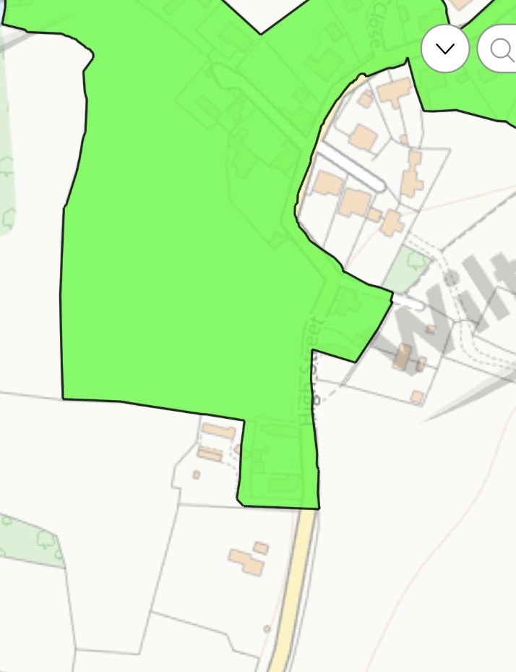
In conclusion, the proposed development would preserve and potentially enhance the character and appearance of the Conservation Area. It achieves a sensitive balance between securing the long-term viable use of the building and maintaining its heritage significance. The proposal is therefore considered to fully comply with local and national heritage policies.

Conservation area boundary fig 1

Landscape Impact

1.9 The proposed change of use of the former Baptist chapel to a residential dwelling would result in a neutral to positive impact on the surrounding landscape character.
Importantly, the shift from a community use to a private residential use would reduce the intensity and frequency of activity associated with the site. The former use as a place of worship generated periodic peaks in activity, including multiple vehicle movements, larger gatherings, and associated noise during services and events. In contrast, a single residential unit would result in a far lower level of activity, leading to a quieter and more stable environment.

From a visual perspective, the introduction of a managed private garden or landscaped area would enhance the immediate setting of the building. Domestic planting, boundary treatments, and general upkeep typically associated with residential occupation would improve the appearance of the site, particularly if it has become underused or lacks regular maintenance in its current form and introduce retrospective wildlife.
Overall, the proposal would preserve the existing character of the area while subtly enhancing the immediate setting of the building. There would be no adverse impact on the wider landscape, and the development would integrate appropriately within its context

Highways and Parking

2.0 The proposal presents a clear betterment in highways and parking terms when compared to the lawful use of the site as a place of worship.

The existing chapel use has historically resulted in concentrated periods of vehicular activity, particularly during services, events, and gatherings. These peak times often led to increased on-street parking demand, with visitors parking along the surrounding roads, sometimes at a distance from the site itself due to the limited on-site parking provision.

The site itself benefits from very limited formal off-street parking. This constraint significantly restricts its suitability for continued or alternative commercial or community uses, which would typically generate higher levels of traffic and parking demand. As such, the building is inherently constrained in its ability to function effectively as a commercial premises without causing adverse impacts to the surrounding highway network.

There is clear evidence of localised parking pressure associated with the former use. A neighbouring resident previously raised concerns regarding church-related activity, specifically noting that attendees would park outside his property during services and events. This resulted in inconvenience and disruption, highlighting the unsuitability of the site for uses that attract larger numbers of visitors.

In contrast, the proposed residential use would generate a significantly lower and more consistent level of vehicular movement. A single dwelling typically requires only a small number of parking spaces and does not create the same peak time pressures associated with community or commercial uses. The demand for parking would therefore be greatly reduced, alleviating previous issues experienced by neighbouring properties.

Furthermore, residential use is inherently more compatible with the surrounding highway conditions, as it distributes vehicle movements throughout the day rather than concentrating them into short periods. This results in improved highway safety and reduced congestion.

In summary:

- The site has limited parking provision, restricting its viability for commercial or community use.
- The former chapel use generated peak parking demand and on-street congestion.
- Neighbouring amenity has previously been affected by overspill parking.
- The proposed residential use would significantly reduce traffic generation and parking demand.
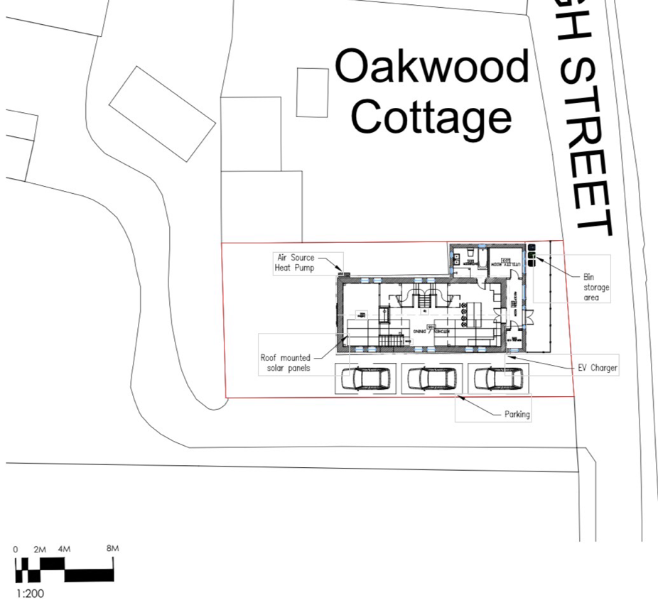
- The development would therefore represent an improvement in highways and parking terms over the existing lawful use.
- Provisions set out for 3 parking spaces within the current site (Ref Block Plan)

Overall, the proposal aligns with sustainable transport principles and would not result in any adverse impact on highway safety or capacity.

Ecology

2.1 The application site comprises an existing chapel building located outside of the defined settlement boundary. However, the site contains an established built structure and the proposal relates to the conversion and reuse of that existing building as a single residential dwelling, with limited external alteration works and no expansion of the existing built footprint. The proposal does not involve the development of an undeveloped greenfield site, nor does it introduce built form into an open countryside location beyond that which already exists on site.

The building is a traditional masonry chapel with a pitched roof structure and associated ceiling voids. Buildings of this type and age can provide potential roosting features for bats, particularly within roof voids, ridge areas, soffits, and junctions within timber structures. The site is located outside the settlement boundary; however, it is not located within or immediately adjacent to any designated ecological sites such as Sites of Special Scientific Interest, Special Areas of Conservation, or other statutory nature conservation designations. A site of special scientific interest (SSSI) is located within the wider locality, however it is sufficiently distant from the application site such that no direct impacts are anticipated. The surrounding area contains a mix of built development, roads, gardens, boundary vegetation and open countryside. As such, while the site’s rural-edge location means ecological matters must be considered carefully, the proposal is limited to the reuse of an existing building and is not expected to result in significant loss of established habitat.Ecological Baseline and Site Context

Bats

It is recognised that all British bat species and their roosts are legally protected under the Wildlife and Countryside Act 1981 (as amended) and the Conservation of Habitats and Species Regulations 2017. As such, it is necessary to consider the potential presence of bats within any works affecting buildings of this nature.

Given the age and construction of the chapel, there is a reasonable possibility that bats could be present within roof voids, ceiling spaces, or other concealed structural features. However, no intrusive works will commence until appropriate ecological checks have been completed.

A Preliminary Bat Roost Assessment (PRA) will be undertaken prior to the commencement of any works affecting the roof structure, ceiling void, or other potential roosting features. The assessment will be carried out by a suitably qualified ecologist in accordance with current best practice guidance.

Should the PRA identify evidence of bats, or features capable of supporting roosting bats, further emergence and activity surveys will be undertaken as necessary. Any required mitigation or licensing arrangements will be implemented in full compliance with relevant wildlife legislation and in consultation with the Local Planning Authority’s ecological advisor.

No works to the roof structure, ceiling void, or associated areas of potential ecological sensitivity will commence until the necessary ecological assessments have been completed and any required mitigation measures agreed.

Birds and Other Protected Species

The building may also provide potential nesting opportunities for birds, particularly during the active nesting season. Any vegetation clearance or building works will therefore be undertaken outside the bird nesting season (March to August inclusive), unless a nesting bird check has been carried out immediately prior to works by a suitably qualified person.

If any active nests are identified, these will be left undisturbed until nesting is complete.

Habitat and Biodiversity Impact

The proposal involves the conversion of an existing building with no significant loss of habitat. The site is largely hardstanding and built form, and therefore has limited ecological value in its current condition.

No hedgerows, trees, or priority habitats will be removed as part of the development. The proposal therefore results in negligible impact on existing biodiversity features.

Enhancement Opportunities

The development provides opportunities to achieve a modest biodiversity enhancement in accordance with local and national planning policy objectives, including those set out in the National Planning Policy Framework (NPPF).

Enhancements may include:

- Installation of bat boxes or bird boxes on suitable elevations of the building
- Sensitive external lighting design to minimise light spill onto potential roosting or foraging areas
- Introduction of small-scale native planting within any private garden area to support pollinators and local wildlife

These measures would result in a net gain in biodiversity where practicable, in line with planning policy expectations.

Conclusion

The proposed development is considered to have no significant adverse ecological impacts. A precautionary approach will be taken in relation to protected species, particularly bats and nesting birds, through the implementation of a Preliminary Bat Roost Assessment prior to works and adherence to nesting bird safeguards.

Subject to the above measures, the proposal is considered compliant with relevant wildlife legislation and national and local planning policy relating to biodiversity and ecological protection.

Flood Risk and Drainage

2.2 The application site has been assessed using the Government’s flood risk mapping data.

The site is located within Flood Zone 1 and is therefore at the lowest risk of fluvial flooding from rivers and the sea. Government data confirms that the risk of flooding from rivers and sea is considered very low with projected climate change scenarios indicating that this level of risk remains very low between 2039 and 2069.

In relation to surface water flood risk, projections similarly indicate a very low annual chance of flooding, including future climate change scenarios extending between 2040 and 2060, where the risk remains classified as very low.

With regard to groundwater, the site is located within a groundwater flood alert area. This indicates that groundwater levels may be sensitive to seasonal variation; however, this does not indicate a high probability of flooding. Appropriate site management and drainage measures will ensure that any potential groundwater-related risk is not exacerbated by the proposed development.

In terms of reservoir flooding, national datasets confirm that flooding from reservoirs is considered unlikely in this location and therefore presents a very low residual risk to the site.

The proposal involves the conversion of an existing building to a single residential dwelling, with no increase in built footprint or impermeable surfacing. As such, the development will not materially alter existing surface water runoff characteristics.

Existing drainage arrangements will be retained where appropriate, and the residential use will not increase flood risk elsewhere. The proposal is therefore considered acceptable in flood risk terms and compliant with national planning policy, including the National Planning Policy Framework.

Biodiversity Net Gain (BNG) Statement

2.3 Site: Porton Baptist Church, High Street, Porton, Wiltshire
Proposal: Change of use from Class F1 (Place of Worship) to Class C3 (Dwellinghouse) with associated minor external works.

The proposed development relates to the change of use of an existing building with limited external alterations. The site is confined to a small red-line boundary comprising the existing chapel footprint and a modest area of surrounding land, with no significant areas of natural habitat present.
The proposal does not involve the removal of any trees, hedgerows, or priority habitats. The land within the site is of negligible ecological value, consisting primarily of previously developed land and hardstanding, with minimal vegetation of low biodiversity importance.

In accordance with the statutory requirements of Schedule 7A of the Town and Country Planning Act 1990 (as amended), it is considered that the proposed development falls within the category of de minimis development, where the extent of habitat impact is below the threshold requiring mandatory biodiversity net gain assessment.

The development is therefore exempt from the requirement to deliver a measurable 10% biodiversity net gain.

Notwithstanding this, the proposal has been designed to avoid adverse ecological impacts. Any minor external works will be undertaken with due care, and opportunities for small-scale biodiversity enhancements (such as soft landscaping or planting) may be incorporated where practical.

In conclusion, the proposal is considered compliant with current biodiversity legislation and guidance, with no requirement for a formal Biodiversity Gain Plan.

Conclusion

2.4 This proposal sets out a carefully considered conversion of the existing chapel into a single residential home, delivering a practical and long-term use for a building that is otherwise constrained in its current form. The scheme works within the fabric of what is already on site, avoiding expansion and focusing on making effective use of an established structure.

Across all planning considerations, the approach has been to respect the existing setting while introducing a viable new function that aligns with the character of the surrounding area. The building would remain visually familiar within the street scene, with only limited and sensitive alterations required to support its new role.
In terms of movement and access the change of use would result in a noticeably lighter level of activity compared with its previous function, easing pressure on nearby streets and reducing sporadic parking demand that has previously affected adjacent properties.

From a wider environmental standpoint the development introduces modern energy improvements while retaining the original structure, helping to bring performance standards up to date without unnecessary loss of existing building fabric. Any ecological considerations have been approached in a precautionary manner, ensuring protected species and habitats are properly accounted for before works proceed.

Ground conditions and flood considerations have been reviewed using national datasets, which indicate no material constraints that would prevent residential occupation. The development does not alter the scale of built form or introduce additional areas of hardstanding, ensuring existing drainage behaviour remains largely unchanged.

The site also sits within a designated heritage context and careful thought has been given to how the proposal sits within that designation. The retained building continues to reflect the historic grain of the area while the proposed alterations are kept restrained and appropriate to its surroundings.

Overall, the proposal brings a redundant community building back into meaningful use, securing its upkeep and ensuring it remains occupied and cared for into the future. It achieves this without introducing harm to its surroundings and provides a sustainable, low-impact transition to a new chapter in the building’s life.

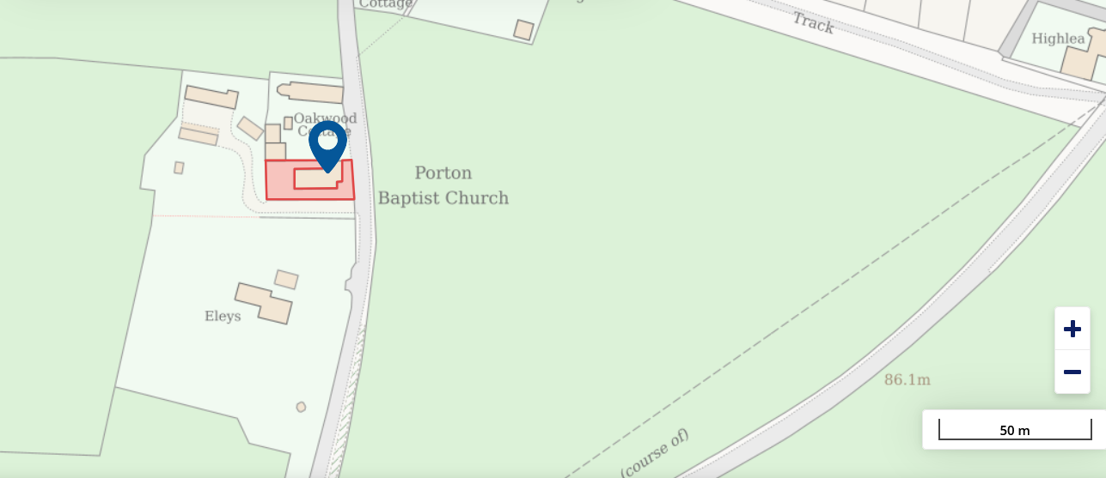
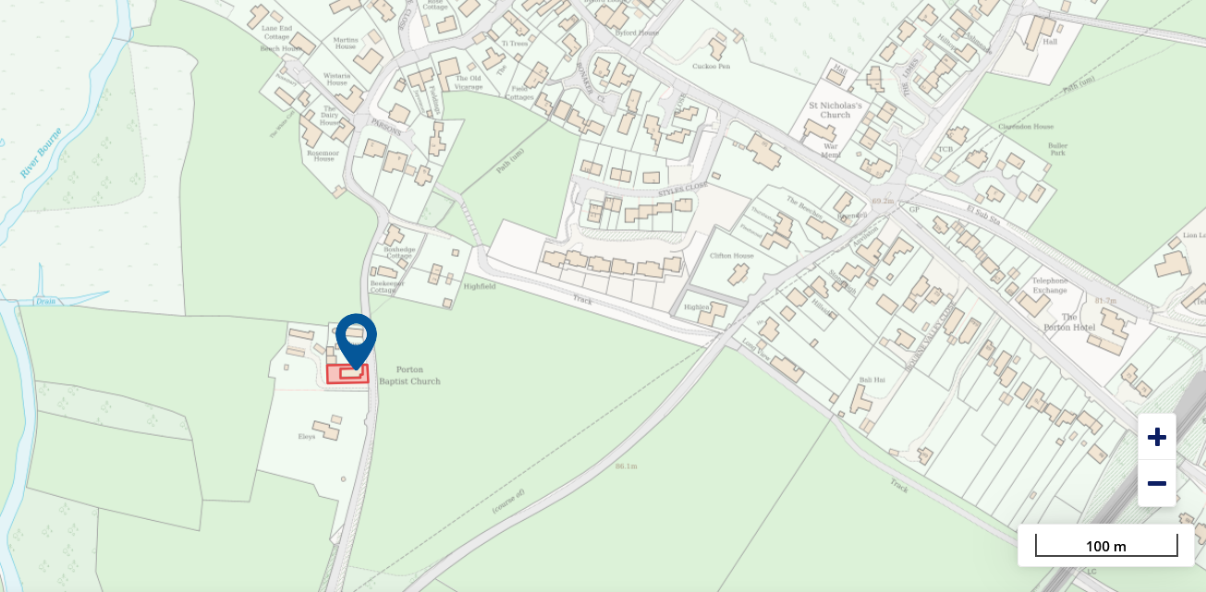

Thank you for considerations to our plans for the chapel, we welcome additional ideas, feedback or any alterations that you see fit so we are able to successfully retain this building from further decay and to preserve the area around it.

Casey and Harriet.

