APPLICATION FOR HOUSEHOLDER PLANNING PERMISSION
DELEGATED REPORT

APPLICATION REFERENCE: | PL/2026/01106
APPLICATION TYPE: | Householder Planning Permission
SITE ADDRESS: | 18 Pound Lane, Semington, Trowbridge, BA14 6LP
DEVELOPMENT DESCRIPTION: | Two storey rear extension, internal alterations. New doors front & rear of existing passage way between house & garage. Polycarbonate roof covering between garage & workshop. Enlargement of patio with garden wall moving. Erection of heating oil tank.
RECOMMENDATION: | That Planning Permission be GRANTED

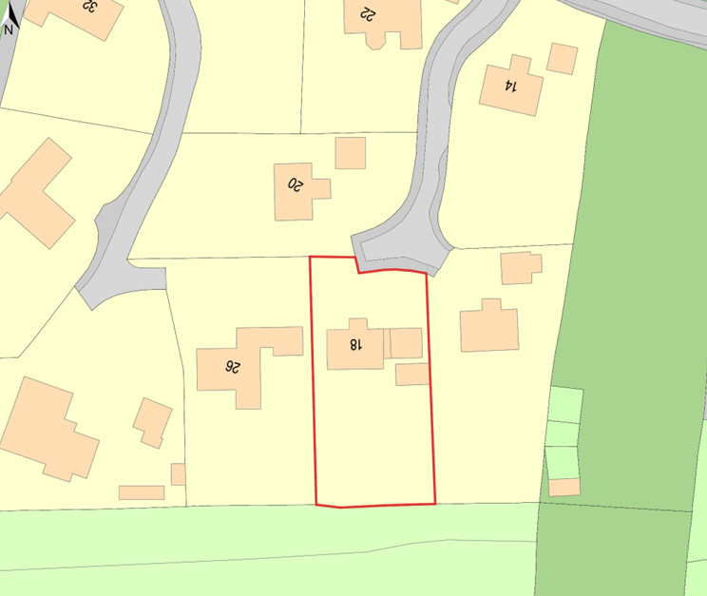

PROPOSAL

The site comprises a two-storey detached dwelling set within its residential curtilage, constructed of red brick elevations beneath a dark clay, double Roman tiled hipped roof. The property is located within a low-density, edge-of-village residential area characterised by similar dwellings of consistent architectural form and materials, extensive hedgerow boundaries, and interspersed mature trees, reflecting the wider estate context. The site lies within the Semington Settlement Boundary and is designated as Flood Zone 1, with no identified risk of surface water flooding, although there is a noted potential for shallow groundwater emergence. A strip of priority habitat woodland lies beyond the rear (southern) boundary. The site is not subject to conservation or ecological constraints.

SITE DESCRIPTION / CONTEXT

The site comprises a two-storey detached dwelling set within its residential curtilage, constructed of red brick elevations beneath a dark clay, double Roman tiled hipped roof. The property is located within a low-density, edge-of-village residential area characterised by similar dwellings of consistent architectural form and materials, extensive hedgerow boundaries, and interspersed mature trees, reflecting the wider estate context. The site lies within the Semington Settlement Boundary and is designated as Flood Zone 1, with no identified risk of surface water flooding, although there is a noted potential for shallow groundwater emergence. A strip of priority habitat woodland lies beyond the rear (southern) boundary. The site is not subject to conservation or ecological constraints.

PLANNING HISTORY

Reference No. | Proposal / Summary | Decision
W/86/00441/FUL | Three detached houses (plots 2 3 and 4) Phase 1 | Approved
W/86/00164/OUT | Nine Dwellings | Approved

RELEVANT LEGILSATION, POLICIES AND GUIDANCE

Wiltshire Core Strategy:

Core Policy 1 Settlement Strategy;
Core Policy 2 Delivery Strategy;
Core Policy 15 Spatial Strategy: Melksham Community Area;
Core Policy 50 Biodiversity and Geodiversity;
Core Policy 51 Landscape;
Core Policy 57 Ensuring High-Quality Design and Place Shaping;
Core Policy 60 Sustainable Transport;
Core Policy 61 Transport and Development;
Core Policy 64 Demand Management;
Core Policy 67 Flood Risk;

Semington Parish Neighbourhood Plan 2023-2038

The National Planning Policy Framework (NPPF) and The Planning Practice Guidance (PPG)

Wiltshire Design Guide - Appendix D – Design Guidance for Householder extensions

The Wiltshire Local Transport Plan 2011 – 2026: Car Parking Strategy (March 2015).

The Wiltshire Local Transport Plan 4 (LTP4) (March 2025)

Emerging Policy – Wiltshire Local Plan Review

The examination of the emerging Wiltshire Local Plan has been paused and the weight to be afforded to any part of the emerging plan can be no more than very limited. A decision on how to proceed will be made by the Council in May 2026.

CONSULTATION RESPONSES

Semington Parish Council – No Objection

REPRESENTATIONS

No comments received.

ASSESSMENT

Section 38(6) of the Planning and Compulsory Purchase Act 2004 states:

"If regard is to be had to the development plan for the purposes of any determination to be made under the planning Acts, the determination must be made in accordance with the plan unless material considerations indicate otherwise."

In accordance with this statutory requirement, this application has been assessed against the relevant policies of the Development Plan, including the adopted Wiltshire Core Strategy (2015) and, where applicable, any made Neighbourhood Plans.

Householder extensions are generally acceptable in principle, as they typically fall within the established residential curtilage of a property and do not result in new residential development in the open countryside. In this case, the proposal also lies within the defined limits of development set out in the Core Strategy, further reinforcing its acceptability in principle.

Design and Impact upon the upon the character and context of the area

Core Policy 57 Ensuring High Quality Design and Place Shaping of the Wiltshire Core Strategy requires all new development to achieve a high standard of design that responds positively to its local context. Proposals must reinforce and enhance local character and distinctiveness, relate appropriately to the surrounding landscape, and demonstrate a thoughtful response to existing townscape features. This includes careful consideration of elements such as building height, scale, massing, building line, materials, and overall appearance, ensuring new development integrates harmoniously with its setting.

The proposed development is considered to be well designed and appropriate to the host dwelling and its setting. External materials are shown to match the existing property, including red brick elevations and double Roman roof tiles, ensuring visual continuity. Two-storey rear extensions with gable-ended roofs are a common design feature within the cul-de-sac, and the proposed extension reflects this established character while remaining clearly subordinate by keeping its ridge height below that of the existing dwelling. The roof structure proposed between the dwelling and the rear outbuilding is modest in scale, largely screened from public view, and finished in matching materials, such that it does not exceed or compete with the scale or massing of the buildings it connects. The proposed heating oil tank within the front garden is of a typical residential size and, given the enclosed nature of the front garden with established hedgerow boundaries, would have a minimal visual presence. Although no specific screening is proposed, its siting and scale are considered characteristic of rural dwellings and would not result in harm to the visual amenities of the area.

In addition, the associated works such as the enlargement of the patio area, the repositioning of the garden wall, and the introduction of new doors and minor changes to fenestration are considered largely inconsequential in design terms. These elements are modest in scale, subordinate to the main built form, and are proposed to be finished in materials that match the existing dwelling, ensuring they sit comfortably within the established character of the site and its immediate context.

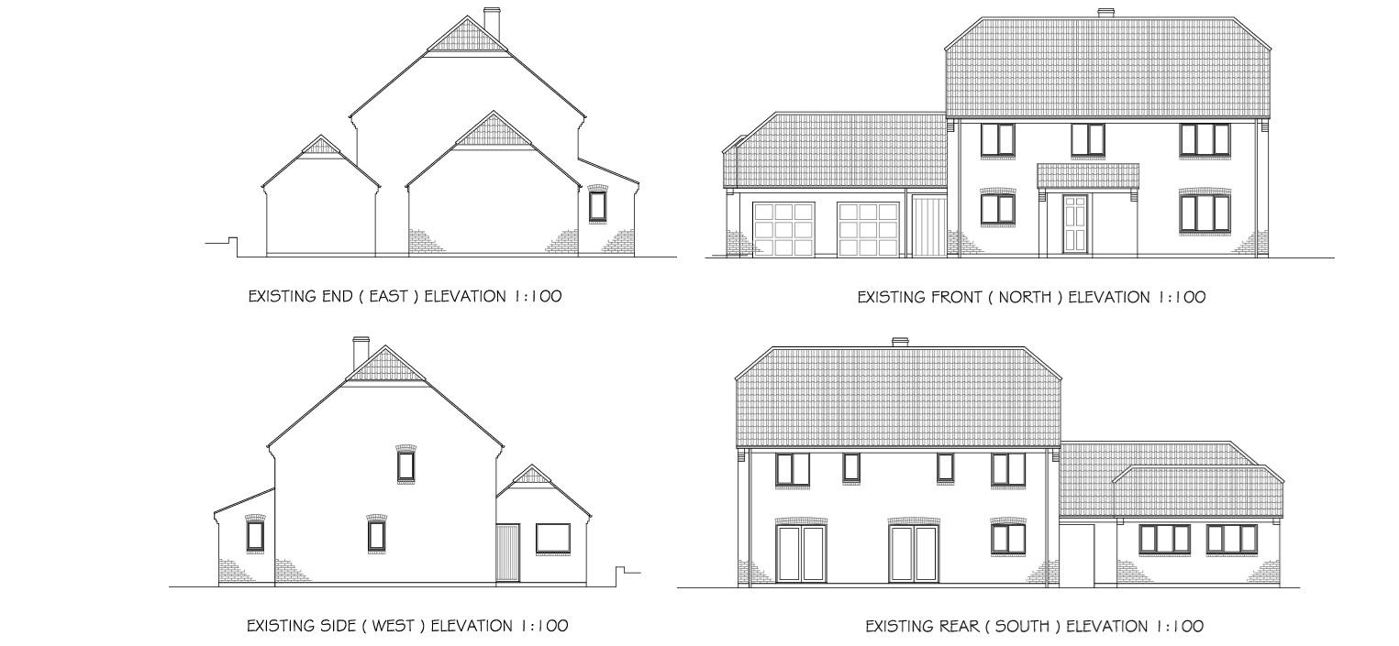
Exisiting Elevations

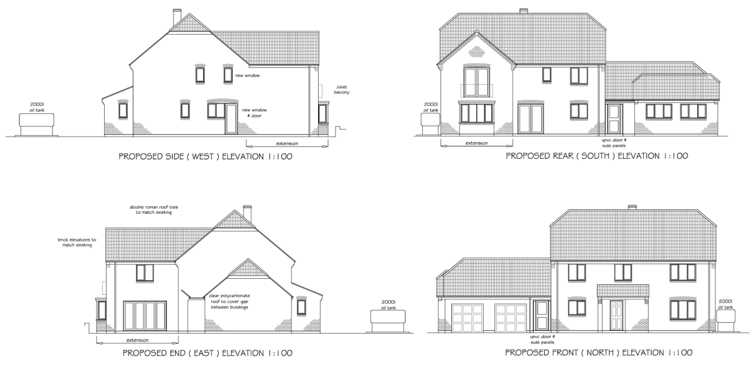
Proposed Elevations

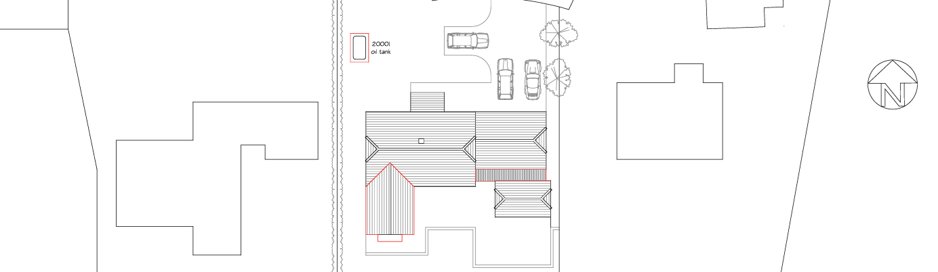
Proposed Site Plan

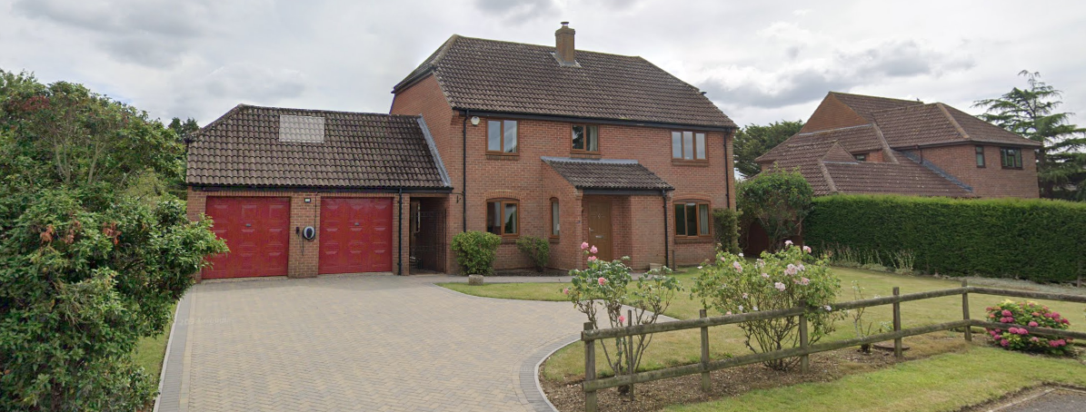
Site Image

Having regard to the above, the proposal complies with the design principles set out in Core Policy 57 of the Wiltshire Core Strategy and Appendix D of the Wiltshire Design Guide.

Amenity

Point vii of Core Policy 57 Ensuring High Quality Design and Place Shaping of the Wiltshire Core Strategy seeks to ensure that developments do not adversely affect neighbouring properties.

The National Planning Policy Framework (NPPF), particularly Paragraph 135, stresses that planning decisions should ensure developments provide a high standard of amenity for existing and future users.

In terms of residential amenity, the proposal is not considered to result in any unacceptable overbearing impact. This includes the two-storey rear extension, which would be set approximately 3 metres from the shared boundary and is positioned such that its bulk and scale would have a limited influence on the neighbouring curtilage, as well as the modest roof linking the dwelling to the rear outbuilding and the proposed oil tank, both of which are small-scale and well related to the existing built form. With regard to overshadowing, the west–east alignment of the dwellings, together with the siting and height of the rear extension, means that any shadowing would be limited to a short period during the early morning only, with no impact through midday or into the afternoon and evening; this would be marginal when compared with existing conditions and the effect of surrounding development. In respect of privacy, the rear-facing windows would be set forward of neighbouring rear elevations and would only allow oblique views into adjoining gardens, while existing first-floor rear windows already face away from neighbouring properties. A new first-floor side window facing east would be located approximately 15 metres from the boundary and is sufficiently offset to prevent any harmful overlooking. Overall, the proposal would not give rise to undue harm in terms of overbearing impact, loss of light, or loss of privacy.

The proposal is appropriately sited, designed, and oriented to ensure that it would not result in unacceptable impact upon/to the amenities or living conditions of neighbouring residential occupiers, particularly in terms of outlook, privacy, or access to natural light.

The proposal therefore accords with Core Policy 57 point vii in respect of safeguarding residential amenity and Appendix D of the Wiltshire Design Guide.

Other Issues

Core Policy 50 of the Wiltshire Core Strategy requires development proposals to avoid and minimise disturbance to sensitive species and habitats, while Biodiversity Net Gain (BNG) has been made a mandatory consideration through Schedule 7A of the Town and Country Planning Act 1990, as amended by the Environment Act 2021. However, householder applications are specifically exempt from the requirement to deliver BNG under Schedule 7A, Section 4(2)(a). In this instance, the site is not subject to any ecological constraints beyond the presence of adjacent priority habitat, and the proposal relates to a typical domestic extension contained wholly within the existing residential curtilage. As such, the development is unlikely to give rise to harm to habitats or protected species. Nevertheless, as the works involve interaction with the existing roof structure, an informative is recommended to advise the applicant of their obligations under the Wildlife and Countryside Act 1981, particularly in the event that bats or other protected species are encountered during construction.

The proposal would increase the dwelling from four to five bedrooms; however, it does not involve any changes to the existing access or parking arrangements. In accordance with the Council’s Car Parking Strategy, both four- and five-bedroom dwellings require a minimum of three off-street parking spaces, which the site is already capable of accommodating. As such, the development would not result in additional parking demand or increased pressure on the local highway network. Given the absence of any alterations affecting access, parking provision, or traffic generation, it is considered that the proposal would not give rise to any highway or transportation concerns and is acceptable in this regard.

In relation to drainage and flood risk, the site is located within Flood Zone 1 and is not subject to any identified risk of surface water flooding, as confirmed by the Council’s Strategic Flood Risk Assessment, although a potential for shallow groundwater flooding is noted. The proposal constitutes householder development of less than 250 sqm and is therefore exempt from the sequential and exception tests set out in the NPPF. The development would result in only a modest increase in impermeable area of approximately 25.5 sqm, largely within areas of existing hardstanding and residential garden, and is not considered likely to materially affect surface water runoff or increase flood risk on or off site. Given the scale and nature of the works, the proposal is considered acceptable in flood risk and drainage terms and compliant with Core Policy 67.

CONCLUSION

The proposal is considered to be acceptable and in accordance with the relevant policies and guidance outlined above.

RECOMMENDATION: That Planning Permission be GRANTED subject to the following conditions:

1.
The development hereby permitted shall be begun before the expiration of three years from the date of this permission.
REASON: To comply with the provisions of Section 91 of the Town and Country Planning Act 1990 as amended by the Planning and Compulsory Purchase Act 2004.

2.
The development hereby permitted shall be carried out in accordance with the following approved plans and documents:

Exisiting and Proposed Elevations 2602-1 (27 April 2026)
Proposed Site Plan 2602-4 (27 April 2026)
Location Plan (25 March 2026)
Proposed Floor Plans 2602-2 (25 March 2026)

REASON: For the avoidance of doubt and in the interests of proper planning.

