APPLICATION FOR VARIATION/REMOVAL OF CONDITION
CASE OFFICER REPORT

APPLICATION REFERENCE: | PL/2025/09457
APPLICATION TYPE: | Removal/variation of conditions
SITE ADDRESS: | Land on the west side of Storridge Road, Westbury
DEVELOPMENT DESCRIPTION: | Variation of conditions 2, 4, 5 and 7 of PL/2021/10592 to allow the approved 29MW solar farm (over 43ha) and associated development to incorporate the use of an existing access from Storridge Road
RECOMMENDATION: | Approve with Conditions

SITE DESCRIPTION/CONTEXT

Planning permission was granted on 12/10/2023 for a 29MW Solar farm (over 43ha) and associated development (application ref. PL/2021/10592).

The application site is approximately 43 hectares in size and is located on the west side of Storridge Road and approximately 200-300 metres southwest of the West Wilts Trading Estate. The site is lies approximately 1.5km north-west of Westbury, 2km north of Dilton Marsh, and 3km south of Trowbridge. The site is situated on generally flat land in the open countryside and is mostly enclosed by mature hedgerow screening. The site consists of agricultural land classified as grade 3 and 4 land. The site falls within the Landscape E3: North Bradley Rolling Clay Lowland Character Area and the Rolling Clay Landscape Character Type The site is located within a core area for bats associated with the Bath & Bradford on Avon Bats Special Area for Conservation (SAC) and the western boundary is shared with the Trowbridge and Westbury Bat Mitigation Strategy (TWBMS) Yellow Zone meaning there is a medium risk for habitat loss for bats associated with the SAC. The River Biss runs parallel to the western boundary of the site at an average distance of 10 metres. In addition part of the Biss Brook also runs to the east of the site. A Scheduled Monument named ‘Medieval settlement and associated field systems west of Brook Farm’ is located to the south of the site on the opposite side of Brook Drove. Public footpath NBRA32 is located to the west along the eastern boundary of Round Wood. Public footpaths DMAR36 and DMAR16 are located directly to the south of th site while DMAR10 is located to the east. Storridge Farmhouse, a grade II listed building is located to the east of the site while Cutteridge Farmhouse, also grade II listed, is located to the north of the site. Brook Farmhouse, also grade II listed is located to the southwest of the site. The site is mainly located within flood zone 1 with some areas susceptible to surface water flooding.

Approved site location plan under PL/2021/10592 (dated 30/8/23):

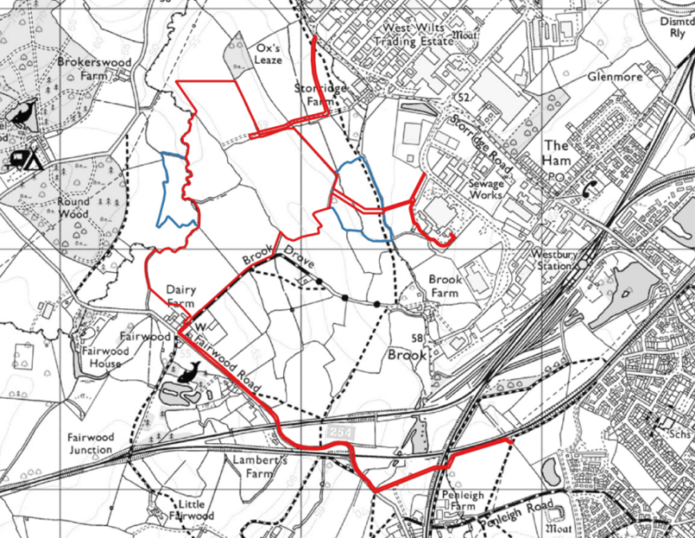

PROPOSAL

This report considers a Section 73 application for the variation/removal of condition(s) imposed on planning permission PL/2021/10592. The application relates to the site at Land on the west side of Storridge Road, Westbury, and seeks to vary/remove conditions 2, 4, 5 and 7 in relation to allow the approved 29MW solar farm (over 43ha) and associated development to incorporate the use of an existing access from Storridge Road.

Proposed revised site plan:

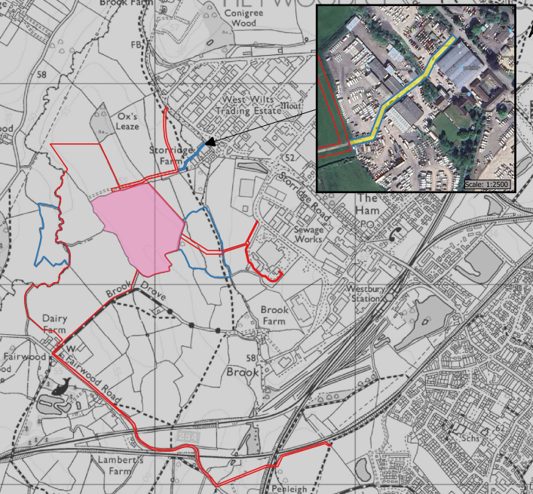

The variations to the conditions seek to add the above blue land to the site plan in order to make use of an existing access road. Full planning permission has been applied for the use of the road (ref. PL/2025/09894).

RELEVANT PLANNING HISTORY

Proposal / Summary
20/08958/SCR – EIA Screening Opinion for solar farm and associated development – Concluded the development does not required EIA screening
20/03136/SCR – Environmental Impact Assessment (EIA) Screening Opinion for proposed development of solar farm and associated development – Concluded the development does not required EIA screening
PL/2021/10592 - Full planning permission Decision - Approve with Conditions Date: 12/10/2023 – 29MW Solar farm (over 43ha) and associated development
PL/2025/09307 - Non-Material Amendment – Amendments to site layout of Phase 1 - Approved
PL/2025/09894 - Full planning permission – Permission for the use of an existing access during construction, maintenance and decommissioning of the solar farm approved under (PL/2021/10592) – to be determined
PL/2025/09457 - Removal/variation of conditions – Variation of conditions 2, 4, 5 and 7 of PL/2021/10592 to allow the approved 29MW solar farm (over 43ha) and associated development to incorporate the use of an existing access from Storridge Road – to be determined
PL/2025/09612 - Screening Opinion - TCPA EIA 2006 – EIA Screening Opinion for the amendments proposed under PL/2025/09457 - Variation of conditions 2, 4, 5 and 7 of PL/2021/10592 to allow the approved 29MW solar farm (over 43ha) and associated development to incorporate the use of an existing access from Storridge Road – to be determined

RELEVANT LEGISLATION, POLICIES AND GUIDANCE

Town and Country Planning Act. 1990 (as amended)

Section 73 of the Town and Country Planning Act. 1990 (as amended) relates to the determination of applications to develop land without compliance with conditions previously attached. It states that:

(2) On such an application the local planning authority shall consider only the question of the conditions subject to which planning permission should be granted, and—

- if they decide that planning permission should be granted subject to conditions differing from those subject to which the previous permission was granted, or that it should be granted unconditionally, they shall grant planning permission accordingly, and

- if they decide that planning permission should be granted subject to the same conditions as those subject to which the previous permission was granted, they shall refuse the application.

The National Planning Practice Guidance (PPG) states the following:

- Nature of the Application: A Section 73 application is treated as a new planning permission, although it does not alter the original permission itself. The original permission remains intact and can still be implemented unless it has expired or been superseded.
- Limitations:
  - Section 73 cannot be used to change the description of development or the operative part of the permission (e.g. the nature or extent of the approved use).
  - It cannot be used to extend the time limit for implementing the original permission.
  - If the proposed changes go beyond what can reasonably be considered under Section 73, a new planning application under Section 70 would be required.
- Decision-making: The local planning authority must consider the application only in relation to the conditions subject to which the original permission was granted. However, it may impose new or revised conditions if granting a new permission.
- Legal Agreements: Because a Section 73 application results in a new permission, any existing Section 106 agreement may need to be varied or replaced via a deed of variation to ensure obligations continue to apply to the new permission.

National Planning Policy:
- National Planning Policy Framework (NPPF)
- Planning Practice Guidance (PPG)
- National Design Guide
Development Plan:
The development plan for Wiltshire comprises the Wiltshire Core Strategy (WCS) (adopted January 2015) and any made neighbourhood plans, which remains the principal statutory planning document guiding development across the county. In line with Section 38(6) of the Planning and Compulsory Purchase Act 2004, planning decisions must be made in accordance with the development plan unless material considerations indicate otherwise.

Though the development plan is considered as a whole, those parts deemed to be particularly relevant to this application are listed below:

The adopted Wiltshire Core Strategy (WCS), with particular regard to:

- Core Policy 1 Settlement Strategy;
- Core Policy 2 Delivery Strategy;
- Core Policy 3 Infrastructure Requirements;
- Core Policy 32 Westbury Spatial Strategy
- Core Policy 42 Standalone Renewable Energy Installations
- Core Policy 50 Biodiversity and Geodiversity;
- Core Policy 51 Landscape
- Core Policy 52 Green Infrastructure
- Core Policy 57 Ensuring High Quality Design and Place Shaping;
- Core Policy 58 Ensuring the Conservation of the Historic Environment;
- Core Policy 60 Sustainable Transport;
- Core Policy 61 Transport & Development;
- Core Policy 62 Development Impacts on the Transport Network;
- Core Policy 64 Demand Management
- Core Policy 67 Flood Risk;

Draft Wiltshire Local Plan Policies

- Policy 1: Settlement Strategy
- Policy 2: Delivery Strategy
- Policy 3: Reserve sites and broad locations for growth
- Policy 4: Addressing climate change
- Policies 52 – 63: Trowbridge Area Strategy
- Policies 64 – 75: Economic, tourism, retail and transport
- Policies 76 – 84: Social, housing, community, public open space and wellbeing
- Policies 85 – 101: Sustainability, ecology, water and landscape, heritage, air quality

The examination of the emerging Wiltshire Local Plan has been paused and the weight to be afforded to any part of the emerging plan can be no more than very limited. A decision on how to proceed will be made by the Council in May 2026.

Supplementary Planning Documents and other Guidance:
Wiltshire Council’s Local Transport Plan 2011-2026 and Car Parking Strategy
Trowbridge and Westbury Bat Mitigation Strategy (TWBMS) SPD, adopted in 2025
West Wiltshire District Landscape Character Assessment March 2007
National Planning Practice Guidance (PPG)
Dilton Marsh Neighbourhood Development Plan (Made September 2025)
Westbury Neighbourhood Plan (Made March 2024)

ISSUES

The key considerations in the assessment of this application are as follows:

- Determining whether the proposed amendments fall within the scope of Section 73 of the Town and Country Planning Act 1990 which allows for the variation or removal of conditions attached to an existing planning permission.
- Assessing whether the development, as amended, remains in accordance with the relevant policies and provisions of the development plan, and whether the changes materially alter the nature or impacts of the approved scheme.

CONSULTATION RESPONSES

WC Highways: “I note the submission seeks Variation of Conditions 2, 4, 5 and 7 of the consent granted under PL/2021/10592, for a 29MW Solar farm. The variations are related to the change in construction access proposals, from that previously agreed. I am also aware of the related submissions made in respect to this matter, under PL/2025/09894 and PL/2025/09612, for which, comments will be made separately.
“The proposed revisions to the stated Conditions are considered acceptable in Highway terms and I thus wish to raise no objection to these Variations.”

WC Public Protection: “…regarding the application to vary Conditions 2, 4, 5 and 7 of planning permission PL/2021/10592. The proposed variation seeks to incorporate the use of an existing access from Storridge Road.
“Having reviewed the revised location plan, I note that the amended access route passes through Storridge Farm. Although the wider Storridge Farm site is predominantly in commercial use, there are several residential properties located to the south. The nearest dwelling appears to be approximately 30m from the proposed access route.
“Vehicle movements associated with both the construction and decommissioning phases have the potential to generate noise and dust. These could adversely affect nearby residential receptors if not appropriately controlled.

“The risk of such impacts is minimised through the use of the previously approved access route, which avoids close proximity to sensitive residential properties.
“However, should you be minded to approve this variation, we would recommend that the Construction Traffic Management Plan (CTMP) approved under Condition 7 of planning permission PL/2021/10592 is fully implemented for both the construction and decommissioning phases. This will help ensure that any noise and dust impacts are appropriately managed and kept to a minimum”.

Dilton Marsh Parish Council: “No objection”

Westbury Town Council: “No objection”

North Bradley Parish Council: “No objection”

REPRESENTATIONS
Below is a summary of the representations received during the consultation period. Only material planning considerations have been taken into account in the assessment of this application. Non-material issues, such as property values or private legal disputes, cannot be considered in the determination process.

Supportive comments – three comments from three addresses:

- Great idea, better than the incinerator.
- Solar panels would be better than housing, but provision for wildlife should be made.
- Extra leisure facilities should be included.

Objections – nine comments from seven addresses:

- Some documents are unavailable.
- A solar site on this scale could negatively impact our town.
- Concerns over negative health and environmental effects of the solar panels.
- The Council should reconsider the application due to harmful effects, and that it would prevent a bypass.
- Object to this solar farm proposal as it would damage the rural landscape, remove valuable farmland, and harm local wildlife. This is an inappropriate site, and the application should be refused.
- It is far too large for this area and an unnecessary facility and eyesore.

ASSESSMENT
Section 38(6) of the Planning and Compulsory Purchase Act 2004 states:

"If regard is to be had to the development plan for the purposes of any determination to be made under the planning Acts, the determination must be made in accordance with the plan unless material considerations indicate otherwise."

In accordance with this statutory requirement, this application has been assessed against the relevant policies of the Development Plan, including the Wiltshire Core Strategy (2015) and, where applicable, any made Neighbourhood Plans. Consideration has also been given to the policies of the National Planning Policy Framework (NPPF) as a material consideration in the assessment.

Principle of the Development – Do the proposed amendments fall within the scope of s73?

The proposed amendments have been reviewed and are considered to fall within the scope of Section 73 of the Town and Country Planning Act 1990. The changes do not result in a fundamentally different development from that originally approved, nor do they seek to alter the description of development or extend the time limit for implementation. As such, the application is valid under Section 73 and can be determined as a variation of condition(s) attached to the original planning permission.

This s73 is being considered alongside two other applications:
PL/2025/09894 – a full planning application for the use of an existing road to access the solar site. This road has its own application red line.

PL/2025/09612 – an EIA Screening Opinion application to consider the proposed changes to the solar site as put forward in the full planning and s73 applications.

This s73 seeks to add the additional access from Storridge Road. In this application the road would be included within the blue land, and the relevant conditions are proposed to be varied accordingly.

This three-application approach has been designed to cover the issues in a robust manner to ensure that the wider scheme remains legally implementable.

Compliance with the Development Plan

The amended scheme remains in accordance with the adopted development plan, including:

- Wiltshire Core Strategy (WCS) policies;
- Neighbourhood Plans (both Dilton Marsh and Westbury Neighbourhood Plans have been updated);
- The National Planning Policy Framework (NPPF).

In considering whether any changes in planning policy since the original permission was granted, officers consider that the updates to the Neighbourhood Plans, and to the NPPF, have not made any substantive difference to the way the proposal would be approached, from a policy perspective. Therefore, the amended proposal remains acceptable and compliant with the relevant local and national policies.

Assessment of Conditions

This application seeks to vary several conditions attached to planning permission PL/2021/10592, which was issued subject to 15 conditions. In order to accommodate the additional access proposed the following conditions are proposed to change: conditions 2, 4, 5 and 7.

Condition 2

The plans list in condition 2 is proposed to be updated to allow the change to the blue line, to allow the control of the additional access, as follows:

2 The development hereby permitted shall be carried out in accordance with the following approved plans and documents:

Site Design drg no. 178-06-PV Rev F1 dated 30/08/2023
Location Plan dated 24/11/2025
15m SLP2 TOWER drg no. WPD-10238 Rev A dated 25/10/2012
Switchgear Housing Rev A1 dated 01/10/2021
Substation Housing Rev A1 dated 01/10/2021
Racking Detail Rev A1 dated 01/10/2021
Battery Transformer Rev A1 dated 01/10/2021
Battery Container Rev A1 dated 01/10/2021
Inverter/Transformer detail Rev A1 dated 01/10/2021
Fence Detail Rev A1 dated 01/10/2021
CCTV Detail Rev A1 dated 01/10/2021
Proposed Culvert Section Rev A2 dated 28/08/2023
Typical Boundary Section Rev A1 dated 11/07/2023
Biodiversity Management Plan by Wychwood Biodiversity dated April 2023
Construction Traffic Management Plan Addendum dated November 2025

REASON: For the avoidance of doubt and in the interests of proper planning

The new access is subject to its own full planning application (PL/2025/09894), with its own red line, in order that the above condition together with the full planning permission would work together to form a complete and controllable access point.

Condition 4

Condition 4 relates to the access arrangements, which this application seeks to change, in conjunction with the accompanying full planning application. A Construction Traffic Management Plan Addendum has been submitted and found to be acceptable by the Highways team. The proposed replace of condition 4 is as follows:

4 All development including, construction, ongoing maintenance and decommissioning, shall be undertaken via the approved access points from Storridge Road, in accordance with the approved Construction Traffic Management Plan (approved under discharge of condition application PL/2024/10092) and hereby approved Construction Traffic Management Plan Addendum.

REASON: In the interests of highway safety.

Condition 5

This condition relates to the visibility splays for the accesses. The information received to vary the condition is acceptable, as found by the Council’s Highways team. Therefore, the condition can be reworded as follows:

5 Prior to the first use of the approved northern access from Storridge Road, the visibility splays shown on the approved plans must be provided with no obstruction to visibility at or above a height of 900mm above the nearside carriageway level. The visibility splays shall always be maintained free of obstruction thereafter.

REASON: In the interests of highway safety.

Condition 7

This condition relates to the approved Construction Traffic Management Plan (approved under discharge of condition application PL/2024/10092 and seeks rewording condition 7 into a compliance condition. However, the changes made to condition 4, above, deals with the same issue and ensures that the CTMP and the CTMP Addendum are considered together in terms of compliance. This gives flexibility in the construction, maintenance and decommissioning phases without causing conflicts within the scheme. Therefore, condition 7 can be removed, as the previous discharge of condition 7 is now worked into the reworded condition 4, above.

Other conditions

The proposed variations to the conditions attached to planning permission PL/2021/10592 have been carefully considered in the context of the amended scheme. Where changes are proposed, these have been assessed to determine whether they are reasonable, necessary and justified, and whether they continue to secure an acceptable form of development. The implications of the proposed amendments for other conditions, including those relating to approved plans, have also been taken into account to ensure internal consistency.

Conditions that have previously been discharged under the original permission have been reviewed, and where necessary updated or removed to reflect their status. Any conditions that are now obsolete or no longer relevant have similarly been identified and omitted. Overall, the revised suite of conditions remains comprehensive, enforceable, and compliant with the relevant tests, and is considered to adequately control the development as amended.

Subject to the revised conditions, the variation of conditions is therefore considered acceptable.

Other Material Considerations/Issues

To deal with comments from the publicity process:

The principle of development has been established through application PL/2021/10592. This is a variation of condition application, which only deals with matters of detail concerning a number of the conditions, as explored in this report. The original decision cannot be revoked in a variation of condition application. Accordingly, the principle of the development cannot be reconsidered.

The relevant documents related to the application are available on the public website.

PLANNING BALANCE AND CONCLUSION
In determining this application under Section 73 of the Town and Country Planning Act 1990, the Local Planning Authority has considered whether the proposed amendments fall within the scope of Section 73. The proposed amendments have been assessed against the relevant policies of the Wiltshire Core Strategy, any applicable Neighbourhood Plan, and the National Planning Policy Framework. The assessment has also considered whether the development, as amended, materially alters the nature or impacts of the approved scheme.

The principle of developing a solar farm on the site has already been established through earlier permissions. The proposed amendments comprise the use of a new access, resulting in updated plans and documents, and revised condition wording, and do not result in a fundamentally different form of development to that previously approved. The application is therefore capable of being determined as a Section 73 variation.

Any identified impacts are considered to be appropriately mitigated and controlled through the revised and retained planning conditions. No material changes in policy or site circumstances have been identified that would justify reaching a different conclusion to that of the parent permission.

On balance, the proposal is considered to remain in accordance with the development plan and relevant national guidance. There are no material considerations that indicate otherwise, and the application is therefore recommended for approval, subject to the conditions set out in this report – the conditions will be subject to new numbering due to the condition 7 being deleted.

RECOMMENDATION:
That Planning Permission be GRANTED subject to the following conditions:

1 The development hereby permitted shall be begun before the expiration of three years from the date of the original permission (PL/2021/10592) 12 October 2023.

REASON: To comply with the provisions of Section 91 of the Town and Country Planning Act 1990 as amended by the Planning and Compulsory Purchase Act 2004.

2 The development hereby permitted shall be carried out in accordance with the following approved plans and documents:

Site Design drg no. 178-06-PV Rev F1 dated 30/08/2023
Location Plan dated 24/11/2025
15m SLP2 TOWER drg no. WPD-10238 Rev A dated 25/10/2012
Switchgear Housing Rev A1 dated 01/10/2021
Substation Housing Rev A1 dated 01/10/2021
Racking Detail Rev A1 dated 01/10/2021
Battery Transformer Rev A1 dated 01/10/2021
Battery Container Rev A1 dated 01/10/2021
Inverter/Transformer detail Rev A1 dated 01/10/2021
Fence Detail Rev A1 dated 01/10/2021
CCTV Detail Rev A1 dated 01/10/2021
Proposed Culvert Section Rev A2 dated 28/08/2023
Typical Boundary Section Rev A1 dated 11/07/2023
Biodiversity Management Plan by Wychwood Biodiversity dated April 2023
Construction Traffic Management Plan Addendum dated November 2025

REASON: For the avoidance of doubt and in the interests of proper planning

3 The permission hereby granted shall be for a temporary period and shall expire 40 years from the date that electricity from the development is first exported to the electricity distribution network (‘First Export Date’) or no later than 45 years from the date of this decision, whichever is the soonest. Written confirmation of the First Export Date shall be provided to the Local Planning Authority no later than 1 calendar month after that First Export Date. Within 12 months of the date of expiry of this planning permission, or, if sooner, the cessation of the use of the solar panels for electricity generation purposes for a continuous period of 6 months, the solar panels together with any supporting/associated infrastructure including the inverter stations, security equipment, poles and fencing shall be removed from the land and the land restored to its former agricultural condition in accordance with a scheme of work to be submitted to, and approved in writing by the Local Planning Authority. The scheme of work, including a restoration plan and a decommissioning scheme, shall be submitted to the local planning authority not less than six months before the removal of the installation. The plan must be supported by an impact assessment based on up to date baseline survey and carried out according to the current guidelines. It must set out clear aims of restoration to benefit key habitats and species.

REASON: In the interests of amenity and the circumstances of the use and to ensure the long-term management of landscape and ecological features retained and created by the development and in the interests of the significance of the heritage assets and their setting.

4 All development including, construction, ongoing maintenance and decommissioning, shall be undertaken via the approved access points from Storridge Road, in accordance with the approved Construction Traffic Management Plan (approved under discharge of condition application PL/2024/10092) and hereby approved Construction Traffic Management Plan Addendum.

REASON: In the interests of highway safety.

5 Prior to the first use of the approved northern access from Storridge Road, the visibility splays shown on the approved plans must be provided with no obstruction to visibility at or above a height of 900mm above the nearside carriageway level. The visibility splays shall always be maintained free of obstruction thereafter.

REASON: In the interests of highway safety.

6 The gradient of the access way shall not at any point be no steeper than 1 metre in 12 metres from its junction with the public highway.

REASON: In the interests of highway safety.

7 The scheme for the discharge of surface water from the site, incorporating sustainable drainage details, approved under application PL/2024/10092 shall be adhered to in the implementation of the development. The development shall not be first brought into use until surface water drainage has been constructed in accordance with the approved scheme.

REASON: The matter is required to be agreed with the Local Planning Authority before development commences in order that the development is undertaken in an acceptable manner and to ensure that the development can be adequately drained.

8 The scheme of hard and soft landscaping approved under application PL/2024/10092 shall be adhered to in the implementation of the development.

REASON: In order that the development is undertaken in an acceptable manner and in the interests of visual amenity and the character and appearance of the area.

9 All soft landscaping comprised in the approved details of landscaping shall be carried out in the first planting and seeding season following the first operation of the development or the completion of the development whichever is the sooner, or in accordance with a schedule and timetable to be agreed in writing by the Local Planning Authority. All shrubs, trees and hedge planting shall be maintained free from weeds and shall be protected from damage by vermin and stock. Any trees or plants which, within a period of five years, die, are removed, or become seriously damaged or diseased shall be replaced in the next planting season with others of a similar size and species, unless otherwise agreed in writing by the Local Planning Authority.

REASON: To ensure a satisfactory landscaped setting for the development and the protection of existing important landscape features.

10 The Landscape and Ecology Management Plan (LEMP) approved under application PL/2024/10092 shall be adhered to in the implementation of the development.

REASON: To ensure the long-term management of landscape and ecological features retained and created by the development, for the benefit of visual amenity and biodiversity for the lifetime of the scheme.

11 The Construction Environmental Management Plan (CEMP) approved under application PL/2024/10092 shall be adhered to in the implementation of the development.

REASON: To ensure adequate protection and mitigation for ecological receptors prior to and during construction, and that works are undertaken in line with current best practice and industry standards and are supervised by a suitably licensed and competent professional ecological consultant where applicable, for the benefit of biodiversity for the lifetime of the scheme.

12 No external light fixture or fitting will be installed within the application site unless details of existing and proposed new lighting have been submitted to and approved by the Local Planning Authority in writing. The submitted details will demonstrate how the proposed lighting will impact on bat habitat compared to the existing situation.

REASON: To avoid illumination of habitat used by bats.

13 The written programme of archaeological monitoring approved under application PL/2024/10092 shall be adhered to in the implementation of the development. The approved programme of archaeological work shall be carried out in accordance with the approved details.

REASON: To enable the recording of any matters of archaeological interest.

14 The Archaeological Management Plan (AMP) approved under application PL/2024/10092 shall be adhered to in the implementation of the development. The approved AMP shall be carried out in accordance with the approved details.

REASON: To enable the recording of any matters of archaeological interest.

Informatives:

No materials, plant, temporary structures or excavations of any kind should be deposited / undertaken which obstruct or adversely affect the public right of way whilst development takes place. The application involves an extension to the existing/creation of a new vehicle access/dropped kerb. The consent hereby granted shall not be construed as authority to carry out works on the highway. The applicant is advised that a licence will be required from Wiltshire’s Highway Authority before any works are carried out on any footway, footpath, carriageway, verge or other land forming part of the highway. Please contact our Vehicle Crossing Team on vehicleaccess@wiltshire.gov.uk and/or 01225 713352 or visit their website at http://wiltshire.gov.uk/highways-streets to make an application.

The applicant is advised that if it is proposed to drain this development directly into the river or carry out any work within 8 metres of the watercourse then Land Drainage Consent is required from the Environment Agency. For further information see www.environment-agency.gov.uk

