APPLICATION FOR FULL-PLANNING PERMISSION
CASE OFFICER REPORT

APPLICATION REFERENCE: | PL/2025/09894
APPLICATION TYPE: | Full planning permission
SITE ADDRESS: | Land at Storridge Farm, Storridge Road, Westbury
DEVELOPMENT DESCRIPTION: | Permission for the use of an existing access during construction, maintenance and decommissioning of the solar farm approved under (PL/2021/10592)
RECOMMENDATION: | Approve with Conditions

SITE DESCRIPTION/CONTEXT

The site is a short stretch of existing road, joining Storridge Road to the application site. The road connects through part of an industrial estate/farm complex and is approximately 190 metres in length. The below map extracts show the location and site plans.

This road would provide an additional access point to the wider site (the blue land), which has planning permission for a 29MW ground mounted solar farm and associated infrastructure (Application No. PL/2021/10592).

Location Plan:
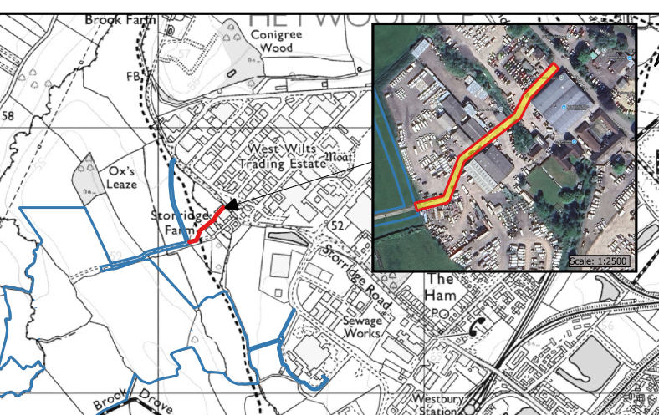

Site Plan:

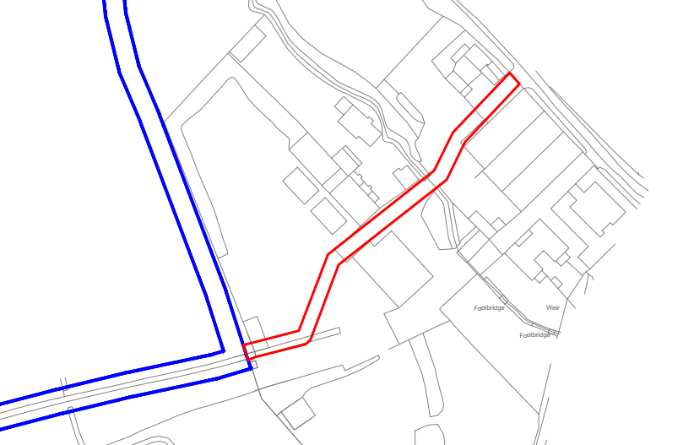

PROPOSAL

The proposal includes no operational development. The application seeks permission to use this short section of existing road for the construction, maintenance and decommissioning of the solar farm approved under (PL/2021/10592).

The road would become an additional access point to those already approved under the original planning permission. The overall volume of traffic has not changed, and the use of this road in addition to the already approved access points would dilute the impacts to the wider road network as deliveries and construction traffic can be further spread between the accesses.

PLANNING HISTORY

Proposal / Summary
20/08958/SCR – EIA Screening Opinion for solar farm and associated development – Concluded the development does not required EIA screening
20/03136/SCR – Environmental Impact Assessment (EIA) Screening Opinion for proposed development of solar farm and associated development – Concluded the development does not required EIA screening
PL/2021/10592 - Full planning permission Decision - Approve with Conditions Date: 12/10/2023 – 29MW Solar farm (over 43ha) and associated development
PL/2025/09307 - Non-Material Amendment – Amendments to site layout of Phase 1 - Approved
PL/2025/09894 - Full planning permission – Permission for the use of an existing access during construction, maintenance and decommissioning of the solar farm approved under (PL/2021/10592) – to be determined
PL/2025/09457 - Removal/variation of conditions – Variation of conditions 2, 4, 5 and 7 of PL/2021/10592 to allow the approved 29MW solar farm (over 43ha) and associated development to incorporate the use of an existing access from Storridge Road – to be determined
PL/2025/09612 - Screening Opinion - TCPA EIA 2006 – EIA Screening Opinion for the amendments proposed under PL/2025/09457 - Variation of conditions 2, 4, 5 and 7 of PL/2021/10592 to allow the approved 29MW solar farm (over 43ha) and associated development to incorporate the use of an existing access from Storridge Road – to be determined

RELEVANT LEGISLATION, POLICIES AND GUIDANCE

National Planning Policy:
- National Planning Policy Framework (NPPF)
- Planning Practice Guidance (PPG)
- National Design Guide
Development Plan:
The development plan for Wiltshire comprises the Wiltshire Core Strategy (WCS) (adopted January 2015) and any made neighbourhood plans, which remains the principal statutory planning document guiding development across the county. In line with Section 38(6) of the Planning and Compulsory Purchase Act 2004, planning decisions must be made in accordance with the development plan unless material considerations indicate otherwise.

Though the development plan is considered as a whole, those parts deemed to be particularly relevant to this application are listed below:

The adopted Wiltshire Core Strategy (WCS), with particular regard to:

- Core Policy 1 Settlement Strategy;
- Core Policy 2 Delivery Strategy;
- Core Policy 3 Infrastructure Requirements;
- Core Policy 32 Westbury Spatial Strategy
- Core Policy 42 Standalone Renewabe Energy Installations
- Core Policy 50 Biodiversity and Geodiversity;
- Core Policy 51 Landscape
- Core Policy 52 Green Infrastructure
- Core Policy 57 Ensuring High Quality Design and Place Shaping;
- Core Policy 58 Ensuring the Conservation of the Historic Environment;
- Core Policy 60 Sustainable Transport;
- Core Policy 61 Transport & Development;
- Core Policy 62 Development Impacts on the Transport Network;
- Core Policy 64 Demand Management
- Core Policy 67 Flood Risk;

Draft Wiltshire Local Plan Policies

- Policy 1: Settlement Strategy
- Policy 2: Delivery Strategy
- Policy 3: Reserve sites and broad locations for growth
- Policy 4: Addressing climate change
- Policies 52 – 63: Trowbridge Area Strategy
- Policies 64 – 75: Economic, tourism, retail and transport
- Policies 76 – 84: Social, housing, community, public open space and wellbeing
- Policies 85 – 101: Sustainability, ecology, water and landscape, heritage, air quality

The examination of the emerging Wiltshire Local Plan has been paused and the weight to be afforded to any part of the emerging plan can be no more than very limited. A decision on how to proceed will be made by the Council in May 2026.

Supplementary Planning Documents and other Guidance:
Wiltshire Council’s Local Transport Plan 2011-2026 and Car Parking Strategy
Trowbridge and Westbury Bat Mitigation Strategy (TWBMS) SPD, adopted in 2025
West Wiltshire District Landscape Character Assessment March 2007
National Planning Practice Guidance (PPG)
Dilton Marsh Neighbourhood Development Plan (Made September 2025)
Westbury Neighbourhood Plan (Made March 2024)

ISSUES

The main issues that need to be addressed in this case include:

- Whether the proposal constitutes EIA development
- Whether the development is acceptable in principle (CP 1 and 2)
- Whether the scheme would have an acceptable impact upon the reasonable living conditions of the adjoining occupants (CP 57)
- Whether the proposal would have a negative effect upon highway safety, including if there is sufficient parking for the proposed development (CP 61 and 64)

CONSULTATION RESPONSES

WC Highways: “No objection” subject to amended conditions under a s73 application.

WC Public Protection: “No objection” subject to amended conditions under a s73 application.

Dilton Marsh Parish Council: “No objection”

Westbury Town Council: “No objection”

REPRESENTATIONS
In accordance with the requirements of the Town and Country Planning (Development Management Procedure) (England) Order 2015 (as amended), the application was publicised by way of:

- Neighbour notification letters sent to adjoining and nearby properties;
- A site notice displayed near the site;
- An advertisement placed in the local press

These methods were used to inform interested parties and provide a period of 21 days for comments to be submitted.

No representations have been received.

ASSESSMENT
Section 38(6) of the Planning and Compulsory Purchase Act 2004 states:

"If regard is to be had to the development plan for the purposes of any determination to be made under the planning Acts, the determination must be made in accordance with the plan unless material considerations indicate otherwise."

In accordance with this statutory requirement, this application has been assessed against the relevant policies of the Development Plan, including the Wiltshire Core Strategy (2015) and, where applicable, any made Neighbourhood Plans. Consideration has also been given to the policies of the National Planning Policy Framework (NPPF) as a material consideration in the assessment.

Environmental Impact Assessment (EIA) Screening
In accordance with the Town and Country Planning (Environmental Impact Assessment) Regulations 2017 (as amended), the local planning authority has considered whether the proposed development constitutes EIA development.

EIA Screening Opinion Issued – Not EIA Development
A formal screening opinion is to be issued by the local planning authority under application ref. PL/2025/09612. The screening concludes that the proposal does not constitute EIA development as it does not exceed the relevant thresholds or criteria set out in Schedule 1 or Schedule 2 of the EIA Regulations, and is not likely to have significant effects on the environment by virtue of factors such as its nature, size, or location.

Principle of Development

The solar farm application has been granted planning permission under application ref. PL/2021/10592. The principle of the wider development has therefore been established.

This current application relates solely to the use of an existing road, which runs through predominantly an industrial area, with some farm buildings also nearby.

Assessment
The principle of using an existing industrial road, for an industrial purpose – the construction, maintenance and, ultimately, the decommissioning of the solar installation – is acceptable. This is because the additional access point would allow the site traffic to be spread out across the accesses and therefore reduce the impact at each.

Conclusion

The use of this existing access is acceptable for the above reasons and those explored later in the report.

Amenity and environmental considerations
Policy Context
Core Policy 57 (Point vii) of the Wiltshire Core Strategy requires development to respect the amenity of existing occupants and ensure appropriate amenity levels for future residents.

The National Planning Policy Framework (NPPF), particularly Paragraph 135, reinforces the need for development to provide a high standard of amenity for both existing and future users.

These policies guide the assessment of amenity impacts, which will be considered in detail below.

Noise and dust

The Council’s Public Protection Service have reviewed this application for the use of an existing access at Storridge Farm during the construction, maintenance and decommissioning of the solar farm approved under (PL/2021/10592).
Having reviewed the site layout and location plans, it is noted that the proposed access route runs through Storridge Farm. While the wider site is predominantly in commercial use, several residential properties are located to the south, with the nearest dwelling approximately 30 metres from the proposed access route.
Vehicle movements associated with both the construction and decommissioning phases have the potential to generate noise and dust. These emissions could adversely affect nearby residential receptors if not appropriately controlled.
In the event of approval, it is essential that the Construction Traffic Management Plan (CTMP) approved under Condition 7 of planning permission PL/2021/10592 (as referenced within the full CTMP addendum) is fully implemented during the construction phase. It is also recommended that the same noise and dust mitigation measures are applied during the decommissioning phase to ensure that any associated impacts are effectively managed and minimised.

Conclusion

Provided the noise and dust mitigation is conditioned and are enforceable, the use of the road is considered to be acceptable.

Highways Impacts and Parking
Policy Context
Transport implications are a key factor in assessing planning applications, especially for larger developments. Proposals must demonstrate:
- Safe and suitable access for all users, including pedestrians, cyclists, and those with mobility impairments.
- No severe residual impacts on the surrounding highway network.
- Promotion of sustainable travel, reducing reliance on private vehicles.
- Adequate parking and cycle provision, in line with adopted standards.
- Protection and enhancement of public rights of way and active travel routes.

Relevant policies include Core Policies 60–64 of the Wiltshire Core Strategy, supported by the Wiltshire Local Transport Plan, and Car Parking Strategy.

Assessment

The Council’s Highways Service have reviewed this application. They note the submission seeks to alter the construction access arrangements of the consent granted under PL/2021/10592, for a 29MW Solar farm. They go on to comment:
“The proposed change in construction access arrangements are noted, with the proposals now seeking to use the existing Storridge Farm access. The access is of a suitable width and has adequate levels of visibility to serve the construction of the development. It is noted that the access will run through the private industrial/agricultural site, which appears to have multiple operators. It will be important for the contractors/owners to maintain the access route through this area is free from parked vehicles and plant etc. However, this is a private matter and the highway aspects of the use of this route are considered acceptable. Therefore, I recommend that no Highway objection is raised.”

Conclusion

The use of the road is acceptable as it has the required dimensions and visibility for the proposed use.

PLANNING BALANCE AND CONCLUSION

The principle of development is considered acceptable when assessed against the settlement strategy of the Wiltshire Core Strategy and the emerging Local Plan.

The proposal is broadly compliant with relevant local and national planning policies in respect of residential amenity and highway safety, subject to the recommended conditions.

No material considerations have been identified that would significantly and demonstrably indicate that permission should be refused, having regard to the assessment above and the consultation responses received.

Accordingly, the proposal is considered acceptable in planning terms and in accordance with the Wiltshire Core Strategy, the National Planning Policy Framework, and all other relevant material considerations.

RECOMMENDATION:
That Planning Permission be GRANTED, subject to conditions

1 The development hereby permitted shall be begun before the expiration of three years from the date of this permission.

REASON: To comply with the provisions of Section 91 of the Town and Country Planning Act 1990 as amended by the Planning and Compulsory Purchase Act 2004.

2 The development hereby permitted shall be carried out in accordance with the following approved plans and documents:

Location Plan dated 16/12/2025
Site Layout Plan 178-02-PV dated 16/12/2025
Construction Traffic Management Plan Addendum dated November 2025

REASON: For the avoidance of doubt and in the interests of proper planning

3 All development including, construction, ongoing maintenance and decommissioning, shall be undertaken via the approved access points from Storridge Road, in accordance with the approved Construction Traffic Management Plan (approved under discharge of condition application PL/2024/10092) and hereby approved Construction Traffic Management Plan Addendum.

REASON: In the interests of highway safety.

