APPLICATION PL/2026/01607 & PL/2026/01995

Recommendation. It is recommended that Applications PL/2026/01607 & PL/2026/01995 are rejected in their entirety. My detailed reasons are set out below.

BACKGROUND
Our property, 50 Bishopstrow, is the closest bar one to the proposed event spaces. We are less than 100 m from Eastleigh Stables, already a holiday let for up to 24 guests, around 120 m from the ‘Pavilion” and 160 m from the proposed marquee site. In addition, the house fronts onto the Bishopstrow Road at the south end of the narrow, built-up section of the Village. As such most traffic passes us at some stage. Apart from our neighbours in Wylye View we are likely to suffer the most impact from these plans. See Fig 1 below:

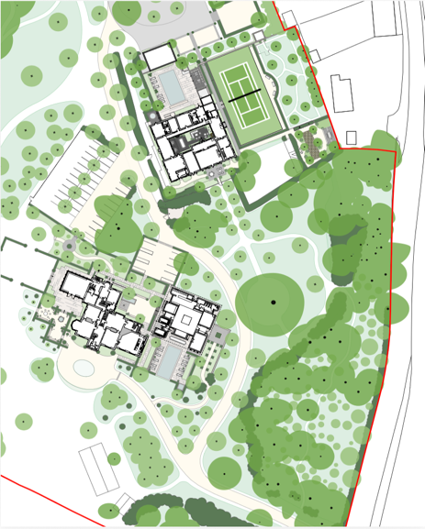
Eastleigh Stables
Marquee AREA
50 Bishopstrow
Figure 1Partial Site Plan
Bishopstrow Village lies in a Conservation Area and was built when traffic was confined to the horse and cart.

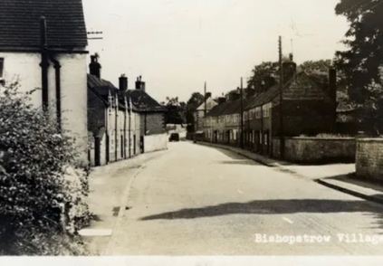  Figure 2 Bishopstrow Village 1920s | 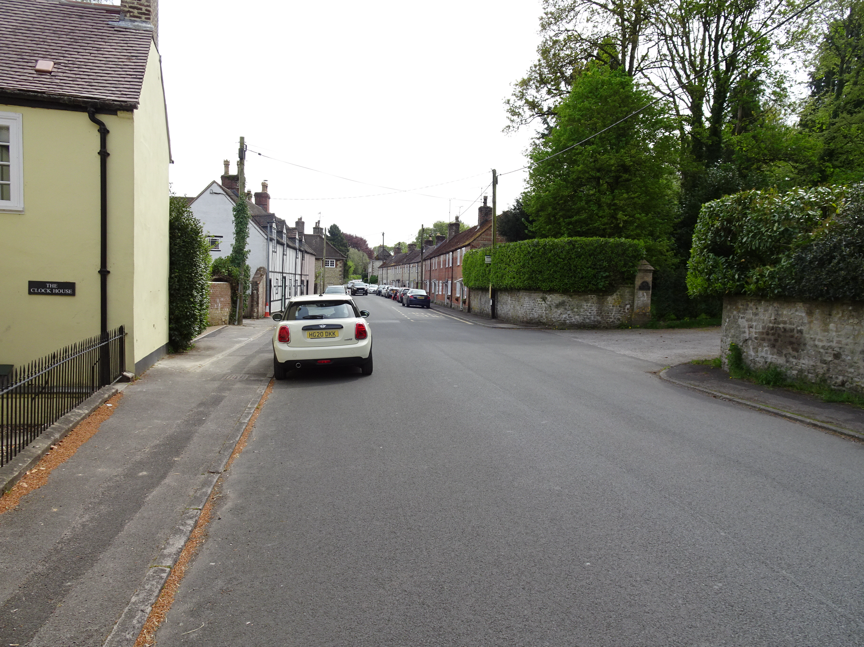  Figure 3 Bishopsstrow Village Today

Over the last 30 years or so ownership of the terraced properties has changed from predominantly older and single occupancy with perhaps 1 car to families with 2, or even more vehicles. Parking is almost exclusively on the west side of the road and there is no central white line, making it, in essence a single carriageway road.
THE PROPOSAL
Kindred Living make much of their experience operating a function venue at Bradmore House in Hammersmith, London, under their associated company Kindred Hospitality. However, there are 3 significant differences; Bradmore House is in Greater London, it has no overnight accommodation and has access to a wide variety of local transport options. A better comparison would be Euridge Manor and North Cadbury Manor both of which target a similar market but are relatively isolated. The Eastleigh Court complex is in a Conservation Area. It is an integral part of a Bishopstrow Village, 19 properties have a direct border with the complex and, when full, the occupants of the complex will comfortably outnumber the Village residents. Finally, it is poorly served by public transport.

Kindred Living propose creating a High Value Event complex with Eastleigh Court and Eastleigh Stables operating either as stand-alone sites or as a single complex. The Stables has its own swimming pool, but the occupants do not have access to the Court’s event spaces. That does not stop a group hiring in catering or inviting extra guests for a special meal or event. An Eastleigh Court booking includes full use of the pool and Pavilion, aka the event space (OMS Para 46b). Accommodation for both must be booked for a minimum of 3 nights so guests are likely to arrive on evening one and depart after the final night of the booking. Visiting guests will require transport to and from the site daily as will hired in catering and other function staff.

Insider knowledge, and recent press reports, of how a similar sized establishment is managed suggests that “special events”, weddings, reunions, and “big” birthdays for example, become 3-day or more events with celebrations on every day. Eastleigh Stables is currently marketed under the name Redmere Hall by Unique Homestays. Their “Booking” page shows that there are weeks this summer when the facilities are booked fully with 3 day or longer stays of groups of varying sizes. It is assumed that the owners will wish for an equivalent density of booking for the Eastleigh Court complex.

Noise. The Operational Management Statement focusses on the sound proofing of the Pavilion, aka the “event space” and but lists on-site staff for “Special Events” only, ie Option 3 at para 46 of the OMS. Para 8.34 of the Town Planning Statement does state that “staff will attend the site when guests are staying” but there is no mention of that in the Operational Management Statement. It is presumed that onsite staff will be responsible for supervising external noise levels, how that is done and under what legal authority, is unclear. However, the application specifically ignores the impact of the 200 or so days when there is no “special event” declared and so no onsite management. Those 50-70 “smaller” gatherings at Eastleigh Court will have full use of the facilities and are free to roam, party and invite outside guests at will. It is likely that there will a group booked into Eastleigh Stables at the same time. On a warm summer evening, with 2 groups, well-refreshed guests and 2 swimming pools, it is suggested that noise control will be an impossible task. Indeed, the Euridge Manor case would suggest that it is almost impossible to impose legally binding noise restrictions on such activities. Individuals paying the high prices that will be demanded will have little compunction to ignore any controls or requests.

Noise Conclusion. This application opens the prospect of an almost continuous use of the outside facilities for both small and large parties, especially during the warmer months. I can only agree with Mr Jacob, the Deputy Leader of Wiltshire Council, apropos Euridge Manor, when he is quoted as saying, “It is simply not fair that residents should have to put up with excessive noise as the result of the absence of a legally enforceable noise management plan….”. It is noted that Euridge Manor is a relatively isolated site. The Eastleigh Court complex is in Bishopstrow Village. The level of disturbance to my property and to my neighbours will be in direct contravention of Core Policies 39, 48 and 57as it will “detract from the character…of the settlement” and will be “detrimental to the amenities of residential areas.”

TRAFFIC
The application attempts to address issues about traffic in detail in Ref B and C. I have 2 related concerns; the volume of traffic the plans will generate and the implementation of a one-way system on the site.

Traffic Volume. Traffic surveys have shown that Bishopstrow sees more than 23,000 vehicle transits a week so although the overall volume of additional traffic generated by this development may not be significant it will make a bad situation worse. The OMS and Traffic Statement assume a single function in a 3-day booking. That is unrealistic and there will be significant additional vehicle trips over each 3-day booking. Of even more significance will be the times at which the traffic is increased. From 19 February to 3 March this year Wiltshire Council had a metro count, Project Number ID-0126-009, in place at a point close to the village SID site. The SID was on “spy” mode, ie counting traffic in both directions but not showing speeds. The overall results for the week were compatible. Fig 3 shows the volume of traffic by hour past the SID over a representative term time weekend Friday 27 February to Monday 2 March.

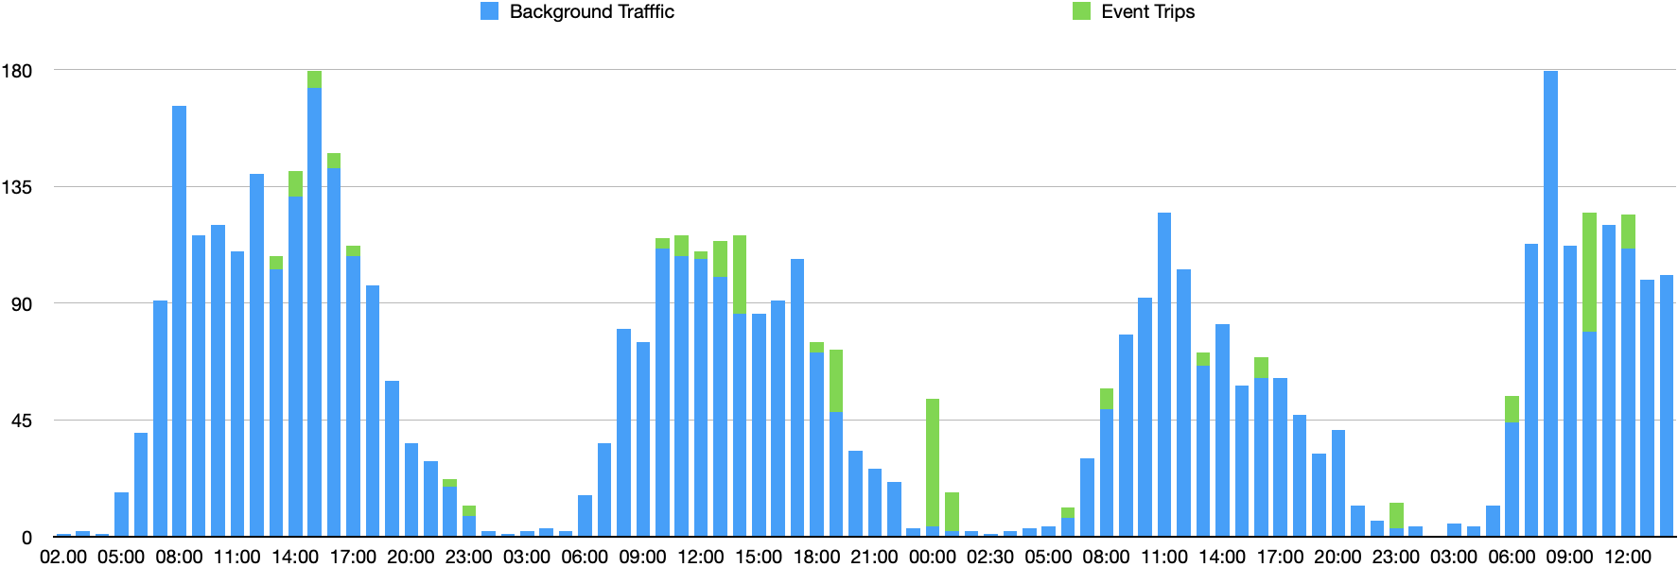
Friday. Saturday(Event Day) Sunday Monday
Figure 4 Weekend Traffic flow
It assumes an “event” on the Saturday. The blue columns show the “normal” traffic flow. The green columns show the estimated additional traffic for an “event” weekend. “Event” related traffic flow will peak in the normally quiet hours of 1700 – 0600hrs.

The One-Way System. I disagree with the Highways’ Department comment and its implication. The proposed one-way system will ensure that every vehicle that calls at the site will pass through the narrowest part of the village, and past my house, at some point in its visit. There is nothing to suggest that it will be used on event days only. If the picture in Fig 4, below, is compared with that included in the Transport Statement at Para 4.3, shown alongside, it shows the developers have no intention of using the North Gate for 2-way traffic. It is accepted that Old Bishopstrow House could benefit as vehicles leaving via the north gate illuminate their gardens as they come down the drive. The downside is the increase in afterhours traffic through the village during a time when residents’ parking guarantees single lane movement, see Fig 3 above. Moreover, it is highly unlikely that Warminster based commercial vehicle drivers, including taxis, leaving via the south entrance, will take kindly to being directed towards Sutton Veny to reach locations in Warminster. Indeed, to give such direction could be illegal.

The North Entrance. The assessment of visibility splays at the North entrance in the Transport Statement is flawed.

Traffic Speeds. The north and south bound speeds quoted are erroneous as the site used for the traffic survey is some 400m to the south of the gateway at a point where vehicles tend to accelerate when leaving the village. Coincidentally it almost exactly the spot where one of the Wiltshire Council surveys, mentioned above, took place. The 85%percentile speeds are very similar. However, Wiltshire Council did a second survey at the same time at a site in the middle of the terraced cottage rows and less than 150 m from the North entrance. At that site the combined 85%percentile speed was 28.58 mph. As noted there have been no recorded traffic accidents at that junction.

Road Layout. The road layout plan used in the visibility splay assessment ignores the fact that parked cars and a marked bus stop make that stretch of road an effective single lane with all traffic moving on the east side of the carriageway, see Fig 3 above. Fig 2, above, shows the North Entrance in quieter times when there was no hedge overgrowing the walls. It is suggested that the overhanging hedge, shown in Fig 4 below, will have had a significant impact of the visibility assessment. That hedge belongs to Eastleigh Stables.

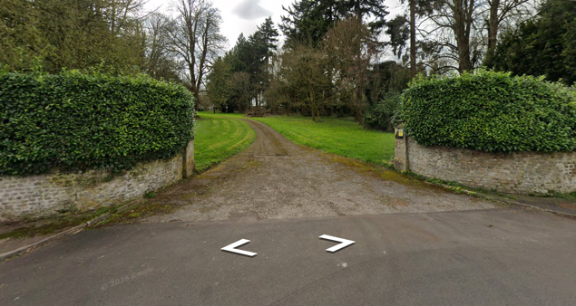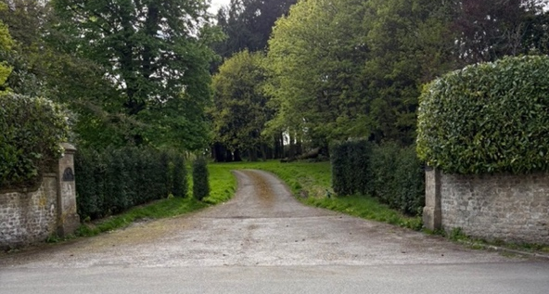
Figure 5 North Entrance Now
Conclusion. The Site Access Visibility Assessment is based on erroneous facts and may well have led to an erroneous conclusion. The proposers would appear to have pre-empted the conclusions of this application as they have narrowed the access by additional planting.

Traffic Conclusion. The proposal significantly downplays the volume and timing of the additional traffic that will be generated by this proposal. The proposed one-way system will exacerbate the impact on the village, making a bad situation worse. There is no attempt to meet the demands of Core policies 60-63 to reduce the reliance on private cars and mitigate the impact on the Village.

EASTLEIGH STABLES
At para 6.13 of the Town Planning Statement, it is stated that no internal or external alterations to the Stables will be made. That is interesting because there has been significant work carried out on the building in 2025 by its current owners. When the property was advertised by Knight Frank in 2024 it was described as having 5/6 bedrooms and 6 bathrooms. In the current application the description is of 7 double bedrooms, a twin room and a bunk room sleeping 8. The plans suggest the ceiling height on the upper floor has been raised, extra rooms created, and additional Velux style roof lights installed since the current owners took possession. Those are significant internal and external changes that could have required planning permission. This issue was raised under ENF/2025/00984, to date there has been no response.

In addition, Fig 2 shows the North entrance as it was. A close look shows an original gate post on the end of one of the curved walls. The gates disappeared in the 1980s. The proposal to position a new gate some metres into the property on the original Eastleigh Court entrance will look ridiculous and not in keeping with the entrance to a Grade 2 listed property.

WATER
I support fully the comments of Ms Phillips about the water supply, their property is some distance from Eastleigh Court down Eastleigh Wood Lane and it is a serious issue in that end of Bishopstrow. The private supply is drawn from the water main in the Bishopstrow Road via a pipe that runs between No 50 and No 47/48 Bishopstrow and through the garden of No 47/48. Certainly, it has not been updated in the past 50 years or more. The plans do not comply with Core Policy 40 as they will not provide for essential infrastructure for the old Eastleigh Estate.

EMPLOYMENT
After construction is complete the plans will provide only 1 long-term full-time post, that of Site manager. All others are part-time and most are at the whim of those making a booking with no guarantee of supporting local business. This does not conform to the requirements of Core Policy 48 -supporting rural life.

TOURISM
The Wiltshire Spatial Strategy directs tourism related projects to towns and “accessible service centres. Bishopstrow Village is neither. Whilst there may be a need for more high value tourist accommodation in Wiltshire the Bishopstrow House Hotel meets that need in Bishopstrow Village. The plans do not conform with Core Policies 39 & 40. There is no local need, they will have a direct adverse impact on the Bishopstrow Village.

.

