APPLICATION FOR HOUSEHOLDER PLANNING PERMISSION DELEGATED REPORT

APPLICATION REFERENCE: | PL/2026/01408
APPLICATION TYPE: | Householder planning permission
SITE ADDRESS: | Pennyfarthing Cottage, 65 High Street, Ansty, Salisbury, SP3 5QF
DEVELOPMENT DESCRIPTION: | Enclosure of car port to provide ancillary room
RECOMMENDATION: | That Planning Permission be GRANTED

PROPOSAL

The proposal seeks planning permission for the enclosure of the existing car port to provide ancillary room. The proposed alterations relate to the front elevation and the ground floor of the car port only. Existing and proposed front elevation and floor plan included below.

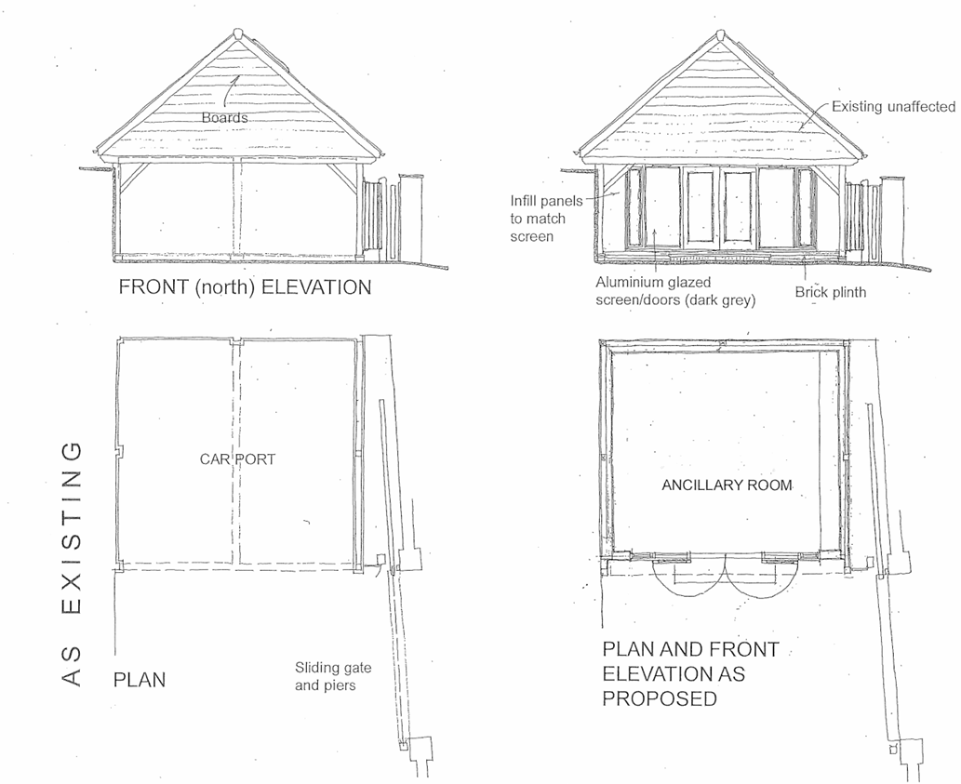

SITE DESCRIPTION/CONTEXT

The application site relates to a grade 2 listed dwelling with a detached garage with annexe over, located in Ansty which is defined as a small village by core policies 1, 2 and 27 of the Wiltshire Core Strategy; the detached garage is not listed. The dwelling is located towards the northern end of the modest sized residential plot with the garage to the southern end. The site is located within the Ansty conservation area and within the National Landscape. The site is located within the Hampshire River Avon Catchment and is Chilmark Quarries Bat SAC.

PLANNING HISTORY

Proposal / Summary
S/2011/1413 - Full planning permission Decision - Approve with Conditions Date: 7/11/2011 – Proposed alterations to ground and first floor of main cottage, including the addition of 2no of small windows to rear of cottage. Alterations to existing timber framed
extension to include raising the roof and making connection at first floor level through to existing cottage to provide a second bedroom
S/2011/1414 - Listed building consent Decision - Approve with Conditions Date: 7/11/2011 – Proposed alterations to ground and first floor of main cottage, including the addition of 2no of small windows to rear of cottage. Alterations to existing timber framed
extension to include raising the roof and making connection at first floor level through to existing cottage to provide a second bedroom
17/02473/FUL - Full planning permission Decision - Approve with Conditions Date: 18/5/2017 – Construction of garage building with studio above and works to site boundary treatments
17/03070/LBC - Listed building consent Decision - Approve with Conditions Date: 19/5/2017 – Construction of garage building with studio above and works to site boundary treatments
17/03620/FUL - Full planning permission Decision - Approve with Conditions Date: 3/7/2017 – Proposed rear extension and associated landscaping
17/04225/LBC - Listed building consent Decision - Approve with Conditions Date: 3/7/2017 – Proposed rear extension and associated landscaping
19/05888/FUL - Full planning permission Decision - Approve with Conditions Date: 7/8/2019 – Erection of summerhouse (retrospective)
18/03680/FUL - Full planning permission Decision - Approve with Conditions Date: 11/6/2018 – Construction of garage building and works to site boundary treatments
18/03850/LBC - Listed building consent Decision - Approve with Conditions Date: 11/6/2018 – Construction of garage building and works to site boundary treatments
19/01139/VAR - Removal/variation of conditions Decision - Refused Date: 27/3/2019 – Variation of Condition 2 of 18/03680/FUL (retrospective changes to the garage/outbuilding and site boundary treatments).
19/01140/LBC - Listed building consent Decision - Refused Date: 27/3/2019 – Retrospective changes to the garage/outbuilding and site boundary treatments.
17/07905/FUL - Full planning permission Decision - Approve with Conditions Date: 4/10/2017 – Proposed car port (revised siting and design of proposed garage pursuant to 17/02473/FUL and 17/03070/LBC)
17/08362/LBC - Listed building consent Decision - Approve with Conditions Date: 4/10/2017 – Proposed car port (revised siting and design of proposed garage pursuant to 17/02473/FUL and 17/03070/LBC)

Relevant Planning Policies:

The development plan for Wiltshire comprises the Wiltshire Core Strategy (WCS) (adopted January 2015) and any made neighbourhood plans, which remains the principal statutory planning document guiding development across the county. In line with Section 38(6) of the Planning and Compulsory Purchase Act 2004, planning decisions must be made in accordance with the development plan unless material considerations indicate otherwise.

Though the development plan is considered as a whole, those parts deemed to be particularly relevant to this pre-application enquiry are listed below:

Section 66 and 72 of the Planning (Listed Buildings and Conservation Areas) Act 1990

National Planning Policy Framework
National Planning Policy Guidance
National Design Guide

The adopted Wiltshire Core Strategy (WCS), with particular regard to:

Core Policy 1 Settlement Strategy
Core Policy 2 Delivery Strategy
Core Policy 27 Tisbury Community Area
Core Policy 50 Biodiversity and Geodiversity
Core Policy 51 Landscaping
Core Policy 57 Ensuring high quality design and place shaping
Core Policy 58 Ensuring the conservation of the historic environment
Core Policy 60, 61, 62 and 64 Transport
Core Policy 69 River Avon SAC

Supplementary Planning Document:

Wiltshire Design Guide
Creating Places Design Guide
Cranbourne Chase and West Wilts Downs National Landscape (formerly AONB) management plan

CONSULTATION RESPONSES

Parish Council: None received

Highways: No objection

Conservation: No objection to the proposed change of use and infilling in of the opening with a mix of glazing and timber cladding.

REPRESENTATIONS

No comments were received.

ASSESSMENT

Section 38(6) of the Planning and Compulsory Purchase Act 2004 states:

"If regard is to be had to the development plan for the purposes of any determination to be made under the planning Acts, the determination must be made in accordance with the plan unless material considerations indicate otherwise."

In accordance with this statutory requirement, this application has been assessed against the relevant policies of the Development Plan, including the adopted Wiltshire Core Strategy (2015) and, where applicable, any made Neighbourhood Plans.

Design, Heritage and Impact on Character and Appearance of the Area including National Landscape

Policy CP57 of the WCS seeks to ensure that all development proposals are of a high standard of design that responds positively to the local context and contributes to a sense of place. This includes consideration of layout, form, materials, scale, and relationship to the surroundings. Proposals should reinforce local distinctiveness, protect the character of settlements, and promote inclusive and attractive environments.

Policy CP58 of the WCS requires development to protect, conserve and, where possible, enhance the historic environment, including the character and setting of heritage assets. This reflects the approach in Sections 66 and 72 of the Planning (Listed Buildings and Conservation Areas) Act 1990, and paragraphs 212–221 of the NPPF. Where harm to a heritage asset is identified, there must be clear and convincing justification.

Policy CP51 requires that proposals protect, conserve and, where possible, enhance the character and quality of Wiltshire’s landscapes. Particular weight is given to National Landscapes (formerly AONBs), locally valued landscapes, and key visual receptors.

In this instance, the design of the proposed elevation to enclose the car port raises no concerns in terms of heritage impacts or impacts on the character of the area. Concerns were raised at preapplication regards the principle of the loss of the car port due to the vehicles then parking much closer to the host dwelling with impacts on the setting of the listed building.

The supporting design and access statement has stated that

The proposal to add a planting bed with raised sleeper surround follows comments arising from preapplication submission and has been introduced in order to maintain distance between car parking and the cottage.

The front elevation of the existing car port and lower part of the building are screened from public views by the existing boundary treatment as shown below.

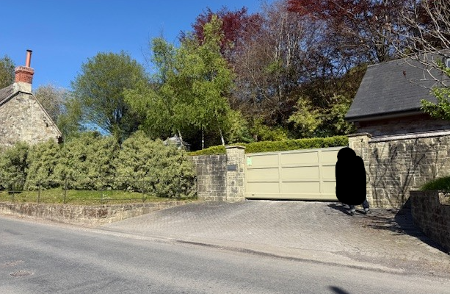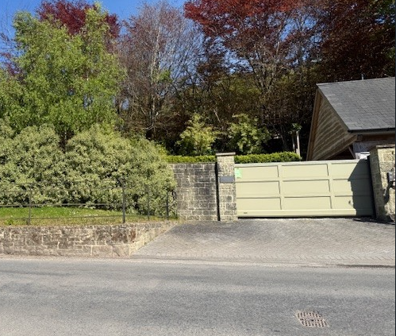

The use of the enclosed car port ancillary to the host dwelling raises no concerns in this context.

Overall, it is not considered that the proposal will have an adverse impact on the character of the area, heritage assets or National Landscape.

Having regard to the above, the proposal complies with the design principles set out in Core Policies 51, 57 and 58 of the Wiltshire Core Strategy and Appendix D of the Wiltshire Design Guide, the relevant provisions of the NPPF and S66 and 72 of the Planning (Listed Buildings and Conservation Areas) Act 1990.

Amenity

Point vii of Core Policy 57 - Ensuring High Quality Design and Place Shaping of the Wiltshire Core Strategy seeks to ensure that developments do not adversely affect neighbouring properties.

The National Planning Policy Framework (NPPF), particularly Paragraph 135(f), stresses that planning decisions should ensure developments provide a high standard of amenity for existing and future users.

The proposed development has been assessed in terms of its potential impact on the residential amenity of neighbouring properties, with particular regard to loss of light, overshadowing, loss of privacy, and overbearing effects.

The nature of the proposed development is unlikely to conflict with neighbour amenity with no new foot print being created and no new openings in the existing building which could lead to overlooking.

The proposal therefore accords with Core Policy 57 point vii in respect of safeguarding residential amenity and Appendix D of the Wiltshire Design Guide.

Highways Impact

Core Policy 57 (xiv) of the Wiltshire Core Strategy seeks to ensure that development must meet the requirements of Core Policy 61. This policy requires proposals to be capable of being served by safe access to the highway network. Core Policy 64 seeks to ensure compliance with parking standards set out in the Local Transport Plan.

The National Planning Policy Framework (NPPF), particularly Paragraph 115 and 116, requires that development proposals do not have an unacceptable impact on highway safety and that safe and suitable access to the site can be achieved for all users.

The proposals do not show any alterations to the existing access but do remove current parking within the garage. The property is a three bed dwelling (two bedrooms in the dwelling and a further bedroom in the annexe) and therefore is required to provide a minimum of two off road parking spaces. There is currently off road parking within the site for two cars and room for vehicles to turn and exit in a forward gear, the Highway Authority has raised no objections as the proposals are in accordance with Wiltshire’s adopted parking standards, and access arrangements are acceptable.

The proposal is therefore considered to comply with Core Policies 57 (xiv), 61 and 64 of the Wiltshire Core Strategy, the NPPF and the Wiltshire Local Transport Plan.

Ecology Impact

Core Policy 50 of the Wiltshire Core Strategy seeks to protect and enhance biodiversity and geodiversity, including through ensuring that development avoids harm to protected species and habitats.

The National Planning Policy Framework (NPPF), in Paragraphs 193, requires that development minimises impacts on and provides net gains for biodiversity, including ensuring mitigation is secured where harm cannot be avoided.

While the application site is located within the Hampshire River Avon Catchment this designation has no implication to the assessment of the enclosure of the car port for ancillary use to the host dwelling.

Biodiversity Net Gain - Householder planning applications are exempt from the requirement to deliver Biodiversity Net Gain under Schedule 7A, Section 4(2)(a) of the Town and Country Planning Act 1990, as inserted by the Environment Act 2021.

As such, the development complies with Core Policy 50 and 69 of the Wiltshire Core Strategy and the relevant provisions of the NPPF.

CONCLUSION

The proposed development is considered to be acceptable in terms of its design, scale, and relationship with the surrounding area. It would not result in any unacceptable harm to the character of the locality, the amenities of neighbouring occupiers, or the interests of highway safety, heritage, or ecology.

The proposal is therefore considered to comply with the relevant policies of the Wiltshire Core Strategy, the Wiltshire Local Plan, and the National Planning Policy Framework. As such, the application is recommended for approval, subject to the conditions set out below.

RECOMMENDATION: That Planning Permission be GRANTED subject to conditions.

1. The development hereby permitted shall be begun before the expiration of three years from the date of this permission.

REASON: to comply with the provisions of Section 91 of the Town and Country Planning Act 1990 as amended by the Planning and Compulsory Purchase Act 2004

2. The development hereby permitted shall be carried out in accordance with the following approved plans:

Application form received 02/03/2026
Site block and details as existing and proposed Drg no 224028/02A received 02/03/2026
Location plan Drg no 224028/01 received 02/03/2026

REASON: for the avoidance of doubt and in the interests of proper planning.

3. The materials to be used in the construction of the external surfaces of the development hereby permitted shall match those detailed on the approved plans.

REASON: In the interests of visual amenity and the character and appearance of the area

Informatives

1. The effect of paragraph 13 of Schedule 7A to the Town and Country Planning Act 1990 is that planning permission granted for development of land in England is deemed to have been granted subject to the condition (biodiversity gain condition) that development may not begin unless:

(a) a Biodiversity Gain Plan has been submitted to the planning authority, and
(b) the planning authority has approved the plan.

The planning authority, for the purposes of determining whether to approve a Biodiversity Gain Plan, if one is required in respect of this permission would be Wiltshire Council.

There are statutory exemptions and transitional arrangements which mean that the biodiversity gain condition does not always apply. For further information on exempt developments please refer to:
https://www.gov.uk/guidance/biodiversity-net-gain-exempt-developments
Based on the information available this permission is considered to be one which will not require the approval of a biodiversity gain plan before development is begun because one or more of the statutory exemptions or transitional arrangements is considered to apply.

