APPLICATION FOR FULL PLANNING PERMISSION DELEGATED REPORT

APPLICATION REFERENCE: | PL/2026/01551
APPLICATION TYPE: | Full planning permission
SITE ADDRESS: | Adjacent the Church Hall, Watersmeet Road, Harnham, Salisbury, SP2 8JH
DEVELOPMENT DESCRIPTION: | Demolition of prefabricated double garage and construction of single garage in traditional material on same footprint
RECOMMENDATION: | That Planning Permission be GRANTED

PROPOSAL

The proposal seeks planning permission for the demolition of an existing garage and the erection of a replacement garage.

The submitted planning statement states:

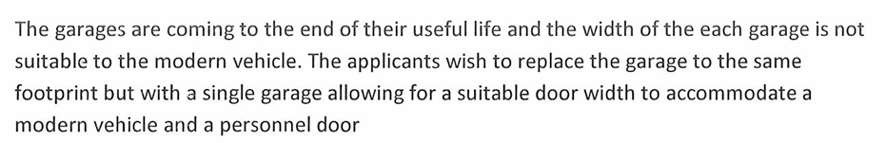

Existing garage to be demolished

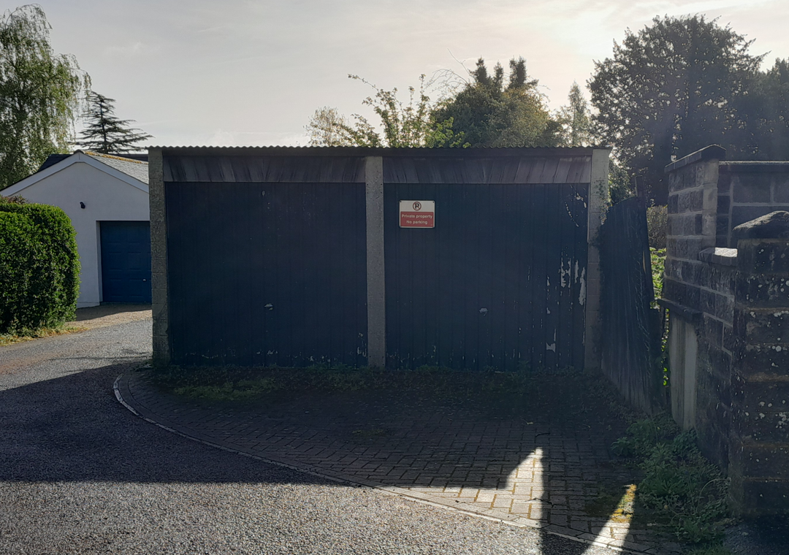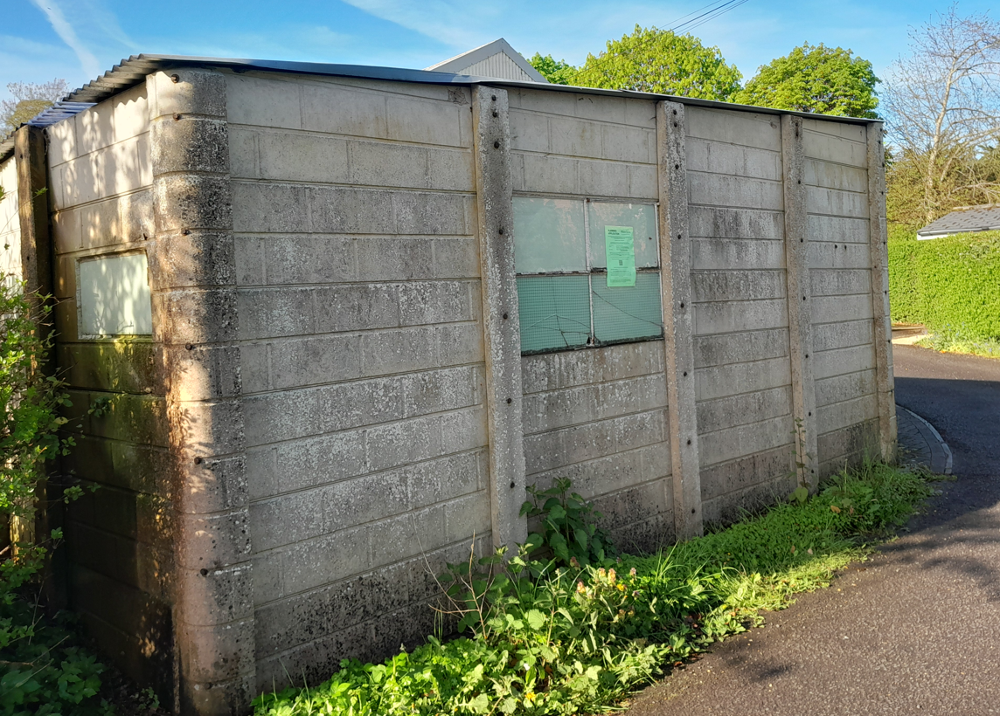

Proposed garage

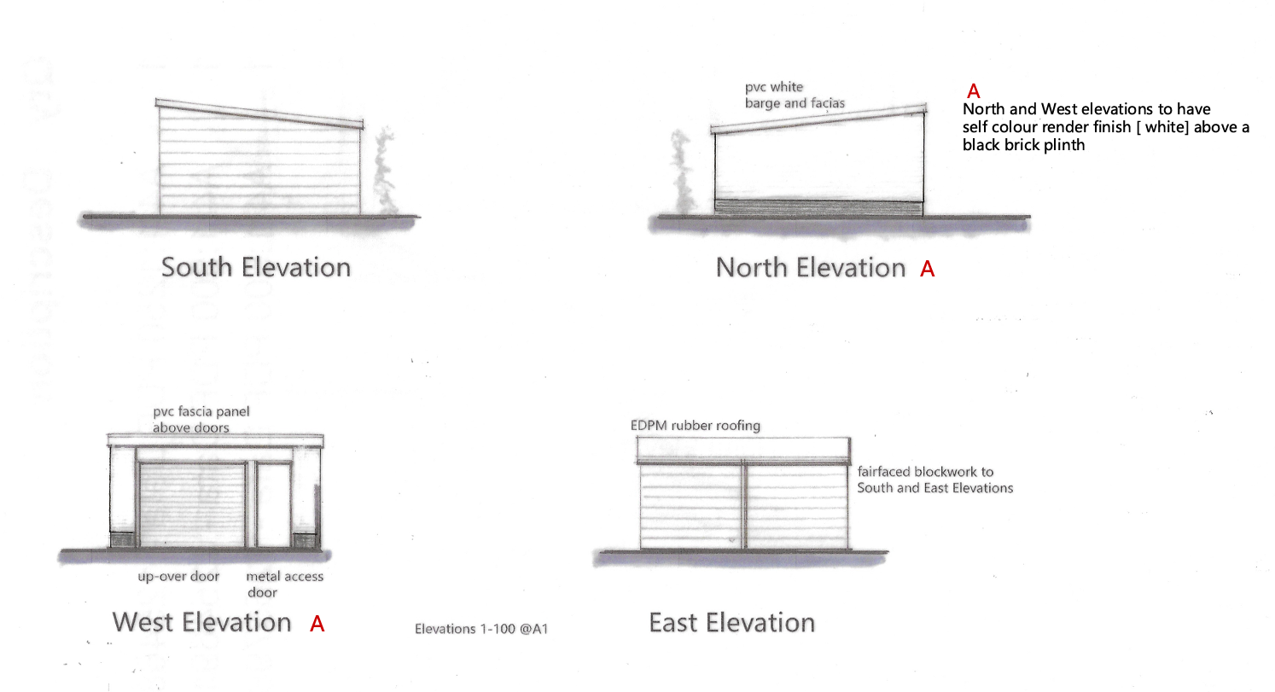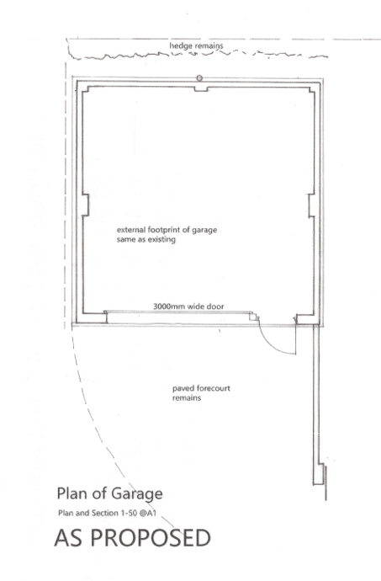

SITE DESCRIPTION/CONTEXT

The application site relates to a double garage situated within a small plot of land; the garage has no associated dwelling. The site is located on a corner plot on Watersmeet Road, a small quiet cul-de-sac which serves a handful of residential properties which is located within an established residential area within the settlement boundary of the principal settlement of Salisbury. Salisbury is defined as a principal settlement by Wiltshire Core Strategy (WCS) core policies 1 (Settlement Strategy), 2 (Delivery Strategy) and 20 (Spatial Strategy for the Salisbury Community Area). The site is located adjacent to the Hall, All Saints Church and Riverside Hotel (formerly Grassmere Hotel).

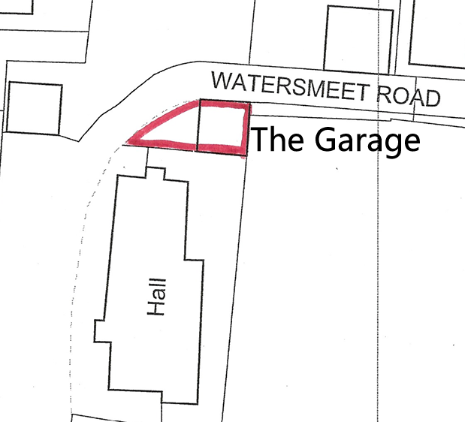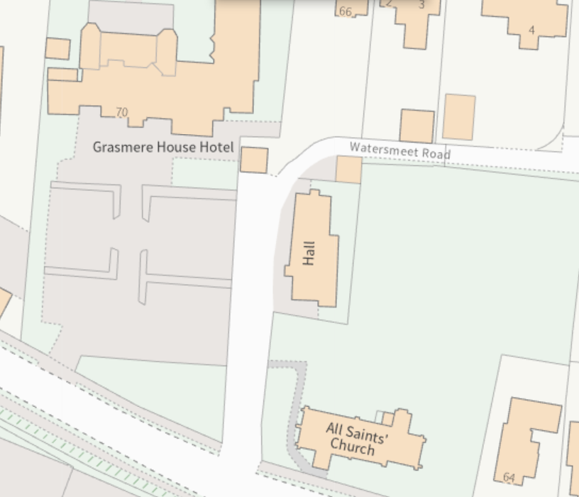

The site is located within the conservation area, is not listed but is adjacent to two grade 2 listed buildings as shown below marked with black hatching, the conservation area is shaded green.

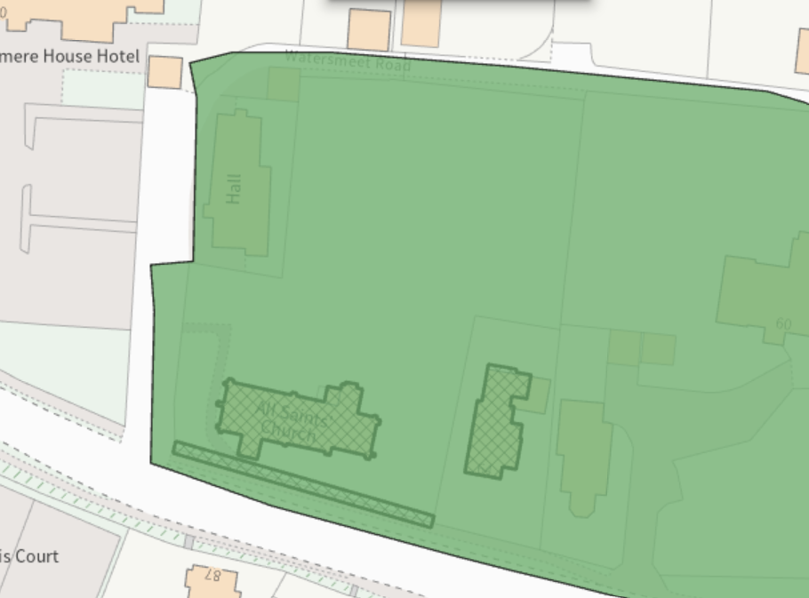

The site is located within the Hampshire River Avon Catchment, and the site lies within the 13.8km zone of influence for the New Forest internationally protected sites, which comprises the New Forest SPA, New Forest SAC and New Forest Ramsar site.

PLANNING HISTORY

None

RELEVANT POLICIES AND GUIDANCE

Statutory Legislation:

Planning (Listed Building and Conservation Areas) Act 1990 sections 66 and 72

National Planning Policy:

- National Planning Policy Framework (NPPF)
- Planning Practice Guidance (PPG)
- National Design Guide

Development Plan:

The development plan for Wiltshire comprises the Wiltshire Core Strategy (WCS) (adopted January 2015) and any made neighbourhood plans, which remains the principal statutory planning document guiding development across the county. In line with Section 38(6) of the Planning and Compulsory Purchase Act 2004, planning decisions must be made in accordance with the development plan unless material considerations indicate otherwise.

Though the development plan is considered as a whole, those parts deemed to be particularly relevant to this application are listed below:

The adopted Wiltshire Core Strategy (WCS), with particular regard to:

Core Policy 1 Settlement Strategy;
Core Policy 2 Delivery Strategy;
Core Policy 20 Spatial Strategy for the Salisbury Community Area;
Core Policy 50 Biodiversity and Geodiversity;
Core Policy 57 Ensuring High Quality Design and Place Shaping;
Core Policy 58 Ensuring the Conservation of the Historic Environment;
Core Policy 69 River Avon SAC

Supplementary Planning Documents:

Creating Places Design Guide
Wiltshire Design Guide
Wiltshire Local Transport Plan – Car Parking Strategy
Neighbourhood Plan

CONSULTATION RESPONSES

City Council: Support

Conservation Officer: No objection

REPRESENTATIONS

No comments were received.

ASSESSMENT

Section 38(6) of the Planning and Compulsory Purchase Act 2004 states:

"If regard is to be had to the development plan for the purposes of any determination to be made under the planning Acts, the determination must be made in accordance with the plan unless material considerations indicate otherwise."

In accordance with this statutory requirement, this application has been assessed against the relevant policies of the Development Plan, including the adopted Wiltshire Core Strategy (2015) and, where applicable, any made Neighbourhood Plans.

Design and Impact upon the character and context of the area

From the point of view of the historic environment the main statutory tests are set out within the Planning (Listed Building and Conservation Areas) Act 1990.

Section 72(1) of the Act requires the Council to pay special attention to the desirability of preserving or enhancing the character or appearance of designated Conservation Areas.

The Council’s Core Strategy Policy CP58 ‘Ensuring the conservation of the historic environment’ requires that designated and non-designated heritage assets and their settings will be conserved, and where appropriate enhanced, in a manner appropriate to their significance and encourages proposals which improve the condition of heritage assets at risk.

The Council’s Core Strategy CP 57: Ensuring high quality design requires a high quality of design in all new developments. The policy requires applicants to “demonstrate how the proposal will make a positive contribution to the character of Wiltshire through (amongst other things) responding to the value of the natural and historic environment and being sympathetic to and conserving historic buildings and landscapes. Development is required to respond positively to the existing in terms of building layouts, built form, height, mass, scale, building line, plot size, elevational design, materials, streetscape and rooflines to effectively integrate the building into its setting.

The NPPF outlines government policy for planning. Chapter 16 of the NPPF 'Conserving and enhancing the historic environment' sets out the Government's high-level policies concerning heritage and sustainable development.

The development site relates to an existing detached garage which is an anomaly in this location as it does not have an associated dwelling. The application site is a small plot of land housing just the garage and small forecourt. The submitted planning statement states -

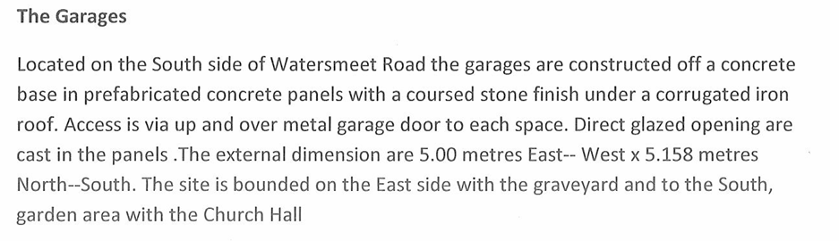
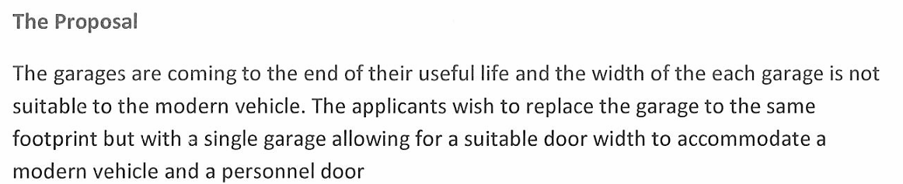
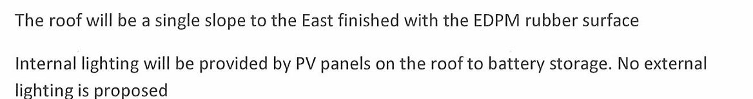

The proposed garage will be built with render over a black brick plinth on the North and West elevations with blockwork to the South and East.

Due to the location of the site within the conservation area and adjacent to listed buildings, the Council’s conservation officer has been consulted and provided the following comments.

The site lies within the Salisbury City CA, to the rear of the churchyard of the grade II listed All Saints' Church and its hall. The existing building is functional mid-C20 structure of no architectural merit in a rather nondescript setting: their loss raises no concerns. The replacement would be very similar in form and scale and would cause no harm to heritage assets, preserving the character of the CA and the setting of the listed building, in accordance with the aims of sections 66 and 72 of the PLBCA Act 1990, the NPPF and CP58.

Given that the proposals will essentially see a replacement garage on the same footprint of the same dimensions and use, Officers concur with the Conservation Officer and can see no reasons to object to the proposed development which will be an improvement in terms of visual impact in this location.

Having regard to the above, the proposal complies with the design principles set out in Core Policy 57 and 58 of the Wiltshire Core Strategy and Appendix D of the Wiltshire Design Guide.

Amenity

Point vii of Core Policy 57 - Ensuring High Quality Design and Place Shaping of the Wiltshire Core Strategy seeks to ensure that developments do not adversely affect neighbouring properties.

The National Planning Policy Framework (NPPF), particularly Paragraph 135(f), stresses that planning decisions should ensure developments provide a high standard of amenity for existing and future users.

The proposed development has been assessed in terms of its potential impact on the residential amenity of neighbouring properties, with particular regard to loss of light, overshadowing, loss of privacy, and overbearing effects.

The application site is bounded by a Church Hall, Church Yard and Hotel with residential dwellings to the north. The development relates to a replacement garage in the same location, footprint and scale as the existing garage but with a different external materials finish to the roadside elevations. There is no intended change of use of the garage which will continue as a garage to park a normal vehicle. Therefore, there are no concerns regards amenity impacts through the scale, design and siting of the garage, it is however considered prudent to add a condition to any permission to ensure the garage isn’t used for commercial purposes without prior consent from the Local Planning Authority.

The proposal therefore accords with Core Policy 57 point vii in respect of safeguarding residential amenity and Appendix D of the Wiltshire Design Guide.

Highways Impact

Core Policy 57 (xiv) of the Wiltshire Core Strategy seeks to ensure that development must meet the requirements of Core Policy 61. This policy requires proposals to be capable of being served by safe access to the highway network. Core Policy 64 seeks to ensure compliance with parking standards set out in the Local Transport Plan.

The National Planning Policy Framework (NPPF), particularly Paragraph 115 and 116, requires that development proposals do not have an unacceptable impact on highway safety and that safe and suitable access to the site can be achieved for all users.

The application site is a small plot of land which comprises a double garage with small open forecourt to the front and will cover the same footprint as the existing garage. As existing, the garage walls form three boundaries with just the west elevation opening onto a small forecourt.

Given that the development proposes a replacement building in the same location, same scale and use but will now be a single rather than double garage, it is considered that the impacts on highway safety is neutral.

The proposal is therefore considered to comply with Core Policies 57 (xiv), 61 and 64 of the Wiltshire Core Strategy, the NPPF, and the Wiltshire Local Transport Plan.

Ecology Impact

Core Policy 50 of the Wiltshire Core Strategy seeks to protect and enhance biodiversity and geodiversity, including through ensuring that development avoids harm to protected species and habitats.

The National Planning Policy Framework (NPPF), in Paragraphs 193, requires that development minimises impacts on and provides net gains for biodiversity, including ensuring mitigation is secured where harm cannot be avoided.

While the application site is located within the Hampshire River Avon Catchment and the New Forest Protected Sites these designations have no implication to the assessment of a replacement garage such as that proposed with this application.

Biodiversity Net Gain - The effect of paragraph 13 of Schedule 7A to the Town and Country Planning Act 1990 is that planning permission granted for development of land in England is deemed to have been granted subject to the condition (biodiversity gain condition) that development may not begin unless:
(a) a Biodiversity Gain Plan has been submitted to the planning authority, and
(b) the planning authority has approved the plan.

The planning authority, for the purposes of determining whether to approve a Biodiversity Gain Plan, if one is required in respect of this permission would be Wiltshire Council. There are statutory exemptions and transitional arrangements which mean that the biodiversity gain condition does not always apply.

Based on the information available this permission is considered to be one which will not require the approval of a biodiversity gain plan before development is begun because one or more of the statutory exemptions or transitional arrangements, in particular it is considered in this instance that the proposal would be exempt from demonstrating Biodiversity Net Gain as it is a temporary development.

As such, the development complies with Core Policy 50 and 69 of the Wiltshire Core Strategy and the relevant provisions of the NPPF.

CONCLUSION

The proposed development is considered to be acceptable in terms of its design, scale, and relationship with the surrounding area. It would not result in any unacceptable harm to the character of the locality, the amenities of neighbouring occupiers, or the interests of highway safety, heritage, or ecology.

The proposal is therefore considered to comply with the relevant policies of the Wiltshire Core Strategy, the Wiltshire Local Plan, and the National Planning Policy Framework. As such, the application is recommended for approval, subject to the conditions set out below.

RECOMMENDATION: That Planning Permission be GRANTED subject to conditions.

1. The development hereby permitted shall be begun before the expiration of three years from the date of this permission.

REASON: to comply with the provisions of Section 91 of the Town and Country Planning Act 1990 as amended by the Planning and Compulsory Purchase Act 2004

2. The development hereby permitted shall be carried out in accordance with the following approved plans:

Replacement garage Drg no 05925 1 Rev A received 24/04/2026

REASON: for the avoidance of doubt and in the interests of proper planning.

3. The development hereby approved shall be used solely for the parking of private motor vehicles and/or incidental domestic storage and for no other purpose, including any commercial, business or industrial use.

REASON: In the interests of residential amenity.

4. The materials to be used in the construction of the external surfaces of the development hereby permitted shall match those detailed on the approved plans.

REASON: In the interests of visual amenity and the character and appearance of the area

Informatives

1. The effect of paragraph 13 of Schedule 7A to the Town and Country Planning Act 1990 is that planning permission granted for development of land in England is deemed to have been granted subject to the condition (biodiversity gain condition) that development may not begin unless:

(a) a Biodiversity Gain Plan has been submitted to the planning authority, and
(b) the planning authority has approved the plan.

The planning authority, for the purposes of determining whether to approve a Biodiversity Gain Plan, if one is required in respect of this permission would be Wiltshire Council.

There are statutory exemptions and transitional arrangements which mean that the biodiversity gain condition does not always apply. For further information on exempt developments please refer to:
https://www.gov.uk/guidance/biodiversity-net-gain-exempt-developments
Based on the information available this permission is considered to be one which will not require the approval of a biodiversity gain plan before development is begun because one or more of the statutory exemptions or transitional arrangements is considered to apply.

2. The applicant is requested to note that this permission does not affect any private property rights and therefore does not authorise the carrying out of any work on land outside their control. If such works are required, it will be necessary for the applicant to obtain the landowner’s consent before such works commence.

If you intend carrying out works in the vicinity of the site boundary, you are also advised that it may be expedient to seek your own advice with regard to the requirements of the Party Wall Act 1996.

3. Any alterations to the approved plans, brought about by compliance with Building Regulations or any other reason must first be agreed in writing with the Local Planning Authority before commencement of work.

