HOUSEHOLDER PLANNING APPLICATION.
CASE OFFICER REPORT

APPLICATION REFERENCE: | PL/2026/01452
APPLICATION TYPE: | Householder
SITE ADDRESS: | 14 Stormore, Dilton Marsh, Westbury, BA13 4BH.
DEVELOPMENT DESCRIPTION: | First Floor Dormer and Rear Extension
RECOMMENDATION: | Approve with Conditions.

PROPOSAL
The proposal seeks planning permission for the construction of a first-floor dormer window on the east side elevation and for the construction of a ground floor rear extension on the south aspect.

SITE DESCRIPTION/CONTEXT
The principal dwelling is a two-storey detached house set within its own plot and located within an established residential area within the Large Village of Dilton Mrash. The host dwelling benefits from an off-road parking area to the front elevation and an attached garage. The surrounding properties are all similar in style comprising of detached buildings.

The application site sits within the Salisbury Plain Spa 6400 metre buffer zone, the Bath and Bradford on Avon BAT SAC and also outside of but near the border of the Yellow zone of the adopted Trowbridge Westbury Bat Mitigation Strategy (TWBMS).

The site is located within a Special Landscape Area and is not in a Conservation Area.

RELEVANT PLANNING HISTORY
Proposal / Summary
N/A

RELEVANT POLICIES AND GUIDANCE
Wiltshire Core Strategy:

- Core Policy 57 Ensuring High Quality Design and Place Shaping
- Core Policy 50: Biodiversity and Geodiversity
- Core Policy 51: Landscape
- Core Policy 58: Ensuring the Conservation of the Historic Environment
- Core Policy 61: Transport and New Development
- Core Policy 64: Demand Management
- Core Policy 67: Flood Risk

Dilton Marsh ‘Made’ Neighbourhood Plan. Special Landscape Area.

Wiltshire Design Guide: Appendix D – Design Guidance for Householder extensions

The National Planning Policy Framework (NPPF)

The Planning Practice Guidance

National Design Guide

Emerging Wiltshire Local Plan:
The examination of the emerging Wiltshire Local Plan has been paused and the weight to be afforded to any part of the emerging plan can be no more than very limited. A decision on how to proceed will be made by the Council in May 2026.

CONSULTATION RESPONSES
Dilton Marsh Parish Council: Chose to comment that that the proposed dormer window would directly overlook a neighbouring property, which would result in loss of privacy and amenity.

Highways: No objections.

REPRESENTATIONS
No comments were received.

PRINCIPLE OF THE PROPOSAL.
The principle of the proposed scheme is considered to be acceptable for the reasons as discussed below.

ASSESSMENT
Section 38(6) of the Planning and Compulsory Purchase Act 2004 states:

"If regard is to be had to the development plan for the purposes of any determination to be made under the planning Acts, the determination must be made in accordance with the plan unless material considerations indicate otherwise."

In accordance with this statutory requirement, this application has been assessed against the relevant policies of the Development Plan, including the adopted Wiltshire Core Strategy (2015) and the made Neighbourhood Plan for Dilton Marsh.

Design and Impact upon the upon the character and context of the area

Core Policy 57 - Ensuring High Quality Design and Place Shaping of the Wiltshire Core Strategy seeks to ensure that all new development is of high design quality, reflecting local context, character, and distinctiveness.

The proposals can be viewed within the plan snippets taken from the submitted plans:

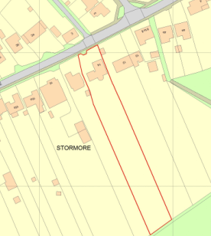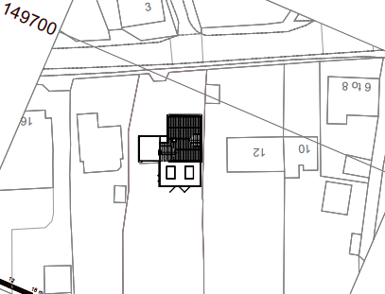
Location Plan Proposed Site Plan

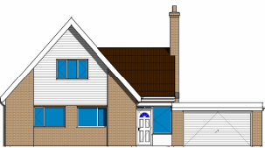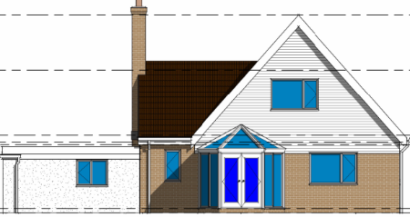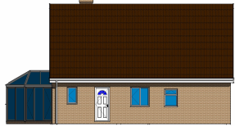
Existing front, rear and side elevations

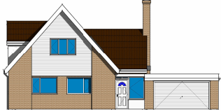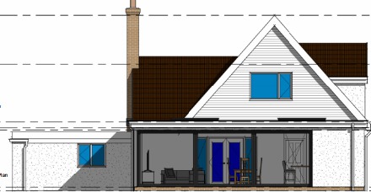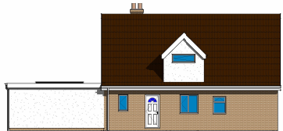
Proposed front, rear and side elevations.

The proposal would see the removal of a conservatory from the rear of the building and for its replacement with a single storey flat roof extension, which would extend to the full width of the host dwelling and would provide an enlarged dining/lounge area. This extension would lead out onto the site’s private rear garden area. The scheme would also see the construction of a small sized dormer window on the east elevation, which would serve as a bathroom. Materials would match those as existing.

In terms of design, such existing design features of the dwelling are those of a contemporary design, the proposed enlarged glazed single storey extension with its flat roof is also arguably contemporary, albeit of a subservient nature. The dormer window mimics the existing roof profile of the building’s front elevation and so would not look out of keeping, and likewise, due to its small size is a subordinate addition to the main house.

Therefore, in summary, having regard to the above, the proposal complies with the design principles set out in Core Policy 57 of the Wiltshire Core Strategy and Appendix D of the Wiltshire Design Guide.

Amenity
Point vii of Core Policy 57 - Ensuring High Quality Design and Place Shaping of the Wiltshire Core Strategy seeks to ensure that developments do not adversely affect neighbouring properties. The National Planning Policy Framework (NPPF), particularly Paragraph 135(f), stresses that planning decisions should ensure developments provide a high standard of amenity for existing and future users.
The proposed single storey rear extension would look out onto and face the rear garden area, it would not harmfully impact on neighbouring amenity. The proposed dormer window would serve a bathroom, and its small sized window would have obscure glazing for privacy, this being as marked up on the plans. Therefore, to allay the Parish Council’s concerns, there would not be any harmful overlooking of neighbours for these reasons.

Likewise, due to the location and orientation of the two proposals, there would not be any significant overshadowing or loss of light to the most immediate neighbour at No.12 or 14a.

The proposal therefore accords with Core Policy 57 point vii. in respect of safeguarding residential amenity and Appendix D of the Wiltshire Design Guide.

Ecology Impact CP50 requires no net loss of biodiversity on site. The application site sits within the Salisbury Plain Spa 6400 metre buffer zone, the Bath and Bradford on Avon BAT SAC and is outside of but borders the yellow zone of the adopted Trowbridge Westbury Bat Mitigation Strategy (TWBMS).

It is considered that due to the proposed development being of a minor nature and being located within a high-density urban location, it is considered unlikely to result in harm to bats or their habitat. There is no mechanism for significant effects from recreational pressure since it does not result in the creation of a new dwelling. Accordingly, the proposal is acceptable in this regard. As such, the development complies with Core Policy 50 of the Wiltshire Core Strategy and the relevant provisions of the NPPF. It is however, considered necessary to include the council’s standard ecology informative relating to bats.

Biodiversity Net Gain. This application is exempt from the requirement to deliver Biodiversity Net Gain under Schedule 7A, Section 4(2)(a) of the Town and Country Planning Act 1990, as inserted by the Environment Act 2021, because the proposal is a householder extension.

Special Landscape Area. It is noted that the site is within a Special Landscape Area (SLA), however, for the above discussed reasons and due to the proposals’ small size being located within an established residential area, it is appraised that there would be no harm inflicted on the open character of the surrounding SLA.

CONCLUSION
The proposed development is acceptable in terms of its design, scale, and relationship with the surrounding area. It would not result in any unacceptable harm. The proposal is therefore considered to comply with the relevant policies of the Wiltshire Core Strategy, the Wiltshire Local Plan, and the National Planning Policy Framework. As such, the application is recommended for approval, subject to the conditions set out below.

RECOMMENDATION: Planning Permission be GRANTED subject to conditions.

