APPLICATION FOR HOUSEHOLDER PLANNING PERMISSION DELEGATED REPORT

APPLICATION REFERENCE: | PL/2026/01656
APPLICATION TYPE: | Wiltshire Council R3
SITE ADDRESS: | 6 Coronation Road, Salisbury, SP2 9DB
DEVELOPMENT DESCRIPTION: | Single storey side extension and associated works
RECOMMENDATION: | That Planning Permission be GRANTED

PROPOSAL

The proposal seeks planning permission for the erection of a single storey side extension.

Existing floor plans

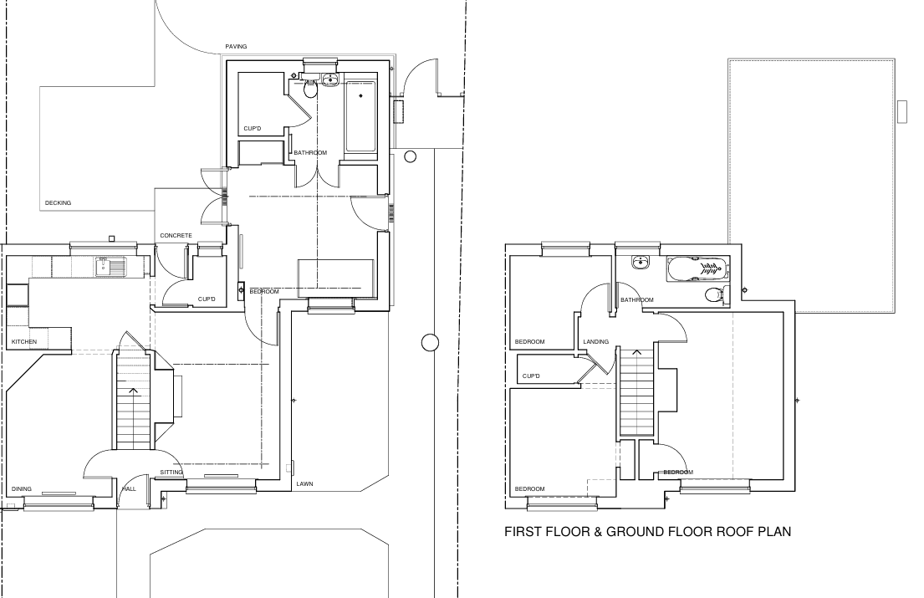

Proposed floor plans.

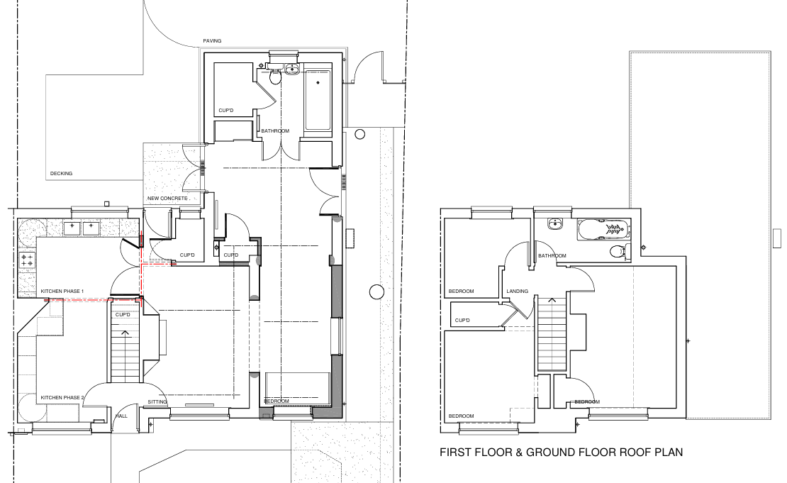

Existing and proposed front elevation

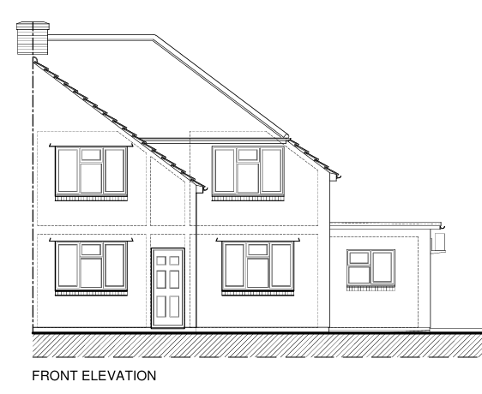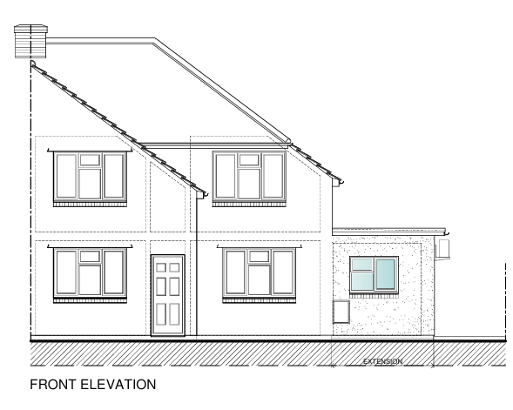

Existing and proposed side elevation

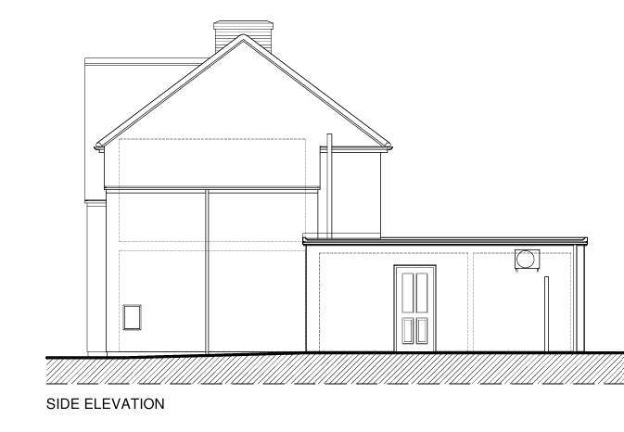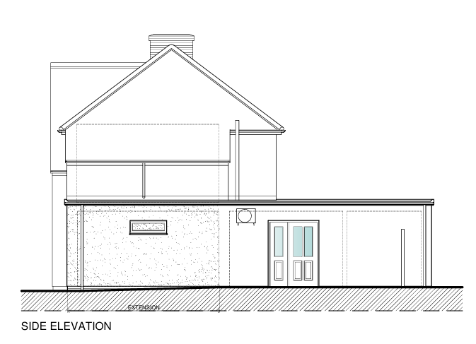

SITE DESCRIPTION/CONTEXT

The application site relates to an extended semi-detached dwelling located on the north eastern side of Coronation Road within an established residential area within the settlement boundary of the principal settlement of Salisbury as defined by Wiltshire Core Strategy (WCS) core policies 1 (Settlement Strategy), 2 (Delivery Strategy) and 20 (Spatial Strategy for the Salisbury Community Area). The property is set back from the road with an area for off road parking to the front; an enclosed garden is located to the rear. The property is not listed, and it is not in a conservation area. The site is located within the Hampshire River Avon Catchment, and the site lies within the 13.8km zone of influence for the New Forest internationally protected sites, which comprises the New Forest SPA, New Forest SAC and New Forest Ramsar site.

PLANNING HISTORY

Proposal / Summary
S/2012/1011 - Full planning permission Decision - Approve with Conditions Date: 22/8/2012 – Single storey flat roof extension to side/rear of property
PL/2024/03447 - Householder planning permission Decision - Approve with Conditions Date: 19/6/2024 – Proposed single storey extensions and internal alterations to provide better accommodation for person with disabilities & their carers.

Of particular note is approved application PL/2024/03447 which is extant but has not been implemented. The approved application also sought permission for single storey side extension and also a single storey rear extension. The approved ground floor plan and approved front and side elevations included below. It can be seen from these approved plans that the scheme now proposed is similar to the previously approved scheme, but the rear extension has now been omitted.

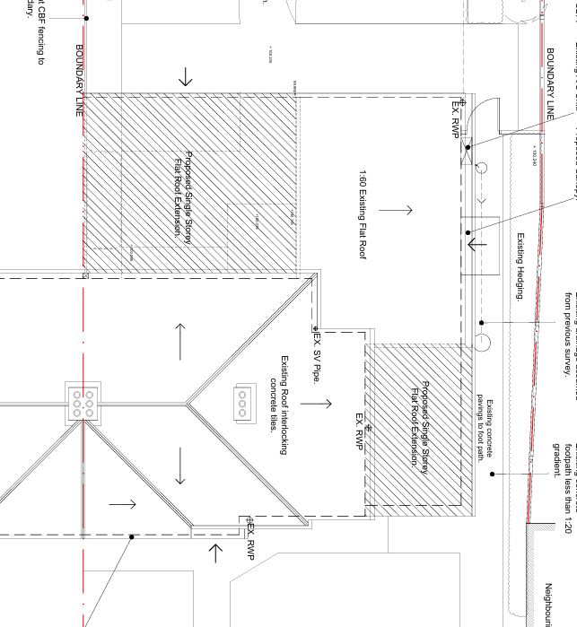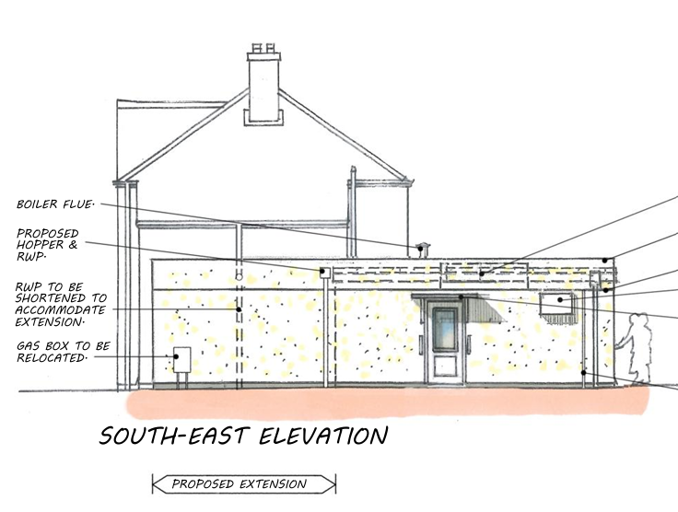

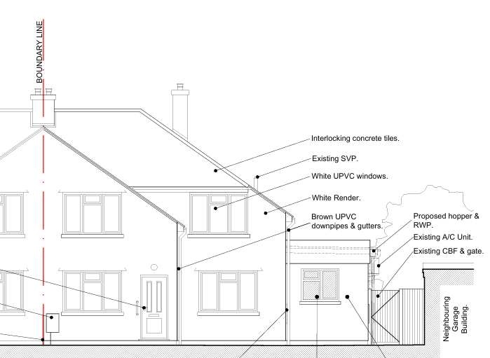

RELEVANT POLICIES AND GUIDANCE

National Planning Policy Framework (NPPF)
National Planning Practice Guidance (NPPG)
National Design Guidance

Wiltshire Core Strategy:

CP1 (Settlement Strategy)
CP2 (Delivery Strategy)
CP20 (Spatial Strategy for the Salisbury Community Area)
CP50 (Biodiversity)
CP57 (Ensuring High Quality Design & Space Shaping)
CP69 (River Avon SAC)

Supplementary Planning Documents:

Creating Places Design Guide SPG (April 2006)
Achieving Sustainable Development SPG (April 2005)
Wiltshire Local Transport Plan – Car Parking Strategy
Wiltshire Design Guide
Neighbourhood Plan

CONSULTATION RESPONSES

City Council: No comment

REPRESENTATIONS

No comments were received.

ASSESSMENT

Section 38(6) of the Planning and Compulsory Purchase Act 2004 states:

"If regard is to be had to the development plan for the purposes of any determination to be made under the planning Acts, the determination must be made in accordance with the plan unless material considerations indicate otherwise."

In accordance with this statutory requirement, this application has been assessed against the relevant policies of the Development Plan, including the adopted Wiltshire Core Strategy (2015) and, where applicable, any made Neighbourhood Plans.

Design and Impact upon the character and context of the area

Core Policy 57 - Ensuring High Quality Design and Place Shaping of the Wiltshire Core Strategy seeks to ensure that all new development is of high design quality, reflecting local context, character, and distinctiveness.

The proposed single-storey side extension is modest in scale and has been designed to reflect the form, proportions and materials of the existing dwelling. Its simple design ensures that it remains subordinate to the host property and integrates comfortably with the character of the original building. As such, the proposal would not result in any visual harm to the appearance of the dwelling or the surrounding area.

Having regard to the above, the proposal complies with the design principles set out in Core Policy 57 of the Wiltshire Core Strategy which seeks to ensure high-quality design that respects local character and context and Appendix D of the Wiltshire Design Guide.

Amenity

Point vii of Core Policy 57 - Ensuring High Quality Design and Place Shaping of the Wiltshire Core Strategy seeks to ensure that developments do not adversely affect neighbouring properties.

The National Planning Policy Framework (NPPF), particularly Paragraph 135(f), stresses that planning decisions should ensure developments provide a high standard of amenity for existing and future users.

The proposed development has been assessed in terms of its potential impact on the residential amenity of neighbouring properties, with particular regard to loss of light, overshadowing, loss of privacy, and overbearing effects.

The application site is located within an established residential area and has neighbouring properties on all sides. The proposed extension is a modest single storey flat roof addition and will be set in from the side boundary. In terms if amenity impacts the proposals due to their scale, siting and design there will be no conflict with the amenity of neighbouring dwellings.

There will still be ample outdoor amenity space retained for the occupants of No. 6, despite the increased footprint of the building. The proposed works will increase the accessibility and enjoyment of the property by its occupants.

The proposal therefore accords with Core Policy 57 point vii in respect of safeguarding residential amenity and Appendix D of the Wiltshire Design Guide.

Ecology Impact

Core Policy 50 of the Wiltshire Core Strategy seeks to protect and enhance biodiversity and geodiversity, including through ensuring that development avoids harm to protected species and habitats.

The National Planning Policy Framework (NPPF), in Paragraphs 193, requires that development minimises impacts on and provides net gains for biodiversity, including ensuring mitigation is secured where harm cannot be avoided.

While the application site is located within the Hampshire River Avon Catchment and the New Forest Protected Sites these designations have no implication to the assessment of householder extensions to existing dwellings.

Biodiversity Net Gain - Householder planning applications are exempt from the requirement to deliver Biodiversity Net Gain under Schedule 7A, Section 4(2)(a) of the Town and Country Planning Act 1990, as inserted by the Environment Act 2021.

As such, the development complies with Core Policy 50 and 69 of the Wiltshire Core Strategy and the relevant provisions of the NPPF.

CONCLUSION

The proposed development is considered to be acceptable in terms of its design, scale, and relationship with the surrounding area. It would not result in any unacceptable harm to the character of the locality, the amenities of neighbouring occupiers or ecology.

The proposal is therefore considered to comply with the relevant policies of the Wiltshire Core Strategy and the National Planning Policy Framework. As such, the application is recommended for approval, subject to the conditions set out below.

RECOMMENDATION:

That Planning Permission be GRANTED subject to the following conditions:

1) The development hereby permitted shall be begun before the expiration of three years from the date of this permission.

REASON: To comply with the provisions of Section 91 of the Town and Country Planning Act 1990 as amended by the Planning and Compulsory Purchase Act 2004.

2) The development hereby permitted shall be carried out in accordance with the following approved plans:

Application form received 11/03/2026
Location plan received 11/03/2026
Block plan received 11/03/2026
Proposed plans and elevations Drg nom 1597/02 Rev C received 11/03/2026

REASON: For the avoidance of doubt and in the interests of proper planning.

3) The materials to be used in the construction of the external surfaces of the development hereby permitted shall match in material, colour and texture to those detailed on the application form and approved plans and to match the existing dwelling.

REASON: For the avoidance of doubt and in the interests of visual amenity and the character and appearance of the area.

INFORMATIVE TO APPLICANT – Party Wall
The applicant is requested to note that this permission does not affect any private property rights and therefore does not authorise the carrying out of any work on land outside their control. If such works are required, it will be necessary for the applicant to obtain the landowners consent before such works commence.

If you intend carrying out works in the vicinity of the site boundary, you are also advised that it may be expedient to seek your own advice with regard to the requirements of the Party Wall Act 1996.

INFORMATIVE TO APPLICANT – Building regs

Any alterations to the approved plans, brought about by compliance with Building Regulations or any other reason must first be agreed in writing with the Local Planning Authority before commencement of work.

INFORMATIVE TO APPLICANT - BNG

The effect of paragraph 13 of Schedule 7A to the Town and Country Planning Act 1990 is that planning permission granted for development of land in England is deemed to have been granted subject to the condition (biodiversity gain condition) that development may not begin unless:

(a) a Biodiversity Gain Plan has been submitted to the planning authority, and
(b) the planning authority has approved the plan.

The planning authority, for the purposes of determining whether to approve a Biodiversity Gain Plan, if one is required in respect of this permission would be Wiltshire Council.

There are statutory exemptions and transitional arrangements which mean that the biodiversity gain condition does not always apply.

Based on the information available this permission is considered to be one which will not require the approval of a biodiversity gain plan before development is begun because one or more of the statutory exemptions or transitional arrangements is considered to apply.

The following exemption is considered to apply -

Development which is subject of a householder application within the meaning of article 2(1) of the Town and Country Planning (Development Management Procedure) (England) Order 2015. A “householder application” means an application for planning permission for development for an existing dwellinghouse, or development within the curtilage of such a dwellinghouse for any purpose incidental to the enjoyment of the dwellinghouse which is not an application for change of use or an application to change the number of dwellings in a building.

