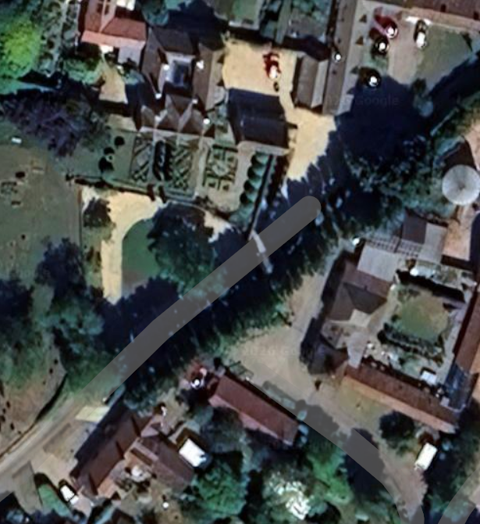
Driveway damage from roots
Steeple Ashton Manor
G1

