APPLICATION FOR HOUSEHOLDER PLANNING PERMISSION
DELEGATED REPORT

APPLICATION REFERENCE: | PL/2026/01011
APPLICATION TYPE: | Householder Planning Permission
SITE ADDRESS: | 32 Marsh Road, Hilperton Marsh, Trowbridge, BA14 7PR
DEVELOPMENT DESCRIPTION: | Single story extension with door and roof
RECOMMENDATION: | That Planning Permission be GRANTED

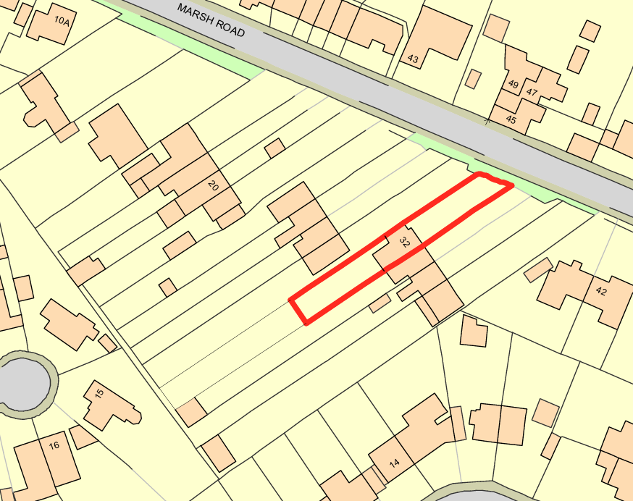

PROPOSAL

The application seeks planning permission for a simple rear conservatory extension. The proposed structure would feature a hipped roof with side-facing patio doors. The elevations would be constructed in red brick with predominantly glazed panels, while the roof would be formed largely of glazing.

SITE DESCRIPTION / CONTEXT

The site comprises a semi-detached, two-storey dwelling with long front and rear gardens, forming part of a short terrace of three linked houses within an established residential area along Marsh Road. The dwelling and neighbouring properties are of a consistent character, typically finished in red brick with white uPVC fenestration and rainwater goods, front-facing bay windows with white render detailing, and hipped roofs clad in dark red pantiles. The area is characterised by its edge-of-settlement location, with generous front garden set-backs and driveways providing separation from the highway. The site lies within the Hilperton Settlement Boundary and Flood Zone 1, with no identified surface or groundwater flood risk, and while a Grade II listed building is located opposite the site, the proposal relates solely to the rear of the property and its residential curtilage.

PLANNING HISTORY

No relevant planning history has been identified for the site subject of this application.

RELEVANT LEGILSATION, POLICIES AND GUIDANCE

Wiltshire Core Strategy:

Core Policy 1 Settlement Strategy;
Core Policy 2 Delivery Strategy;
Core Policy 29 Spatial Strategy: Trowbridge Community Area;
Core Policy 50 Biodiversity and Geodiversity;
Core Policy 51 Landscape;
Core Policy 57 Ensuring High-Quality Design and Place Shaping;
Core Policy 60 Sustainable Transport;
Core Policy 61 Transport and Development;
Core Policy 64 Demand Management;
Core Policy 67 Flood Risk;

Hilperton Neighbourhood Development Plan 2017-2026 (November 2018)

The National Planning Policy Framework (NPPF) and The Planning Practice Guidance (PPG)

Wiltshire Design Guide - Appendix D – Design Guidance for Householder extensions

The Wiltshire Local Transport Plan 2011 – 2026: Car Parking Strategy (March 2015).

The Wiltshire Local Transport Plan 4 (LTP4) (March 2025)

Emerging Policy – Wiltshire Local Plan Review

The examination of the emerging Wiltshire Local Plan has been paused and the weight to be afforded to any part of the emerging plan can be no more than very limited. A decision on how to proceed will be made by the Council in May 2026.

CONSULTATION RESPONSES

Hilperton Parish Council – No Objection

REPRESENTATIONS

No comments received.

ASSESSMENT

Section 38(6) of the Planning and Compulsory Purchase Act 2004 states:

"If regard is to be had to the development plan for the purposes of any determination to be made under the planning Acts, the determination must be made in accordance with the plan unless material considerations indicate otherwise."

In accordance with this statutory requirement, this application has been assessed against the relevant policies of the Development Plan, including the adopted Wiltshire Core Strategy (2015) and, where applicable, any made Neighbourhood Plans.

Householder extensions are generally acceptable in principle, as they typically fall within the established residential curtilage of a property and do not result in new residential development in the open countryside. In this case, the proposal also lies within the defined limits of development set out in the Core Strategy, further reinforcing its acceptability in principle.

Design and Impact upon the upon the character and context of the area

Core Policy 57 Ensuring High Quality Design and Place Shaping of the Wiltshire Core Strategy requires all new development to achieve a high standard of design that responds positively to its local context. Proposals must reinforce and enhance local character and distinctiveness, relate appropriately to the surrounding landscape, and demonstrate a thoughtful response to existing townscape features. This includes careful consideration of elements such as building height, scale, massing, building line, materials, and overall appearance, ensuring new development integrates harmoniously with its setting.

The proposed conservatory reflects a common and well-established form of householder development within the immediate area, with a neighbouring property already benefiting from a rear conservatory of comparable scale and design, providing clear contextual precedent. The use of red brick and extensive glazing closely matches the materials and appearance of the host dwelling, ensuring visual continuity, while the reduced height relative to the existing rear extension ensures the proposal remains clearly subservient, low-scale, and lightweight in its appearance. Although a Grade II listed building is located opposite the site, the proposal relates solely to the rear of the property and there is no public right of way from which both the listed building and the development can be viewed together, resulting in no intervisibility. Given the modern character of the existing dwelling and surrounding properties, which already define the prevailing streetscape, the proposed conservatory would not alter this character and would have a neutral impact on the setting of nearby heritage assets.

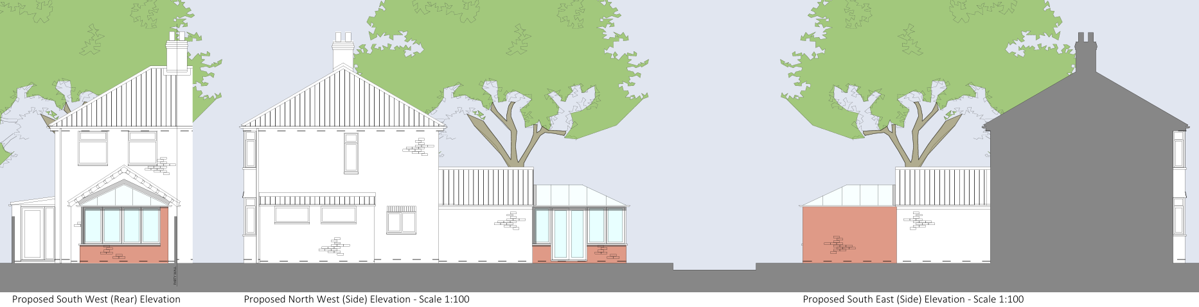
Proposed Elevations

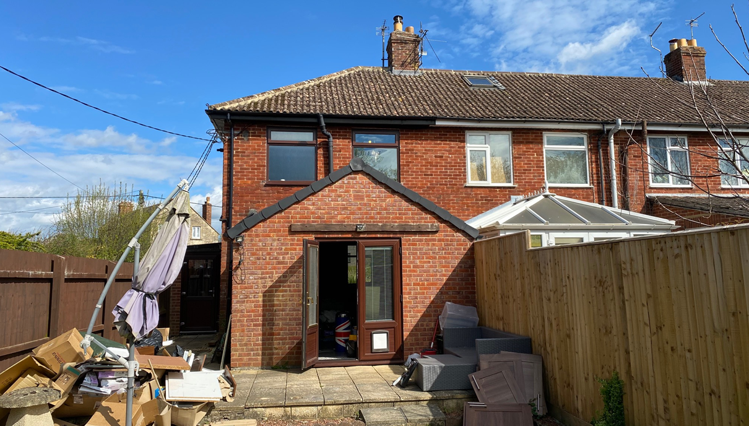
Site Visit Rear Elevation

Having regard to the above, the proposal complies with the design principles set out in Core Policy 57 of the Wiltshire Core Strategy and Appendix D of the Wiltshire Design Guide.

Amenity

Point vii of Core Policy 57 Ensuring High Quality Design and Place Shaping of the Wiltshire Core Strategy seeks to ensure that developments do not adversely affect neighbouring properties.

The National Planning Policy Framework (NPPF), particularly Paragraph 135, stresses that planning decisions should ensure developments provide a high standard of amenity for existing and future users.

The proposed conservatory would be lower than the existing rear extension and would only project minimally above the boundary fencing, resulting in no perceivable overbearing or enclosing impact on neighbouring properties. Due to its modest scale, hipped roof form, and rearward siting, the development would not give rise to any material loss of daylight or sunlight to adjacent occupiers. All glazing is located at ground-floor level and faces solely into the site’s own residential curtilage, ensuring there is no overlooking or loss of privacy. Overall, no adverse residential amenity impacts have been identified.

The proposal is appropriately sited, designed, and oriented to ensure that it would not result in unacceptable impact upon/to the amenities or living conditions of neighbouring residential occupiers, particularly in terms of outlook, privacy, or access to natural light.

The proposal therefore accords with Core Policy 57 point vii in respect of safeguarding residential amenity and Appendix D of the Wiltshire Design Guide.

Other Issues

Core Policy 50 of the Wiltshire Core Strategy seeks to ensure that development avoids harm to wildlife and habitats. While Biodiversity Net Gain (BNG) is now a mandatory consideration under Schedule 7A of the Town and Country Planning Act 1990 (as amended by the Environment Act 2021), householder applications are exempt from this requirement. The proposal involves a very modest increase in floorspace within an existing residential garden that is largely hard-surfaced, and as such gives rise to no identifiable harm to habitats or protected species. The site’s location within the TWBMS Grey Zone raises no additional concerns, and given the limited scale, reduced height relative to the existing dwelling, and absence of any interference with the existing roof structure, the development is considered benign in ecological, drainage, and wider environmental terms.

The application does not propose the introduction of any additional bedrooms to the property, nor does it include any alteration to the existing parking and access arrangements. It is therefore considered that there is no highway or transportation concerns present with the proposal, and it is otherwise considered acceptable.

Core Policy 67 of the Wiltshire Core Strategy seeks to ensure development does not increase flood risk. The proposal constitutes exempt householder development of well below 250m² and is therefore not subject to the sequential or exception test as set out in the NPPF. The site lies within Flood Zone 1 and the Council’s Strategic Flood Risk Assessment identifies no risk of ground or surface water flooding. The proposal would result in only a negligible increase in impermeable area within an existing garden that already contains areas of hardstanding, and therefore would be unlikely to have any adverse impacts on surface water drainage or flood risk elsewhere.

CONCLUSION

The proposal is considered to be acceptable and in accordance with the relevant policies and guidance outlined above.

RECOMMENDATION: That Planning Permission be GRANTED subject to the following conditions:

1.
The development hereby permitted shall be begun before the expiration of three years from the date of this permission.
REASON: To comply with the provisions of Section 91 of the Town and Country Planning Act 1990 as amended by the Planning and Compulsory Purchase Act 2004.

2.
The development hereby permitted shall be carried out in accordance with the following approved plans and documents:

Plans and Elevations 373/101 (9 March 2026)

REASON: For the avoidance of doubt and in the interests of proper planning.

