APPLICATION FOR HOUSEHOLDER PLANNING PERMISSION
DELEGATED REPORT

APPLICATION REFERENCE: | PL/2026/01306
APPLICATION TYPE: | Householder planning permission
SITE ADDRESS: | Wyneshore House, 2 White Street, West Lavington, Devizes, SN10 4LW
DEVELOPMENT DESCRIPTION: | Demolition of the existing conservatory, construction of front and rear extensions, landscaping works (including decking and out‑buildings), and updates to the pond area
RECOMMENDATION: | That Planning Permission be GRANTED

PROPOSAL

The proposal seeks planning permission for Demolition of the existing conservatory, construction of front and rear extensions, landscaping works (including decking and out‑buildings), and updates to the pond area at Wyneshore House, 2 White Street, West Lavington.

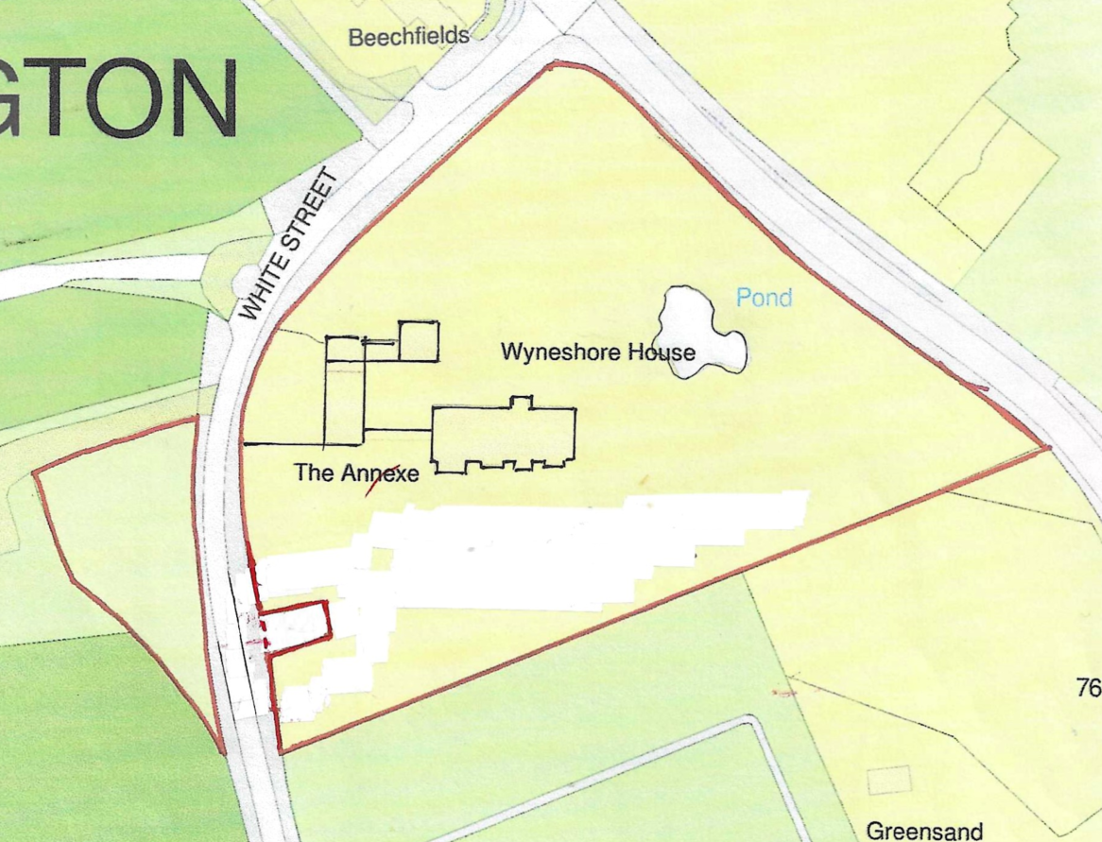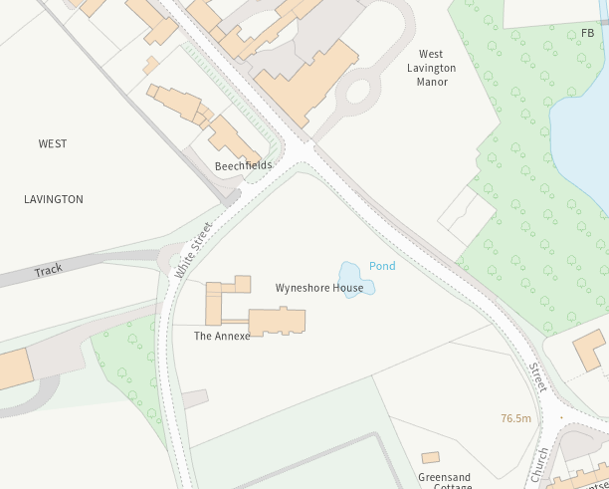

Site Location Plan and Council Mapping Image of the site

The proposal involves demolishing the existing conservatory on the southern front elevation and build a replacement extension using matching bricks. It would have a flat roof but behind a parapet roof and stone capping.

On the rear northern elevation, there would be a large rear extension, (also flat roofed) extending an existing flat roofed side extension that accommodated the existing kitchen/dining room. The extension would have two bedrooms, shower room, therapy room and store. This is to accommodate a family member who needs care along with accommodation for a carer. The extension would also be built using matching bricks.

The proposal also includes creating a large decking area (built on an above ground frame) approximately 200-250mm above the ground. The decking area would have a footprint of approximately 400m2 which would overhang the existing pond and provide access to a ‘bar area’ and a gym outbuilding. The gym would be built using the same decking materials and would be a composite material with a dark oak colour. The decking is to help the family member enjoy the outside space from the main dwelling on a single level platform whilst using a wheelchair.

The principal elevation drawings shows velux windows to the roof. These are considered permitted development and are not assessed within this report.

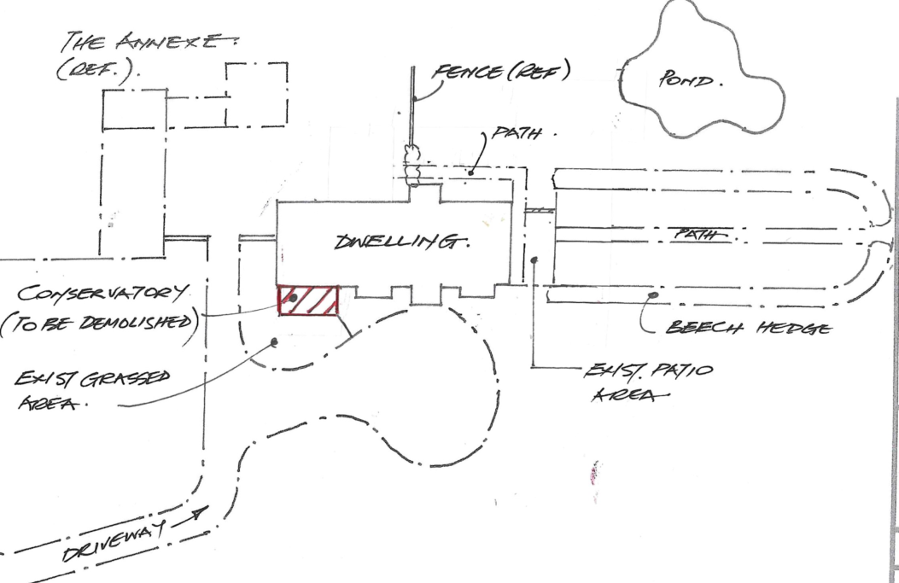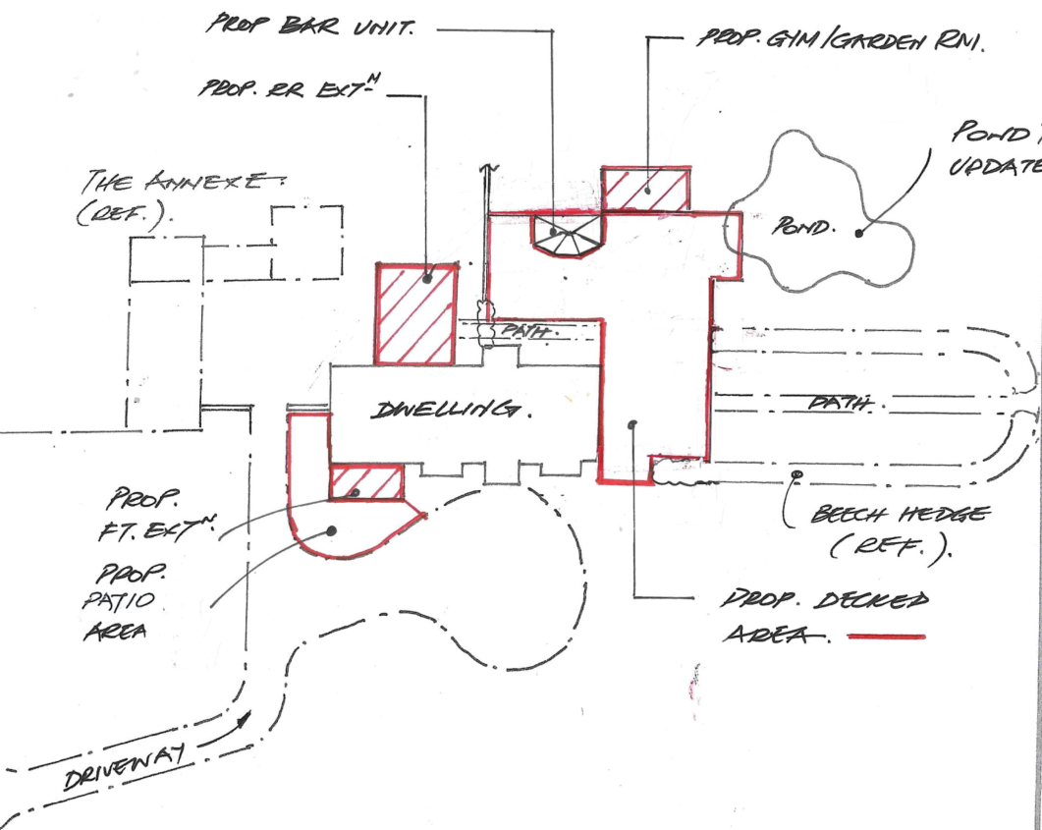

Existing and Proposed Block Plan

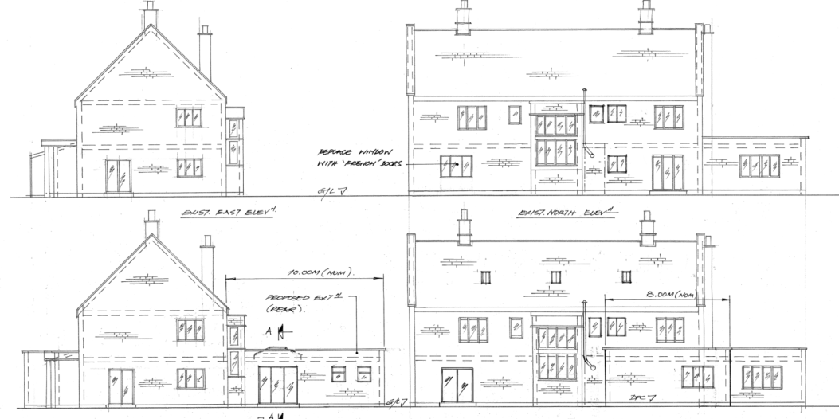

Existing and Proposed North and East Elevations

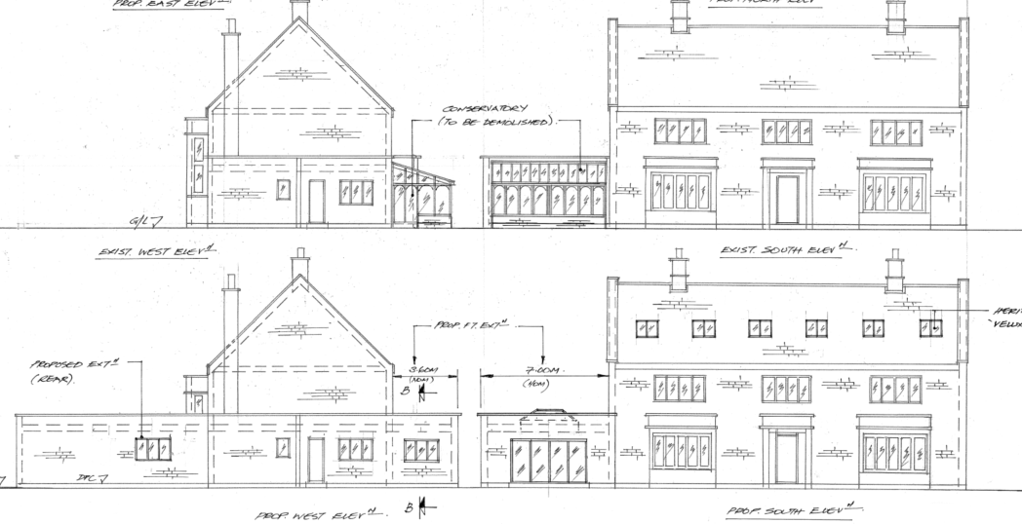

Existing and Proposed West and South

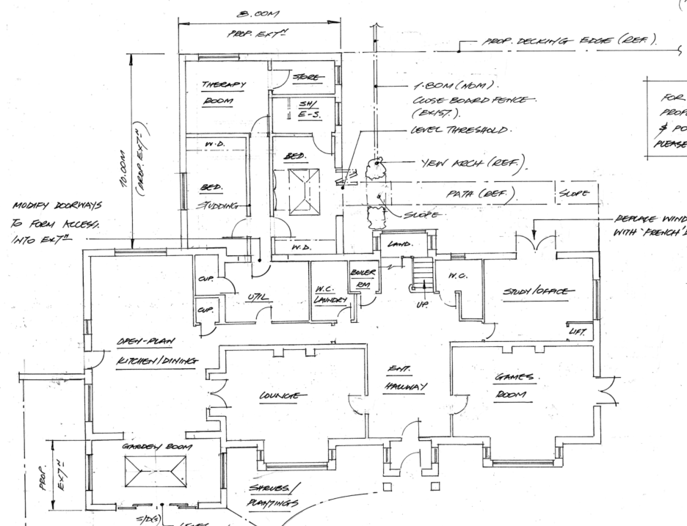

Proposed Ground Floor Plan

SITE DESCRIPTION/CONTEXT

Wyneshore House is a large detached two storey dwelling sat within a very large plot of approximately 0.91 hectares. To the west of the main building there is a link detached outbuilding identified as ‘annex’ on the OS maps. The planning history indicates that this was from application K/16408 to convert the garages into an annexe. However, in application 20/10526/FUL, permission was given to further spilt the outbuilding into a one-bedroom holiday let.

The supporting statement for 20/010526/FUL refers to the existing (K16408) annexe as being a one bedroom apartment which helps with the costs of maintaining the property (as the large grounds requires a lot of maintenance). However, there does not appear to be any planning history that has allowed the use of the house keepers annexe into a separate unit of accommodation that can be rented out separately from Wyneshore House. This matter will be addressed in the principle of development section of this report.

The site is enclosed by two public roads, White Street to the west and north and Church Street to the east. The southern boundary of the application site is shared with Greensand Cottage and the Old Manor House. The boundaries of the application site along the public roads are defined by a mixture of mature trees and hedgerow which only allows for brief views into the site capturing only the roof of the main building and its annex.

The application site sits just outside the defined limits of development of West Lavington/Littleton Panell, which is defined as a large village in the Wiltshire Core Strategy.

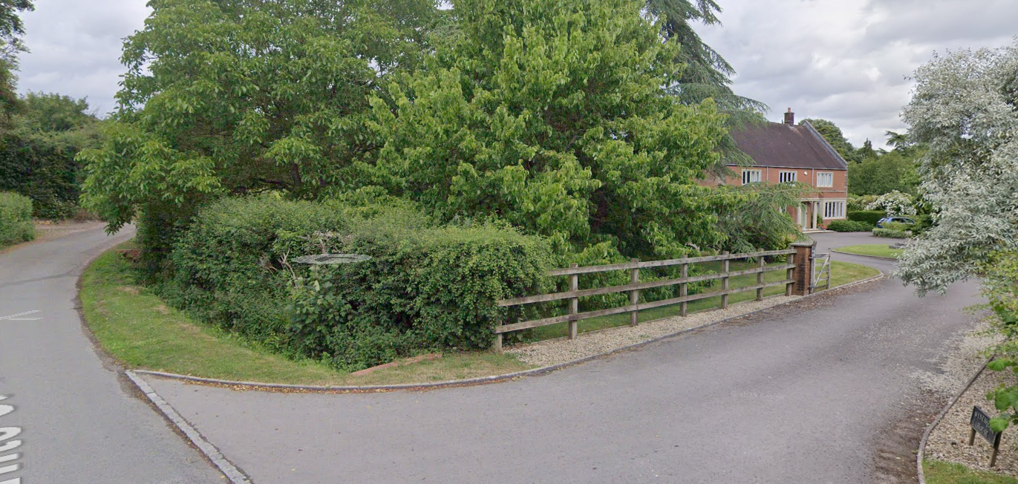

June 2025 Google Street View Image from White Street

The application site is subject to the following planning policy constraints:

- Sailsbury Plain Special Protection Area – 6.4km buffer
- Areas susceptible to ground water flooding (within 0.025 and 0.5m of the surface) and 1:1000 year surface water flood risk
- West Lavington and Littleton Panell Conservation Area
- To the south is The Old Manor House – a grade II listed building
- There are three grade II listed buildings to the east

-West Lavington Manor

-Arched Gateway in Garden Wall, South of Lavington Manor

-Wall to West Lavington Manor

PLANNING HISTORY

K/81/0439 - Erection of private dwelling – Approved with conditions

K/16408 – Conversion of existing garages/workshop into housekeepers annexe – Approved with conditions on 06.09.1990.

K/31765 - To remove existing aluminium greenhouse and replace with Amdega conservatory – Approved with conditions

20/10526/FUL - Convert a Games Room to a 1 bedroom holiday let, 2 garage doors to the existing car port and erect a new with 2 car ports, a garage, and store/work shop, including all other associated works – Approved with conditions

PL/2025/06262 - Demolition of existing post and rail fence, with gates and the erection of walls, piers and new gates on the access to the property – Approved with conditions

RELEVANT POLICIES AND GUIDANCE

National Context:

The National Planning Policy Framework (NPPF)

The NPPF outlines government policy for planning. Chapter 16 of the NPPF 'Conserving and enhancing the historic environment' sets out the Government's high-level policies concerning heritage and sustainable development.

The Planning Practice Guidance

From the point of view of the historic environment the main statutory tests are set out within the Planning (Listed Building and Conservation Areas) Act 1990.

Section 66 of the Planning (Listed Buildings and Conservation Areas) Act 1990 requires ‘special regard’ to be given to the desirability of preserving a listed building or its setting.

Section 72 of the Planning (Listed Buildings and Conservation Areas) Act 1990 states that in the exercise of any functions, with respect to any buildings or other land in a conservation area, under or by virtue of any of the provisions mentioned in this Section, special attention shall be paid to the desirability of preserving or enhancing the character or appearance of that area.

Local Context:

Wiltshire Core Strategy:

- Core Policy 50: Biodiversity and Geodiversity
- Core Policy 57: Ensuring High Quality Design and Place Making
- Core Policy 58: Ensuring the Conservation of the Historic Environment
- Core Policy 67: Flood Risk

The Council’s Core Strategy Policy CP58 ‘Ensuring the conservation of the historic environment’ requires that designated and non-designated heritage assets and their settings will be conserved, and where appropriate enhanced, in a manner appropriate to their significance and encourages proposals which improve the condition of heritage assets at risk.

The Council’s Core Strategy CP 57: Ensuring high quality design requires a high quality of design in all new developments. The policy requires applicants to “demonstrate how the proposal will make a positive contribution to the character of Wiltshire through (amongst other things) responding to the value of the natural and historic environment and being sympathetic to and conserving historic buildings and landscapes. Development is required to respond positively to the existing in terms of building layouts, built form, height, mass, scale, building line, plot size, elevational design, materials, streetscape and rooflines to effectively integrate the building into its setting.

West Lavington Neighbourhood Plan 2017 – 2026 – Made June 2019

- Policy BE1 – Settlement Boundary
- Policy BE2 – Design of New Development and Local Distinctiveness
- Policy BE3 – Highway Impact
- Policy BE4 – Heritage Assets

Wiltshire Design Guide: Appendix D – Design Guidance for Householder extensions

West Lavington and Littleton Panell Conservation Area Statement – January 2003

CONSULTATION RESPONSES

West Lavington Parish Council: No objection

Wiltshire Council Highways Officer: No objection

Wiltshire Council Landscape Officer: No objection

Wiltshire Council Archaeology Officer: No objection - There are no archaeological issues that I would wish to raise in this instance.

REPRESENTATIONS

One letter of support received

- This seems to be an attractive development proposal for the homeowner which should not impact on other dwellings. Very happy to support.

ASSESSMENT

Section 38(6) of the Planning and Compulsory Purchase Act 2004 states:

"If regard is to be had to the development plan for the purposes of any determination to be made under the planning Acts, the determination must be made in accordance with the plan unless material considerations indicate otherwise."

In accordance with this statutory requirement, this application has been assessed against the relevant policies of the Development Plan, including the adopted Wiltshire Core Strategy (2015) and, where applicable, any made Neighbourhood Plans.

Principle of Development

The principle of development is considered acceptable as this is an extension to an existing residential property, subject to the detailed assessment of design, amenity, and other material considerations set out below.

Design and Impact upon the character and context of the area

Core Policy 57 - Ensuring High Quality Design and Place Shaping of the Wiltshire Core Strategy seeks to ensure that all new development is of high design quality, reflecting local context, character, and distinctiveness.

The proposal would introduce fairly large flat roofed extensions but in the context that Wyneshore House is a large detached dwelling with existing flat roofed sections. The site is located in extensive grounds, which are extremely well screened from public view by the existing boundary landscaping. As such the conservatory replacement, the north elevation extension and the very extensive decking would not be visible from public view.

The extent of the decking area is of minor concern, but it would only incorporate a relatively small % of the overall plot and would be built using composite, which is considered to be a high-quality material. The decking area would also have the benefit of being reversable in the long term should the occupants decide to do so.

The outbuildings proposed are considered proportionate and appropriate for their setting.

The Council’s Landscape Officer provided the following comments

The domestic property is well screened by existing hedgerows from views associated with Public Rights of Ways and village roads and lanes and therefore would have negligible impact on the strategic landscape character of the settlement.

Having regard to the above, the proposal complies with the design principles set out in Core Policies 51 and 57 of the Wiltshire Core Strategy and Appendix D of the Wiltshire Design Guide.

Amenity

Point vii of Core Policy 57 - Ensuring High Quality Design and Place Shaping of the Wiltshire Core Strategy seeks to ensure that developments do not adversely affect neighbouring properties.

The National Planning Policy Framework (NPPF), particularly Paragraph 135(f), stresses that planning decisions should ensure developments provide a high standard of amenity for existing and future users.

The proposed development has been assessed in terms of its potential impact on the residential amenity of neighbouring properties, with particular regard to loss of light, overshadowing, loss of privacy, and overbearing effects.

The extensions would be over 50m away from the nearest neighbouring dwelling and is also screened by the extensive boundary landscaping. As such no harm would be caused to neighbouring amenity.

The proposal therefore accords with Core Policy 57 point vii in respect of safeguarding residential amenity and Appendix D of the Wiltshire Design Guide.

Heritage Impact

It is considered that the settings of all the neighbouring listed buildings do not extend into the application site and therefore the settings of the listed buildings would be preserved. Furthermore, no harm would be caused to their historic significance.

The application site is also fully within the conservation area. The conservation area statement identifies 7 green spaces which contribute to the ‘Conservation Area Character’, where the garden of Wyneshore House is identified as one of those spaces. However, the statement does not specifically detail these spaces and only identifies them as being open spaces.

It is submitted that the garden, contributing to the overall character of open space within the village, with its extensive landscaping is the most important element of the contribution to the character of the conservation area; and in this context, the open space would still be preserved as there would be only minimal impact on existing landscaping from the proposed decking which is in effect a temporary structure.

Therefore, the proposal, by virtue of its scale, design, and use of materials, is considered to preserve the character and appearance of the conservation area and would cause no harm to its historic significance.

The development is therefore considered to comply with Core Policy 58 of the Wiltshire Core Strategy and Sections 66 and 72 of the Planning (Listed Buildings and Conservation Areas) Act 1990, as well as the relevant provisions of the NPPF.

Ecology Impact

Core Policy 50 of the Wiltshire Core Strategy seeks to protect and enhance biodiversity and geodiversity, including through ensuring that development avoids harm to protected species and habitats.

The National Planning Policy Framework (NPPF), in Paragraphs 193, requires that development minimises impacts on and provides net gains for biodiversity, including ensuring mitigation is secured where harm cannot be avoided.

The Council’s Ecology Officer has not been consulted on this application, but the application site is within the 6.4km zone of influence of the Salisbury Plain SPA and in light of the HRA for the Wiltshire Core Strategy and the HRA for the Wiltshire Housing Site Allocations Plan it is screened into Appropriate Assessment due to the potential impact of recreational pressure on stone curlew in combination with other plans and projects.

A strategic Appropriate Assessment (AA) has been prepared pertaining to development within the 6.4 km zone of influence that could result in a likely significant effect on the SPA as a result of an increase in recreational / visitor pressure. The AA reached a conclusion of no adverse effects on the integrity of the SPA or its qualifying features provided that the council’s mitigation strategy continues to be implemented. Annual stone curlew monitoring and protection measures continue to be secured by the Council.

In January 2026 Natural England (NE) confirmed that the 2025 strategic AA for Salisbury Plain SPA continues to be supported by NE.

Drainage and Flood Risk

The application site is within flood zone 1 but is within the second highest risk category of ground water flooding and in accordance with the Council’s 2019 and 2024 Strategic flood risk assessments (SFRA) the site cannot be considered to be at a low risk of flooding.

Consequently the applicant has submitted an appropriate flood risk assessment, setting out that the proposed floor levels will be no lower than the existing dwelling. This is considered acceptable. Officers consider that the submitted Flood Risk Assessment is sufficient and therefore the risk of ground water can be effectively managed.

Biodiversity Net Gain

Householder planning applications are exempt from the requirement to deliver Biodiversity Net Gain under Schedule 7A, Section 4(2)(a) of the Town and Country Planning Act 1990, as inserted by the Environment Act 2021.

CONCLUSION

The proposed development is considered to be acceptable in terms of its design, scale, and relationship with the surrounding area. It would not result in any unacceptable harm to the character of the locality, the amenities of neighbouring occupiers, or the interests heritage or ecology.

The proposal is therefore considered to comply with the relevant policies of the Wiltshire Core Strategy, the Wiltshire Local Plan, and the National Planning Policy Framework. As such, the application is recommended for approval, subject to the conditions set out below.

RECOMMENDATION: That Planning Permission be GRANTED subject to conditions.

