APPLICATION FOR HOUSEHOLDER PLANNING PERMISSION DELEGATED REPORT

APPLICATION REFERENCE: | PL/2026/01837
APPLICATION TYPE: | Householder planning permission
SITE ADDRESS: | Haywood, Maddington Street, Shrewton, Salisbury, SP3 4JL
DEVELOPMENT DESCRIPTION: | Single storey extension to front of bungalow
RECOMMENDATION: | That Planning Permission be GRANTED

PROPOSAL

The proposal seeks planning permission for the erection of a single storey front extension.

Existing elevations

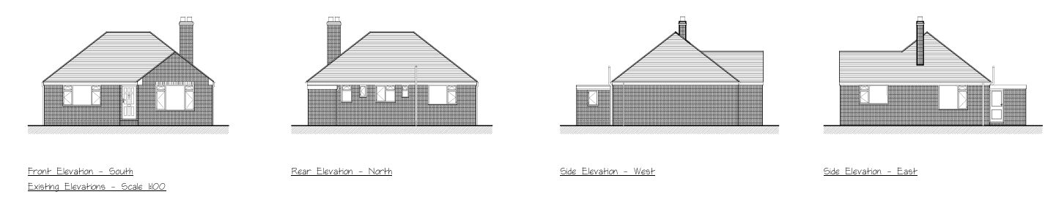

Proposed elevations

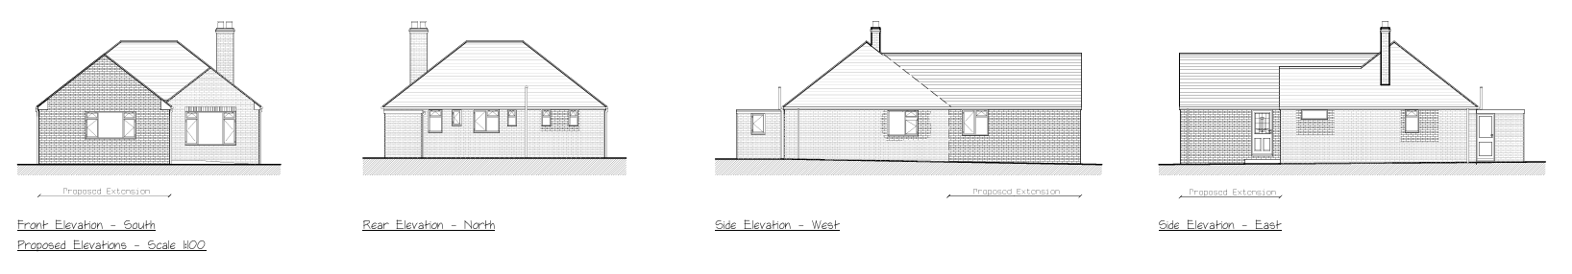

Existing and proposed floor plans

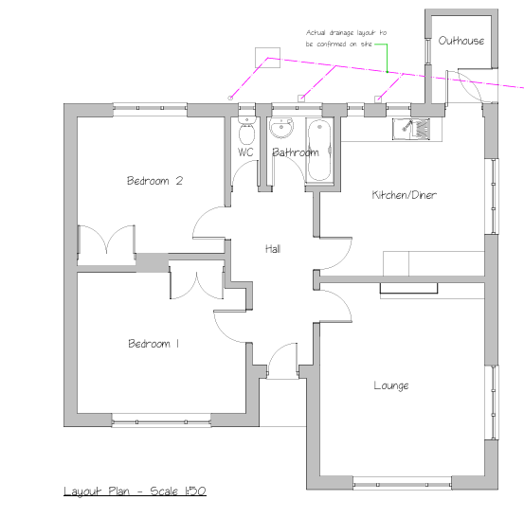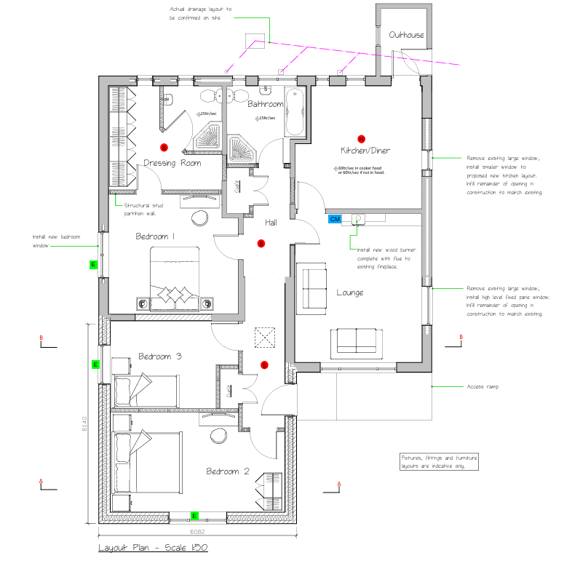

Existing and proposed block plans

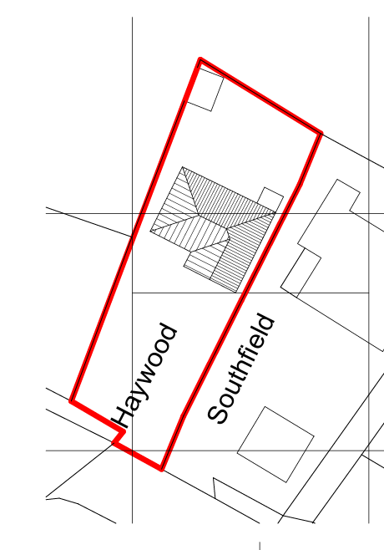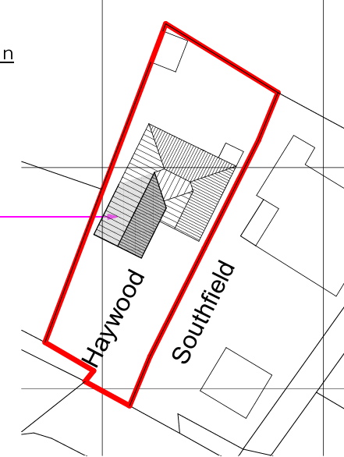

Also of note is a recent approval on the site for the erection of a detached garage/carport to the front of the property, this has not yet been built. At the request of the case officer the applicant provided a site plan which included both the approved garage/car port and the proposed extension so the overall relationship could be seen and understood on plan.

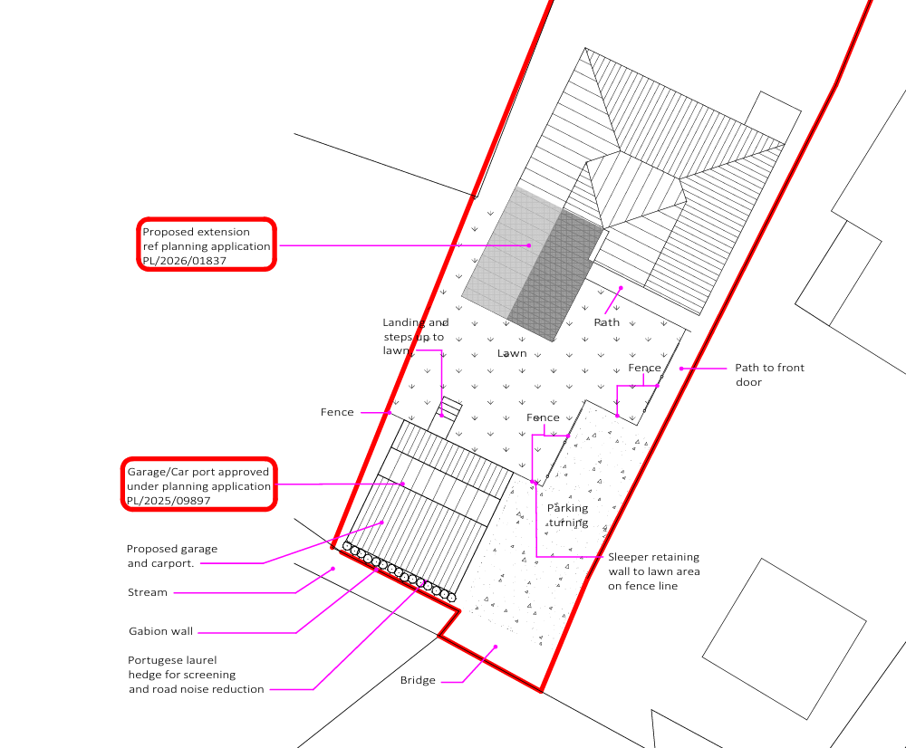

SITE DESCRIPTION/CONTEXT

The application site relates to an existing detached residential dwelling and its associated amenity land and parking. The site is located within the settlement boundary of the large village of Shrewton, as defined by Wiltshire Core Strategy (WCS) policies CP1 (Settlement Strategy), CP2 (Delivery Strategy) and CP4 (Amesbury Community Area). The site is located on the north side of the A360 and is bounded by residential properties to the east, west and south; the property backs onto fields/paddocks to the north.

The site is located within a Special Landscape Area; the front part of the site alongside the road to the south is situated within flood zones 2 and 3 as shown below.

Flood zone 2 Flood zone 3

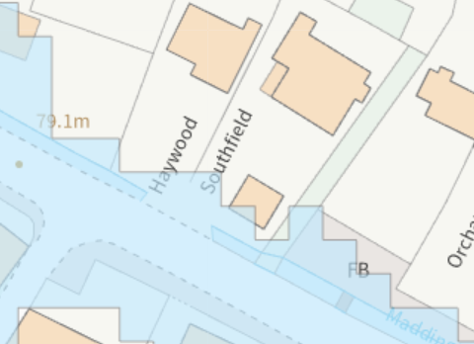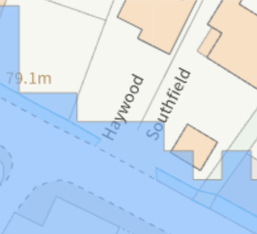

The site is located within the River Avon 20m buffer and within the River Avon SAC.

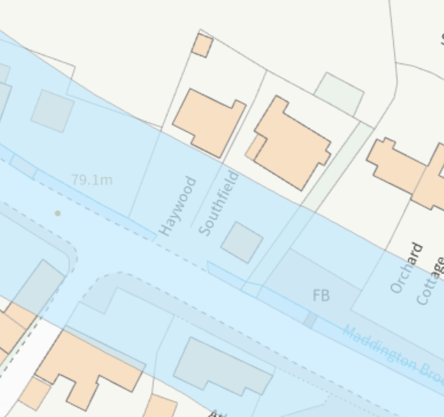

PLANNING HISTORY

Proposal / Summary
PL/2025/09897 - Householder planning permission Decision - Approve with Conditions Date: 10/2/2026 – Detached garage with side car port

RELEVANT POLICIES AND GUIDANCE

National Planning Policy Framework (NPPF)
National Planning Practice Guidance (NPPG)
National Design Guide (NDG)
Salisbury District Local Plan policies (Saved by Wiltshire Core Strategy) (SDLP):
C6 – Special Landscape Area
Wiltshire Core Strategy (January 2015) (WCS):
CP1 (Settlement Strategy)
CP2 (Delivery Strategy)
CP4 (Amesbury Community Area)
CP50 (Biodiversity and Geodiversity)
CP51 (Landscape)
CP57 (Ensuring High Quality Design & Space Shaping)
CP58 (Ensuring the Conservation of the Historic Environment)
CP67 (Flood Risk)
CP69 (River Avon SAC)
Supplementary Planning Documents:
Creating Places Design Guide SPG (April 2006)
Achieving Sustainable Development SPG (April 2005)
Wiltshire Local Transport Plan – Car Parking Strategy
Stonehenge and Avebury World Heritage Site Management Plan (2015)
Wiltshire Design Guide: Appendix D – Design Guidance for Householder extensions

CONSULTATION RESPONSES

Parish Council: No objection

REPRESENTATIONS

No comments were received.

ASSESSMENT

Section 38(6) of the Planning and Compulsory Purchase Act 2004 states:

"If regard is to be had to the development plan for the purposes of any determination to be made under the planning Acts, the determination must be made in accordance with the plan unless material considerations indicate otherwise."

In accordance with this statutory requirement, this application has been assessed against the relevant policies of the Development Plan, including the adopted Wiltshire Core Strategy (2015) and, where applicable, any made Neighbourhood Plans.

Design and Impact upon the character and context of the area

Core Policy 57 - Ensuring High Quality Design and Place Shaping of the Wiltshire Core Strategy seeks to ensure that all new development is of high design quality, reflecting local context, character, and distinctiveness.

The proposed extension sill be single storey and will be constructed using materials to match the existing dwelling, the proposed design of the extension reflects the design and character of the host dwelling.
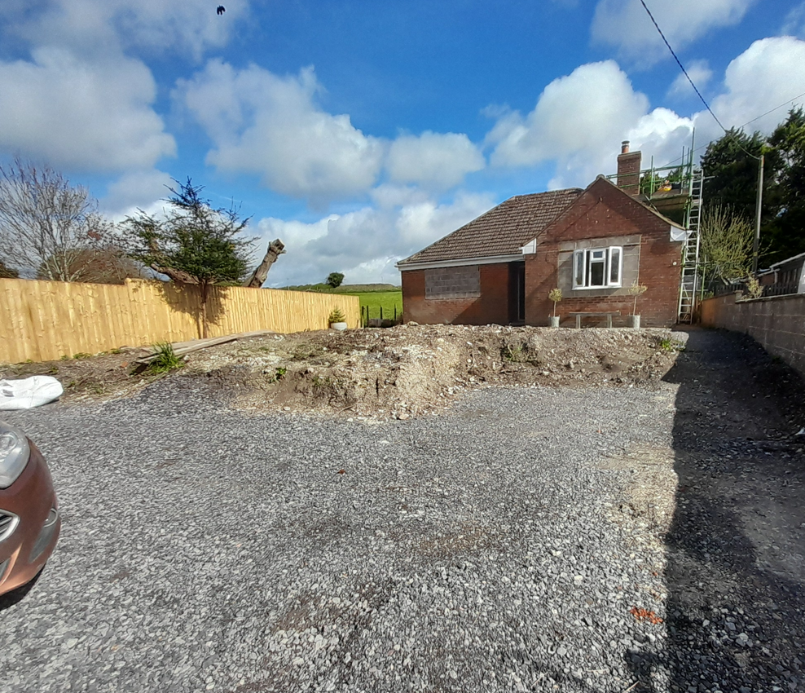

Inevitably, a front extension to a property alongside a busy A road such as this is prominent within the streetscene and any changes have the potential to impact on the streetscene and character and appearance of the locality. However, in this instance, the existing dwelling is set back from the road with a large front garden, the proposed extension will project out to the front by approx. 6m and will form an L-shaped built form for the dwelling. The ridge height of the proposed extension will be set lower than the existing to help retain a form of subserviency.

It is therefore not considered that the proposed extension will result in an unacceptable development in this location, the design, scale, siting and materials will help the proposals integrate with the existing built form.

Having regard to the above, the proposal complies with the design principles set out in Core Policy 57 of the Wiltshire Core Strategy and Appendix D of the Wiltshire Design Guide.

Furthermore, the cumulative impact of the proposed extension and previously approved garage/car port are not considered to be overdevelopment for this site, and the property will still retain an acceptable amount of front garden to soften the overall impacts on the streetscene.

Amenity

Point vii of Core Policy 57 - Ensuring High Quality Design and Place Shaping of the Wiltshire Core Strategy seeks to ensure that developments do not adversely affect neighbouring properties.

The National Planning Policy Framework (NPPF), particularly Paragraph 135(f), stresses that planning decisions should ensure developments provide a high standard of amenity for existing and future users.

The proposed development has been assessed in terms of its potential impact on the residential amenity of neighbouring properties, with particular regard to loss of light, overshadowing, loss of privacy, and overbearing effects.

The application site is located in an established residential area within the village of Shrewton, the property of neighbouring dwelling to both sides and to the front on the opposite side of the A360. Given the separation distance of the proposed extension, scale and design it is not considered that there will be any amenity impacts to properties on the south side of the A360.

Baden House is located to the west of the site and Southfield is located to the east, no letters of representation have been received from either of these adjacent dwellings for this application. However, given the single storey height of the proposed development, siting within the residential curtilage for Haywood and overall scale and design there are no neighbour amenity concerns regarding overbearing, overshadowing or overlooking impacts.

The proposal therefore accords with Core Policy 57 point vii in respect of safeguarding residential amenity and Appendix D of the Wiltshire Design Guide.

Highways Impact

Core Policy 57 (xiv) of the Wiltshire Core Strategy seeks to ensure that development must meet the requirements of Core Policy 61. This policy requires proposals to be capable of being served by safe access to the highway network. Core Policy 64 seeks to ensure compliance with parking standards set out in the Local Transport Plan.

The National Planning Policy Framework (NPPF), particularly Paragraph 115 and 116, requires that development proposals do not have an unacceptable impact on highway safety and that safe and suitable access to the site can be achieved for all users.

The proposed extension will increase the number of bedrooms from two to three which does not require the provision of additional off road paring spaces to meet Wiltshire Council parking standards. The proposed extension is not being constructed over previously shown and agreed parking areas and therefore no highway objections are raised.

The proposed development would not result in any adverse impact on highway safety. Adequate parking and turning provision are provided in accordance with Wiltshire’s adopted parking standards, and access arrangements are acceptable.

The proposal is therefore considered to comply with Core Policies 57 (xiv), 61 and 64 of the Wiltshire Core Strategy, the NPPF, and the Wiltshire Local Transport Plan.

Ecology Impact

Core Policy 50 of the Wiltshire Core Strategy seeks to protect and enhance biodiversity and geodiversity, including through ensuring that development avoids harm to protected species and habitats.

The National Planning Policy Framework (NPPF), in Paragraphs 193, requires that development minimises impacts on and provides net gains for biodiversity, including ensuring mitigation is secured where harm cannot be avoided.

The site is located adjacent to Maddington Brook which feeds into the River Avon, the location of the extension is within the 20m buffer of the River Avon SAC. Core Policy 69 of the Wiltshire Core Strategy relates to the protection of the River Avon SAC and states:

In order to avoid and reduce potential environmental effects on the River Avon SAC, development will need to incorporate measures during construction and operation to avoid and prevent pollution and mitigate potential disturbance effects; appropriate measures may include consideration of suitable buffer zones along watercourses, habitat enhancements and river access management measures. All development within 20m of the river banks should submit a construction management plan to the local planning authority to ensure measures proposed during construction are satisfactory.

The applicant has submitted a construction management plan which is considered to contain sufficient measures to prevent pollution/harmful impacts on the River Avon SAC during construction, this will therefore be conditioned as part of any permission given.

Householder planning applications are exempt from the requirement to deliver Biodiversity Net Gain under Schedule 7A, Section 4(2)(a) of the Town and Country Planning Act 1990, as inserted by the Environment Act 2021.

As such, the development complies with Core Policy 50 and 69 of the Wiltshire Core Strategy and the relevant provisions of the NPPF.

Flood Risk

Core Policy 67 of the Wiltshire Core Strategy and paragraph 181 of the NPPF requires that all new development avoids increasing flood risk on-site or elsewhere and, where appropriate, incorporates sustainable drainage measures. Development must also comply with national policy on flood risk management and drainage design. Paragraph 176 (via footnote 62) of the NPPF states that householder development should not be subject to the sequential test, nor the exception test.

In this instance the proposals relate to the erection of a single storey front extension which will be constructed outside of the flood zones. As can be seen on the flood maps included above. However, a flood risk assessment has been submitted with the application which states

“The existing dwelling has a damp proof course (DPC) level approximately 2100mm above the base of the adjacent watercourse and at least 1500mm above the level of the adjacent road. The proposed extension will be constructed with a DPC level matching that of the existing dwelling, at a distance at the front elevation of the proposed extension of 13.9 meters from the watercourse. This provides a substantial level difference between the property and the nearby watercourse and surrounding ground levels, offering a significant degree of freeboard above potential flood levels. In addition, the property has been in continuous residential use since 1959, during which time there have been no recorded instances of floodwater reaching the dwelling. On this basis, the risk of floodwater affecting the proposed extension is considered to be very low”.

The proposal therefore complies with Core Policy 67 of the Wiltshire Core Strategy and the provisions within the NPPF, ensuring that flood risk is not increased.

CONCLUSION

The proposed development is considered to be acceptable in terms of its design, scale, and relationship with the surrounding area. It would not result in any unacceptable harm to the character of the locality, the amenities of neighbouring occupiers, or the interests of highway safety, flood risk or ecology.

The proposal is therefore considered to comply with the relevant policies of the Wiltshire Core Strategy, the Wiltshire Local Plan, and the National Planning Policy Framework. As such, the application is recommended for approval, subject to the conditions set out below.

RECOMMENDATION: That Planning Permission be GRANTED subject to conditions.

1) The development hereby permitted shall be begun before the expiration of three years from the date of this permission.

REASON: To comply with the provisions of Section 91 of the Town and Country Planning Act 1990 as amended by the Planning and Compulsory Purchase Act 2004.

2) The development hereby permitted shall be carried out in accordance with the following approved plans

Application form received 18/03/2026
Location plan Drg no 03 received 18/03/2026
Site plan Drg no 04 received 18/03/2026
Proposed details Drg no 02 received 18/03/2026
Flood risk assessment received 18/03/2026
Construction method statement received 18/03/2026
General arrangement Drg no 07 A received 18/03/2026

REASON: For the avoidance of doubt and in the interests of proper planning

3. The materials to be used in the construction of the external surfaces of the development hereby permitted shall match in material, colour and texture those used in the existing building.

REASON: To protect the character and appearance of the existing dwelling

4. The development will be carried out in strict accordance with the following documents:
Flood risk assessment and Construction Method Statement received 18/03/2026

REASON: For the avoidance of doubt and for the protection of biodiversity and the river system and in the interests of flood risk.

Informatives to Applicant

BNG not required
The effect of paragraph 13 of Schedule 7A to the Town and Country Planning Act 1990 is that planning permission granted for development of land in England is deemed to have been granted subject to the condition (biodiversity gain condition) that development may not begin unless:

(a) a Biodiversity Gain Plan has been submitted to the planning authority, and
(b) the planning authority has approved the plan.

The planning authority, for the purposes of determining whether to approve a Biodiversity Gain Plan, if one is required in respect of this permission would be Wiltshire Council.

There are statutory exemptions and transitional arrangements which mean that the biodiversity gain condition does not always apply. For further information on exempt developments please refer to:
https://www.gov.uk/guidance/biodiversity-net-gain-exempt-developments
Based on the information available this permission is considered to be one which will not require the approval of a biodiversity gain plan before development is begun because one or more of the statutory exemptions or transitional arrangements is considered to apply.

Wildlife and countryside act
The applicant should note that under the terms of the Wildlife and Countryside Act (1981) and the Habitats Regulations (2010) it is an offence to disturb or harm any protected species, or to damage or disturb their habitat or resting place. Please note that this consent does not override the statutory protection afforded to any such species. In the event that your proposals could potentially affect a protected species you should seek the advice of a suitably qualified and experienced ecologist and consider the need for a licence from Natural England prior to commencing works. Please see Natural England’s website for further information on protected species.

Building Regulations
Any alterations to the approved plans, brought about by compliance with Building Regulations or any other reason must first be agreed in writing with the Local Planning Authority before commencement of work.

