APPLICATION FOR ADVERTISEMENT CONSENT
CASE OFFICER REPORT

APPLICATION REFERENCE: | PL/2026/01391
APPLICATION TYPE: | Consent to display an advertisement
SITE ADDRESS: | Boyton Old Station, Station Road, Codford, Warminster, BA12 0JX
DEVELOPMENT DESCRIPTION: | 2 no free standing business sign boards
RECOMMENDATION: | Approve with Conditions

SITE DESCRIPTION/CONTEXT

The application site is Boyton Old Station, (which is also understood to be known as Wylye House) which is a commercial building used as office spaces and work studios. The site is also immediately adjacent to the railway line (hence its past use as a station).

The site is quite rural and is only part of a small hamlet of adjacent residential properties and is not physically part of Codford or Boyton. The site is within the Cranborne Chase and West Wiltshire Downs National Landscape which is also an International Dark Sky Reserve (IDSR). It is also within a Special Area of Control for Advertisements.

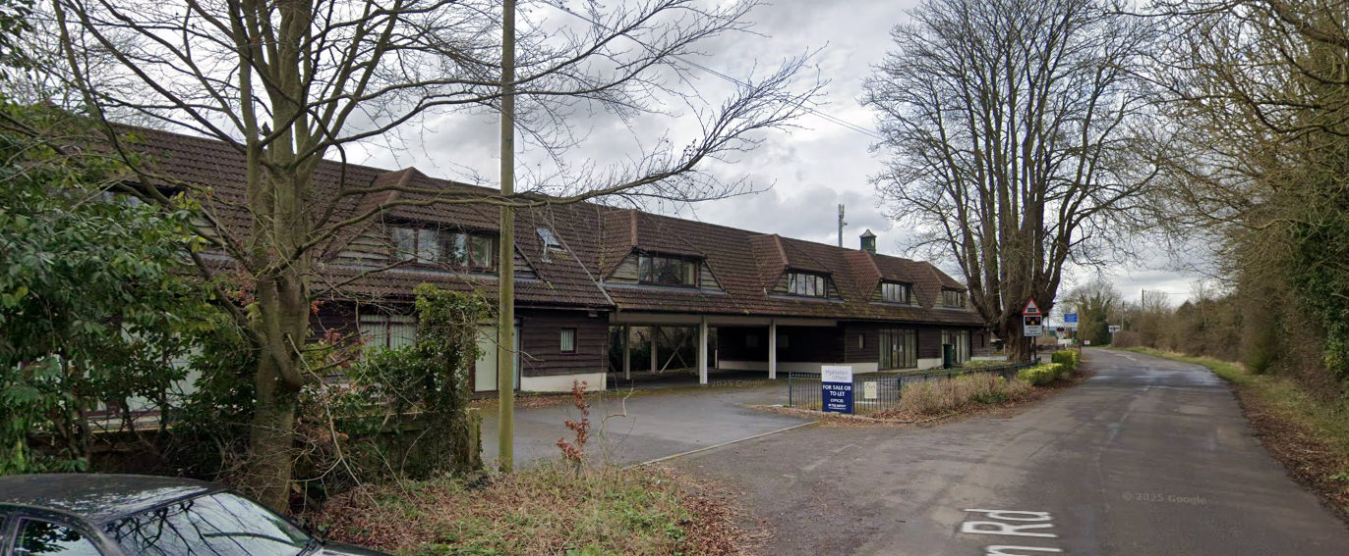

March 2024 Google Street View Image of the site

Ashton Cottage is a Grade II listed building, but would be approximately 90m away.

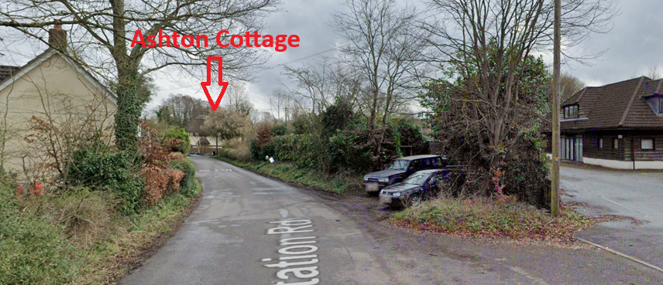

View from approximate location to listed building Ashton Cottage

PROPOSAL:

The application seeks advertisement consent for one free standing sign on timber posts that would be 1.8m high, 1m wide and 0.1m deep. There would be 5 additional horizontal timber slats to display the individual business names. The sign would be painted in black, white and brown. The sign would be located on the main entrance to the car park as seen on the first street view image.

Revised plans have been received (and re-consulted) that have removed a second sign (which would have been in potential conflict with a level crossing warning sign), reduced the height from 2.2m to 1.8m and removed the trough light, given the IDSR designation.

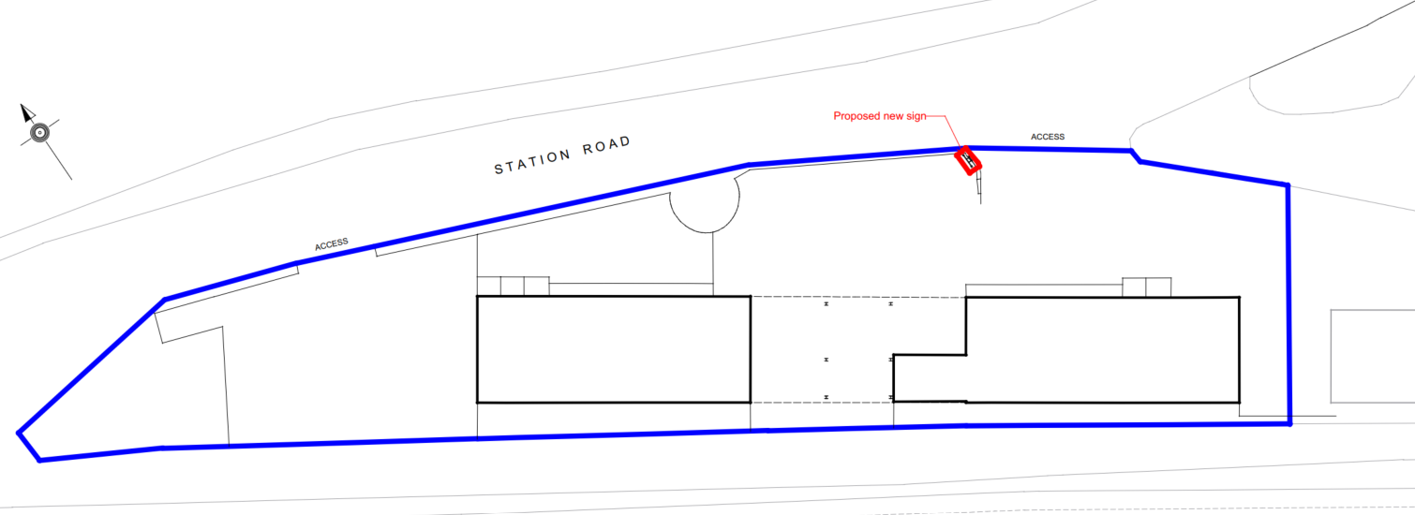

Proposed Site Plan

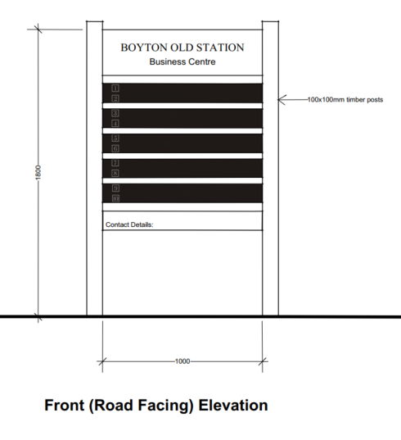
RELEVANT LEGISLATION, POLICIES AND GUIDANCE

The Town and Country Planning (Control of Advertisements) (England) Regulations 2007

National Planning Policy Framework (NPPF)
- Paragraph 141

Planning Practice Guidance (PPG)
- Advertisements

Wiltshire Core Strategy 2015 (WCS):
- Core Policy 51 Landscape
- Core Policy 57 Ensuring High Quality Design & Space Shaping
- Core Policy 58 Ensuring the Conservation of the Historic Environment
- Core Policy 62 Development Impacts on the Transport Network

Neighbourhood Plan: Codford does not have a neighbourhood plan or area designation

Supplementary Planning Documents:

Cranborne Chase Management Plan 2019-2024
Cranborne Chase International Dark Sky Reserve Status (2019)
Position Statement on Light Pollution, Good Practice Guides on Good Lighting, and IDSR criteria
Institute of Lighting Professionals: The Brightness of Illuminated Advertisements (2014) PLG 05.

RELEVANT PLANNING HISTORY:

There is no relevant planning history relating to advertisement consents.

ISSUES

The issues that are relevant to the consideration of an application for consent to display advertisements are the effects of the proposal on ‘amenity’ and ‘public safety’.

CONSULTEE RESPONSES

The following consultees were invited to comment on this application:

Codford Parish Council: No objection

Wiltshire Council’s Highways Engineer: No objection

RESPRESENTATIONS

Below is a summary of the representations received during the consultation period. Only material planning considerations have been taken into account in the assessment of this application. Non-material issues, such as property values or private legal disputes, cannot be considered in the determination process.

No comments received.

ASSESSMENT

Regulation 3 of The Town and Country Planning (Control of Advertisements) (England) Regulations 2007 requires that local planning authorities exercise their powers in relation to the display of advertisements in the interests of amenity and public safety, taking into account the provisions of the development plan, in so far as they are material, and any other relevant factors.

The NPPF (141) is clear that the quality and character of places can suffer when advertisements are poorly sited and designed and should be subject to control only in the interests of amenity and public safety, also considering the cumulative impacts.

Impact on Amenity:

Policy Context
“Amenity” is not exhaustively defined in the Town and Country Planning (Control of Advertisements) (England) Regulations 2007, but is generally understood to include both visual and aural amenity. Factors relevant to amenity include the general characteristics of the locality, such as the presence of features of historic, architectural, cultural, or similar interest.

In broader planning terms, as reflected in the National Planning Policy Framework (NPPF), amenity refers to the quality or character of an area and the elements that contribute to the overall enjoyment and liveability of a place.

CP57 requires a high standard of design in all proposals, including (x) the sensitive design of advertisements and signage.

Assessment

The application site is rural in character forming a very small cluster of buildings within a wider open countryside setting. Boyton Old Station, is however a large building that is clearly used for commercial purposes and has a visible car park.

The application site however does not have any advertisements for the unit or for the individual businesses that occupy the spaces. It is considered that the sign, being made from timber and painted, black, brown and white would both be appropriate to the commercial unit and would assimilate well into its surrounding context.

The sign has been negotiated down to 1.8m in height (from 2.2), which still allows for the advertisement to be clearly seen (as intended) but whilst respecting the wider rural character of its surroundings. A 2.2m high sign would have looked too large for this rural context.

The trough light has been removed due to the IDSR designation and therefore there would be no impact on the National Landscape.

It is also considered that the setting of the nearby listed building would be preserved and no harm would be caused to its historic significance.

The sign would also be easily removed if and once the need for the sign no longer applies.

It is considered that the proposed advertisement would not cause harm to the visual amenity of the area, including the setting of any heritage assets, and would therefore comply with the relevant provisions of the Town and Country Planning (Control of Advertisements) Regulations 2007.

Impact on Public Safety:

Policy Context
“Public safety” is not exhaustively defined in the Town and Country Planning (Control of Advertisements) (England) Regulations 2007, but it generally refers to the potential impact of a development or advertisement on the safe use and operation of public spaces, including roads, footpaths, and other areas accessible to the public.

In assessing public safety, the Local Planning Authority (LPA) may consider:
- Whether the proposal would obstruct visibility for road users or pedestrians;
- Whether it could distract, confuse, or mislead drivers, particularly near junctions or crossings;
- Whether it interferes with traffic signs, signals, or street lighting;
- Whether it poses a physical hazard, such as through poor structural integrity or inappropriate siting.

The National Planning Policy Framework (NPPF) also supports the principle that planning decisions should ensure developments create places that are safe, inclusive, and accessible, and that they do not undermine public safety or security.

CP62 advises that proposals should provide appropriate mitigating measures to offset any adverse impacts on the transport network at both the implementation and operational stages.

Assessment

The Councils’ Highways Officer has no objection to the proposal.

The second sign that could have competed with the important level crossing sign has been removed, and lighting removed thereby removing any potential for driver distraction.

Cumulative Impact
There would not be any cumulative impacts as the site does not have any existing advertisements.

Mitigation and Conditions
In order to ensure that the signs are not illuminated at a later date a condition will be added to the consent.

It is considered that the proposal would not result in an unacceptable impact on public safety, either individually or cumulatively, and would therefore satisfy the relevant provisions of the Town and Country Planning (Control of Advertisements) Regulations 2007.

CONCLUSION:

The proposed advertisement has been assessed in accordance with the relevant provisions of the Town and Country Planning (Control of Advertisements) (England) Regulations 2007.

It is considered that the advertisement, by reason of its design, scale, siting, and method of illumination, would not result in harm to the visual amenity of the area, including the setting of any nearby heritage assets. Furthermore, the proposal is not considered to pose a risk to public safety, either individually or cumulatively with other signage in the vicinity.

Subject to the recommended conditions, the proposal is therefore considered acceptable, and it is recommended that advertisement consent be granted.

RECOMMENDATION:
It is recommended that advertisement consent be GRANTED subject to condition(s).

