APPLICATION FOR HOUSEHOLDER PLANNING APPLICATION.
CASE OFFICER REPORT

APPLICATION REFERENCE: | PL/2026/00706
APPLICATION TYPE: | Householder.
SITE ADDRESS: | 155 Winsley, Bradford on Avon.
DEVELOPMENT DESCRIPTION: | Proposed single-storey rear extension.
RECOMMENDATION: | Approve with Conditions.

PROPOSAL
The proposal seeks planning permission for the construction of a single storey rear extension.

SITE DESCRIPTION/CONTEXT
The site consists of an end of terrace two storey stone constructed cottage, the building is within the village of Winsley and is within the Winsley Conservation Area and Special Landscape Atrea. The building is not listed. The site is surrounded by other stone constructed buildings with the Winsley Social Club and ‘Seven Stars’ public house being nearby. The cottage is believed to date from the Victorian period and merits being considered as a Non- Designated Heritage Asset and is located within an area where there are several listed buildings.

RELEVANT PLANNING HISTORY
Proposal / Summary
W/07/01221/FUL Enlargement of existing single storey extension, new porch, minor external alterations, new parking area and changes to boundary walls. Approved
PL/2022/04466 Single storey rear extension. Approved

RELEVANT POLICIES AND GUIDANCE
Wiltshire Core Strategy:

- Core Policy 57 Ensuring High Quality Design and Place Shaping
- Core Policy 50: Biodiversity and Geodiversity
- Core Policy 51: Landscape
- Core Policy 58: Ensuring the Conservation of the Historic Environment
- Core Policy 61: Transport and New Development
- Core Policy 64: Demand Management
- Core Policy 67: Flood Risk

Wiltshire Design Guide: Appendix D – Design Guidance for Householder extensions

The National Planning Policy Framework (NPPF)

The Planning Practice Guidance

National Design Guide

Emerging Wiltshire Local Plan:
The examination of the emerging Wiltshire Local Plan has been paused and the weight to be afforded to any part of the emerging plan can be no more than very limited. A decision on how to proceed will be made by the Council in May 2026.

CONSULTATION RESPONSES
Winsley Parish Council: No objections.

Ecology: No objections subject to conditions.

REPRESENTATIONS
Two emails were received raising the following points:
-Support the proposals.
-Ownership and easement rights of rear side access pertaining to No.152, prior to this element of the scheme being withdrawn and superseded.

PRINCIPLE OF THE PROPOSAL.
The proposed development comprises an extension to an existing residential property set in an established residential curtilage within the settlement boundary of Bradford on Avon (Winsley). The proposed extension is wholly within the residential curtilage and as such the principle of development is acceptable subject to the following considerations.

ASSESSMENT
Section 38(6) of the Planning and Compulsory Purchase Act 2004 states:

"If regard is to be had to the development plan for the purposes of any determination to be made under the planning Acts, the determination must be made in accordance with the plan unless material considerations indicate otherwise."

In accordance with this statutory requirement, this application has been assessed against the relevant policies of the Development Plan, including the adopted Wiltshire Core Strategy (2015)

Design and Impact upon the upon the character and context of the area

Paragraph 216 of the NPPF states “The effect of an application on the significance of a non-designated heritage asset should be taken into account in determining the application. In weighing applications that affect directly or indirectly non-designated heritage assets, a balanced judgement will be required having regard to the scale of any harm or loss and the significance of the heritage asset”.

Core Policy 57 requires a high standard of design in all new developments. of particular relevance to householder extensions is paragraph (iii) which requires development to respond positively to the existing townscape and landscape features in terms of building layouts, built form, height, mass, scale, building line, plot size, elevational design, materials, streetscape and rooflines to effectively integrate the building into its setting.

The property known as 155 Winsley and its attached neighbours are identifiable on the historic OS maps the Council has access to and is considered to date from the Victorian period and merits being considered as a non-designated heritage asset. The historical importance and significance of the dwelling is formed from its traditional construction, its materials and the contribution it makes to the immediate environs.
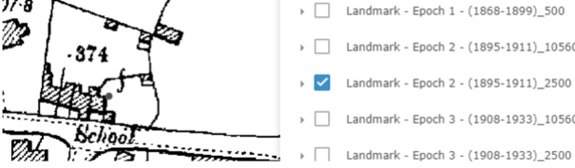

The host dwelling sits in a prominent position on the main route through the village with the front and side elevations readily visible from the public highway.

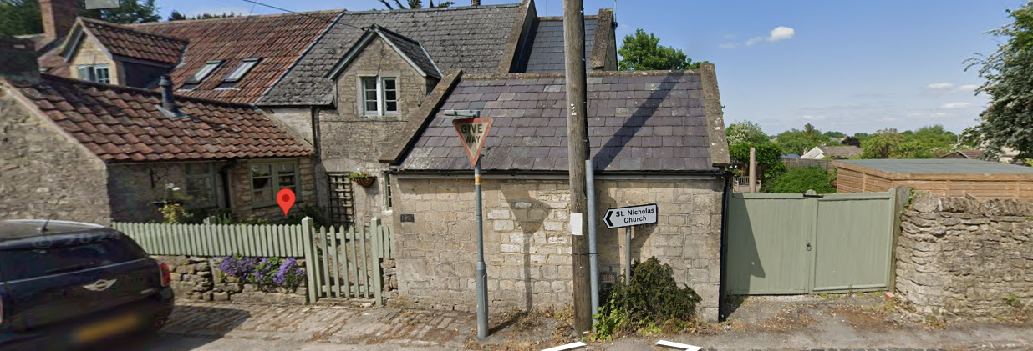
‘Street View’ Photograph of 155 Winsley.
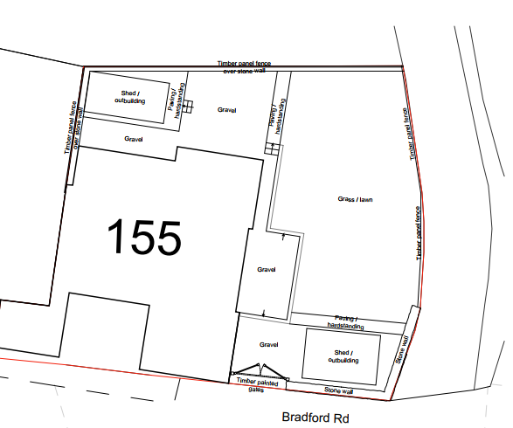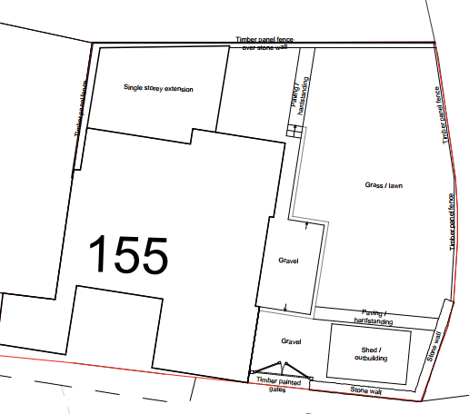
Existing & Proposed Block Plans.

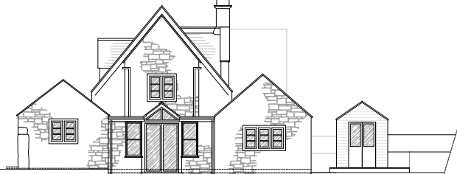
Existing East Elevation

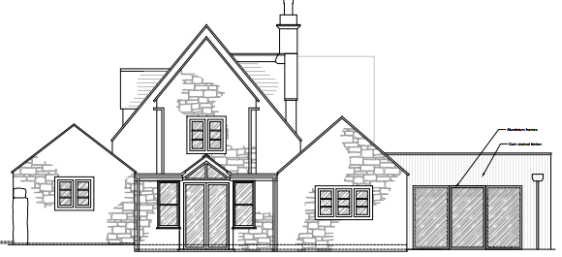
Proposed East Elevation
The proposed extension would be positioned on the rear elevation on the common shared boundary with the adjoining neighbour. At a maximum height of 3.1m the proposed extension would be viewed as a subservient addition to the host dwelling. The elevations would be clad in cedar boards, with the use of cladding being seen as a contemporary addition that would help identify the new addition from the original building and would not harm the character or appearance of the immediate area.

The subservient scale and design of the proposal is acceptable, with the proposed design representing an acceptable subordinate addition by virtue of its height, scale and positioning. Therefore, it is appraised that the development would not harm the significance or character and appearance of the non-designated heritage asset, with the proposal complying with CP57 and CP58 of the adopted Wiltshire Core Strategy.

Impact on the Conservation Area and Special Landscape Area
Section 72(1) of the Planning (Listed Building and Conservation Areas) Act 1990 requires the Council to pay special attention to the desirability of preserving or enhancing the character or appearance of designated Conservation Areas.

The Council’s Core Strategy Policy CP58 ‘Ensuring the conservation of the historic environment’ requires that “designated heritage assets and their settings will be conserved, and where appropriate enhanced, in a manner appropriate to their significance”.

Core Policy 51 of the adopted Wiltshire Core Strategy states that “great weight will be afforded to conserving and enhancing landscapes and scenic beauty”. As the application site adjoins a special landscape area, views into and out of the application site need to be appraised with any potential negative impact of any future development assessed.

The application site lies within the Winsley Conservation Area and also a Special Landscape Area, therefore due consideration has to be given to any development that may adversely impact upon the scenic quality of the special landscape designation. The single storey extension would extend some 5 m from the rear elevation, positioned between the north elevation of the host dwelling and the site’s boundary. Access would be granted via patio doors positioned on the east side elevation.
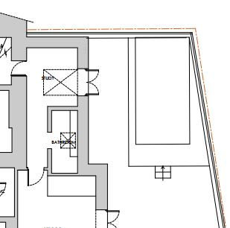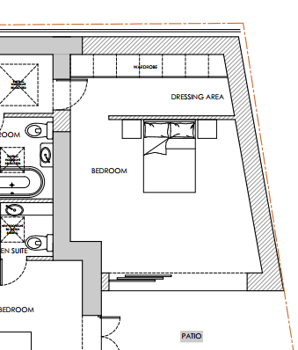

Existing & Proposed Gound Floor plans.
It is considered that the proposal would by virtue of its height, scale and design constitute a complementary addition to the host dwelling that would appear commensurate to the size of the property and plot. The development would therefore comply with Policy CP57 and CP58 of the WCS.

It is also considered that the proposal would not detrimentally impact the wider much valued landscape character of the special landscape area, as the additional form would be erected within the established built envelope of the application site. It is therefore considered to comply with CP51 of the adopted Wiltshire Core Strategy.

Impact on the Setting of the host non designated heritage asset and nearby listed buildings
Section 66 of the Planning Listed Building and Conservation Area Act 1990 states that the local planning authority has a duty to pay special attention to the desirability of preserving the building or its setting or any features of special architectural or historic interest that it possesses.

Section 16 of the NPPF 'Conserving and enhancing the historic environment' sets out the Government's high-level policies concerning heritage and sustainable development. Paragraph 216 of the NPPF require a balanced approach with any harm which would be caused being weighed against the potential public benefits which might be achieved.

Paragraph 205 requires local planning authorities should take into account the desirability of sustaining and enhancing the significance of heritage assets and of new development making a positive contribution to local character and distinctiveness.

The Council’s Core Strategy Policy CP58 ‘Ensuring the conservation of the historic environment’ requires that “designated heritage assets and their settings will be conserved, and where appropriate enhanced, in a manner appropriate to their significance”.

The application site is located in close proximity to a number of Grade II listed buildings which include St Nicholas’s Church positioned 40 metres to the northwest of the application site, as shown below.

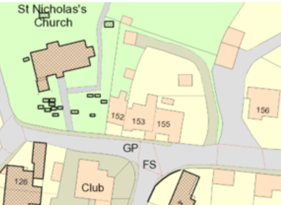

However, given the limited footprint of the proposed scheme, that would be positioned on the rear elevation of the host dwelling, which would not be readily visible from the public realm and contained within the built curtilage of the application site, it is assessed that the development proposal would cause no harm to the host building nor any harm to the significance of the listed buildings or their settings. The development therefore complies with Core Policies, 57 and 58 of the Core Strategy.

Amenity
Point vii of Core Policy 57 - Ensuring High Quality Design and Place Shaping of the Wiltshire Core Strategy seeks to ensure that developments do not adversely affect neighbouring properties.
The National Planning Policy Framework (NPPF), particularly Paragraph 135(f), stresses that planning decisions should ensure developments provide a high standard of amenity for existing and future users.
All windows proposed would look out over the applicant’s private rear garden area to the east and given the single storey nature of the proposed build, no overlooking concerns are raised. No concerns are raised about either overbearing or overshadowing impacts to any neighbouring properties given the limited height (3.1m) of the proposed extension.

Given the scale of the development proposal, it is considered that the proposed extension would not result in unacceptable loss of light, overlooking, overshadowing and would not have an overbearing impact upon neighbouring properties. For these reasons, the development proposals would comply with Policy CP57 of the adopted Wiltshire Core Strategy

Highway Matters.
Core Policy 57 (xiv) of the Wiltshire Core Strategy seeks to ensure that development must meet the requirements of Core Policy 61. This policy requires proposals to be capable of being served by safe access to the highway network. Core Policy 64 seeks to ensure compliance with parking standards set out in the Local Transport Plan.

The National Planning Policy Framework (NPPF), particularly Paragraph 115 and 116, requires that development proposals do not have an unacceptable impact on highway safety and that safe and suitable access to the site can be achieved for all users.

The initial plans showed a proposal that would utilise a private accessway to the north and east of the site relating to No.152, however, this aspect of the application has been dropped and superseded with the scheme relying on the as existing access and parking arrangements. Therefore, any such concerns raised by the Highways officer and No.152 have been addressed and resolved.

As such, the proposal is therefore considered to comply with Core Policies 57 (xiv), 61 and 64 of the Wiltshire Core Strategy, the NPPF, and the Wiltshire Local Transport Plan.

Ecology Impact CP50 requires no net loss of biodiversity on site. The site is located within the Bath and Bradford on Avon Bat SAC. Consequently, the Council ecologist was consulted whereby a test of likely significance (screening assessment) was been carried out by Wiltshire Council as required under Regulation 63 of the Conservation of Habitats and Species Regulations 2017 (as amended) (also known as the Habitat Regulations).

The Ecologist’s findings were that the proposals would not result in a significant increase in human disturbance in this area, no foraging/commuting habitat would be removed, and no lighting is proposed. Furthermore, the small single-storey extension (with no enclosed void) would be constructed which would not be likely to offer significant bat roosting potential. Overall, given the scale and nature of the currently proposed development, there is no mechanism for adverse impact on the Conservation Objectives of the SAC, and the proposal was able to be screened out of Appropriate Assessment.

The ecologist has requested that a pre-commencement condition relating to site clearance be attached, which officers consider relevant and necessary, the agent has been made aware of this and has given consent for it to be attached to the decision notice.

Biodiversity Net Gain. This application is exempt from the requirement to deliver Biodiversity Net Gain under Schedule 7A, Section 4(2)(a) of the Town and Country Planning Act 1990, as inserted by the Environment Act 2021, because the proposal is a householder extension.

Other Matters. The original scheme involved the stopping off of the existing access and the creation of a new side access, which has now been discontinued. The landowner neighbour of where the new access would have taken place has been made aware of this situation by the case officer.

CONCLUSION
The proposed development is acceptable in terms of its design, scale, and relationship with the surrounding area. It would not result in any unacceptable harm to the character of the locality, the amenities of neighbouring occupiers, or the interests of highway safety, heritage, or ecology.

The proposal is therefore considered to comply with the relevant policies of the Wiltshire Core Strategy, the Wiltshire Local Plan, and the National Planning Policy Framework. As such, the application is recommended for approval, subject to the conditions set out below.

RECOMMENDATION: Planning Permission be GRANTED subject to conditions.

