APPLICATION FOR HOUSEHOLDER PLANNING PERMISSION
DELEGATED REPORT

APPLICATION REFERENCE: | PL/2026/01045
APPLICATION TYPE: | Householder Planning Permission
SITE ADDRESS: | The Beeches, Showell, Chippenham, SN15 2NU
DEVELOPMENT DESCRIPTION: | Two-storey side extension to replace existing single-storey structures, a first-floor rear extension, associated internal remodelling, installation of an air-source heat pump and photovoltaic panels, replacement and alteration of fenestration throughout, and external works to unify the elevations and roofscape.
RECOMMENDATION: | That Planning Permission be GRANTED

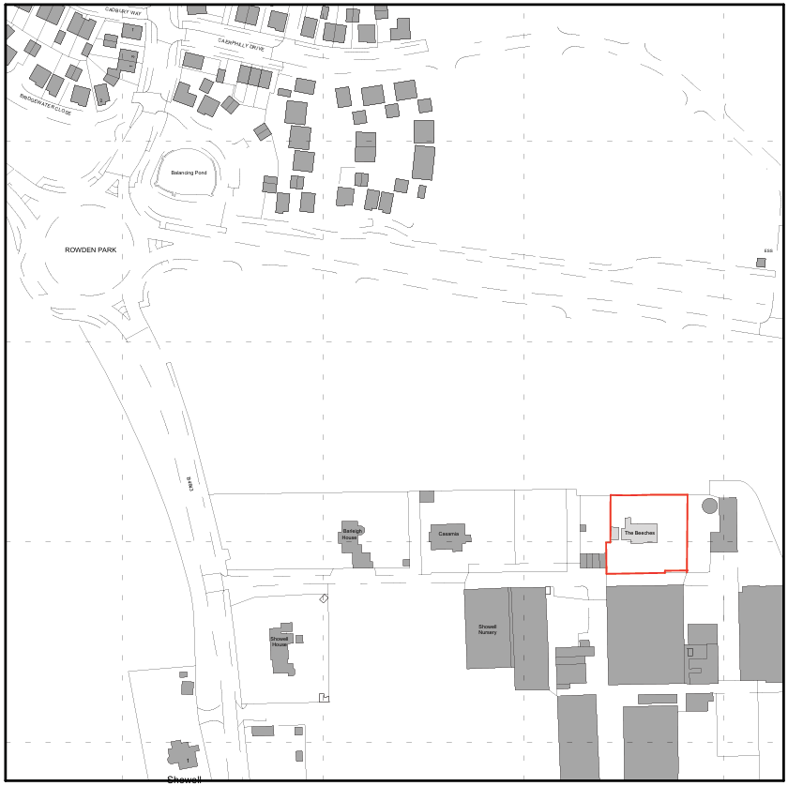
PROPOSAL

The application seeks planning permission for a comprehensive remodelling and extension of the existing dwelling. The proposals comprise the replacement of existing ad hoc single-storey side and rear structures with a two-storey side extension, a first-floor rear extension, and a single-storey flat-roofed link connecting the dwelling to the existing garage. Associated works include internal reconfiguration to facilitate a revised staircase arrangement and improved family living accommodation, installation of an air source heat pump and photovoltaic panels, replacement and alteration of fenestration throughout, and external works intended to unify the appearance of the elevations and roofscape. The ground floor of the two-storey extension would be finished in natural stone, with timber cladding wrapping the first floor and extending to the gable elevations, while the garage link extension would be timber-clad with a flat roof. A balcony is proposed at first-floor level on the east elevation. The scheme also includes minor landscaping works and repairs to existing render.

SITE DESCRIPTION / CONTEXT

The application site comprises a detached two-storey dwelling set within a generous residential curtilage on the southern edge of Chippenham, approximately 1 kilometre outside the defined settlement boundary. The existing house is finished in cream render with a dark red pantile roof formed by parallel dual-pitched roofs, resulting in an “M-shaped” gable profile when viewed from the side. White uPVC windows are present throughout. At the time of the site visit, the dwelling was notably isolated from other completed residential properties and formed part of an active construction environment associated with an adjoining housing development currently under build-out (outline permission ref. 14/12118/OUT). Reserved matters approval (ref. 20/02334/REM) confirms that new dwellings are proposed to the north of the site, with the nearest plots anticipated to be located approximately 22.5 metres from the application property, which carries some weight in the assessment of future context. The site is affected by a Bechstein bat 1.5km core roost buffer and, in part, by areas identified within the Strategic Flood Risk Assessment as being at high risk of groundwater flooding. Notwithstanding this, the site lies outside any SSSI, conservation area, national landscape or other statutory landscape designation.

PLANNING HISTORY

No relevant planning history has been identified for the site subject of this application.

The land to the North is subject to a housing scheme (ref 20/02334/REM, 18/11942/REM, 20/02334/REM).

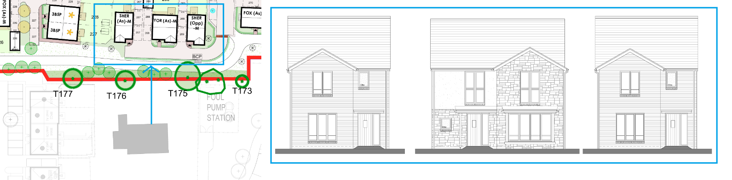
Site Plan and House Types 20/02334/REM

RELEVANT LEGILSATION, POLICIES AND GUIDANCE

Wiltshire Core Strategy:

Core Policy 1 Settlement Strategy;
Core Policy 2 Delivery Strategy;
Core Policy 10 Spatial Strategy: Chippenham Community Area;
Core Policy 50 Biodiversity and Geodiversity;
Core Policy 51 Landscape;
Core Policy 57 Ensuring High-Quality Design and Place Shaping;
Core Policy 58 Ensuring Conservation of the Historic Environment;
Core Policy 60 Sustainable Transport;
Core Policy 61 Transport and Development;
Core Policy 64 Demand Management;
Core Policy 67 Flood Risk;

The National Planning Policy Framework (NPPF) and The Planning Practice Guidance (PPG)

Wiltshire Design Guide - Appendix D – Design Guidance for Householder extensions

The Wiltshire Local Transport Plan 2011 – 2026: Car Parking Strategy (March 2015).

The Wiltshire Local Transport Plan 4 (LTP4) (March 2025)

Emerging Policy – Wiltshire Local Plan Review

The examination of the emerging Wiltshire Local Plan has been paused and the weight to be afforded to any part of the emerging plan can be no more than very limited. A decision on how to proceed will be made by the Council in May 2026.

CONSULTATION RESPONSES

Lacock Parish Council – Supports

REPRESENTATIONS

No comments received.

ASSESSMENT

Section 38(6) of the Planning and Compulsory Purchase Act 2004 states:

"If regard is to be had to the development plan for the purposes of any determination to be made under the planning Acts, the determination must be made in accordance with the plan unless material considerations indicate otherwise."

In accordance with this statutory requirement, this application has been assessed against the relevant policies of the Development Plan, including the adopted Wiltshire Core Strategy (2015) and, where applicable, any made Neighbourhood Plans.

Householder extensions are generally acceptable in principle, as they typically fall within the established residential curtilage of a property and do not result in new residential development in the open countryside. In this case, the proposal also lies within the defined limits of development set out in the Core Strategy, further reinforcing its acceptability in principle.

Design and Impact upon the upon the character and context of the area

Core Policy 57 Ensuring High Quality Design and Place Shaping of the Wiltshire Core Strategy requires all new development to achieve a high standard of design that responds positively to its local context. Proposals must reinforce and enhance local character and distinctiveness, relate appropriately to the surrounding landscape, and demonstrate a thoughtful response to existing townscape features. This includes careful consideration of elements such as building height, scale, massing, building line, materials, and overall appearance, ensuring new development integrates harmoniously with its setting.

From a design perspective, the proposal represents a considered and largely positive reworking of the host dwelling. The scheme includes the removal of the existing side conservatory and rationalisation of a number of loose and ad hoc historic extensions, replacing them with a single, consolidated form which, although larger, sits more appropriately within the proportions and scale of the original dwelling. The rear extension would extend approximately 2.4 metres beyond the extent of the existing rear additions, representing only a modest increase to the overall envelope and ensuring the building remains largely within its established bulk and massing. The rear elevation introduces a new first floor gable that reflects the distinctive “M-shaped” gable profile present on the existing east elevation; while the rear arrangement incorporates a recessed element with a projecting extension, it aligns with the existing ridge height and principal building line, resulting in a balanced and cohesive alteration. The proposals also seek to rationalise and unify the roofscape through consistent roof forms and matching materials, reducing visual clutter and reinforcing the legibility of the building as a single, coherent dwelling.

The eastern elevation would remain largely unchanged in its overall character, notwithstanding the visibility of the rear extension and the introduction of a first-floor balcony. The balcony is read as a clearly subordinate element within the wider elevation, modest in scale and well-integrated into the overall composition rather than appearing visually dominant. While the use of timber cladding and natural stone represents a departure from the existing rendered palette, these materials are applied in a structured and comprehensive manner, reinforcing a farmhouse-influenced aesthetic and avoiding the perception of piecemeal or incongruous additions. The proposal also includes the repositioning of the garage slightly further back within the plot and its recladding in timber, allowing it to better integrate with the revised dwelling. The front elevation would be further enhanced through the introduction of upper floor timber cladding, the replacement of white uPVC fenestration with aluminium–timber composite frames, and the addition of a new bay window which directly mirrors the existing bay, maintaining symmetry and visual consistency. The proposed replacement porch, utilising a more refined timber-framed design, is considered a clear improvement over the existing arrangement. Overall, in the absence of strong established local context and with nearby residential development currently under construction, the proposal is considered to represent a well-composed update that would result in a visual enhancement to the host dwelling and respond appropriately to its evolving surroundings.

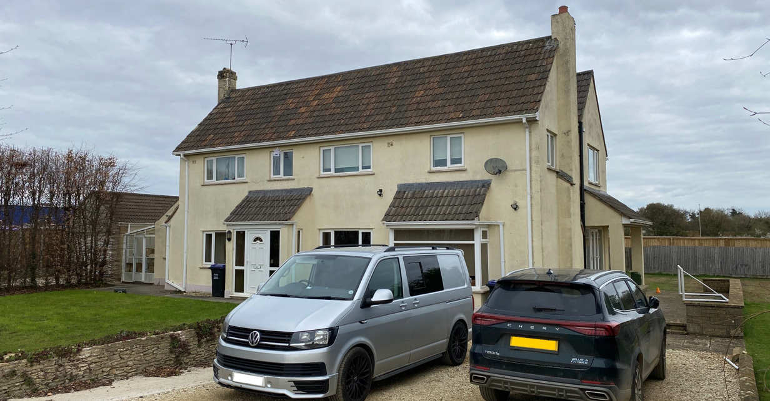
Site Visit Image

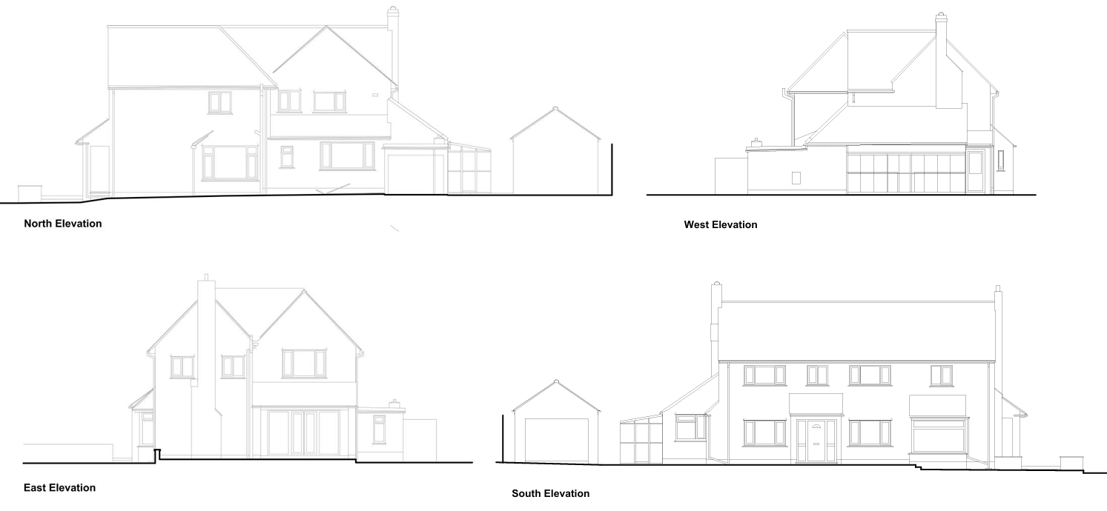
Existing Elevations

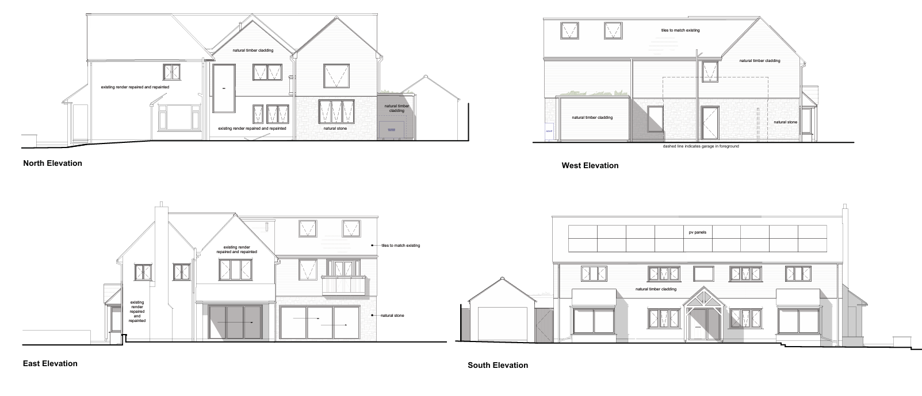
Proposed Elevations

Having regard to the above, the proposal complies with the design principles set out in Core Policy 57 of the Wiltshire Core Strategy and Appendix D of the Wiltshire Design Guide.

Amenity

Point vii of Core Policy 57 Ensuring High Quality Design and Place Shaping of the Wiltshire Core Strategy seeks to ensure that developments do not adversely affect neighbouring properties.

The National Planning Policy Framework (NPPF), particularly Paragraph 135, stresses that planning decisions should ensure developments provide a high standard of amenity for existing and future users.

The proposal has been assessed with regard to its potential impact on the amenity of neighbouring occupiers in terms of overlooking, overbearing impact and loss of light. The proposed first-floor balcony on the east elevation would not result in overlooking, as there are no residential properties located to the east of the site and the distance from this elevation to the site boundary measures approximately 28 metres, which is considered substantial. The rear extension would project marginally beyond the footprint of the existing rear extension and introduces additional first-floor windows; however, there are currently no dwellings to the north of the property that would be affected. Approved reserved matters drawings for the adjacent development indicate that future dwellings would be located at a distance of approximately 20 metres, with an intervening road and established vegetation providing further separation, such that no harmful overlooking or loss of privacy would arise either now or in the future. A new first-floor window is also proposed on the west elevation, though the nearest residential property in this direction lies at a distance of approximately 75 metres and therefore no adverse amenity impacts would result.

In terms of bulk, scale and overbearing effects, the site is currently relatively isolated and the modest northward extension of the building is unlikely to result in any material loss of daylight or sunlight to surrounding land or future neighbouring properties. Even when considering the approved adjacent development, the primary influence on any future shadowing would remain the existing dwelling, with the proposal not materially altering this relationship. Overall, with separation distances to site boundaries remaining generous at approximately 9 metres, the development is not considered to cause harm to residential amenity, either in the current context or as the surrounding area develops.

The proposal is appropriately sited, designed, and oriented to ensure that it would not result in unacceptable impact upon/to the amenities or living conditions of neighbouring residential occupiers, particularly in terms of outlook, privacy, or access to natural light.

The proposal therefore accords with Core Policy 57 point vii in respect of safeguarding residential amenity and Appendix D of the Wiltshire Design Guide.

Other Issues

Core Policy 50 of the Wiltshire Core Strategy requires development to avoid and reduce disturbance to sensitive wildlife species and habitats. The proposal relates entirely to works within the existing residential curtilage of the dwelling and it is not anticipated that the development would result in any material impact on existing habitats or protected species. Householder developments are exempt from the requirement to deliver measurable Biodiversity Net Gain under Schedule 7A of the Town and Country Planning Act 1990 (as inserted by the Environment Act 2021), and as such no BNG assessment is required in this instance. Notwithstanding this, the site lies within a defined Bechstein bat core roost buffer and the proposals include works to the existing roof structure. In light of this, it is recommended that the applicant has regard to the informative attached to this decision and remains mindful of their ongoing obligations under the Wildlife and Countryside Act 1981, should any protected species be discovered during the course of the approved works.

The proposal would not alter the existing access, egress or parking arrangements, and while the number of bedrooms would increase from four to five, this does not result in any conflict with adopted parking standards, which continue to require a minimum of three parking spaces that can be accommodated on site.

Core Policy 67 of the Wiltshire Core Strategy requires development to be located and designed so as to minimise vulnerability to flooding and avoid increasing flood risk elsewhere, with the NPPF advocating a sequential, risk-based approach to development. It is acknowledged that parts of the site fall within an area identified by the Strategic Flood Risk Assessment as being at high risk of groundwater flooding; however, the proposal relates to householder development within an existing residential curtilage and involves a relatively modest increase in built form. The overall footprint of the proposed development is approximately 96 sqm and is largely situated on areas currently occupied by existing structures or hardstanding. In this context, the development does not result in a material change to surface water run-off characteristics. Paragraph 176 of the NPPF confirms that householder development of less than 250 sqm is exempt from the Sequential and Exception Tests, and this threshold is comfortably met in this instance. Having regard to the nature and scale of the proposal, it is therefore considered that the development accords with flood risk policy, and that no objection is raised on drainage or flood risk grounds.

CONCLUSION

The proposal is considered to be acceptable and in accordance with the relevant policies and guidance outlined above.

RECOMMENDATION: That Planning Permission be GRANTED subject to the following conditions:

1.
The development hereby permitted shall be begun before the expiration of three years from the date of this permission.
REASON: To comply with the provisions of Section 91 of the Town and Country Planning Act 1990 as amended by the Planning and Compulsory Purchase Act 2004.

2.
The development hereby permitted shall be carried out in accordance with the following approved plans and documents:

Design and Access Statement (16 February 2026)
Proposed First Floor Plan (16 February 2026)
Proposed Garage Elevations (16 February 2026)
Proposed Elevations S – W (24 February 2026)
Proposed Site Plan (24 February 2026)
Proposed Roof Plan (24 February 2026)
Proposed Elevations N – E (24 February 2026)
Proposed Ground Floor Plan (26 February 2026)
Location Plan (24 February 2026)

REASON: For the avoidance of doubt and in the interests of proper planning.

