APPLICATION FOR HOUSEHOLDER PLANNING PERMISSION
DELEGATED REPORT

APPLICATION REFERENCE: | PL/2026/01415
APPLICATION TYPE: | Householder planning permission
SITE ADDRESS: | 17 Granby Way, Ludgershall, Andover, SP11 9GB
DEVELOPMENT DESCRIPTION: | Single storey wrap around extension comprising a new sun room and an external store, under a shallow pitched zinc roof with new window and door openings.
RECOMMENDATION: | That Planning Permission be GRANTED

PROPOSAL

The proposal seeks planning permission for a single storey, wraparound side and rear extension. The extension would have facing brickwork and timber cladding with a standing seam zinc roof.

Proposed floor plans

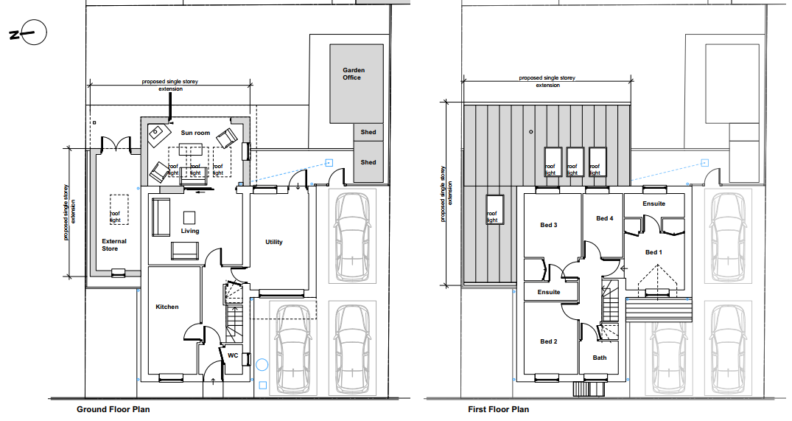

Proposed elevations

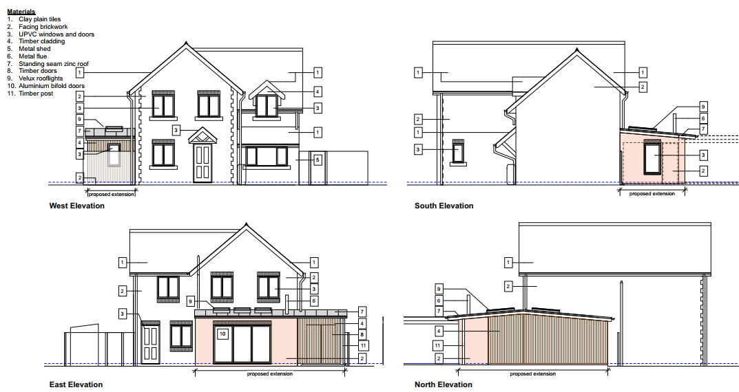

SITE DESCRIPTION/CONTEXT

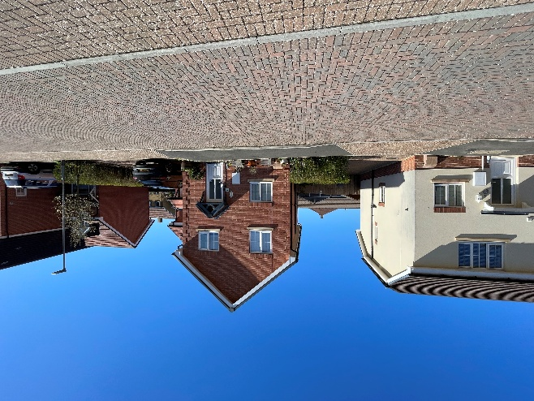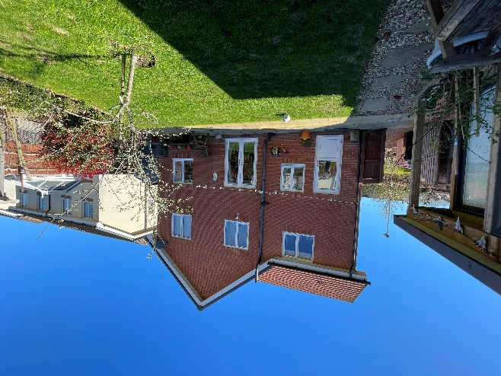
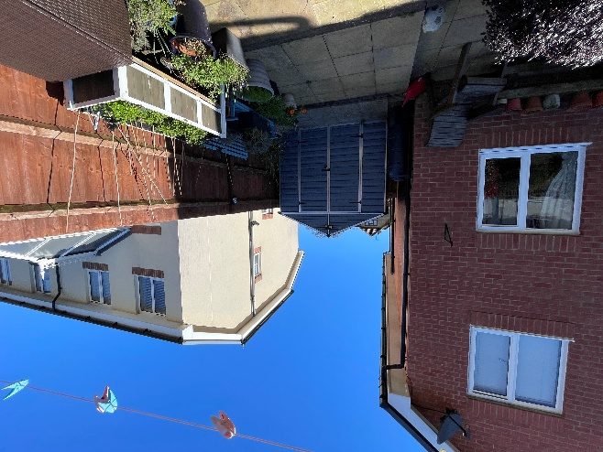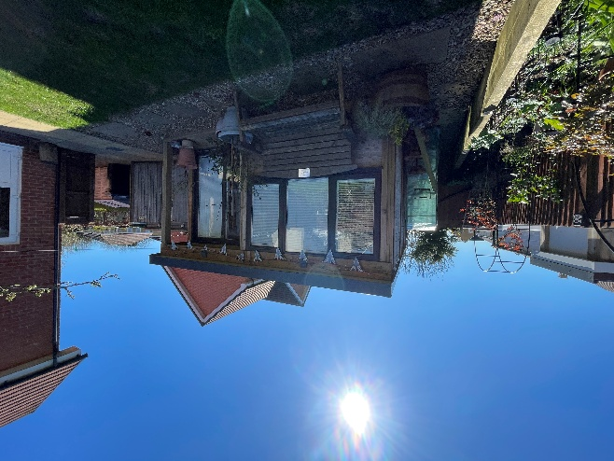
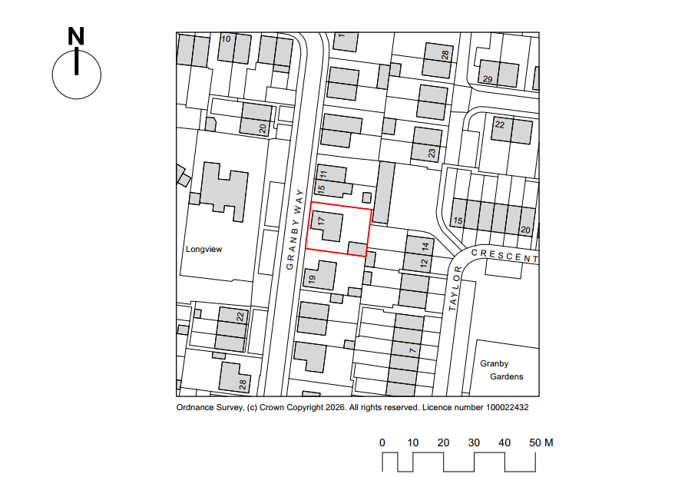

The application relates to 17 Granby Way, a modern, detached two storey dwelling located within the market town of Ludgershall, as defined by Wiltshire Core Strategy (WCS) core policies 1 (Settlement Strategy), 2 (Delivery Strategy) and 26 (Spatial Strategy for the Tidworth Community Area).
The property sits close to the pavement, has a driveway to the south, front garden to the north and a rear garden to the east. The immediate area comprises residential neighbours. There are sheds and garden office within the rear garden.

The application site is subject to the following planning policy constraints:
- Salisbury Plain SPA 6.4km buffer
- River Test Catchment
- Salisbury Plain and West Wiltshire Downs Countryside Character Areas
- Flood zone 1

PLANNING HISTORY

Proposal / Summary
14/06522/FUL - Full planning permission Decision - Approve with Conditions Date: 15/5/2015 – Full planning application for the residential redevelopment of the site for 181 units and their associated car parking, provision of areas of open space and play, and re-use/enhancement of the existing vehicular access from Astor Crescent, along with another new vehicular access from Simonds Road, and off-site pedestrian improvements alongside New Drove, following demolition of the Garden Centre and its associated outbuildings at Granby Gardens, Astor Crescent, Ludgershall
15/10775/VAR - Removal/variation of conditions Decision - Approve with Conditions Date: 1/3/2016 – Proposed variation of condition 5 of application 14/06522/FUL, seeking to vary the approved plans relating to plots 9-10, 34-36, 134-141, and 134-135.

RELEVANT POLICIES AND GUIDANCE

Wiltshire Core Strategy:
- Core Policy 1: Settlement Strategy
- Core Policy 2: Delivery Strategy
- Core Policy 26: Spatial Strategy for the Tidworth Community Area
- Core Policy 57 Ensuring High Quality Design and Place Shaping
- Core Policy 50: Biodiversity and Geodiversity
- Core Policy 67: Flood Risk

Wiltshire Design Guide: Appendix D – Design Guidance for Householder extensions

The National Planning Policy Framework (NPPF)

The Planning Practice Guidance

National Design Guide

CONSULTATION RESPONSES

Ludgershall Town Council: Support with no comments

REPRESENTATIONS

No comments were received.

ASSESSMENT

Section 38(6) of the Planning and Compulsory Purchase Act 2004 states:

"If regard is to be had to the development plan for the purposes of any determination to be made under the planning Acts, the determination must be made in accordance with the plan unless material considerations indicate otherwise."

In accordance with this statutory requirement, this application has been assessed against the relevant policies of the Development Plan, including the adopted Wiltshire Core Strategy (2015) and, where applicable, any made Neighbourhood Plans.

Design and Impact upon the character and context of the area

Core Policy 57 - Ensuring High Quality Design and Place Shaping of the Wiltshire Core Strategy seeks to ensure that all new development is of high design quality, reflecting local context, character, and distinctiveness.

This application is seeking planning permission to construct a single-storey wraparound side and rear extension to create a store and sunroom. The extension would extend beyond the north elevation by 2.5m and beyond the east elevation by 3.46m, the footprint will be approximately 41m². The side extension would replace an existing shed.
The roof is proposed to be a shallow pitch, standing zinc roof with 4 velux roof windows and a metal flue, it is proposed to overhang on the north east corner, creating a porch for the store door.
No windows are proposed on the north elevation, facing the shared boundary. The proposed store would have a window on the south elevation, facing the street and a set of timber doors on the east elevation. The sunroom is proposed to have a set of aluminium bifold doors and a window on the south elevation.
The materials are proposed to be facing brickwork and vertical timber cladding. The elevations show a soldier course above the windows in the brick elements.

The proposed extension would be subservient to the existing dwelling and reflects elements of the existing dwelling character in terms of materials and detailing. The design is contemporary but considered appropriate for this modern dwelling. The side extension will be partially visible from the streets scene but set back from the road and sited behind an existing 1.8m timber close boarded fence.

The proposed householder development would result in a substantial proportion of the rear garden being developed, given the existing sheds and office outbuilding, such that it approaches the upper limit of what would be considered acceptable in terms of maintaining adequate private amenity space and avoiding an overdeveloped appearance. The scale and layout are judged to be acceptable on balance in this instance.

Having regard to the above, the proposal complies with the design principles set out in Core Policy 57 of the Wiltshire Core Strategy and Appendix D of the Wiltshire Design Guide.

Amenity

Point vii of Core Policy 57 - Ensuring High Quality Design and Place Shaping of the Wiltshire Core Strategy seeks to ensure that developments do not adversely affect neighbouring properties.

The National Planning Policy Framework (NPPF), particularly Paragraph 135(f), stresses that planning decisions should ensure developments provide a high standard of amenity for existing and future users.

The proposed development has been assessed in terms of its potential impact on the residential amenity of neighbouring properties, with particular regard to loss of light, overshadowing, loss of privacy, and overbearing effects.

The proposed extension has the potential to impact the neighbours 15 Granby Way to the north due to the proposed siting of the extension adjacent to the shared boundary. There is an existing fence and shed on the boundary and the driveway for 15 Granby Way is located on the other side of the fence. No windows are proposed on the north elevation. It is therefore considered that the proposed extension would not cause an overbearing effects or loss of privacy.

Photo showing 15 & 17 Granby Way
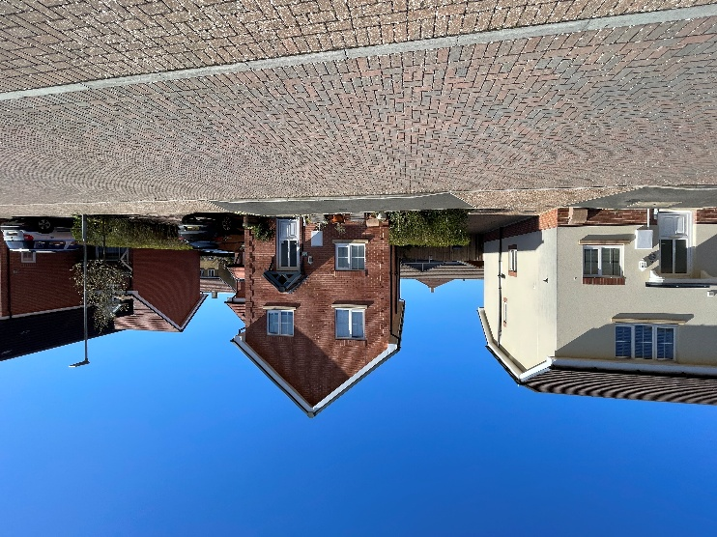

The rear extension will site away from the shared boundaries with 8 – 12 Taylor Crescent to the east. The proposed windows on the east elevation are not considered to introduce any new opportunities for overlooking as the extension is single storey. A window is proposed in the south elevation of the extension, but this would face towards the existing shed and garden office on the site, and it is not considered they will affect the privacy of the occupiers of 19 Granby Way.

The proposal therefore accords with Core Policy 57 point vii in respect of safeguarding residential amenity and Appendix D of the Wiltshire Design Guide.

Ecology Impact
Core Policy 50 of the Wiltshire Core Strategy seeks to protect and enhance biodiversity and geodiversity, including through ensuring that development avoids harm to protected species and habitats.

The National Planning Policy Framework (NPPF), in Paragraphs 193, requires that development minimises impacts on and provides net gains for biodiversity, including ensuring mitigation is secured where harm cannot be avoided.

The proposal relates to a single-storey extension to a dwelling with no trees or roof voids affected. The application site is within the catchment of the River Test, which drains into the Solent. This region is protected by a number of international designations including the Solent Maritime Special Area of Conservation (SAC), Chichester and Langstone Harbours Special Protection Area (SPA) and Ramsar site, Portsmouth Harbour SPA and Ramsar site, Solent and Southampton Water SPA and Ramsar site; as well as the nationally designated Sites of Special Scientific Interest (SSSIs) that underpin these international designations. The site is also within the 6.4km recreational buffer of the Salisbury Plain Special Protection Area (SPA) but due to the nature of the development, ecological impact is not an issue for this application. There is no reasonable likelihood of protected species being present or affected.
As such, the development complies with Core Policy 50 of the Wiltshire Core Strategy and the relevant provisions of the NPPF.

Drainage and Flood Risk
Core Policy 67 of the Wiltshire Core Strategy and paragraph 181 of the NPPF requires that all new development avoids increasing flood risk on-site or elsewhere and, where appropriate, incorporates sustainable drainage measures. Development must also comply with national policy on flood risk management and drainage design. Paragraph 176 (via footnote 62) of the NPPF states that householder development should not be subject to the sequential test, nor the exception test.

The site lies within Flood Zone 1 and is not in an area identified as being at risk of surface water flooding. The proposal would not increase the risk of flooding to the site or surrounding land. The development is considered to comply with Core Policy 67 and Section 14 of the NPPF.

Biodiversity Net Gain

Householder planning applications are exempt from the requirement to deliver Biodiversity Net Gain under Schedule 7A, Section 4(2)(a) of the Town and Country Planning Act 1990, as inserted by the Environment Act 2021.

CONCLUSION

The proposed development is considered to be acceptable in terms of its design, scale, and relationship with the surrounding area. It would not result in any unacceptable harm to the character of the locality, the amenities of neighbouring occupiers, or the interests of heritage, or ecology.

The proposal is therefore considered to comply with the relevant policies of the Wiltshire Core Strategy, the Wiltshire Local Plan, and the National Planning Policy Framework. As such, the application is recommended for approval, subject to the conditions set out below.

RECOMMENDATION: That Planning Permission be GRANTED subject to conditions.

- The development hereby permitted shall be begun before the expiration of three years from the date of this permission.
REASON: To comply with the provisions of Section 91 of the Town and Country Planning Act 1990 as amended by the Planning and Compulsory Purchase Act 2004.

- The development hereby permitted shall be carried out in accordance with the following approved plans and documents:

2516/01_001 Location Plan, received 02/03/2026
2516/02_103 Proposed Site Plan inc Roof Plan, received 02/03/2026
2516/02_104 Proposed Ground & First Floor Plans, received 02/03/2026
2516/02_105 Proposed Elevations, received 02/03/2026

REASON: For the avoidance of doubt and in the interests of proper planning.

- The materials to be used in the construction of the external surfaces of the development hereby permitted shall match in material, colour and texture those used in the existing building and detailed on the application form and approved plans.

REASON: In the interests of visual amenity and the character and appearance of the area.

