Planning statement – Land adjacent to Wormecliffe House

Application

We are applying to place 24 ground mounted Solar panels in our field adjacent to Wormecliffe House. We will use "low profile" panels in trays to keep them as flat to the ground as possible.

We also apply for a change of use from agricultural land for the circa 5x16 meter area required to place the panels.

Background

Wormecliffe House is grade two listed and we understand the council prefers the panels to be placed outside the residential curtilage. Hence the application to place the panels in the field (owned by us) adjacent to Wormecliffe House.

Having considered various locations in our field, the site selected was chosen to minimise visual impact from both Wormecliffe Lane as well other directions, whilst ensuring the panels are not in a shaded position.

The panels will be shielded from view of Wormecliffe Lane thanks to slightly more elevated position of the field as well as the hedgerow / low shrubs between road and field.

(Please also note that we will be planting a number of small trees to enhance the density of the hedgerow between field and road to meet BNG requirements).

From the other direction, visual impact is limited thanks to the small copse in the field.

These are two pictures of the site, the arial view showing the approximate location of the panels, as well as the orientation of the field (North towards the left, East towards top etc):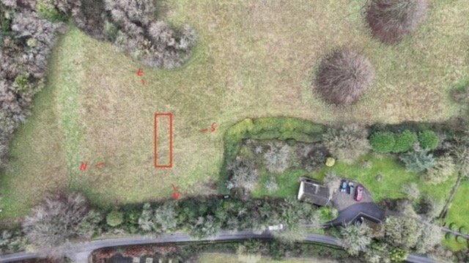

And a view from the Northern side of the field:

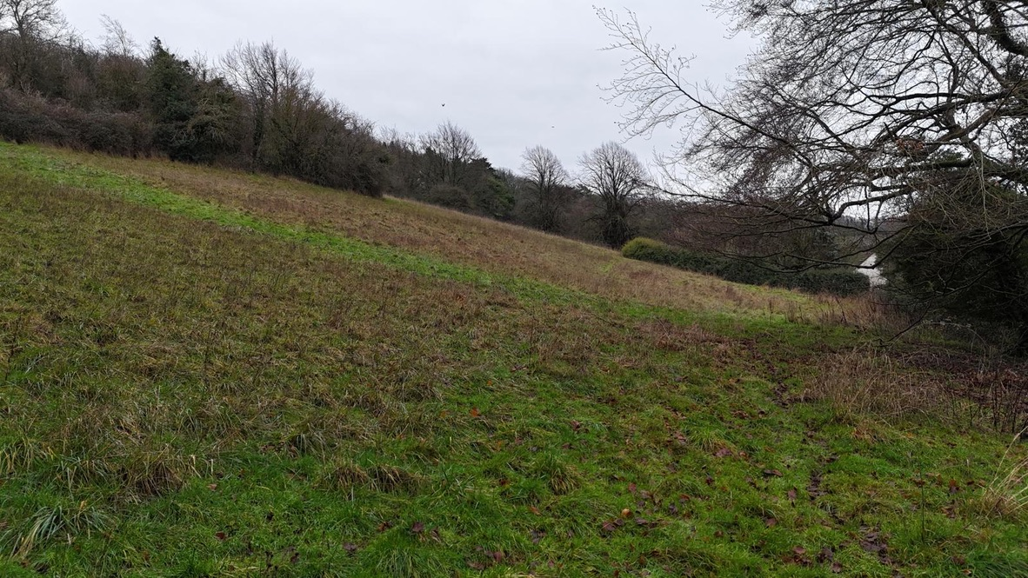

For clarity we also attach a screenshot from mapping software (effectively 90degrees rotated from aerial view above).

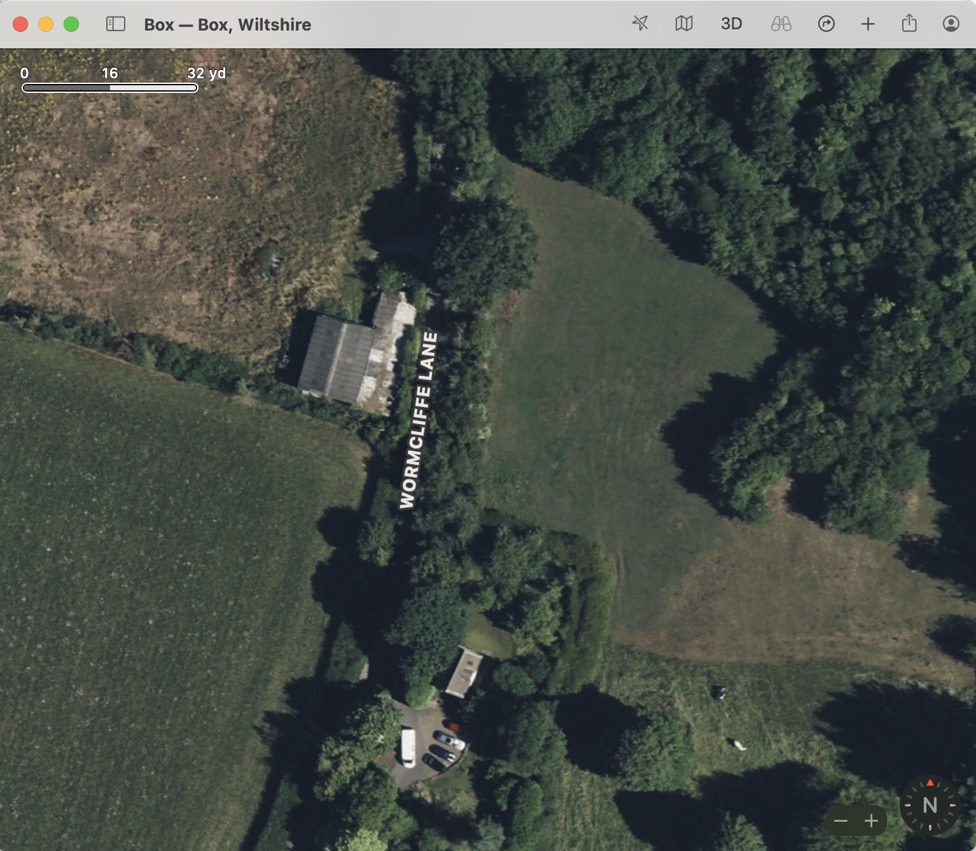

Dimensions of the proposed system:

The following two plans show the dimensions of the system to scale (the dimensions are also included in the BNG documents, as well as the Technical document from RedBridge).

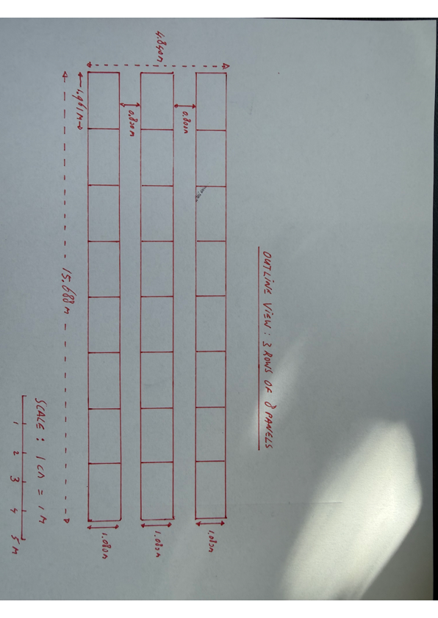

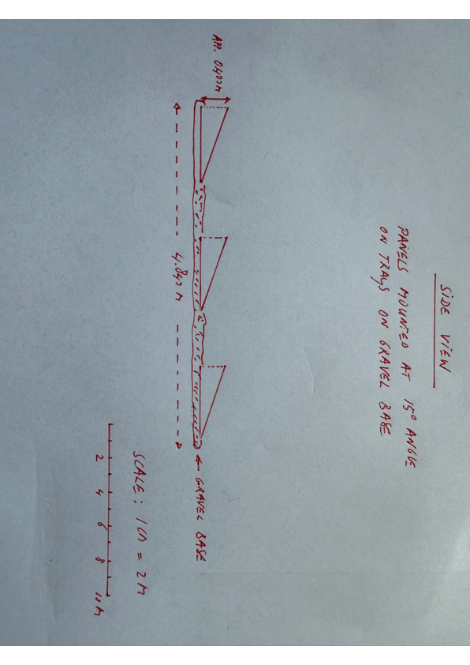

Technical dertails of the System and anticipated energy savings

Details of the system can be seen in the document attached from RedBridge energy.

Details of the panels and mounting system are on next two pages.

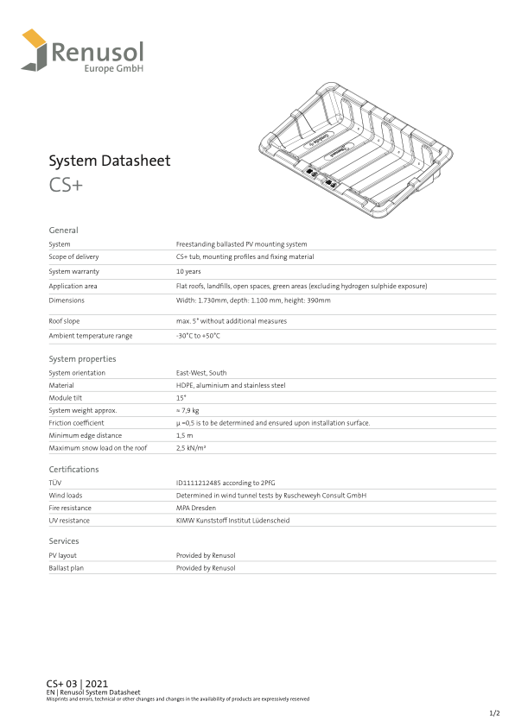

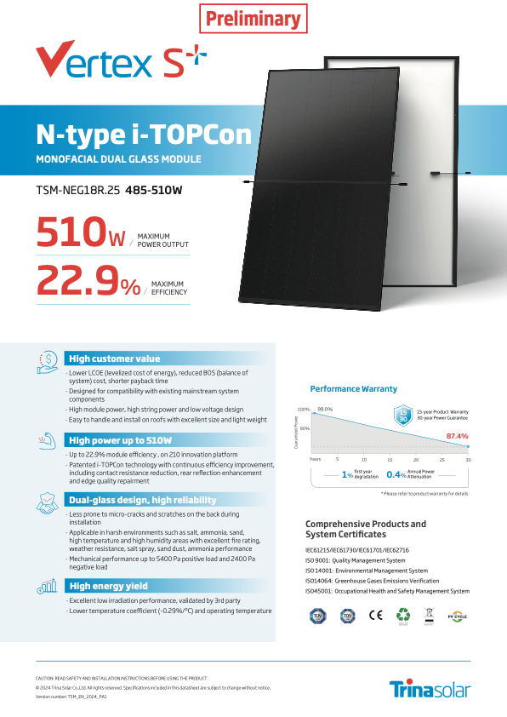

Visual illustration:

By way of visual illustration of the mounting system and panels we attach a picture of a similar installation:





