APPLICATION FOR FULL PLANNING PERMISSION
CASE OFFICER REPORT

APPLICATION REFERENCE: | PL/2025/09295
APPLICATION TYPE: | Full planning permission
SITE ADDRESS: | Coombe Down Farm, Blandford Road, Coombe Bissett, SP5 4LJ
DEVELOPMENT DESCRIPTION: | Retrospective Application for Farm Office
RECOMMENDATION: | Refuse

SITE DESCRIPTION/CONTEXT

The application site relates to Coome Down Farm, a primarily agricultural property with approx. 7.86 hectares of agricultural land and associated agricultural buildings; mixed with a B2 commercial use to provide engineering workshop facilities to serve rural land-based industry with associated flat above. The residential flat is tied by condition for occupation solely by a person(s) employed in the B2 use of the property. The site is located on the west side of the A354, accessed direct from the A354 via a sloping private driveway. The land rises steeply to the west, and the site is located in a prominent location within the Coombe Bissett valley.

The application site is located outside of the settlement boundary for Coombe Bissett which is defined as a large village through Core Polices 1, 2 and 23 of the Wiltshire Core Strategy and is therefore considered to be in the open countryside.

The application site is located within the Cranborne Chase & West Wiltshire Downs National Landscape formerly (AONB); the Hampshire River Avon Catchment, it is also within the 13.8 kilometres recreational zone of influence for the New Forest SAC, Special Protection Area (SPA) and Ramsar site.

PROPOSAL

The application is seeing retrospective permission for the erection of a farm office within an agricultural field to the south west of the main buildings on the site. The location of the farm office is highlighted in yellow for ease on the extract below from the submitted site plan.

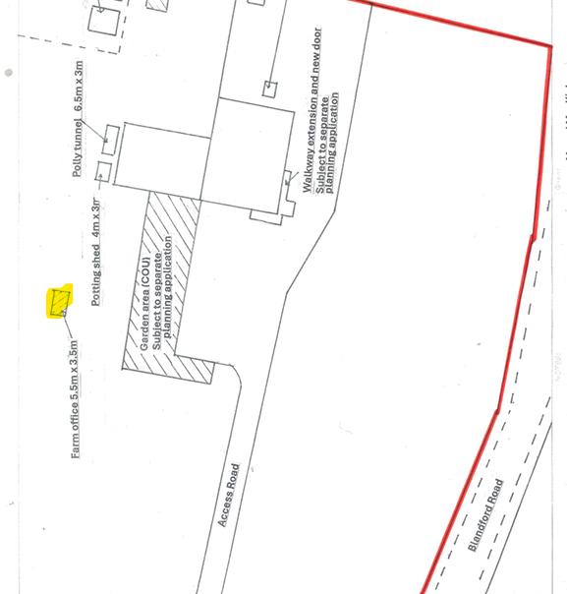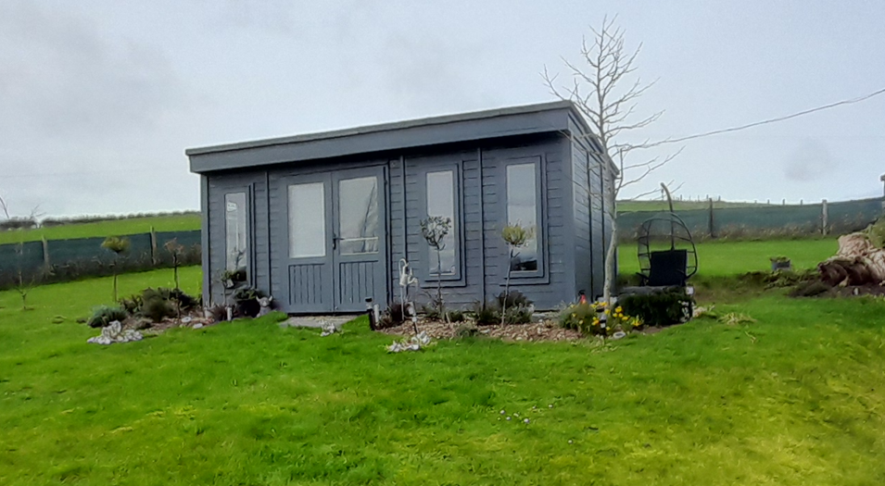

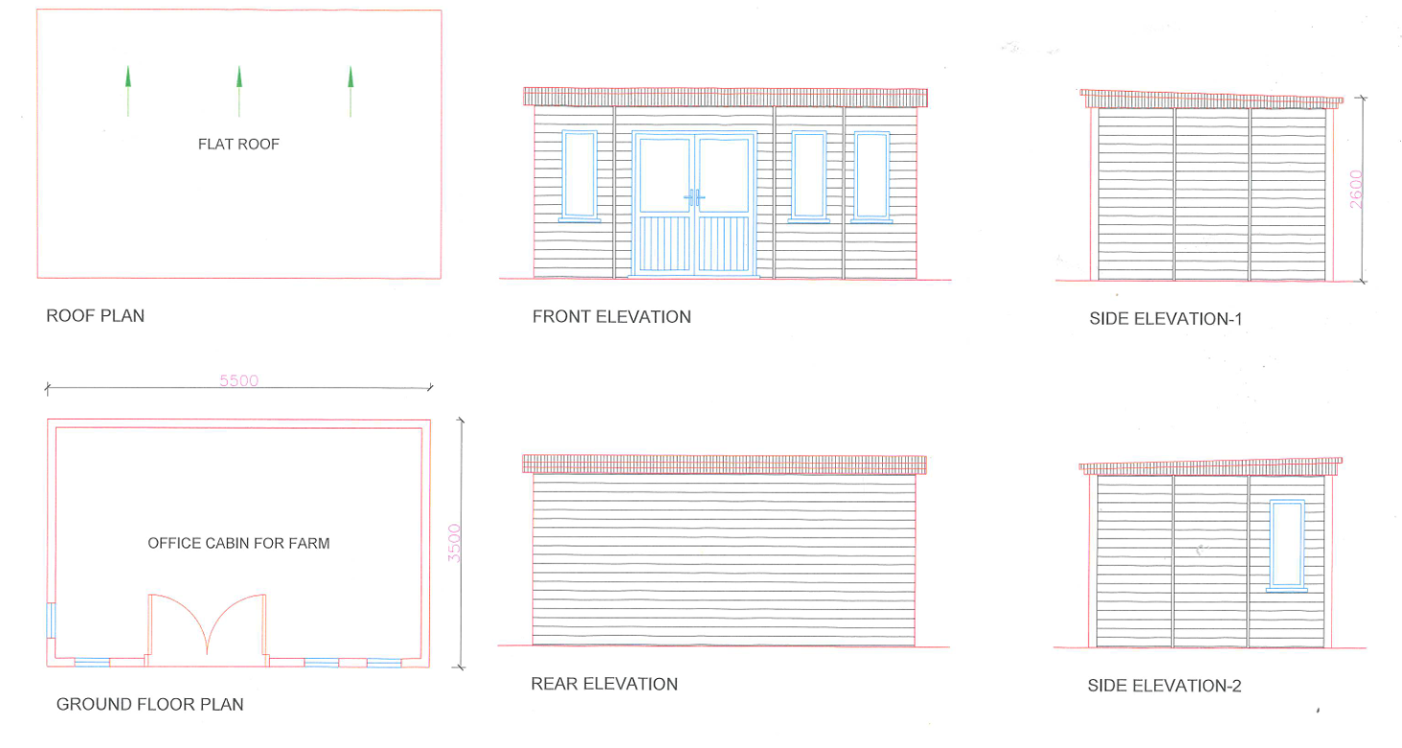

The reason for the farm office provided by the applicant is as follows-

The top workshop is agriculture repairs which have been carried out here since 2011 ,i have always had a separate office to the commercial unit which was a caravan which we used to move around and the last place it was put was where the office is now but the axle fell off it when we went to move it so it got scrapped and as it was an office with a view and we decided to put up a shed there in its place in 2020. After a few years we upgraded this with an office unit from Dunster House , I do Agricultural repairs here and go out on sites as well, i also have a subby who works with me at busy times ,the office at this present time has had filing cabinets removed with workshop manuals and parts books etc to store personal belonging and clothes while our flat is having a major overhaul when everything will go back in this office unit as it was before , i do need a separate unit for this , there was a large shed very close to where the office is. I have always kept the Agricultural side separate to the commercial side .

PLANNING HISTORY

Proposal / Summary
PL/2025/09300 - Full planning permission – Retrospective Application for Creation of a Vehicle Ramp. UNDER CONSIDERATION
PL/2025/09304 - Full planning permission – Retrospective Change of Use of Farm Land to Domestic/Farm Garden Area. UNDER CONSIDERATION
13/01037/ADV - Consent to display an advertisement Decision - Approve with Conditions Date: 13/6/2014 – Retrospective application for the erection of 6 non illuminated signs (relating to the business) siturated near vehicular access to site
PL/2022/02111 - Full planning permission Decision - Approve with Conditions Date: 2/8/2022 – Change of use of first floor store into small living accommodation.
PL/2023/03919 - Full planning permission Decision - Refuse Date: 9/8/2023 – Erection of bungalow
PL/2023/07449 - Full planning permission Decision - Approve with Conditions Date: 8/11/2023 – Formation of balcony with external stairs and two new windows.
PL/2025/09224 - Full planning permission – Addition of external door on first floor and extension of landing area to existing balcony. UNDER CONSIDERATION
S/1997/1620 - Full planning permission Decision - Refused Date: 16/12/1997 – erection of a replacement agricultural worker's dwelling
S/2009/0853 - Full planning permission Decision - Withdrawn Date: 10/8/2009 – demolition of corrugated iron structure. change of use of redundant agricultural buildings to commercial (b1) use, alterations and extensions to building together with formation of replacement highway access and track and associated landscaping works
S/2009/1806 - Full planning permission Decision - Approve with Conditions Date: 15/2/2010 – change of use of redundant agricultural buildings to b2 commercial use to provide engineering workshop facilities to serve rural land-based industry. demolition of corrugated iron structure, alterations and extension to existing buildings together with formation of a new highway access and associated landscaping works
S/2011/1610 - Lawful development: Proposed use Decision - Approve with Conditions Date: 15/12/2011 – Certificate of lawful development for the proposed use to ascertain that the existing B2 use allows the installation and operation of an MOT station

RELEVANT LEGISLATION, POLICIES AND GUIDANCE

National Planning Policy:
- National Planning Policy Framework (NPPF)
- Planning Practice Guidance (PPG)
- National Design Guide

Development Plan:

The development plan for Wiltshire comprises the Wiltshire Core Strategy (WCS) (adopted January 2015) and any made neighbourhood plans, which remains the principal statutory planning document guiding development across the county. In line with Section 38(6) of the Planning and Compulsory Purchase Act 2004, planning decisions must be made in accordance with the development plan unless material considerations indicate otherwise.

Though the development plan is considered as a whole, those parts deemed to be particularly relevant to this application are listed below:

The adopted Wiltshire Core Strategy (WCS), with particular regard to:

- Core Policy 1 Settlement Strategy;
- Core Policy 2 Delivery Strategy;
- Core Policy 3 Infrastructure Requirements;
- Core Policy 23 Southern Wiltshire Spatial Strategy Community Area;
- Core Policy 35 Existing Employment Land;
- Core Policy 48 Supporting Rural Life;
- Core Policy 50 Biodiversity and Geodiversity;
- Core Policy 51 Landscape;
- Core Policy 57 Ensuring High Quality Design and Place Shaping;
- Core Policy 60-64 Transport;
- Core Policy 69 River Avon SAC;

Draft Wiltshire Local Plan Policies

The examination of the emerging Wiltshire Local Plan has been paused and the weight to be afforded to any part of the emerging plan can be no more than very limited. A decision on how to proceed will be made by the Council in May 2026.

Supplementary Planning Documents and other Guidance:

Wiltshire Design Guide (adopted April 2024)
Wiltshire Local Transport Plan 2011-2026, adopted 2015 - including the Car Parking Strategy and Cycling Strategy, adopted 2015
Creating Places Design Guide
Cranborne Chase & West Wiltshire Downs National Landscape formerly (AONB) Management Plan

ISSUES

Principle
Character, Design and Landscape impacts.
Amenity
Highway safety
Ecology

CONSULTATION RESPONSES

Parish Council: None received.

REPRESENTATIONS

In accordance with the requirements of the Town and Country Planning (Development Management Procedure) (England) Order 2015 (as amended), the application was publicised by way of:

- Neighbour notification letters sent to adjoining and nearby properties;
- A site notice displayed near the site;

These methods were used to inform interested parties and provide a period of 21 days for comments to be submitted.

Below is a summary of the representations received during the consultation period. Only material planning considerations have been taken into account in the assessment of this application. Non-material issues, such as property values or private legal disputes, cannot be considered in the determination process.

Two letters received and included in full below.

- I am writing in support of the above application as I believe there are no negative aspects from the construction of the farm office
- There is no impact on the surrounding area, and it is understandably required for managing the estate

ASSESSMENT

Section 38(6) of the Planning and Compulsory Purchase Act 2004 states:

"If regard is to be had to the development plan for the purposes of any determination to be made under the planning Acts, the determination must be made in accordance with the plan unless material considerations indicate otherwise."

In accordance with this statutory requirement, this application has been assessed against the relevant policies of the Development Plan, including the Wiltshire Core Strategy (2015) and, where applicable, any made Neighbourhood Plans. Consideration has also been given to the policies of the National Planning Policy Framework (NPPF) as a material consideration in the assessment.

Principle of Development

The proposals are to retain a new building within the open countryside. Core Policies 34 (Additional Employment Land) and 48 (Supporting Rural Life) of the Wiltshire Core Strategy allow for employment-related development in such locations only where there is a clearly demonstrated essential need for a countryside location such as for farm diversification. However, in this instance, no adequate justification or business case has been provided to demonstrate that the farm office is functionally necessary for the operation of the agricultural land. Furthermore, there has been no explanation as to why existing buildings on the site cannot reasonably be used or adapted to accommodate the farm office use. In the absence of this evidence, the development represents unjustified new development in the open countryside which is designated National Landscape and is therefore unacceptable in principle.

Character, Design and Landscape impacts

At a local level, WCS policy CP57 (Ensuring High Quality Design & Place Shaping), further requires a high standard of design in all new developments through, in particular, enhancing local distinctiveness; retaining and enhancing existing important landscaping and natural features; being sympathetic to and conserving historic buildings and landscapes in terms of layouts, massing, building heights and plot sizes; and making efficient use of land whilst taking into account the local context and surrounding uses.

The NPPF puts a great emphasis on the need for good design. Paragraph 135 sets out that developments should function well and add to the overall quality of the area; demonstrate good architecture, layout and appropriate and effective landscaping; be sympathetic to local character; and establish a sense of place. It states at Paragraph 139 that development that is not well designed should be refused.

Core Policy CP51 of the WCS requires development to protect, conserve and where possible enhance landscape character and must not have a harmful impact upon landscape character, while any negative impacts must be mitigated as far as possible through sensitive design and landscape measures

The development under consideration relates to the retention of a detached single storey building which has been erected on agricultural land. The wider site at Coombe Down Farm is a mixed use site but predominantly agricultural with an element of commercial and an associated C3 residential flat for use by someone who works in the commercial unit. It is understood that the applicant who owns the property lives on site within the flat, the flat was granted permission solely on the premise that it was required due to security reasons following a spate of attempted break-ins on the site.

It was seen during the case officers site visit that a number of buildings exist on site which include the main large agricultural/commercial building as well as a couple of shipping containers and other sheds. The buildings on site are contained to an area alongside the northern boundary of the overall site.

The farm office building is a modest size measuring approx. 5.5 metres by 3.5 metres with a shallow mono pitch roof with a height of approx. 2.60m. The farm office building is somewhat domestic in character and design and has the appearance of a summer house. The farm office is located within a parcel of land which is mainly enclosed except for access along the southern boundary which is a gap in the fence/hedge leading into an area the applicant describes as their garden. It is necessary to note that the are described as garden is also unauthorised and there is separate planning application under consideration for the retrospective change of use from agriculture to residential garden, reference PL/2025/09304.
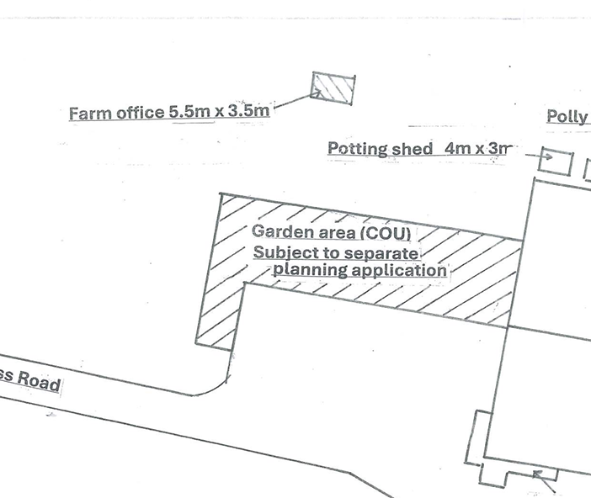
The parcel of land within which the farm office has been erected has a similar character to the area the applicant calls a garden, the photos below show both areas. During the site visit the applicant stated that occasionally sheep may graze the land around the farm office building, there was no evidence of this at the time of the site visit.

Site of farm office

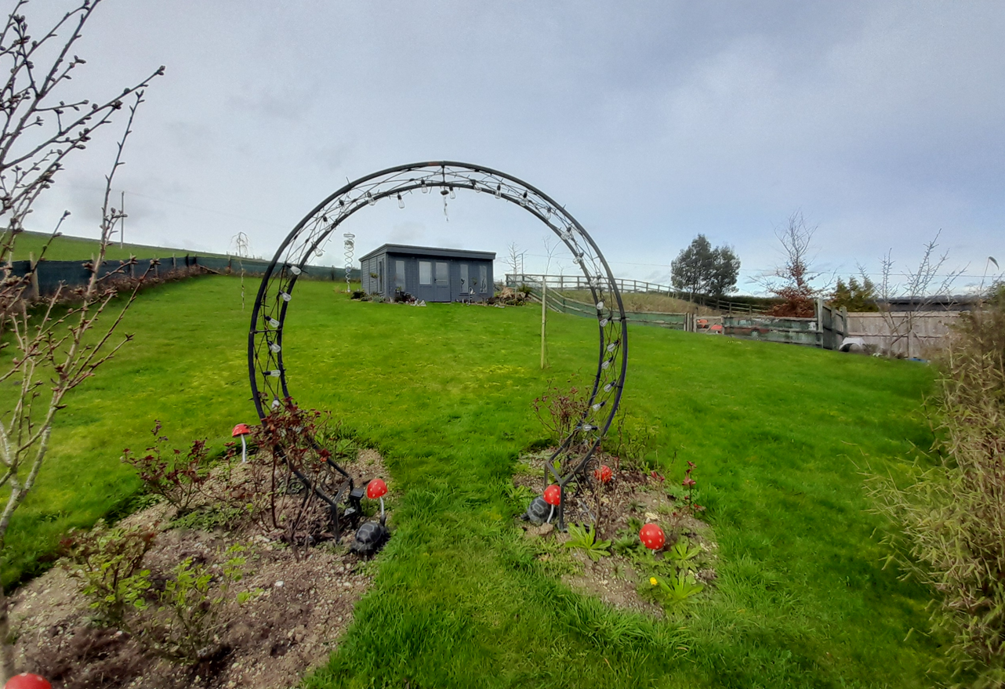

Garden

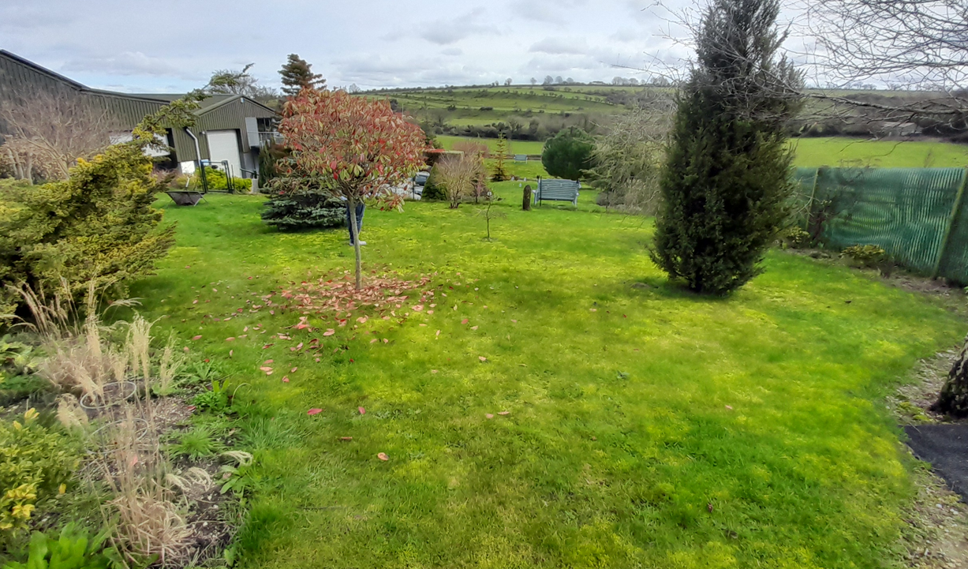

Internally, for an office use there is a single desk and chair and associated computer, the photo below was provided by the applicant. However, during the site visit, it was seen that the farm office has clothes and other domestic items inside, the applicant stated these had been moved here temporarily whilst the flat was decorated. It was also discussed that filing cabinets had been removed to make space for the temporary domestic items and would be returned when possible. It is not known where the filing cabinets have been moved to.
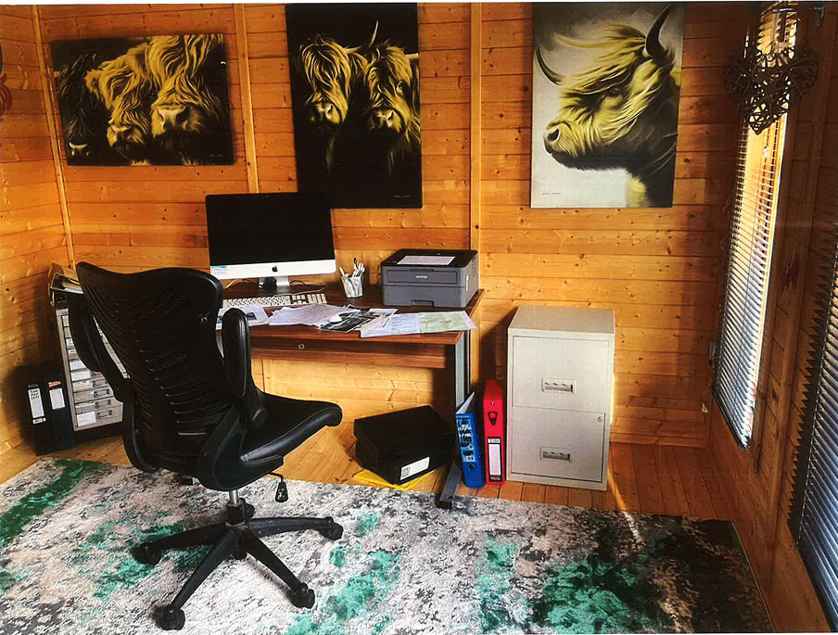

The applicant was requested to provide justification for the need for the proposed farm office in this countryside location; however, having carefully considered the information submitted, it is not considered that sufficient evidence has been provided to demonstrate that the development is acceptable in principle or necessary in this location. Again, no information has been provided as to why the farm office activities cannot be undertaken within the existing buildings on site and given the present day use of technology – laptop/smart phones and general move for society to be paperless. With the planning consent for the commercial use of the building conditioned as engineering workshop facilities to serve rural land-based industry it does seem wholly appropriate that workshop manuals and parts books are kept within the existing commercial building which does have an associated office internally.

From a visual and landscape perspective, the building appears incongruous within its rural setting by reason of its apparent domestic form, detailing and its relationship with the surrounding land, which is managed in a manner more reflective of domestic garden space than agricultural land. The development is perceptible from the wider landscape and contributes to the incremental spread of apparent domestication within the countryside, resulting in a localised but harmful visual impact.

When considered cumulatively with existing buildings and domestic influences within the holding, the proposal would further erode the open and undeveloped character of the rural landscape and detract from the scenic quality and special qualities of the National Landscape.
The proposal would also result in the unjustified expansion of land of a domestic appearance beyond the established developed area of the property, introducing an unwelcome expansion of built form that is incompatible with its countryside setting.

As such, the development fails to conserve landscape character, contrary to Core Policy 51 (Landscape), and does not demonstrate a design response that reflects or enhances local character, as required by Core Policy 57 (Ensuring High Quality Design and Place Shaping) of the Wiltshire Core Strategy. In the absence of any compelling justification, the proposal represents an unacceptable and harmful intrusion into the rural landscape.

Amenity

Point vii of Core Policy 57 - Ensuring High Quality Design and Place Shaping of the Wiltshire Core Strategy seeks to ensure that developments do not adversely affect neighbouring properties.

The National Planning Policy Framework (NPPF), particularly Paragraph 135(f), stresses that planning decisions should ensure developments provide a high standard of amenity for existing and future users.

There are no immediate neighbouring residential properties that will be affected by the farm office use given its siting within the Coombe Down Farm site.

Highways Impacts and Parking

The development relates to a farm office for use by the applicant who lives on site in the flat within/above the commercial unit for an engineering workshop facility to serve rural land-based industry. The applicant has stated that occasionally another person uses the farm office. Given the scale of building and agricultural practices on the site, it is not considered that the farm office use will generate the need for a significant increase in vehicles travelling to and from the site. There is also adequate parking within the wider site noting the applicant already parks vehicles on site. There are therefore no highway safety concerns raised.

Ecology and Biodiversity

Core Policy 50 of the Wiltshire Core Strategy and the National Planning Policy Framework requires that the planning authority ensures protection of important habitats and species in relation to development and seeks enhancement for the benefit of biodiversity through the planning system.

BNG - From 12 February 2024 Biodiversity Net Gain (BNG) became mandatory under Schedule 7A of the Town and Country Planning Act 1990 (as inserted by Schedule 14 of the Environment Act 2021). Based on the information available the biodiversity gain planning condition is not considered to apply to this application as the application is for retrospective consent and BNG does not apply to retrospective development.

River Avon SAC - This development falls within the catchment of the River Avon SAC and has potential to cause adverse effects alone or in combination with other developments through discharge of phosphorus in wastewater. A test of likely significance has been carried out by the relevant Competent Authority (Wiltshire Council) as required by Regulation 63 of the Conservation of Habitats and Species Regulations 2017 (as amended). Given that technically there will be no net increase in overnight accommodation (the proposed works are not to add a new dwelling, but to retain a farm office), it can be considered that there would be no overall mechanism for adverse effect. The HRA has concluded that the application is not likely to have significant impacts on the SAC and subsequently the application is screened out of Appropriate Assessment.

New Forest SPA, New Forest SAC and New Forest Ramsar site -The site is located within the 13.8km zone of influence for the New Forest internationally protected sites, which comprises the New Forest SPA, New Forest SAC and New Forest Ramsar site. Any applications within this area are screened into appropriate assessment under the Conservation of Habitats and Species Regulations 2017 (as amended) on account of its potential to cause adverse effects on the New Forest protected sites through increased recreational pressure which may occur alone and in-combination with other plans and projects. Many of the special features of the New Forest protected sites afforded protection are vulnerable to adverse effects associated with an increase in recreation as demonstrated in Natural England’s supplementary advice issued for the SPA on 19 March 2019 and for the SAC on 18 March 2019. Following a Cabinet decision on 7 May 2024, Wiltshire Council’s “Interim recreation mitigation strategy for the New Forest internationally protected sites” (Version 1.1, 21 March 2023) is being revised. However, as the development relates to the retention of a farm office and does not involve new overnight accommodation, nor will it be bringing additional people to the locality which will impact on the New Forest protected sites it can be screened out of Appropriate Assessment.

PLANNING BALANCE AND CONCLUSION

At the heart of the NPPF there is a presumption in favour of sustainable development requiring local planning authorities to approve development proposals that accord with an up-to-date development plan without delay; and where there are no relevant development plan policies, or the policies which are most important for determining the application are out-of-date, permission should be granted unless (taken from paragraph 11d of the NPPF):

- The application of policies in the NPPF that protect areas or assets of particular importance provides a clear reason for refusing development proposed; or
- any adverse impacts of doing so would significantly and demonstrably outweigh the benefits, when assessed against the policies in the NPPF taken as a whole;

The application is seeking consent for the retention of a farm office located in a prominent location in a small parcel of land to the south west of the main complex of building on the Coombe Down Farm site. The farm office building is domestic in appearance, more akin to a summer house than office building, the surrounding parcel of land also appears more domestic than in agricultural use. It is not considered that adequate justification as to the need for the farm office of this nature, in this location and why given the small scale nature of the Coombe Down Farm agricultural site the office use can’t be accommodated within another existing building on the site.

In this instance it is considered that the development results in an unwelcome expansion of built form into the rural landscape, in particular of a domestic character and is considered to have an unacceptable impact on the National Landscape.

RECOMMENDATION: That Planning Permission be REFUSED.

The development fails to demonstrate an essential agricultural or functional need for a new building in this countryside location, nor has it been shown why existing buildings could not be used. By reason of its domestic form, siting and associated use, the proposal appears incongruous within the rural landscape and results in an unjustified domestication of the countryside. The development therefore causes harm to landscape character and fails to reflect local distinctiveness, contrary to Core Policies 51 (Landscape) and 57 (Ensuring High Quality Design and Place Shaping) of the Wiltshire Core Strategy.

INFORMATIVE

The development has been assessed against the following plans:

Application form received 01/12/2025
Site plan received 25/02/2026
Proposed elevations, floor plan and roof plan received 09/02/2026
Location plan received 25/02/2026

REASON: For the avoidance of doubt

