APPLICATION FOR FULL PLANNING PERMISSION
CASE OFFICER REPORT

APPLICATION REFERENCE: | PL/2025/09300
APPLICATION TYPE: | Full planning permission
SITE ADDRESS: | Coombe Down Farm, Blandford Road, Coombe Bissett, SP5 4LJ
DEVELOPMENT DESCRIPTION: | Retrospective Application for Creation of a Vehicle Ramp
RECOMMENDATION: | Refuse

SITE DESCRIPTION/CONTEXT

The application site relates to Coome Down Farm, a primarily agricultural property with approx. 7.86 hectares of agricultural land and associated agricultural buildings; mixed with a B2 commercial use to provide engineering workshop facilities to serve rural land-based industry with associated flat above. The residential flat is tied by condition for occupation solely by a person(s) employed in the B2 use of the property. The site is located on the west side of the A354, accessed direct from the A354 via a sloping private driveway. The land rises steeply to the west, and the site is located in a prominent location within the Coombe Bissett valley.

The application site is located outside of the settlement boundary for Coombe Bissett which is defined as a large village through Core Polices 1, 2 and 23 of the Wiltshire Core Strategy and is therefore considered to be in the open countryside.

The application site is located within the Cranborne Chase & West Wiltshire Downs National Landscape formerly (AONB); the Hampshire River Avon Catchment, it is also within the 13.8 kilometres recreational zone of influence for the New Forest SAC, Special Protection Area (SPA) and Ramsar site.

PROPOSAL

The application is seeking retrospective consent for the creation of a vehicle ramp, case officer photo included below.

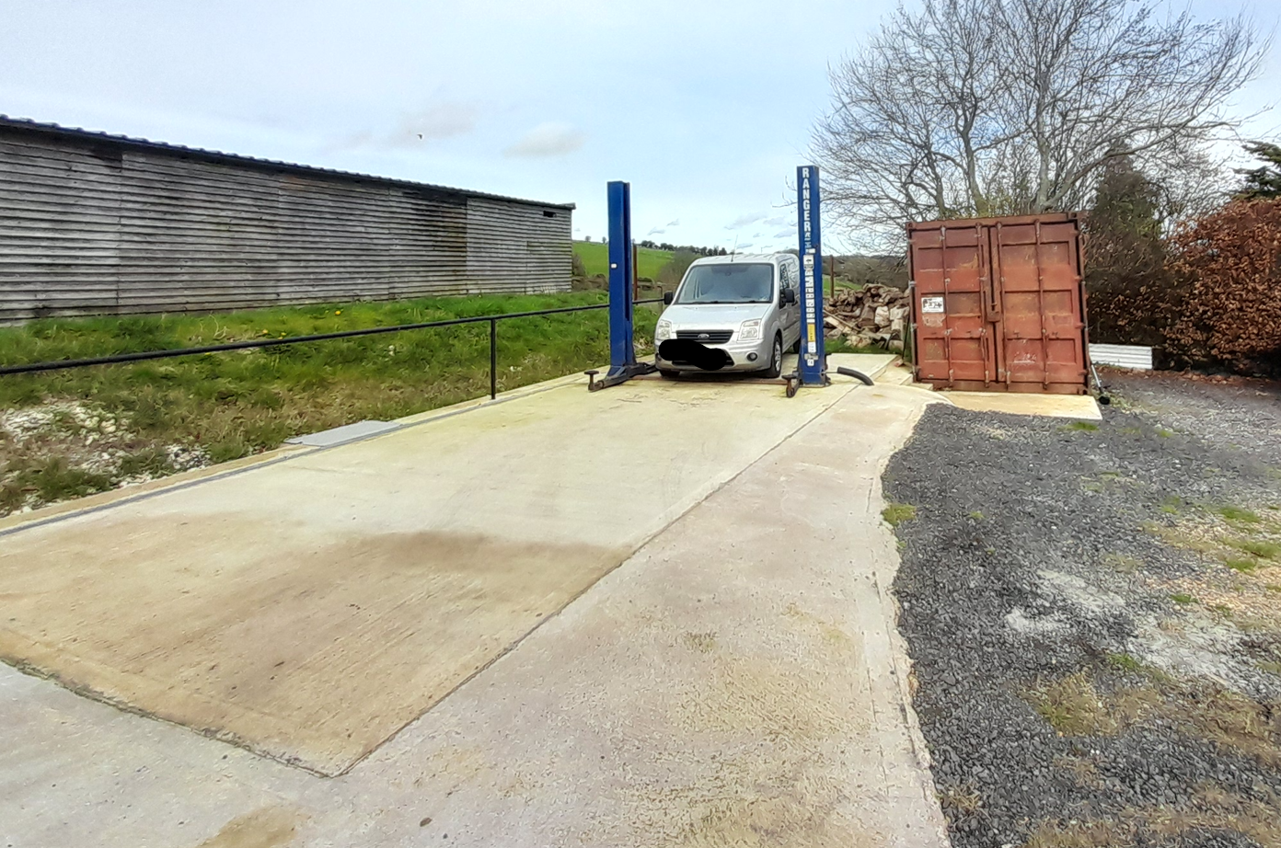

The ramp is located in the open air in the yard to the north of the existing agricultural and commercial buildings, alongside the northern boundary of the site. The images below have been submitted with the application documentation and shows the size of the ramp as 3.3 metres is width and a height of 2.90 metres; the ramp is set on a concrete base.

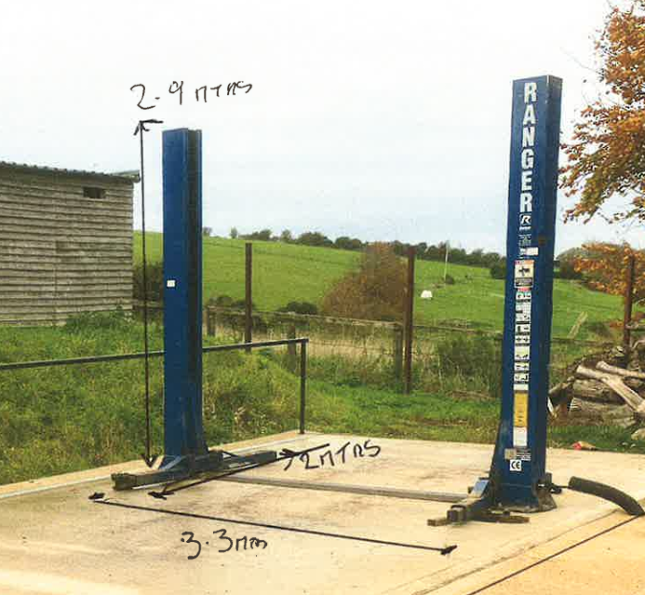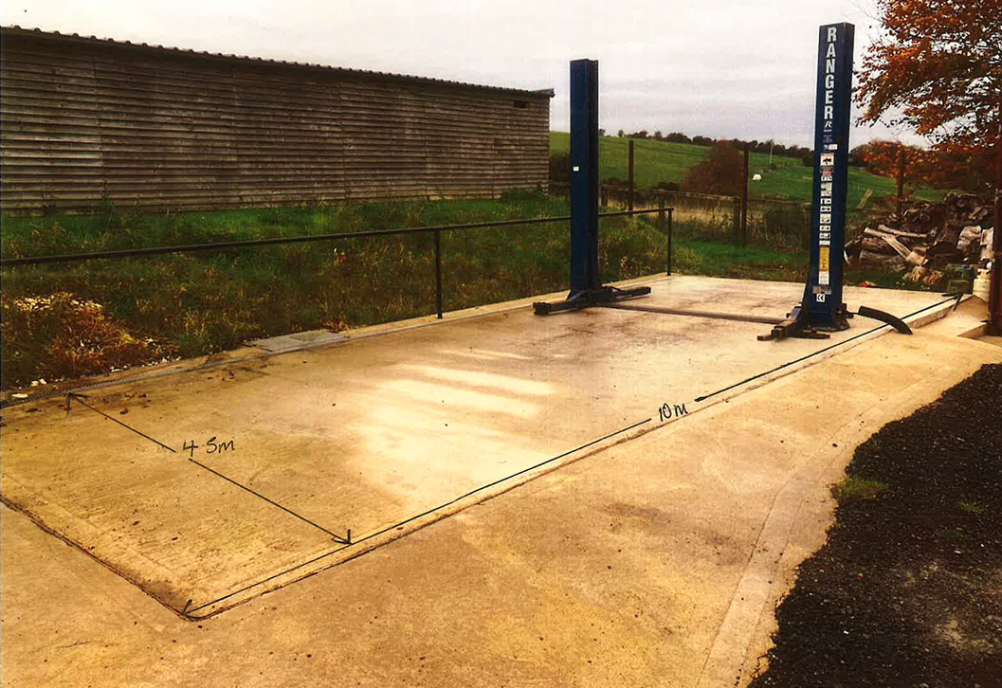

The applicants supporting statement states -

The structure is a mechanical lift that is used and is needed occasionally for access to the vehicles that are too large to lift within the existing building. This lift is not used on a daily basis and is only used occasionally; however, it is a necessary part for the carrying out the function of the garage business. This lift is also critical requirement for providing a service to the customers of the garage workshop. This structure consists of two small lifting columns on a 150mm concrete base.

PLANNING HISTORY

Proposal / Summary
PL/2025/09295 - Retrospective Application for Farm Office- UNDER CONSIDERATION
PL/2025/09304 - Full planning permission – Retrospective Change of Use of Farm Land to Domestic/Farm Garden Area. UNDER CONSIDERATION
13/01037/ADV - Consent to display an advertisement Decision - Approve with Conditions Date: 13/6/2014 – Retrospective application for the erection of 6 non illuminated signs (relating to the business) situated near vehicular access to site
PL/2022/02111 - Full planning permission Decision - Approve with Conditions Date: 2/8/2022 – Change of use of first floor store into small living accommodation.
PL/2023/03919 - Full planning permission Decision - Refuse Date: 9/8/2023 – Erection of bungalow
PL/2023/07449 - Full planning permission Decision - Approve with Conditions Date: 8/11/2023 – Formation of balcony with external stairs and two new windows.
PL/2025/09224 - Full planning permission – Addition of external door on first floor and extension of landing area to existing balcony. Withdrawn
S/1997/1620 - Full planning permission Decision - Refused Date: 16/12/1997 – erection of a replacement agricultural worker's dwelling
S/2009/0853 - Full planning permission Decision - Withdrawn Date: 10/8/2009 – demolition of corrugated iron structure. change of use of redundant agricultural buildings to commercial (b1) use, alterations and extensions to building together with formation of replacement highway access and track and associated landscaping works
S/2009/1806 - Full planning permission Decision - Approve with Conditions Date: 15/2/2010 – change of use of redundant agricultural buildings to b2 commercial use to provide engineering workshop facilities to serve rural land-based industry. demolition of corrugated iron structure, alterations and extension to existing buildings together with formation of a new highway access and associated landscaping works
S/2011/1610 - Lawful development: Proposed use Decision - Approve with Conditions Date: 15/12/2011 – Certificate of lawful development for the proposed use to ascertain that the existing B2 use allows the installation and operation of an MOT station

RELEVANT LEGISLATION, POLICIES AND GUIDANCE

National Planning Policy:
- National Planning Policy Framework (NPPF)
- Planning Practice Guidance (PPG)
- National Design Guide

Development Plan:

The development plan for Wiltshire comprises the Wiltshire Core Strategy (WCS) (adopted January 2015) and any made neighbourhood plans, which remains the principal statutory planning document guiding development across the county. In line with Section 38(6) of the Planning and Compulsory Purchase Act 2004, planning decisions must be made in accordance with the development plan unless material considerations indicate otherwise.

Though the development plan is considered as a whole, those parts deemed to be particularly relevant to this application are listed below:

The adopted Wiltshire Core Strategy (WCS), with particular regard to:

- Core Policy 1 Settlement Strategy;
- Core Policy 2 Delivery Strategy;
- Core Policy 3 Infrastructure Requirements;
- Core Policy 23 Southern Wiltshire Spatial Strategy Community Area;
- Core Policy 35 Existing Employment Land;
- Core Policy 48 Supporting Rural Life;
- Core Policy 50 Biodiversity and Geodiversity;
- Core Policy 51 Landscape;
- Core Policy 57 Ensuring High Quality Design and Place Shaping;
- Core Policy 60-64 Transport;
- Core Policy 69 River Avon SAC;

Draft Wiltshire Local Plan Policies

The examination of the emerging Wiltshire Local Plan has been paused and the weight to be afforded to any part of the emerging plan can be no more than very limited. A decision on how to proceed will be made by the Council in May 2026.

Supplementary Planning Documents and other Guidance:

Wiltshire Design Guide (adopted April 2024)
Wiltshire Local Transport Plan 2011-2026, adopted 2015 - including the Car Parking Strategy and Cycling Strategy, adopted 2015
Creating Places Design Guide
Cranborne Chase & West Wiltshire Downs National Landscape formerly (AONB) Management Plan

ISSUES

Principle, visual and landscape impacts
Amenity
Highway safety impacts
Ecology

CONSULTATION RESPONSES

Parish/Town Council: None received

REPRESENTATIONS
In accordance with the requirements of the Town and Country Planning (Development Management Procedure) (England) Order 2015 (as amended), the application was publicised by way of:

- Neighbour notification letters sent to adjoining and nearby properties;
- A site notice displayed near the site;

These methods were used to inform interested parties and provide a period of 21 days for comments to be submitted.

Below is a summary of the representations received during the consultation period. Only material planning considerations have been taken into account in the assessment of this application. Non-material issues, such as property values or private legal disputes, cannot be considered in the determination process.

Two letters have been received and included in full below –

- I am writing in support of this application. The vehicle ramp is not detrimental visually and is part of the business of the site.
- No objections

ASSESSMENT

Section 38(6) of the Planning and Compulsory Purchase Act 2004 states:

"If regard is to be had to the development plan for the purposes of any determination to be made under the planning Acts, the determination must be made in accordance with the plan unless material considerations indicate otherwise."

In accordance with this statutory requirement, this application has been assessed against the relevant policies of the Development Plan, including the Wiltshire Core Strategy (2015) and, where applicable, any made Neighbourhood Plans. Consideration has also been given to the policies of the National Planning Policy Framework (NPPF) as a material consideration in the assessment.

Principle, Character and Landscape impacts

At a local level, WCS policy CP57 (Ensuring High Quality Design & Place Shaping), further requires a high standard of design in all new developments through, in particular, enhancing local distinctiveness; retaining and enhancing existing important landscaping and natural features; being sympathetic to and conserving historic buildings and landscapes in terms of layouts, massing, building heights and plot sizes; and making efficient use of land whilst taking into account the local context and surrounding uses.

The NPPF puts a great emphasis on the need for good design. Paragraph 135 sets out that developments should function well and add to the overall quality of the area; demonstrate good architecture, layout and appropriate and effective landscaping; be sympathetic to local character; and establish a sense of place. It states at Paragraph 139 that development that is not well designed should be refused.

Core Policy CP51 of the WCS requires development to protect, conserve and where possible enhance landscape character and must not have a harmful impact upon landscape character, while any negative impacts must be mitigated as far as possible through sensitive design and landscape measures.

Coombe Down Farm was originally wholly an agricultural site but in 2010 application S/2009/1806 was approved with conditions for the change of use of redundant agricultural buildings to B2 commercial use to provide engineering workshop facilities to serve rural land-based industry. demolition of corrugated iron structure, alterations and extension to existing buildings together with formation of a new highway access and associated landscaping works.

Particular conditions of the above approval are relevant to this current application, these include -

2 Notwithstanding the provisions of the Town and Country Planning (General Permitted Development) Order 1995 (or any Order revoking or re-enacting or amending that Order with or without modification), the site shall be used solely for the purpose of repairing and maintaining agricultural and rural based vehicles used in connection with agricultural and rural land-based industries and for no other use within Class B2 of the Schedule to the Town and Country Planning (Use Classes) Order 1987 (as amended by the Town and Country Planning (Use Classes) (Amendment)(England) Order 2005 (or in any provisions equivalent to that class in any statutory instrument revoking or re-enacting that Order with or without modification).

REASON: The proposed use is acceptable but the Local Planning Authority wish to consider any future proposal for a change of use, having regard to the circumstances of the case, in particular the isolated location in the AONB POLICY: C2 and C5 Protection of countryside and AONB.

7 No materials, goods, plant, machinery, equipment, finished or unfinished products/parts of any description, skips, crates, containers, waste or any other item whatsoever shall be placed, stacked, deposited or stored outside any building on the site without the prior approval in writing of the Local Planning Authority.

REASON: In the interests of the appearance of the site and the amenities of the area. POLICY: C2 and C5 Protection of the countryside and the AONB

8 No industrial processes, repair or maintenance of any vehicle, plant or machinery shall be carried out/installed outside of any building on the site or undertaken unless the doors to the building are closed.

REASON: In the interests of the appearance of the site and the amenities of the area. POLICY: G2, C2 and C5 General criteria for development, protection of the countryside and the AONB

9 No industrial processes, repair or maintenance of any vehicle, plant or machinery shall be carried out or undertaken within any of the buildings, unless the doors to those buildings are closed.

REASON: In the interests of the amenities of the neighbours POLICY: G2 General criteria for development.

The above conditions on the original consent sought to restrict works to inside of the buildings and prevent works being undertaken outside within the yard, the reasons for these were for neighbour amenity and also in the interests of the appearance of the site, to protect the countryside and AONB (now National landscape).

Whilst policy at both national and local levels has changed since 2010 with the adoption of the Wiltshire Core Strategy and the NPPF, it is considered that both neighbour amenity impacts and visual impacts on the character of the rural landscape which is designated National Landscape are still key considerations.

Whilst the ramp is located in the yard outside of the commercial building it is actually sited on land currently designated as agricultural land which has not benefitted from change of use and change of use has not been sought with this current application.

Q22 on the application confirms the ramp is for use in conjunction with the commercial use of the garage,

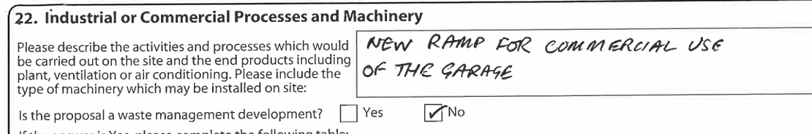

The plan below was provided by the applicant at the request of the case officer to clearly show the division between commercial and agricultural land on the site.

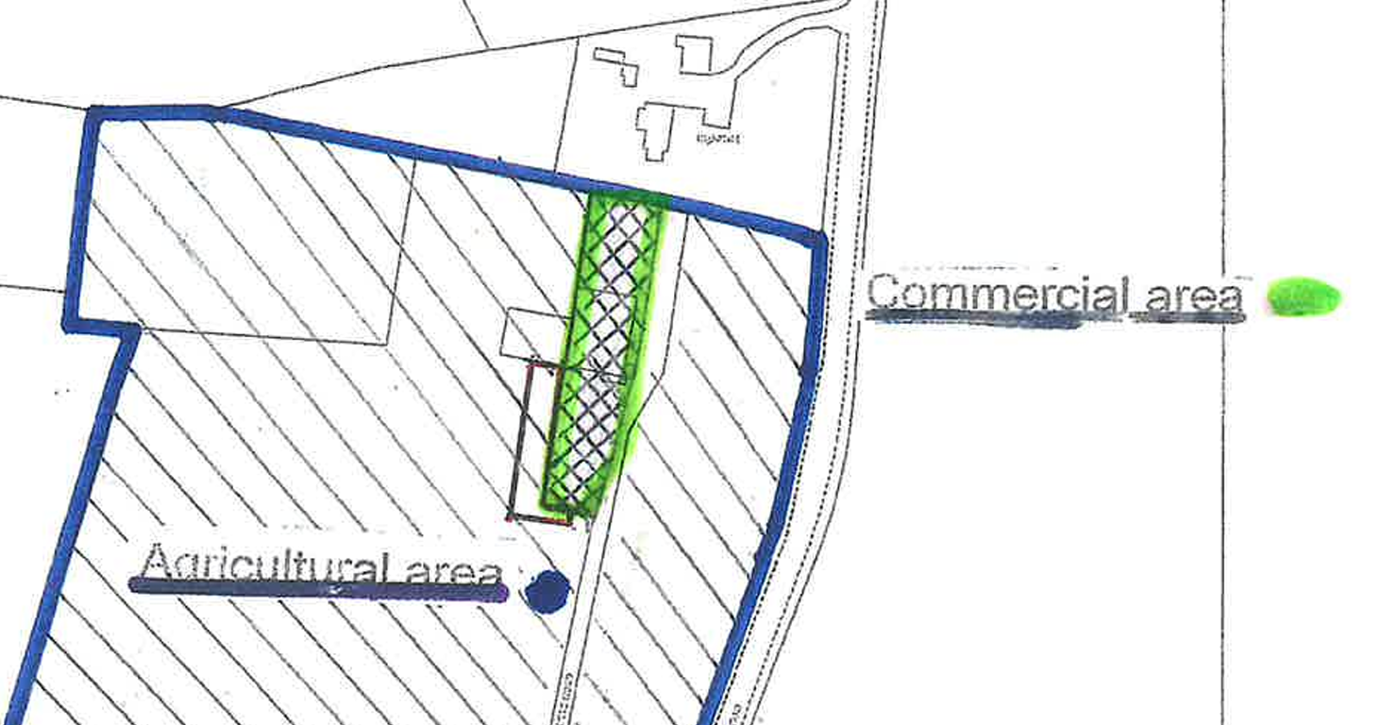

The extract below from the submitted site plan shows the location of the vehicle ramp to the west of the commercial land, the ramp has been highlighted in yellow for ease.

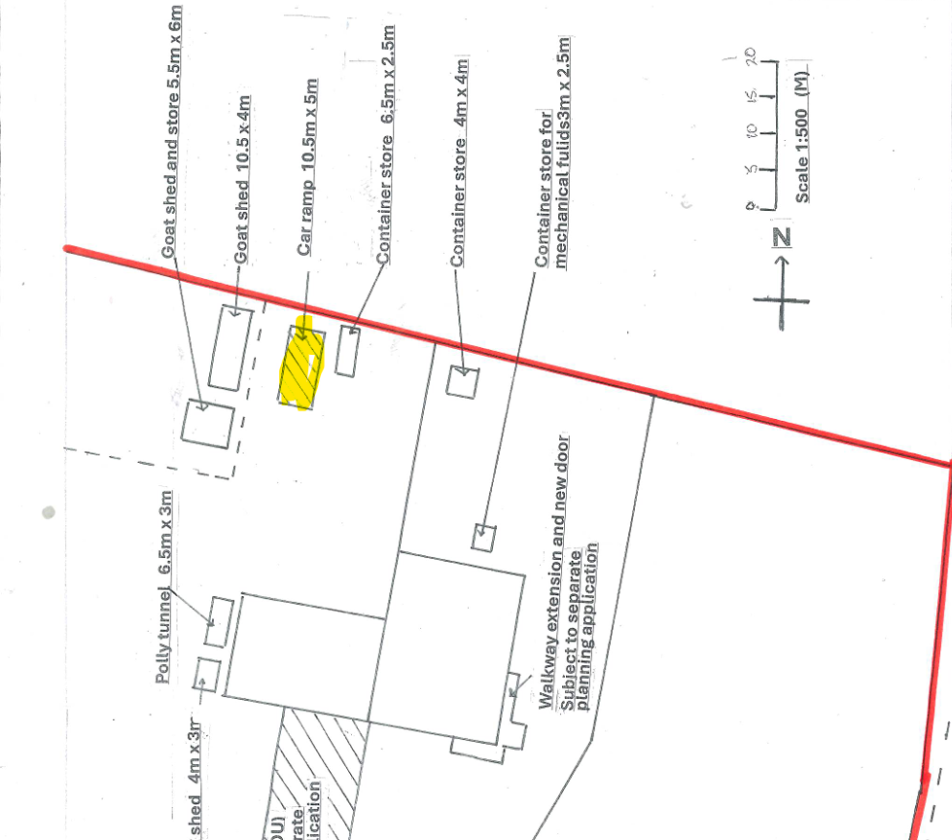

No justification has been provided with the application as to the need for the expansion of commercial activities outside of the existing building other than occasional need for vehicles too large to use the existing facilities inside the building. However, the scale and location of the ramp does not appear to provide for large vehicles that would appear to be able to access the existing internal workshop. In the case officers photo below, it is understood that the applicant had carried out works to his own small van on the ramp. Officers cannot condition the size of vehicles that can use the ramp or that it can only be used on the odd occasion, such conditions would not meet the six tests of the NPPF.

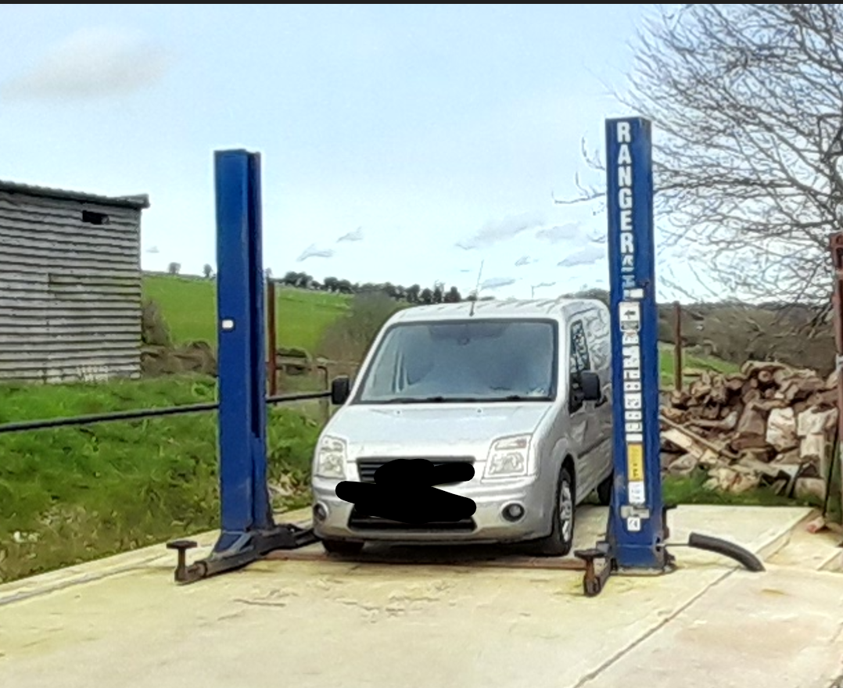

Although the vehicle ramp is seen in the context of the overall Coombe Down Farm site, given that it is located on agricultural land but for commercial use, the industrial nature of the ramp is such that it is considered to be an unacceptable addition to the National Landscape which detrimentally impacts on the character of the area.

Amenity

Point vii of Core Policy 57 - Ensuring High Quality Design and Place Shaping of the Wiltshire Core Strategy seeks to ensure that developments do not adversely affect neighbouring properties.

The National Planning Policy Framework (NPPF), particularly Paragraph 135(f), stresses that planning decisions should ensure developments provide a high standard of amenity for existing and future users.

The ramp is located close to the north boundary of the site, in close proximity to the nearest neighbouring residential property known as Highfield. The ramp is located approximately where the black dot is shown on the map extract below. The map below shows the close proximity of the ramp to the amenity space and rear elevation of Highfield.

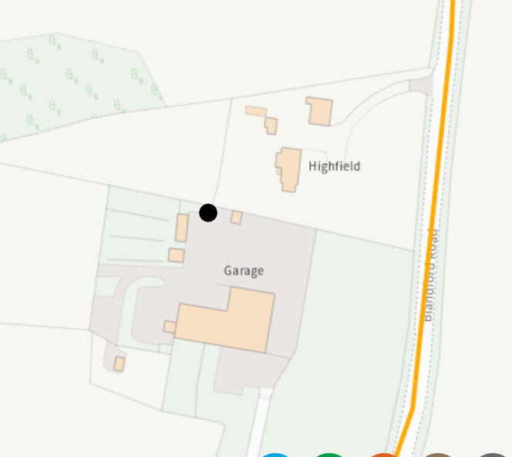

The external vehicle ramp would facilitate vehicle repair and maintenance activities associated with the B2 commercial use in close proximity to Highfield. The outdoor nature of the works would result in potential noise, vibration, engine testing and general disturbance that would be readily perceptible to the occupiers of Highfield, leading to an unacceptable loss of residential amenity. As such, the proposal fails to ensure a satisfactory relationship between industrial activity and sensitive residential uses, contrary to Core Policy 57 (Ensuring High Quality Design and Place Shaping) of the Wiltshire Core Strategy and the National Planning Policy Framework, which requires development to create places with a high standard of amenity for existing and future users.

Highways Impacts and Parking

The development relates to a vehicle ramp for use in association with the existing commercial unit for an engineering workshop facility to serve rural land-based industry. The ramp is for use in association with the existing commercial business, there are no changes proposed to the existing access or parking area. There are therefore no highway safety concerns raised.

Ecology and Biodiversity

Core Policy 50 of the Wiltshire Core Strategy and the National Planning Policy Framework requires that the planning authority ensures protection of important habitats and species in relation to development and seeks enhancement for the benefit of biodiversity through the planning system.

BNG - From 12 February 2024 Biodiversity Net Gain (BNG) became mandatory under Schedule 7A of the Town and Country Planning Act 1990 (as inserted by Schedule 14 of the Environment Act 2021). Based on the information available the biodiversity gain planning condition is not considered to apply to this application as the application is for retrospective consent and BNG does not apply to retrospective development.

River Avon SAC - This development falls within the catchment of the River Avon SAC and has potential to cause adverse effects alone or in combination with other developments through discharge of phosphorus in wastewater. A test of likely significance has been carried out by the relevant Competent Authority (Wiltshire Council) as required by Regulation 63 of the Conservation of Habitats and Species Regulations 2017 (as amended). Given that technically there will be no net increase in overnight accommodation (the proposed works are not to add a new dwelling, but to retain a vehicle ramp), it can be considered that there would be no overall mechanism for adverse effect. The HRA has concluded that the application is not likely to have significant impacts on the SAC and subsequently the application is screened out of Appropriate Assessment.

New Forest SPA, New Forest SAC and New Forest Ramsar site -The site is located within the 13.8km zone of influence for the New Forest internationally protected sites, which comprises the New Forest SPA, New Forest SAC and New Forest Ramsar site. Any applications within this area are screened into appropriate assessment under the Conservation of Habitats and Species Regulations 2017 (as amended) on account of its potential to cause adverse effects on the New Forest protected sites through increased recreational pressure which may occur alone and in-combination with other plans and projects. Many of the special features of the New Forest protected sites afforded protection are vulnerable to adverse effects associated with an increase in recreation as demonstrated in Natural England’s supplementary advice issued for the SPA on 19 March 2019 and for the SAC on 18 March 2019. Following a Cabinet decision on 7 May 2024, Wiltshire Council’s “Interim recreation mitigation strategy for the New Forest internationally protected sites” (Version 1.1, 21 March 2023) is being revised. However, as the development relates to the retention of a vehicle ramp and does not involve new overnight accommodation, nor will it be bringing additional people to the locality which will impact on the New Forest protected sites it can be screened out of Appropriate Assessment.

PLANNING BALANCE AND CONCLUSION

At the heart of the NPPF there is a presumption in favour of sustainable development requiring local planning authorities to approve development proposals that accord with an up-to-date development plan without delay; and where there are no relevant development plan policies, or the policies which are most important for determining the application are out-of-date, permission should be granted unless (taken from paragraph 11d of the NPPF):

- The application of policies in the NPPF that protect areas or assets of particular importance provides a clear reason for refusing development proposed; or
- any adverse impacts of doing so would significantly and demonstrably outweigh the benefits, when assessed against the policies in the NPPF taken as a whole;

The application seeks permission for the retention of the external vehicle ramp. The external vehicle ramp would facilitate industrial activity outside of the approved buildings, on land that remains in agricultural use, undermining the purpose and effectiveness of the original planning conditions which sought to restrict external works in the interests of landscape protection and amenity. No compelling functional justification has been provided to demonstrate a need for the ramp in this sensitive location, nor can its use be adequately or reasonably controlled by condition. While no highway safety issues arise, this neutral consideration does not outweigh the identified harm, particularly in relation to amenity impacts on the adjacent residential property known as Highfield. Overall, the proposal conflicts with Core Policies 51 and 57 of the Wiltshire Core Strategy and the objectives of the NPPF, and planning permission is therefore not supported.

RECOMMENDATION: That Planning Permission be REFUSED.

The installation of an external vehicle ramp on agricultural land, to facilitate engineering workshop activities associated with the existing commercial business, would enable repair, maintenance of vehicles to take place outside of any building. This would be contrary to Conditions 2, 7, and 8 of the original planning consent S/2009/1806 , which strictly restrict the nature of the authorised use, prohibit the carrying out of industrial processes and the storage of equipment externally, and require all repair and maintenance activities to take place within enclosed buildings in the interests of landscape protection and neighbouring amenity.

The external ramp, by its nature and intended use, would intensify activity outside the approved buildings, resulting in unacceptable harm to the open rural character and scenic quality of the National Landscape, and would give rise to additional noise, disturbance and visual impacts detrimental to the amenities of nearby occupiers. Furthermore, insufficient justification has been provided to demonstrate a functional or operational need for the ramp in this sensitive countryside location. The proposal therefore represents inappropriate development within the National Landscape and conflicts with the original intent of the planning conditions imposed to safeguard the countryside and residential amenity, contrary to Core Policy 51 (Landscape) and Core Policy 57 (Ensuring High Quality Design and Place Shaping) of the Wiltshire Core Strategy and the aims of the NPPF.

Informative

The development has been assessed against the following plans:

Application form received 01/12/2025
Site plan received 25/02/2026
Location plan received 25/02/2026
Elevations/plans received 19/01/2026
Vehicle ramp photos and specifications received 26/11/2025

REASON: For the avoidance of doubt

