APPLICATION FOR VARIATION/REMOVAL OF CONDITION
CASE OFFICER REPORT

APPLICATION REFERENCE: | PL/2026/01076
APPLICATION TYPE: | Removal/variation of conditions
SITE ADDRESS: | County Hall, Bythesea Road, Trowbridge, BA14 8JN
DEVELOPMENT DESCRIPTION: | Variation of conditions 2 (Approved Plans/Docs), 3 (BNG), 4 (Tree Protection), 5 (External Materials), 6 (Acoustics), 7 (LEMP), 8 (Drainage), 9 (Swift Boxes), 11 (Soft Landscaping) and 13 (Site Parking) in relation to PL/2024/08255.
RECOMMENDATION: | Approve with Conditions

SITE DESCRIPTION/CONTEXT

This application seeks a variation of PL/2024/08255 for the approved construction of a leisure centre and ancillary works in Trowbridge. Application PL/2024/08255 was granted in December 2024 at Strategic Planning Committee and was reported to members in accordance with the Constitution scheme of delegation. Since this application has not been subject to an objection it can be processed under delegated powers, again following the terms of the aforesaid Constitution.

The application site as illustrated below and is within the centre of Trowbridge and sits opposite County Hall to the northeast.

Fig. 1: Location Plan
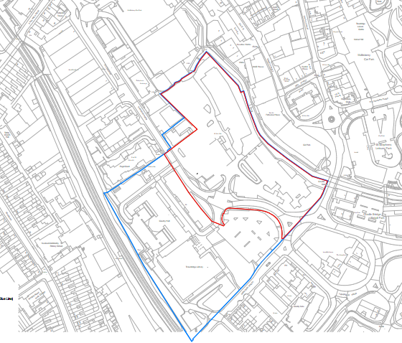
To the north of the site is the rear of the ASDA building. The northeast boundary is formed by the River Biss with tall buildings beyond, including historic former mills.

The riverbank is lined with mature trees and vegetation below the tree canopy. The south and west of the site is bounded by Castle Street and Bythesea Road.

The site is outside of, but immediately adjacent to, the Trowbridge Town Centre Conservation Area. The Conservation Area sits to the northeast and includes the River Biss.

The site predominantly lies within the Grey Zone of the Trowbridge and Westbury Bat Mitigation Strategy (TWBMS); with the river corridor being located within the Yellow Zone of the TWBMS.
Fig. 2: Aerial view showing vegetation
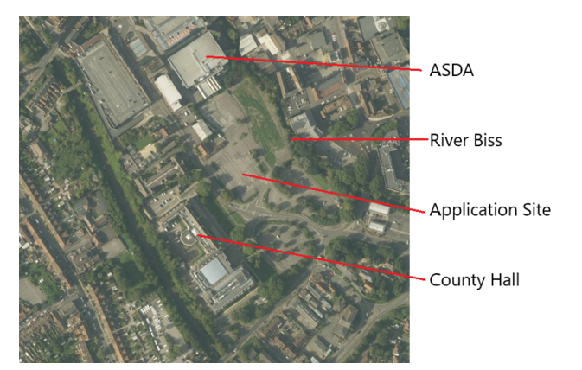

PROPOSAL

This report considers a Section 73 application for the variation of conditions imposed on planning permission PL/2024/08255.

The application relates to the site at Land at former East Wing, County Hall, Trowbridge, and seeks to vary conditions 2, 3, 4, 5, 6, 7, 8, 9, 11 and 13 to planning permission PL/2024/08255 under Section 73 of the Town and Country Planning Act 1990 in order to allow for minor amendments to the approved scheme.

The proposed changes do not alter the overall nature or principle of the development and are limited to modest design/layout refinements. The following site plans illustrate the changes:

Fig. 3: Approved layout:

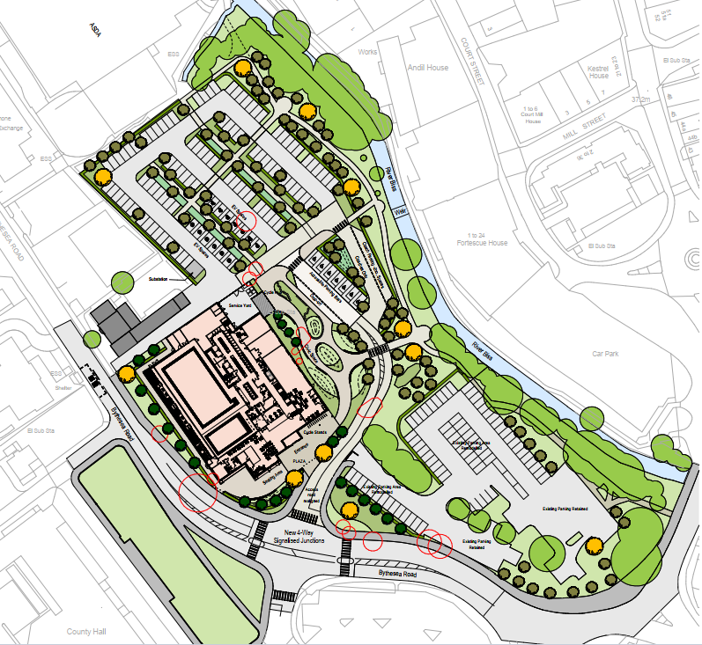

Fig. 4: Proposed layout:

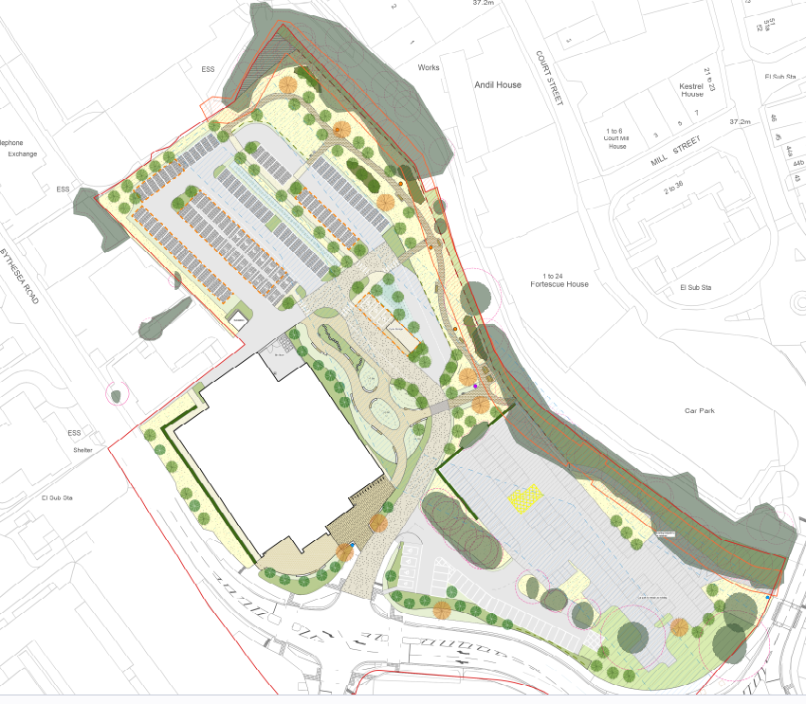

RELEVANT PLANNING HISTORY

Proposal / Summary
PL/2024/08255 - Construction of a Leisure Centre and Ancillary Works - Land at former East Wing Site, Bythesea Road, Trowbridge, BA14 8JN – Approved with conditions 11th December 2024

RELEVANT LEGISLATION, POLICIES AND GUIDANCE

Town and Country Planning Act. 1990 (as amended)

Section 73 of the Town and Country Planning Act. 1990 (as amended) relates to the determination of applications to develop land without compliance with conditions previously attached. It states that:

(2) On such an application the local planning authority shall consider only the question of the conditions subject to which planning permission should be granted, and—

- if they decide that planning permission should be granted subject to conditions differing from those subject to which the previous permission was granted, or that it should be granted unconditionally, they shall grant planning permission accordingly, and

- if they decide that planning permission should be granted subject to the same conditions as those subject to which the previous permission was granted, they shall refuse the application.

The National Planning Practice Guidance (PPG) states the following:

- Nature of the Application: A Section 73 application is treated as a new planning permission, although it does not alter the original permission itself. The original permission remains intact and can still be implemented unless it has expired or been superseded.
- Limitations:
  - Section 73 cannot be used to change the description of development or the operative part of the permission (e.g. the nature or extent of the approved use).
  - It cannot be used to extend the time limit for implementing the original permission.
  - If the proposed changes go beyond what can reasonably be considered under Section 73, a new planning application under Section 70 would be required.
- Decision-making: The local planning authority must consider the application only in relation to the conditions subject to which the original permission was granted. However, it may impose new or revised conditions if granting a new permission.
- Legal Agreements: Because a Section 73 application results in a new permission, any existing Section 106 agreement may need to be varied or replaced via a deed of variation to ensure obligations continue to apply to the new permission.

National Planning Policy:
- National Planning Policy Framework (NPPF)
- Planning Practice Guidance (PPG)
- National Design Guide
Development Plan:
The development plan for Wiltshire comprises the Wiltshire Core Strategy (WCS) (adopted January 2015) and any made neighbourhood plans, which remains the principal statutory planning document guiding development across the county. In line with Section 38(6) of the Planning and Compulsory Purchase Act 2004, planning decisions must be made in accordance with the development plan unless material considerations indicate otherwise.

Though the development plan is considered as a whole, those parts deemed to be particularly relevant to this application are listed below:

The adopted Wiltshire Core Strategy (WCS), with particular regard to:

- Core Policy 1 Settlement Strategy;
- Core Policy 2 Delivery Strategy;
- Core Policy 29: Trowbridge Community Area
- Core Policy 41 Sustainable Construction and Low-Carbon Energy;
- Core Policy 50 Biodiversity and Geodiversity;
- Core Policy 57 Ensuring High Quality Design and Place Shaping;
- Core Policy 58 Ensuring the Conservation of the Historic Environment;
- Core Policy 60 Sustainable Transport;
- Core Policy 61 Transport & Development;
- Core Policy 64 Demand Management
- Core Policy 67 Flood Risk;
- Core Policy 68 Water Resources;

Draft Wiltshire Local Plan Policies

The examination of the emerging Wiltshire Local Plan has been paused and the weight to be afforded to any part of the emerging plan can be no more than very limited. A decision on how to proceed will be made by the Council in May 2026.

ISSUES

The key considerations in the assessment of this application are as follows:

- Determining whether the proposed amendments fall within the scope of Section 73 of the Town and Country Planning Act 1990 which allows for the variation or removal of conditions attached to an existing planning permission.
- Assessing whether the development, as amended, remains in accordance with the relevant policies and provisions of the development plan, and whether the changes materially alter the nature or impacts of the approved scheme.

CONSULTATION RESPONSES

Trowbridge Town Council – No objections

Public Protection – No objections

Drainage – No objection subject to condition.

Highways – No objection. The highway officer also confirmed: -

“I note the variations to the approval granted under PL/2024/08255, for a new leisure centre. The variations include some minor alterations to car parking for the new leisure centre, with the overall number of spaces unchanged. The alterations are considered acceptable. The proposals also include alterations to the retained County Hall staff car parking area, with additional spaces now shown. Again, the alterations are considered acceptable”.

Arboricultural Officer – No objections subject to the arb reports and plans being added as approved documents.

Ecology – No objection but a Habitat Management and Monitoring Plan is required as a condition.

REPRESENTATIONS

One representation was received, as follows:

Trowbridge Civic Society previously raised concerns about the lack of quality and local distinctiveness in the proposed development, and its relation to the distinguished setting of County Hall. We would now urge the Council to be satisfied that the submitted details are fully compliant with the objectives of the Council's Core Policy 57.

ASSESSMENT
Section 38(6) of the Planning and Compulsory Purchase Act 2004 states:

"If regard is to be had to the development plan for the purposes of any determination to be made under the planning Acts, the determination must be made in accordance with the plan unless material considerations indicate otherwise."

In accordance with this statutory requirement, this application has been assessed against the relevant policies of the Development Plan, including the Wiltshire Core Strategy (2015) and, where applicable, any made Neighbourhood Plans. Consideration has also been given to the policies of the National Planning Policy Framework (NPPF) as a material consideration in the assessment.

Principle of the Development – Do the proposed amendments fall within the scope of s73?

The proposed amendments have been reviewed and are considered to fall within the scope of Section 73 of the Town and Country Planning Act 1990. The changes do not result in a fundamentally different development from that originally approved, nor do they seek to alter the description of development or extend the time limit for implementation. As such, the application is valid under Section 73 and can be determined as a variation of condition(s) attached to the original planning permission.

Compliance with the Development Plan

The application is a valid submission under Section 73 of the Town and Country Planning Act 1990, seeking to vary conditions attached to an existing, extant planning permission. The principle of development has therefore already been established by the parent consent.

In assessing this application, officers have had due regard to the adopted development plan and other material considerations. It is considered that the proposal continues to accord with:

- The relevant policies of the Wiltshire Core Strategy, including those relating to settlement strategy, design quality, landscape character, heritage assets, ecology and sustainable development; and
- The National Planning Policy Framework (NPPF), particularly sections relating to sustainable development, good design, conserving the natural and historic environment, and decision-making.

Officers have also considered whether any material changes in national or local planning policy since the grant of the original permission would render the amended proposal unacceptable, or alternatively more acceptable. It is concluded that no such policy changes arise that would materially alter the planning balance or justify a different outcome. The proposed amendments remain acceptable in planning terms and do not give rise to new or additional policy conflicts.

Assessment of Conditions

This application seeks to vary several conditions attached to planning permission PL/2024/08255, which was issued subject to 25 conditions. In order to accommodate the design and layout changes proposed the following conditions are proposed to change: conditions 2, 3, 4, 5, 6, 7, 8, 9, 11 and 13.

Condition 2

The plans list in condition 2 is proposed to be updated to allow these changes as follows:

2 The development hereby permitted shall be carried out in accordance with the following approved plans and documents:
11120-RL-XX-ZZ-DR-L-08003 P18 Landscape GA
11120-RL-00-ZZ-DR-A-P2001-A3-C03_Proposed Site Plan
11120-RL-XX-01-DR-A-P2100-A3-C04_Proposed Ground Floor Plan
11120-RL-XX-01-DR-A-P2101-A3-C04_Proposed First Floor Plan
11120-RL-XX-01-DR-A-P2102-A3-C04_Proposed Roof Plan
11120-RL-XX-ZZ-DR-A-P2201-A3-C04_Proposed Elevations
11120-RL-XX-ZZ-DR-A-P2300-A3-C03_Proposed Sections
11120-RL-XX-ZZ-DR-A-P0401-A3-C02_Existing Contextual Sections
11120-RL-XX-ZZ-DR-A-P0002-A3-C01_Existing Site Plan
11120-RL-XX-ZZ-DR-A-P0001-A3-C01_Site Location Plan
11120-RL-XX-ZZ-DR-A-F0008_C06_(A5)_Site Setup Plan
16262_R08a_Arboriculture Technical Note_AS_12022026
16262_BNG_Statutory Metric_10022026
16262_P05a_Biodiversity Enhancement Plan_VKC_12022026
16262_R01c_EcIA_VKC_12022026
Construction Environmental Management Plan
116262_P04_Tree Constraints Plan
61701-BB-B0-ZZ-LX-E-99999.P01
TLC-HYD-XX-XX-RP-C-7000_P02_LR
TLC-HYD-00-ZZ-DR-C-7000
31436-HYD-00-ZZ-DR-C-7200
TLC-HYD-00-ZZ-DR-C-7001
31436-HYD-00-ZZ-DR-C-7201
TLC-HYD-00-ZZ-DR-C-7410
TLC-HYD-00-ZZ-DR-C-7001
Pellikaan Construction Ltd CPP Trowbridge V7
31436-HYD-XX-XX-RP-WENV-0001 Trowbridge Leisure Centre Flood Risk Assessment_1
16262_R03d_AMS_1202026_RM_NC
11120-RL-XX-ZZ-DR-A-PL2203_C02_(A4)_ Swift Boxes Elevation
11120-RL-XX-ZZ-SH-A-PL2400_C03_(A4)_ External Finishes Schedule
TLC-STN-XX-XX-LT-AC-0001 - Acoustic Addendum
16262_R07d_LEMP_12022026
11120-RL-XX-00-DR-L-08301-Planting Plan Sheet 1 of 2
11120-RL-XX-00-DR-L-08302-Planting Plan Sheet 2 of 2
11120-RL-XX-ZZ-DR-L-08401 Soft Landscape
31436-HYD-XX-XX-RP-WENV-0004 - Flood Evacuation Management Plan_1
TLC-HYD-00-ZZ-DR-C-7000 (P05)
TLC-HYD-00-ZZ-DR-C-7001 (P05)
TLC-HYD-00-ZZ-DR-C-7104 (P01)
TLC-HYD-00-ZZ-DR-C-7105 (P01)
TLC-HYD-00-ZZ-DR-C-7106 (P01)
TLC-HYD-XX-XX-CA-C-0001_Surface Water Calculations
260212_SK22386_TN08(-01) TA Addendum Vol 1 & 2

REASON: For the avoidance of doubt and in the interests of proper planning.

Condition 3

Condition 3 relates to the Biodiversity Net Gain Plan, which has been submitted and found to be acceptable, although the Habitats Management and Monitoring Plan needs to be submitted to complete this work. The proposed replace of condition 3 is as follows:

3 The development hereby approved shall not be brought into operational use until a Habitat Management and Monitoring Plan (the HMMP), prepared in accordance with the statutory Biodiversity Gain Plan and including:

- a non-technical summary;
- the roles and responsibilities of the people or organisation(s) delivering the HMMP;
- the planned habitat creation and enhancement works to create or improve habitat to achieve the biodiversity net gain in accordance with the statutory Biodiversity Gain Plan and schedule for implementation;
- the management measures to maintain habitat in accordance with the statutory Biodiversity Gain Plan for a period of 30 years from the completion of development; and
- the monitoring methodology and specification of a Monitoring Pack (to include but not exclusively up to date Management Actions Logs, Habitat Condition Assessment Reports, metric calculation; and corresponding post intervention Habitat Map) which shall be submitted to the Local Planning Authority in years 2 (two) 5 (five) 10 (ten) 15 (fifteen) 20 (twenty) and 30 (thirty) of the Maintenance Period,

has been submitted to the local planning authority for approval.

The created and/or enhanced habitat shall be managed and maintained in accordance with the HMMP at all times thereafter.

REASON: To ensure the development delivers a biodiversity net gain on site in accordance with Schedule 7A of the Town and Country Planning Act 1990.

Condition 4

This condition relates to the protection of the retained trees on site. The information received to discharge the condition is acceptable, as found by the Council’s Arboricultural Officer. Therefore, the condition can be reworded into a compliance condition as follows:

4 The mitigation measures set out in the approved Tree Protection Plan (drawing No. 16262_P04 Rev. E), the Arboricultural Method Statement (16262_R03d_AMS_1202026_RM_NC), the Arboriculture Technical Note (16262_R08a) shall be fully implemented to the area of works, and;

The protective fencing shall be erected to the construction site where works are being carried out in accordance with the approved details. The protective fencing shall remain in place for the period of the construction works and until all equipment, machinery and surplus materials have been removed from the area of the site where works are being carried out. Such fencing shall not be removed or breached during construction operations.

No retained trees shall be cut down, uprooted or destroyed, nor shall any retained trees be topped or lopped other than in accordance with the approved plans and particulars unless agreed otherwise in writing. Any topping or lopping approval shall be carried out in accordance British Standard 3998: 2010 “Tree Work – Recommendations” or arboricultural techniques where it can be demonstrated to be in the interest of good arboricultural practice.

If any retained tree is removed, uprooted, destroyed or dies, another tree shall be planted at the same place unless agreed otherwise in writing, at a size and species and planted at such time, that must be agreed in writing with the Local Planning Authority.

No fires shall be lit within 15 metres of the furthest extent of the canopy of any retained trees or hedgerows or adjoining land and no concrete, oil, cement, bitumen or other chemicals shall be mixed or stored within 10 metres of the trunk of any tree or group of trees to be retained on the site or adjoining land.

[In this condition “retained tree” means an existing tree which is to be retained in accordance with the approved plans and particulars; and paragraphs above shall have effect until the expiration of five years from the first occupation or the completion of the development, whichever is the later].

REASON: To ensure the retention of trees on the site in the interests of visual amenity and biodiversity.

Condition 5

This condition relates to the materials to be used on the external surfaces of the building. The information received to discharge the condition is acceptable, as detailed in the proposed elevations (11120-RL-XX-ZZ-DR-A-P2201_C04_A3) and the external finishes (11120-RL-XX-ZZ-SH-A-PL2400_C03) documents. Therefore, the condition can be reworded into a compliance condition as follows:

5 The materials to be used for the external walls shall accord with the approved plans and documents ref. 11120-RL-XX-ZZ-DR-A-P2201_C04_A3 and 11120-RL-XX-ZZ-SH-A-PL2400_C03.

REASON: In order that the development is undertaken in an acceptable manner, in the interests of visual amenity and the character and appearance of the area.

Condition 6

This condition relates to the acoustic impacts of the development. The information received to discharge the condition is acceptable – the Acoustic Addendum 31436-HYD-XX-XX-TN-AC-0001 P02 – as found by the Council’s Public Protection team. This document confirms that no changes are being made in regard to this issue since the discharge of the condition under application ref. PL/2025/04792. Therefore, the condition can be reworded into a compliance condition, whilst retaining the follow up requirement, as follows:

6 The construction and arrangement of the development shall adhere to the details of documents ref. Acoustic Report 31436-HYD-XX-XX-TN-AC-0001 P02 and the Acoustic Addendum 31436-HYD-XX-XX-TN-AC-0001 P02.

A post installation noise assessment shall be carried out within 3 months of commissioned plant being operational within the development to confirm compliance with the noise criteria and additional steps required to achieve compliance shall be taken, as necessary. The details as approved shall be implemented prior to occupation of the development and thereafter be permanently retained.

REASON: WCS Core Policy 57, Ensuring high design and place shaping such that appropriate levels of amenity are achievable.

Condition 7

This condition relates to the submission of a LEMP. The information received to discharge the condition is acceptable, as found by the Council’s Ecologist. Therefore, the condition can be reworded into a compliance condition as follows:

7 The development hereby approved shall be carried out in accordance with the submitted and approved Landscape and Ecology Management Plan (LEMP).

The LEMP shall be implemented in full and for the lifetime of the development in accordance with the approved details.

REASON: To ensure the long-term management of landscape and ecological features retained and created by the development, for the benefit of visual amenity and biodiversity for the lifetime of the scheme.

Condition 8

This condition relates to the drainage of the site. The information received to discharge the condition is partially acceptable but, as found by the Council’s Drainage team, requires more information in order to be fully discharged. Therefore, the condition must remain as originally written, with an explanatory informative detailing the additional information that the Drainage team requires:

8 The development hereby approved shall not be brought into operational use until details of the following have been submitted to, and been approved in writing by, the Local Planning Authority in relation to the surface water drainage strategy:

The applicant has stated flows from the western catchment will be restricted to greenfield rates, while the eastern catchment will not be restricted, just treated. To mitigate the eastern catchment of the development being detrimental in the future accounting for climate change, the applicant must ensure the eastern catchment will attenuate the effects of climate change.

The applicant must provide detailed cross and long section drawings of each proposed SuDS intervention, including the attenuation tank, permeable paving, rain garden, tree pits, swales, to ensure they are designed appropriately, and in line with the Ciria C753 (SuDS Manual).

Observing Drainage Layout – Sheet 2, as these SuDS interventions are included in water quality calculations and the drainage calculations, the applicant must confirm that SuDS interventions will be proposed as per submitted plans, or if not, resubmit all drainage and water quality calculations omitting SuDS, and provide revised surface water drainage strategy details in accordance with Wiltshire Council policy.

The applicant must provide details of how, in an extreme rainfall event, the surcharging from the culverted watercourse, or from a 1-in-100 year storm, will be managed safely.

The applicant must provide a Flood Evacuation Plan to demonstrate how safe egress and access to the building can be maintained during such an event.

REASON: To mitigate any impact from the development onto flooding and drainage infrastructure.

Informative:

Condition 8 cannot be discharged until, in addition to the submitted documents, the following information is submitted and accepted by the LLFA:
• It is noted in Section 5.7 of the Drainage Strategy Report that there is not sufficient water quality treatment provided by the proposed drainage strategy. The applicant must ensure that the mitigation indices are equal or greater than pollution indices.
• The applicant must provide a Flood Evacuation Plan to demonstrate how safe egress and access to the building can be maintained during such an event.
• The applicant must provide details of how, in an extreme rainfall event, the surcharging from the culverted watercourse, or from a 1-in-100 year storm, will be managed safely.
• The applicant must demonstrate an agreement with Wessex Water to discharge into WW-4707 at 3l/s.
• It is noted in Appendix H the applicant has provided cross and long section drawings of various SuDS features, including swales, rain gardens, permeable paving. The applicant must clarify whether tree pits are still proposed, and if so, a section drawing must be provided.
For clarity, the total amount of information required must be submitted together within a discharge of condition application.

Condition 9

This condition relates to the inclusion of swift boxes into the development. The information received to discharge the condition is acceptable, as found by the Council’s Ecologist. Therefore, the condition can be reworded into a compliance condition as follows:

9 The development hereby approved shall not be brought into operational use until the swift boxes shown on plan ref. ref 11120.RL.XX.ZZ.DR.A Rev CO3 shall be incorporated into the north-west elevation of the building. The boxes shall be installed in accordance with the approved plans and details.

REASON: In order to support the local swift population.

Condition 11

This condition relates to the implementation of the landscaping on site. The revised landscaping plan ref. 11120-RL-XX-ZZ-DR-L-08003_P18 has been found acceptable. It represents a suitable landscaping arrangement for this site. Therefore, the condition can remain as a compliance condition as follows:

11 All soft landscaping comprised in the approved details of landscaping (drawing No. 11120-RL-XX-ZZ-DR-L-08003_P18 and the Arboricultural Method Statement) shall be carried out in the first planting and seeding season following the first occupation of the building or the completion of the development whichever is the sooner; All shrubs, trees and hedge planting shall be maintained free from weeds and shall be protected from damage by vermin and stock. Any trees or plants which die, are removed, or become seriously damaged or diseased shall be replaced in the next planting season with others of a similar size and species, unless otherwise agreed in writing by the local planning authority. All hard landscaping shall also be carried out in accordance with the approved details prior to the occupation of any part of the development or in accordance with a programme to be agreed in writing with the Local Planning Authority.

REASON: To ensure a satisfactory landscaped setting for the development and the protection of existing important landscape features

Condition 13

This condition relates to the provision of parking and turning areas, along with the access arrangements on site. The information received to discharge the condition is acceptable, as found by the Council’s Highways team. Therefore, the condition can be reworded into a compliance condition as follows:

13 The development hereby approved shall not be brought into operational use until the on-site access, turning areas and parking spaces (112), as well as the cycle parking facilities, have been completed in accordance with the details shown on the approved plans (Drawing No. 11120-RL-00-ZZ-DR-A-P2001-A3-C04). Thereafter, the areas shall be maintained for those purposes for the lifetime of the development.

REASON: In the interests of highway safety.
The proposed variations to the conditions attached to planning permission PL/2024/08255 have been carefully considered in the context of the amended scheme. Where changes are proposed, these have been assessed to determine whether they are reasonable, necessary and justified, and whether they continue to secure an acceptable form of development. The implications of the proposed amendments for other conditions, including those relating to approved plans, have also been taken into account to ensure internal consistency.

Conditions that have previously been discharged under the original permission have been reviewed, and where necessary updated or removed to reflect their status. Any conditions that are now obsolete or no longer relevant have similarly been identified and omitted. Overall, the revised suite of conditions remains comprehensive, enforceable, and compliant with the relevant tests, and is considered to adequately control the development as amended.

Subject to the revised conditions, the variation of conditions is therefore considered acceptable.

Material Considerations/Issues

In assessing this application, due regard has been given to the consultation responses as well as to the amended plans and supporting information submitted by the applicant. Only material planning considerations have been taken into account.

Design and Visual Impacts, including Heritage
Core Policies 57 and 58 of the Wiltshire Core Strategy require development to respond positively to local character, protect the setting of the Conservation Area and achieve a high standard of design.

The proposed amendments would result in relatively minor layout and aesthetic changes to the originally approved scheme. No objections have been received.

The proposed changes retain the fundamental character of the approved scheme. The minor changes reflect that, in commencing the development, more efficient and sustainable ways of laying out the site have been found. These changes, as shown in this submitted application would not alter the provision of the leisure centre, but would improve the way it fits into the local character, aesthetically and functionally.

The changes would have no impact on the setting of the Conservation Area over and above that already approved.

Highways
The Highway Authority has raised no objection to the proposal. The development would continue to utilise the approved access, and sufficient on-site parking provision is available to serve the leisure centre and the Council. No highway safety or capacity concerns arise, and the proposal accords with Core Policies 60 and 62 of the Wiltshire Core Strategy.

Ecology
The proposed scheme continues to accord with the ecological mitigation measures approved under the parent permission. Further information is required in the form of an HMMP, which will be reimposed as a condition.

Subject to full compliance with the ecological conditions, the proposal is acceptable in ecological terms and complies with Core Policy 50.

Drainage
Similar to the above, more information is required and will be reimposed as a condition to be discharged.

PLANNING BALANCE AND CONCLUSION
This application has been considered under Section 73 of the Town and Country Planning Act 1990 and seeks to vary a number of conditions attached to an extant planning permission. The assessment has focused on whether the proposed amendments fall within the scope of Section 73 and whether, taken as a whole, the development as amended would remain acceptable in planning terms.

The principle of developing a leisure centre on the site has already been established through earlier permissions. The proposed amendments comprise relatively minor design and layout changes, updated plans and documents, and revised condition wording, and do not result in a fundamentally different form of development to that previously approved. The application is therefore capable of being determined as a Section 73 variation.

Any identified impacts are considered to be appropriately mitigated and controlled through the revised and retained planning conditions. No material changes in policy or site circumstances have been identified that would justify reaching a different conclusion to that of the parent permission.

On balance, the proposal is considered to remain in accordance with the development plan and relevant national guidance. There are no material considerations that indicate otherwise, and the application is therefore recommended for approval, subject to the conditions set out in this report – the conditions will be subject to new numbering due to the commencement condition being already met.

RECOMMENDATION:
That Planning Permission be GRANTED subject to the following conditions:

1 The development hereby permitted shall be carried out in accordance with the following approved plans and documents:

11120-RL-XX-ZZ-DR-L-08003 P18 Landscape GA
11120-RL-00-ZZ-DR-A-P2001-A3-C03_Proposed Site Plan
11120-RL-XX-01-DR-A-P2100-A3-C04_Proposed Ground Floor Plan
11120-RL-XX-01-DR-A-P2101-A3-C04_Proposed First Floor Plan
11120-RL-XX-01-DR-A-P2102-A3-C04_Proposed Roof Plan
11120-RL-XX-ZZ-DR-A-P2201-A3-C04_Proposed Elevations
11120-RL-XX-ZZ-DR-A-P2300-A3-C03_Proposed Sections
11120-RL-XX-ZZ-DR-A-P0401-A3-C02_Existing Contextual Sections
11120-RL-XX-ZZ-DR-A-P0002-A3-C01_Existing Site Plan
11120-RL-XX-ZZ-DR-A-P0001-A3-C01_Site Location Plan
11120-RL-XX-ZZ-DR-A-F0008_C06_(A5)_Site Setup Plan
16262_R08a_Arboriculture Technical Note_AS_12022026
16262_BNG_Statutory Metric_10022026
16262_P05a_Biodiversity Enhancement Plan_VKC_12022026
16262_R01c_EcIA_VKC_12022026
Construction Environmental Management Plan
116262_P04_Tree Constraints Plan
61701-BB-B0-ZZ-LX-E-99999.P01
TLC-HYD-XX-XX-RP-C-7000_P02_LR
TLC-HYD-00-ZZ-DR-C-7000
31436-HYD-00-ZZ-DR-C-7200
TLC-HYD-00-ZZ-DR-C-7001
31436-HYD-00-ZZ-DR-C-7201
TLC-HYD-00-ZZ-DR-C-7410
TLC-HYD-00-ZZ-DR-C-7001
Pellikaan Construction Ltd CPP Trowbridge V7
31436-HYD-XX-XX-RP-WENV-0001 Trowbridge Leisure Centre Flood Risk Assessment_1
16262_R03d_AMS_1202026_RM_NC
11120-RL-XX-ZZ-DR-A-PL2203_C02_(A4)_ Swift Boxes Elevation
11120-RL-XX-ZZ-SH-A-PL2400_C03_(A4)_ External Finishes Schedule
TLC-STN-XX-XX-LT-AC-0001 - Acoustic Addendum
16262_R07d_LEMP_12022026
11120-RL-XX-00-DR-L-08301-Planting Plan Sheet 1 of 2
11120-RL-XX-00-DR-L-08302-Planting Plan Sheet 2 of 2
11120-RL-XX-ZZ-DR-L-08401 Soft Landscape
31436-HYD-XX-XX-RP-WENV-0004 - Flood Evacuation Management Plan_1
TLC-HYD-00-ZZ-DR-C-7000 (P05)
TLC-HYD-00-ZZ-DR-C-7001 (P05)
TLC-HYD-00-ZZ-DR-C-7104 (P01)
TLC-HYD-00-ZZ-DR-C-7105 (P01)
TLC-HYD-00-ZZ-DR-C-7106 (P01)
TLC-HYD-XX-XX-CA-C-0001_Surface Water Calculations
260212_SK22386_TN08(-01) TA Addendum Vol 1 & 2

REASON: For the avoidance of doubt and in the interests of proper planning.

2 The development shall not be brought into operational use until a Habitat Management and Monitoring Plan (the HMMP), prepared in accordance with the statutory Biodiversity Gain Plan and including:

- a non-technical summary;
- the roles and responsibilities of the people or organisation(s) delivering the HMMP;
- the planned habitat creation and enhancement works to create or improve habitat to achieve the biodiversity net gain in accordance with the statutory Biodiversity Gain Plan and schedule for implementation;
- the management measures to maintain habitat in accordance with the statutory Biodiversity Gain Plan for a period of 30 years from the completion of development; and
- the monitoring methodology and specification of a Monitoring Pack (to include but not exclusively up to date Management Actions Logs, Habitat Condition Assessment Reports, metric calculation; and corresponding post intervention Habitat Map) which shall be submitted to the Local Planning Authority in years 2 (two) 5 (five) 10 (ten) 15 (fifteen) 20 (twenty) and 30 (thirty) of the Maintenance Period,

has been submitted to the local planning authority for approval.

The created and/or enhanced habitat shall be managed and maintained in accordance with the HMMP at all times thereafter.

REASON: To ensure the development delivers a biodiversity net gain on site in accordance with Schedule 7A of the Town and Country Planning Act 1990.

3 The mitigation measures set out in the approved Tree Protection Plan (drawing No. 16262_P04 Rev. E), the Arboricultural Method Statement (16262_R03d_AMS_1202026_RM_NC), the Arboriculture Technical Note (16262_R08a) shall be fully implemented to the area of works, and;

The protective fencing shall be erected to the construction site where works are being carried out in accordance with the approved details. The protective fencing shall remain in place for the period of the construction works and until all equipment, machinery and surplus materials have been removed from the area of the site where works are being carried out. Such fencing shall not be removed or breached during construction operations.

No retained trees shall be cut down, uprooted or destroyed, nor shall any retained trees be topped or lopped other than in accordance with the approved plans and particulars unless agreed otherwise in writing. Any topping or lopping approval shall be carried out in accordance British Standard 3998: 2010 “Tree Work – Recommendations” or arboricultural techniques where it can be demonstrated to be in the interest of good arboricultural practice.

If any retained tree is removed, uprooted, destroyed or dies, another tree shall be planted at the same place unless agreed otherwise in writing, at a size and species and planted at such time, that must be agreed in writing with the Local Planning Authority.

No fires shall be lit within 15 metres of the furthest extent of the canopy of any retained trees or hedgerows or adjoining land and no concrete, oil, cement, bitumen or other chemicals shall be mixed or stored within 10 metres of the trunk of any tree or group of trees to be retained on the site or adjoining land.

[In this condition “retained tree” means an existing tree which is to be retained in accordance with the approved plans and particulars; and paragraphs above shall have effect until the expiration of five years from the first occupation or the completion of the development, whichever is the later].

REASON: To ensure the retention of trees on the site in the interests of visual amenity and biodiversity.

4 The materials to be used for the external walls shall accord with the approved plans and documents ref. 11120-RL-XX-ZZ-DR-A-P2201_C04_A3 and 11120-RL-XX-ZZ-SH-A-PL2400_C03.

REASON: In order that the development is undertaken in an acceptable manner, in the interests of visual amenity and the character and appearance of the area.

5 The construction and arrangement of the development shall adhere to the details of documents ref. Acoustic Report 31436-HYD-XX-XX-TN-AC-0001 P02 and the Acoustic Addendum 31436-HYD-XX-XX-TN-AC-0001 P02.

A post installation noise assessment shall be carried out within 3 months of commissioned plant being operational within the development to confirm compliance with the noise criteria and additional steps required to achieve compliance shall be taken, as necessary. The details as approved shall be implemented prior to occupation of the development and thereafter be permanently retained.

REASON: WCS Core Policy 57, Ensuring high design and place shaping such that appropriate levels of amenity are achievable.

6 The development shall be carried out in accordance with the submitted and approved Landscape and Ecology Management Plan (LEMP).

The LEMP shall be implemented in full and for the lifetime of the development in accordance with the approved details.

REASON: To ensure the long-term management of landscape and ecological features retained and created by the development, for the benefit of visual amenity and biodiversity for the lifetime of the scheme

7 The development shall not be brought into operational use until details of the following have been submitted to, and been approved in writing by, the Local Planning Authority in relation to the surface water drainage strategy:

The applicant has stated flows from the western catchment will be restricted to greenfield rates, while the eastern catchment will not be restricted, just treated. To mitigate the eastern catchment of the development being detrimental in the future accounting for climate change, the applicant must ensure the eastern catchment will attenuate the effects of climate change.

The applicant must provide detailed cross and long section drawings of each proposed SuDS intervention, including the attenuation tank, permeable paving, rain garden, tree pits, swales, to ensure they are designed appropriately, and in line with the Ciria C753 (SuDS Manual).

Observing Drainage Layout – Sheet 2, as these SuDS interventions are included in water quality calculations and the drainage calculations, the applicant must confirm that SuDS interventions will be proposed as per submitted plans, or if not, resubmit all drainage and water quality calculations omitting SuDS, and provide revised surface water drainage strategy details in accordance with Wiltshire Council policy.

The applicant must provide details of how, in an extreme rainfall event, the surcharging from the culverted watercourse, or from a 1-in-100 year storm, will be managed safely.

The applicant must provide a Flood Evacuation Plan to demonstrate how safe egress and access to the building can be maintained during such an event.

REASON: To mitigate any impact from the development onto flooding and drainage infrastructure.

Informative Note:

Condition 7 cannot be discharged until, in addition to the submitted documents, the following information is submitted and accepted by the LLFA:
• It is noted in Section 5.7 of the Drainage Strategy Report that there is not sufficient water quality treatment provided by the proposed drainage strategy. The applicant must ensure that the mitigation indices are equal or greater than pollution indices.
• The applicant must provide a Flood Evacuation Plan to demonstrate how safe egress and access to the building can be maintained during such an event.
• The applicant must provide details of how, in an extreme rainfall event, the surcharging from the culverted watercourse, or from a 1-in-100 year storm, will be managed safely.
• The applicant must demonstrate an agreement with Wessex Water to discharge into WW-4707 at 3l/s.
• It is noted in Appendix H the applicant has provided cross and long section drawings of various SuDS features, including swales, rain gardens, permeable paving. The applicant must clarify whether tree pits are still proposed, and if so, a section drawing must be provided.
For clarity, the total amount of information required must be submitted together within a discharge of condition application.

8 The development shall not be brought into operational use until the swift boxes shown on plan ref. ref 11120.RL.XX.ZZ.DR.A Rev CO3 shall be incorporated into the north-west elevation of the building. The boxes shall be installed in accordance with the approved plans and details.

REASON: In order to support the local swift population.

9 The development shall not be brought into operational use until final details of the low-carbon and renewable energy technologies (such as air source heat pumps and roof-mounted solar PV) have been submitted to and been approved in writing by the local planning authority. Details shall include, but not necessarily be limited to location, number, dimensions and manufacturer’s details. Thereafter, the development shall be carried out in accordance with the approved details.

REASON: In order to define the terms of the permission and in order to support and encourage sustainable construction in accordance with WCS policies CP41, CP55 and CP57.

10 All soft landscaping comprised in the approved details of landscaping (drawing No. 11120-RL-XX-ZZ-DR-L-08003_P18 and the Arboricultural Method Statement) shall be carried out in the first planting and seeding season following the first occupation of the building or the completion of the development whichever is the sooner; All shrubs, trees and hedge planting shall be maintained free from weeds and shall be protected from damage by vermin and stock. Any trees or plants which die, are removed, or become seriously damaged or diseased shall be replaced in the next planting season with others of a similar size and species.

All hard landscaping shall also be carried out in accordance with the approved details prior to the bringing into use of any part of the development.

REASON: To ensure a satisfactory landscaped setting for the development and the protection of existing important landscape features

11 The development shall not be brought into operational use until the electric vehicle charging infrastructure has been provided and made available for use in accordance with the approved details.

REASON: To ensure that the objectives of sustainable development set out in WCS policies CP41, CP55, CP57 and CP60 are achieved.

12 The development shall not be brought into operational use until the on-site access, turning areas and parking spaces (112), as well as the cycle parking facilities, have been completed in accordance with the details shown on the approved plans (Drawing No. 11120-RL-00-ZZ-DR-A-P2001-A3-C04). Thereafter, the areas shall be maintained for those purposes for the lifetime of the development.

REASON: In the interests of highway safety.

13 The development shall not be brought into operational use until the cycle parking facilities shown on the approved plans have been provided in full and made available for use. Thereafter, the cycle parking facilities shall be retained for use in accordance with the approved details for the lifetime of the development.

REASON: To ensure that satisfactory facilities for the parking of cycles are provided and to encourage travel by means other than the private car in accordance with the objectives of sustainable development set out in WCS policies CP41, CP55, CP57 and CP60.

14 The development hereby permitted shall not be brought into use until the associated connections to the public water and sewer infrastructure have been completed following an agreement being reached with Wessex Water as the statutory undertaker.

REASON: To ensure that the development is provided with a satisfactory water and waste drainage connections.

15 The Hydrock document Sustainability Statement and Energy Strategy (ref. 31436-HYD-XX-ZZ-RP-ME-0002 - P02) explaining the low-carbon approach of the scheme taken in the technical design stages shall be complied with and, where necessary, updated/finalised.

This shall include but not necessarily be limited to consideration of operational carbon, embodied carbon, climate change adaptation and sustainable transport. Thereafter, the development shall be carried out in accordance with the agreed details.

Any update to this document shall be submitted to the local planning authority for approval in writing.

REASON: To ensure that the objectives of sustainable development set out in WCS policies CP41, CP55, CP57 and CP60 are achieved.

16 The development hereby permitted shall be carried out in strict accordance with the following documents:

Framework Travel Plan (Document Ref. 240830/SK22386/FTP01(-02)) 4th September 2024.

REASON: To protect and maintain highway safety and to encourage sustainable travel modes.

17 Notwithstanding the submitted details, the proposed development shall not be brought into use until means/works have been implemented to avoid private water from entering the highway.

REASON: To ensure that the highway is not inundated with private water.

18 During the construction phase no machinery shall be operated, no process shall be carried out and no delivery shall be taken or dispatched from the site outside of the following hours; Mon-Fri 07:30 to 18:00 (no machinery to be used prior to 08:00), Saturday 08:00 to 13:00, nor anytime on Sundays or public holidays.

REASON: In the interest of neighbouring amenity.

19 The approved Construction Phase Plan shall be implemented on site and fully adhered to at all times unless agreed otherwise in writing.

REASON: Core policy 57, Ensuring high design and place shaping such that appropriate levels of amenity are achievable.

20 The Hydrock document Phase 2 Ground Investigation Report (Ref. 31436-HYD-XX-XX-RP-GE-1001-S02-P01) shall be complied with in full. Any contamination that is found during the course of construction of the development hereby permitted that was not previously identified shall be reported immediately to the local planning authority. Development on the part of the site affected shall be suspended until a risk assessment has been carried out and submitted to and approved in writing by the local planning authority. Where unacceptable risks are found, the development [or relevant phase of development] shall not resume or continue until remediation and verification schemes have been carried out in accordance with details that shall first have been submitted to and approved in writing by the local planning authority. The remediation and verification report(s) shall include results of sampling and monitoring carried out in accordance with the approved verification plan to demonstrate that the site remediation criteria have been met.

REASON: WCS Core Policy 56, To reduce the risks associated with land contamination and to ensure that the development does not contribute to, and is not put at unacceptable risk from or adversely affected by, unacceptable levels of water pollution in line with paragraph 180 of the National Planning Policy Framework.

21 No external lighting shall be installed on site until plans showing the type of light appliance, the height and position of fitting, lamp post details, illumination levels and light spillage have been submitted to and approved in writing by the Local Planning Authority. The plans will be in accordance with the appropriate Environmental Zone standards set out by the Institute of Lighting Engineers in their publication GN01/21, “Guidance for the Reduction of Obtrusive Light” (ILP, 2021), and Guidance note GN08/23 “Bats and artificial lighting at night” (ILP, 2023), issued by the Bat Conservation Trust and Institution of Lighting Professionals.

Where light spill has the potential to impact bat habitat, a lighting impact assessment must be submitted and approved in writing to demonstrate the requirements of section 8.3 of the Trowbridge and Westbury Bat Mitigation Strategy (adopted February 2025) are met.

The approved lighting shall be installed and maintained in accordance with the approved details and no additional external lighting shall be installed.

This condition would only be discharged when a post-development lighting survey conducted in accordance with section 8.3.4 of the Trowbridge and Westbury Bat Mitigation Strategy has been submitted to the Local Planning Authority demonstrating compliance with the approved lighting plans, having implemented and retested any necessary remedial measures.

REASON: In the interests of the amenities of the area, to minimise unnecessary light spillage above and outside the development site and to ensure lighting meets the requirements of the Trowbridge and Westbury Bat Mitigation Strategy.

22 The development hereby permitted shall achieve a BREEAM (Building Research Establishment Environment Assessment Method) rating of ‘Excellent’. Within 12 months of the development hereby approved first being brought into use a BREEAM Certificate certifying that ‘Excellent’ status has been achieved shall be submitted to the Local Planning Authority unless agreed otherwise in writing.

REASON: In the interests of the conservation of energy resources.

23 No new tree planting within 8 metres of the main river (River Biss).

REASON: To allow ease of access to the River Biss for maintenance.

24 Oil and Petrol separators or appropriately approved pollution prevention measures should be applied to any drainage scheme to minimise risk of pollution from surface water.

REASON: To prevent pollution of the water environment in line with paragraph 174 of the National Planning Policy Framework.

Informatives:

Highways informative:

The proposal may require a separate s278 legal agreement to secure all the associated highway works. The applicant would normally be required to enter into a S.278 Highways Agreement for the proposed highway works. However, as the developer in this case is Wiltshire Council, discussions will need to be held internally about how these works will be secured.

Drainage informatives:

In addition, a separate Land Drainage Consent is required for the discharge into an ordinary watercourse and works within an ordinary watercourse. The proposal also requires an agreement to be reached with Wessex Water for a foul water discharge rate from the site.

The applicant should also be mindful of the Wiltshire Council Flood Evacuation Guidance: https://www.wiltshire.gov.uk/civil-emergencies-planning-for-anemergency-plan

Environment Agency Informatives:

Flood risk:
This development has been proposed within an area identified as being at risk of flooding and includes the provision of car parking. The applicant should be aware that vehicles can start to float in flood depths of less than 60cm – less if it is fast-flowing. The applicant must satisfy themselves that any relevant building will be constructed in such a way that vehicles floating or displaced as a result of flooding, would not jeopardise its structural stability.

In addition, the applicant should ensure that any sensitive infrastructure such as gas and water pipes or electrical cabling are located and designed to withstand the potential impacts of floating or displaced vehicles.

Movement of waste off-site:
The Environmental Protection (Duty of Care) Regulations 1991 for dealing with waste materials are applicable to any off-site movements of wastes.

The code of practice applies to you if you produce, carry, keep, dispose of, treat, import or have control of waste in England or Wales.

The law requires anyone dealing with waste to keep it safe and make sure it’s dealt with responsibly and only given to businesses authorised to take it. The code of practice can be found here: https://www.gov.uk/government////_data///waste-duty-care-code-practice-2016.pdf

If the applicant needs to register as a carrier of waste, please follow the instructions here: https://www.gov.uk/register-as-a-waste-carrier-broker-or-dealer-wales

If the applicant needs flood risk advice or guidance please contact your local Environment Agency office.

Characterisation and classification of waste:
In order to meet the applicant’s objectives for the waste hierarchy and obligations under the duty of care, it is important that waste is properly classified. Some waste (e.g. wood and wood based products) may be either a hazardous or non-hazardous waste dependent upon whether or not they have had preservative treatments.

Proper classification of the waste both ensures compliance and enables the correct onward handling and treatment to be applied. In the case of treated wood, it may require high temperature incineration in a directive compliant facility. More information on this can be found here: https://www.gov.uk/how-to-classify-different-types-of-waste

Waste hierarchy:
The developer must apply the waste hierarchy as a priority order of prevention, re-use, recycling before considering other recovery or disposal options. Government guidance on the waste hierarchy in England can be found here:
https://www.gov.uk/government/uploads/system/uploads/attachment_data/file/69403/pb13530-waste-hierarchy-guidance.pdf

Site Waste Management Plans (SWMP) are no longer a legal requirement, however, in terms of meeting the objectives of the waste hierarchy and your duty of care, they are a useful tool and considered to be best practice.

Where applicable the Definition of Waste Code of Practice (DoWCoP) principles should be followed. If using this code of practice send a copy of their statement and any relevant documents to Wessex.Waste@environment-agency.gov.uk

Parking informative:

As a further informative, within 12 months of the development hereby approved being brought into use, the respective owner of the site is encouraged to undertake an on-site car parking review with specific reference to the use of the identified number and location of the disabled parking spaces associated to the said leisure centre, and to make any reasonable adjustment should there be no requirement or regular take-up of the full disabled parking provision.

