APPLICATION FOR HOUSEHOLDER PLANNING PERMISSION
DELEGATED REPORT

APPLICATION REFERENCE: | PL/2026/01312
APPLICATION TYPE: | Householder Planning Permission
SITE ADDRESS: | 3 The Wilderness, Bradford On Avon, BA15 1RB
DEVELOPMENT DESCRIPTION: | Proposed double storey rear extension and alterations
RECOMMENDATION: | That Planning Permission be GRANTED

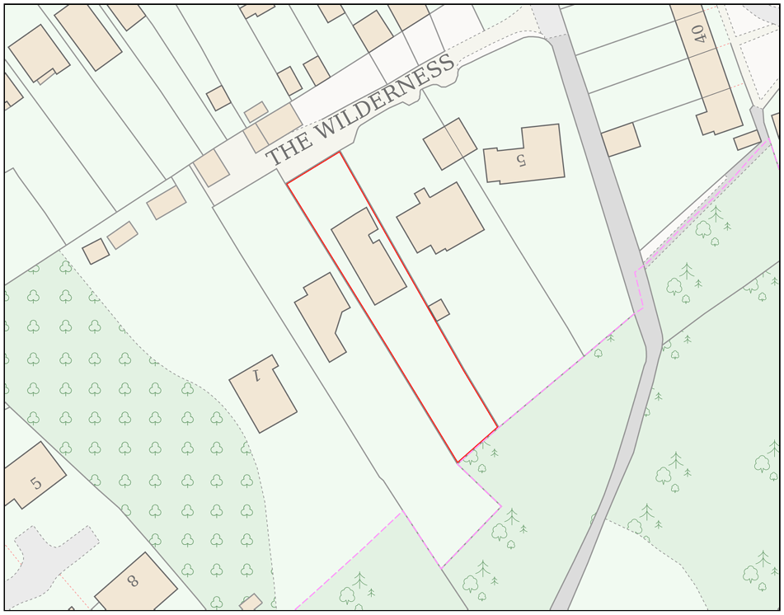

PROPOSAL

The proposal comprises a two‑storey rear extension and a series of internal and external alterations to an existing detached dwelling. The development would reconfigure the internal layout to alter the first floor from two to three bedrooms with an enlarged bathroom. At ground‑floor level, the rear extension would allow the existing living room, snug and sunroom to be combined into an open‑plan kitchen, dining and family area. The existing dining room would be converted into a formal living room, with an infill extension between the current bathroom and guest bedroom forming a new ensuite, alongside a new bay window to the new living room. The two‑storey rear extension would extend the existing building line, with eaves set at ground‑floor roof height and a pitched roof over the first floor to create a chalet‑style form. Additional works include dormer additions, fenestration upgrades, roof alterations, and modest improvements to the external appearance. Proposed external alterations include changes to the front roof form, vertical timber cladding, cream rendered finishes, side dormers, powder‑coated aluminium windows, and minor general enhancements.

SITE DESCRIPTION / CONTEXT

The site comprises a detached two‑storey dwelling located within a residential cul‑de‑sac of similar properties on a sloping hillside within the Bradford on Avon settlement boundary. The house is finished in Bath stone with white uPVC windows and a grey tiled roof formed of multiple intersecting pitched elements. To the rear, the property includes a modern ground‑floor extension with extensive glazing and a first‑floor balcony with rendered elevations. The dwelling benefits from a large rear garden backing onto established woodland, which forms a priority habitat and contributes to the verdant character of the area. The site lies within Flood Zone 1, has no identified surface water flood risk, and is subject to bat‑related ecological buffer designations.

PLANNING HISTORY

Reference No. | Proposal / Summary | Decision
W/94/00078/FUL | Extension and alterations | Approved

RELEVANT LEGILSATION, POLICIES AND GUIDANCE

Wiltshire Core Strategy:

Core Policy 1 Settlement Strategy;
Core Policy 2 Delivery Strategy;
Core Policy 7 Spatial Strategy: Bradford on Avon Community Area;
Core Policy 50 Biodiversity and Geodiversity;
Core Policy 51 Landscape;
Core Policy 57 Ensuring High-Quality Design and Place Shaping;
Core Policy 60 Sustainable Transport;
Core Policy 61 Transport and Development;
Core Policy 64 Demand Management;
Core Policy 67 Flood Risk;

Bradford on Avon Neighbourhood Plan 2013-2026

The National Planning Policy Framework (NPPF) and The Planning Practice Guidance (PPG)

Wiltshire Design Guide - Appendix D – Design Guidance for Householder extensions

The Wiltshire Local Transport Plan 2011 – 2026: Car Parking Strategy (March 2015).

The Wiltshire Local Transport Plan 4 (LTP4) (March 2025)

Emerging Policy – Wiltshire Local Plan Review

The examination of the emerging Wiltshire Local Plan has been paused and the weight to be afforded to any part of the emerging plan can be no more than very limited. A decision on how to proceed will be made by the Council in May 2026.

CONSULTATION RESPONSES

Bradford on Avon Town Council – No Objection

Local Highway Authority (Wiltshire Council) – No Objection

REPRESENTATIONS

Comments were received from two third‑party consultees. Bradford on Avon Preservation Trust confirmed that it had no comments to make on the application. A neighbouring property owner at No. 2 The Wilderness raised concerns relating to the scale and siting of the proposed rear extension, particularly its increased projection beyond the existing rear building line, and the perceived impact on daylight, outlook and openness when viewed from No. 2. Specific concerns were raised regarding potential overlooking from a first‑floor dormer window and loss of visible sky from internal areas, with suggestions including the introduction of a hipped or ‘bonnet hip’ roof form to reduce perceived bulk. It was suggested that the use of obscured glazing to the lower portion of a dormer window overlooking neighbouring habitable rooms should be considered, with a request that obscured glazing be specifically secured by condition to a height of 1.5m if permission is granted.

ASSESSMENT

Section 38(6) of the Planning and Compulsory Purchase Act 2004 states:

"If regard is to be had to the development plan for the purposes of any determination to be made under the planning Acts, the determination must be made in accordance with the plan unless material considerations indicate otherwise."

In accordance with this statutory requirement, this application has been assessed against the relevant policies of the Development Plan, including the adopted Wiltshire Core Strategy (2015) and, where applicable, any made Neighbourhood Plans.

Householder extensions are generally acceptable in principle, as they typically fall within the established residential curtilage of a property and do not result in new residential development in the open countryside. In this case, the proposal also lies within the defined limits of development set out in the Core Strategy, further reinforcing its acceptability in principle.

Design and Impact upon the upon the character and context of the area

Core Policy 57 Ensuring High Quality Design and Place Shaping of the Wiltshire Core Strategy requires all new development to achieve a high standard of design that responds positively to its local context. Proposals must reinforce and enhance local character and distinctiveness, relate appropriately to the surrounding landscape, and demonstrate a thoughtful response to existing townscape features. This includes careful consideration of elements such as building height, scale, massing, building line, materials, and overall appearance, ensuring new development integrates harmoniously with its setting.

The proposed two-storey rear extension follows the established form and proportions of the existing dwelling by aligning with the current roof ridge, eaves height and pitch, and extending the building footprint in a southerly direction to form a new gable. As such, it represents a logical continuation of the host building rather than a departure from its architectural language. The use of render to the rear elevation reflects existing materials already present on the dwelling, while the proposed fibre-cement slate roof covering would closely match the appearance of the existing roof. A limited section of timber cladding is introduced to frame the new large patio doors, providing a positive architectural accent that adds interest to the overall material palette without dominating the rear elevation.

Alterations to the front ground-floor bedroom, including the replacement of the existing dual-pitched roof with a flat roof, are considered reflective of the dwelling’s established design, given the presence of an existing flat roof element above the main entrance. Lowering this roofline to align with that feature reinforces visual consistency across the front elevation. The use of vertical timber cladding introduces texture and variety, helping to break up the massing and complement the surrounding context, where timber is prevalent on boundary treatments and ancillary structures and reflects the wooded character of the area. The proposed infill extension to the rear of this bedroom occupies an existing recessed area, would not be visible from public viewpoints, and would use matching masonry to integrate it fully into the host building. In addition, a new front-facing bay window is proposed to serve the reconfigured living room; this would have a minimal projection, utilise render and powder-coated aluminium fenestration consistent with the wider scheme, and is considered acceptable in design terms when assessed against the scale and proportions of the existing dwelling.

Wider material changes include the introduction of render to the front elevation and the replacement of existing windows and rainwater goods with powder‑coated aluminium. While aluminium fenestration departs from the existing uPVC, it is generally regarded as a higher‑quality, contemporary material and is acceptable given the enclosed nature of the site and its limited visibility from the wider public realm. The proposal also includes a green sedum roof to the new flat roof on the front elevation. While this feature does not reflect a consistent architectural treatment within the immediate area, it responds well to the notably verdant character of the site and its wooded surroundings and is considered a positive, ecologically supportive element within the overall design. The proposed side‑elevation dormers are modest in scale relative to the roof form and utilise dark grey cladding that closely relates to the roof covering, reducing their visual prominence. As the dwelling already contains a dormer element, the proposal represents a continuation of an established design feature and is acceptable in terms of scale, appearance and overall coherence.

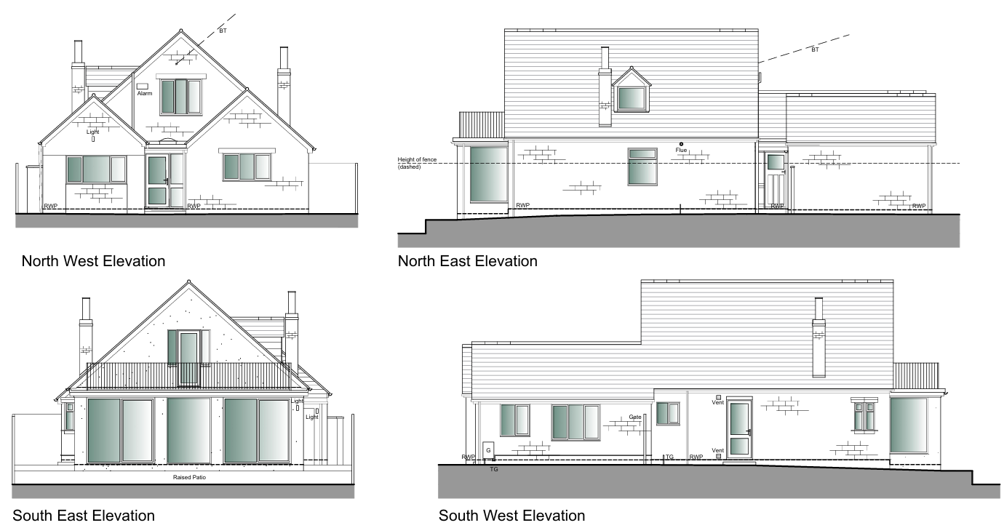
Exisiting Elevations

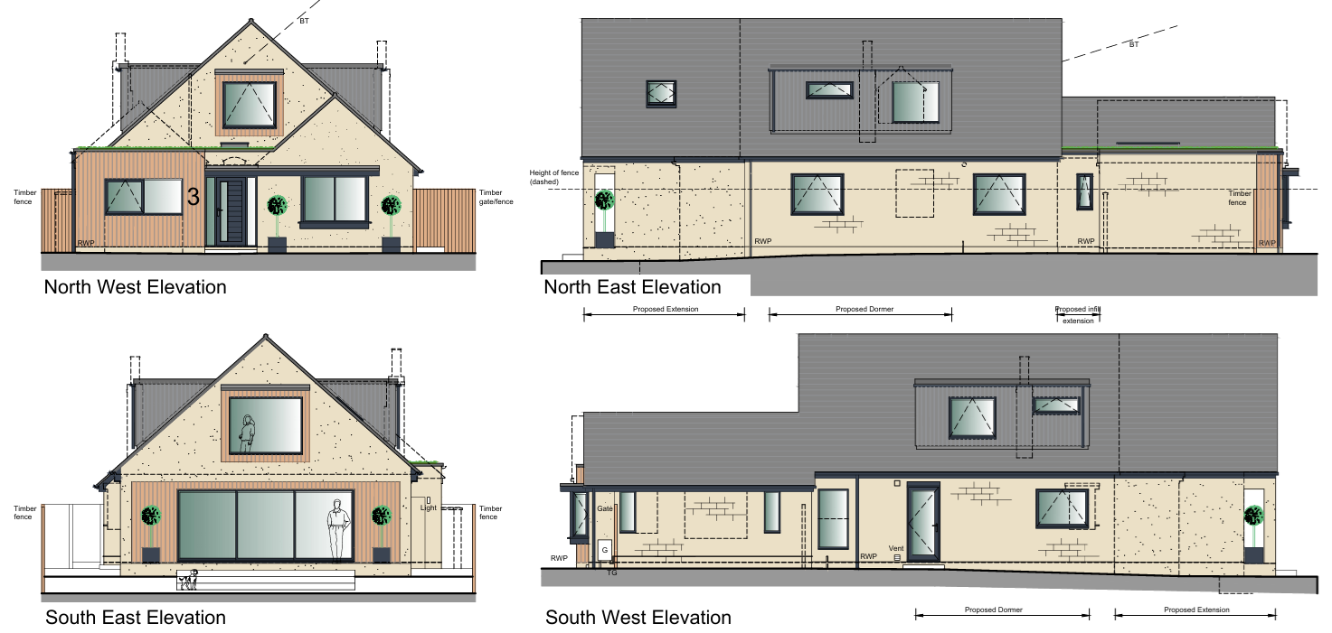
Proposed Elevations

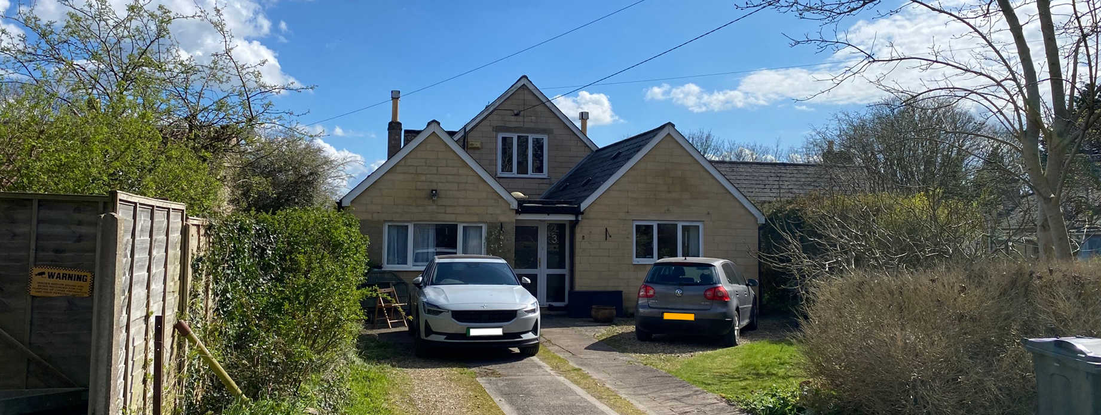
Site Visit (Front Elevation)

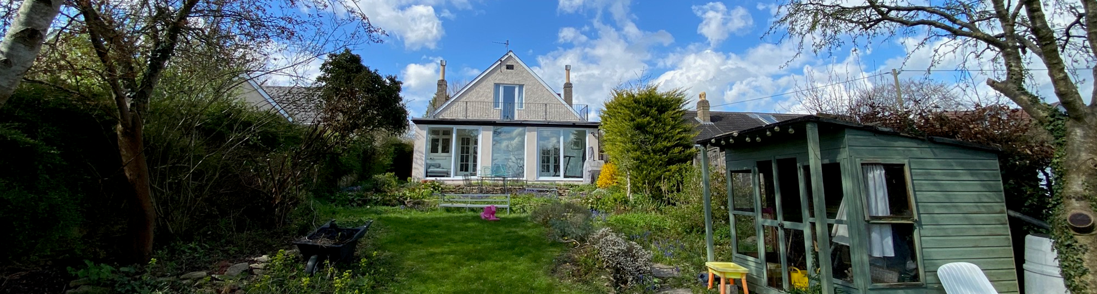
Site Visit (Rear Elevation)

Having regard to the above, the proposal complies with the design principles set out in Core Policy 57 of the Wiltshire Core Strategy and Appendix D of the Wiltshire Design Guide.

Amenity

Point vii of Core Policy 57 Ensuring High Quality Design and Place Shaping of the Wiltshire Core Strategy seeks to ensure that developments do not adversely affect neighbouring properties.

The National Planning Policy Framework (NPPF), particularly Paragraph 135, stresses that planning decisions should ensure developments provide a high standard of amenity for existing and future users.

Concerns were raised by a neighbouring occupier regarding the potential overbearing impact, bulk and loss of natural light arising from the scale of the proposed rear extension. The development would represent a continuation of the existing rear eaves line, extending outwards by approximately 2.8 m, with the ridge extending by around 4.5 m. While this would introduce additional built form where none currently exists adjacent to the courtyard area of No. 2 The Wilderness, the eaves height would remain unchanged over the additional depth, limiting the sense of enclosure at lower levels. It is acknowledged that the extension would be perceptible from this outlook and could be experienced as having some enclosing effect when compared to the existing arrangement. However, the height of the proposed eaves sits only marginally above the existing boundary treatments, and the majority of the additional perceived bulk would be contained within the roof form, which slopes away from the shared boundary at approximately 45 degrees. As a result, the scale and visual presence of the extension diminishes as it moves away from the neighbouring property, reducing its overall overbearing impact.

In terms of natural light, the site is arranged on a broadly north–south axis with a slight incline toward the north-west, and No. 2 The Wilderness is positioned set back from the rear building line of the application property. Updated 3D shadow modelling has been undertaken for 31 May and 22 December to assess potential overshadowing at different times of year. This analysis indicates that there would be limited additional overshadowing compared with the existing situation, occurring primarily during the beginning, and final hours of the day, with an estimated difference of approximately one hour at most. While this demonstrates that some additional shadowing would occur, it would be short-lived, seasonal and not of sufficient duration or severity to result in a materially harmful loss of daylight. When considered alongside the roof form and orientation of the extension, the development is therefore not considered to give rise to an unacceptable level of overbearing impact, bulk or loss of natural light, and is acceptable in amenity terms.

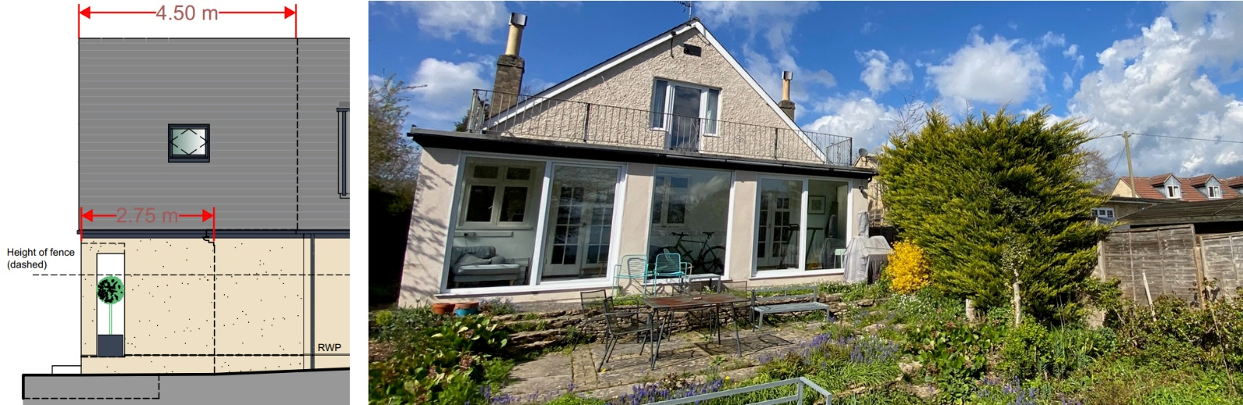
Proposed Elevations and Exisiting Rear Elevation

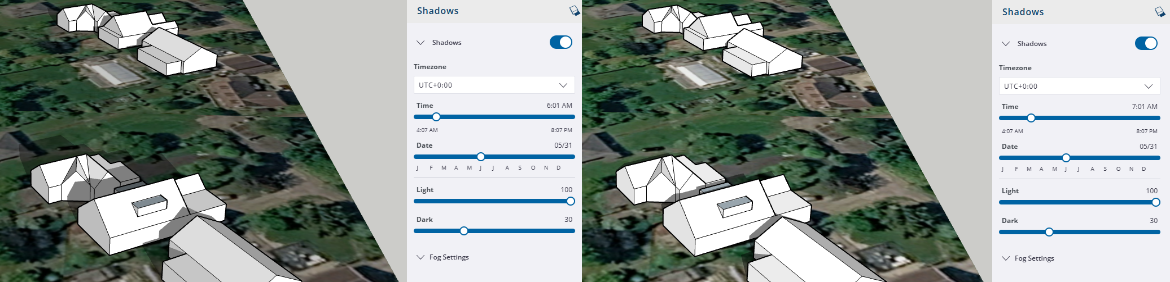
31st May (6am and 7am)

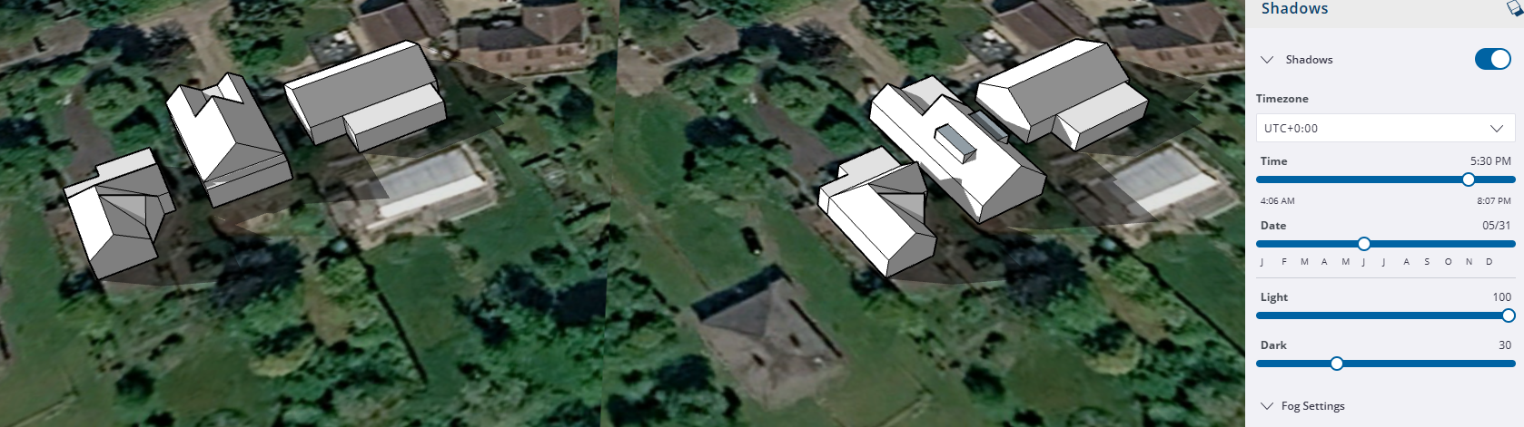
31st May (5:30pm)
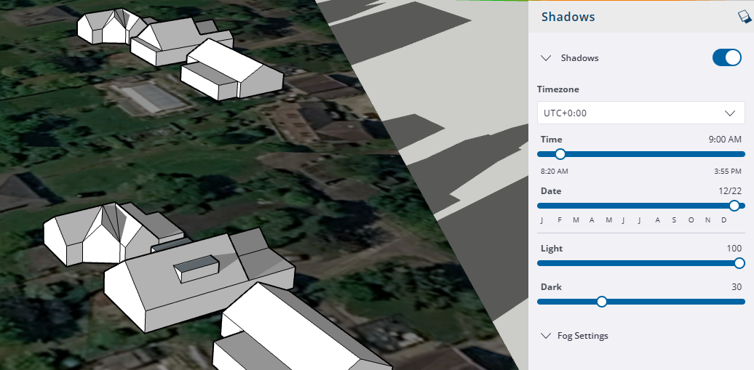
22nd December (9am)
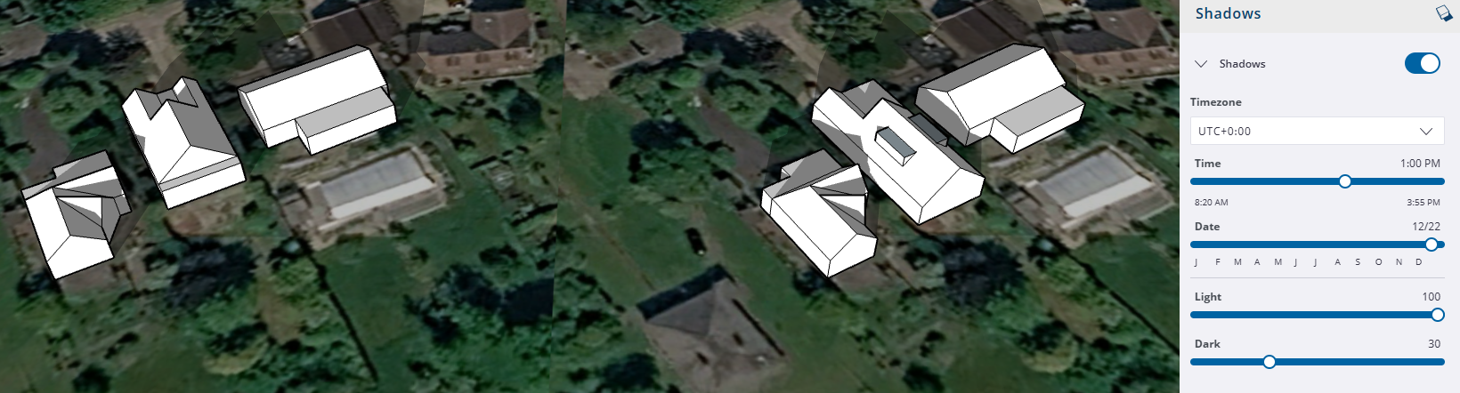
22nd December (1pm)

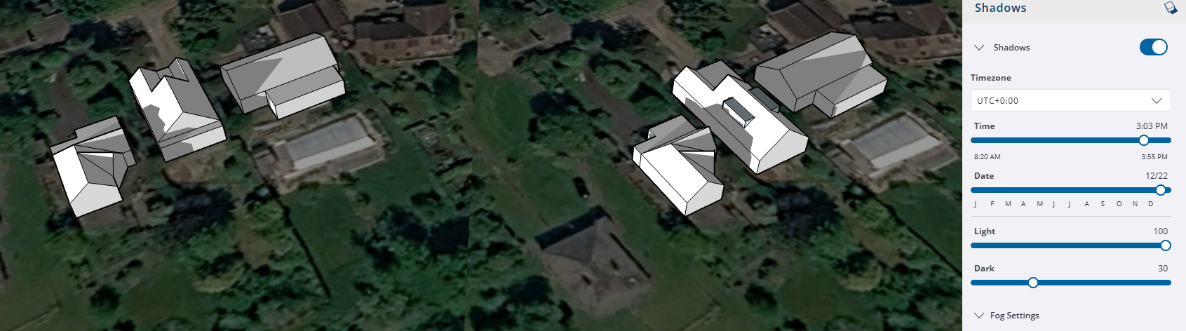
22nd December (3pm)

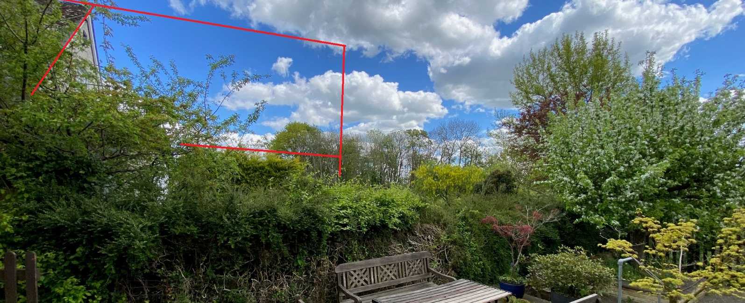
Rough indication of scale from No2

With regard to overlooking and privacy, it is noted that the majority of the proposed development would not materially alter the existing relationship between the application property and neighbouring dwellings. Notably, the proposal incorporates the removal of the existing first-floor balcony at the rear by enclosing it within the two-storey extension, which represents a clear betterment in privacy terms when compared to the current situation. The southward extension of the rear elevation also relocates the southern gable and associated window further away from neighbouring properties, reducing the angle of view and effectively eliminating any direct overlooking of neighbouring patio areas. The principal privacy concern, as identified by neighbouring representations, relates to the proposed side-elevation dormer windows at first-floor level. The north-east-facing dormer would serve a bathroom and stairwell and replaces an existing dormer, meaning some degree of overlooking is already present, although it is acknowledged that the increased size of the dormer and glazing could heighten the perception of overlooking. The south-west-facing dormer would serve a bedroom and, given the approximately 4 m separation distance between dwellings, introduces potential for direct views toward the neighbouring property. While the submitted block plan demonstrates that the larger glazed elements are positioned toward the northern end of the dormer and align more closely with the neighbouring property’s side elevation—thereby reducing the extent of overlooking—it is considered appropriate to secure obscured glazing to the relevant dormer windows by condition. This would allow for the continued provision of natural light whilst preventing harmful overlooking and safeguarding neighbouring privacy.

Subject to the aforementioned condition, the proposal is appropriately sited, designed, and oriented to ensure that it would not result in unacceptable impact upon/to the amenities or living conditions of neighbouring residential occupiers, particularly in terms of outlook, privacy, or access to natural light.

The proposal therefore accords with Core Policy 57 point vii in respect of safeguarding residential amenity and Appendix D of the Wiltshire Design Guide.

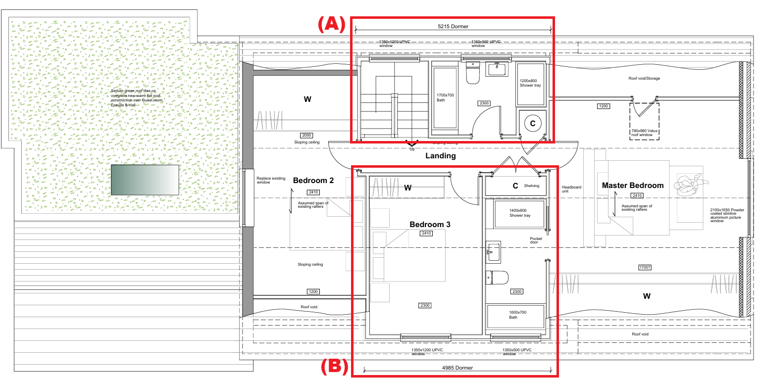
Proposed First Floor Plan – (A) Northeast Facing Dormer; (B) Southwest Facing Dormer

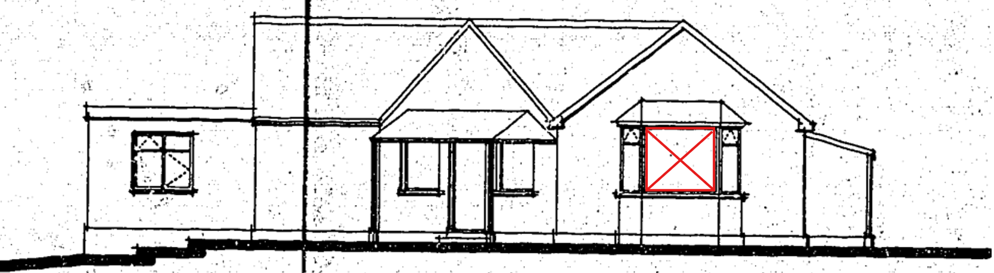
Side Elevation of No2 (Red - east facing window)

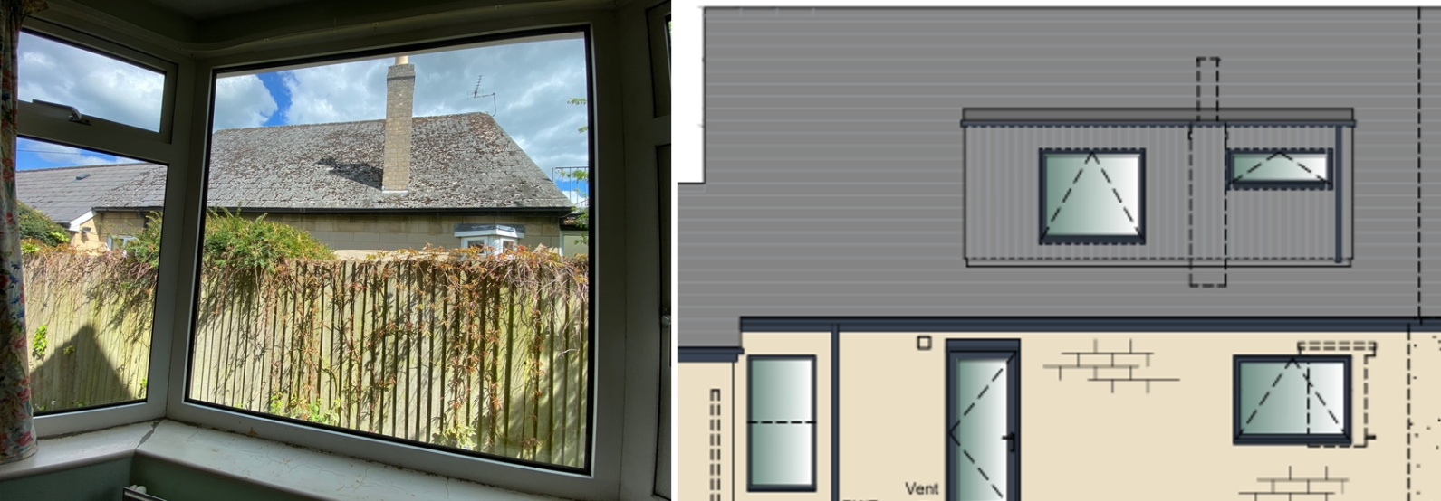
Image from east facing window of No2 and Proposed Elevation (Showing dormer)

Transport and Highways

The Wiltshire Core Strategy, through Core Policy 64, requires development proposals to comply with adopted minimum parking standards. This requirement is supported by the Wiltshire Local Transport Plan, including Policy PS6, which states that residential development should take account of dwelling size and the associated parking demand. The adopted Car Parking Strategy indicates that a minimum of three off-street parking spaces is required for a four-bedroom dwelling. While the proposal would increase the size of the dwelling from three to four bedrooms, the existing front parking area is of sufficient size to accommodate the required level of parking without alteration. In addition, the proposal includes no changes to the existing access or egress arrangements. On this basis, the development is considered to comply with relevant parking and highway policies and is acceptable in transport and parking terms.

Ecology

The Wiltshire Core Strategy, through Core Policy 50, requires development proposals to avoid, mitigate and, where possible, enhance impacts on biodiversity and protected habitats. Biodiversity Net Gain (BNG) is now a mandatory consideration in planning through Schedule 7A of the Town and Country Planning Act 1990 (as amended by the Environment Act 2021); however, householder applications are exempt from this requirement under Schedule 7A, Section 4(2)(a). Notwithstanding this exemption, the application site lies within designated bat consultation buffer zones associated with nearby European sites, and the proposal includes works to the existing roof structure. As such, it is appropriate that an informative is attached reminding the applicant of their obligations under the Wildlife and Countryside Act 1981, in the event that protected species are discovered during construction, including the requirement to cease works immediately and seek appropriate ecological advice should bats or evidence of roosting be encountered.

The proposal relates to a residential property and would result in only a modest increase to the built footprint, largely extending into areas of existing hardstanding and domestic garden. No works are proposed within the adjacent woodland priority habitat, and there would be no removal of established vegetation of ecological value. Given the limited scale of development, its containment within the existing residential curtilage, and the nature of the areas affected, the likelihood of harm to protected species or habitats is considered low. Subject to the inclusion of an appropriate ecological informative, the proposal is therefore acceptable in ecological terms and complies with Core Policy 50.

Flooding and Drainage

Core Policy 67 (Flood Risk) of the Wiltshire Core Strategy requires development to be located, designed and constructed so as to minimise vulnerability to flooding and avoid increasing flood risk elsewhere. In this instance, the proposal relates to a householder development and would result in only a minimal increase in impermeable surface area within the existing residential curtilage. The site is located within Flood Zone 1, and the Strategic Flood Risk Assessment (sFRA) identifies no risk from fluvial, ground or surface water flooding. Given the small scale of the development, the low-risk residential nature of the use, and the absence of any identified flood risk constraints, the proposal is not considered to give rise to adverse flood risk or drainage impacts. As such, the development is acceptable in flood risk and drainage terms and complies with Core Policy 67.

CONCLUSION

The proposal is considered to be acceptable and in accordance with the relevant policies and guidance outlined above.

RECOMMENDATION: That Planning Permission be GRANTED subject to the following conditions:

1.
The development hereby permitted shall be begun before the expiration of three years from the date of this permission.
REASON: To comply with the provisions of Section 91 of the Town and Country Planning Act 1990 as amended by the Planning and Compulsory Purchase Act 2004.

2.
The development hereby permitted shall be carried out in accordance with the following approved plans and documents:

Proposed First Floor Plans (3 March 2026)
Proposed Ground Floor Plans (3 March 2026)
Proposed Elevations (3 March 2026)
Location Plan (25 February 2026)
Proposed Block Plan (25 February 2026)

REASON: For the avoidance of doubt and in the interests of proper planning.

3.
Prior to the first occupation of the development hereby permitted, the dormer windows in the north‑east and south‑west elevations shall be fitted with obscure glazing to a minimum height of 1.5 metres above internal finished floor level, to an obscurity level of no less than Pilkington Level 4. The obscure glazing shall be retained as such thereafter in perpetuity, and the affected windows shall be non‑opening below 1.7 metres above finished floor level.

REASON: To safeguard the residential amenity and privacy of neighbouring occupiers, in accordance with Core Policy 57 of the Wiltshire Core Strategy and the National Planning Policy Framework.

