APPLICATION FOR FULL-PLANNING PERMISSION
CASE OFFICER REPORT

APPLICATION REFERENCE: | PL/2026/01388
APPLICATION TYPE: | Full planning permission
SITE ADDRESS: | 1 Kingsdown Grove, Kingsdown, Corsham, SN13 8BN
DEVELOPMENT DESCRIPTION: | Opening up ground floor kitchen, forming first floor bathroom extension and new windows.
RECOMMENDATION: | Approve with Conditions

SITE DESCRIPTION/CONTEXT
The subject property is a mid/late C20 detached dwelling built of stone blockwork under a pantiled roof. The dwelling is built into the hill, negotiating the tricky topography of the area and so can be described as three stories or two-stories and cellar.

The site is on a modern cul de sac; Kingsdown Grove, set back form the highway that runs between Bathford and Box.

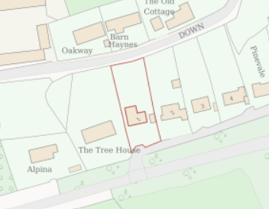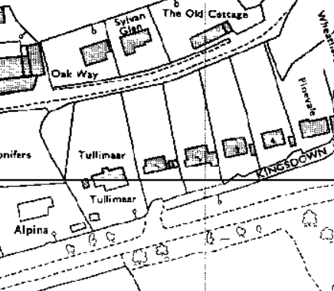
Location Plan and 5th (post 1952) epoch mapping

The subject property is within North Wiltshire Green Belt, the Cotswolds National Landscape (formerly AONB), and buffer zones of various bat roosts but outside of any statutory protected areas.

PROPOSAL

The proposal is for:
- Ground floor side extension rebuilt to enlarge the kitchen
- First floor extension to enlarge the bathroom
- Internal reconfiguration namely to knock through to both extensions
- New windows

Proposed materials include zinc cladding over a timber frame, against the existing recon stone blockwork, matching pantiles roof to match and uPVC windows to replace existing metal framed windows and timber doors.

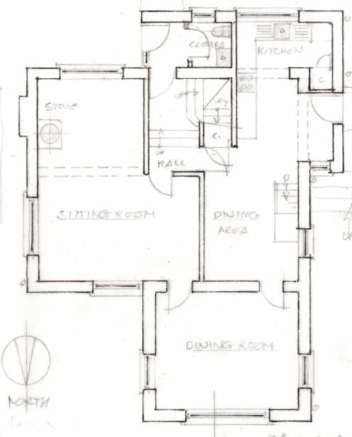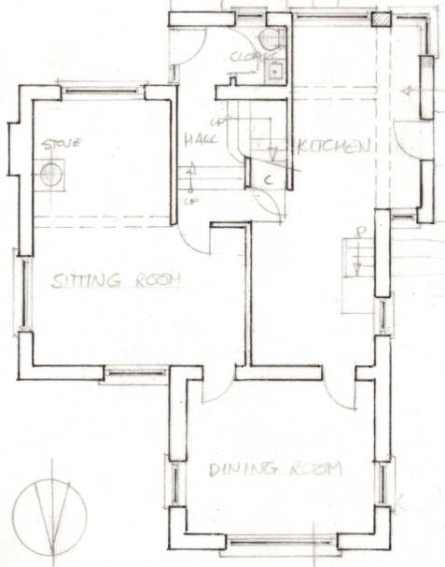

Existing Ground Floor Plan

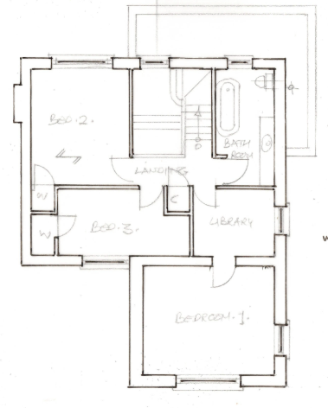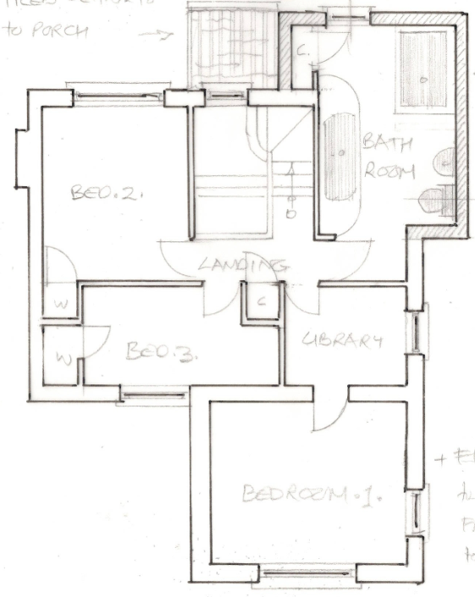

Existing First Floor Plan

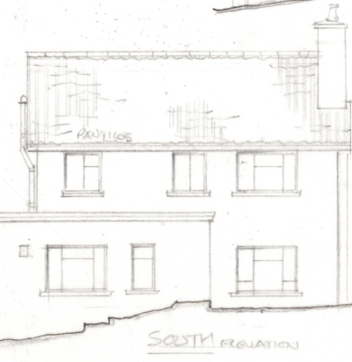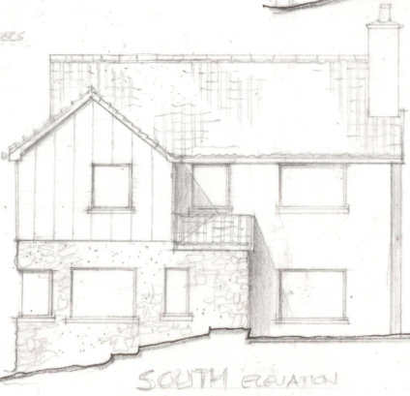

Existing and Proposed South Elevation

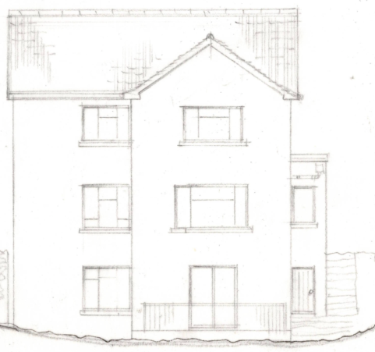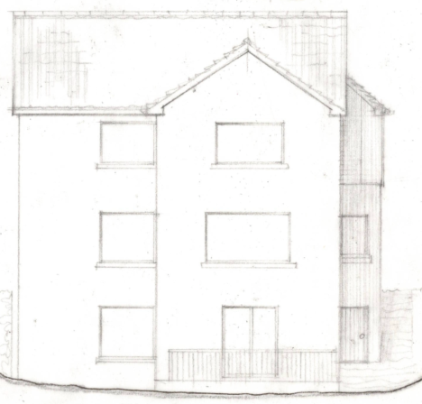

Existing and Proposed North Elevation

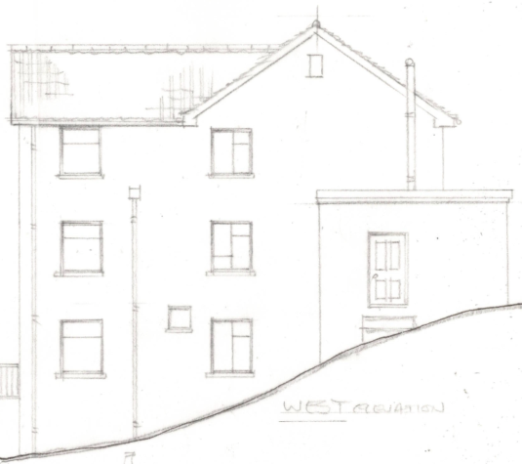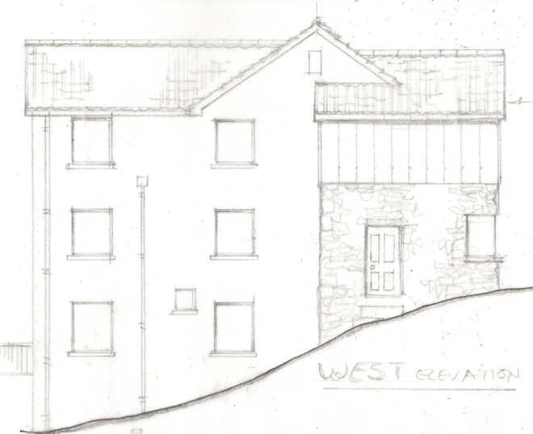

Existing and Proposed West Elevation

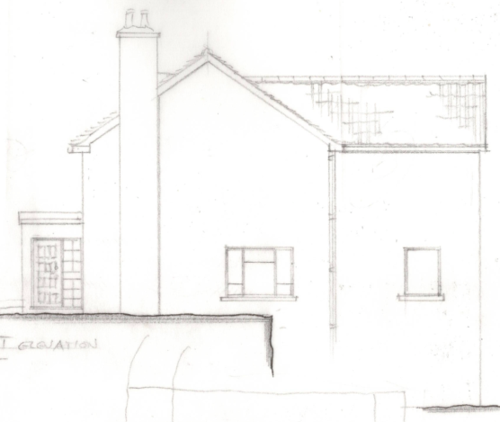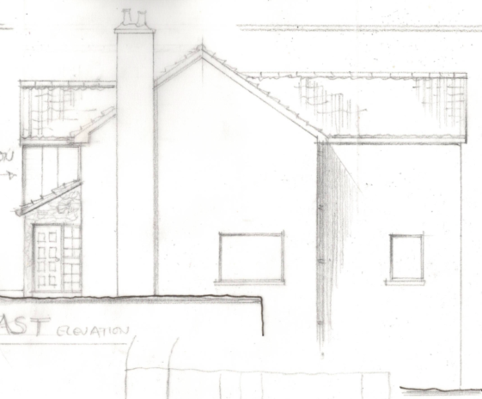

Existing and Proposed East Elevation

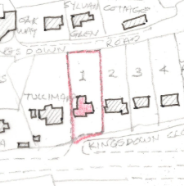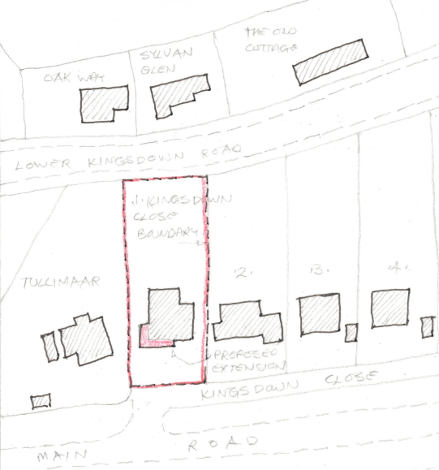
Existing and Proposed Site Plan

PLANNING HISTORY

None.

18/08833/FUL - Full planning permission Decision - Approve with Conditions Date: 28/11/2018 – Single storey side extension & 2no. dormer windows to replace previously unbuilt permitted extension, together with reconfigured external deck, fenestration changes, garden office, storage shed, revised parking and landscaping – The Tree House to west.
N/03/03038/FUL - Full planning permission Decision - Approve with Conditions Date: 22/12/2003 – THREE PITCHED ROOF DORMER WINDOWS – Tree House, previously known as Tullimaar.
N/09/00240/FUL - Full planning permission Decision - Approve with Conditions Date: 8/4/2009 – Extensions to Side and Rear Elevation and Raised Decked Terrace Site visit 10:30 27 January 2010 – Tullimaar.

RELEVANT LEGISLATION, POLICIES AND GUIDANCE

Statutory Legislation:

National Planning Policy:
- National Planning Policy Framework (NPPF)
- Planning Practice Guidance (PPG)
- National Design Guide
Development Plan:
The development plan for Wiltshire comprises the Wiltshire Core Strategy (WCS) (adopted January 2015) and any made neighbourhood plans, which remains the principal statutory planning document guiding development across the county. In line with Section 38(6) of the Planning and Compulsory Purchase Act 2004, planning decisions must be made in accordance with the development plan unless material considerations indicate otherwise.

Though the development plan is considered as a whole, those parts deemed to be particularly relevant to this application are listed below:

The adopted Wiltshire Core Strategy (WCS), with particular regard to:
- Core Policy 41 Sustainable Construction and Low-Carbon Energy;
- Core Policy 51 Landscape
- Core Policy 57 Ensuring High Quality Design and Place Shaping;

Box has a designated Neighbourhood Plan area but no made plans as yet.
Cotswold National Landscape Management Plan, 2018-2023.

Supplementary Planning Documents and other Guidance:
- Wiltshire Design Guide (adopted April 2024)
- Wiltshire Local Transport Plan 2011-2026, adopted 2015 - including the Car Parking Strategy and Cycling Strategy, adopted 2015

ISSUES
The main issues that need to be addressed in this case include:
- Whether the scheme constitutes high quality design (CP 57)
- Whether the scheme would have an acceptable impact upon the reasonable living conditions of the adjoining occupants (CP 57)
- Whether the scheme would have an acceptable landscape impact (CP 51)
- Whether the scheme would have an acceptable impact upon the Green Belt (NPPF Chapter 13)
- What planning obligations are required to make the development acceptable in planning terms?

CONSULTATION RESPONSES
Box Parish Council: No objection.

REPRESENTATIONS
No comments received.

ASSESSMENT

Principle of Development and Impact on the Openness of the Green Belt and Impact on Special Landscape Character:
The primary considerations are the impact of the proposals on the landscape;
- if it would be inappropriate development in the Green Belt,
- the impact on the openness and purposes of the Green Belt, and
- the effect on the landscape and scenic beauty of the Cotswold National Landscape.
The NPPF, paragraph 153, is clear in asserting that inappropriate development is ‘harmful to the Green Belt and should not be approved except in very special circumstances’.

Paragraph 142 states that “the fundamental aim of Green Belt Policy is to prevent urban sprawl by keeping land permanently open; the essential characteristics of Green Belts are their openness and their permanence.”

CP51 of the WCS, states that ‘development should protect, conserve and where possible enhance landscape character and must not have a harmful impact upon landscape character …’ including the ‘special qualities of National Landscapes, where great weight will be afforded to conserving and enhancing landscapes and scenic beauty.’

The National Planning Policy Framework (NPPF), in Paragraph 189, states that “great weight” should be given to conserving and enhancing landscape and scenic beauty in National Landscapes (formerly Areas of Outstanding Natural Beauty). Development within or affecting the setting of a National Landscape must demonstrate that it will not result in unacceptable harm to the special qualities of that area.
In considering applications where new development is proposed to an existing building within the Green Belt, the following two criteria must be met:
1. Would the proposed development comprise a disproportionate addition to the original building as it was when erected, or since 1st July 1948? and/or,
2. Would there be any material harmful impact on the openness of the Green Belt?

The NPPF does not, elaborate on the definition of ‘disproportionate’ addition nor does it quantify what would represent a disproportionate addition. In light of the above and in accordance with well-established planning practices, each case must be assessed on its own individual merits.

The proposal does not seek urban sprawl or further encroach on the countryside but is an alteration to an existing residential dwelling.

There is no proposed alteration of the 105m² ground floor plan, but an approx. 12m² increase at first floor level. This is clearly not a disproportionate addition but a considered reworking of existing volume, finding opportunities to improve the layout for modern living with minimal intervention to the original dwelling.

The proposal site is within a wedge of late C20 development, south/west of historic Kingswood, and as such the proposal is considered acceptable due to its minor scale and invisibility to the wider landscape within this built cluster.

The proposal, by virtue of its scale, siting, and design, would not harm the special qualities or scenic character of the Cotswolds National Landscape.

The development therefore complies with Core Policy 51 of the Wiltshire Core Strategy and Paragraph 189 of the NPPF in conserving and enhancing the National Landscape.

Design and Impact on the Character and Appearance of the Area
Policy Context
Core Policy 57 of the WCS requires high-quality design that:
- Enhances local character.
- Responds to the natural, historic, and built environment.
- Retains important features (e.g., trees, hedges).
- Supports sustainable construction and compatibility with surrounding uses.
- Creates safe, legible, and accessible spaces.

Section 12 of the NPPF emphasises design that is:
- Visually attractive.
- Functionally effective.
- Contributes to the quality of the built environment.

The Wiltshire Design Guide encourages sensitivity to local character, materials, and architectural styles and supports modern living standards while maintaining aesthetic and functional quality.

The proposed development is small in scale, with a moderate increase of first floor footprint only.

The extension would amalgamate a single storey flat roof extension that, according to historic 5th epoch mapping, is not original, and also appears incongruous. The proposal utilises roof forms and pitches to harmonise with the existing.

Proposed roofing would match existing, with the proposed introduction of zinc cladding, enabling legibility, and a high contrast to the existing stonework, seeking to make the extension recede and blend into the surroundings.

It is unfortunate to introduce uPVC windows, but given how ubiquitous it is on the street, it is reasonable and provides an upgrade to existing metal windows.

The proposal, by virtue of its scale, design, and use of materials, is considered to preserve the character and appearance of the area.

The development is therefore considered to comply with Core Policy 57 of the Wiltshire Core Strategy, as well as the relevant provisions of the NPPF.

Amenity
Policy Context
Core Policy 57 (Point vii) of the Wiltshire Core Strategy requires development to respect the amenity of existing occupants and ensure appropriate amenity levels for future residents.

The National Planning Policy Framework (NPPF), particularly Paragraph 135, reinforces the need for development to provide a high standard of amenity for both existing and future users.

These policies guide the assessment of amenity impacts, which will be considered below:

Given the spatial gap between the subject dwelling and immediate neighbours The Tree House to the west, and scale of development, there is no concern with overbearing or overshadowing.

The proposal includes a new corner window wrapping around the south and west elevations. At ground floor level, even with the cellar below, any impact to neighbouring privacy caused by this additional window, is easily negotiated by standard boundary treatments.

The window to the proposed extended bathroom, would provide a new vantage point, set 1.7m further forward than the existing, but continuing to face down the front garden/drive, so is not assessed to cause harm to neighbouring amenity.

The proposal therefore accords with Core Policy 57 point vii in respect of safeguarding residential amenity and Appendix D of the Wiltshire Design Guide.

CONCLUSION
The proposed development is considered to be acceptable in terms of its design, scale, and relationship with the surrounding area. It would not result in any unacceptable harm to the character of the locality, or the amenities of neighbouring occupiers.

The proposal is therefore considered to comply with the relevant policies of the Wiltshire Core Strategy, the Wiltshire Local Plan, and the National Planning Policy Framework. As such, the application is recommended for approval, subject to conditions.

RECOMMENDATION: That Planning Permission be GRANTED subject to conditions.

