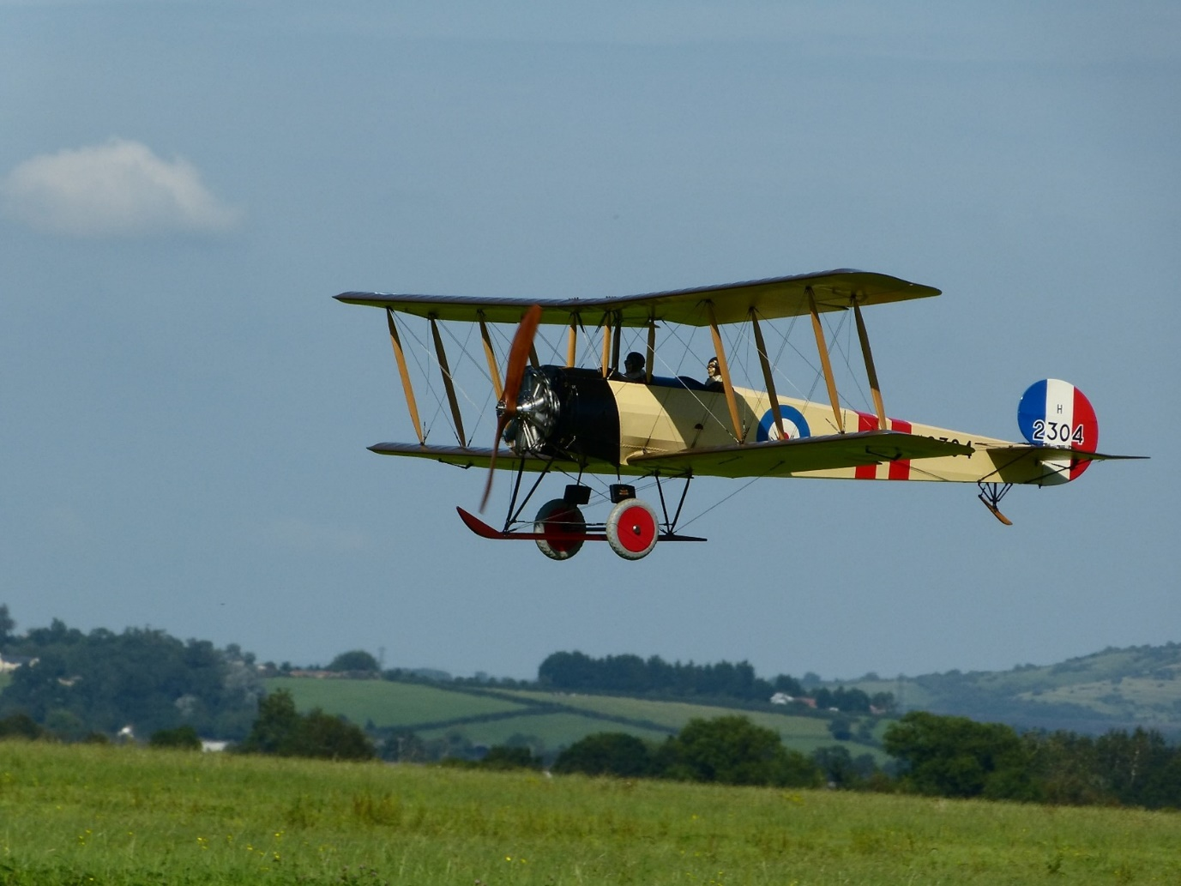

Wessex Model Flying Club
Byde Mill Lane, Poulshot

Planning Statement
To support
The erection of a Field Shelter at the flying field

Wessex Model Flying Club has been flying at the above site since 2017 and was retrospectively granted Full Planning Permission for flying radio controlled model planes on 20th October 2020 (Application reference 20/06487FUL)

The club consists of approx. 60 members whose ages range from 11 to 89. The average age is in excess of 65.
Due to the nature of the hobby, it is weather dependant.
Recent summers have become increasingly hot and concern has been expressed by members, particularly the older ones, that there is no shade from the sun and this determines the length of time they feel they should be exposed to the sun’s rays. Risk of skin cancer needs to be eliminated. This application is for the club to gain approval to erect a Field Shelter to provide this shading.
It will be a typical shelter used for livestock but it will not be moveable and the corner posts will be set into the ground.
It will be of timber construction with a steel roof. The structural timber will be C24 grade. The structural timbers and feather edge cladding will all be tanalised and of a brown colour. The roof sheets will be green coloured.
Width will be 4.5 metres across the corner posts and 2.8 metres from front to back. There will be no services.
There will be no floor only the natural ground.
It will be located in the area known as the “pits” where the models are prepared for flight. There is an existing row of short timber posts approx.. 450mm high set into the ground to prevent cars from accessing the pits area. It is proposed to install the shelter adjacent to these posts and just inside the pits area.
The club is very keen that this shelter should be approved as it will enable to members to continue to take the benefit of this hobby without any associated risks from the sun.

Wessex Model Flying Club
April 2026

