APPLICATION FOR ANNEXED ACCOMODATION
DELEGATED REPORT

APPLICATION REFERENCE: | PL/2026/01297
APPLICATION TYPE: | Householder planning permission
SITE ADDRESS: | Whitehill Farmhouse, White Hill, Pitton, Salisbury, SP5 1DY
DEVELOPMENT DESCRIPTION: | Change of use of outbuilding to residential annex (retrospective)
RECOMMENDATION: | That Planning Permission be GRANTED

PROPOSAL

The proposal seeks retrospective planning permission for the conversion of an existing outbuilding to a residential annexe for ancillary and occasional use in association with Whitehill Farmhouse.

The outbuilding was constructed as part of S/2010/1707 to provide garage, garden store and games room with WC. The provision of sleeping accommodation and kitchen facilities have been introduced, this has therefore triggered the need for planning permission as this use goes beyond the scope of the previous permission granted for the outbuilding.

Location and site plan

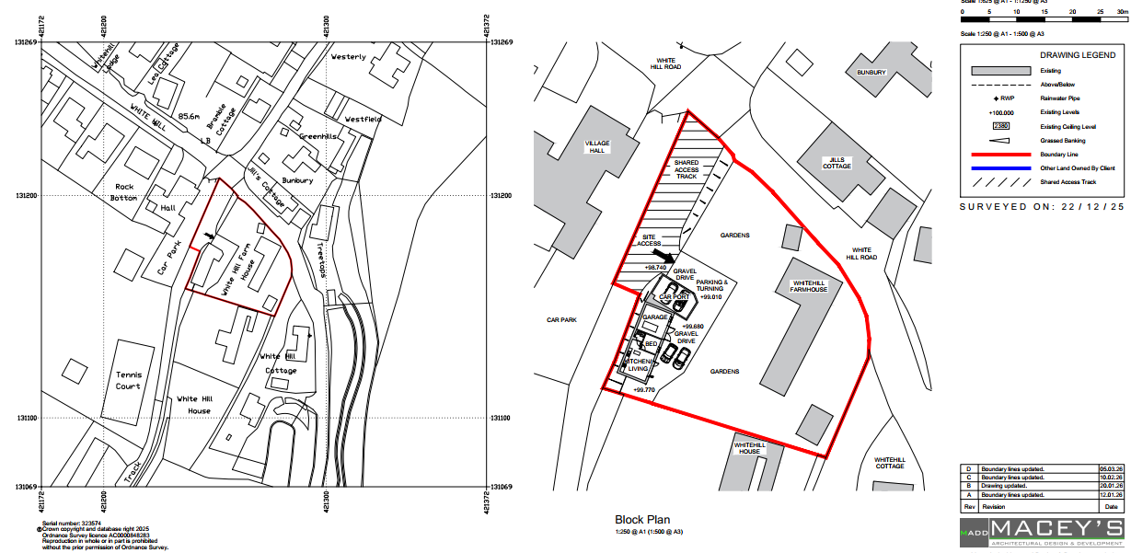

Elevations

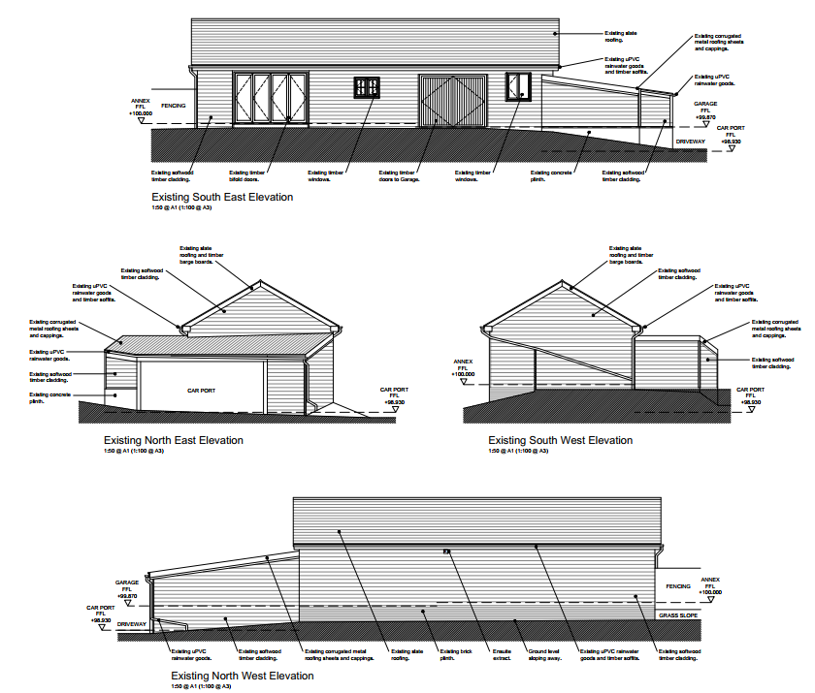

Plan

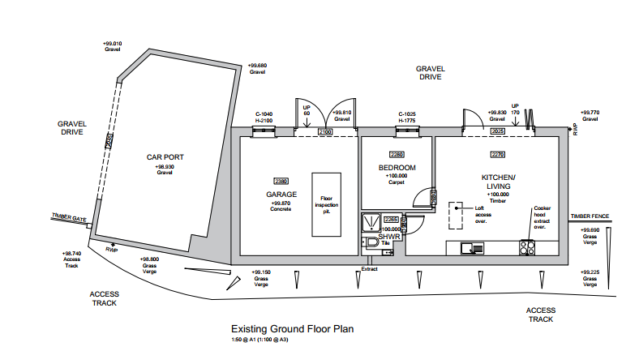

SITE DESCRIPTION/CONTEXT
The application relates to Whitehill Farmhouse, a detached house located on a corner plot, within the large village of Pitton, as defined by Wiltshire Core Strategy (WCS) core policies 1 (Settlement Strategy), 2 (Delivery Strategy) and 23 (Spatial Strategy for the Southern Wiltshire Community Area).

Map showing site, PRoW (purple) and listed buildings (hatched)
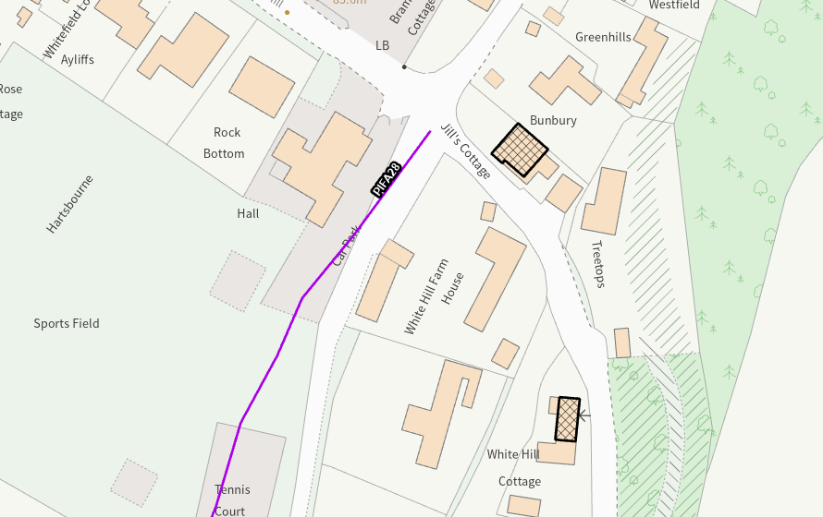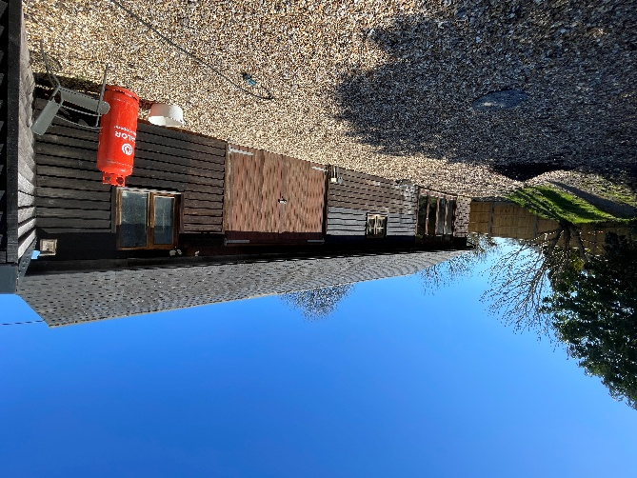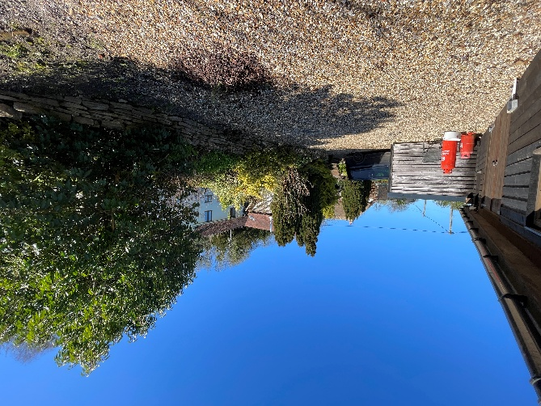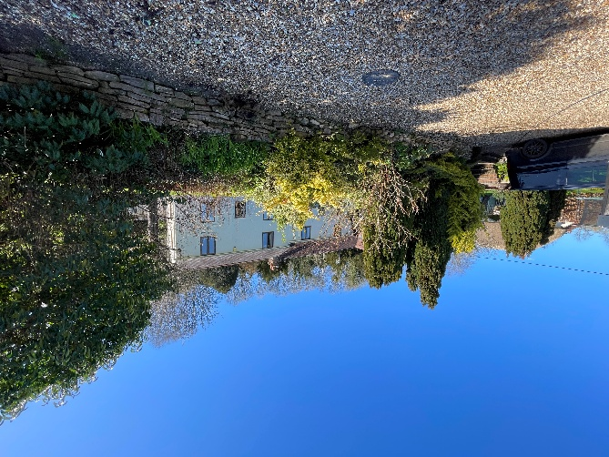

The site is outside of the Pitton Conservation Area, Grade II listed ‘Netherhill Patch’ lies to the north of the site and Grade II listed ‘White Hill Cottage’ lies to the east. The village hall and sports field are to the north of the site and there are residential neighbours to the south. Public Right of Way PIFA28 runs north to south along the west site boundary.

The site is within the New Forest Special Area of Conservation (SAC), River Test Special Area of Conservation (SAC) and Salisbury Plain and West Wiltshire Downs countryside character area. The site is in flood zone 1.

PLANNING HISTORY

Proposal / Summary
S/2001/0167 - Full planning permission Decision - Approve with Conditions Date: 14/3/2001 – EXTENSION TO PROVIDE ADDITIONAL ROOMS IN TWO STOREY TIMBER FRAMED BUILDING AND LANDSCAPING/EARTH WORKS TO GARDEN
S/1993/0360 - Full planning permission Decision - Approve with Conditions Date: 3/6/1993 – TEMPORARY SITING OF MOBILE HOME
S/2010/1707 - Full planning permission Decision - Approve with Conditions Date: 29/12/2010 – Demolish existing four bay open barn, retain existing carport, construct replacement building to provide garage, garden store and games room
S/2002/1387 - Full planning permission Decision - Approved Date: 21/8/2002 – GROUND FLOOR REAR HALL AND TOILET
S/1984/1161 - Full planning permission Decision - Approved Date: 17/10/1984 – O/L APPLICATION - ERECTION OF SINGLE DWELLING

RELEVANT POLICIES AND GUIDANCE

Wiltshire Core Strategy:

- Core Policy 1: Settlement Strategy
- Core Policy 2: Delivery Strategy
- Core Policy 57: Ensuring High Quality Design and Place Shaping
- Core Policy 50: Biodiversity and Geodiversity
- Core Policy 51: Landscape
- Core Policy 58: Ensuring the Conservation of the Historic Environment
- Core Policy 61: Transport and New Development
- Core Policy 64: Demand Management

Wiltshire Design Guide

The National Planning Policy Framework (NPPF)

The Planning Practice Guidance

National Design Guide

CONSULTATION RESPONSES

Parish/Town Council: Object

Pitton and Farley Parish Council is concerned that the property is being overdeveloped, and that the proposed residential annexe, with no mention of permanent occupation by relatives, may be utilised as holiday accommodation.
There are also concerns regarding parking of two vehicles. It is the opinion of the council that there is insufficient space to maneuver vehicles in and out of the premises, onto a private access (which is also a public footpath), let alone park two cars side by side, which would then result in parking elsewhere within the village - already struggling with parking on the roads.
The PC has concerns regarding Health & Safety; with plans being revised from the original recreational/games room to residential; adding a kitchenette and separate bedroom. The PC seek assurance that considerations have been made regarding building control/mitigation measures for fire/fumes etc., given the loft void and proximity of both garage and car port within the building area itself.

Highways Officer: No Objection – subject to condition
I refer to the above planning application for change of use of outbuilding to residential annex (retrospective).
The site benefits from adequate off street parking for the main dwelling and the annexe and the existing vehicle access is not proposed to be altered.
I raise no highway objection providing the following condition is imposed:
The building hereby permitted shall not be occupied at any time other than for purposes ancillary to the residential use of the dwelling known as Whitehill Farmhouse.
REASON: The additional accommodation is sited in a position where the Local Planning Authority, having regard to the reasonable standards of residential amenity, access, and planning policies pertaining to the area, would not permit a wholly separate dwelling.

REPRESENTATIONS
One joint representation was received from two as follows:

The following comments are jointly made by William and Lydia Judd of Coldharbour Cottages and Matthew and Julia Judd of Hide Cottage.
Whilst we have no objection to the planning proposal in principle, we do have concerns over the parking facilities proposed. The access track marked ‘shared access’ on the plans is owned solely by my brother, William, and me, being part of Coldharbour Farm which is jointly owned by us. Whitehill Farmhouse has historically been granted a right of way only over the track from Whitehill to their property with no provision for parking.
The track is used not only for our two residential properties but it is also the access to our farmyard and as such we require unimpeded access for farm traffic at all times.
We note that the applicant has answered ‘No’ to the question ‘Will the proposed works affect existing car parking arrangements?’
We feel that existing parking arrangements are inadequate for the property as it is now, with only two cars in the household and visitors regularly parking on the track and obstructing our access. When family have stayed in the annexe they have either parked in the village hall car park or on the track. We suggested to the applicant when he talked to us about the application that he consider increasing the area for parking within his property to alleviate the problem, but he apparently does not think this necessary. Increasing the area for parking would also allow vehicles to turn and exit forwards onto the track.
The Highways dept in their comments say, ‘The site benefits from adequate off-street parking for the main dwelling and the annexe and the existing vehicle access is not proposed to be altered.’
We assume that the Highways dept. came to this conclusion from looking at the plan showing two cars neatly parked in the car port and two cars neatly parked in front of the annexe. We believe that such parking is not possible and would question the scale of the four vehicles on the plan. We would very much appreciate the Highways dept. making a site visit to see this for themselves.
We note with peace of mind the highways comment:
The building hereby permitted shall not be occupied at any time other than for purposes ancillary to the residential use of the dwelling known as Whitehill Farmhouse.
REASON: The additional accommodation is sited in a position where the Local Planning Authority, having regard to the reasonable standards of residential amenity, access, and planning policies pertaining to the area, would not permit a wholly separate dwelling.

ASSESSMENT

Section 38(6) of the Planning and Compulsory Purchase Act 2004 states:

"If regard is to be had to the development plan for the purposes of any determination to be made under the planning Acts, the determination must be made in accordance with the plan unless material considerations indicate otherwise."

In accordance with this statutory requirement, this application has been assessed against the relevant policies of the Development Plan, including the adopted Wiltshire Core Strategy (2015) and, where applicable, any made Neighbourhood Plans.

Principle of Development
Policy Context
When assessing proposals for annexed accommodation, it is essential to determine whether the development genuinely constitutes an annexe or whether it functions as an independent dwelling. An annexe should have a clear physical and/or functional relationship with the main dwelling. This means it must be subordinate in scale and use, and typically reliant on the main house for access, services, or shared facilities.

This means considering:
- Physical relationship – proximity to the main dwelling, whether it is attached or detached, and how it integrates with the existing residential curtilage.
- Functional relationship – whether the annexe is intended for use by family members, whether it shares access, garden space, or utilities, and whether it is dependent on the main house for day-to-day living such as provision of care.

In assessing whether the accommodation is ancillary, consideration should be given to the presence of self-contained facilities such as a separate kitchen, bathroom, and independent access. These features may indicate a level of autonomy inconsistent with ancillary use and could suggest the accommodation functions as a separate dwelling.

Where the proposed accommodation does not demonstrate a clear physical or functional relationship with the host dwelling, it may constitute a new dwelling and therefore not in accordance with the terms of what has been applied for i.e., ancillary accommodation.

The annexe is detached and located to the west of the dwelling within the residential curtilage. Due to the topography of the site (Whitehill Farmhouse being elevated), the proposed annexe has a degree of physical separation from the main dwelling but the access from the track and parking areas are shared.

The facilities within the annexe include for a kitchen and bathroom so the accommodation would not be reliant on the main dwelling. The planning statement confirms that the annexe will remain in the same planning unit, has no independent curtilage and will not be sold, let or occupied separately. It is intended for occasional use by family members and guests. It is therefore considered appropriate to include a condition to ensure that the annexe remains ancillary to the residential use of the main dwelling and shall remain within the same planning unit.

Design and Impact upon the upon the character and context of the area
Core Policy 57 - Ensuring High Quality Design and Place Shaping of the Wiltshire Core Strategy seeks to ensure that all new development is of high design quality, reflecting local context, character, and distinctiveness.

No external alterations are proposed to the existing outbuilding within this application. It is therefore considered that the proposals are acceptable in relation to Core Policy 57.

Part of the objection from the Parish Council relates to overdevelopment of the site. As the existing outbuilding benefits from planning permission this is not a material consideration for this application.

Amenity
Point vii of Core Policy 57 - Ensuring High Quality Design and Place Shaping of the Wiltshire Core Strategy seeks to ensure that developments do not adversely affect neighbouring properties.

The National Planning Policy Framework (NPPF), particularly Paragraph 135(f), stresses that planning decisions should ensure developments provide a high standard of amenity for existing and future users.

The proposed development has been assessed in terms of its potential impact on the residential amenity of neighbouring properties, with particular regard to loss of light, overshadowing, loss of privacy, and overbearing effects.

No new extensions or openings are proposed to the existing outbuilding, therefore there are no concerns regarding loss of light / overshadowing, loss of privacy or overbearing impact.

Highways Impact
Policy Context
Core Policy 57 (xiv) of the Wiltshire Core Strategy seeks to ensure that development must meet the requirements of Core Policy 61. This policy requires proposals to be capable of being served by safe access to the highway network. Core Policy 64 seeks to ensure compliance with parking standards set out in the Local Transport Plan.

The National Planning Policy Framework (NPPF), particularly Paragraph 115 and 116, requires that development proposals do not have an unacceptable impact on highway safety and that safe and suitable access to the site can be achieved for all users.

The proposed annexe will be served by the same vehicular access as the main dwelling (via a shared access track on the west boundary), with no changes to the existing access proposed. The shared access track is also Public Right of Way PIFA28

The Parish Council has raised objections regarding the adequacy of on-site space for vehicle manoeuvring, particularly in relation to accessing the private drive and the adjacent public footpath. It is suggested that insufficient manoeuvring and parking provision could result in overspill parking elsewhere within the village. Similar representations have been received from the owners of the access track, which serves nearby residential properties and Coldharbour Farm. They are concerned that visitor parking along the track could impede access and have requested that the level of parking within the application site be increased to mitigate this issue. The scale of the vehicles shown on the submitted drawings has also been questioned, and it has been requested that the Highway Authority undertakes a site visit.

The Wiltshire Local Transport Plan 2011 – 2016: Car Parking Strategy (March 2011) Parking Standards required dwellings of four bedrooms or more to have a minimum of three parking spaces. The submitted site plan shows parking for four vehicles, two within the existing carport and two on the driveway to the east of the outbuilding. The scale of the drawings has been checked and is taken as correct. The Highways Officer has raised no objection and commented that the site benefits from adequate off-street parking for the main dwelling and the annexe. A condition ensuring the use of the annexe as ancillary to the main dwelling will be included on the decision notice.

It is noted that there is space within the site to create additional parking/ manoeuvring space but given that the submitted site plan shows that the existing driveway meets the parking standards of the Local Transport Plan, it is not considered appropriate to request this as an amendment or add a planning condition.

Ecology Impact
Core Policy 50 of the Wiltshire Core Strategy seeks to protect and enhance biodiversity and geodiversity, including through ensuring that development avoids harm to protected species and habitats.

The National Planning Policy Framework (NPPF), in Paragraphs 193, requires that development minimises impacts on and provides net gains for biodiversity, including ensuring mitigation is secured where harm cannot be avoided.

The Environment Act 2021 introduces a statutory requirement for most developments to deliver a minimum 10% Biodiversity Net Gain (BNG).

As no alterations are proposed to the volume or envelope of the existing outbuilding there are no concerns regarding protected species or priority habitats.

The application site lies within the catchment of the River Test Special Area of Conservation (SAC), where development that results in a net increase in overnight accommodation may be required to demonstrate nutrient neutrality in accordance with the Conservation of Habitats and Species Regulations 2017.

In this case, the proposed annexed accommodation is considered to be ancillary to the main dwelling and does not result in a net increase in independent residential units. As such, it does not constitute a new dwelling or separate overnight accommodation for the purposes of nutrient neutrality assessment.

On this basis, the development is not considered to give rise to additional nutrient loading and therefore does not require phosphate or nitrate mitigation. Consequently, no Appropriate Assessment is required under the Habitats Regulations.

This conclusion is reached on the proviso that a planning condition is imposed to ensure the annexe remains ancillary to the main dwelling and is not used as a separate unit of accommodation.

The application site lies within the zone of influence of the New Forest Special Area of Conservation (SAC), where residential development—including proposals that result in a net increase in overnight accommodation—may contribute to increased recreational pressure on protected habitats. In accordance with the Conservation of Habitats and Species Regulations 2017, such development may be required to demonstrate that it will not have an adverse effect on the integrity of the designated site, either alone or in combination with other plans or projects.

In this case, the proposed annexed accommodation is considered to be ancillary to the main dwelling and does not result in a net increase in independent residential units. It is not intended to function as a separate dwelling or generate additional recreational visits to the New Forest SAC.

On this basis, the development is not considered to give rise to additional recreational pressure and therefore does not require mitigation under the New Forest Strategic Access Management and Monitoring (SAMM) Strategy. Consequently, no Appropriate Assessment is required under the Habitats Regulations.

This conclusion is reached on the proviso that a planning condition is imposed to ensure the annexe remains ancillary to the main dwelling and is not used as a separate unit of accommodation.

Biodiversity Net Gain
Householder planning applications are exempt from the requirement to deliver Biodiversity Net Gain under Schedule 7A, Section 4(2)(a) of the Town and Country Planning Act 1990, as inserted by the Environment Act 2021.

Other issues
The Parish Council raised concerns regarding the safety of the alterations to include a kitchen within the outbuilding and possible fire risks with the roof void and proximity to garage and carport. Matters relating to Building Regulations compliance are separate to the planning process and not a material consideration for this application. An informative regarding the need to apply for building regulations will be included with the decision notice.

CONCLUSION

The comments received from the Parish Council and member of the public are duly noted and have been carefully considered. The matter raised around the use of the ‘shared’ private access track and the parking of any vehicles upon the track impeding any other vehicle user is a civil issue to be resolved between the relevant landowner and vehicle owner. This is not a matter for the Local Planning Authority to become involved within.

Other matters raised around manoeuvrability within the site, increases in parking provision and overspill parking elsewhere have been addressed within this report and the parking layout confirmed by the Council’s Highways Officer as being acceptable. As a consequence, the use of the existing building as an annexe is considered to be acceptable in terms of its design, scale, and relationship with the surrounding area. It would subject to the imposing of the suggested conditions as outlined within the recommendation section of this report, not result in any unacceptable harm to the character of the locality, the amenities of neighbouring occupiers, highway safety or ecological implications..

The proposal is therefore considered to comply with the relevant policies of the Wiltshire Core Strategy, the Wiltshire Local Plan, and the National Planning Policy Framework. As such, the application is recommended for approval, subject to the conditions set out below.

RECOMMENDATION: That Planning Permission be GRANTED subject to conditions.

- The development hereby permitted shall be carried out in accordance with the
following approved plans and documents:

25/1091/100 Rev D Location Plan and Existing Block Plan, received 10/03/2026
25/1097/101 Rev B Existing Outbuilding Plans, received 10/03/2026
25/1097/102 Rev B Existing Outbuildings Elevations, received 10/03/2026
Planning Statement, received 24/02/2026

REASON: For the avoidance of doubt and in the interests of proper planning.

- The ancillary accommodation hereby permitted shall not be occupied at any time as a separate or independent residential unit and shall only be used for purposes ancillary to the enjoyment of the main dwellinghouse known as Whitehill Farmhouse, White Hill, Pitton, Wiltshire, SP5 1DY. It shall be occupied solely in association with the occupants of the main dwelling.

REASON: To ensure the accommodation remains ancillary to the main dwelling and to prevent the creation of a separate dwelling unit, in the interests of sustainable development and in accordance with local planning policy.

