APPLICATION FOR VARIATION/REMOVAL OF CONDITION
CASE OFFICER REPORT

APPLICATION REFERENCE: | PL/2026/00470
APPLICATION TYPE: | Removal/variation of conditions
SITE ADDRESS: | Land adjacent to Walnut House, Cholderton, Salisbury, SP4 0DH
DEVELOPMENT DESCRIPTION: | Variation of condition 2 (Approved plans) on PL/2021/10166, to allow for a change in design to the new dwelling including new access.
RECOMMENDATION: | Approve with Conditions

SITE DESCRIPTION/CONTEXT

The application site relates to a plot of land to the east of Walnut House which was formerly part of the residential curtilage for Walnut House but is understood to have been sold and separated from Walnut House and its associated curtilage following the grant of planning permission for subdivision of the site and erection of a new detached dwelling.

The site is situated in the countryside on the western edge of the Small Village of Cholderton, as defined by Wiltshire Core Strategy (WCS) policy CP1 (Settlement Strategy), CP2 (Delivery Strategy) and CP4 (Amesbury Community Area). It is surrounded to the north, east and south by open countryside/fields. The A338 defines the northern edge of the site. The site is situated wholly within the Cholderton Conservation Area; and is also within a special landscape area, as defined by Saved Salisbury District Local Plan (SDLP) policy C6. Some of the buildings opposite the site and in the centre of the village are also Grade II listed buildings, with The Manor House being Grade II* - marked with black hatching on the image below -

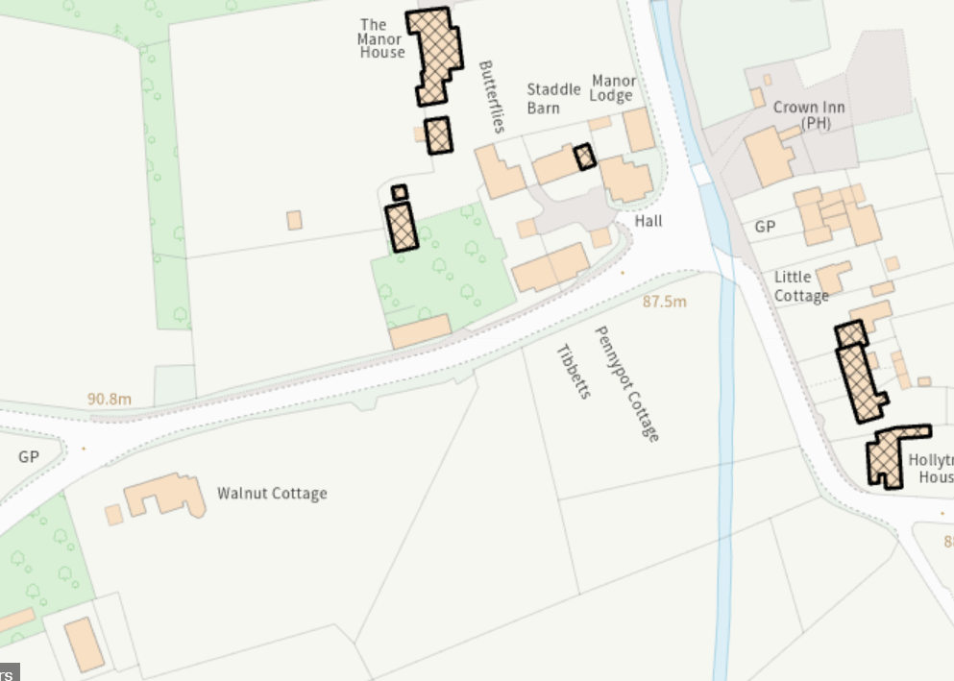

The River Bourne and its associated flood zones run through the centre of the village to the east of the site and wraps around the wider site to the south. Flood Zones 2 and 3 do not however extend into this site. The site is also in an area that is at low risk of ground water flooding. The site is however situated within the catchment of the River Avon Special Area of Conservation (SAC) and is within the 6.4 kilometre recreational buffer of the Salisbury Plain Special Protection Area (SPA). A number of public footpaths exist in the vicinity of the site, including CHOL4 to the west and CHOL5 to the east, marked in purple on the image below. The nearest is approximately 89 metres away to the east.

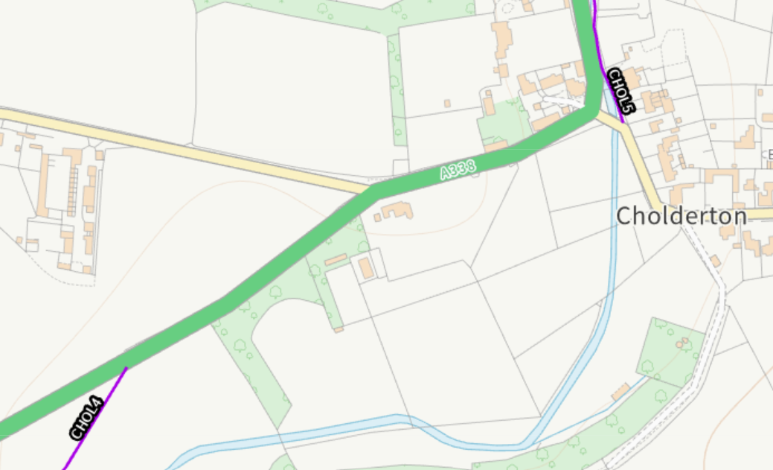

PROPOSAL

This report considers a Section 73 application for the variation/removal of condition(s) imposed on planning permission PL/2021/10166. The application relates to the site at land adjacent to Walnut House in Cholderton and seeks to vary condition 2 to amend the design of the previous approved dwelling on the site and the creation of a new access onto the site as the previously approved access is no longer viable.

The submitted Design and Access Statement states

“3. Design Context

This application proposes very little in the way of changes to the approved design. The internal layout has been modified to better suit the new applicants and the floor area reduced from the original approval. Externally, the previously approved external materials remain much the same with the exception of the roof for which now natural slate it proposed. The location of the proposed dwelling has moved slightly to the west due to the wider boot room to the east of the new dwelling. The previously approved access, unfortunately, is no longer viable and this application seeks an alternative access on to the site.”

In addition, the design of the previously approved detached garage has also been amended.

Approved garage/car port

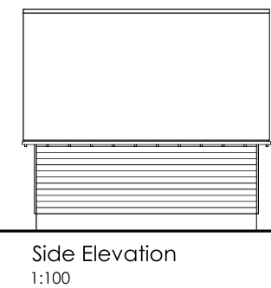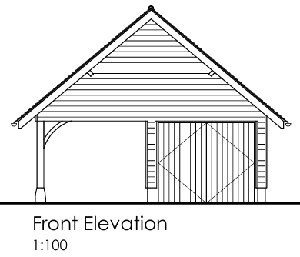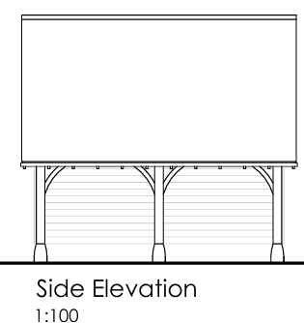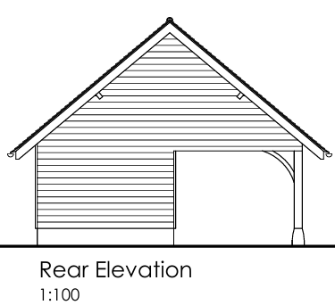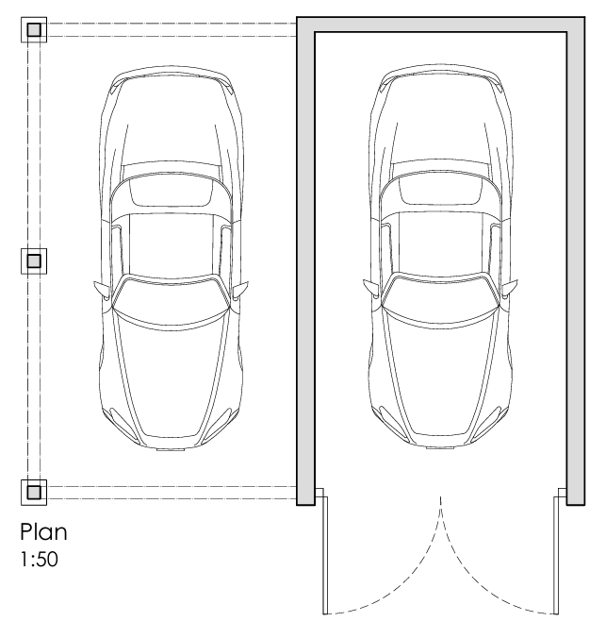

Proposed amended garage

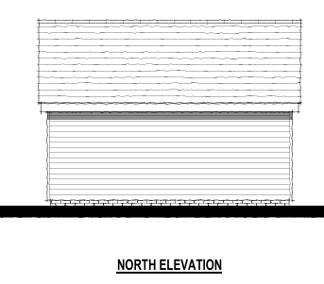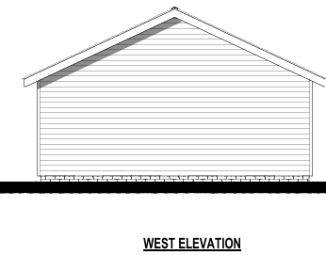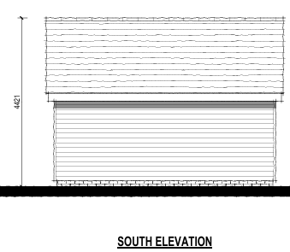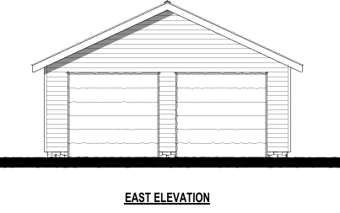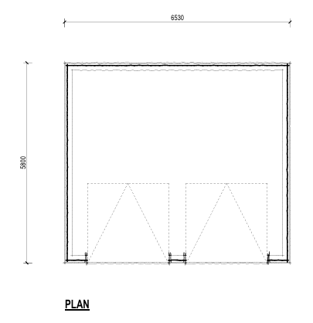

Approved site plan Proposed amended site plan

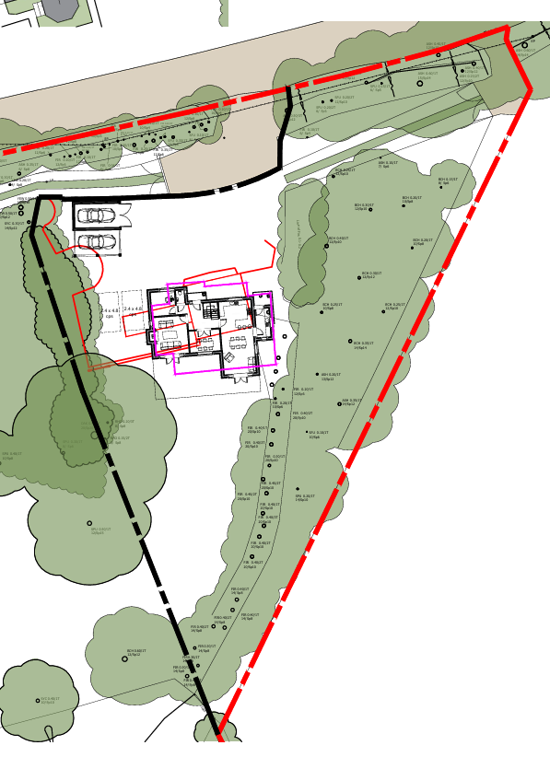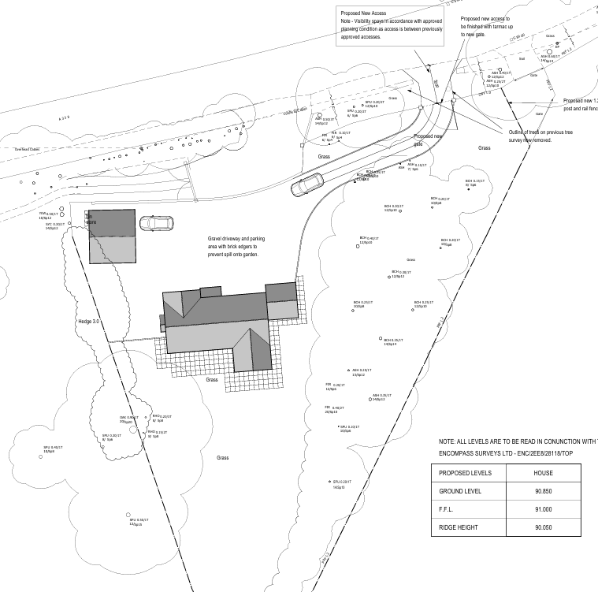

Approved north elevation Proposed amended north elevation

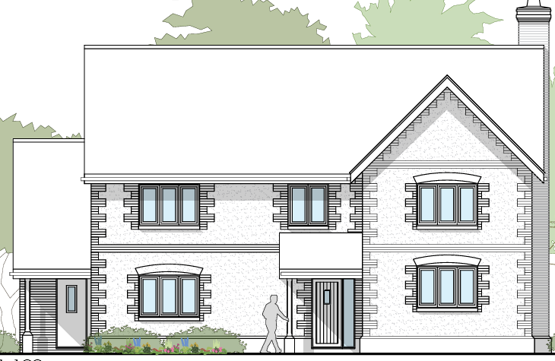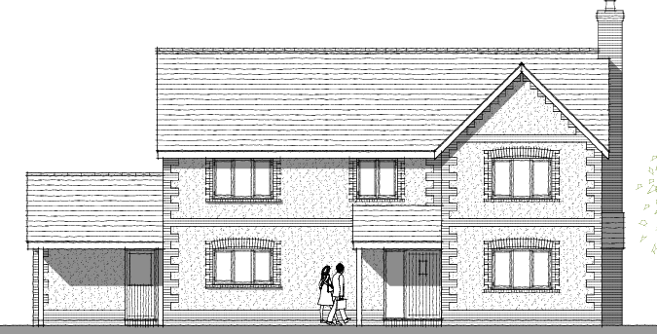

Approved south elevation Proposed amended south elevation

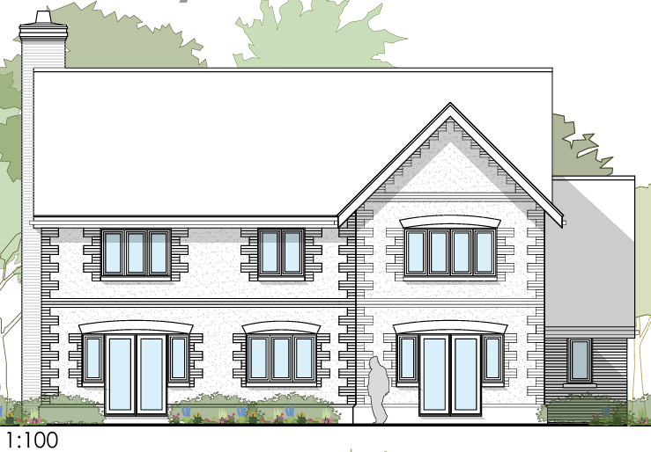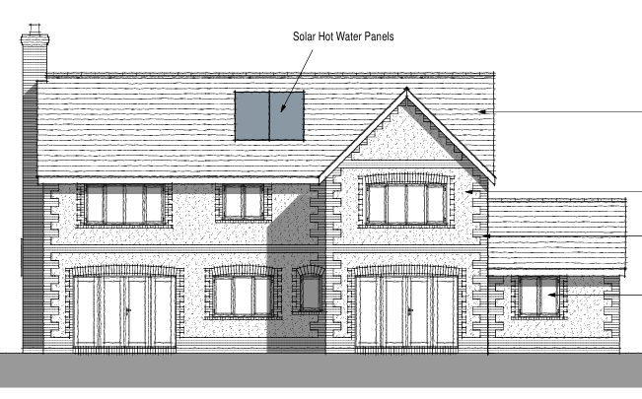

Approved west elevation Proposed amended west elevation

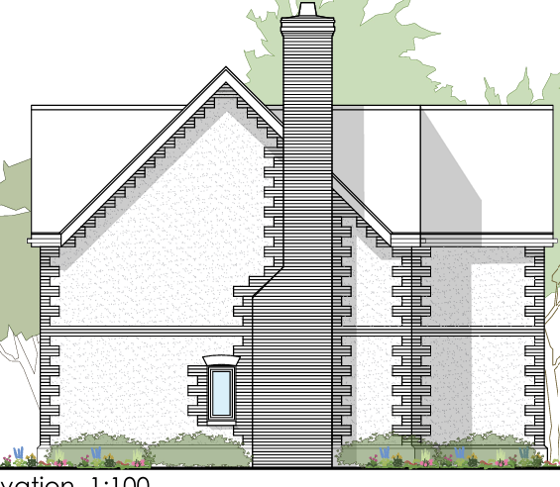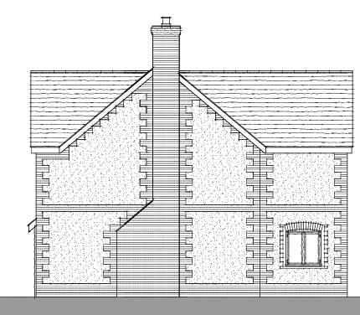

Approved east elevation Proposed amended south elevation

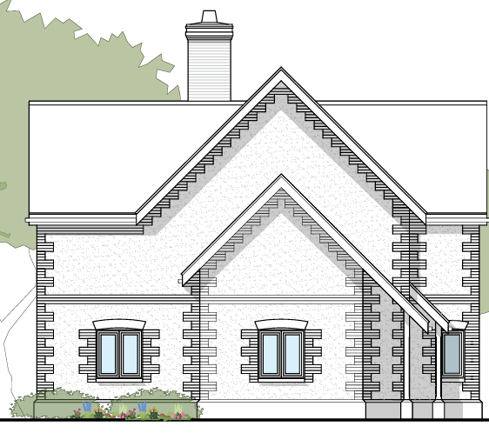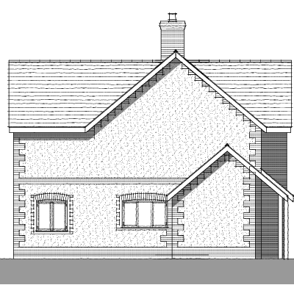

Approved ground floor plan

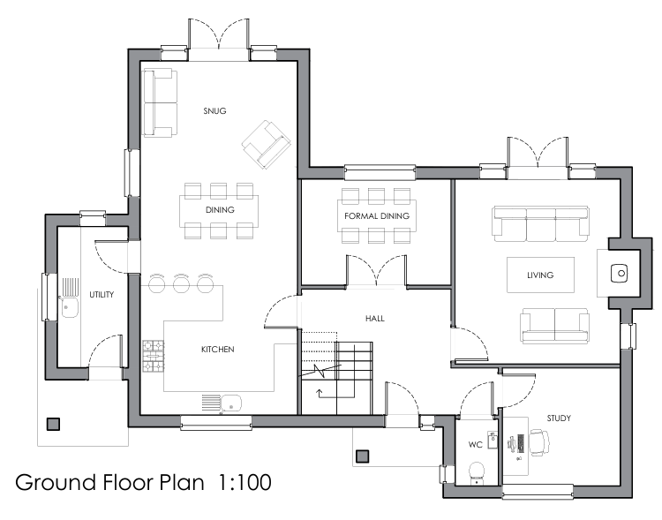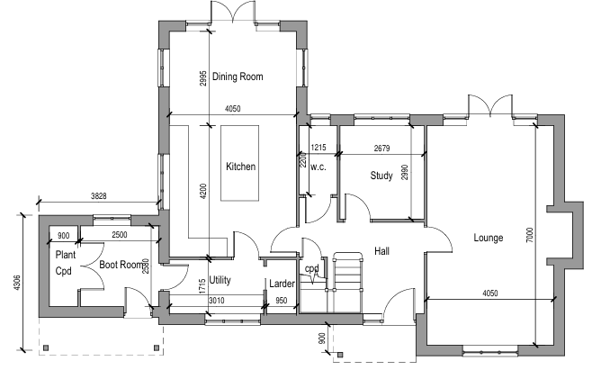

Approved first floor plan

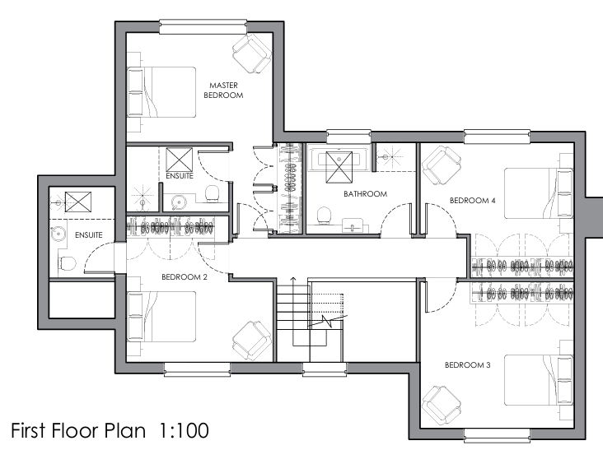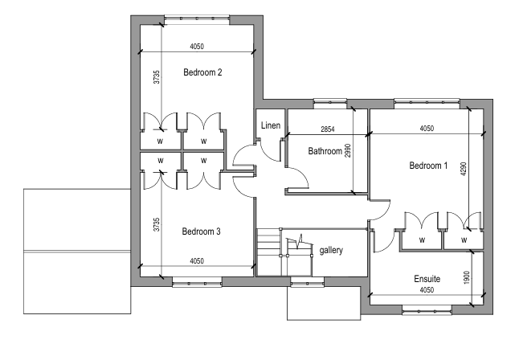

RELEVANT PLANNING HISTORY

Proposal / Summary
PL/2021/10166 - Removal/variation of conditions Decision - Approve with Conditions Date: 18/2/2022 – Variation of condition 2 (Approved plans) on 19/03210/FUL, to allow for a change in design to the new dwelling and erection of a replacement detached garage
19/03210/FUL - Full planning permission Decision - Approve with Conditions Date: 19/6/2019 – Demolish existing 210 m3 garage in Conservation Area and replace with a C3 eco-dwelling, re-use two existing lawful accesses (closing-off a third sub-standard access), new access carriage tracks, division of land to create two separate plots, hard and soft landscaping
PL/2022/02219 - Approval of details reserved by a condition Decision - Approve Date: 20/5/2022 – Discharge of Conditions 3 -Details of materials, 4 Hard & soft landscaping, 8 - Details of stopping up the existing access & 10 - Visibility splays of PL/2021/10166

RELEVANT LEGISLATION, POLICIES AND GUIDANCE

Town and Country Planning Act. 1990 (as amended)

Section 73 of the Town and Country Planning Act. 1990 (as amended) relates to the determination of applications to develop land without compliance with conditions previously attached. It states that:

(2) On such an application the local planning authority shall consider only the question of the conditions subject to which planning permission should be granted, and—

- if they decide that planning permission should be granted subject to conditions differing from those subject to which the previous permission was granted, or that it should be granted unconditionally, they shall grant planning permission accordingly, and

- if they decide that planning permission should be granted subject to the same conditions as those subject to which the previous permission was granted, they shall refuse the application.

The National Planning Practice Guidance (PPG) states the following:

- Nature of the Application: A Section 73 application is treated as a new planning permission, although it does not alter the original permission itself. The original permission remains intact and can still be implemented unless it has expired or been superseded.
Limitations:
- Section 73 cannot be used to change the description of development or the operative part of the permission (e.g. the nature or extent of the approved use).
- It cannot be used to extend the time limit for implementing the original permission.
- If the proposed changes go beyond what can reasonably be considered under Section 73, a new planning application under Section 70 would be required.
- Decision-making: The local planning authority must consider the application only in relation to the conditions subject to which the original permission was granted. However, it may impose new or revised conditions if granting a new permission.

National Planning Policy:

National Planning Policy Framework (NPPF)
Planning Practice Guidance (PPG)
National Design Guide

Development Plan:

The development plan for Wiltshire comprises the Wiltshire Core Strategy (WCS) (adopted January 2015) and any made neighbourhood plans, which remains the principal statutory planning document guiding development across the county. In line with Section 38(6) of the Planning and Compulsory Purchase Act 2004, planning decisions must be made in accordance with the development plan unless material considerations indicate otherwise.

Though the development plan is considered as a whole, those parts deemed to be particularly relevant to this application are listed below:

The adopted Wiltshire Core Strategy (WCS), with particular regard to:

CP1 (Settlement Strategy)
CP2 (Delivery Strategy)
CP3 (Infrastructure Requirements)
CP4 (Amesbury Community Area)
CP45 (Meeting Wiltshire’s Housing Needs)
CP50 (Biodiversity and Geodiversity)
CP51 (Landscape)
CP57 (Ensuring High Quality Design & Space Shaping)
CP58 (Ensuring the Conservation of the Historic Environment)
CP60 (Sustainable Transport)
CP61 (Transport & Development)
CP62 (Development Impacts on the Transport Network) CP64 (Demand Management)
CP69 (Protection of the River Avon SAC)

Salisbury District Local Plan policies (Saved by Wiltshire Core Strategy): C6 – Special Landscape Area

Wiltshire Housing Site Allocations Plan (February 2020) (WHSAP)

Supplementary Planning Documents:

Wiltshire Design Guide (March 2024)
Creating Places Design Guide SPG (April 2006)
Achieving Sustainable Development SPG (April 2005)
Wiltshire Climate Strategy 2022-2027
Wiltshire Local Transport Plan – Car Parking Strategy

ISSUES

The key considerations in the assessment of this application are as follows:

Determining whether the proposed amendments fall within the scope of Section 73 of the Town and Country Planning Act 1990 which allows for the variation or removal of conditions attached to an existing planning permission.

Assessing whether the development, as amended, remains in accordance with the relevant policies and provisions of the development plan, and whether the changes materially alter the nature or impacts of the approved scheme.

CONSULTATION RESPONSES

Parish Council: None received

Conservation: No comment

Highways: No objection subject to condition

Tree Officer: No objection subject to condition

REPRESENTATIONS

None received

ASSESSMENT
Section 38(6) of the Planning and Compulsory Purchase Act 2004 states:

"If regard is to be had to the development plan for the purposes of any determination to be made under the planning Acts, the determination must be made in accordance with the plan unless material considerations indicate otherwise."

In accordance with this statutory requirement, this application has been assessed against the relevant policies of the Development Plan, including the Wiltshire Core Strategy (2015) and, where applicable, any made Neighbourhood Plans. Consideration has also been given to the policies of the National Planning Policy Framework (NPPF) as a material consideration in the assessment.

Principle of the Development – Do the proposed amendments fall within the scope of s73?

The proposed amendments have been reviewed and are considered to fall within the scope of Section 73 of the Town and Country Planning Act 1990. The changes do not result in a fundamentally different development from that originally approved, nor do they seek to alter the description of development or extend the time limit for implementation. As such, the application is valid under Section 73 and can be determined as a variation of condition(s) attached to the original planning permission.

Compliance with the Development Plan

There have been no significant planning policy changes that would alter the suitability of the principle of development on this site. This officer report solely assesses the changes between the proposed scheme and that previously approved

Character, design and visual impacts

From the point of view of the historic environment the main statutory tests are set out within the Planning (Listed Building and Conservation Areas) Act 1990.

Section 72(1) of the Act requires the Council to pay special attention to the desirability of preserving or enhancing the character or appearance of designated Conservation Areas.

The Council’s Core Strategy CP58 ‘Ensuring the conservation of the historic environment’ requires that designated and non-designated heritage assets and their settings will be conserved, and where appropriate enhanced, in a manner appropriate to their significance and encourages proposals which improve the condition of heritage assets at risk.

Core Policy 51 of the WCS requires that development should protect, conserve and where possible enhance landscape character and must not have a harmful impact upon landscape character, while any negative impacts must be mitigated as far as possible through sensitive design and landscape measures having regard to the visual amenity of the open landscape character.

The site is not within the National Landscape (formerly Area of Outstanding Natural Beauty) and therefore lies outside of any nationally recognised designation. However, it does lie with the local designation of 'Special Landscape Area' defined by saved policy C6 of the Salisbury Local Plan.

Policy C6 states that 'Within the Special Landscape Area, proposals for development in the countryside will be considered having particular regard to the high quality of the landscape. Where proposals which would not have an adverse effect on the quality on the landscape are acceptable, they will be subject to the following criteria;

(i) the siting and scale of development to be sympathetic with the landscape; and
(ii) high standards of landscaping and design, using materials which are appropriate to the locality and reflect the character of the area.'

Core Policy 57 requires that applications should demonstrate how the proposal will make a positive contribution to the character of Wiltshire through –

(i) enhancing local distinctiveness by responding to the value of the natural and historic environment, relating positively to its landscape setting and the existing pattern of development and responding to local topography by ensuring that important views into, within and out of the site are to be retained and enhanced;
(iii) responding positively to the existing townscape and landscape features in terms of building layouts, built form, height, mass, scale, building line, plot size, elevational design, materials, streetscape and rooflines to effectively integrate the building into its setting and
(iv) being sympathetic to and conserving historic buildings and historic landscapes.

The proposed design changes to the proposed dwelling itself and to the proposed garage are considered to be modest amendments in the overall context of the scheme. As can be seen above in the comparison between the as approved and proposed/amended plans and elevations, the proposed dwelling retains the character and appearance of the approved dwelling. The proposed garage has a lower profile than the previously approved garage/car port and has less visual impact than the approved scheme. The proposed amended scheme intends to use the same materials as previously approved except for the roofing material for the dwelling which has been changed to natural slate, there are no objections to the use of slate.

The main element of the proposed changes to the approved scheme relate to the creation of a new access to serve the new dwelling. Whilst the approved scheme was to use an existing access to the east which served the fields, it has become apparent that the access and some of the adjoining land is owned by a third party and cannot be used for the development as the third party does not give consent. Therefore, it is now proposed to create a separate access to serve the new dwelling which will be located a few metres to the west of the existing/approved access which is no longer viable. There are concerns regarding the visual impacts of creating another access which will result in three accesses off the A338 in close proximity and the impacts on the conservation area. However, the Council’s conservation office did not provide comment or object to this change to the streetscene and therefore whilst Officers acknowledge that this is not ideal, as the site is essentially landlocked with no other access in order for the new dwelling to be built and used going forward, with the lack of housing supply within Wiltshire, it is considered that the harm is not significant enough to warrant a refusal.

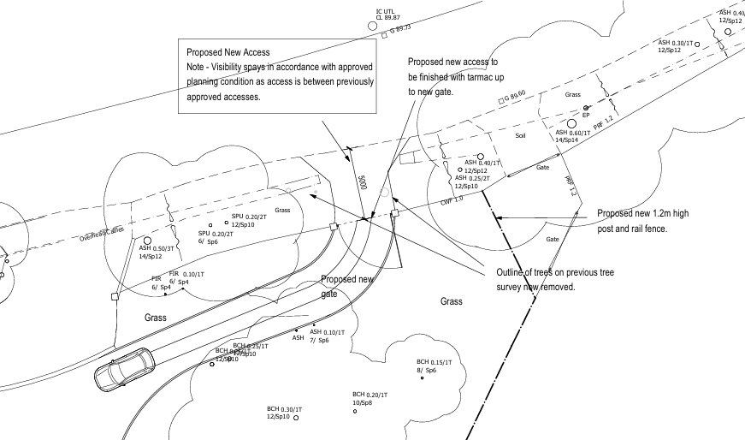

Neighbour amenity

The proposed amendments are not considered to have any differing impacts on amenity in comparison to the previously approved scheme.

Highways

This application proposes a new access from the A338 as the original access can no longer be used as it is under separate ownership and will be retained as existing to serve the adjacent fields.

The new access has been assessed by the Highway Authority who have confirmed no objections subject to conditions and accept the visibility splays are adequate. The parking arrangements are as approved and the new design for the detached garage does not affect the parking provision. The proposed driveway, parking/turning areas are of a sufficient size and can provide the necessary parking provision to be compliant with the Wiltshire Local Transport Plan Car Parking Strategy.

Trees

The alterations to the design of the dwelling and garage and creation of the new access are not considered to harm trees on or adjacent to the site subject to the works being carried out in accordance with the agreed tree protection plan and arboricultural assessment,

Ecology

The application site benefits from an extant planning permission which can be built at any time. As part of the original consent a bat survey was carried out due to the demolition of the existing garage. The previously existing garage has now been demolished. Given the fall back of the extant permission, there are no further impacts/concerns raised through the amendments now proposed to the new dwelling. Therefore, there are no ecology based objections to the proposed development.

PLANNING BALANCE AND CONCLUSION

In determining this application under Section 73 of the Town and Country Planning Act 1990, the Local Planning Authority has considered whether the proposed amendments fall within the scope of Section 73. The proposed amendments have been assessed against the relevant policies of the Wiltshire Core Strategy, any applicable Neighbourhood Plan, and the National Planning Policy Framework. The assessment has also considered whether the development, as amended, materially alters the nature or impacts of the approved scheme.

The proposed design changes to the approved scheme for the new dwelling, and the creation of anew access are considered to be acceptable by reason of its scale, siting ,design and materials, with no significant impact to neighbouring amenities, highway safety or character of the area including historic environment. It is therefore considered to be in accordance with the above listed Core Policies of the adopted Wiltshire Core Strategy and the aims of the NPPF.

RECOMMENDATION:

That Planning Permission be GRANTED subject to the following conditions

1. The development hereby permitted shall be carried out in accordance with the following
approved plans:

Proposed site plan Drg no 25-1110/SP1 received 23/01/2026
Location plan Drg no 25-1110/LP1 received 11/02/2026
Proposed garage Drg no 25-1110/G1 received 23/02/2026
Proposed visibility splay Drg no 25-1110/VS1 received 23/01/2026
Proposed plans and elevations Drg no 25-1110/1 received 23/01/2026
Bat Survey received 24/01/2022
Tree Survey and Arboricultural Impact Assessment received 06/03/2026
Landscape plan Drg 25-1110/LP1 received 20/04/2026
Tree protection plan Drg no 25-1110/TPP1 received 20/04/2026
Arboricultural Assessment received 20/04/2026

REASON: For the avoidance of doubt and in the interests of proper planning.

2. The development shall be carried out in accordance with the details for materials approved under discharge of conditions application PL/2022/02219 or to use natural slate for the roofs of the dwelling and garage.

REASON: In the interests of visual amenity and the character and appearance of the area.

3. The development hereby permitted shall not be occupied until the first 5m of the access, measured from the edge of the carriageway, has been consolidated and surfaced (not loose stone or gravel). The access shall be maintained as such thereafter.
REASON: In the interests of highway safety.
4. Any gates shall be set back 4.5m from the edge of the carriageway, such gates to open inwards only.
REASON: In the interests of highway safety.
5. No part of the development hereby permitted shall be occupied until the access, turning area & parking spaces [3] have been completed in accordance with the details shown on the approved plans. The areas shall always be maintained for those purposes thereafter and maintained free from the storage of materials.
REASON: In the interests of highway safety.
6. No part of the development shall be occupied, until the visibility splays shown on the approved plans have been provided with no obstruction to visibility at or above a height of 900mm above the nearside carriageway level. The visibility splays shall always be maintained free of obstruction thereafter.
Reason: In the interests of highway safety.

7. The dwelling hereby approved shall not be occupied until the Building Regulations Optional requirement of a maximum water use of 110 litres per day has been complied with.

REASON: To avoid any adverse effects upon the integrity of the River Avon Special Area of
Conservation (SAC).

8. No construction or demolition work shall take place on Sundays or Public Holidays or outside the hours of 08:00 to 18:00 Monday to Friday and 08:00 to 13:00 on Saturdays.

REASON: Core policy 57, Ensuring high design and place shaping such that appropriate levels of amenity are achievable.

9. The development should be carried out strictly in accordance with the Arboricultural Impact Assessment and Tree Protection Plan received 20/04/2026. The trees must be protected in accordance with the agreed report/plan throughout the period of development, unless the Local Planning Authority has given its prior written consent to any variation.

REASON: To comply with the duties indicated in Section 197 of the Town and Country Planning Act 1990, so as to ensure that the amenity value of the important trees, shrubs and hedges growing within or adjacent to the site is adequately protected during the period of construction.

10. All soft landscaping comprised in the approved details of landscaping shall be carried out in the first planting and seeding season following the first occupation of the building(s) or the
completion of the development whichever is the sooner; All shrubs, trees and hedge planting
shall be maintained free from weeds and shall be protected from damage by vermin and stock. Any trees or plants which, within a period of five years, die, are removed, or become seriously damaged or diseased shall be replaced in the next planting season with others of a similar size and species, unless otherwise agreed in writing by the local planning authority.
All hard landscaping shall also be carried out in accordance with the approved details prior to the occupation of any part of the development or in accordance with a programme to be agreed in writing with the Local Planning Authority.

REASON: To ensure a satisfactory landscaped setting for the development and the protection of existing important landscape features.

11. Notwithstanding the approved plans prior to the erection of the proposed entrance gates, details including elevations and materials shall be submitted to and approved in writing with the Local Planning Authority.

The development shall be carried out in accordance with the agreed details.

REASON: In the interests of visual amenity and the character and appearance of the area.

12. Notwithstanding the provisions of the Town and Country Planning (General Permitted Development) (England) Order 2015 (or any Order revoking or re- enacting or amending those Orders with or without modification), no development within Part 2 Class A shall take place within the application site other than those shown on the approved plans within prior written agreement from the Local Planning Authority.

REASON: In the interests of visual amenity and the character and appearance of the area and to enable the Local Planning Authority to consider individually whether planning permission should be granted for further means of enclosure due to the rural landscape setting of the dwelling and to protect the character of the area.

INFORMATIVES

1. The application involves the creation of a new vehicle access. The consent hereby granted shall not be construed as authority to carry out works on the highway. The applicant is advised that a licence will be required from Wiltshire’s Highway Authority before any works are carried out on any footway, footpath, carriageway, verge or other land forming part of the highway. Please contact our Vehicle Crossing Team on vehicleaccess@wiltshire.gov.uk and/or 01225 713352 or visit their website at http://wiltshire.gov.uk/highways-streets to make an application.

2. Any alterations to the approved plans, brought about by compliance with Building Regulations or any other reason must first be agreed in writing with the Local Planning Authority before commencement of work.

3. The applicant is advised that, if it is proposed to drain this development directly into the river or carry out any work within 8 metres of the watercourse then a Land Drainage Consent is required from the Environment Agency. For further information see www.environment-agency.gov.uk

4. The applicant is requested to note that this permission does not affect any private property rights and therefore does not authorise the carrying out of any work on land outside their control. If such works are required, it will be necessary for the applicant to obtain the landowner’s consent before such works commence.

If you intend carrying out works in the vicinity of the site boundary, you are also advised that it may be expedient to seek your own advice with regard to the requirements of the Party Wall Act 1996.

