APPLICATION FOR HOUSEHOLDER PLANNING PERMISSION
DELEGATED REPORT

APPLICATION REFERENCE: | PL/2026/00145
APPLICATION TYPE: | Householder planning permission
SITE ADDRESS: | 76a, Main Street, Keevil, BA14 6ND
DEVELOPMENT DESCRIPTION: | Refurbishment of existing property to demolish existing double garage; single garage extension; the rebuild of existing dormer structures, incorporating vertical hanging tiles
RECOMMENDATION: | That Planning Permission be GRANTED

SITE DESCRIPTION/CONTEXT
The subject property is a detached dwelling built in the 1980s, 1 ½ storeys, in red brick with stone detailing, under a concrete tiled roof.

The dwelling is highly visible within the village of Keevil; a small village in policy terms, and within the designated Conservation Area.

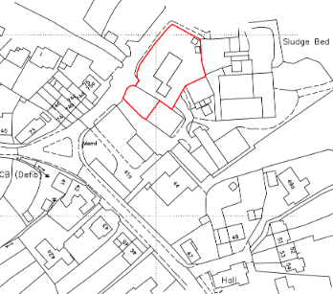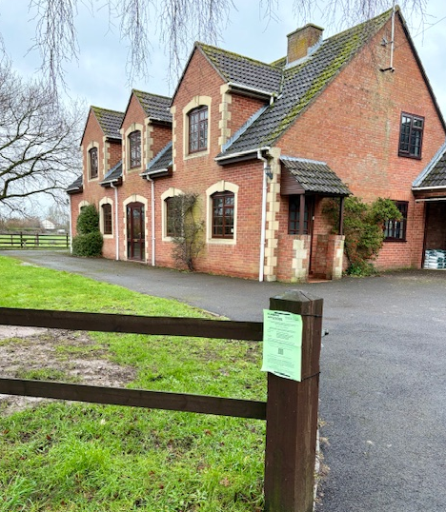

Location Plan and Google Earth Site Photo

The site was once a farmyard within the cluster of historic Longleaze Farm, with the remaining historic structures/farmhouse to the south/west of the proposal site and modern farm buildings immediately to the east/rear, such that the subject dwelling presents as a clear modern infill between various designated and non-designated heritage assets and a modern working farm.

GII Vale House at approx. 35m to the north and GII Stable and Carriage House 55m to the southwest, are the only two nearby listed buildings, both at a distance or across intervening structures to not be affected by the proposals. The barn at Longleaze Farm has now been delisted as it was demolished by a hurricane.

A stream that flows from the west of the village to link up with Semington Brook to the east, is subverted underground past the subject property, meaning it is within a buffer zone of a watercourse.

Accordingly, the site is at increased risk of groundwater flooding and groundwater levels are either at or very near the ground surface.

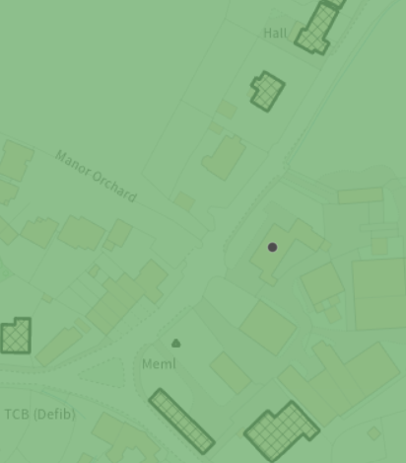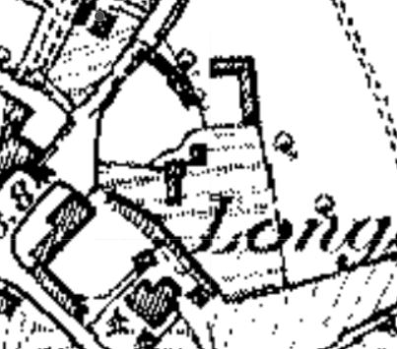
Conservation Area (shaded green) and listed buildings (hatched), 1st epoch mapping, showing the site (circled) was once a yard in front of a lost farming structure.

The site is also within buffer zones of various bat roosts.

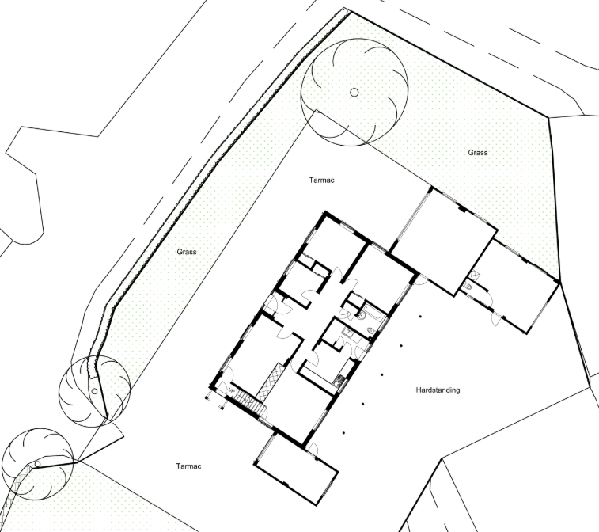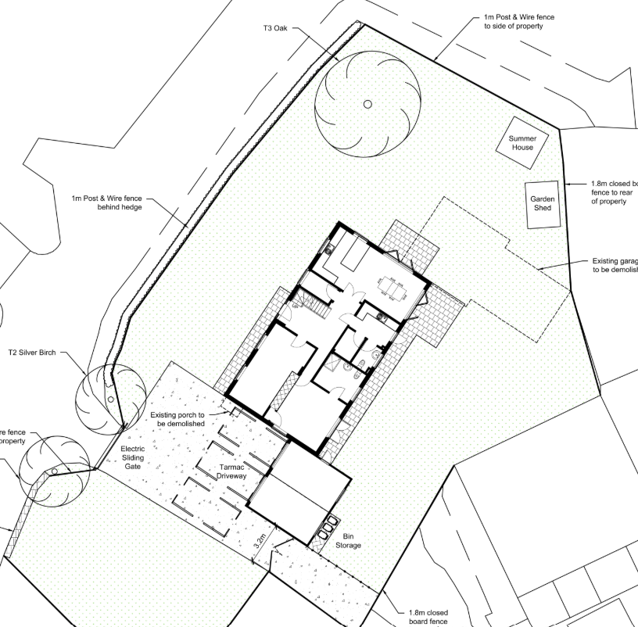

Existing and Proposed Site Plan

PROPOSAL

The proposal seeks planning permission for:
- Demolish attached double garage structure and its chimney stack, to the northwest
- Replace with garden shed and summer house
- Extend the single garage to the south into a double garage, hiding the bin store to the rear.
- Rebuild existing dormers to west and east elevations, to improve thermal performance, with vertical tile hanging to replace existing brick, as per the rear dormers.
- Removal of rear open lean-to structure and small side porch
- Install 1m post and wire fence behind front boundary hedge, and 1.8m close boarded fencing to rear.
- Install Electric sliding gate, so as to not impact the stone wall abutting the highway, and create area of hardstanding to park 3 cars
- Internal reconfiguration:
  - Knock through two GF bedrooms to create a double aspect kitchen/dining space
  - Relocate stairs, remove study partitions, creating a two-storey hallway, stairway, cloakroom at GF and wider landing.
  - Kitchen reconfigured to ensuite/plant room/utility and WC.
  - Knock through two FF bedrooms to create an ensuite master bedroom
  - Reconfiguration of dormers to extend internal partitions , FF kitchen to become a family bathroom.
  - Introduction of French doors to Bed 4 and kitchen/diner and replacement of all other windows with modern aluminium DG units, retaining design and glazing bars.
  - Removal of existing solar panels to rear E-facing roof pitch, and replacement with 18 solar panels, each panel measuring approx. 2m x 1.1m, 2 arrays of 8, and another of 6 on the eastern pitch of the garage.

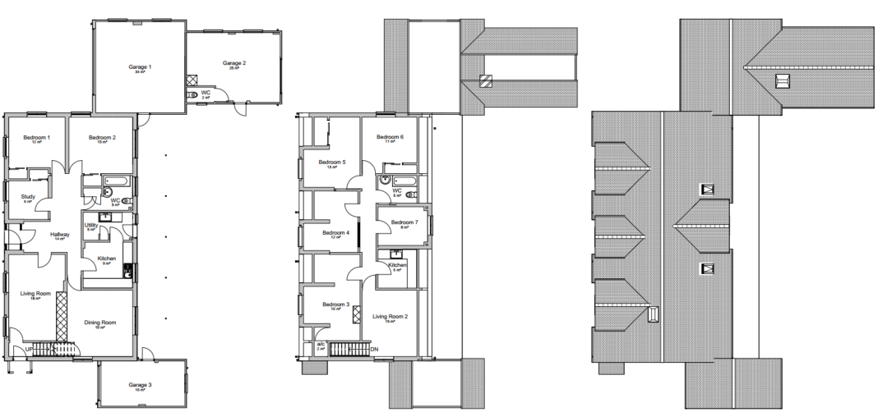

Existing Ground Floor, First Floor and Roof Plan

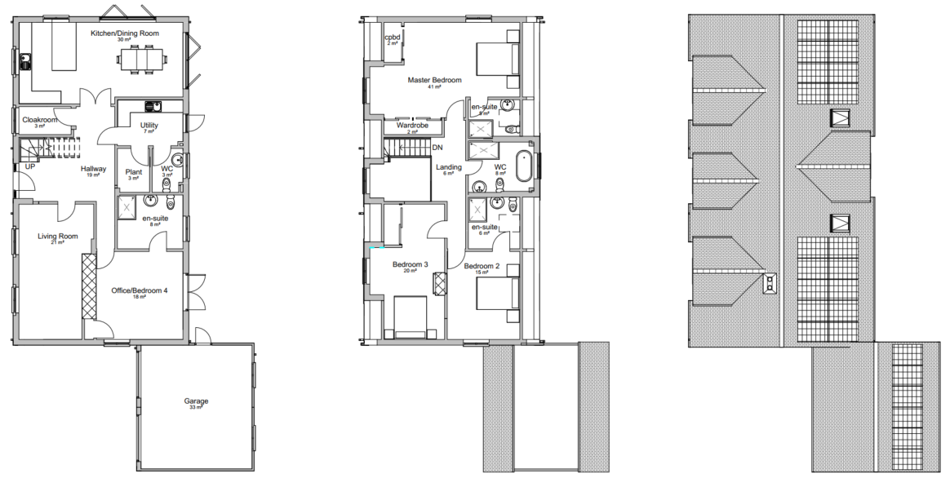

Proposed Ground Floor, First Floor and Roof Plan

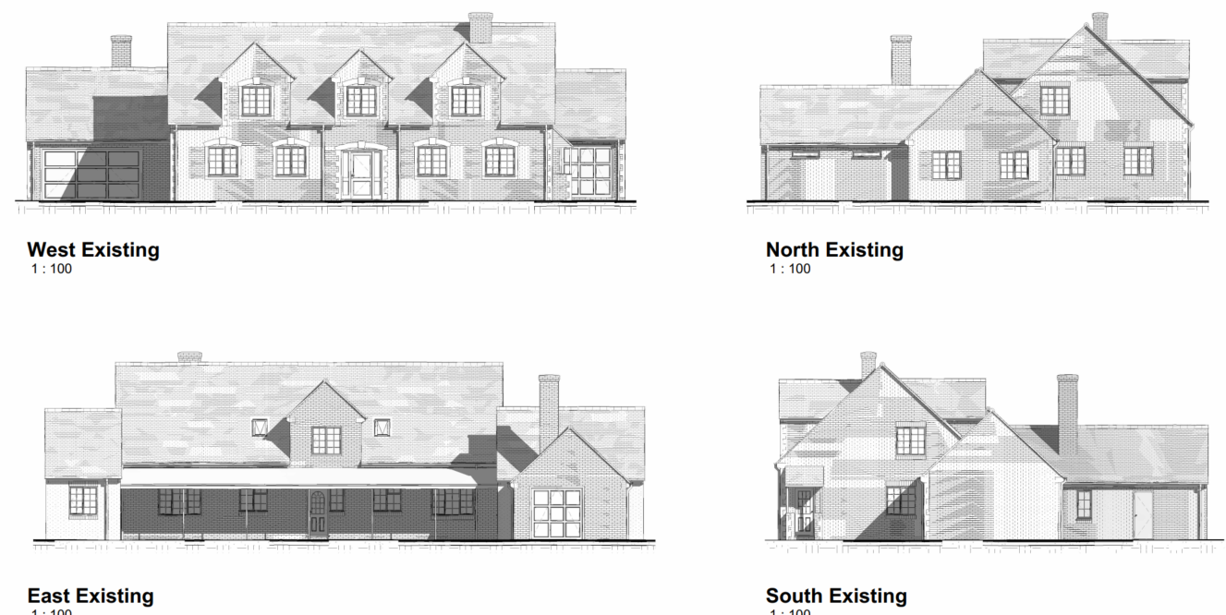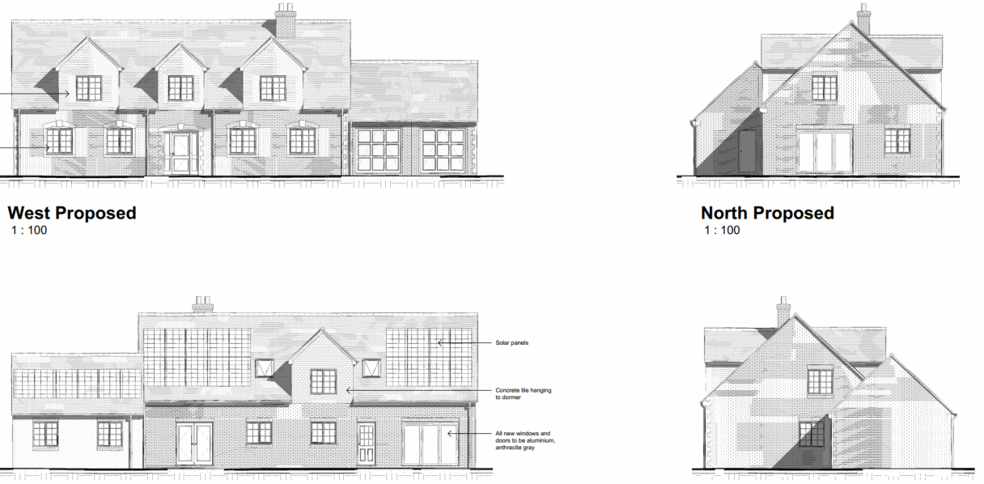

Existing and Proposed West (front) Elevations

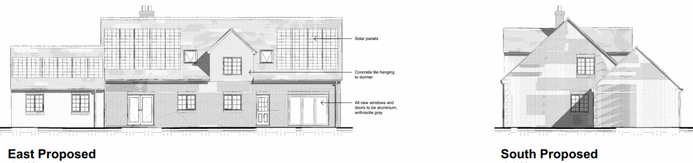

Existing and Proposed Eat (rear) Elevations

Existing and Proposed North (side) Elevations

Existing and Proposed South (side) Elevations

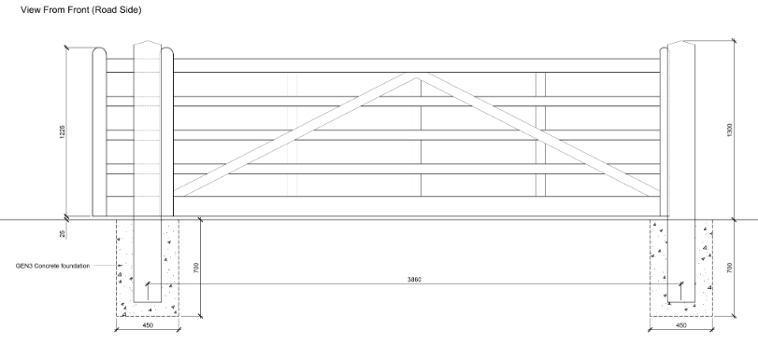

Proposed Gate Details

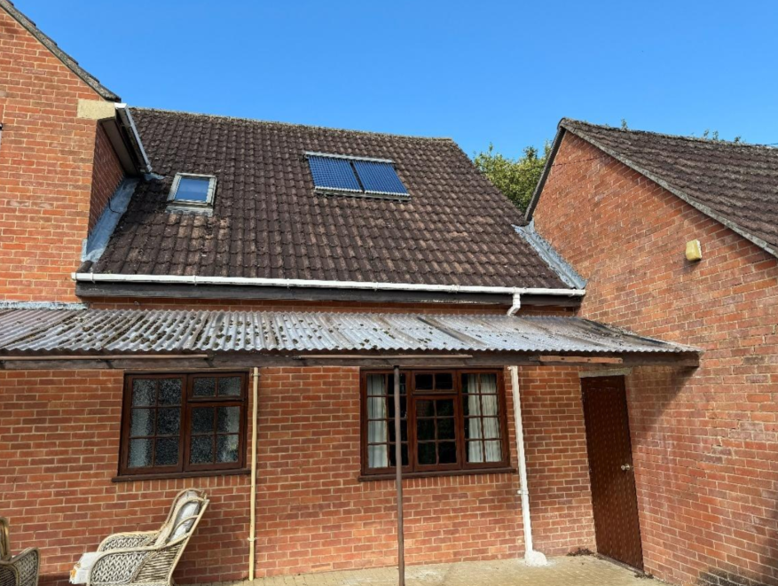

Site Photo of existing rear lean to proposed to be demolished

PLANNING HISTORY

W/81/00366/HIS – outline application for erection of dwelling – approve with conditions

W/06/01974/FUL – solar panels fitted on to roof (to rear elevation) - approve

RELEVANT POLICIES AND GUIDANCE
The National Planning Policy Framework (NPPF)
The Planning Practice Guidance
National Design Guide
Wiltshire Design Guide: Appendix D – Design Guidance for Householder extensions

Section 72 of the Planning (Listed Building and Conservation Areas) Act 1990

Wiltshire Core Strategy:
- Core Policy 57 Ensuring High Quality Design and Place Shaping
- Core Policy 58 Ensuring the Conservation of the Historic Environment
- Core Policy 50: Biodiversity and Geodiversity
- Core Policy 61: Transport and New Development
- Core Policy 64: Demand Management
- Core Policy 67: Flood Risk

Keevil does not have a designated Neighbourhood Plan Area.
Keevil Conservation Area Appraisal
Keevil Village Design Statement

CONSULTATION RESPONSES

Keevil Parish Council: No objection.
Having reviewed the detailed Planning & Heritage Statement and other application documents, members noted the proposals appeared proportionate, sympathetic, in harmony with the current dwelling and surroundings, and accorded with Village Planning Policy to preserve and enhance the conservation area, protect open spaces and views to open countryside, and respect the built environment.
Members particularly understood the need to address the 'sinking' garage area, and noted views across open farmland would actually improve with its removal. Further assurances that structural interior changes would not change the outside appearance of the dormer windows, that window materials would be the same as the immediately adjacent property, that solar panels would be to the rear of the building, and the planned position for the gate would be adjusted to comply with requirements for a turning area were welcomed.
Highways: Following the submission of a revised site plan and parking area, no objection subject to conditions.

Ecology: no comment submitted at the time of writing.

Arboricutural: no comment submitted at the time of writing.

REPRESENTATIONS

One comment of support received, noting the significant subsidence of the garage and workshop, with damage noticeable from Main Street, such that the proposals would enable an enhancement to the Conservation Area.

ASSESSMENT

Principle of Development:
Section 70(2) of the Town and Country Planning Act 1990 and section 38(6) of the Planning and Compulsory Purchase Act 2004, require that the determination of planning applications must be made in accordance with the Development Plan, unless material considerations indicate otherwise.

The proposal comprises development to an existing residential property set in an established residential area within the village of Keevil. The proposal is wholly within the residential curtilage, and as such, the principle of development is acceptable subject to the following considerations.

In accordance with this statutory requirement, this application has been assessed against the relevant policies of the Development Plan, including the adopted Wiltshire Core Strategy (2015) and, where applicable, any made Neighbourhood Plans.

Heritage, Design and Impact upon the character and context of the area
From the point of view of the historic environment the main statutory tests are set out within the Planning (Listed Building and Conservation Areas) Act 1990.

Section 66 requires that special regard be given to the desirability of preserving listed buildings, their settings or any features of special architectural or historic interest which they possess.

Section 72(1) of the Act requires the Council to pay special attention to the desirability of preserving or enhancing the character or appearance of designated Conservation Areas.

The Council’s Core Strategy Policy CP58 ‘Ensuring the conservation of the historic environment’ requires that designated and non-designated heritage assets and their settings will be conserved, and where appropriate enhanced, in a manner appropriate to their significance and encourages proposals which improve the condition of heritage assets at risk.

The Council’s Core Strategy CP 57: Ensuring high quality design requires a high quality of design in all new developments. The policy requires applicants to “demonstrate how the proposal will make a positive contribution to the character of Wiltshire through (amongst other things) responding to the value of the natural and historic environment and being sympathetic to and conserving historic buildings and landscapes. Development is required to respond positively to the existing in terms of building layouts, built form, height, mass, scale, building line, plot size, elevational design, materials, streetscape and rooflines to effectively integrate the building into its setting.

The NPPF outlines government policy for planning. Chapter 16 of the NPPF 'Conserving and enhancing the historic environment' sets out the Government's high-level policies concerning heritage and sustainable development.

The proposal includes a reduction in overall volume and a simplification/refinement of the built mass.

Design details, scale and materiality will not challenge the C20 ‘heritage’ design, retaining scale and roof forms, and keeping the clear legibility of a modern infill dwelling. The approach is light-touch, not seeking to alter the aesthetics but improve functionality with modern upgrades and understanding of past structural issues.

Proposed materials for the garage and dormers would match existing to the rear so ensuring the alterations/additions integrate successfully with the host dwelling.

Together the proposed minor changes, would have an accumulated impact, which will have a positive impact upon the Conservation Area and the dwelling’s viability.

The thermal efficiency upgrades are welcome, as are the solar panels, all restricted to the rear/east elevation, as still considered controversial within a Conservation Area.

Fencing and boundary treatments are appropriate and enable improved privacy given the proximity to the working farm, and as stated, would be permitted development outside of a Conservation Area.

The proposal, by virtue of its scale, design, and use of materials, is considered to preserve the character and appearance of the Conservation Area, without impact on the setting of any listed buildings.

The development is therefore considered to comply with Core Policy 58 of the Wiltshire Core Strategy and Section 72 of the Planning (Listed Buildings and Conservation Areas) Act 1990, as well as the relevant provisions of the NPPF.

Amenity
Point vii of Core Policy 57 - Ensuring High Quality Design and Place Shaping of the Wiltshire Core Strategy seeks to ensure that developments do not adversely affect neighbouring properties.

The National Planning Policy Framework (NPPF), particularly Paragraph 135(f), stresses that planning decisions should ensure developments provide a high standard of amenity for existing and future users.

The proposed development has been assessed in terms of its potential impact on the residential amenity of neighbouring properties, with particular regard to loss of light, overshadowing, loss of privacy, and overbearing effects.

Given the absence of any immediate neighbours and scale of the proposals, there are no concerns regarding overshadowing or overbearing. Only two windows are proposed to be extended to French Windows, causing no negative impact to neighbouring privacy.

The proposal therefore accords with Core Policy 57 point vii in respect of safeguarding residential amenity and Appendix D of the Wiltshire Design Guide.

Highways Impact
Core Policy 57 (xiv) of the Wiltshire Core Strategy seeks to ensure that development must meet the requirements of Core Policy 61. This policy requires proposals to be capable of being served by safe access to the highway network. Core Policy 64 seeks to ensure compliance with parking standards set out in the Local Transport Plan.

The National Planning Policy Framework (NPPF), particularly Paragraph 115 and 116, requires that development proposals do not have an unacceptable impact on highway safety and that safe and suitable access to the site can be achieved for all users.

It is noted that car users may find that when leaving the space closest to the house, they may over run the grass, as to turn a 45-degree angle is not practical and they may find themselves shunting to then get out of the gate, however this is not of concern for the other two spaces.

Following revisions to the proposed extent of hardstanding before the double garage, there are no objections from WC Highways.

The proposed development would not result in any adverse impact on highway safety. Adequate parking and turning provision is provided in accordance with Wiltshire’s adopted parking standards, and access arrangements are acceptable.

The proposal is therefore considered to comply with Core Policies 57 (xiv), 61 and 64 of the Wiltshire Core Strategy, the NPPF, and the Wiltshire Local Transport Plan.

Ecology Impact
Core Policy 50 of the Wiltshire Core Strategy seeks to protect and enhance biodiversity and geodiversity, including through ensuring that development avoids harm to protected species and habitats.

The National Planning Policy Framework (NPPF), in Paragraphs 193, requires that development minimises impacts on and provides net gains for biodiversity, including ensuring mitigation is secured where harm cannot be avoided.

The application site is not subject to any statutory or non-statutory ecological designations. It is noted that proposals are distanced from the mature oak abutting the highway which is a notable feature of the Conservation Area.

All UK bat species are protected by European and UK legislation; the Conservation of Habitats and Species Regulations and the Wildlife and Countryside Act. Considering the scale and form of proposed development, to an established residential dwelling, no substanitave ecology impact is raised and as such does not meet the threshold for a habitat regulations assessment.

An informative is included as a precautionary measure, highlighting that if any evidence of bat activity is detected, that the applicant should follow the advice of a professional ecologist or contact Natural England.

As such, the development complies with Core Policy 50 of the Wiltshire Core Strategy and the relevant provisions of the NPPF.

Drainage and Flood Risk
Core Policy 67 of the Wiltshire Core Strategy and paragraph 181 of the NPPF requires that all new development avoids increasing flood risk on-site or elsewhere and, where appropriate, incorporates sustainable drainage measures. Development must also comply with national policy on flood risk management and drainage design. Paragraph 176 (via footnote 62) of the NPPF states that householder development should not be subject to the sequential test, nor the exception test.

The proposal site is within buffer zones of a watercourse with the associated increased risk of groundwater flooding.

Householder development is considered Minor Development, under the Flood Risk planning guidance, if “physical extensions to the existing dwelling itself,” and, barring a few exceptions not relevant here, “are unlikely to raise significant flood risk.” The proposal to remodel an existing property, is therefore deemed to not result in any loss of land prone to flood risk.

As such, the proposal is deemed to be safe for its users for the intended lifetime of the development with respect to the level and nature of the flood risk.

The proposal therefore complies with Core Policy 67 of the Wiltshire Core Strategy and the policy in the NPPF, ensuring that flood risk is not increased and that surface water drainage is appropriately managed.

Biodiversity Net Gain
Householder planning applications are exempt from the requirement to deliver Biodiversity Net Gain under Schedule 7A, Section 4(2)(a) of the Town and Country Planning Act 1990, as inserted by the Environment Act 2021.

CONCLUSION
The proposed development is considered to be acceptable in terms of its design, scale, and relationship with the surrounding area. It would not result in any unacceptable harm to the character of the locality, the amenities of neighbouring occupiers, or the interests of highway safety, heritage, or ecology.

The proposal is therefore considered to comply with the relevant policies of the Wiltshire Core Strategy, the Wiltshire Local Plan, and the National Planning Policy Framework. As such, the application is recommended for approval, subject to conditions.

RECOMMENDATION: That Planning Permission be GRANTED subject to conditions.

