

Design and Access Statement

For: Construction of a Field Store

At: Land East of Cadley Farmhouse,
Chute Cadley
Andover
SP11 9EB

///tenders.earplugs.dilute

Prepared by:
Equestrian Blueprint
enquiries@equestrianblueprint.co.uk
https://equestrianblueprint.co.uk/
April 2026

Contents
1. Introduction 3
2. Site Context 3
3. Proposal 4
4. Design 4
4.1 Amount and Scale 4
4.2 Layout 4
4.3 Appearance 4
4.4 Landscaping 5
5. Access 5
6. Character and Impact 5
7.0 Biodiversity and Habitat 5
8. Conclusion 6

1. Introduction

This Design and Access Statement has been prepared in support of a planning application for the erection of a small timber outbuilding on land to the east of Cadley Farmhouse, Chute Cadley.

The proposed building is modest in scale and intended to support the ongoing maintenance and management of the paddock. The proposal has been carefully designed to sit comfortably within its rural context and to reflect the established character of the surrounding area.

2. Site Context

The site lies within a rural setting on the edge of the village of Chute Cadley, characterised by agricultural land, paddocks, and scattered farmsteads.

The immediate context is well contained. A recently constructed agricultural barn provides substantial screening from the farmhouse and wider views, while existing vegetation and boundary treatments further limit visibility from the surrounding area.

The site does not form part of a prominent or sensitive skyline and is experienced as part of a working rural landscape.
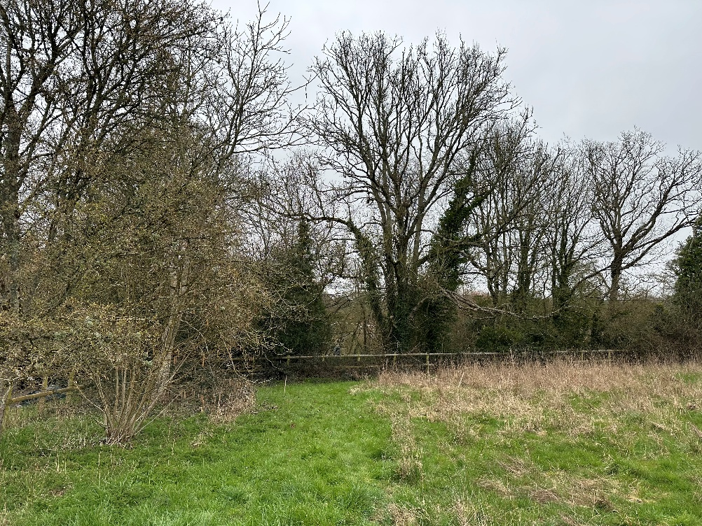
Figure 1 Site area looking north towards the highway.

3. Proposal

The application seeks permission for the erection of a small, single-storey timber outbuilding for the storage of paddock maintenance equipment.

The building will:

Have a footprint of less than 30 square metres
Be single storey with a maximum height of under 3.1 metres
Have a eave height of approximately 2.3 metres
Be positioned discreetly within the site, adjacent to existing structures and screening

The building will accommodate items such as a ride-on mower and hand tools required for the upkeep of the land. It is not intended for residential, commercial, or intensive use.

4. Design

4.1 Amount and Scale

The proposed development is deliberately modest. Its scale reflects its functional purpose and ensures it remains subservient within the wider site.

The low ridge height and compact footprint ensure the structure does not appear dominant or intrusive.

4.2 Layout

The building has been positioned to take advantage of existing screening, including the recently constructed barn and surrounding vegetation.

Its siting minimises visibility from public vantage points and maintains the open character of the wider landscape.

4.3 Appearance

The building will be of a simple, traditional form consistent with rural outbuildings.

Materials will include:

Timber weatherboard cladding
A simple pitched roof of subdued finish
Timber double doors on the south-facing elevation

The design avoids unnecessary domestic features and reflects the utilitarian character of agricultural structures in the area.

4.4 Landscaping

No significant landscaping works are required. The building will sit within an established paddock setting, with existing vegetation and built form providing sufficient screening.

The proposal will not result in the loss of important landscape features.

5. Access

Access to the site is already established and will remain unchanged.

The building will be accessed informally via the existing paddock, with no requirement for new formal access arrangements, parking areas, or intensification of use.

The proposal is low key and will not generate additional traffic movements beyond those associated with routine land management.

6. Character and Impact

The proposal has been designed to respect and respond to the rural character of Chute Cadley.

Its small scale, simple design, and use of traditional materials ensure that it integrates appropriately with its surroundings. The presence of existing screening, including the adjacent barn, further reduces any visual impact.

The development will not result in harm to the character or appearance of the area and is consistent with the established pattern of small-scale rural outbuildings.

7.0 Biodiversity and Habitat

The existing trees and hedgerows within and adjacent to the site have been fully considered as part of the design process. A Tree Plan has been submitted in support of the application, which demonstrates that the proposed outbuilding has been carefully sited to avoid any conflict with existing root protection areas. The development will not require the removal or pruning of any trees or hedgerows, and no adverse impacts on these features are anticipated. As such, the proposal retains all existing trees and hedgerows, preserving their contribution to the character and setting of the site.
The proposal will involve the localised removal of grass and low-level vegetation within the footprint of the building and its immediate base; however, this is limited in extent and confined to an area of managed paddock with low ecological value. There will be no loss or fragmentation of higher value habitats, and the development will not give rise to any wider ecological impacts.

8. Conclusion

The proposed outbuilding represents a small-scale, functional addition to an established rural site.

Its design, scale, and siting have been carefully considered to ensure it remains discreet, proportionate, and in keeping with the character of the area. The proposal will not give rise to adverse impacts and is considered to accord with relevant planning policies.

Planning permission is therefore respectfully sought.

