HOUSEHOLDER PLANNING APPLICATION.
CASE OFFICER REPORT

APPLICATION REFERENCE: | PL/2026/00297
APPLICATION TYPE: | Householder
SITE ADDRESS: | The Coach House, 112a Church Street, Hilperton, Trowbridge, BA14 7RG.
DEVELOPMENT DESCRIPTION: | Erection of a single-storey rear extension to the rear of the dwelling to provide accessible ground-floor accommodation, responding to the occupants’ disability and mobility needs.
RECOMMENDATION: | Approve with Conditions.

PROPOSAL
The proposal seeks planning permission for the construction of a single storey rear extension that would be attached to the side of the summer room, as located to the rear north elevation of the Coach House. The proposed extension would be utilised as ground floor accommodation for an elderly person who has mobility restrictions.

SITE DESCRIPTION/CONTEXT
The property is a converted coach house, which is of linear design and which is set back from the main arterial route of Church Street, through the Large Village of Hilperton. The building is located within an established residential area of Hilperton. The Coach House is not listed but is located within close proximity to the Grade II listed No.s 110 and 112 (Woodcote) Church Street. The Coach House does not directly fall within the Hilperton Conservation Area, but borders it to the east.

RELEVANT PLANNING HISTORY
Proposal / Summary
15/07347/FUL - Change of use of coach house to separate dwelling with single storey extension. Proposed new single storey dwelling. Approved.

16/02685/VAR - Removal of condition 2 attached to planning permission 00/01239/FUL to allow the Coach House to be used as a separate dwelling. Approved.

16/06173/FUL - Change of use of Coach House and extension to form separate dwelling. Approved.

18/00277/FUL - Erection of conservatory to north elevation. Approved.

RELEVANT POLICIES AND GUIDANCE
Wiltshire Core Strategy:

- Core Policy 57 Ensuring High Quality Design and Place Shaping
- Core Policy 50: Biodiversity and Geodiversity
- Core Policy 51: Landscape
- Core Policy 58: Ensuring the Conservation of the Historic Environment
- Core Policy 61: Transport and New Development
- Core Policy 64: Demand Management
- Core Policy 67: Flood Risk

Hilperton ‘Made’ Neighbourhood Plan

Wiltshire Design Guide: Appendix D – Design Guidance for Householder extensions

The National Planning Policy Framework (NPPF)

The Planning Practice Guidance

National Design Guide

Emerging Wiltshire Local Plan:
The examination of the emerging Wiltshire Local Plan has been paused and the weight to be afforded to any part of the emerging plan can be no more than very limited. A decision on how to proceed will be made by the Council in May 2026.

CONSULTATION RESPONSES
Hilperton Parish Council: Resolved to make a ‘No Comment’ response to the application.

REPRESENTATIONS
No comments were received.

PRINCIPLE OF THE PROPOSAL.
The principle of the proposed scheme is considered to be acceptable for the reasons as discussed below.

ASSESSMENT
Section 38(6) of the Planning and Compulsory Purchase Act 2004 states:

"If regard is to be had to the development plan for the purposes of any determination to be made under the planning Acts, the determination must be made in accordance with the plan unless material considerations indicate otherwise."

In accordance with this statutory requirement, this application has been assessed against the relevant policies of the Development Plan, including the adopted Wiltshire Core Strategy (2015) and the Neighbourhood Plan for Hilperton.

Design and Impact upon the upon the character and context of the area.
Core Policy 57 - Ensuring High Quality Design and Place Shaping of the Wiltshire Core Strategy seeks to ensure that all new development is of high design quality, reflecting local context, character, and distinctiveness.
The proposals can be viewed within the plan snippets taken from the submitted plans:

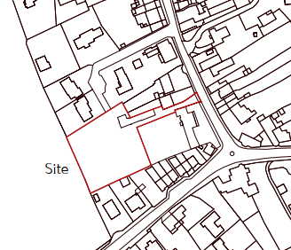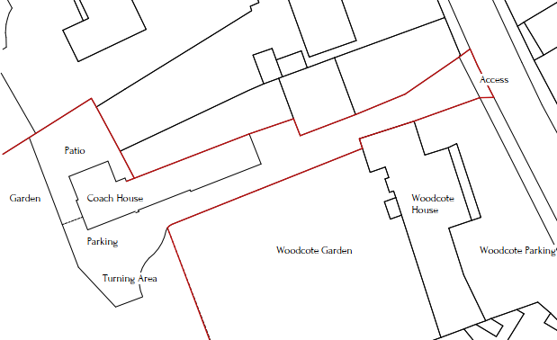
Location Plan Proposed Site Plan

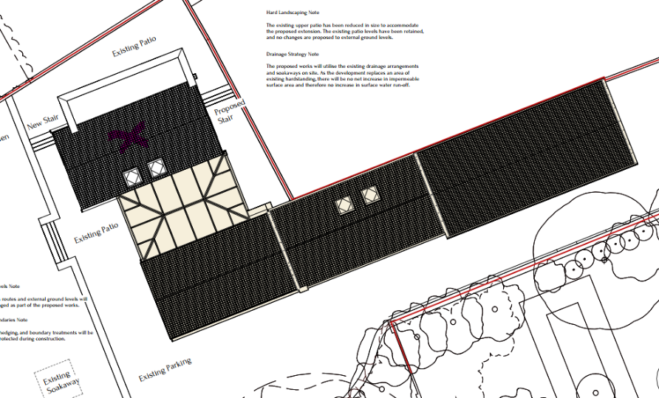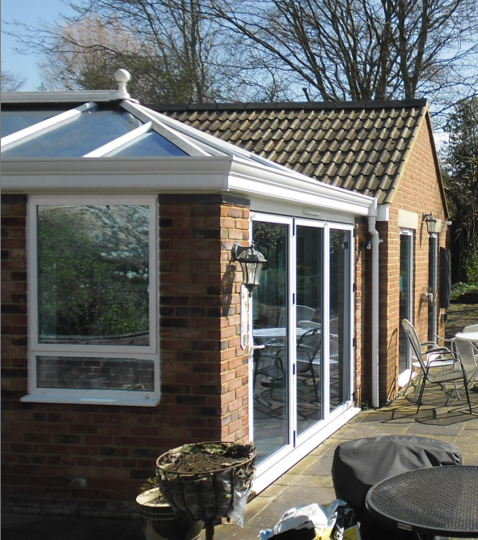
Site plan with highlighted proposal. Site photograph.

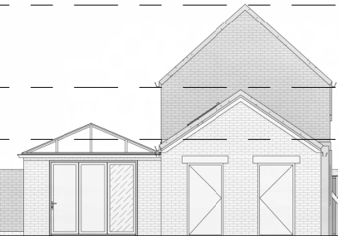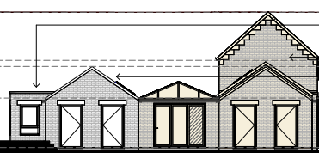
Existing & Proposed West Elevations

The proposal would be connected to the north elevation of the brick constructed orangery, with the proposal’s materials matching those of the existing building’s. In terms of design, the extension has been designed in accordance with the existing built form, in that it would have matching roof pitch with the host building, whilst including a small flat roof element to the north aspect. The small sized flat roof would be set back from the main primary elevation and has been designed to reduce its visual impact. Window sizes and their positioning have been designed and orientated to match those as existing to reinforce continuity.

The roof height of the proposal would be significantly lower than that of the main roof of the existing two storey building and so would be a subservient addition to the principal dwelling.

Therefore, in summary, having regard to the above, the proposal complies with the design principles set out in Core Policy 57 of the Wiltshire Core Strategy and Appendix D of the Wiltshire Design Guide.

Amenity
Point vii of Core Policy 57 - Ensuring High Quality Design and Place Shaping of the Wiltshire Core Strategy seeks to ensure that developments do not adversely affect neighbouring properties. The National Planning Policy Framework (NPPF), particularly Paragraph 135(f), stresses that planning decisions should ensure developments provide a high standard of amenity for existing and future users.
The proposed extension would be single storey and would look out onto and face its rear garden area and so there would not be any overlooking of neighbours.

The proposed extension would be of limited height and mass and due to the detached nature of the host dwelling with extended separation distances to any neighbouring occupiers, therefore, no overshadowing, overbearing or loss of light impacts are raised.

The proposal therefore accords with Core Policy 57 point vii. in respect of safeguarding residential amenity and Appendix D of the Wiltshire Design Guide.

Highway Matters.
Core Policy 57 (xiv) of the Wiltshire Core Strategy seeks to ensure that development must meet the requirements of Core Policy 61. This policy requires proposals to be capable of being served by safe access to the highway network. Core Policy 64 seeks to ensure compliance with parking standards set out in the Local Transport Plan.

The National Planning Policy Framework (NPPF), particularly Paragraph 115 and 116, requires that development proposals do not have an unacceptable impact on highway safety and that safe and suitable access to the site can be achieved for all users.

The proposed development would continue to use the established site access which would not be altered and so would not have any adverse impact on highway safety. As the plans show, there is more than adequate parking and turning provision provided within the site and such access arrangements are acceptable.

The proposal is therefore considered to comply with Core Policies 57 (xiv), 61 and 64 of the Wiltshire Core Strategy, the NPPF, and the Wiltshire Local Transport Plan.

Heritage Impact The Coach House is located within close proximity to the Grade II listed Nos. of 110 and 112 (Woodcote) Church Street. The Coach House does not directly fall within the Hilperton Conservation Area, but borders it to the east.

Section 66 of the Planning (Listed Buildings and Conservation Areas) Act 1990 requires ‘special regard’ to be given to the desirability of preserving a listed building or its setting. Both the nearby listed buildings face towards Church Street, giving them some visual prominence within the street-scene. As the proposed extension would be set back from these frontages and would be single storey, it is not considered that the proposal would harm the setting or character of these nearby listed buildings.

Paragraphs 207 and 208 of the NPPF requires local planning authorities to identify and assess the particular significance of any heritage asset that may be affected by a proposal and to make an assessment as to whether there would be substantial harm, less than substantial harm or no harm to the heritage asset. The significance of the nearby listed buildings is considered to include their architectural form and their visual prominence along this section of Church Street. As the proposed extension would be set back from the road and would be sympathetic to the existing appearance of the Coach House, by using red brick to match existing and matching glazing within the walls, it is considered that the proposal would cause no harm to the significance of the nearby listed buildings.

Conservation Area. The NPPF, Section 72 of the Planning (Listed Building and Conservation Area) Act 1990 and Core Policy 58 of the Council’s adopted Core Strategy set out the critical importance on attributing special attention to the preservation and enhancement of the character and appearance of the Conservation Area, when appraising applications that could affect such protected areas.

The site is located within the Hilperton Conservation Area and careful consideration has been given to CP58 of the Core Strategy and to the statutory requirement as mentioned above, whereby, as it has been explained throughout and subsequently concluded that the proposed works would result in no harm to the character and special appearance and setting of the Conservation Area.
Ecology Impact CP50 requires no net loss of biodiversity on site. The site is located within the Bath and Bat SAC and also within the grey hatched zone of the Trowbridge Westbury Bat Mitigation Strategy Area. The proposed development because of its minor nature and high-density urban location is considered unlikely to result in harm to bats or their habitat. There is no mechanism for significant effects from recreational pressure since it does not result in the creation of a new dwelling. Accordingly, the proposal is acceptable in this regard. As such, the development complies with Core Policy 50 of the Wiltshire Core Strategy and the relevant provisions of the NPPF.

Biodiversity Net Gain. This application is exempt from the requirement to deliver Biodiversity Net Gain under Schedule 7A, Section 4(2)(a) of the Town and Country Planning Act 1990, as inserted by the Environment Act 2021, because the proposal is a householder extension.

CONCLUSION
The proposed development is acceptable in terms of its design, scale, and relationship with the surrounding area. It would not result in any unacceptable harm to the character of the locality, the amenities of neighbouring occupiers, or the interests of highway safety, heritage, or ecology.

The proposal is therefore considered to comply with the relevant policies of the Wiltshire Core Strategy, the Wiltshire Local Plan, and the National Planning Policy Framework. As such, the application is recommended for approval, subject to the conditions set out below.

RECOMMENDATION: Planning Permission be GRANTED subject to conditions.

