APPLICATION FOR HOUSEHOLDER PLANNING PERMISSION
DELEGATED REPORT

APPLICATION REFERENCE: | PL/2026/00664
APPLICATION TYPE: | Householder planning permission
SITE ADDRESS: | Littlebrook House, 12 The Brownings, Box, Corsham, SN13 8HP
DEVELOPMENT DESCRIPTION: | Replace one existing window at the front of the house with a larger window
RECOMMENDATION: | That Planning Permission be GRANTED

SITE DESCRIPTION/CONTEXT
The subject property is a detached, two-storey dwelling within a late C20 developmnet, south of the historic core of Box. The property sits at the end of a private cul-de-sac. Despite its modernity, the site is still within the Box Conservation Area, having been built in the 1990s. The village is within North Wiltshire Green Belt and Cotswolds National Landscape.

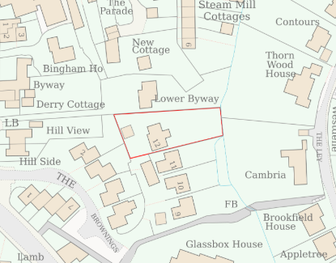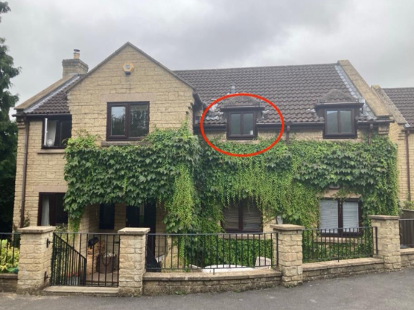

Location Plan and submitted site photo

The latest aerial photo below, explains the private drive leading off The Browning’s. The photo to the right shows the view from a first-floor window.

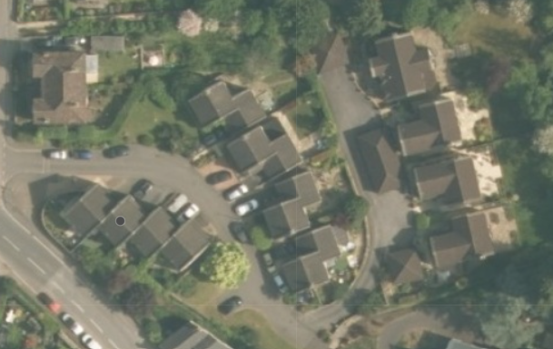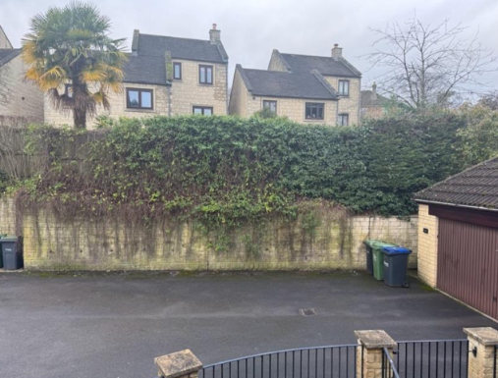

PROPOSAL
The proposal seeks retrospective planning permission to extend an existing window opening, and insert a matching glazed unit, to improve natural light to the landing/staircase. The current window is 920mm high with the proposed window being 1650mm. Proposed materials are wood-effect uPVC as per all other windows as approved under 18/05154/FUL.

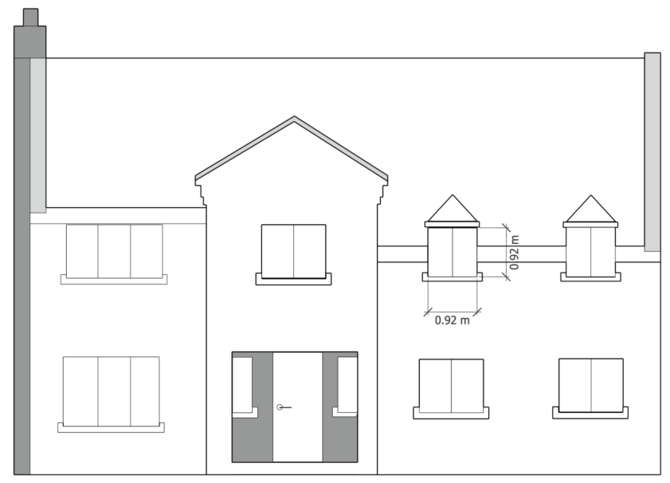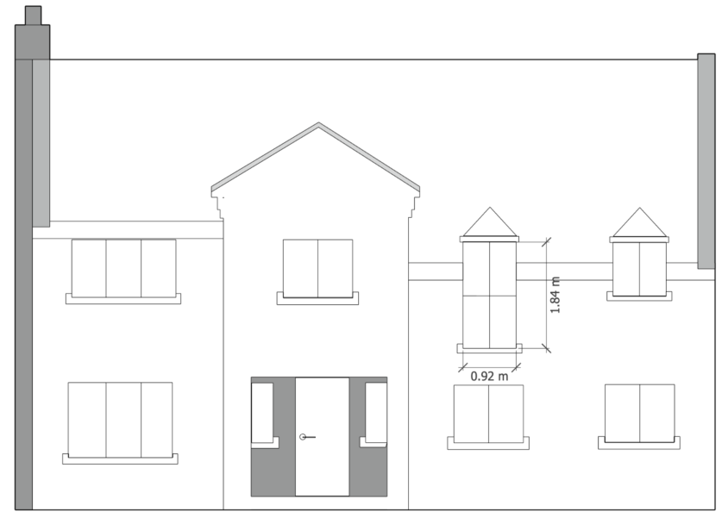

Existing and Proposed Front Elevation

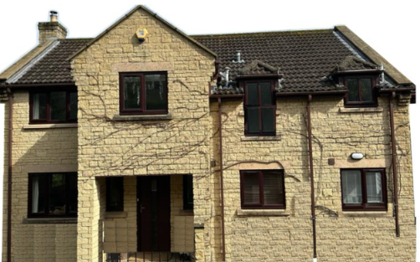

Rendering of proposed new window

PLANNING HISTORY
N/94/02339/FUL - Full planning permission Decision - Approve with Conditions Date: 17/1/1995 – TWO STOREY HOUSE HOUSE
18/05154/FUL - Full planning permission Decision - Approve with Conditions Date: 24/7/2018 – Replacement of the original windows and doors with uPVC wood effect replacements. Replace some existing exterior wooden panelling with brickwork to match existing materials.
N/10/00591/FUL - Full planning permission Decision - Approved Date: 12/4/2010 – External Spiral Staircase and Door to Rear (Resubmission of 09/01586/FUL)
17/00086/FUL - Full planning permission Decision - Approve with Conditions Date: 19/4/2017 – Replacement of remaining original windows with uPVC wood effect replacements – no.11.
N/88/00949/FUL - Full planning permission Decision - Approve with Conditions Date: 6/6/1988 – ERECTION OF 3 NO.DWELLINGS WITH ASSOCIATED DOUBLE GARAGESPARKING SPACES AND EXTERNAL WORKS
N/89/00831/FUL - Full planning permission Decision - Approve with Conditions Date: 24/4/1989 – ERECTION OF 3 No 4 BEDROOM DWELLINGS AND 1 No 5 BEDROOM DWELLING WITH ASSOCIATED DOUBLE GARAGES PARKING SPACE &EXTERNAL WORKS
N/91/00656/FUL - Full planning permission Decision - Approved Date: 11/6/1991 – ERECTION OF FOUR DWELLINGS AND GARAGES

RELEVANT POLICIES AND GUIDANCE
Planning (Listed Buildings and Conservation Areas) Act 1990
Section 72 – Conservation Areas

The National Planning Policy Framework (NPPF)
The Planning Practice Guidance
National Design Guide
Wiltshire Design Guide: Appendix D – Design Guidance for Householder extensions

Wiltshire Core Strategy:
- Core Policy 57 Ensuring High Quality Design and Place Shaping
- Core Policy 58: Ensuring the Conservation of the Historic Environment

Box has a designated Neighbourhood Plan area but no made plans as yet
Box Conservation Area Appraisal
Cotswold National Landscape Management Plan, 2018-2023.

CONSULTATION RESPONSES
Box Parish Council: No objection.

REPRESENTATIONS
No comments were received.

ASSESSMENT

Principle of Development and Impact on the Openness of the Green Belt and Impact on Special Landscape Character:
The primary considerations are the impact of the proposals on the landscape;
- if it would be inappropriate development in the Green Belt,
- the impact on the openness and purposes of the Green Belt, and
- the effect on the landscape and scenic beauty of the Cotswold National Landscape.
The NPPF, paragraph 153, is clear in asserting that inappropriate development is ‘harmful to the Green Belt and should not be approved except in very special circumstances’.

Paragraph 142 states that “the fundamental aim of Green Belt Policy is to prevent urban sprawl by keeping land permanently open; the essential characteristics of Green Belts are their openness and their permanence.”

CP51 of the WCS, states that ‘development should protect, conserve and where possible enhance landscape character and must not have a harmful impact upon landscape character …’ including the ‘special qualities of National Landscapes, where great weight will be afforded to conserving and enhancing landscapes and scenic beauty.’

The National Planning Policy Framework (NPPF), in Paragraph 189, states that “great weight” should be given to conserving and enhancing landscape and scenic beauty in National Landscapes (formerly Areas of Outstanding Natural Beauty). Development within or affecting the setting of a National Landscape must demonstrate that it will not result in unacceptable harm to the special qualities of that area.
In considering applications where new development is proposed to an existing building within the Green Belt, the following two criteria must be met:
1. Would the proposed development comprise a disproportionate addition to the original building as it was when erected, or since 1st July 1948? and/or,
2. Would there be any material harmful impact on the openness of the Green Belt?

The NPPF does not, elaborate on the definition of ‘disproportionate’ addition nor does it quantify what would represent a disproportionate addition. In light of the above and in accordance with well-established planning practices, each case must be assessed on its own individual merits.

The proposal does not seek urban sprawl or further encroach on the countryside but is an alteration to an existing residential dwelling. No increase of volume is proposed and so the proposal cannot be a disproportionate addition.

The proposal site is central to a dense late C20 development and as such the proposal is considered acceptable due to its minor scale and invisibility to the wider landscape.

The proposal, by virtue of its scale, siting, and design, would not harm the special qualities or scenic character of the Cotswolds National Landscape.

The development therefore complies with Core Policy 51 of the Wiltshire Core Strategy and Paragraph 189 of the NPPF in conserving and enhancing the National Landscape.

Heritage, Design and Impact upon the character and context of the area
From the point of view of the historic environment the main statutory tests are set out within the Planning (Listed Building and Conservation Areas) Act 1990.

Section 72(1) of the Act requires the Council to pay special attention to the desirability of preserving or enhancing the character or appearance of designated Conservation Areas.

The Council’s Core Strategy Policy CP58 ‘Ensuring the conservation of the historic environment’ requires that designated and non-designated heritage assets and their settings will be conserved, and where appropriate enhanced, in a manner appropriate to their significance and encourages proposals which improve the condition of heritage assets at risk.

The Council’s Core Strategy CP 57: Ensuring high quality design requires a high quality of design in all new developments. The policy requires applicants to “demonstrate how the proposal will make a positive contribution to the character of Wiltshire through (amongst other things) responding to the value of the natural and historic environment and being sympathetic to and conserving historic buildings and landscapes. Development is required to respond positively to the existing in terms of building layouts, built form, height, mass, scale, building line, plot size, elevational design, materials, streetscape and rooflines to effectively integrate the building into its setting.

The NPPF outlines government policy for planning. Chapter 16 of the NPPF 'Conserving and enhancing the historic environment' sets out the Government's high-level policies concerning heritage and sustainable development.

The subject dwelling is within the Box Conservation Area. The dwelling was built in the late 1990s, and the Conservation Area established in 1973.

The NPPF paragraph 204 highlights the designation of Conservation Areas and justification of their status as such for special architectural or historic interest, noting that Conservation Areas should not be devalued through designation of areas that lack special interest. It could be argued that the extent of the Box Conservation Area could be reconsidered through a Conservation Area reappraisal.

The architectural design of the modern dwelling is not reliant on the balance or rhythm of fenestration, with the front elevation having varying sized windows, including the paired dormers. The roof of the dormer, and therefore its height would not be altered and so would continue to read as a pair with the other dormer. Therefore the proposal is not considered harmful to the character of the property or wider modern area.

The proposal, by virtue of its scale, design, and use of materials, is considered to preserve the character and appearance of the area.

The development is therefore considered to comply with Core Policy 58 of the Wiltshire Core Strategy and Section 72 of the Planning (Listed Buildings and Conservation Areas) Act 1990, as well as the relevant provisions of the NPPF.

Amenity
Point vii of Core Policy 57 - Ensuring High Quality Design and Place Shaping of the Wiltshire Core Strategy seeks to ensure that developments do not adversely affect neighbouring properties.

The National Planning Policy Framework (NPPF), particularly Paragraph 135(f), stresses that planning decisions should ensure developments provide a high standard of amenity for existing and future users.

The proposed development has been assessed in terms of its potential impact on the residential amenity of neighbouring properties, with particular regard to loss of light, overshadowing, loss of privacy, and overbearing effects.

The proposed window is for a landing, so a non-habitable space, and does not create a new vantage point, so not harming neighbouring amenity.

The proposal therefore accords with Core Policy 57 point vii in respect of safeguarding residential amenity and Appendix D of the Wiltshire Design Guide.

Biodiversity Net Gain
Householder planning applications are exempt from the requirement to deliver Biodiversity Net Gain under Schedule 7A, Section 4(2)(a) of the Town and Country Planning Act 1990, as inserted by the Environment Act 2021.

CONCLUSION
The proposed development is considered to be acceptable in terms of its design, scale, and relationship with the surrounding area. It would not result in any unacceptable harm to the character of the locality, the amenities of neighbouring occupiers, or the interests of highway safety, heritage, or ecology.

The proposal is therefore considered to comply with the relevant policies of the Wiltshire Core Strategy, the Wiltshire Local Plan, and the National Planning Policy Framework. As such, the application is recommended for approval, subject to conditions.

RECOMMENDATION: That Planning Permission be GRANTED subject to conditions.

