APPLICATION FOR FULL-PLANNING PERMISSION
CASE OFFICER REPORT

APPLICATION REFERENCE: | PL/2026/00071
APPLICATION TYPE: | Full planning permission
SITE ADDRESS: | 65 Bulford Road, Durrington, Salisbury, SP4 8EU
DEVELOPMENT DESCRIPTION: | Siting of an InPost Parcel Locker within the car park
RECOMMENDATION: | Approve subject to conditions

SITE DESCRIPTION/CONTEXT

This application relates to 65 Bulford Road, a post office and shop within Durrington, part of the Market Town of Amesbury (including Bulford and Durrington) as defined by Wiltshire Core Strategy (WCS) core policies 1 (Settlement Strategy), 2 (Delivery Strategy) and CP 4 (Spatial Strategy for the Amesbury Community Area).

The application site is a corner plot with the front of the shop facing onto Bulford Road and a carpark located to the rear (west), accessed from New Road. The site is within a residential area.

At the time of the Officer’s site visit there were three InPost Parcel Lockers located on the pavement of New Road, against the south elevation of the shop and another at the front of the shop on the east elevation. There is an enforcement case ENF/2025/00834 relating to the existing lockers on site.

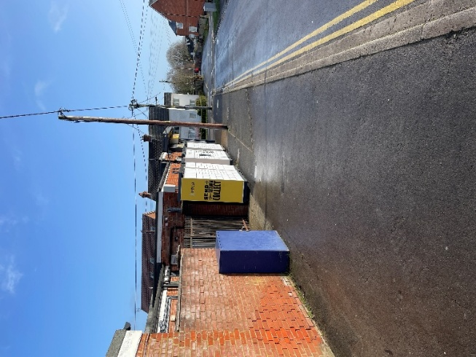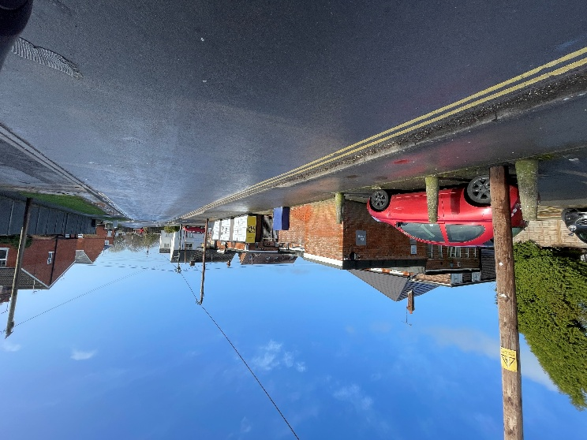
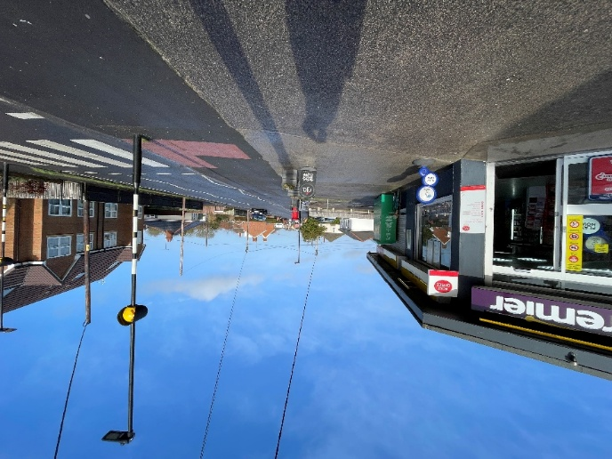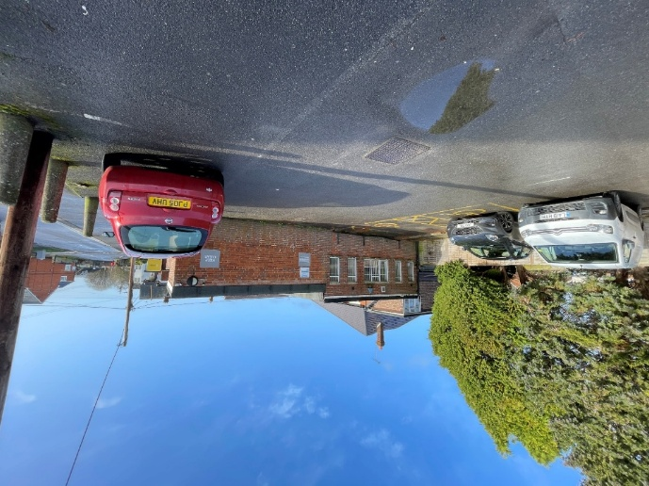

PROPOSAL

The application seeks planning permission for a single ‘InPost Parcel Locker’ to be located against the rear (west) wall of the shop, within the car park. The proposed locker is a freestanding structure that would measure 5m x 0.9m, with a protecting canopy over part of the locker and a height of 2.424m. The locker is comprised of metal cladding with grey vinyl wrapping, integrated security camera and a vertical touch screen.

Three new bollards are proposed in the carpark to protect the locker from vehicles and the revised site plan shows 2no accessible parking bays relocated within the existing car park.

Site plan
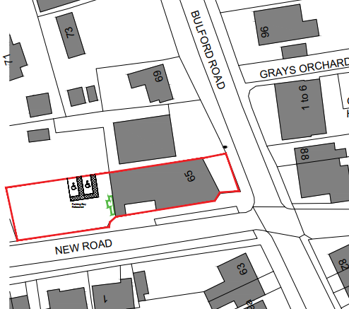

Proposed plans
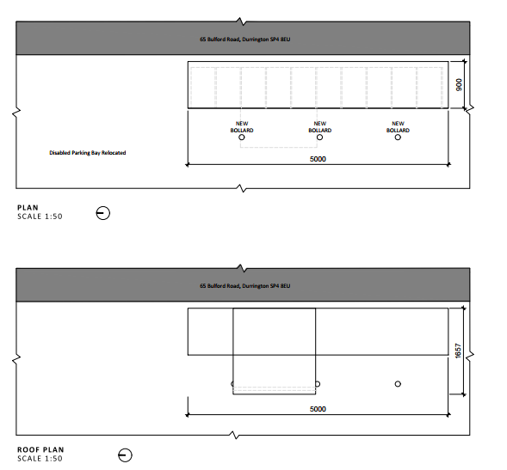

Proposed elevations
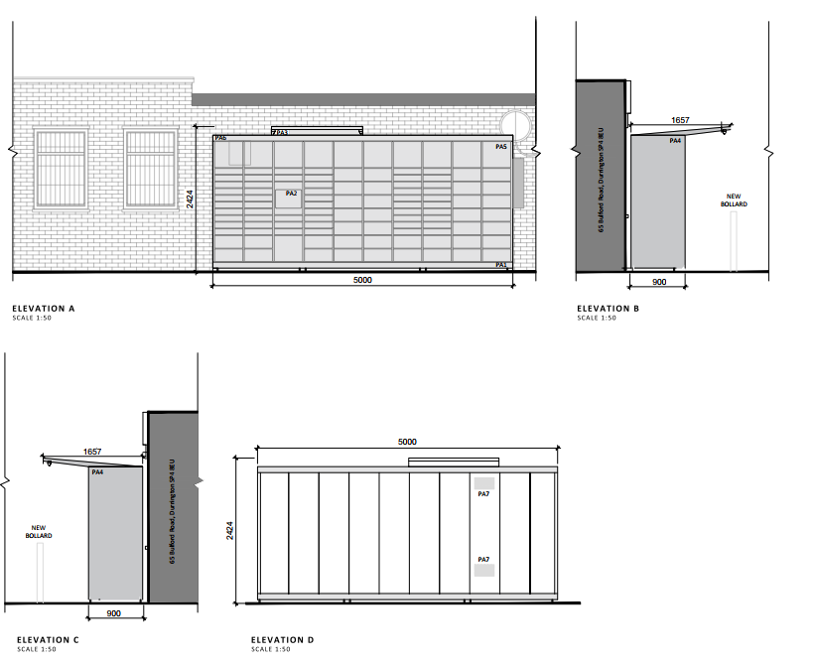

Revised plans were received 23.02.2026 reducing the length of the proposed locker from 8m to 5m.

PLANNING HISTORY

Proposal / Summary

PL/2021/07939 - Full planning permission Decision - Approve with Conditions Date: 20/12/2021 – Upwards extension of an existing commercial building to provide 1 x 3-bedroom apartment and 2 x 2-bedroom apartments, and associated parking, cycle store and bin store.

S/1997/1611 - Full planning permission Decision - Approved Date: 1/12/1997 – PROPOSED ALTERATIONS AND REFURBISHMENT OF EXISTING STORE

S/2004/1067 - Full planning permission Decision - Approved Date: 28/6/2004 – INSTALLATION OF AUTOMATIC TELLER MACHINE

S/2002/0371 - Consent to display an advertisement Decision - Approve with Conditions Date: 22/4/2002 – 2 DOUBLE SIDED PROJECTING SIGNS NON ILLUMINATED LOGO AND NAME ONLY 1 GRAPHIC PANELS MENU BOARDS LOGO/TOWN NAME SIGN EXTERNALLY ILLUMINATED (RETROSPECTIVE)

S/2008/1130 - Consent to display an advertisement Decision - Approve with Conditions Date: 30/7/2008 – INTERNALLY ILUMINATED SIGNAGE

S/2011/1456 - Full planning permission Decision - Refused Date: 8/12/2011 – Installation of a internally illuminated free standing double sided display unit

15/11944/FUL - Full planning permission Decision - Refused Date: 11/4/2016 – Proposed installation of an automated teller machine and non-illuminated top sign.

15/12231/ADV - Consent to display an advertisement Decision - Refused Date: 11/4/2016 – Proposed installation of an automated teller machine and non-illuminated top sign.

PL/2022/00209 - Removal/variation of conditions Decision - Approve with Conditions Date: 7/3/2022 – Variation of conditions 9 (restrictions on deliveries) & 10 (hours of opening) on PL/2021/07939 to allow for early morning newspaper deliveries and to alter opening hours to 06:00 to 21:00 - 1 hour earlier.

S/1990/1720 - Full planning permission Decision - Approve with Conditions Date: 30/1/1991 – CONSTRUCTION OF CAR PARKING AREA FOR EXISTING SHOP

S/2005/2389 - Full planning permission Decision - Approved Date: 5/1/2006 – RETROSPECTIVE APPLICATION - ALTERATIONS TO SHOP FRONT

S/2007/0143 - Full planning permission Decision - Approved Date: 15/3/2007 – SITING OF 2 AIR CONDITIONING CONDENSERS TO THE REAR ELEVATIONS

RELEVANT LEGISLATION, POLICIES AND GUIDANCE

National Planning Policy:
- National Planning Policy Framework (NPPF)
- Planning Practice Guidance (PPG)
- National Design Guide
Development Plan:
The development plan for Wiltshire comprises the Wiltshire Core Strategy (WCS) (adopted January 2015) and any made neighbourhood plans, which remains the principal statutory planning document guiding development across the county. In line with Section 38(6) of the Planning and Compulsory Purchase Act 2004, planning decisions must be made in accordance with the development plan unless material considerations indicate otherwise.

Though the development plan is considered as a whole, those parts deemed to be particularly relevant to this application are listed below:

The adopted Wiltshire Core Strategy (WCS), with particular regard to:

- Core Policy 1 Settlement Strategy;
- Core Policy 2 Delivery Strategy;
- Core Policy 4 Spatial Strategy Amesbury Community Area
- Core Policy 57 Ensuring High Quality Design and Place Shaping;
- Core Policy 58 Ensuring the Conservation of the Historic Environment;
- Core Policy 60 Sustainable Transport;
- Core Policy 61 Transport & Development;
- Core Policy 62 Development Impacts on the Transport Network;
- Core Policy 63 Transport Strategies
- Core Policy 64 Demand Management
- Core Policy 67 Flood Risk;

Supplementary Planning Documents and other Guidance:
- Wiltshire Design Guide (adopted April 2024)
- Wiltshire Local Transport Plan 2011-2026, adopted 2015 - including the Car Parking Strategy and Cycling Strategy, adopted 2015

ISSUES
- Principle of development
- Design and impact upon visual amenity
- Impact on neighbour amenity
- Highways

CONSULTATION RESPONSES

WC Highways: No objection subject to conditions:

I refer to the above planning application for retrospective approval for the siting of an InPost Parcel Locker.
I note the application is retrospective, however no photos have been submitted of the lockers in place.
The plan shows the lockers to be positioned on the back wall of the shop where there are two disabled parking bays. The parking bays are not shown on the submitted plans.
Please can it be confirmed how the disabled parking bays will be repositioned to allow full access for disabled users of the bays.

Following submission of revised plans, comments were received as follows:

I refer to the amended plans for the above application.
I note that the disabled parking spaces are to be relocated to still provide 2 but away from the rear of the building and that the lockers are to be positioned on road site of the rear of the building. This is all acceptable in highway terms.
I therefore raise no highway objection providing the following condition is imposed:
No part of the development hereby permitted shall be first brought into use until the disabled parking spaces [2] have been completed in accordance with the details shown on the approved plans. The areas shall always be maintained for those purposes thereafter and maintained free from the storage of materials.
REASON: In the interests of highway safety.

Durrington Town Council: Comments received as follows:

The Council wishes to draw attention to the location of the proposed lockers within a residential area. There is a potential concern regarding noise, particularly if the lockers are accessed or used during night-time hours. The Council requests that the planners take this into consideration when assessing the application.

REPRESENTATIONS
In accordance with the requirements of the Town and Country Planning (Development Management Procedure) (England) Order 2015 (as amended), the application was publicised by way of:

- Neighbour notification letters sent to adjoining and nearby properties;
- A site notice displayed near the site;

These methods were used to inform interested parties and provide a period of 21 days for comments to be submitted.

Two representations were received with no objection to the siting of lockers in the car park:

I have no objection to the In-Post lockers being moved from the current location alongside the property on New Road to the car park at the rear of the property as per the retrospective planning application. Currently where they are sited, along the side of the property on New Road, I would object if they were to remain there for a couple of reasons. Firstly where they are sited, double yellow lines are on both sides of New Road and the reason there are the yellow lines is because it is already a highly congested area. Also I would like clarification on the number of lockers there are meant to be as the planning application refers to 'an' In-Post locker when in fact 3 have been sited already and are in operational use.

Having viewed the plans, I note that the lockers are to be sited at the rear of the property within the car park.
As this is retrospective, I would have expected the lockers to be sited at the rear and not down the side of the property along New Road. New Road already has an in issue with vehicle use and to place them in an area where there are double yellow lines will just cause added problems to an area that is a concern.
I have no issues with them if they are re-sited at the rear of the property but if they are to stay where they are then I would raise an objection.

One objection was received:
Objection to Planning Application for Additional Post Parcel Lockers
I am formally object to the planning application for the installation of additional post parcel lockers. My objection is based on the following concerns:
Existing Parcel Lockers: There are already multiple parcel lockers installed at this location, both in front of the shop and down the side. The addition of further lockers is unnecessary and will exacerbate existing issues.
Increased Traffic and Congestion: The proposed lockers will inevitably lead to increased traffic in the area, particularly during peak times such as rush hours. This will worsen the already problematic congestion, as the site is located on a road with double yellow lines, where parking is prohibited.
Parking Issues: The area is already under significant strain due to limited parking availability. The terraced houses in the vicinity rely on the 12 on-road parking spaces, which are insufficient to meet the needs of residents. Additionally, there are two residential care homes nearby, staffed 24 hours a day, further increasing the demand for parking. The proposed lockers, which will be accessible 24/7, are likely to attract vehicles at all hours, further reducing the availability of parking for residents and care home staff.
Safety Concerns: The increased traffic and parking issues pose safety risks for pedestrians and other road users. Due to poor driving behaviors and the lack of proper parking for users of the local facilities, Shop, chemist, increase to the illegal or unsafe parking, increasing the hazards in the area (neither the council, police, shop owners are willing to address). The 24/7 accessibility of the lockers could also result in disturbances during unsociable hours, further impacting the local community.
Previous Discussions with Authorities: There have already been numerous meetings with the police and council regarding the ongoing parking and traffic issues in this area. These discussions highlight the existing challenges, which will only be exacerbated by the addition of more parcel lockers.
In light of the above points, I strongly urge the council to reject this planning application. The proposed development will have a detrimental impact on the local community, worsening traffic, parking, and safety issues in an already overburdened area.
Thank you for considering my objection. I trust that the council will take these concerns into account when making its decision.

Only material planning considerations have been taken into account in the assessment of this application. Non-material issues, such as property values or private legal disputes, cannot be considered in the determination process.

ASSESSMENT
Section 38(6) of the Planning and Compulsory Purchase Act 2004 states:

"If regard is to be had to the development plan for the purposes of any determination to be made under the planning Acts, the determination must be made in accordance with the plan unless material considerations indicate otherwise."

In accordance with this statutory requirement, this application has been assessed against the relevant policies of the Development Plan, including the Wiltshire Core Strategy (2015) and, where applicable, any made Neighbourhood Plans. Consideration has also been given to the policies of the National Planning Policy Framework (NPPF) as a material consideration in the assessment.

Principle of Development
Policy Context
Core Policy 1: Settlement Strategy of the WCS establishes a hierarchy of settlements to guide where development should be focused. The policy prioritises growth in:
- Principal Settlements (e.g., Salisbury, Chippenham, Trowbridge) – main focus for strategic growth.
- Market Towns – support local services and employment; suitable for sustainable development.
- Local Service Centres – smaller towns and villages with a range of services; limited development supported.
- Large and Small Villages – development should be limited and respond to local needs.
- Outside the defined settlements – development is strictly controlled and generally not supported unless exceptional circumstances apply.
.
Core Policy 2: Delivery Strategy of the WCS sets out how development will be distributed and delivered across Wiltshire. The policy emphasises:
- Sustainable patterns of growth, reducing the need to travel and supporting local services.
- Development should be plan-led, aligning with the settlement strategy and supported by infrastructure.
- Windfall development (not allocated in plans) must still comply with the principles of sustainable development.
- Development outside settlement boundaries is generally not permitted, unless it meets specific policy exceptions (as set out in paragraph 4.25 of the WCS).

Together, CP1 and CP2 ensure that new development is strategically located, sustainable, and supports the character and function of Wiltshire’s communities.

The site is identified under CP4 as being within the Market Town of Amesbury (including Bulford and Durrington) and part of the Amesbury Community Area. CP4 requires developers to demonstrate how issues and considerations found at paragraph 5.19 have been considered, those relevant to this scheme include how:
- delivery of greater retail choice in the town
- the need to make Durrington and Bulford more self-contained, the need to have local services and facilities to meet their own needs
- all development within the Community Area will need to conserve the designated landscape of the of Cranbourne Chase and West Wiltshire Downs AONB (now National Landscape) and its setting, and where possible enhance its locally distinctive characteristics

The stationing of an InPost locker in this location is considered to provide a service to local residents and as such there is no objection to the principle of development.

It is noted that click and collect facilities are considered as permitted development within Part 7, Class C of the GDPO. However, officers note the requirements of criterion C.1 (a) of the GPDO that states if there is more than one collection facility within the curtilage of a shop, planning permission is required. In this instance, there are already existing click and collect facilities within the curtilage of the shop. By virtue of there being more than one collection facility already present upon the site (albeit unauthorised), the proposal is contrary to criterion C.1 (a) of the GPDO and therefore, planning permission is required.

Design and Impact on the Character and Appearance of the Area
Core Policy 57 of the WCS requires high-quality design that:
- Enhances local character.
- Responds to the natural, historic, and built environment.
- Retains important features (e.g., trees, hedges).
- Supports sustainable construction and compatibility with surrounding uses.
- Creates safe, legible, and accessible spaces.

Section 12 of the NPPF emphasises design that is:
- Visually attractive.
- Functionally effective.
- Contributes to the quality of the built environment.

The Wiltshire Design Guide encourages sensitivity to local character, materials, and architectural styles and supports modern living standards while maintaining aesthetic and functional quality.

The nature of the proposals as a vinyl wrapped metal structure means that it does not enhance the local character or contribute to the quality of the built environment. However, it is considered that the development is modest in scale and the proposed location, at the rear of a modern and utilitarian shop, within an existing carpark, does not cause harm to the character and appearance of the locality.

Amenity
Core Policy 57 (Point vii) of the Wiltshire Core Strategy requires development to respect the amenity of existing occupants and ensure appropriate amenity levels for future residents.

The National Planning Policy Framework (NPPF), particularly Paragraph 135, reinforces the need for development to provide a high standard of amenity for both existing and future users.

The proposed development has been assessed in terms of its potential impact on the residential amenity of neighbouring properties, with particular regard to loss of light, overshadowing, loss of privacy, and overbearing effects.

The application site is within a residential area but due to the nature of the proposal as a small, single storey structure on the rear of an existing building there are no concerns regarding overlooking/loss of privacy, loss of light or overbearing impact.

The Parish Council and a representative have raised concerns regarding potential noise, given that the lockers could be accessed at any time. However, it is not considered appropriate to impose a condition restricting the use of the lockers or the timing of deliveries, as such restrictions would be difficult to monitor and enforce. It is anticipated that the lockers would predominantly be used by local residents, with most trips likely to be made on foot or involving vehicle movements comparable to those associated with the existing shop. In addition, the use of a locker delivery system could reduce the frequency of delivery vehicle visits to the local area.

It is noted that if any noise complaints were received, they could be investigated under the provisions of the Environmental Protection Act 1990.

Highways Impacts and Parking
Core Policy 57 (xiv) of the Wiltshire Core Strategy seeks to ensure that development must meet the requirements of Core Policy 61. This policy requires proposals to be capable of being served by safe access to the highway network.

The National Planning Policy Framework (NPPF), particularly Paragraph 115 and 116, requires that development proposals do not have an unacceptable impact on highway safety and that safe and suitable access to the site can be achieved for all users.

The proposals do not include for any new access. Three new bollards are proposed in the carpark to protect the locker from vehicles, and the revised site plan shows 2no accessible parking bays relocated within the existing car park.

Comments and objections were received from representatives raising concerns regarding highways impact and safety. Concerns were raised about the loss of on street parking and increased traffic from deliveries and collections, as well as an increase in illegal or unsafe parking.

The Highways Officer has confirmed that the proposals are acceptable and raised no objections. A condition requiring the two disabled parking spaces be completed prior to the first use of the development and maintained thereafter will be included.

Biodiversity Net Gain
As of 2 April 2024, the requirement for Biodiversity Net Gain (BNG) on all new sites came into force. Any small scale (non-major)/major scheme will need to demonstrate no net loss and a minimum of 10% net gain in biodiversity on the site, in line with the requirements of the NPPF, WCS policy CP50 (Biodiversity and Geodiversity) and the Environment Act.

However based on the information available the biodiversity gain planning condition is not considered to apply to this application as the development meets the following exemption criteria and is therefore below the de minimis threshold, meaning the development: − does not impact an onsite priority habitat (a habitat specified in a list published under section 41 of the Natural Environment and Rural Communities Act 2006); and − impacts less than 25 square metres of onsite habitat that has biodiversity value greater than zero and less than 5 metres in length of onsite linear habitat (as defined in the statutory metric).

Other
All three representations received commented on the other parcel lockers on the site. These lockers are in breach of planning regulations and are the subject of an enforcement notice. An informative highlighting this will be included with the approval.

CONCLUSION
The proposals are considered acceptable in the context of its surroundings, providing facilities to Durrington, in accordance with CP4 and with the general criteria set out in the aforementioned policies of the local development plan.

RECOMMENDATION:
That Planning Permission be GRANTED subject to the following conditions:

- The development hereby permitted shall be begun before the expiration of three years from the date of this permission.
REASON: To comply with the provisions of Section 91 of the Town and Country Planning Act 1990 as amended by the Planning and Compulsory Purchase Act 2004.

- The development hereby permitted shall be carried out in accordance with the following approved plans and documents:

2815-0616 L(000)000 Rev P3 Location Plan, received 23/02/2026
2815-0616 L(00)100 Rev P2 Block Plan, received 23/02/2026
2815-0616 L(01)101 Rev P2 Proposed Plan, received 23/02/2026
2815-0616 L(02)101 Rev P2 Proposed Elevations, received 23/02/2026

REASON: For the avoidance of doubt and in the interests of proper planning.

- No part of the development hereby permitted shall be first brought into use until the disabled parking spaces [2] have been completed in accordance with the details shown on the approved plans. The areas shall always be maintained for those purposes thereafter and maintained free from the storage of materials.
REASON: In the interests of highway safety.

- At such a time that the locker hereby permitted is no longer required for purposes of as a parcel locker, it shall be removed and the land restored to its former condition.

REASON: In the interests of visual amenity and the character and appearance of the area.

Informative(s) to Applicant(s):

- The applicant is advised that the parcel lockers currently positioned within the site are not included within the scope of this planning permission. Based on the information available, the Local Planning Authority considers that these structures are unauthorised and thus, do not benefit from any permitted development right and therefore require planning permission for their retention

Accordingly, the parcel lockers should be removed from the site. Alternatively, should it be intended to retain them, a separate application for planning permission must be submitted to, and approved in writing by, the Local Planning Authority to secure their retention.

- The effect of paragraph 13 of Schedule 7A to the Town and Country Planning Act 1990 is that planning permission granted for development of land in England is deemed to have been granted subject to the condition (biodiversity gain condition) that development may not begin unless:
(a) a Biodiversity Gain Plan has been submitted to the planning authority, and
(b) the planning authority has approved the plan.
The planning authority, for the purposes of determining whether to approve a Biodiversity Gain Plan, if one is required in respect of this permission would be Wiltshire Council.
There are statutory exemptions and transitional arrangements which mean that the biodiversity gain condition does not always apply. For further information on exempt developments please refer to:
https://www.gov.uk/guidance/biodiversity-net-gain-exempt-developments
Based on the information available this permission is considered to be one which will not require the approval of a biodiversity gain plan before development is begun because one or more of the statutory exemptions or transitional arrangements is considered to apply.

