APPLICATION FOR HOUSEHOLDER PLANNING PERMISSION
DELEGATED REPORT

APPLICATION REFERENCE: | PL/2026/01016
APPLICATION TYPE: | Householder planning permission
SITE ADDRESS: | Winter Lodge, Durley Park, Neston, Corsham, SN13 9YG
DEVELOPMENT DESCRIPTION: | Demolition of an existing double garage and construction of a new smaller single garage, landscape works including new recon stone boundary walls and replacement aluminium windows.
RECOMMENDATION: | That Planning Permission be GRANTED

SITE DESCRIPTION/CONTEXT

The subject property is a detached, two-storey, 4-bedroom dwelling, in an area of shared C20 design and materiality on a modern cul-de-sac, on the outskirts of Corsham.

The site was once known as Moor Green, and to the rear of the property is now an area of woodland, which was once part of Westwells quarry, and later a larger WWII Military Camp. Neston Conservation Area ends at the entrance to Durley Park so is sufficiently distanced to not be impacted.

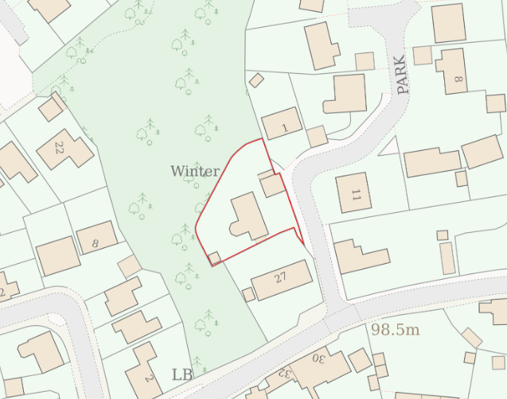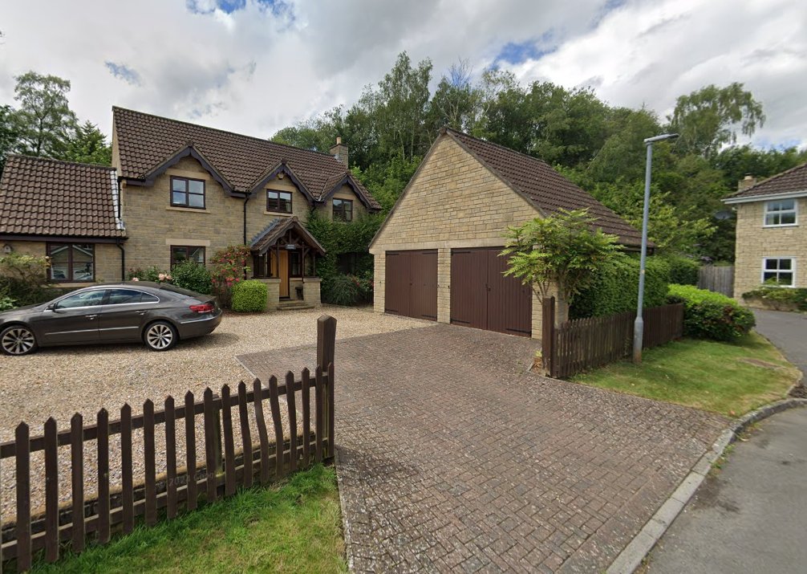

Location Plan and Google Earth Site Photo

The application site is within buffer zones of various bat roosts but outside of the Bradford on Avon and Bath SAC.

PROPOSAL

The proposal seeks planning permission to:
- Demolish existing double garage (12.5m²) abutting front boundary
- Replace with shorter, longer garage (10.5m²) closer to the dwelling, materials to match existing – recon stone walls, concrete roof tile, aluminium garage door.
- Replace timber fencing around the whole site with a recon stone boundary wall at 1.8m high between dwellings and 1m along the short section immediately fronting the highway.
- New patio paving to east and low retaining wall
- Brick paving/gravel driveway replaced with permeable paving (no change to existing off-street parking spaces)
- All timber framed window replaced with painted aluminium windows.

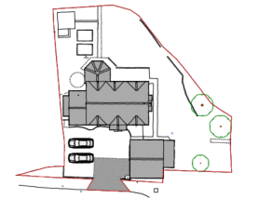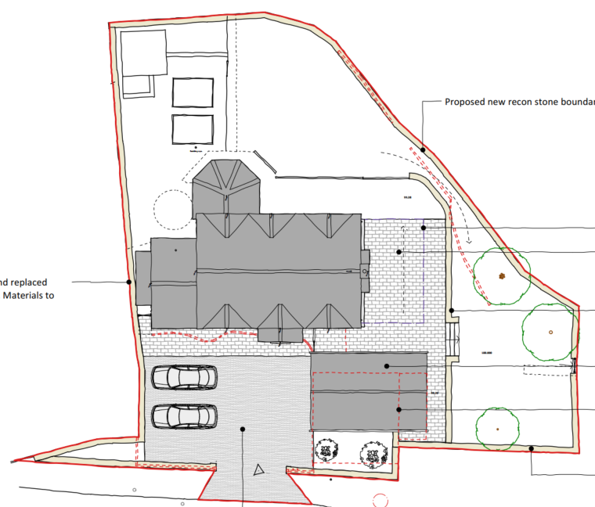

Existing and Proposed Site Plan

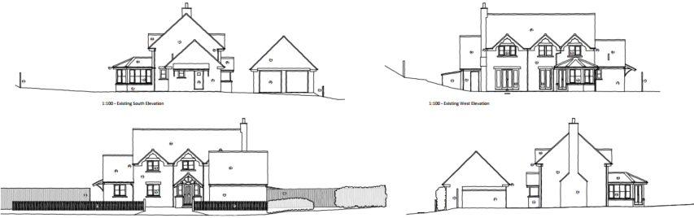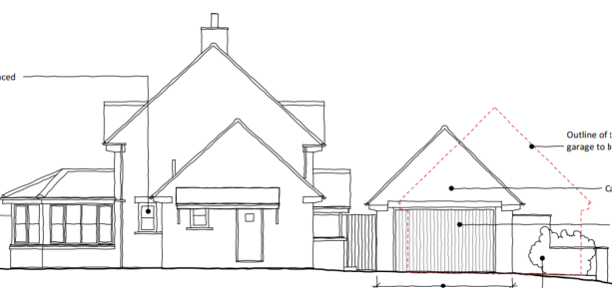

Existing and Proposed South Elevation

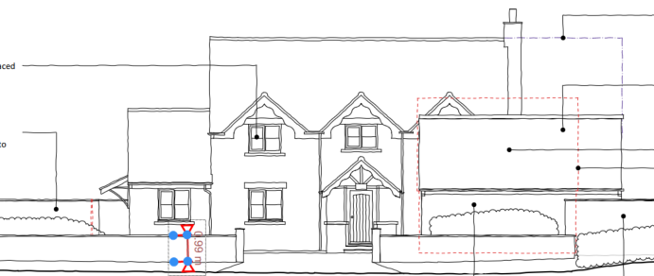

Existing and Proposed East (front) Elevation

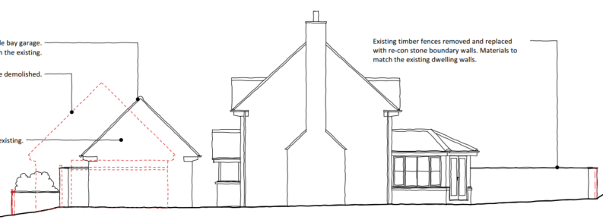

Existing and Proposed South Elevation

Recently approved application PL/2025/07082 (approved ground floor plan included below for ease), included a link between the dwelling and existing garage. It is noted that this application does not include such a link to the new garage and as such has not been assessed and is not considered as part of this approval.

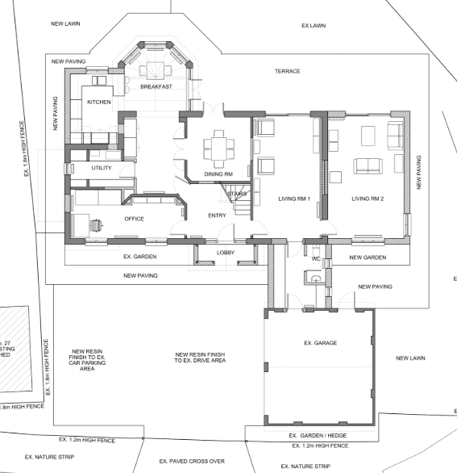

PLANNING HISTORY
PL/2025/07082 - Householder planning permission Decision - Approve with Conditions Date: 16/10/2025 – The construction of a new two storey side extension, a new single storey rear extension and a new single storey connection between the existing detached house & existing detached double garage, and general interior refurbishment.
N/97/02604/REM - Reserved Matters Decision - Approve Date: 22/12/1997 – ERECTION OF DETACHED HOUSE & GARAGE (REVISION TO N/97/1734/D) DWELLING & GARAGE (REVISION)
N/90/02793/OUT - Outline Planning Decision - Approve with Conditions Date: 13/7/1994 – RESIDENTIAL DEVELOPMENT OF 78 DWELLINGS WITH ASSOCIATED ROADWORKS AND OPEN SPACE

RELEVANT POLICIES AND GUIDANCE
The National Planning Policy Framework (NPPF)
The Planning Practice Guidance
National Design Guide
Wiltshire Design Guide: Appendix D – Design Guidance for Householder extensions

Wiltshire Core Strategy:
- Core Policy 57 Ensuring High Quality Design and Place Shaping
- Core Policy 50: Biodiversity and Geodiversity
- Core Policy 61: Transport and New Development

Corsham Neighbourhood Plan, made 2019

CONSULTATION RESPONSES
Corsham Town Council: No objection.
Highways: No objection, subject to conditions.

REPRESENTATIONS
No comments were received.
ASSESSMENT

Principle of Development:
Section 70(2) of the Town and Country Planning Act 1990 and section 38(6) of the Planning and Compulsory Purchase Act 2004, require that the determination of planning applications must be made in accordance with the Development Plan, unless material considerations indicate otherwise.

The proposal comprises development to an existing residential property set in an established residential area within the settlement boundary of Westwood. The proposal is wholly within the residential curtilage, and as such, the principle of development is acceptable subject to the following considerations.

In accordance with this statutory requirement, this application has been assessed against the relevant policies of the Development Plan, including the adopted Wiltshire Core Strategy (2015) and, where applicable, any made Neighbourhood Plans.

Design and Impact upon the character and context of the area
Core Policy 57 - Ensuring High Quality Design and Place Shaping of the Wiltshire Core Strategy seeks to ensure that all new development is of high design quality, reflecting local context, character, and distinctiveness.

The proposal includes demolishing a dominant double garage abutting the highway, and replacing with a narrower, longer garage with reduced ridge height, set back, and materials to match the existing (the proposed stone would replicate that of the existing dwelling in stone colour, size, texture and coursing etc.). The scheme will therefore result in positive visual impacts and integrate successfully with the host dwelling and modern character of the wider area.

The area includes precedents for small sections of recon stone wall, with historic rubble stone walls evident at the junction with the Conservation Area at the entrance to Durley Park. As such, the proposed boundary wall will harmonise successfully. It should be noted that the stone boundary walls to the side and rear are permissible under permitted development. The 1m section fronting the highway is also permitted development.

Replacement aluminium windows, whilst not much evident in the area, are a sustainable alternative to timber frames, and assessed to not harm the character of the dwelling or wider area.

Likewise, replacing the exiting gravel driveway with permeable paving is an acceptable replacement, providing a sustainable drainage solution.

Having regard to the above, the proposal complies with the design principles set out in Core Policy 57 of the Wiltshire Core Strategy and Appendix D of the Wiltshire Design Guide.

Amenity
Point vii of Core Policy 57 - Ensuring High Quality Design and Place Shaping of the Wiltshire Core Strategy seeks to ensure that developments do not adversely affect neighbouring properties.

The National Planning Policy Framework (NPPF), particularly Paragraph 135(f), stresses that planning decisions should ensure developments provide a high standard of amenity for existing and future users.

The proposed development has been assessed in terms of its potential impact on the residential amenity of neighbouring properties, with particular regard to loss of light, overshadowing, loss of privacy, and overbearing effects.

The proposed replacement garage will be longer than the existing, so will therefore project further northwards towards no.1, but given there is still a notable spatial gap, this does not raise concerns.

The proposal therefore accords with Core Policy 57 point vii in respect of safeguarding residential amenity and Appendix D of the Wiltshire Design Guide.

Highways Impact
Core Policy 57 (xiv) of the Wiltshire Core Strategy seeks to ensure that development must meet the requirements of Core Policy 61. This policy requires proposals to be capable of being served by safe access to the highway network. Core Policy 64 seeks to ensure compliance with parking standards set out in the Local Transport Plan.

The National Planning Policy Framework (NPPF), particularly Paragraph 115 and 116, requires that development proposals do not have an unacceptable impact on highway safety and that safe and suitable access to the site can be achieved for all users.

The site has existing access to Durley Park; an unclassified section of public highway subject to a speed limit of 30mph.

The proposal seeks to demolish the existing double garage and replace with a single garage, in addition to replacing the existing brick paviours and gravel finishes to the parking area with permeable paving. This will include alterations within the public highway between the property curtilage and the running carriageway and as such will require a licence to carry out the works.

The proposed reduction in garage space would not adversely impact parking provision on site and the parking would still be in accordance with minimum standards for a 4+ bedroom dwelling.

The proposals include replacing the boundary fence with a wall, this would appear to be some 2m from the edge of the carriageway on Durley Park and as such should not interfere with the existing visibility splay. Any works undertaken within the public highway for the replacement boundary treatment may require a licence.

The proposal is therefore considered to comply with Core Policies 57 (xiv), 61 and 64 of the Wiltshire Core Strategy, the NPPF, and the Wiltshire Local Transport Plan.

Ecology Impact
Core Policy 50 of the Wiltshire Core Strategy seeks to protect and enhance biodiversity and geodiversity, including through ensuring that development avoids harm to protected species and habitats.

The National Planning Policy Framework (NPPF), in Paragraphs 193, requires that development minimises impacts on and provides net gains for biodiversity, including ensuring mitigation is secured where harm cannot be avoided.

All UK bat species are protected by European and UK legislation; the Conservation of Habitats and Species Regulations and the Wildlife and Countryside Act. Considering the scale and form of proposed development, as a first floor extension to an existing ground floor inhabitated structure, within a suburban area, no substanitave ecology impact is raised and as such does not meet the threshold for a habitat regulations assessment.

An informative is included as a precautionary measure, raising the profile of the Bat SAC, including that if any evidence of bat activity is detected, that the applicant should follow the advice of a professional ecologist or contact Natural England.

Biodiversity Net Gain
Householder planning applications are exempt from the requirement to deliver Biodiversity Net Gain under Schedule 7A, Section 4(2)(a) of the Town and Country Planning Act 1990, as inserted by the Environment Act 2021.

CONCLUSION
The proposed development is considered to be acceptable in terms of its design, scale, and relationship with the surrounding area. It would not result in any unacceptable harm to the character of the locality, the amenities of neighbouring occupiers, nor the interests of highway safety or ecology.

The proposal is therefore considered to comply with the relevant policies of the Wiltshire Core Strategy, the Wiltshire Local Plan, and the National Planning Policy Framework. As such, the application is recommended for approval, subject to conditions.

RECOMMENDATION: That Planning Permission be GRANTED subject to conditions.

