

Land north of High Street, Dilton Marsh

Planning Compliance Statement

Date: April 2026 Revision No: North Somerset
BS21 7BU

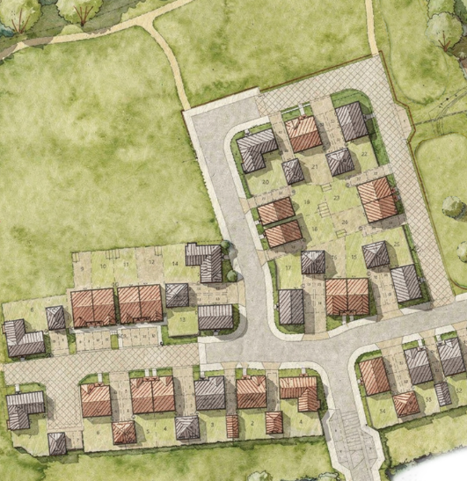

CONTENTS
1. INTRODUCTION 1
Purpose of Statement 1
The outline planning permission 1
The application submission 1
2. The site context and Scheme 3
Context 3
Application proposal 4
3. compliance with the outline consent 6
Parameters of the outline planning permission 6
Conditions 2&3 – Reserved Matters Submission 6
Condition 4 – Approved Plans/parameters of application 7
4. SUMMARY AND CONCLUSION 8

- INTRODUCTION
Purpose of Statement
  - This Reserved Matters application has been produced by Redcliffe Homes; the applicant, for the site located north of High Street, Dilton Marsh.
  - The proposal seeks Reserved Matters approval for up to 54 dwelling houses.
  - The site sits to the centre of Dilton Marsh and encompasses an existing field, which is surrounded by an existing hedge and vegetation to the north and housing to the south.
  - The purpose of this Statement is to assist Wiltshire Council in its consideration of the accompanying Reserved Matters submission for the detailed matters relating to Layout, Landscaping, Appearance and Scale.
  - The supporting statement follows detailed consideration of the planning merits of the development proposal, an analysis of the Local Development Framework and assessment of relevant Government guidance.
The outline planning permission
  - Outline planning permission was granted by the Planning Inspectorate on Wiltshire Council on 12th March 2025. This followed an appeal as a result of Wiltshire Council refusing Planning Permission on 19th March 2024. The appeal granted consent for outline planning permission for up to 54 residential dwellings, with all matters reserved save for access (PL/2023/01880).
  - Condition 2 of the outline permission states that submission of the reserved matters in respect of the development shall be made to the Local Planning Authority in respect of layout, scale, appearance and landscaping before the expiration of three years from the date of outline permission.
  - Condition 3 of the outline permission requires all of the reserved matters, as submitted, to be approved prior to the commencement of development.
  - This Reserved Matters statement is made in full accordance with the parameters set out in the outline permission.
The application submission
  - This Reserved Matters Application for details of appearance, layout, scale and landscaping has been submitted via the Planning Portal, with the requisite planning application fee also paid by Redcliffe Homes.
  - This application submission is supported by the following technical information
- Completed Planning Application Forms;
- Planning Compliance Statement by Redcliffe Homes;
- Design and Access Statement by Thrive Architects;
- Architectural Plans and Elevations by Thrive Architects;
- Accommodation Schedule by Thrive Architects
- Landscaping details by ACD Environmental.
- Engineering Details by Morgan Civils and Structural;
- Drainage Strategy by Morgan Civils and Structural;
- Lighting details by Highway Lighting Solutions;
- Energy Statement by Energist;
- Biodiversity Net Gain Statement and metric by GE Consulting;
- Construction Environmental Management Plan (CEMP) by Pegasus;
- Arboricultural Impact Assessment by Bosky Trees;

- The site context and Scheme
Context
  - The site is located within the village of Dilton Marsh, to the north of the High Street. The land comprises grazed grassland that is sub-divided into smaller paddocks by electric and wired fencing. The northern boundary is lined with trees which screen the site from views from the north, as well as a watercourse that runs along its boundary. The eastern boundary consists of a tree belt that extends into the adjacent parcel, the south is bound by terraced housing and a range of other detached residential dwellings, and the western boundary consists of planted trees and a continuation of the watercourse that defines the northern boundary.
  - The site can be accessed via a corridor formed by land that links the paddocks to the highway. This access currently features a steel gate.
  - Beyond this access and to the south is Dilton Marsh High Street, which provides a direct route into the village and to Dilton Marsh train station to the east. The larger town of Westbury lies towards the north-east, a town that features a wide array of everyday facilities and a substantial trading estate which supports extensive local employment opportunities.
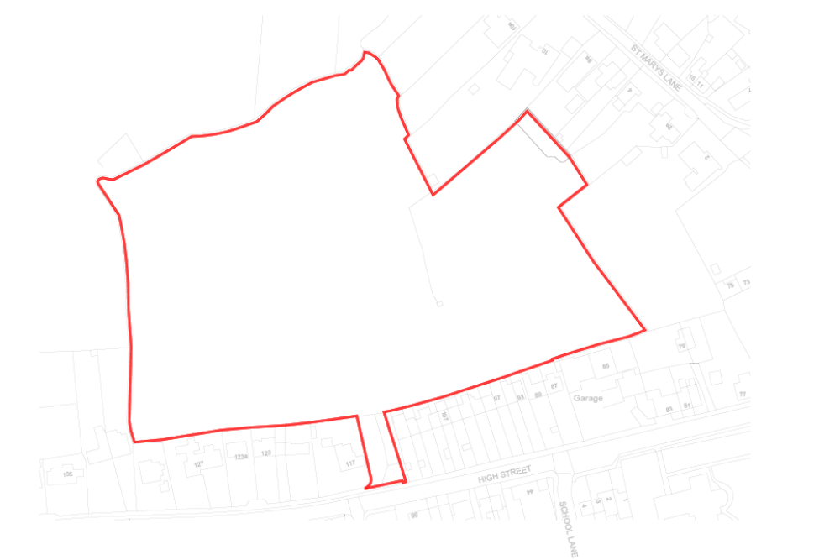Figure 1: Location Plan
  - The land on which the proposed development sits can be seen in figure 1 above. The site generally slopes down from its southern boundary in a northerly direction. The properties along the southern boundary, that back onto the site, generally have large front gardens, with small back gardens that directly abut the site’s southern boundary.
  - There are a number of facilities provided within Dilton Marsh, generally focused on the High Street, including a village hall, pub, fish and chip shop, car repair services and a post office, café and shop that are situated within Fairfield Farm College. Dilton Marsh Church of England Primary School lies in close proximity and directly south of the site, on School Lane. Other services can also be found elsewhere in the village, such as Dilton Marsh Social Club, Step-Up Nursery and a Garden Centre.
  - Additional everyday facilities can be found in the settlement of Westbury, which lies directly to the east of Dilton Marsh, including an Aldi, Morrisons, Lidl and Tesco supermarket, leisure centre, doctors’ surgery and chemist, letting agency, accountants, hairdressers and barbers, pubs, cafes, motor services shop, vets, charity shops and various takeaways. Babe Tots Nursery, Bitham Brook and Westbury Church of England Primary schools and Matravers Secondary school are also located within the town. The majority of these facilities lie within walking distance of the application site.
  - A frequent bus service stops on the High Street and provides links to Westbury, Trowbridge and Frome. Dilton Marsh train station which lies to the east of the village also provides services to and from the site.

Application proposal
  - This Reserved Matters proposal comprises a total of 54 residential dwellings comprising a mix of 2, 3 and 4 bedroom properties.
  - In addition to the residential dwellings, the development will also comprise the provision of open space and landscaping. The open space comprises a significant amount of Public Open Space, including a trim trail and seating, together with informal footpaths and sustainable drainage.
  - The design of the buildings is set out in the Design and Access Statement, however all buildings will comprise of high-quality materials utilising a range of treatments from stone, render to red brick with numerous design features.
  - The development proposals in relation to the submitted Reserved Matters fully comply with the parameters set out in the approved outline permission.
  - The outline permission includes approved parameters in the form of:
- BNG Plan
- Ecological Parameters Plan
- Site Access Highway Layout Plan
- Site Access general arrangement Drawing
- Offsite Highways Works Option 1
  - The offsite access arrangements are in accordance with those submitted and approved as part of the Outline permission.
  - The proposed summary of accommodation schedule is shown below.
Market Housing
Beds | Number
1 | 0
2 | 4
3 | 24
4 | 10
Total | 38
Affordable Housing inc First Homes
Beds | Number
1 | 6
2 | 6
3 | 4
4 | 0
Total | 16
Overall Total | 54

  - This

- compliance with the outline consent
Parameters of the outline planning permission
  - The outline planning consent was subject to 14 conditions and a legal agreement under Section 106 of the Town and Country Planning Act.
  - Whilst the conditions cover a range of matters, only some relates to matters to be addressed within the Reserved Matters application submission. These include conditions 2, 3 and 4. The remaining conditions that require the submission of technical information will be discharged via a separate submission(s).
Conditions 2&3 – Reserved Matters Submission
  - Conditions 2&3 requires the submission of all reserved matters within 2 years of outline approval and to be approved prior to commencement.
  - This Reserved Matter submission provides full details of the layout, appearance, scale and landscaping for the proposed development through the submission of a suite of architectural drawings and Design & Access Statement produced by Thrive, and a landscape drawings produced by David Jarvis.
  - Further details regarding the design evolution of the scheme can be found within the submitted Design & Access Statement.
  - As submitted as part of the Reserved Matters submission, the following 4 key matters are sought for approval.
Layout
  - The proposed layout follows the approved site access layout plan and ecological parameters plan. Whilst not formally approved, the layout also closely follows the masterplan as submitted during the outline planning approval. Details of the proposed layout an be found within the architectural package.
Appearance
  - The appearance for the proposed houses is set out within the enclosed house type drawings and streetscenes. These show a rage of housing types with materials that closely follow those found in the local area, including red brick together with lesser quantities of stone and render. The area is split into two main character areas with the materials with the materials differing depending on the specific area.
  - Further information and context can be found within the enclosed design and access statement.
Scale
  - The proposal comprises 54 dwellings which are predominantly 2 storey in height with the exception of two houses which are 2.5 storey in height. There are elements of terracing, but the predominant form is that of detached houses, again to mimic that of Dilton Marsh.
Landscaping
  - The proposed landscaping follows closely the parameters of the site which include the detailed ecological parameters together with the requirements for play space (in the form of a trim trail), suds drainage and the retention of the wildflower meadow.
Condition 4 – Approved Plans/parameters of application
  - Condition 4 sets out the approved documents, for which the Reserved Matters application must accord. The specific plans and documents comprise:
- BNG Plan
- Ecological Parameters Plan
- Site Access Highway Layout Plan
- Site Access general arrangement Drawing
- Offsite Highways Works Option 1
  - The reserved matters submission incorporates these documents fully and accords with the relevant parameters.

- SUMMARY AND CONCLUSION
  - This application has been prepared by Redcliffe Homes; the applicant, for the site located North of High Street Dilton Marsh. The development proposals seek to construct up to 54 houses together with associated parking, landscaping and sustainable urban drainage in the form of ponds and rain gardens.
  - The reserved matters submission is in full conformity with the outline approval (Ref: PL/2023/01880).
  - The layout, appearance, scale and landscaping are appropriate in the wider context of Dilton Marsh and the proposals are compliant with the adopted Development Plan.
  - We therefore request that this reserved matters application is progressed to determination and approved at the earliest opportunity.

