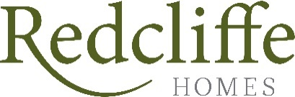

Land north of High Street, Dilton Marsh

Statement of Community Involvement

Date: April 2026 Revision No: North Somerset
BS21 7BU

CONTENTS
1. INTRODUCTION 2
2. Planning Polocy Context 3
National Planning Policy Framework (NPPF) 3
Wiltshire Statement of Community Involvement (July 2020) 3
3. Consultation Methodogy 5
4. Consultation response 7
6. SUMMARY AND CONCLUSION 8
7. Appendices 9
Appendix A – Copy of leaflet sent to residents 9

- INTRODUCTION
  - This application has been produced by Redcliffe Homes, who now own the land north of High Street, Dilton Marsh.
  - The site sits to the centre of Dilton Marsh, directly to the north of High Street and bounded by housing to the south and east. The site is currently un-developed and comprises a small field. The application seeks Reserved Matters planning permission for residential development on this site, following the grant of outline planning permission in 2025 (ref: PL/2023/01880).
  - This statement summarises the public engagement process that has led to the planning submission.
  - The current engagement took place between 3rd March and 22nd March 2026.

- Planning Polocy Context
  - The Planning Legislation and Compulsory Purchase Act 2004, the Planning Act 2008 and the Localism Act 2011 sets out the requirement for Local Planning Authorities to produce a Statement of Community Involvement giving communities the opportunity to engage in the planning process.
  - In considering the appropriate engagement strategy for the proposed development, there has been a review of the relevant national planning guidance, local policy and in particular, the Wiltshire Statement of Community Involvement which was adopted by the Council in July 2020.
National Planning Policy Framework (NPPF)
  - The Government considers that pre-application engagement and frontloading of work prior to the submission of a planning application as key to ensuring timely decision making, reducing days and cost to the applicant while achieving quality outcomes. Paragraphs 39-42 refer to the role of pre-application engagement with the community in further detail. In essence, national policy states that:
- Early engagement has the significant potential to improve efficiency and effectiveness of the planning application system for all parties, and good quality pre-application discussion enables better coordination between public and private resources and improved outcomes for the community (Paragraph 39);
- Local planning authorities should encourage applicants to engage with the local community before submitting a planning application (Paragraph 40);
- The more issues that can be resolved at the pre-application stage, the greater the benefits (Paragraph 41); and
- The participation of statutory planning consultees with an early pro-active approach will assist local authorities in issuing timely decisions, helping to ensure that applicants do not experience unnecessary delays and costs (Paragraph 42).
  - Paragraph 126 of the NPPF states that applicants will be expected to work closely with those directly affected by their proposals to evolve designs that take account of the views of the community. It goes on to state that proposals which can demonstrate this in developing the design of the new development should be looked on more favourably.
Wiltshire Statement of Community Involvement (July 2020)
  - The Wiltshire SCI is intended to provide the community with clarity on the levels of involvement that they should expect in planning processes. The SCI explains in detail Wiltshire Council’s policy for engaging the community in the preparation of Wiltshire’s planning policy documents and in the consideration of planning applications.

  - Wiltshire Council encourages prospective developers to undertake more extensive public involvement at an early stage, before a planning application is submitted. It will expect the developer to discuss with Wiltshire Council's planning officers details of how the community should be involved in the decision making process. The purpose of these discussions will be to:
- identify the groups/individuals that should be involved.
- agree how they should be involved.
- agree a timetable for their involvement.
- establish how the feedback from the consultation will be provided.
- discuss how the feedback from the consultation exercises will be incorporated into the development proposal.
  - The level of community involvement agreed will aim to reflect the scale and complexity of the proposal and will be the responsibility of the developer. Residents' groups, the local town/parish council and elected members should be invited to respond, either via meeting or online.
  - The proposal should not be presented as a completed project but should cover the options that can be considered. Feedback should be encouraged both at the event and subsequently.
  - When the planning application is submitted, Wiltshire Council will expect the applicant to provide evidence that sets out how the community has been involved. This should take the form of a Statement of Community Involvement outlining what public consultation has been carried out and how the results of the exercise have been taken into account in the submitted application. A Statement of Community Involvement is a validation requirement for major development proposals.

- Consultation Methodogy
  - Redcliffe Homes have undertaken public engagement on this site in early March 2026.
  - In addition to the current public engagement, the outline application was the subject to comprehensive engagement and a formal pre-application. This was submitted to Wiltshire Council in April 2022 (ref: ENQ/2022/00752).
  - The previous engagement is set out within the SCI report prepared by Grassroots Planning and dated February 2023
  - The response from Wiltshire Council to the pre-application submission was largely an in-principle objection at the time to housing generally.
  - The previous public consultation carried out in May/June 2022, generated a wide range of concerns including:
  - Drainage/ surface water flooding and existing sewerage capacity – floods in the High Street opposite 107/109 High Street in previous years due to blocked drains;
  - Road safety due to increased traffic (there would be at least 70 cars adding to the overuse of the road). Concern over availability of parking spaces on new development as no evidence of parking spaces or garages is shown;
  - Bus and train services intermittent;
  - Noise;
  - Damage to critical wildlife;
  - House value depreciation;
  - Security;
  - Access – narrow access;
  - Pressure on local services such as school’s and doctors (the village school is already at capacity and as it is a village school, it is not built to accommodate huge numbers of children. Additionally, the primary school in Westbury Leigh will already face a huge influx of students from the new development that is currently underway;
  - Parking on the High Street; and
  - Amenity.
  - The latest public engagement comprised a leaflet drop to over 150 houses together with contact to the Parish Council.
  - Leaflets (Appendix A) were sent via post to all registered addresses within the below catchment area which is consistent with the previous catchment (as per the outline application) as shown below:
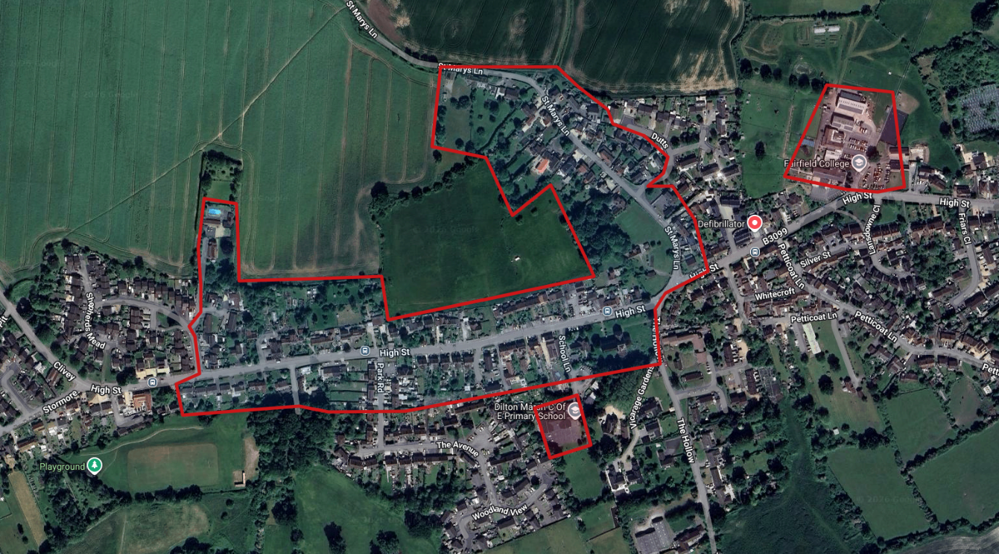
  - The leaflets were sent out on Tuesday 3rd March 2026 by Royal Mail 2nd Class and should have been received by Thursday 5th March 2026. The leaflet did provide a deadline for comments of 22nd March, however any received after this date have been included. Notwithstanding the above, Redcliffe did not penalise any late comments and kept the consultation open until the point of submission.
  - Members of the public were asked to respond to specific questions, although there was an option to respond directly via post or email.
  - In addition to the public consultation, Dilton Marsh Parish Council were also contacted by RHL on the proposed submission of a formal Reserved Matters planning application.

- Consultation response
  - A total of 19 responses were received via the email or post from 17 individuals.
  - In total, 17 responses objected or raised concerns to the proposal and 2 supported it.
  - The main themes for discussion were:
- General concern for the addition of new homes in the area and pressure this may have on local services and facilities;
- Impact on road safety from construction and future residents vehicular movements;
- Flooding concerns;
- Impact on local wildlife;
- Impact on local school; and
- Request for public meeting.
  - Following feedback, amendments have been made to the proposals, including detailed reports to cover a range of topics. The following documents and reports will be included with the Reserved Matters application to ensure minimal harm and impact on the exiting village:
  - Travel Plan to encourage new residents to utilise alternative travel;
  - Constriction Management Plan to ensure that construction vehicular movements are managed in a sensitive and appropriate manner;
  - CEMP and LEMPs are included to ensure the protection, enhancement and ongoing maintenance of the ecological and landscape proposals;
  - Detailed drainage strategy is included to include the latest SuDs requirements as per DEFRA guidance to confirm how surface water will be managed;
  - In additional, any application will need to provide financial contributions via the S106 and Cil to be made available to the local school and Parish Council to mitigate the impact from additional residents.
  - Given the Reserved Matters nature of the proposed application, it was accepted that there were limited areas to comment on the application.
  - As set out above, Dilton Marsh Parish Council were also contacted by RHL on the proposed submission of a formal outline planning application. The consultation was due to be discussed at a meeting on 19th March 2026 but to date, no feedback has been provided.

- SUMMARY AND CONCLUSION
  - This Statement of Community Involvement (SCI) has been produced in support of a Reserved Matters application submitted by Redcliffe Homes Ltd for:
Reserved Matters submission, comprising details of Landscaping, Layout, Appearance and Scale pursuant to Outline planning permission for the development of up to 54 dwellings, including 30% affordable, and supporting infrastructure on land to the rear of 117 High Street, Dilton Marsh BA13 4DP
  - Pre-application consultation in accordance with the Localism Act 2011, and Wiltshire Council’s Statement of Community Involvement (2020) was undertaken prior to the previous outline application with key stakeholders relevant to the site.
  - The opportunity for community involvement in the preparation of the current proposals for the site was widely advertised, and the applicant has undertaken various methods to engage and communicate the evolving scheme to the community.
  - The project team is confident that all parties to the planning process have been appropriately informed and have been given an opportunity to participate in the process, which has been transparent and open, and proportionate to the scale and significance of the development that is proposed.

- Appendices
Appendix A – Copy of leaflet sent to residents
