Photographs to accompany application for Listed Building Consent for replacement of decorative shutters and fire surround on Grade II listed building

Photograph 1: existing front elevation (2024 image)

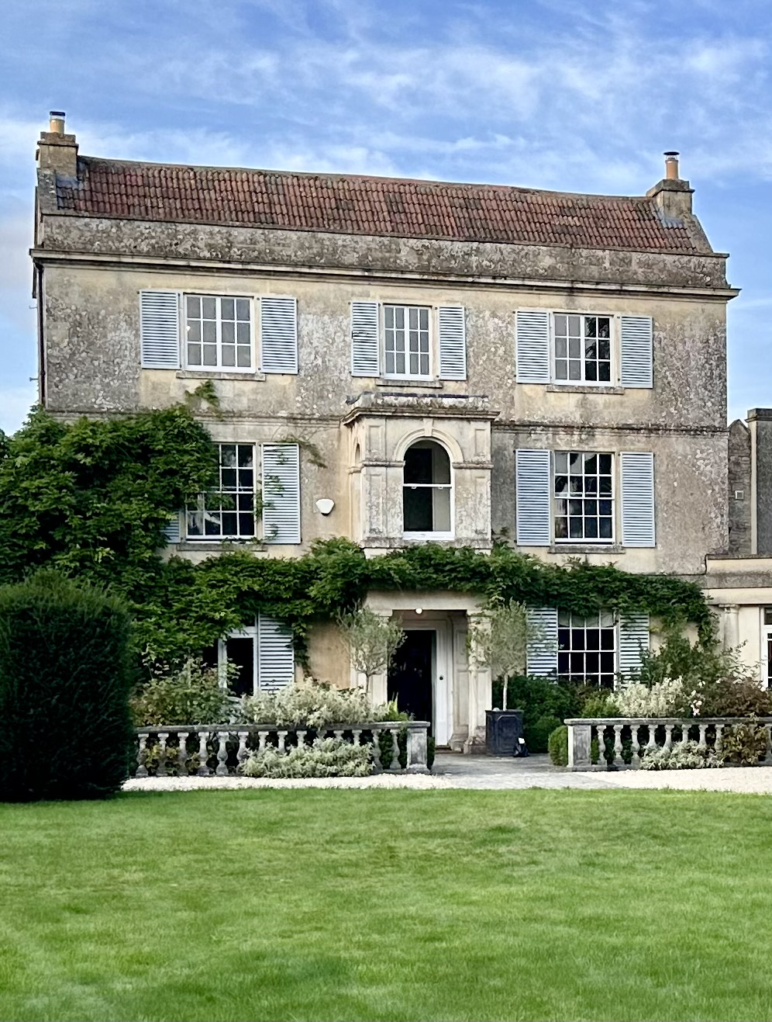

Photograph 2: existing elevation of West side of cottage (shutters to be replaced are above windows marked by red dots)

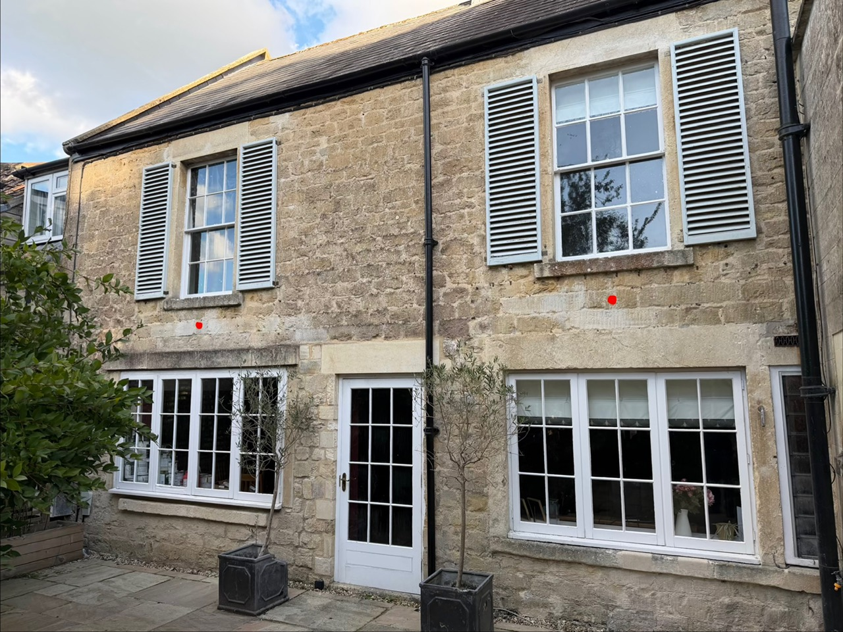

Photograph 3: close up of existing shutter (removed as wood is rotting) to show example of visual design, paint colour, condition, and poor quality corner joints

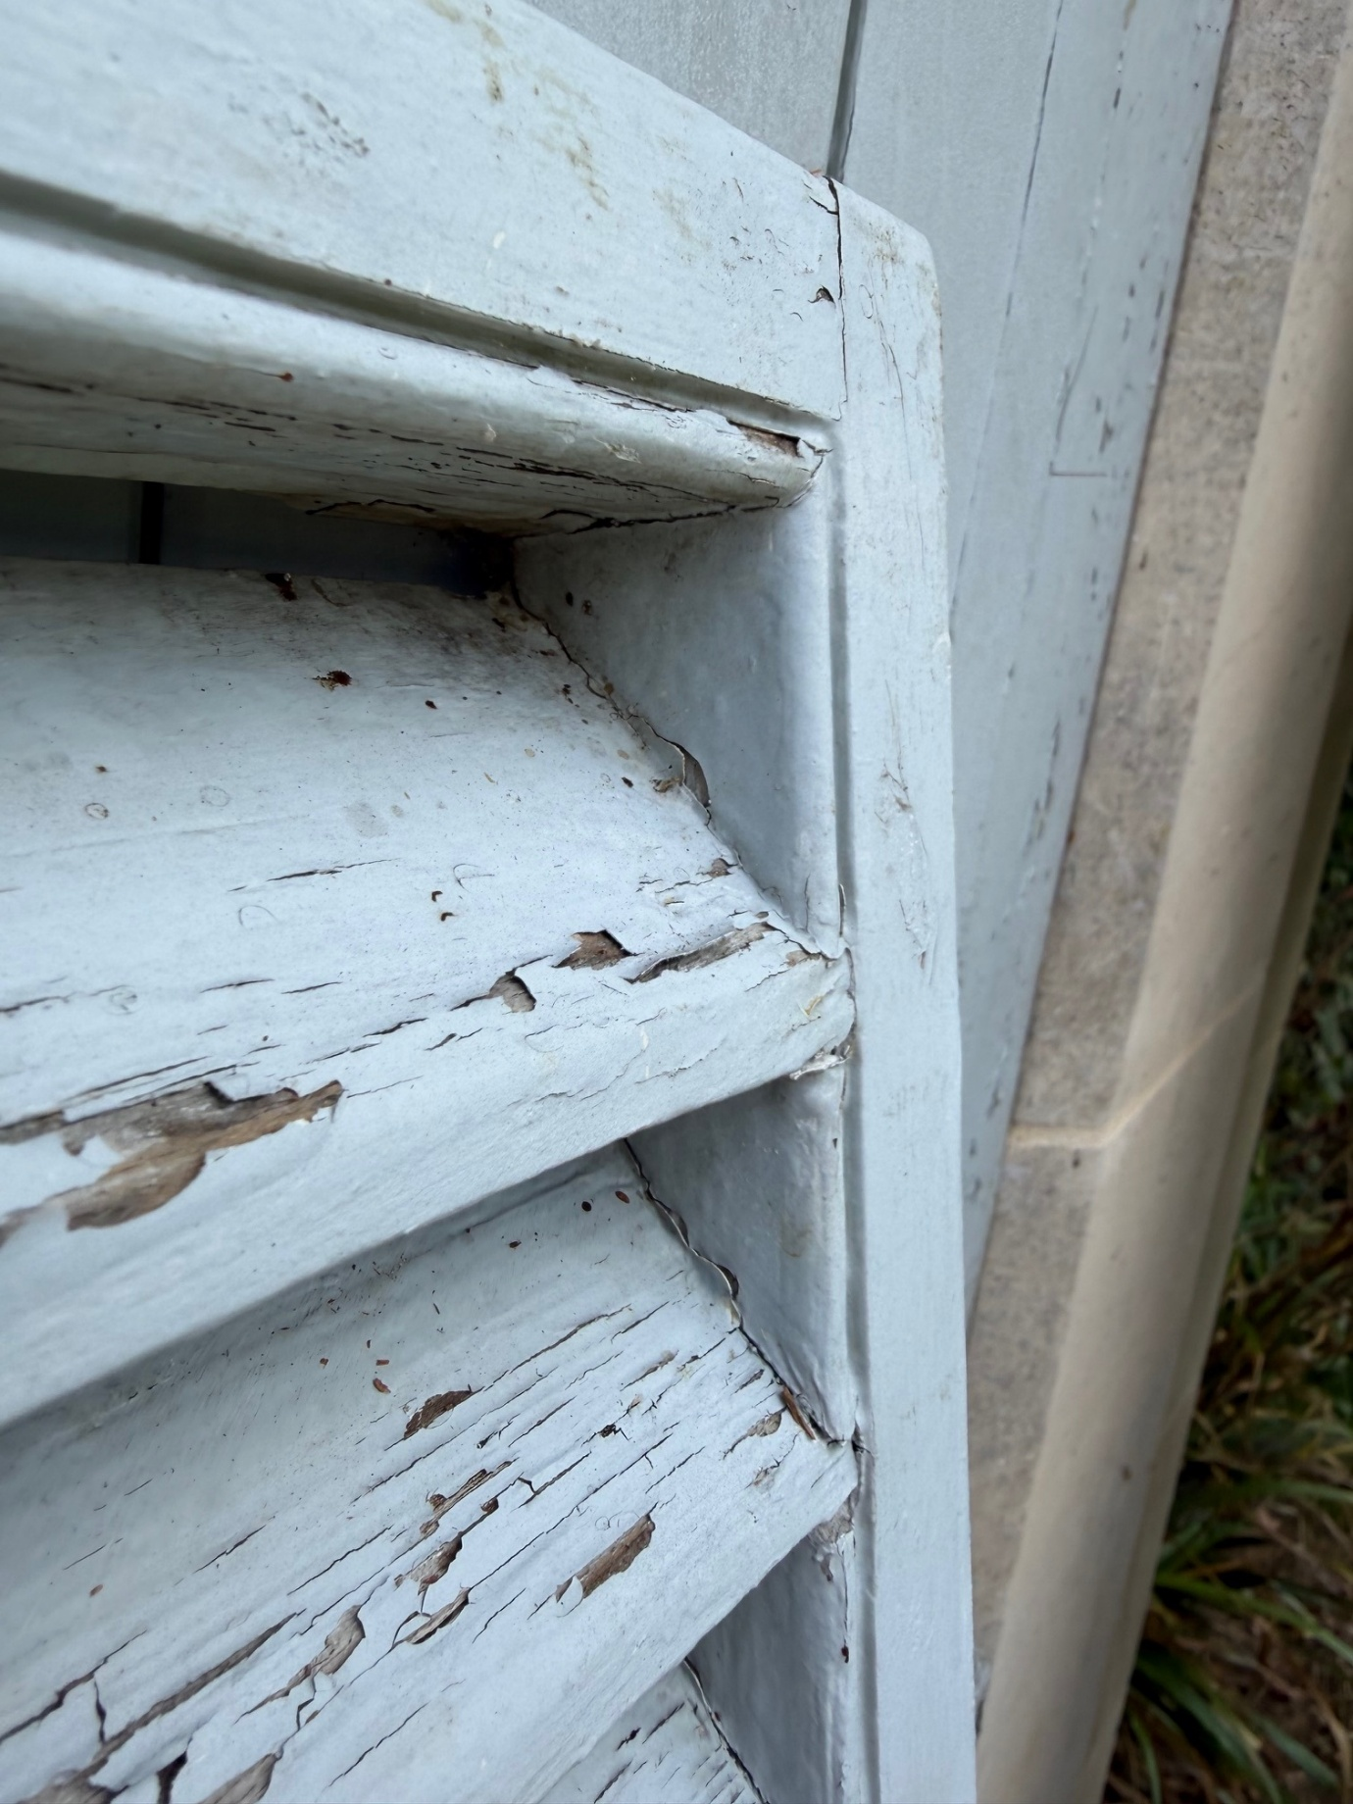

Photograph 4: full view of example shutter removed from first floor of front elevation

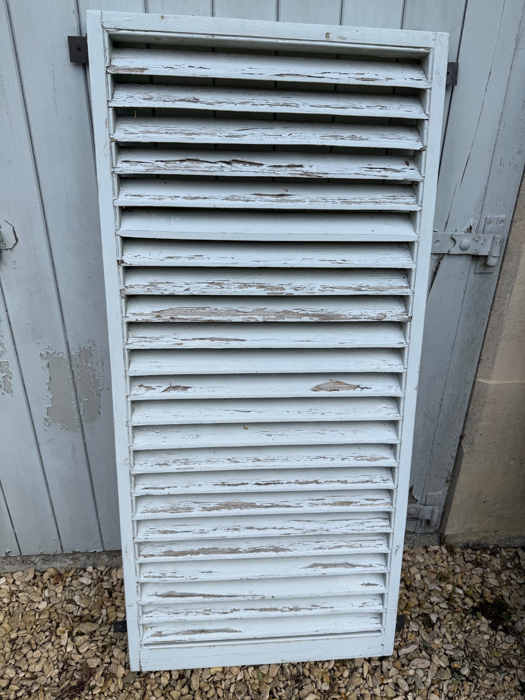

Photograph 5: example of very poor condition of shutters (shutter in central window on third floor)

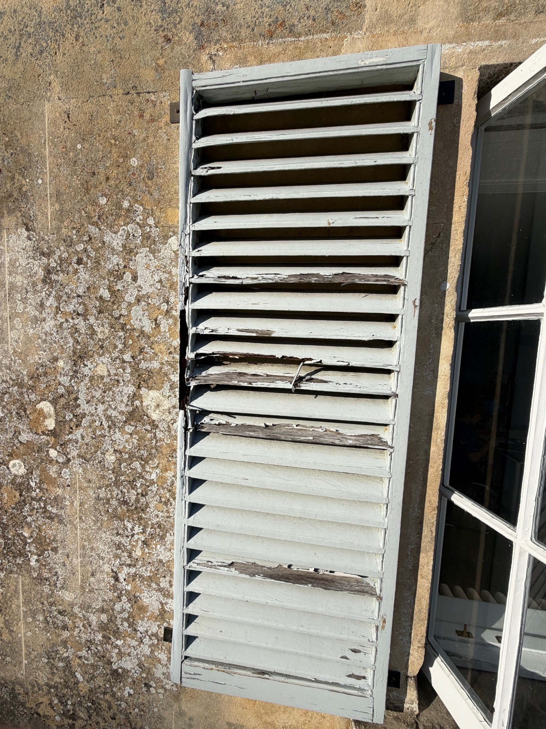

Photograph 6: existing fire surround

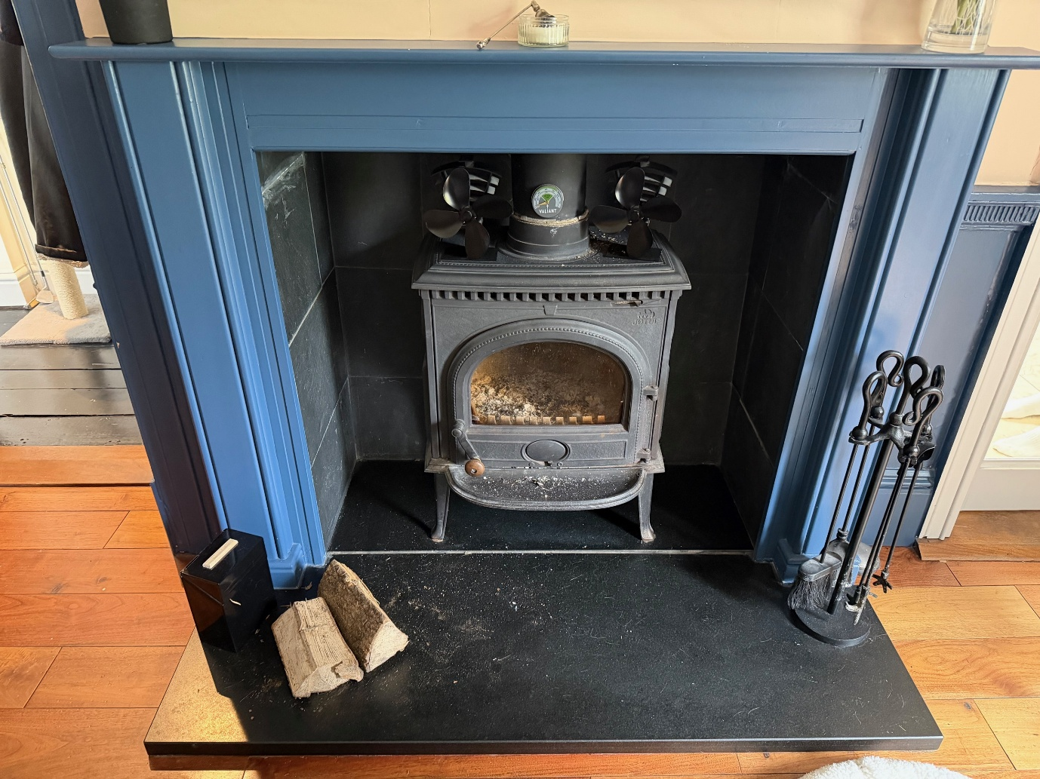

Photograph 7: proposed fire surround

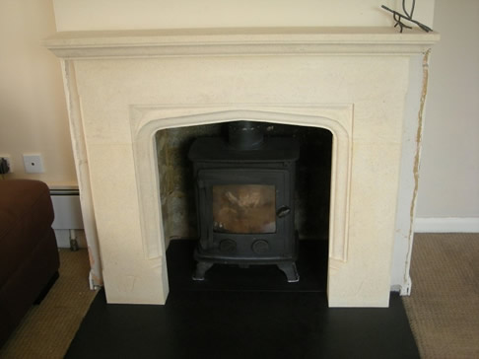

Proposed design of fire surround. As set out in the Schedule of Works, the hearth is to be made of Bath stone (rather than the granite in the image above) and the fireplace is to be lined with Bath stone slips.

